

**HUS System**

:By

Huseen Bouzieh 202111625

Mohammad Jarrad 202111605

Yousef Brooq 202110908

Mostafa Shomali  202111335

Ahmad A Yahya  202111593

**:Supervisor**

Dr.Osama Hamed

[git repositorie](https://github.com/Nalokun/SE_project)

.HUS:helping university students

ABSTRACT

Thank God always and forever. Before

Mention thoughts, don't forget to always thank God for his grace.

The proposed idea is a comprehensive platform designed to support university students in their educational endeavors by providing a variety of files relevant to their academic curricula.

The site serves as a central center where students have access to educational resources and study materials tailored to a specific level of progress in their colleges

.

In addition, the website has tools for personal learning recommendations, progress tracking and performance analyses to further enhance the learning experience. With a focus on accessibility, inclusion and good content, the site aims to enable university students to excel academically and achieve their goalseducational goals.

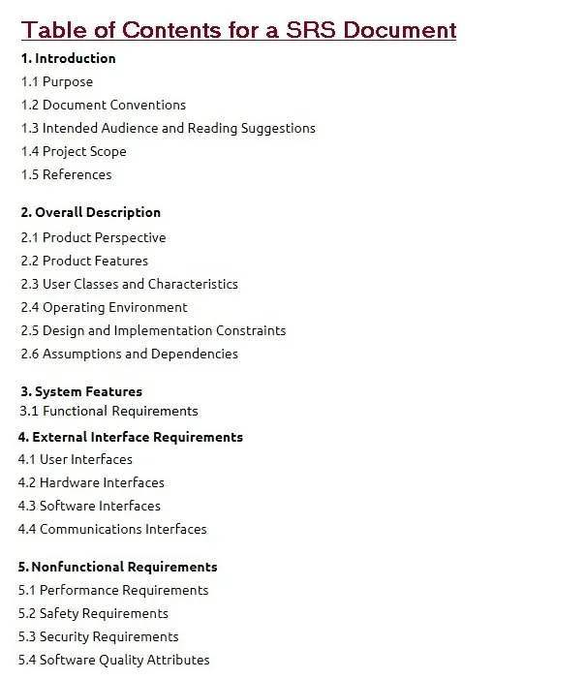

**1.1 Purpose**

**The primary aim of the website** is to provide college students with a accessible platform that supports their learning journey by offering a wide array of courses relevant to their academic curriculum. By leveraging technology and educational resources, the website aims to:

**Enhance Learning**: Facilitate student learning by providing access to high-quality courses, lectures, and study materials tailored to their college curriculum, thus supplementing traditional classroom instruction.

**Promote Accessibility**: Ensure that educational resources are readily accessible to all students, regardless of their geographical location, schedule constraints, or learning preferences, thereby democratizing access to higher education.

**Support Personalized Learning**: Tailor learning experiences to individual student needs and preferences through personalized recommendations, progress tracking, and performance analytics, empowering students to learn at their own pace and style.

By striving to fulfill these aims, the website endeavors to contribute positively to the educational experience of college students, fostering a culture of lifelong learning.

**1.2 DOCUMENT CONVENTIONS**

|  |  |
| --- | --- |
| **ER** | **Entity Relationship** |
| **DB** | **Database** |

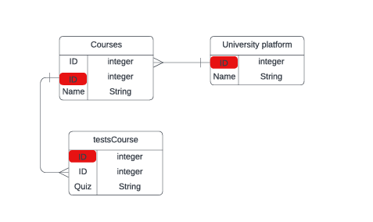

**1.3 INTENDED AUDIENCE AND READING SUGGESTIONS**

The website is primarily targeted towards college students enrolled in various academic programs who seek additional support and resources to enhance their learning experience. This audience includes:

**Undergraduate Students:** Those pursuing bachelor's degrees in diverse fields such as arts, sciences, engineering, business, and more.

**Continuing Education Students:** Adult learners and professionals returning to academia for further education or skill development.

**Remote Learners:** Students enrolled in online or distance education programs who require digital resources for their coursework.

1.4 Project scope

This site currently provides services that focus more on Arab students. The system will consist of a distinct database that raises page performance to another level of ease and speed when users access it. It will deal with large amounts of data through an easy-to-use interface suitable for all university students, ensuring user comfort during use.

**1.5 REFERENCES :**

[YouTube](https://www.youtube.com/)

[wikp](https://www.wikipedia.org/)

[chat 3.5](https://chat.openai.com/)

[lucid.app](https://lucid.app/)

Chapter 2

**Through this Chaptre we will talk more accurately about the website we want to bulid for help students study**

**2.1 Product Perspective:**

*Through this online platform, it helps students enhance their learning experience. It provides an appropriate learning environment by providing students with access to a variety of study tools and resources, for example: questions from previous years, etc. The elements of this education system are as follows:*

#### - System Interfaces :

* ***Video Conferencing Tools****: Integration with platforms like Youtube vidoes, and Mega files to facilitate virtual study sessions and tutoring.*

*\** ***support Management Systems (SMS)****:Integration with popular SMS communication platforms (such as Facebook, Telegram and Whatsapp) for students to submit a site inquiry request or to submit a problem with files in a system, e.g. video files or document files*

#### *- User Interfaces:*

*\** ***Dashboard****: A dashboard that makes students use a site easily displays educational files and videos.*

#### *- Hardware Interfaces:*

***\** ***Client-side****: Desktops, laptops, tablets, and smartphones can to internet access with no problam of dashboard of user.***

***2.2 Product FEATURES :***

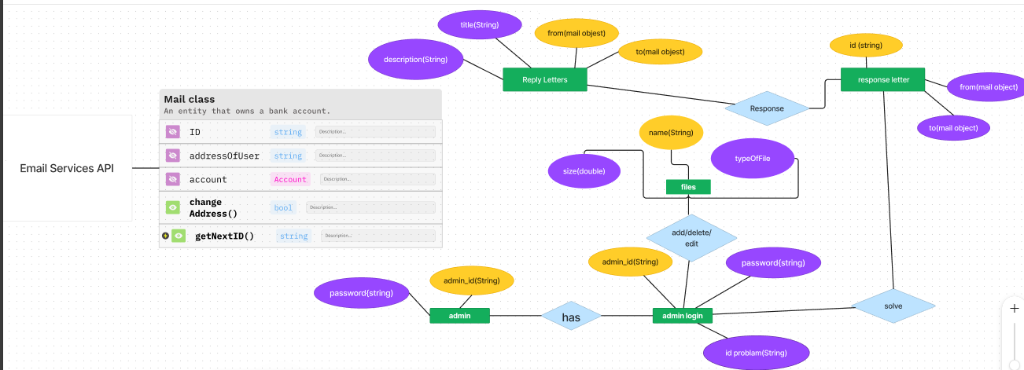

*****2.3 USER CLASS and CHARACTERISTICS:*****

*****The Categories and Characteristics section identifies the different types of users who will interact with a site. Understanding the needs, skills and behaviors of these user classes helps design a user-friendly and efficient system.*****

*****- Students*****

*****Age group: 20-30 years*****

*****Technical skills: basic to technical technology*****

*****Requirements:*****

*****Access to study materials and resources*****

*****Collaboration Tools*****

### ***2.4* ***Operating******Environment:*****

***The operating environment section specifies the conditions under which the site will operate, including hardware, software and network requirements.***

***This ensures that the system is compatible with users' hardware and infrastructure and operates efficiently under different conditions****.*****

#### *****- Hardware Environment:*****

Devices used by students to access the website.

**\* Specifications of PC/Laptop**:

Processor: Intel Core i3 or equivalent

RAM: 1 GB

Storage: 100 MB free space for browser cache

**\* Specifications of tablet/mobile**:

Processor: Quad-core processor

RAM: 1 GB

Storage: 100 MB free space for app/cache

##### - Server Hardware:

**\* Cloud-based Servers**:

Providers: hostinger

**\* Specifications:**

*Processor: 4 vCPUs or more*

*RAM: 8 GB*

*Storage: 100 GB SSD*

#### ***- Software Environment:***

***\* Web Browsers:***

*1- Supported Browsers Latest versions of Google Chrome, Mozilla Firefox, Safari, Microsoft Edge*

*2- Cookies and Local Storage enabled for session management*

*\** ***Mobile website:***

*1-* ***Operating Systems****: iOS 12.0 or later, Android 8.0 (Oreo) or later*

*2-* ***Permissions****: Internet access, storage access for offline content, notification permissions*

*2.5* **DESIGN and IMPLEMENTATION CONSTRAINTS *:***

***- User Interface Design :***

***\* Consistency****: The user interface (UI) must maintain a consistent look and feel across all pages and features to enhance usability.*

*\** ***Accessibility****: The UI must be accessible to users with disabilities*

*-* ***Performance:***

***\** ***Response Time:*** *The system should have fast response times, ideally within 2 seconds for most interactions.***

*\** ***Scalability:*** *The design must support scaling to handle increasing numbers of users and data without significant performance degradation.*

*-* ***Modularity:***

***\* Separation of Concerns: The design should separate different functional modules to simplify maintenance and upgrades.***

***\** ***Extensibility****: The system should be designed to easily integrate new features or third-party services in the future.***

*2.6* ***ASSUMPTION DEPENDENCIES:***

*The ASSUMPTION DEPENDENCIES section identifies factors that are presumed to be true for the successful execution of the project. It also highlights dependencies on external systems, services, or conditions that could impact the project's success.*

***- User access****: It is assumed that all users have devices that provide the specifications mentioned and a fixed internet connection.*

*-* ***Basic Technical Proficiency****: Users possess basic technical skills.*

*-* ***Content Delivery Network (CDN)****: services to deliver content quickly*

*-* ***Hardware and Software Compatibility****: Website compatibility with a variety of devices and browsers.*

*-* ***Cloud Service Providers:*** *Relying on cloud service providers such as AWS, drive to patch education files*

***:Chapter 3***

***of this chapter will take about:*** *The System Features section identifies key functions and features that the site will offer to enhance students' learning experience. Each feature is described in terms of its purpose, function, and any specific requirements or limitations.*

***3.1******functional requirements:***

#### *- Personalized Dashboard:*

*A central center for students to manage reporting on files in teaching files.*

*\** ***Allow*** *users to customize their dashboard using tools to quickly access frequently used features.*

*\** ***Provide*** *notifications and reminders regarding the modification of files.*

*\** ***Ensure*** *fast loading times and respond to user interactions on a dashboard.*

#### *- Performance Analytics:*

*Analytics tools to help students track students' actions in order to identify areas of improvement for the RAH website. This is the subject of a private Python library, for example: Pandas*

*\* Display detailed analytics and insights based on user activities and performance.*

*\* Ensure data accuracy and timely updates.*

*\* Implement data visualization techniques for clear and actionable insights.*

#### *- Help Matching:*

*Submit suggestions to students in communities for additional support and guidance on Scord, for example, or Facebook*

*\* Allow students to search for someone based on subject*

*\* Enable booking and scheduling of tutoring sessions within someone of these*

*:Chapter 4*

*The Interface Requirements section identifies a user's software in a location, including user interfaces and a database to make a site*

***4.1 USER INTERFACES :***

*\** ***Front-end software****: html , css ,* *Pynecone*

*\** ***Back-end software****: Django , NoSQL(Firebase)*

*4.2 HARDWARE INTERFACES :*

* Windows, Linux distributions , Mac os

* A browser that supports HTML & python & CSS.

***4.3 SOFTWARE  INTERFACES :***

|  |  |
| --- | --- |
| **Operating system** | We have chosen Windows operating system for its best support and user- friendliness or can use another software opertation. |
| **Database** | To save the files of videos and document we have chosen NoSQL. |
| Website lang | To implement the project we have chosen python frameworks |

*4.4* ***COMMUNICATION INTERFACES*** *:*

**This project supports all types of web browsers.**

***:Chapter 5***

5.1 **PERFORMANCE REQUIREMENTS**:

The steps required to implement a database of the education site are set out below.

**- E-R DIAGRAM :**

The E-R Diagram is technique for representing the logical structure of a database in a pictorial manner. This analysis is then used to organize data as a relation:

**ENTITIES**: These specify distinct real-world items in an application.

**ATTRIBUTES**: These specify properties of an entity and relationships.

**RELATIONSHIPS**: These connect entities and represent meaningful dependencies between them.



**- NORMALIZATION:**

*Normalization is the process of breaking down a table into smaller tables. So that each table deals with a single theme. There are three different kinds of modifications of anomalies and formulated the first, second, and third normal forms (3NF) is considered sufficient for most practical purposes. It should be considered only after a thorough analysis and complete understanding of its implications.*

***The basic objective of*** *normalization is to reduce redundancy which means that information is to be stored only once. Storing information several times leads to a wastage of storage space and an increase in the total size of the data stored.*

5.2 **SAFETY REQUIREMENTS**:

*If there is extensive damage to a wide portion of the database due to catastrophic failure, such as a disk crash, the recovery method restores a past copy of the database that was backed up to archival storage (typically tape) and reconstructs a more current state by reapplying or redoing the operations of committed transactions from the backed up log, up to the time of failure.*

**5.3 SECURITY REQUIREMENTS**:

*Security systems need database storage just like many other applications. However, the special requirements of the security market mean that vendors must choose their database partner carefully.*

**5.4 SOFTWARE QUALITY ATTRIBUTES** :

- **USABILITY:**

*Ease of Use: The interface should be intuitive and easy to navigate for users of all ages and technical skill levels.*

*Clear instructions, helpful tooltips, and user-friendly design elements should be incorporated.*

- **Maintainability :**

***Modularity****: The system should be designed in a modular fashion, making it easier to update or replace individual components without affecting the whole system.*

***Documentation****: Comprehensive documentation should be provided for both the codebase and the user interface to facilitate maintenance and future development.*

- **CORRECTNESS :**

*All functionalities of the system should work as intended and according to the specified requirements. This includes accurate display and processing of user data, correct functioning of study tools, and proper execution of user commands.*

*-* **AVAILABILITY *:***

*The system should be designed to be available 99.9% of the time, minimizing downtime and ensuring that users can access the platform whenever needed. This includes operational hours, peak usage times, and during maintenance windows.*