

**HUS System**

:By

Huseen Bouzieh 202111625

Mohammad Jarrad 202111605

Yousef Brooq 202110908

Mostafa Shomali  202111335

Ahmad A Yahya  202111593

**:Supervisor**

Dr.Osama Hamed

[git repositorie](https://github.com/Nalokun/SE_project)

.HUS:helping university students

ABSTRACT

N”**Praise be to God always and forever**”. Before we

mention ideas, do not forget to thank God always and forever.

The proposed idea is a comprehensive platform designed to support university students in their educational endeavors by offering a variety of courses relevant to their academic curriculum.

The website acts as a central hub where students can access educational resources, lectures, tutorials and study materials tailored to specific courses offered at their colleges.

With intuitive navigation and user-friendly interfaces, students can navigate these courses and track their progress with ease.

The Platform also includes interactive features such as quizzes and quizzes. Additionally, the Website may integrate tools for personalized learning recommendations, progress tracking, and performance analytics to further enhance the learning experience. With an emphasis on accessibility, comprehensiveness, and quality content, the site aims to empower college students to excel academically and achieve their educational goals.

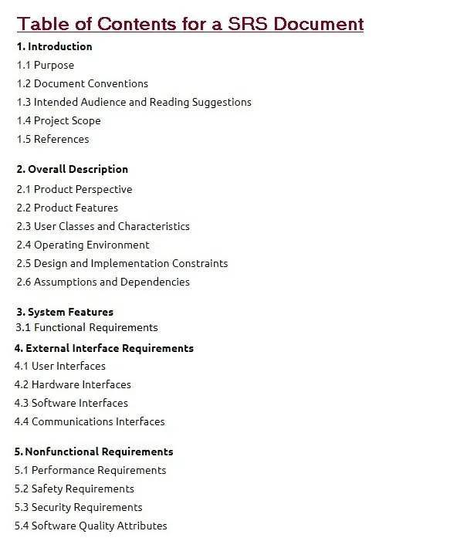

**1.1 Purpose**

**The primary aim of the website** is to provide college students with a accessible platform that supports their learning journey by offering a wide array of courses relevant to their academic curriculum. By leveraging technology and educational resources, the website aims to:

**Enhance Learning**: Facilitate student learning by providing access to high-quality courses, lectures, and study materials tailored to their college curriculum, thus supplementing traditional classroom instruction.

**Promote Accessibility**: Ensure that educational resources are readily accessible to all students, regardless of their geographical location, schedule constraints, or learning preferences, thereby democratizing access to higher education.

**Support Personalized Learning**: Tailor learning experiences to individual student needs and preferences through personalized recommendations, progress tracking, and performance analytics, empowering students to learn at their own pace and style.

By striving to fulfill these aims, the website endeavors to contribute positively to the educational experience of college students, fostering a culture of lifelong learning.

**1.2 DOCUMENT CONVENTIONS**

|  |  |
| --- | --- |
| **ER** | **Entity Relationship** |
| **DB** | **Database** |

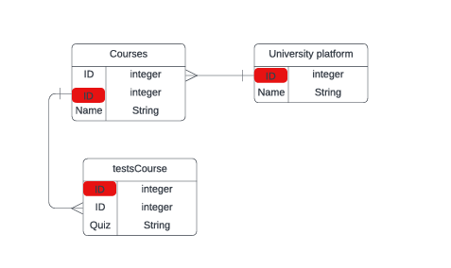

**1.3 INTENDED AUDIENCE AND READING SUGGESTIONS**

The website is primarily targeted towards college students enrolled in various academic programs who seek additional support and resources to enhance their learning experience. This audience includes:

**Undergraduate Students:** Those pursuing bachelor's degrees in diverse fields such as arts, sciences, engineering, business, and more.

**Continuing Education Students:** Adult learners and professionals returning to academia for further education or skill development.

**Remote Learners:** Students enrolled in online or distance education programs who require digital resources for their coursework.

1.4 Project scope

This site currently provides services that focus more on Arab students. The system will consist of a distinct database that raises page performance to another level of ease and speed when users access it. It will deal with large amounts of data through an easy-to-use interface suitable for all university students, ensuring user comfort during use.

**1.5 REFERENCES :**

[YouTube](https://www.youtube.com/)

[wikp](https://www.wikipedia.org/)

[chat 3.5](https://chat.openai.com/)

[lucid.app](https://lucid.app/)