

Requirement & Design Specification

**Club Management System(SMS)**

**Version: 1.0**

**Group 4**

**HE181666 – Pham Hoang Nam**

**HE181122 – Thai Ngoc Anh Dai**

**HE180102 – Do Quang Thang**

# Table of content

**Table of content 2**

**Record of Changes 7**

**I. Overview 10**

1. User Requirements 10

1.1 Actors 10

1.2 Use Cases 10

a. Diagram(s) 10

b. Descriptions 13

2. Overall Functionalities 15

2.1 Screens Flow 15

2.2 Screen Descriptions 20

2.3 Screen Authorization24

3. System High Level Design 24

3.1 Database Design 24

a. Database Schema 25

b. Table Descriptions

**II. Requirement Specifications 27**

1. Common Functions 27

1.1 UC-1_SignUp 27

1.2 UC-2_Sign In 28

1.3UC-3_View all skills 28

**III. Design Specifications 52**

**IV. Appendix 92**

1. Assumptions & Dependencies 92

2. Limitations & Exclusions 92

3. Business Rules 92

# I. Overview

The Store ManagementDB project is a web application project for store management. The project is developed using Microsoft Visual Studio technology, Entity Framework and data is managed by Microsoft SQL database system. The project was developed to optimise store management capabilities.

## 1. User Requirements

### 1.1 Actors

|  |  |  |
| --- | --- | --- |
| **#** | **Actor** | **Description** |
| 1 | Admin | Have full system management, including all CRUD functionality for user accounts, customers, orders, and order details. |
| 2 | Staff | Only permissions to manage customers, orders, and order details, including all CRUD functionality. |

### 1.2 Use Cases

#### a. Diagram(s)

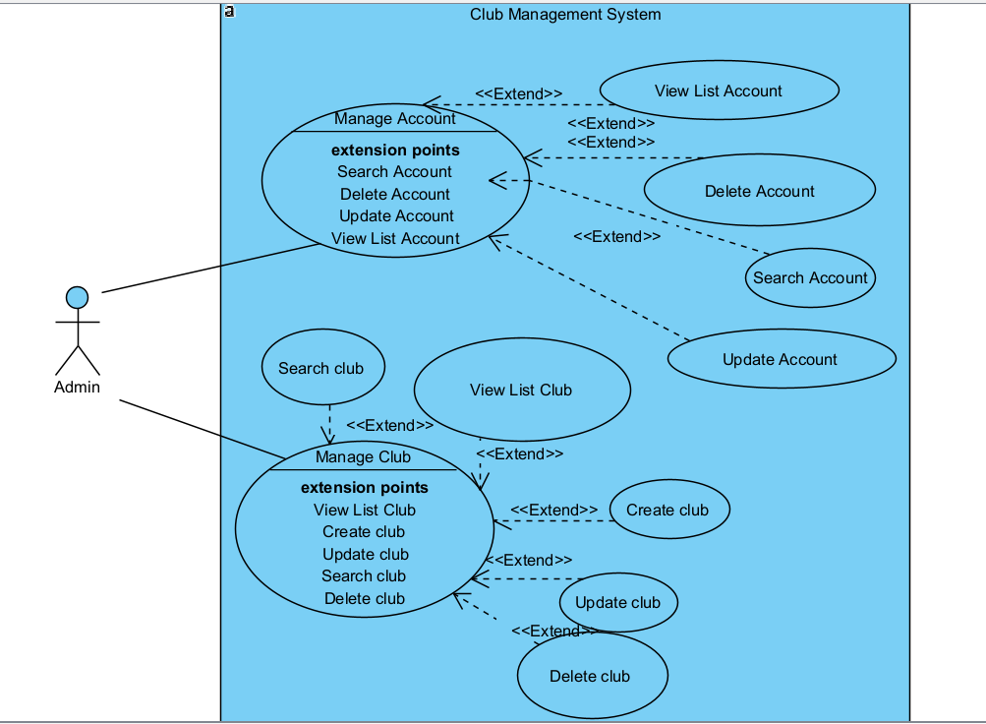

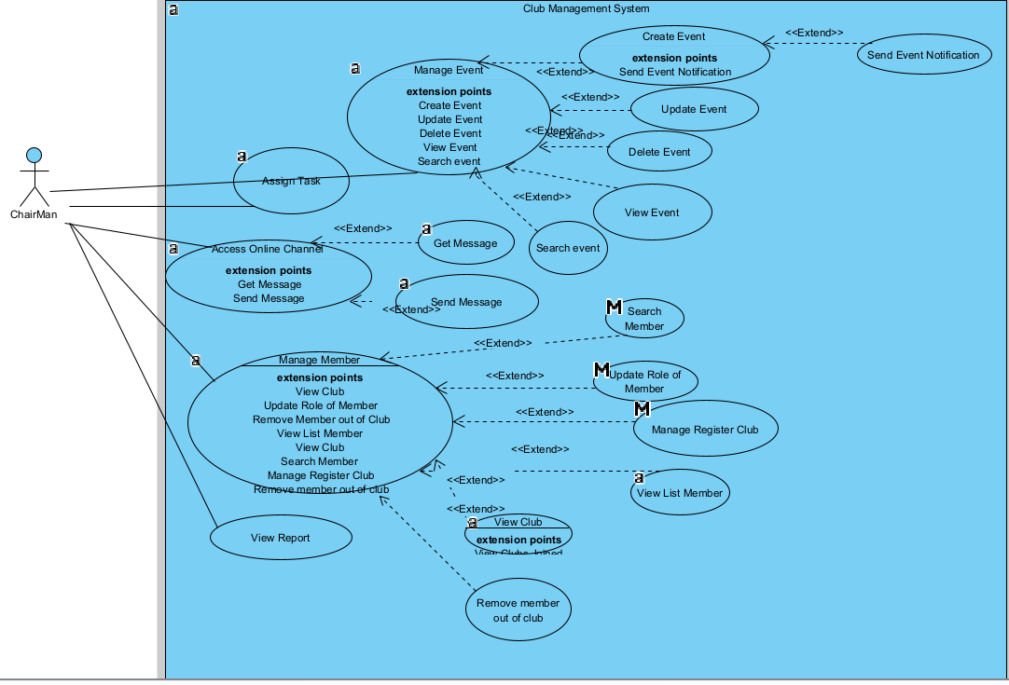

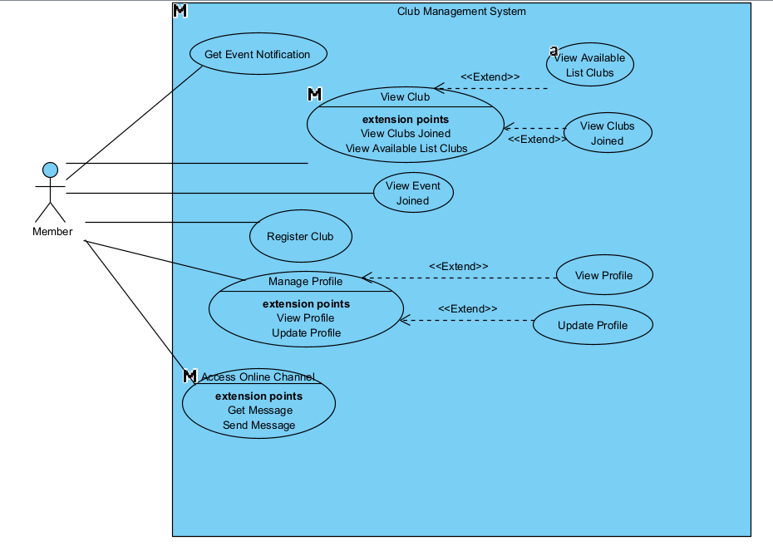

#### b. Descriptions

|  |  |  |  |
| --- | --- | --- | --- |
| **ID** | **Feature** | **Use Case** | **Use Case Description** |
| 01 | Admin | Manage Accounts | Edit, delete, view , search account information. |
| 02 | Manage Clubs | Add, edit, delete, view club information. |
| 03 | Chairman | Manage Events | Add, edit, delete, view , search event information. |
| 04 | Manage Members | Edit, delete, view , search member information. |
| 05 | View Reports | View report information. |
| 06 | Chairman | Manage Register Club | Accept or decline member request |
| 07 | Chairman | Send Event Notification | Send notification to member email |
| 08 | Chairman | Assign Tasks | View , add , update , delete task information |
| 09 | Chairman | Access Online Chat | View , add , update , delete own message |
| 10 | Member | Get Event Notification | Get event information from email |
|  | Member | View clubs | View available clubs to join or view club joined |
|  | Member | View event | View event joined |
|  | Member | Register Club | Register a club |
|  | Member | Manage Profile | View , update profile |
|  | Member | Access Online Chat | View , add , update , delete own message |

## 2. Overall Functionalities

### c2.1 Screens Flow

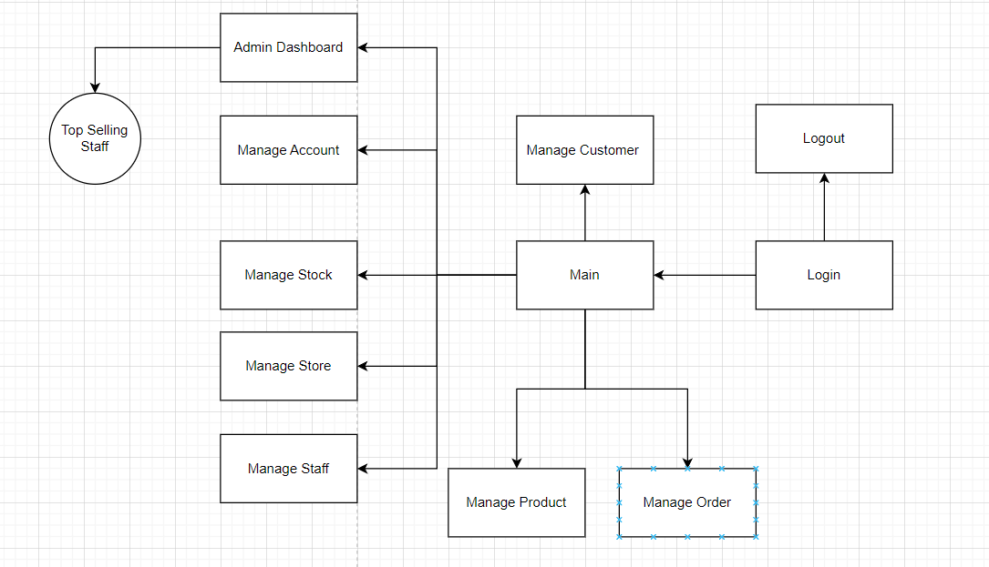

### 2.2 Screen Descriptions

|  |  |  |  |
| --- | --- | --- | --- |
| **#** | **Feature** | **Screen** | **Description** |
| 1 | Staff Login | Log in | This page allows User to enter username and password to login |
| 2 | Staff Management | Home | Staff home screen interface |
| 3 | Customer Management | Customer Management | Staff can add, edit or delete users on the manage customers page |
| 4 | Order Management | Order Management | Staff can add, edit or delete orders on the orders order page |
| 5 | Product Management | Product Management | Staff can add, edit or delete products on the products order page |
| 6 | Admin Login | Login | Admin logs in with the designated account |
| 7 | Admin Management | Home | Admin screen after logging in |
| 8 | Customer Management | Customer Management | Admin can add, edit or delete users on the manage customers page |
| 9 | Order Management | Order Management | Admin can add, edit or delete orders on the orders order page |
| 10 | Product Management | Product Management | Admin can add, edit or delete products on the products order page |
| 11 | Staff Management | ManageStaff | Admin can add, edit, and delete staff on the staff management page |
| 12 | Account Management | Manage Account | Admin can add, edit, and delete staff on the manage account page |
| 13 | Admin Dashboard | Admin Dashboard | Admin dashboard can view the number of products in stock and can edit product quantities as well as view the top selling staff of each month and year. |

### 2.3 Screen Authorization

|  |  |  |  |
| --- | --- | --- | --- |
| **#** | **Screen** | **Admin** | **Manager** |
| 1 | Log in | X | X |
| 2 | Home | X | X |
| 3 | Customer Management | X | X |
| 4 | Order Management | X | X |
| 5 | Product Management | X | X |
| 6 | ManageStaff | X |  |
| 7 | Manage Account | X |  |
| 8 | Admin Dashboard | X |  |

### System High Level Design

### 3.1 Database Design

#### Database Schema

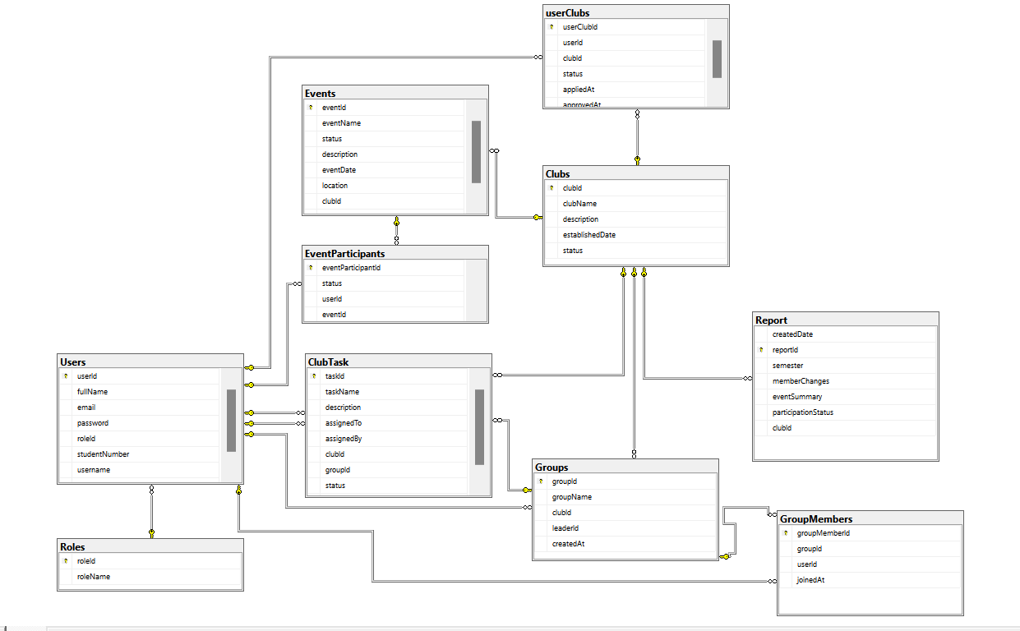

#### b. Table Descriptions

| **No** | **Table** | **Description** |
| --- | --- | --- |
| 01 | Clubs | - Manages clubs with fields for clubId, clubName , description, etc.  - Primary keys: clubId |
| 02 | EventPaticipants | - Manages event participant information with fields for eventParticipantId, status , etc  - Primary keys: eventParticipantId  - Foreign keys: userId , eventId |
| 03 | Events | - Manages events with fields for eventId , eventName , etc.  - Primary keys: for eventID  - Foreign keys: clubId |
| 04 | Report | - Manages report with fields for reportId,createDate , etc.  - Primary keys: reportId  - Foreign keys: clubId |
| 05 | Users | - Manage Users information  - Primary keys: userId  - Foreign keys: roleId |
| 06 | Roles | - Manage Roles information  - Primary keys: roleId |
| 07 | userClubs | Manage club which user join information  - Primary keys: userClubId  - Foreign keys: clubId , userId |
| 08 | Groups | Manage Group information  - Primary keys: groupId  - Foreign keys: clubId , leaderId |
| 09 | GroupMembers | Manage Group of a leader manage information  - Primary keys: groupMemberId  - Foreign keys: groupId , userId |
| 10 | ClubTasks | Manage Task information  - Primary keys: taskId  - Foreign keys: groupId , clubId , assignedTo , assignedBy |

4. Class diagram,

*4.1. 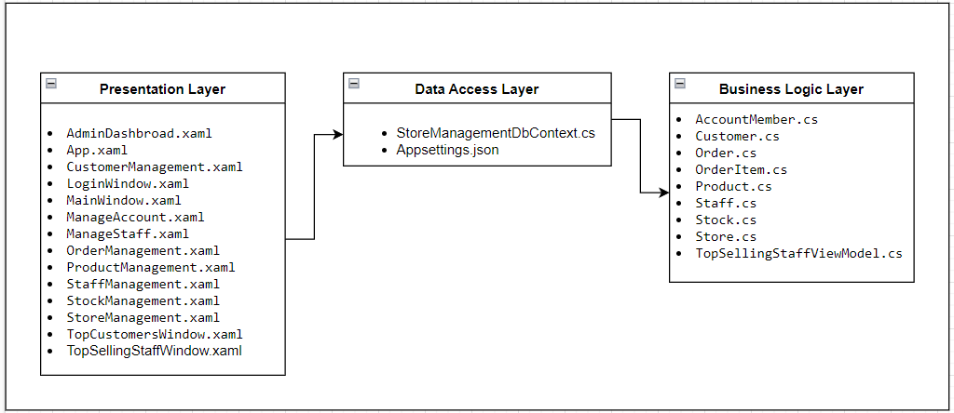*

*4.2. Class diagram*

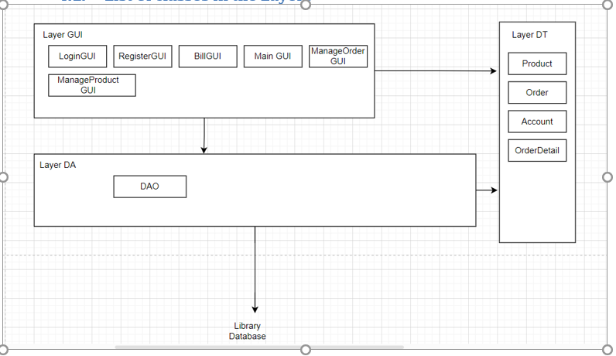

# II. Requirement Specifications (OPTIONAL)

## 1. Common Functions

### 1.1 UC1_ Login

**Functional Description Template**

|  |  |  |  |
| --- | --- | --- | --- |
| ID and Name: | UC-1_ User Login | | |
| Created By: | HE190001  Nguyen Van A | Date Created: |  |
| Primary Actor: | User (Admin/Staff) | Secondary Actors: |  |
| Description: | This use case describes the authentication process for users by verifying their email and password. | | |
| Trigger: | User attempts to log in. | | |
| Preconditions: | PRE-1: User has an existing account. | | |
| Postconditions: | * POST-1: User is logged into the system and can access authorized functionalities. | | |
| Normal Flow: | 1. User enters an email and password. 2. System verifies credentials. 3. If valid, user is logged in; otherwise, an error message is displayed | | |
| Alternative Flows: | AF-1: User clicks "Forgot Password", redirects to Password Reset page. | | |
| Exceptions: | EX-1: Database connection error. | | |
| Priority: | High | | |
| Frequency of Use: | Frequently used by all users. | | |
| Business Rules: | BR- 1: Default admin account: MemberID is “Admin” and password is “123456”.  BR- 2: Default staff account: MemberID is “Staff1” and password is “123456”. | | |
| Other Information: | N/A | | |
| Assumptions: | N/A | | |

### 1.2 UC2_Customer Manage

a. Functional Description

|  |  |  |  |
| --- | --- | --- | --- |
| ID and Name: | UC-2_ Customer Manage | | |
| Created By: | HE190002  Nguyen Van B | Date Created: |  |
| Primary Actor: | Admin | Secondary Actors: | None |
| Description: | As an admin, I want to manage customer information, including adding, updating, viewing, and deleting customer records. | | |
| Trigger: | Admin clicks on the "Customer Manage" button in the HomePage Screen | | |
| Preconditions: | Admin must be logged in to access the customer management functionalities. | | |
| Postconditions: | Customer information is added, updated, viewed, or deleted as per the admin's actions. | | |
| Normal Flow: | 1. Admin clicks on the "Customer Manage" button. 2. The system displays a list of all customers. 3. Admin can choose to add a new customer by clicking "Add Customer". 4. Admin fills in the customer details and clicks "Save". 5. The system saves the new customer information and displays it in the list. 6. Admin can select an existing customer to update by clicking "Edit". 7. Admin updates the customer details and clicks "Save". 8. The system saves the updated customer information and updates the list. 9. Admin can delete a customer by selecting them and clicking "Delete". 10. The system deletes the customer and removes them from the list. | | |
| Alternative Flows: | N/A | | |
| Exceptions: | N/A | | |
| Priority: | High | | |
| Frequency of Use: | Usually | | |
| Other Information: | N/A | | |
| Assumptions: | N/A | | |

### 1.3 UC3_Order Manage

|  |  |  |  |
| --- | --- | --- | --- |
| ID and Name: | UC3_Order Manage | | |
| Created By: | HE190003  Nguyen Van C | Date Created: |  |
| Primary Actor: | Admin | Secondary Actors: | None |
| Description: | As an admin, I want to manage order information, including adding, updating, viewing, deleting, and clearing order records. | | |
| Trigger: | Admin clicks on the "Order Manage" button in the Admin Dashboard Screen. | | |
| Preconditions: | Admin must be logged in to access the order management functionalities. | | |
| Postconditions: | Order information is added, updated, viewed, or deleted as per the admin's actions | | |
| Normal Flow: | 1. Admin clicks on the "Order Manage" button. 2. The system displays a list of all orders. 3. Admin can choose to add a new order by clicking "Add Order". 4. Admin fills in the order details and clicks "Save". 5. The system saves the new order information and displays it in the list. 6. Admin can select an existing order to update by clicking "Edit". 7. Admin updates the order details and clicks "Save". 8. The system saves the updated order information and updates the list. 9. Admin can delete an order by selecting it and clicking "Delete". 10. The system deletes the order and removes it from the list. 11. Admin can clear the input fields by clicking "Clear". | | |
| Alternative Flows: | N/A | | |
| Exceptions: | N/A | | |
| Priority: | High | | |
| Frequency of Use: | Frequent | | |
| Other Information: | N/A | | |
| Assumptions: | N/A | | |

### 1.4 UC4_Product Manage

a. Functional Description

|  |  |  |  |
| --- | --- | --- | --- |
| ID and Name: | Product Manage | | |
| Created By: | HE190001  Nguyen Van A | Date Created: |  |
| Primary Actor: | Admin | Secondary Actors: | none |
| Description: | As an admin, I want to manage product information, including adding, updating, viewing, deleting, and clearing product records. | | |
| Trigger: | Admin clicks on the "Product Manage" button in the Admin Dashboard Screen. | | |
| Preconditions: | Admin must be logged in to access the product management functionalities. | | |
| Postconditions: | Product information is added, updated, viewed, or deleted as per the admin's actions. | | |
| Normal Flow: | 1. Admin clicks on the "Product Manage" button. 2. The system displays a list of all products. 3. Admin can choose to add a new product by clicking "Add Product". 4. Admin fills in the product details and clicks "Save". 5. The system saves the new product information and displays it in the list. 6. Admin can select an existing product to update by clicking "Edit". 7. Admin updates the product details and clicks "Save". 8. The system saves the updated product information and updates the list. 9. Admin can delete a product by selecting it and clicking "Delete". 10. The system deletes the product and removes it from the list. 11. Admin can clear the input fields by clicking "Clear". | | |
| Alternative Flows: | If the admin clicks "Cancel" during the add or update process, the system will discard the changes and return to the product list without saving. | | |
| Exceptions: | If there is an error saving product information, the system will display an error message and prompt the admin to retry.  If there is an error deleting the product, the system will display an error message and prompt the admin to retry. | | |
| Priority: | High | | |
| Frequency of Use: | Usually | | |
| Other Information: | N/A | | |
| Assumptions: | Admin has the necessary permissions to manage product information.  The system is operational and able to process database transactions. | | |

### 1.5 UC5_Staff Manage

a. Functional Description

|  |  |  |  |
| --- | --- | --- | --- |
| ID and Name: |  | | |
| Created By: | HE190002  Nguyen Van B | Date Created: |  |
| Primary Actor: | Admin | Secondary Actors: | none |
| Description: | As an admin, I want to manage staff information, including adding, updating, viewing, deleting, and resetting staff records. | | |
| Trigger: | Admin clicks on the "Staff Manage" button in the Admin Dashboard Screen | | |
| Preconditions: | Admin must be logged in to access the staff management functionalities. | | |
| Postconditions: | Staff information is added, updated, viewed, or deleted as per the admin's actions. | | |
| Normal Flow: | * Admin clicks on the "Staff Manage" button. * The system displays a list of all staff members. * Admin can choose to add a new staff member by clicking "Add Staff". * Admin fills in the staff details and clicks "Save". * The system saves the new staff information and displays it in the list. * Admin can select an existing staff member to update by clicking "Edit". * Admin updates the staff details and clicks "Save". * The system saves the updated staff information and updates the list. * Admin can delete a staff member by selecting it and clicking "Delete". * The system deletes the staff member and removes it from the list. * Admin can clear the input fields by clicking "Reset". | | |
| Alternative Flows: | If the admin clicks "Cancel" during the add or update process, the system will discard the changes and return to the staff list without saving.  If the admin attempts to delete a staff member who is associated with existing records, the system will display a warning and prompt the admin to confirm the deletion. | | |
| Exceptions: | If there is an error saving staff information, the system will display an error message and prompt the admin to retry.  If there is an error deleting the staff member, the system will display an error message and prompt the admin to retry. | | |
| Priority: | High | | |
| Frequency of Use: | Usually | | |
| Other Information: | N/A | | |
| Assumptions: | N/A | | |

### 1.6 UC6_Manage Account

|  |  |  |  |
| --- | --- | --- | --- |
| ID and Name: |  | | |
| Created By: |  | Date Created: |  |
| Primary Actor: | Admin | Secondary Actors: | none |
| Description: | As an admin, I want to manage account information, including adding, updating, viewing, deleting, and resetting account records. | | |
| Trigger: | Admin clicks on the "Manage Account" button in the Admin Dashboard Screen. | | |
| Preconditions: | Admin must be logged in and have appropriate permissions to manage account information. | | |
| Postconditions: | Account information is added, updated, viewed, or deleted according to the admin's actions. | | |
| Normal Flow: | * Admin clicks on the "Manage Account" button. * The system displays a list of all accounts. * Admin can choose to add a new account by clicking "Add Account". * Admin fills in the account details and clicks "Save". * The system saves the new account information and displays it in the list. * Admin can select an existing account to update by clicking "Edit". * Admin updates the account details and clicks "Save". * The system saves the updated account information and updates the list. * Admin can delete an account by selecting it and clicking "Delete". * The system deletes the account and removes it from the list. * Admin can clear the input fields by clicking "Reset". | | |
| Alternative Flows: | If the admin clicks "Cancel" during the add or update process, the system will discard the changes and return to the account list without saving.  If the admin attempts to delete an account that has associated records or is currently in use, the system will display a warning and prompt the admin to confirm the deletion. | | |
| Exceptions: | If there is an error saving account information, the system will display an error message and prompt the admin to retry.  If there is an error deleting the account, the system will display an error message and prompt the admin to retry. | | |
| Priority: | High | | |
| Frequency of Use: | Usually | | |
| Other Information: | N/A | | |
| Assumptions: | N/A | | |

### 1.7 UC7_Manage Account

|  |  |  |  |
| --- | --- | --- | --- |
| ID and Name: |  | | |
| Created By: | HE190003  Nguyen Van C | Date Created: |  |
| Primary Actor: | Admin | Secondary Actors: | None |
| Description: | As an admin, I want to manage various functionalities on the Admin Dashboard, including adding, updating, deleting, and resetting records, and viewing the top-selling staff members. | | |
| Trigger: | Admin clicks on the "Admin Dashboard" button in the main menu. | | |
| Preconditions: | Admin must be logged in and have appropriate permissions to access the Admin Dashboard. | | |
| Postconditions: | Admin has managed records and viewed top-selling staff information as required. | | |
| Normal Flow: | Admin clicks on the "Admin Dashboard" button.  The system displays the Admin Dashboard screen.  Admin can view various sections including:   * List of records (e.g., orders, accounts) with options to add, update, delete, and reset. * A section displaying top-selling staff based on sales performance.   Admin can choose to add a new record by clicking "Add Record".  Admin fills in the details for the new record and clicks "Save".  The system saves the new record and updates the list.  Admin can select an existing record to update by clicking "Edit".  Admin updates the record details and clicks "Save".  The system saves the updated record and updates the list.  Admin can delete a record by selecting it and clicking "Delete".  The system deletes the record and removes it from the list.  Admin can clear the input fields by clicking "Reset".  The system refreshes the top-selling staff information, displaying the current top performers. | | |
| Alternative Flows: | If the admin clicks "Cancel" during the add or update process, the system will discard the changes and return to the dashboard without saving.  If the admin attempts to delete a record that has dependencies or is currently in use, the system will display a warning and prompt the admin to confirm the deletion. | | |
| Exceptions: | If there is an error saving or updating record information, the system will display an error message and prompt the admin to retry.  If there is an error deleting the record, the system will display an error message and prompt the admin to retry.  If there is an issue retrieving the top-selling staff information, the system will display an error message. | | |
| Priority: | High | | |
| Frequency of Use: | Usually | | |
| Other Information: | N/A | | |
| Assumptions: | N/A | | |

# III. Design Specifications

1. Staff logs in with the designated account

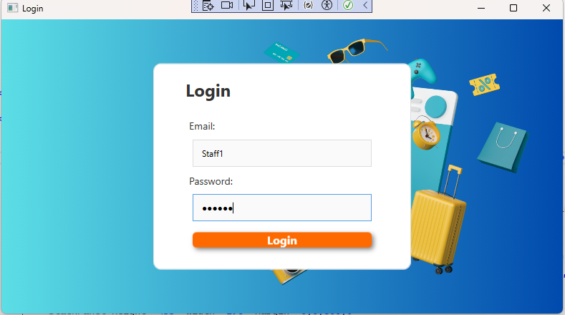

|  |  |  |
| --- | --- | --- |
| **Field Name** | **Field Type** | **Description** |
| User name | Text Box | This is for user to input user name for logging in |
| Password | Password Box | This is for user to input password for logging in |
| Login | Button | User clicks to authenticate him/herself into the system with provided email/user name & password |

2. Staff screen after logging in

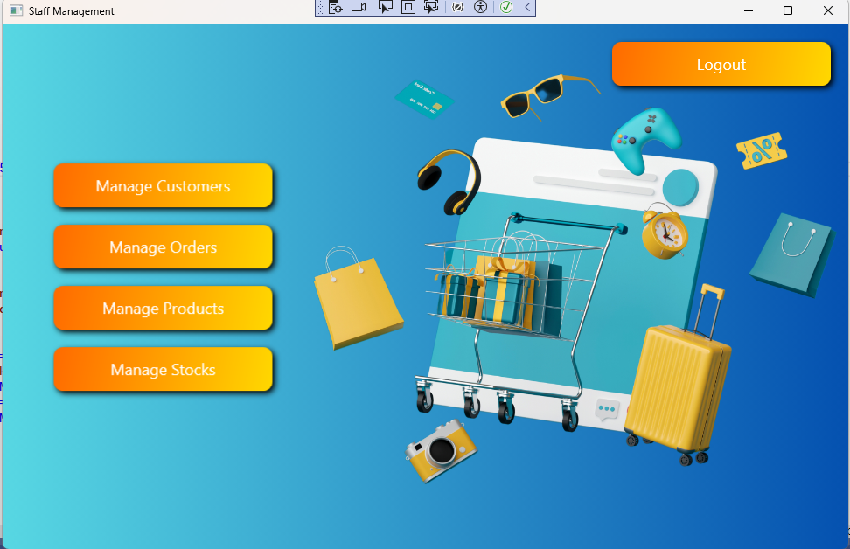

|  |  |  |
| --- | --- | --- |
| **Field Name** | **Field Type** | **Description** |
| Manage Customers | Button | Navigates to the customer management section. |
| Manage Orders | Button | Navigates to the order management section. |
| Manage Products | Button | Navigates to the product management section. |
| Manage Stocks | Button | Navigates to the stock management section. |
| Logout | Button | Logs the user out of the application. |

3. Staff can add, edit or delete users on the manage customers page

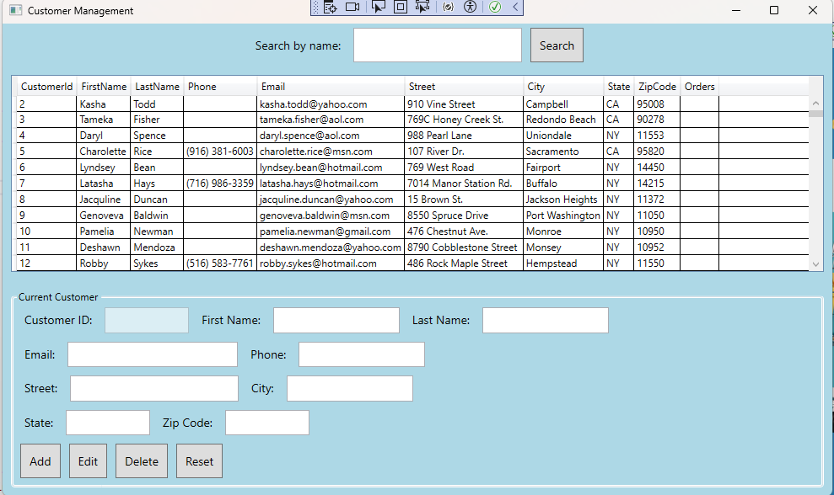

4. Staff can add, edit or delete orders on the orders order page

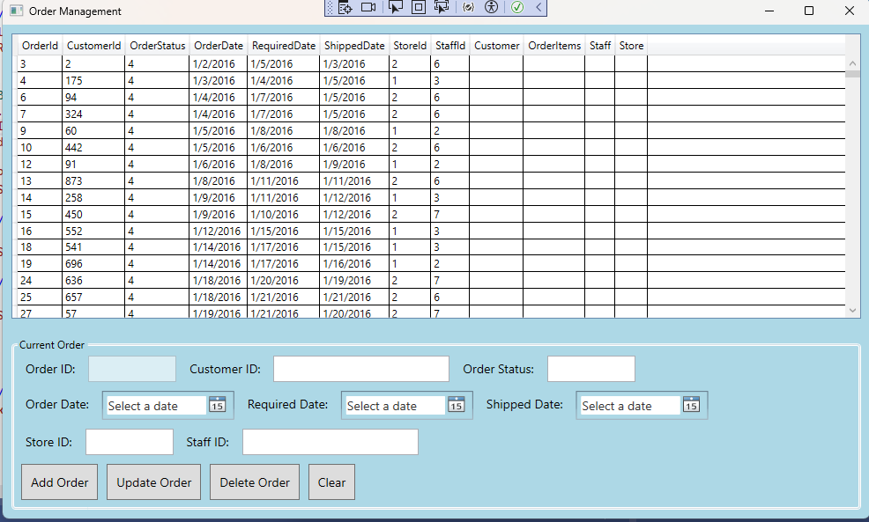

5. Staff can add, edit or delete products on the products order page

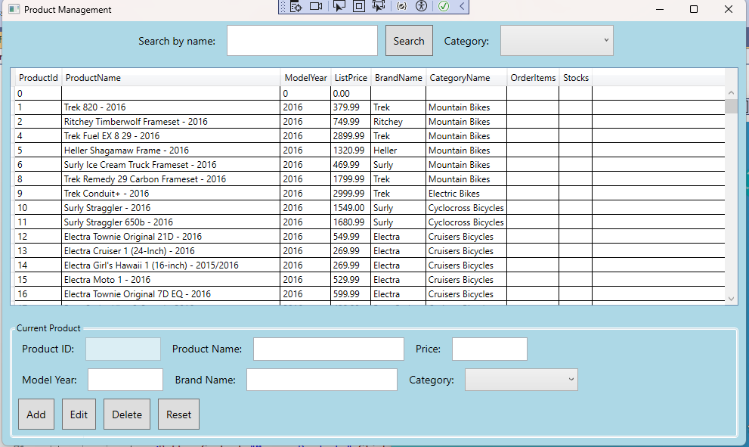

1. Admin logs in with the designated account

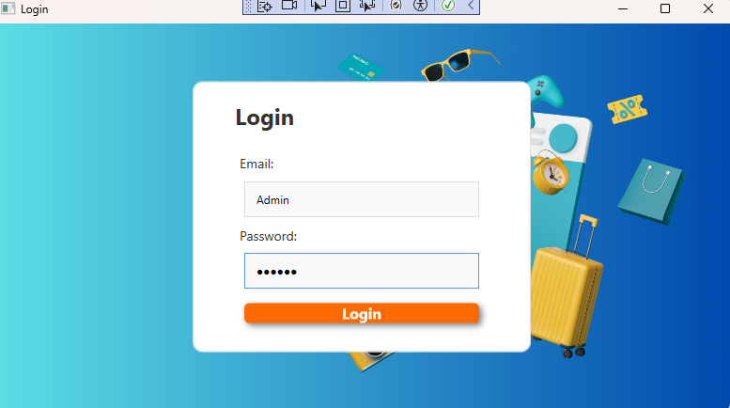

1. Admin screen after logging in

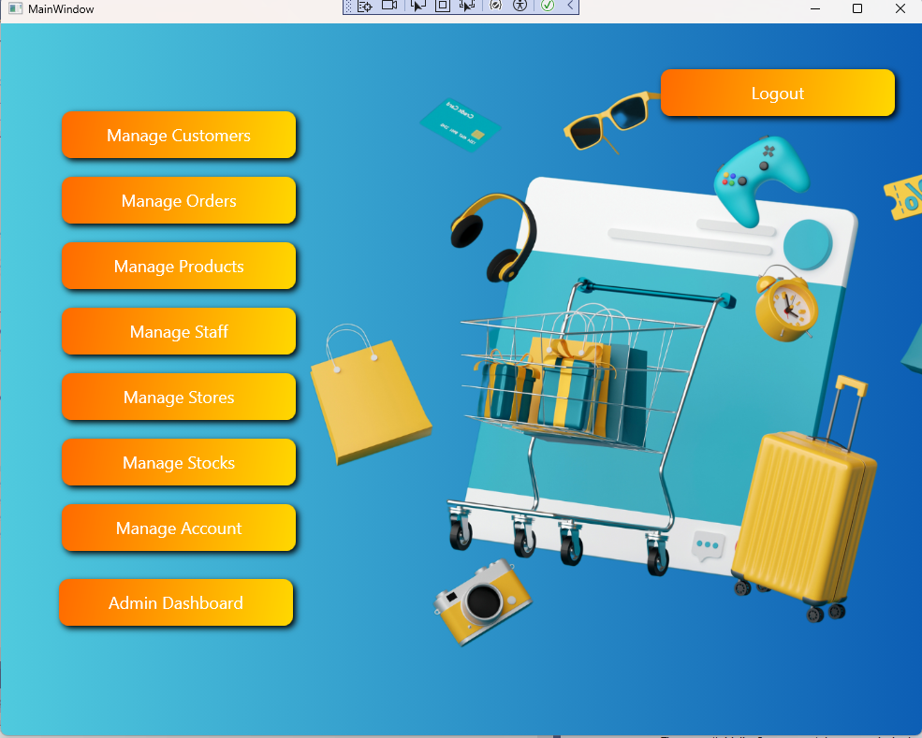

1. Admin can add, edit or delete users on the manage customers page

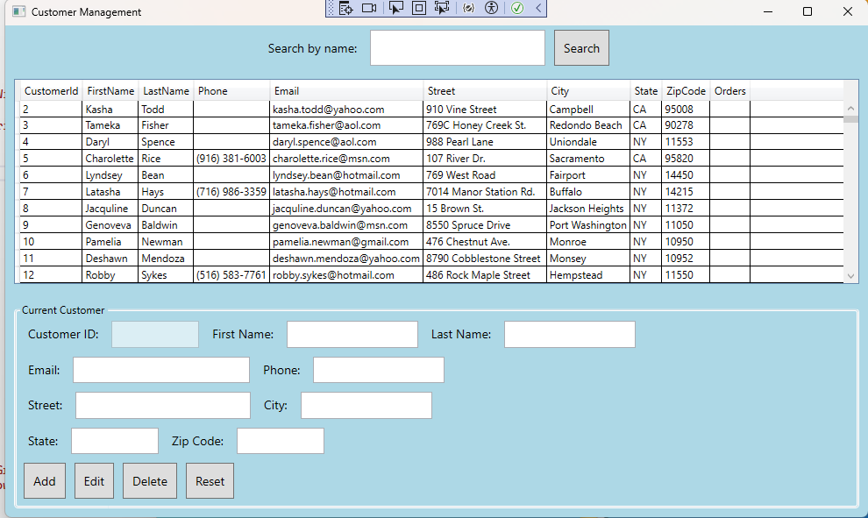

1. Admin can add, edit or delete orders on the orders order page

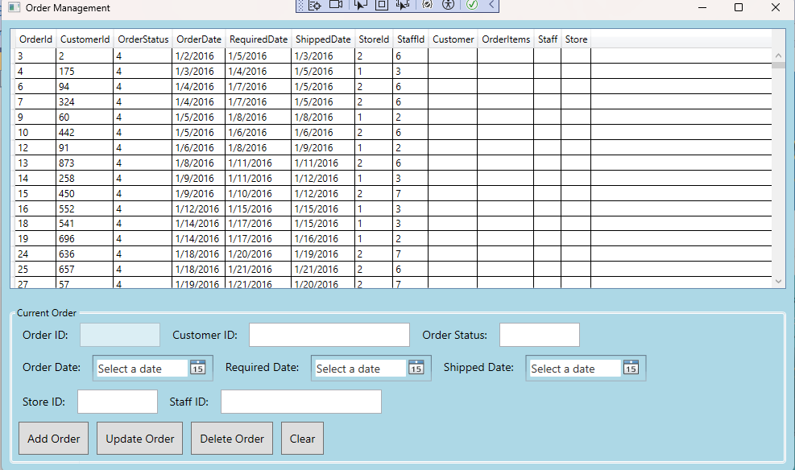

1. Admin can add, edit or delete products on the products order page

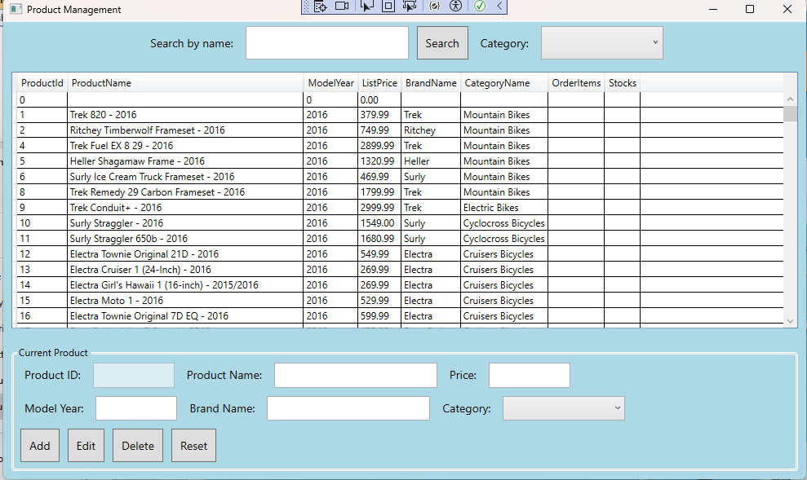

**11.** Admin can add, edit, and delete staff on the staff management page

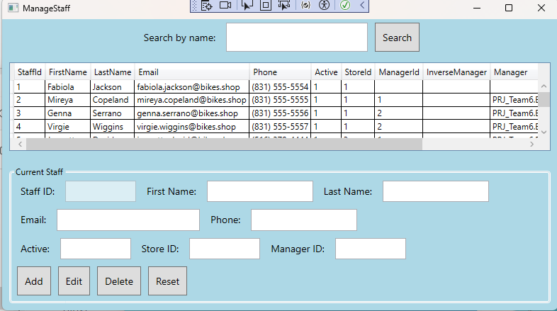

**12.** Admin can add, edit, and delete staff on the manage account page

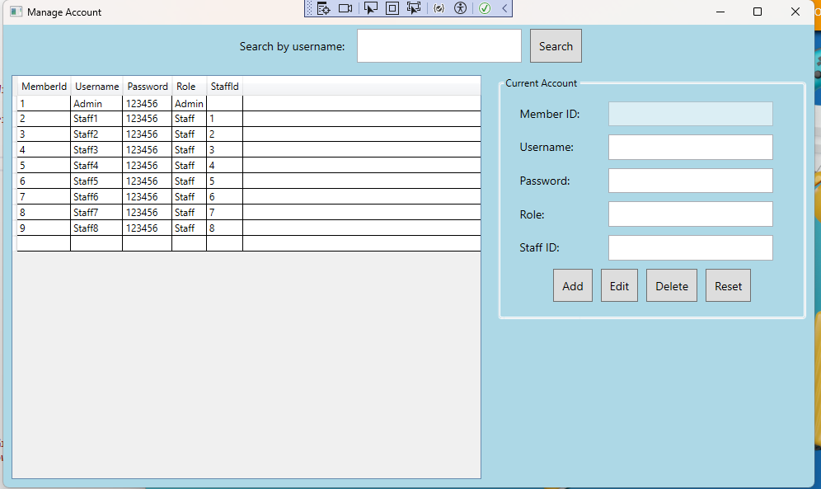

**13.** Admin dashboard can view the number of products in stock and can edit product quantities as well as view the top selling staff of each month and year.

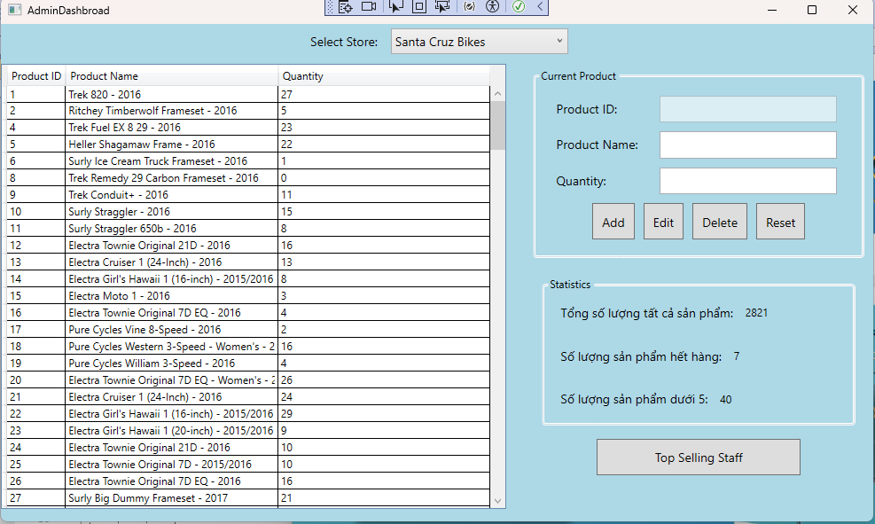

# IV. Appendix

## 1. Assumptions & Dependencies

AS-1: The system will be used within the organization's internal network.

DE-1: Users have basic knowledge of using Windows applications.

## 2. Limitations & Exclusions

L-E : The system will not support mobile platforms in the current version..

## 3. Business Rules

## 

BR- 1: Default admin account: MemberID is “Admin” and password is “@admin123”.

BR- 2: Default staff account: MemberID is “Staff” and password is “@staff123”.