

**FPT International School**

--- o0o ---

**PROJECT REPORT**

**< Crystal >**

Batch: **T2103E**

Semester: 1

Group: 02

1. Vũ Nam
2. Nguyễn Hoài Nam
3. Lưu Bình Minh
4. Trần Phương Nam
5. Nguyễn Quang Minh

Faculty: Nguyễn Quang

**Hanoi - 2/2021**

**Hanoi - MM/YYYY**

**Table of Contents**

1. Problem Definition 3

i. Introduction 3

ii. Implementation Environment 3

User Stories 4

1.2 User type 1 (Example: Admin) 4

i. Story 1 4

ii. Story 2 4

iii. Story 3 4

iv. … 4

1.3 User type 2 (Example: Staff) 4

i. Story 1 4

ii. Story 2 4

iii. … 4

1.4 User type 3 (Example: Customer) 4

i. Story 1 4

ii. Story 2 4

iii. Story 3 4

iv. … 4

1.5 … 4

1.6 … 4

1.7 ... 4

1.8 ... 4

2. Database 5

2.1 DB Relationship Diagram 5

2.2 Table 1 (Example: Account) 5

2.3 Table 2 (Example: Caegory) 6

2.4 Table 3 (Example: Product) 6

2.5 … 6

2.6 … 6

2.7 ... 6

2.8 ... 6

3. UI\UX 7

3.1 GUI 1 (Example: Login Form) 7

3.2 GUI 2 (Example: Address Book Form) 7

3.3 GUI 3 8

3.4 … 8

3.5 … 9

3.6 … 9

3.7 ... 9

3.8 ... 9

3.9 ... 9

3.10 ... 9

3.11 ... 9

4. Summary 10

**Table of Contents**

1. Problem Definition 3

i. Introduction 4

ii. Implementation Environment 4

User Stories 5

User type (Example: Customer) 5

Story 1 : View 5

Story 2 : Search 5

Story 3 : Dowload 5

2. Flow chart 6

2.1 View model 6

2.2 Search 7

2.3 Dowload 8

3. UI\UX 9

3.1 GUI 1 - HOME 9

3.2 GUI 2 - Products 13

3.3 GUI 3 - New Arrivals 18

3.4 GUI 4 - Specials offers 22

3.5 GUI 5 - Contact Us 27

3.6 GUI 6 - About Us 28

3.7 GUI 7 - Add to bag……………………………………………………………...32

3.8 GUI 8 - Check in/Check out…………………………………………………….33

4. Sumary 34

# Problem Definition

### Introduction

Today, people are drawn to crystals for a number of reasons, including primarily that they are very beautiful objects and their different shapes, sizes and colours have proved fascinating and mysterious as well.  They can be found in various forms of beautiful jewellery, or on their own in rough uncut specimens that are sometimes used as ornaments to decorate homes.

**Crystals** are used to enhance the body's own healing abilities, reduce stress and improve the quality of your life. They hold a massive amount of energy and those who work with them believe that they have their own individual energy field or personality.

Holding **crystals** or placing them on your body is thought to promote physical, emotional and spiritual healing. **Crystals** supposedly do this by positively interacting with your body's energy field, or chakra. While some **crystals** are said to alleviate stress, others purportedly improve concentration or creativity.

Many times people call them to ask questions like:

1. Would diamond or ruby jewelry suit them better?

2. What type of jewelry stone will suit their level?

3. Is there a jewelry stone that can improve their health and creativity?

4. What kind of gemstone jewelry will sui their affordability?

5. What kind of jewelry should they choose to give to the person they love?

6. They want to buy gem jewelry that is both luxurious and unique, which type should they choose?

And many more problems. So in order to consider sharing more information with everyone, the team decided to design a website, Its name is Crystal.

Website will present the information about gemstone jewelry made from many luxurious materials and with many usrs such as beauty, health improvemnet, show love to someone who their love,…

The website is to be developed for the Windows Platform using HTML5, JavaScript and Geolocation. The site should work well in all leading browsers including Chrome,IE, Firefox etc.

**Customer Expectation:**

1. The Home Page should be created making use of Sections with a suitable logo, the header section can be added which will show images of various products.
2. The site must contain the links to navigate through any category for the information.
3. The site should display a menu which will contain the options for brief introduction about the various products available, location of the shop and any other information if required.
4. The information should be categorized according to the various crystals like if a User wants to see only “Diamond/Amber/Amethyst etc” products then he/she can click on a Link/button/menu etc and can see only that crystal products.
5. When a user selects any particular crystal, a list of all the products for that crystal will be displayed
6. A brief summary of features of the product should be displayed on the Web Page along with the picture but detailed Features should be stored in Individual Word documents which can be downloaded or viewed by the User who wishes to see the same.
7. The user should also be able to compare the various products
8. There should be a “Contact Us” page which will have the Address of the Company which should be displayed using GeoLocation API (eg. GoogleMaps) and the email address which when clicked will invoke the local mail client from where they can send an email.

### Implementation Environment

# Notepad/HTML editor

# Dreamweaver

# IE 5.0/ Netscape 6.0User Stories

## User type 1 (Example:Customer)

### Story 1 : View

User can view all interested information of interest from gemstones, gemstone jewelry, gem uses,… by select what customer need to view to responds as a wide popular common such as:

* What kind of diamond jewelry should I choose ?
* Should I choose jewelry as necklace, bracelet, earrings or ring to beautify and show nobility?
* What kind of ring should I choose for our wedding or engagement ?
* How should I choose accessories or gems to make my room or my desk shine?
* Where can I find information about these product?
* How can I place an order ?
* Where can I see discounted products or new products ?

### Story 2 : Search

Allow user to Search and filter information to view only interested information in range of area The website will respond according to the information of searching criteria like Jewelry, Love and engagement , Home & décor, …

### Story 3 : Download

Allow user to download the complete historic reason and its description as pdf or doc file.

# Flow chart

# 2.1 View model

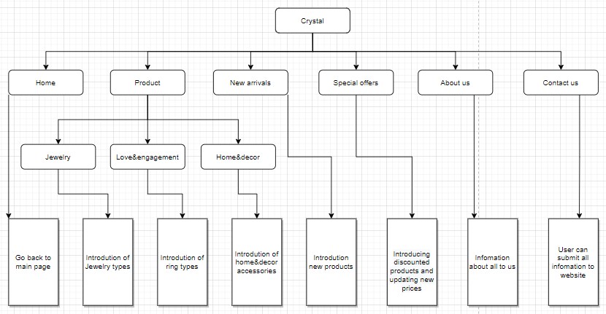

# 2.2 Search

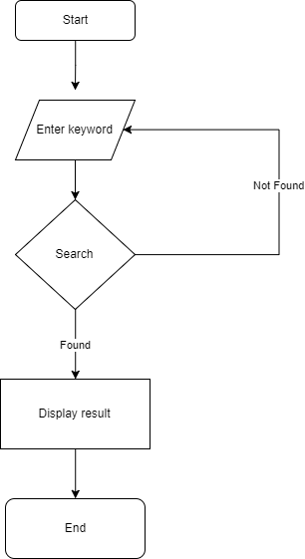

# 2.2 Download

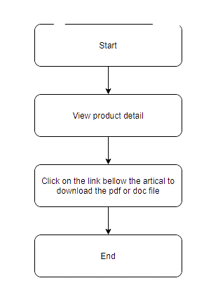

# 

# UI\UX

## GUI 1 (Example : Home)

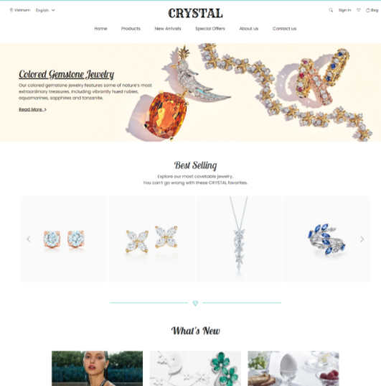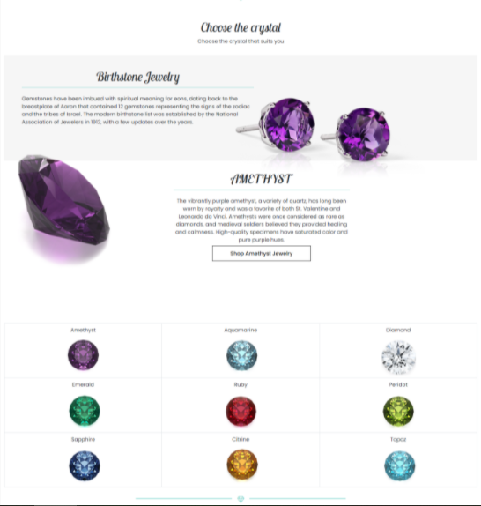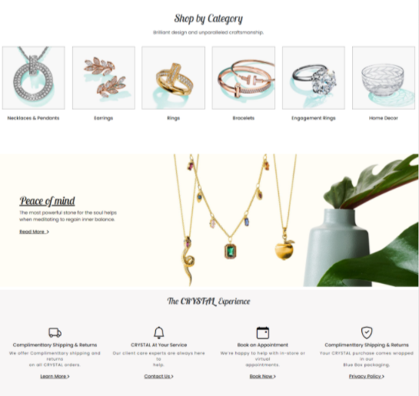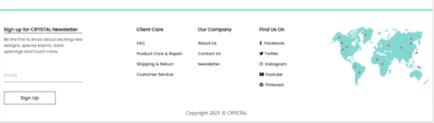

## GUI 2 (Example: Product)

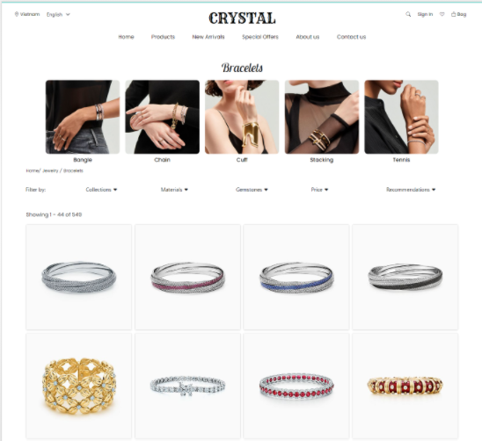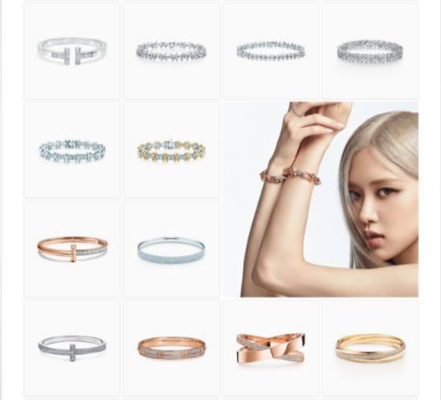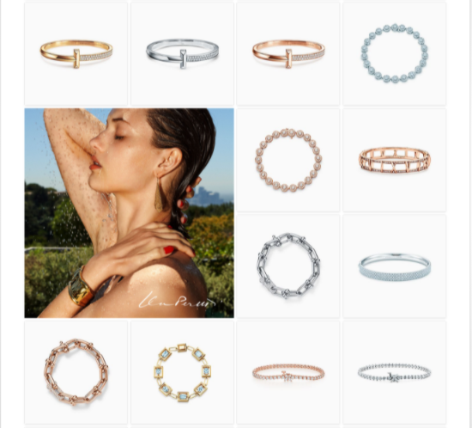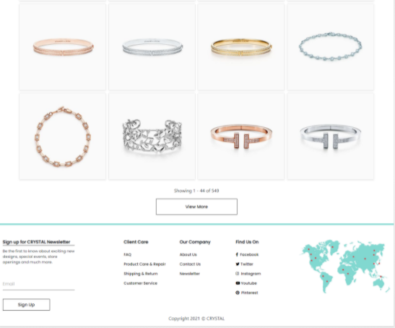

## GUI 3 (Example: New arrivals)

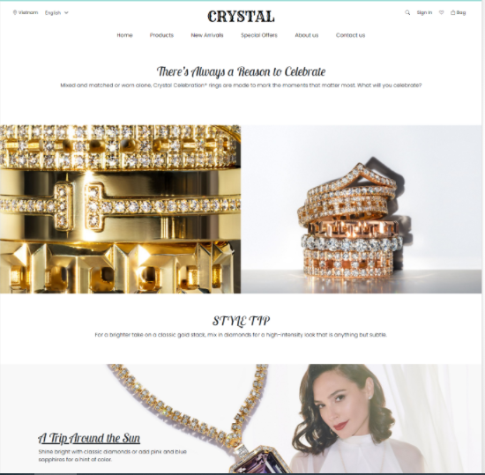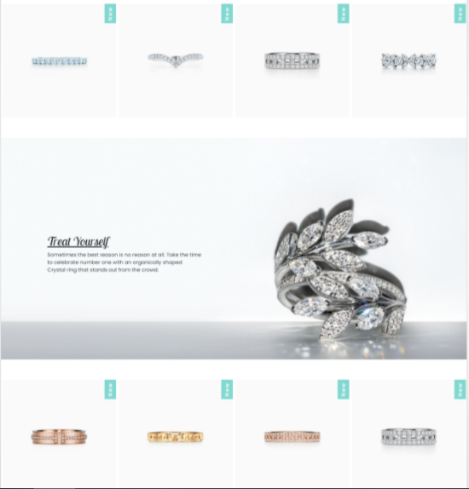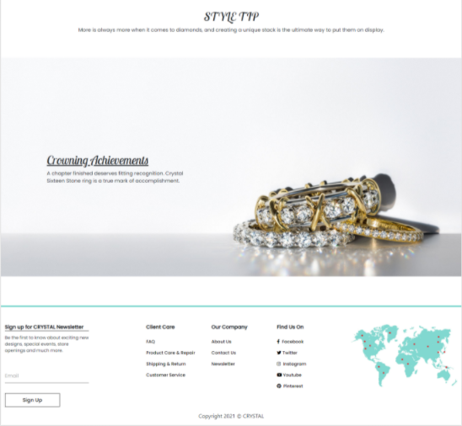

## GUI 4 (Example: Speacial offers)

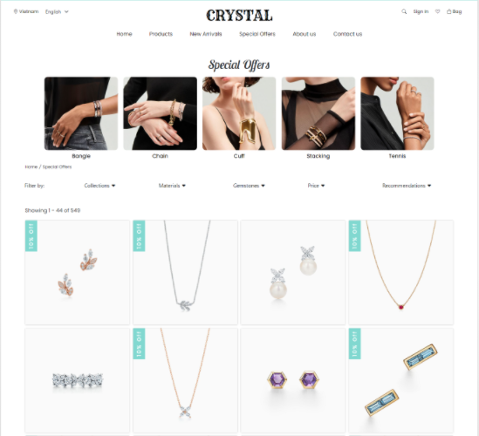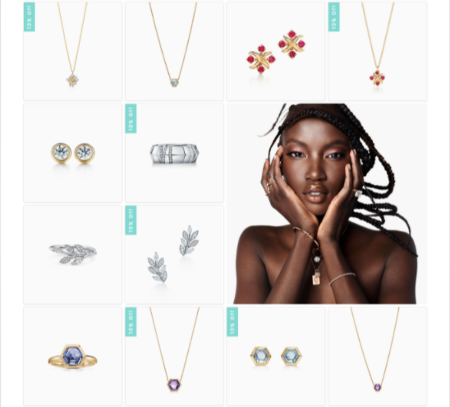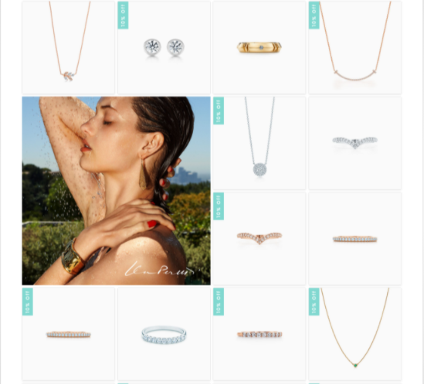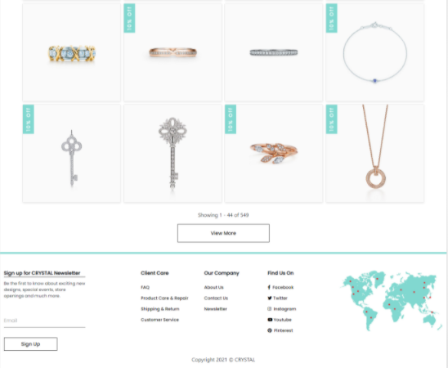

## GUI 5 (Example:Contact Us)

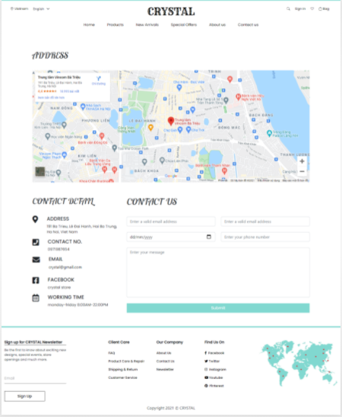

## GUI 6 (Example: About Us)

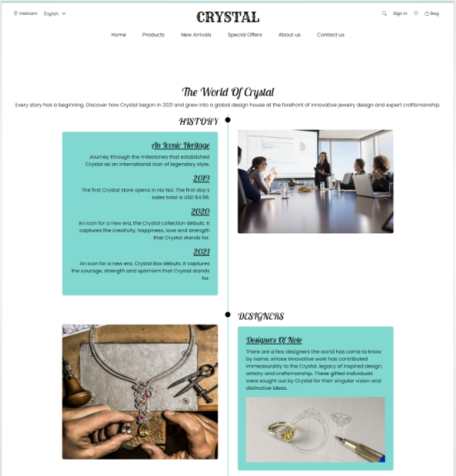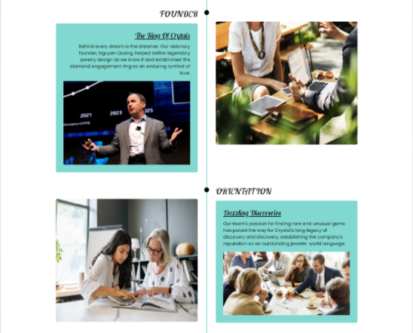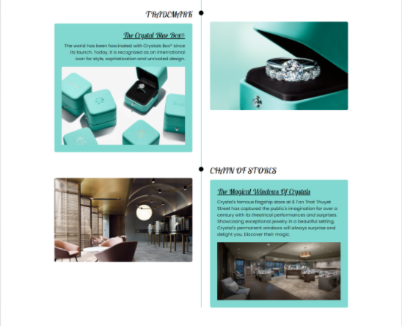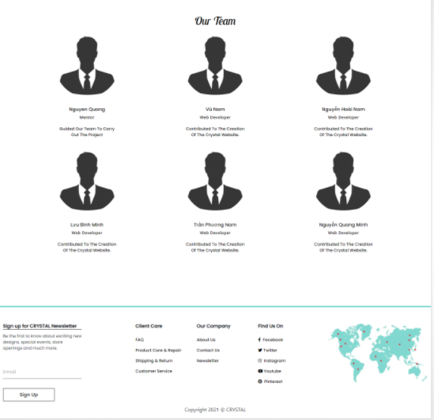

## GUI 7 (Example: Add to bag):

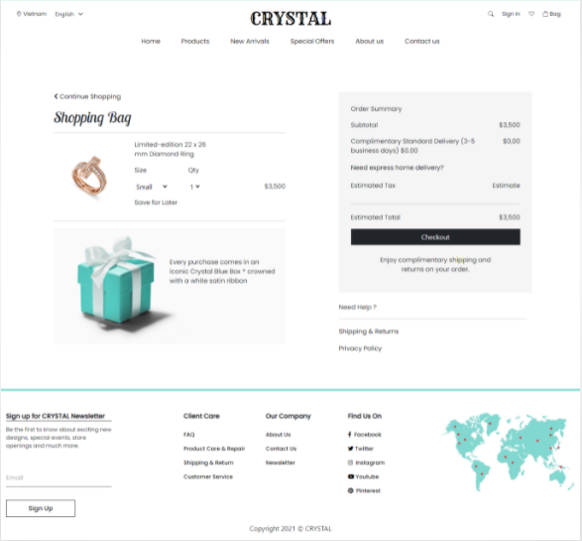

## GUI 8: Check in/Check out (Example: Check out)

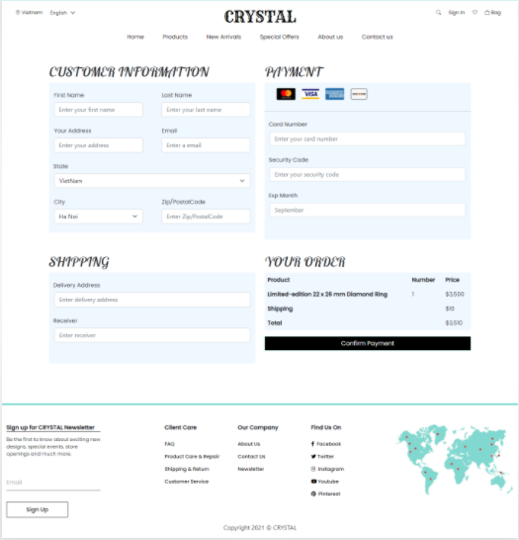

# Sumary

With the requirements of the project, the team needs to build a website with many pages that containing the necessary information, including 8 pages.

|  |  |  |
| --- | --- | --- |
| ID | Item | Details (Wiki) |
|  |  |  |
| 1 | Home | With nav bar on top then the menu. |
| 2 | Product | Information about product list |
| 3 | New arrivals | Information about new products |
| 4 | Special offers | Information about discounted products and price change products |
| 5 | Contact Us | Information for contact info |
| 6 | About Us | Information for about us |
| 7 | Add to bag | Information about products you plan to buy. |
| 8 | Check in/Check out | Place where you will login or register an account/you will complete the payment procedure. |