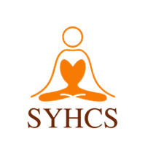

**SRI YOGA HANUMAN CULTURAL SOCIETY**

#4, 13415, COMBER WAY, SURREY, BC, V3W-5V8

yogahanumantemple@gmail.com | www.sriyogahanuman.org

Ph: 778-780-1914

**TAX RECEIPT CHARITY NO: 83823 2312 RR0001**

RECEIPT NO: R-2024-001

DONATED BY: John Doe

PHONE NUMBER: 123-456-7890

EMAIL: john@example.com

AMOUNT: $100.00

PAYMENT BY: ONLINE PAYMENT

ISSUED BY: Temple Admin

DUPLICATE ONE RECEIPT FOR 2024 TAX PURPOSES – THANKS FOR YOUR INTEREST AND SUPPORT!

**Donation Details**

|  |  |  |
| --- | --- | --- |
| Date | Description | Amount |
| 2024-05-01 | Temple Fund | $50.00 |
| 2024-05-02 | Festival | $50.00 |

NOTE: Thank you for your generous donation.