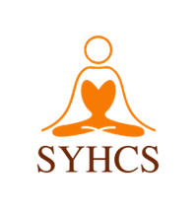

**SRI YOGA HANUMAN CULTURAL SOCIETY**

#4, 13415, COMBER WAY, SURREY, BC, V3W-5V8

yogahanumantemple@gmail.com | www.sriyogahanuman.org

Ph: 778-780-1914

**TAX RECEIPT CHARITY NO: 83823 2312 RR0001**

RECEIPT NO: R-1746705776401

DONATED BY: Anthony Moore

PHONE NUMBER: +13053127621

EMAIL: cindy25@example.org

AMOUNT: $104.48

PAYMENT BY: ONLINE PAYMENT

ISSUED BY: Admin

DUPLICATE ONE RECEIPT FOR 2025 TAX PURPOSES – THANKS FOR YOUR INTEREST AND SUPPORT!

**Donation Details**

|  |  |  |
| --- | --- | --- |
| Date | Description | Amount |
| 2025-05-02 |  | $25.00 |
| 2025-05-01 |  | $79.48 |

NOTE: Thank you for donating!