

Python Core

Training Assignments

|  |  |
| --- | --- |
| Program Code |  |
| Issue/Revision | x/y |
| Effective date | 26/Jun/2023 |

**Assignment Day 05**

1. **Implement the algorithm from description (File I/O: 6-13):**

When data is written to a file, it is often organized into records and fields. A record is a complete set of data that describes one item, and a field is a single piece of data within a record. For example, suppose we want to store data about employees in a file. The file will contain a record for each employee. Each record will be a collection of fields, such as name, ID number, and department. Each time you write a record to a sequential access file, you write the fields that make up the record, one after the other.

Saves records to the employee.txt file.

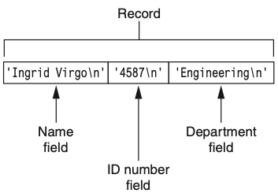

1. **Reads records from employee.txt file and display on screen (File I/O: 6-14)**
2. Requirement is same as 1, 2. However, store data in json file instead of txt file. Using json libraries.