Introduction to Software Engineering

Requirements Analysis

The student team is required to complete the Software Requirements Specification (SRS) document for the assigned course project, following the attached template.


Software Engineering Department
Faculty of Information and Technology
University of Science
Table of Contents

Objectives 1
1 Member Contribution Assessment 2
2 Problem Statement 3
3 Requirements Overview 4
4 Requirements Analysis 7
5 Prototype/Mockup 35

Software Requirements Specification

Objectives
This document focus on the following topics:
- Complete the Software Requirements Specification (SRS) document with the following contents:
Hiển thị dữ liệu phức tạp
DataGridView

  - Elaborate on the Problem Statement
  - Overview of Requirements (Functional and Non-Functional), Stakeholders
  - Use Case Model
  - Use Case Specifications
  - Create Prototype and Mockup Diagrams of the System Interface
- Đọc hiểu tài liệu phân tích yêu cầu.

Member Contribution Assessment

ID | Name | Contribution (%) | Signature
23127192 | Nguyễn Văn Hộp | 100
23127411 | Lê Long | 100
23127430 | Đinh Hoàng Nam | 100

Problem Statement
- PetCare Management System is a web application system designed to digitize and streamline the daily operations of professional pet care centers. It is developed to address the limitations of manual management tools like notebooks or messaging apps. The main objective of the software is to provide a centralized platform that helps customers book appointments easily while allowing staff to manage medical records and schedules efficiently.
- The system allows users to register and log in with different roles, including Customers, Veterinarians, and Managers:
- Customers can create accounts, manage their personal and pet profiles, book appointments online for specific services, view their appointment history, and access their pets' medical records and prescriptions.
- Veterinarians can manage their working availability, view their assigned daily schedules, search for pet records, and update medical information (diagnosis, treatments) after consultations.
- Managers are responsible for managing user accounts (creating staff profiles, managing customer data), overseeing the appointment flow (assigning veterinarians, rescheduling or canceling bookings), and generating revenue reports and statistical dashboards.
- In addition to the core scheduling functionality, the system focuses on Electronic Medical Records (EMR) management. This feature addresses the need for accurate health tracking by allowing veterinarians to store and retrieve diagnoses, vaccinations, and treatment notes securely ensuring better care for pets compared to paper-based methods.
- The website will operate in a web environment and be compatible with modern browsers such as Google Chrome, Microsoft Edge, and Firefox with support for HTML5 and CSS3 standards. The interface is built using Bootstrap 5 to ensure users can access the site effectively from both desktop and mobile devices.

Requirements Overview

Stakeholders
STT | Stakeholder | Description
1 | Customer | Pet owners who register accounts, manage pet profiles, book appointments, and view medical history.
2 | Veterinarian | Medical staff responsible for managing their schedule, viewing assigned appointments, and updating pet medical records.
3 | Manager | Responsible for managing staff and customer accounts, assigning veterinarians, and monitoring revenue statistics.
4 | Project Sponsor | The faculty or client provides the requirements and evaluating the project outcome.
5 | Development Team | The student team is responsible for analyzing, designing, building, and testing the PetCare system.

Requirements
    - Functional Requirements Specification
Authentication and Authorization:
- a. Related use cases: UC01 - UC02 - UC03
- b. Requirements Specification:
  - FR1.1: The system shall allow users (Customer, Veterinarian, Manager) to sign in using a username/email and password.
  - FR1.2: The system validates credentials and redirects the user to the dashboard corresponding to their role.
  - FR1.3: If login info is wrong, the system displays "Incorrect username or password".
  - FR1.4: The system shall allow users to sign out, invalidating their current session.
  - FR1.5: The system shall allow users to reset their password via email if forgotten.
Customer and Pet Profile Management:
- a. Related use cases: UC04 - UC05 - UC09
- b. Requirements Specification:
  - FR2.1: Customers can view and update their personal profile information (name, phone, address).
  - FR2.2: Customers can view a list of their registered pets with basic details (Name, Species, Breed, Age).
  - FR2.3: Customers can view the medical history, prescriptions, and vaccination records for their pets.
  - FR2.4: If no pets are registered, the system displays a message "You have not added any pets yet".
Appointment Management (Customer):
- a. Related use cases: UC06 - UC07 - UC08
- b. Requirements Specification:
  - FR3.1: Customers can book a new appointment by selecting a pet, service, and available time slot.
  - FR3.2: The system prevents booking if the selected time slot is no longer available.
  - FR3.3: Customers can view the history of their appointments (Upcoming, Completed, Canceled).
  - FR3.4: Customers can cancel an upcoming appointment, provided it is not too close to the scheduled time.
Veterinarian Operations:
- a. Related use cases: UC10 - UC11 - UC12 - UC13
- b. Requirements Specification:
  - FR4.1: Veterinarians can register or update their available working time slots.
  - FR4.2: Veterinarians can view a list of appointments assigned to them for the day or week.
  - FR4.3: Veterinarians can search for pet records using phone number, customer name, or pet name.
  - FR4.4: Veterinarians can create new medical records (diagnosis, prescription, treatment notes) for a pet.
Manager Administrative Tasks:
- a. Related use cases: UC14 - UC15 - UC16 - UC17 - UC18
- b. Requirements Specification:
  - FR5.1: Managers can create and update staff accounts (Veterinarians, Receptionists).
  - FR5.2: Managers can view, edit, or disable customer accounts.
  - FR5.3: Managers can assign a specific veterinarian to an unassigned appointment.
  - FR5.4: Managers can create appointments on behalf of a customer.
  - FR5.5: Managers can cancel or reschedule existing appointments.
Statistics and Reporting:
- a. Related use cases: UC19 - UC20
- b. Requirements Specification:
  - FR6.1: Managers can generate and export revenue reports (e.g., PDF, CSV) based on date ranges.
  - FR6.2: Managers can view a visual dashboard with statistics such as Revenue per Month or Appointments per Day.
  - FR6.3: The dashboard widgets should update dynamically based on selected filters.
    - Non-Functional Requirements Specification
Performance: The system must provide a login response time of less than 2 seconds. Search and save operations should also be completed within 2 seconds.
Security: Passwords must be securely stored (hashed and salted). All communication must be secure (SSL/TLS). Access to staff and customer data must be restricted to authorized roles only.
Availability: The system uses a web browser environment supporting HTML5.
Data Integrity: The system must ensure real-time synchronization of schedule data to prevent double-booking. Medical records must be immutable after saving; corrections require addendum entries.
Scalability: The system should be scalable to support at least 10 branches and 1000+ customers.
Usability: The interface must be simple, intuitive, and responsive across desktop and mobile devices.

Requirements Analysis

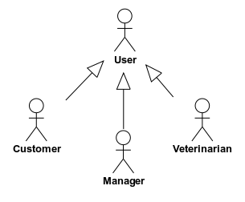
Use Case model
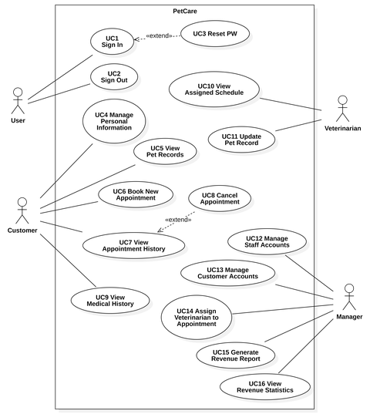

Use Case Specification
    - Use Case 1
Use case ID | U001
Use Case | Sign In
Brief Description | Allows a registered user (Customer, Veterinarian, Manager) to access the system using their credentials.
Actor | Customer, Veterinarian, Manager
Pre-Condition | - The Actor has a valid, registered account in the system.  - The Actor is on the Sign In page.
Result | The Actor is successfully authenticated and the system establishes a session and redirects the Actor to the dashboard corresponding to their role.
Main Scenario | - The Actor accesses the Sign In page.  - The Actor enters their Username (or Email) and Password.  - The Actor clicks the "Sign In" button.  - The system validates the credentials.  - The system grants access, creates a session, and redirects the Actor to their main dashboard.
alternative Scenarios | 4.1 Invalid Credentials:  4.1.1. The system displays the error message: "Incorrect username or password".  4.1.2. The Actor remains on the Sign In page.
Non-Functional Constraints | Security:  Passwords must be securely stored (hashed and salted).  The system must prevent brute-force attacks (e.g., account lockout after 5 failed attempts).  Performance: Login response time must be < 2 seconds.
    - Use case 2
Use case ID | U002
Use Case | Sign out
Brief Description | Allows a currently logged-in user to securely exit the system.
Actor | Customer, Veterinarian, Manager
Pre-Condition | - The Actor is logged in (UC1 has been completed).
Result | The Actor's session is terminated and has been redirected to the Sign In page (UC1).
Main Scenario | - The Actor clicks the "Sign Out" button.  - The system invalidates and destroys the Actor's current session.  - The system redirects the Actor to the Sign In page.
alternative Scenarios | None
Non-Functional Constraints | Security: All session and authentication cookies must be cleared upon sign out.

    - Use case 3
Use case ID | U003
Use Case | Reset PW
Brief Description | Allows an Actor who forgot their password to set a new one.  This use case <<extends>> from UC1: Sign In.
Actor | Customer, Veterinarian, Manager
Pre-Condition | - The Actor is on the Sign In page (UC1).
Result | The Actor's password is securely updated in the database.
Main Scenario | - The Actor clicks the "Forgot Password?" link on the UC1 page.  - The system displays a page requesting the Actor's registered email address.  - The Actor enters their email and clicks "Submit".  - The system validates the email, generates a secure reset token/code, and sends it to the Actor's email.  - The Actor follows the instructions (e.g., clicks a link or enters the code) to access the new password form.  - The Actor enters and confirms their new password.  - The system validates the token and the new password (checking complexity rules).  - The system updates the password in the database and displays a "Password successfully reset" message.
alternative Scenarios | 4.1 Email Not Found:  4.1.1. The system displays the message: "Email not found in our system".
Non-Functional Constraints | Security:  The password reset token/link must be secure and expire after a short duration (e.g., 15 minutes).  The system must enforce password complexity rules.  All communication (email, pages) must be secure (SSL/TLS).
    - Use case 4
Use case ID | U005
Use Case | Manage Personal Information
Brief Description | Allows a Customer to view and update their personal profile information (e.g., name, phone number, address).
Actor | Customer
Pre-Condition | - The Actor is on the Sign In page (UC1).
Result | The Customer's personal information is validated and updated in the system.
Main Scenario | - The Customer navigates to the "My Profile" or "Account Information" page.  - The system retrieves and displays the Customer's current personal information in an editable form.  - The Customer modifies the desired information (e.g., Phone Number, Address).  - The Customer clicks the "Save Changes" button.  - The system validates the new information.  - The system updates the record in the database and displays a "Profile updated successfully" message.
alternative Scenarios | 5.1 Invalid Information:  5.1.1. The system detects an error (e.g., "Invalid phone number format").  5.1.2. The system displays an error message next to the invalid field.  5.1.3. The Customer remains on the page to correct the information.
Non-Functional Constraints | Security: Data must be transmitted securely (SSL).  Usability: The interface must be responsive and intuitive.  Performance: Response time for saving changes must be < 2 seconds.
    - Use case 5
Use case ID | U005
Use Case | View Pet Records
Brief Description | Allows a Customer to view a list and basic information of all pets registered to their account.
Actor | Customer
Pre-Condition | - The Customer is logged in (UC1).
Result | The system displays a list of pets owned by the Customer, with high-level details.
Main Scenario | - The Customer navigates to the "My Pets" section.  - The system queries the database for all pets linked to the Customer's account.  - The system displays a list of pets, showing (e.g.) Pet Name, Species, Breed, and Age.
alternative Scenarios | 3.1 No Pets Registered:  3.1.1. The system finds no pets linked to the account.  3.1.2. The system displays the message: "You have not added any pets yet".
Non-Functional Constraints | Performance: Pet data retrieval time should be < 2 seconds.  Usability: The interface must be simple and easy to read.
    - Use case 6
Use case ID | U006
Use Case | Book New Appointment
Brief Description | Allows a Customer to fill a form to select a pet, service, and time slot to book a new appointment.
Actor | Customer
Pre-Condition | - The Customer is logged in (UC1).  - The Customer has at least one pet registered (UC5).
Result | A new appointment record is created in the system with a "Pending" or "Booked" status
Main Scenario | - The Customer selects the "Book New Appointment" function.  - The system displays a form.  - The Customer selects their Pet (from UC5 list), the desired Service, and the desired Date/Time slot (based on available slots).  - The Customer clicks "Confirm Booking".  - The system validates the selected time slot (checking for conflicts).  - The system saves the new appointment record.  - The system displays a confirmation message: "Appointment booked successfully".
alternative Scenarios | 5.1 Time Slot Conflict:  5.1.1. The system checks (step 5) and finds the slot is no longer available.  5.1.2. The system displays an error: "This time slot is no longer available. Please select another time".  5.1.3. The Customer must select a different slot (returns to step 3).
Non-Functional Constraints | Reliability & Data Integrity: The system must use real-time availability (from UC10) to prevent double-booking (high concurrency).  Usability:  The interface must be simple and intuitive.  A confirmation (email/SMS) should be sent to the customer upon booking.
    - Use case 7
Use case ID | U007
Use Case | View Appointment History
Brief Description | Allows a Customer to view a list of their past (completed, canceled) and upcoming appointments.
Actor | Customer
Pre-Condition | - The Customer is logged in (UC1).
Result | The system displays a categorized list of all appointments associated with the Customer.
Main Scenario | - The Customer navigates to the "My Appointments" or "Appointment History" page.  - The system retrieves all appointments for that Customer.  - The system displays the appointments, typically separated into tabs or sections (e.g., "Upcoming", "Completed", "Canceled").
alternative Scenarios | 3.1 No Appointments Found:  3.1.1. The system finds no appointments for the account.  3.1.2. The system displays the message: "You have no appointments".
Non-Functional Constraints | Reliability & Data Integrity: Data must be accurate and reflect the real-time status of all appointments.  Usability: The interface must be simple and intuitive.  Performance: Retrieval time for appointment history must be < 2 seconds.
    - Use case 8
Use case ID | U008
Use Case | Cancel Appointment
Brief Description | Allows a customer to cancel a previously booked appointment.
Actor | Customer
Pre-Condition | 1. The Customer is logged in (UC1).  2. The Customer is on the "View Appointment History" (UC7) page.
Result | The selected appointment's status is updated to "Canceled" in the system.
Main Scenario | 1. From the appointment history list (UC7), the Customer selects an "upcoming" appointment.  2. The Customer clicks the "Cancel Appointment" button.  3. The system displays a confirmation prompt.  4. The Customer selects "Confirm Cancelation".  5. The system updates the appointment status to "Canceled".  6. The system displays a success message.
alternative Scenarios | 4.1. Customer does not confirm:  4.1.1. The Customer clicks "No" or closes the dialog.  4.1.2. The system returns to the appointment history screen; no changes are made.  2.1. Canceling too close to the appointment time:  2.1.1. The system checks (less than 2 hours until the appointment).  2.1.2. The system displays a message: "Cannot cancel online. Please call the branch."
Non-Functional Constraints | Minimum online cancellation window must be defined (2 hours before appointment). (This value is configurable in admin settings.)  Audit trail must record: who canceled, when, and cancellation reason (if provided).  UI must be responsive; confirmation modal must be accessible (keyboard, screen reader).  System must send cancellation notification (email/SMS/push) to customer and optionally to staff.  All status changes must be atomic and idempotent.
    - Use case 9
Use case ID | U009
Use Case | View Medical History
Brief Description | Allows a Customer to review the complete medical and treatment history (diagnoses, prescriptions) for their pet.
Actor | Customer
Pre-Condition | 1. The Customer is logged in (UC1).  2. The Customer is on the "View Pet Records" (UC5) page.
Result | The system displays a list of medical records, prescriptions, and vaccination history for the selected pet.
Main Scenario | 1. From the pet list (UC5), the Customer selects one pet.  2. The Customer selects the "Medical History" tab/section.  3. The system queries and displays a list of past visits (in chronological order).  4. Each entry shows: Visit Date, Symptoms, Diagnosis, Attending Veterinarian.  5. The Customer can select "View Details" to see the issued prescription.
alternative Scenarios | 3.1. Pet has no medical history  3.1.1. The system displays the message: "This pet has no medical history yet."
Non-Functional Constraints | Medical data must be accurate, complete, and securely stored in compliance with data protection standards.  Only the pet’s registered owner (the logged-in customer) may access medical history.  Page load and retrieval time for medical history should be less than 3 seconds under normal conditions.  Audit logs must record every access to medical history for accountability.

    - Use case 10
Use case ID | U010
Use Case | View Assigned Schedule
Brief Description | Allows a Veterinarian to view the list of appointments (customer name, pet, time) that have been assigned to them.
Actor | Veterinarian
Pre-Condition | - The Veterinarian is logged in (UC1).
Result | The system displays all appointments assigned to the veterinarian for the selected day or week.  The display includes relevant customer, pet, and service information.  Data reflects real-time updates (including new bookings or cancellations).
Main Scenario | - The Veterinarian accesses the “My Schedule” page (typically the default home page after login).  - The system retrieves and displays a list or calendar view of confirmed appointments assigned to the veterinarian.  - Each appointment entry includes the following details:  - Appointment Time  - Customer Name  - Pet Name  - Requested Service (e.g., Checkup, Vaccination, Surgery, etc.)  - The Veterinarian can switch between Day View and Week View to review their schedule.  - The system allows viewing additional appointment details by clicking on an entry.
Alternative Scenarios | 2.1 No upcoming appointments  2.1.1 The system finds no assigned appointments for the selected day/week.  2.1.2 The system displays the message: “You have no upcoming appointments.”  2.2 Data synchronization delay  2.2.1 The system temporarily fails to fetch the latest appointment data (due to server delay …).  2.2.2 The system displays a message: “Unable to refresh schedule. Please try again shortly.”  2.2.3 Once reconnected, the system automatically reloads the updated appointment list.  3.1 Canceled or reassigned appointment  3.1.1 If an appointment has been canceled or reassigned (UC18), it should immediately disappear or update from the schedule.  3.1.2 The system refreshes the view automatically and shows the latest data without manual reload.
Non-Functional Constraints | Schedule data must be synchronized in real-time with booking (UC16) and cancellation (UC18) modules.  The system must auto-refresh the schedule view when updates occur.  Data retrieval time must be < 2 seconds under normal load.  The interface must be responsive across desktop and mobile devices.  Appointment data must be protected to ensure that only the assigned veterinarian can view it.

    - Use case 11
Use case ID | U011
Use Case | Update Pet Record
Brief Description | Allows a Veterinarian to record medical information — such as symptoms, diagnosis, prescriptions, and treatment details — after examining a pet.  This use case is an <<include>> from UC12 – Search Pet Records.
Actor | Veterinarian
Pre-Condition | - The Veterinarian is logged in (UC1).  2. The veterinarian has searched and selected a pet record (UC12 is completed).
Result | A new medical record (diagnosis, prescription) is created and saved to the pet's profile.
Main Scenario | - After locating the pet record (UC12), the Veterinarian selects “Create New Medical Record” for the current appointment.  - The system displays a Medical Record Form with fields for relevant details.  - The Veterinarian enters the following information:  - Symptoms / Observations  - Diagnosis  - Prescribed Medication (selected from available inventory)  - Treatment Notes  - Vaccination Updates (if applicable)  - The Veterinarian clicks “Save Record”.  - The system performs validation and then saves the information to the database.  - The system updates the appointment status and displays a confirmation message: “Medical record successfully saved.”
Alternative Scenarios | 3.1 Invalid or Incomplete Information  3.1.1 One or more fields are missing or invalid (e.g., Diagnosis field empty, or invalid medicine).  3.1.2 The system displays an appropriate error message: “Diagnosis is required.”, “Selected medicine is out of stock.”  3.1.3 The Veterinarian corrects the data and re-saves the record.  4.1 System or Network Error  4.1.1 The system fails to save due to network issues or database errors.  4.1.2 The system displays an alert: “Unable to save record. Please try again later.”  4.1.3 The unsaved data is temporarily cached locally until the system is available again.
Non-Functional Constraints | Data Integrity:  Saved medical records are immutable — they cannot be edited directly after saving.  Any corrections must be done by creating an addendum entry linked to the original record.  Reliability: Medical records must be stored safely and backed up regularly.  Performance: Save operation should complete within 2 seconds under normal conditions.  Security: Only authenticated veterinarians can create or update records.  Auditability: Each medical record must store metadata (e.g., created_by, created_at, pet_id, appointment_id).

    - Use case 12
Use case ID | U012
Use Case | Manage Staff Accounts
Brief Description | Allows a Manager to create, view, and update account information for staff members (e.g., Veterinarians, Receptionists, or Administrative Staff).
Actor | Manager
Pre-Condition | - The Manager is logged in (UC1).  - The Manager has appropriate privileges to access the Staff Management module.
Result | The staff member's information/account is created or updated in the system.
Main Scenario | - The Manager selects the “Staff Management” function from the system dashboard.  - The system displays a list of all current staff members, including names, roles, and statuses.  - The Manager chooses one of the following actions:  - Add New Staff Member  - Edit Existing Staff Member  - The Manager fills in or updates the following information fields:  - Full Name  - Email Address  - Role (Veterinarian, Receptionist, Admin Staff, etc.)  - Assigned Branch  - Login Credentials (Username, Password)  - The Manager clicks “Save”.  - The system validates the entered data.  - If all inputs are valid, the system updates the Supabase database with the new or modified account information.  - The system displays a confirmation message:  “Staff account successfully saved.”
alternative Scenarios | 4.1 Invalid Information  4.1.1. The system detects an error in input (e.g., duplicate email, missing required field).  4.1.2. The system displays an error message such as: “Email already exists.”, “Role selection is required.”  4.1.3. The Manager corrects the data and re-submits.  6.1 Database or Network Error  6.1.1. Connection to the Supabase database fails during the update.  6.1.2. The system displays a message: “Unable to save at the moment. Please try again later.”  6.1.3. The operation is retried automatically or saved to a queue for later synchronization.
Non-Functional Constraints | Security:  All staff information must comply with privacy and data protection standards (e.g., secure password encryption).  Only users with the Manager role can access and modify staff account information.  Performance: The system should load and save account data within 2 seconds.  Data Integrity: Email addresses must be unique identifiers across all accounts.  Auditability: Each medical record must store metadata (e.g., created_by, created_at, pet_id, appointment_id).

    - Use case 13
Use case ID | U013
Use Case | Manage Customer Accounts
Brief Description | Allows a Manager to search for, view, and edit customer account information, including contact details and account status.
Actor | Manager
Pre-Condition | - The Manager is logged in (UC1).  - The Manager has authorized access to the Customer Management module.
Result | Customer information is updated.
Main Scenario | - The Manager selects the “Customer Management” function from the system menu.  - The system displays a list of all registered customers.  - The Manager uses the search bar to locate a customer by Phone Number or Name.  - The system displays the matching results.  - The Manager selects a customer to view details, including personal information and their list of registered pets.  - The Manager clicks “Edit” to update fields such as address, phone number, or account status.  - The Manager can also choose to “Disable” a customer account (preventing further logins or bookings).  - The Manager clicks “Save”.  - The system validates and saves the updated customer data.  - The system displays a confirmation message:  “Customer information updated successfully.”
alternative Scenarios | 3.1 Customer Not Found  3.1.1 The search returns no results.  3.1.2 The system displays a message: “Customer not found.”  3.1.3 The Manager can refine the search or create a new customer record (linked to UC15 – Register Customer).  6.1 Invalid Information  6.1.1 One or more required fields are empty or invalid (e.g., phone format incorrect).  6.1.2 The system displays an error message: “Please enter a valid phone number.”  6.1.3 The Manager corrects the data and retries.  9.1 Database Error  9.1.1 System fails to update data due to network or Supabase connection issues.  9.1.2 The system shows: “Unable to save changes. Please try again later.”  9.1.3 The update is queued or retried automatically.
Non-Functional Constraints | Security:  Only Managers can access and modify customer data.  All operations must comply with personal data protection and privacy standards.  Performance: Search and update operations must complete within 2 seconds.  Data Integrity: All updates must preserve existing linked data (appointments, pets, payments).  Auditability: Each medical record must store metadata (e.g., created_by, created_at, pet_id, appointment_id).

    - Use case 14
Use case ID | U014
Use Case | Assign Veterinarian to Appointment
Brief Description | Allows a Manager to assign an available Veterinarian to a new or unassigned appointment based on their schedule (UC10) and specialty.
Actor | Manager
Pre-Condition | - The Manager is logged in (UC1).  - An appointment exists with an "Unassigned" or "Pending" status (created via UC6 or UC17).
Result | The appointment record is updated with an assigned Veterinarian ID.  The Veterinarian's schedule (UC11) reflects the new assignment.
Main Scenario | - 1. The Actor accesses the "Appointment Management" dashboard.  - The Actor selects an "Unassigned" appointment.  - The system displays appointment details and a list of available Veterinarians (based on UC10).  - The Actor selects a Veterinarian from the list.  - The Actor clicks "Assign".  - The system updates the appointment, links it to the Veterinarian, and (optionally) sends a notification to the Veterinarian.
alternative Scenarios | 3.1 No Veterinarian Available:  3.1.1 The system finds no veterinarians matching the required time/specialty.  3.1.2 The system displays a message: "No veterinarians are available for this slot."
Non-Functional Constraints | Synchronization:  Must have real-time synchronization with Veterinarian availability (UC10) to prevent conflicts.  Auditability:  All assignment actions (who assigned, when) must be logged.  Performance:  Checking availability must return results in < 2 seconds.

    - Use case 15
Use case ID | U015
Use Case | Generate Revenue Report
Brief Description | Allows a Manager to generate and export detailed financial reports (e.g., daily, monthly, by service) based on completed and paid appointments.
Actor | Manager
Pre-Condition | - The Manager is logged in (UC1).  - The Manager has authorization to view financial data.
Result | The system generates a downloadable file (e.g., PDF, CSV, Excel) containing the requested revenue data.
Main Scenario | - The Manager navigates to the "Reports" module.  - The Manager selects "Revenue Report".  - The Manager selects report parameters (e.g., Date Range, Service Type, specific Veterinarian, Branch).  - The Manager clicks "Generate Report".  - The system queries the database (e.g., payment records linked to appointments).  - The system compiles the data and presents a "Download" link.  - The Manager downloads the file.
Alternative Scenarios | 5.1 No Data Found:  5.1.1. The system finds no completed transactions matching the criteria.  5.1.2. The system displays a message: "No revenue data found for the selected parameters."
Non-Functional Constraints | Security: Access must be strictly restricted to the Manager role.  Data Accuracy: Reports must be 100% accurate, reflecting completed transactions only.  Performance: Generation of a monthly report should complete within 10 seconds.

    - Use case 16
Use case ID | U016
Use Case | View Revenue Statistics
Brief Description | Allows a Manager to view a visual, interactive dashboard of key performance indicators (KPIs) and revenue statistics (e.g., charts, graphs).
Actor | Manager
Pre-Condition | - The Manager is logged in (UC1).
Result | The system displays a dashboard populated with real-time (or near-real-time) statistical widgets.
Main Scenario | - The Manager navigates to the "Dashboard" or "Statistics" page (often the default page after login for Managers).  - The system retrieves and displays various visual widgets, such as:  - "Revenue per Month" (Line Chart)  - "Services by Popularity" (Pie Chart)  - "Appointments per Day" (Bar Chart)  - The Manager can (optionally) apply filters to the dashboard (e.g., "Last 30 Days", "This Quarter").  - The dashboard widgets update dynamically based on the filters.
alternative Scenarios | 2.1 Data Loading:  2.1.1. The system is fetching large amounts of data.  2.1.2. The system displays "Loading..." spinners on the widgets until data is ready.
Non-Functional Constraints | Performance: The dashboard must load (including data) in < 5 seconds.  Usability: Data visualizations must be clear, easy to understand, and accurate.  Data Freshness: Dashboard data should be near-real-time (e.g., refreshed automatically or manually, with data no older than 1 hour).

Prototype/Mockup
5.1 Sign up

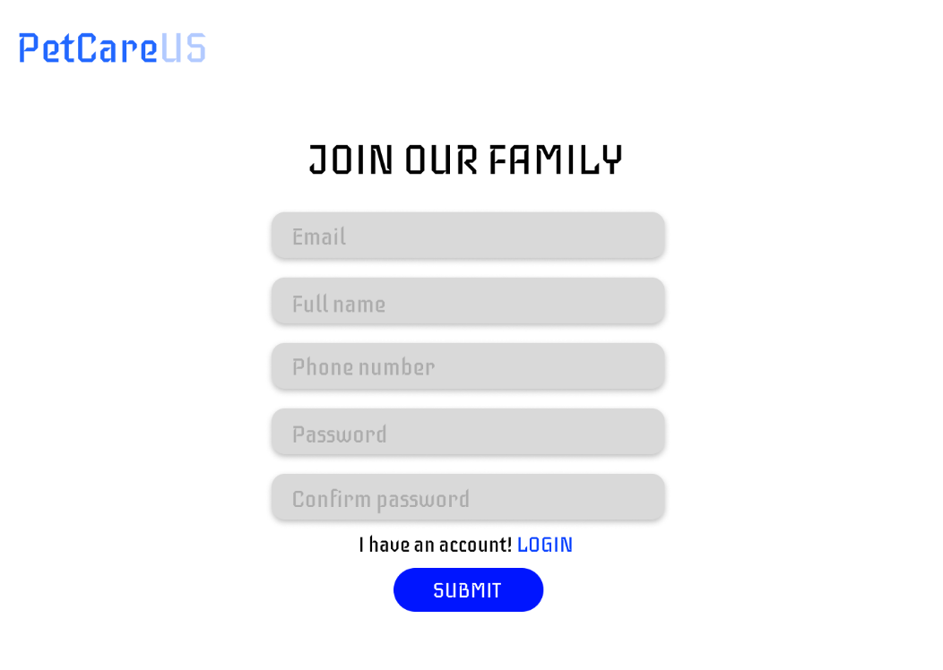

5.2 Login

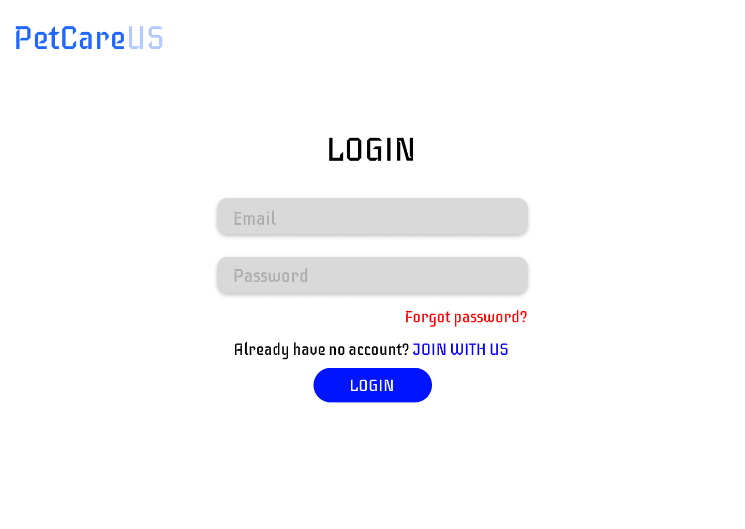

5.3 Home page
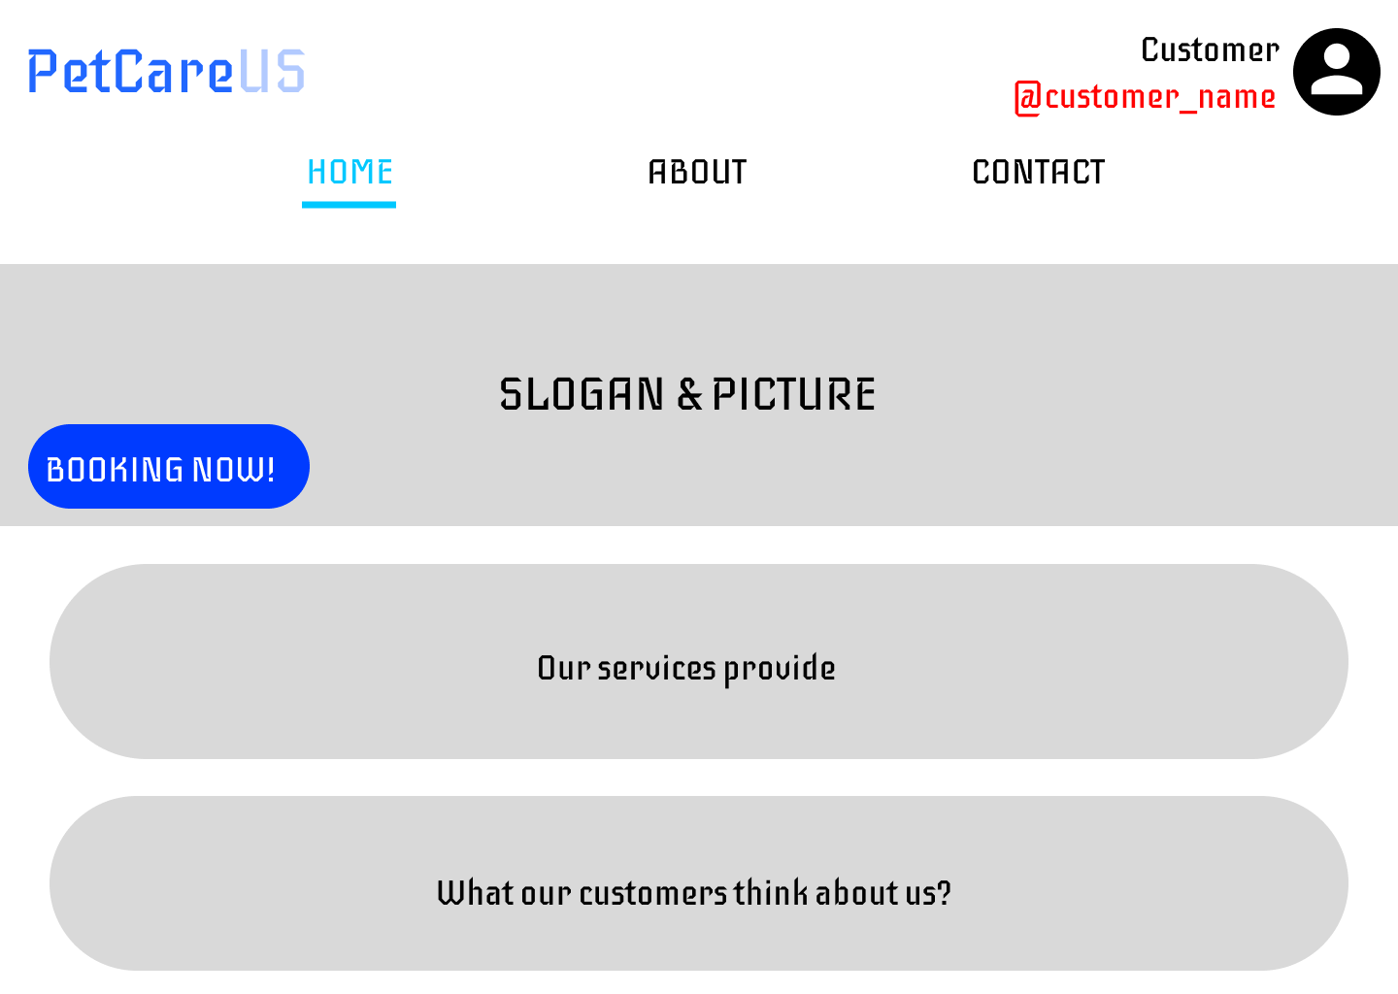
5.4 About page
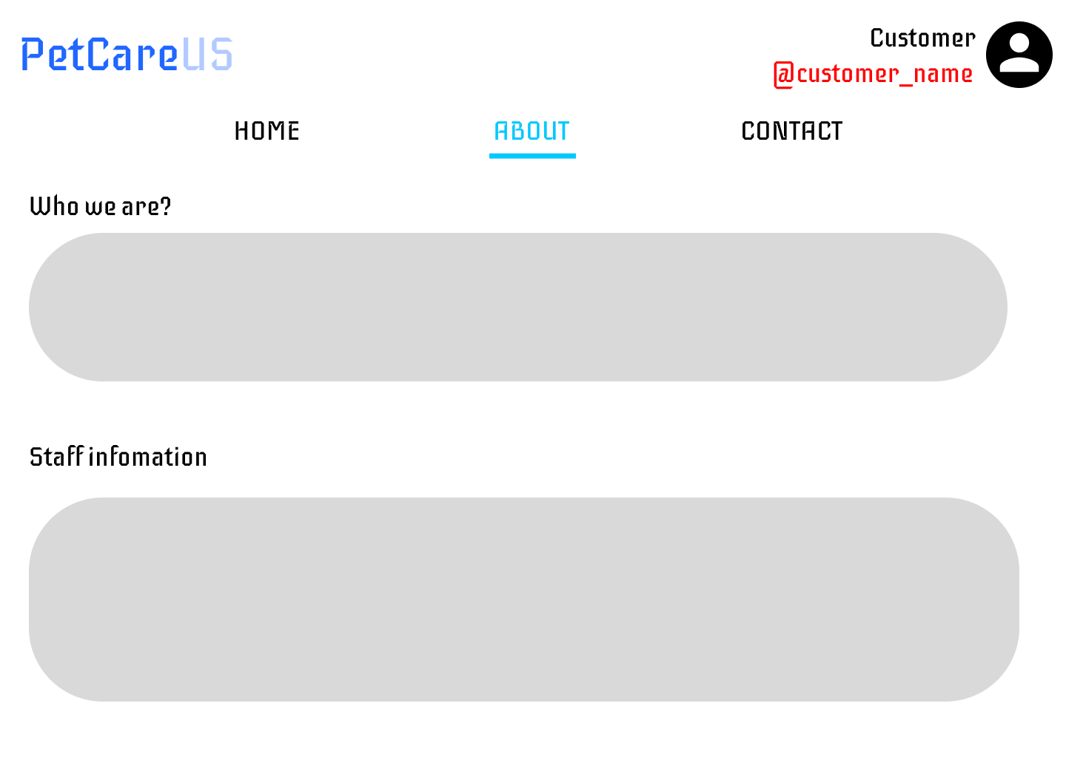

5.5 Contact page
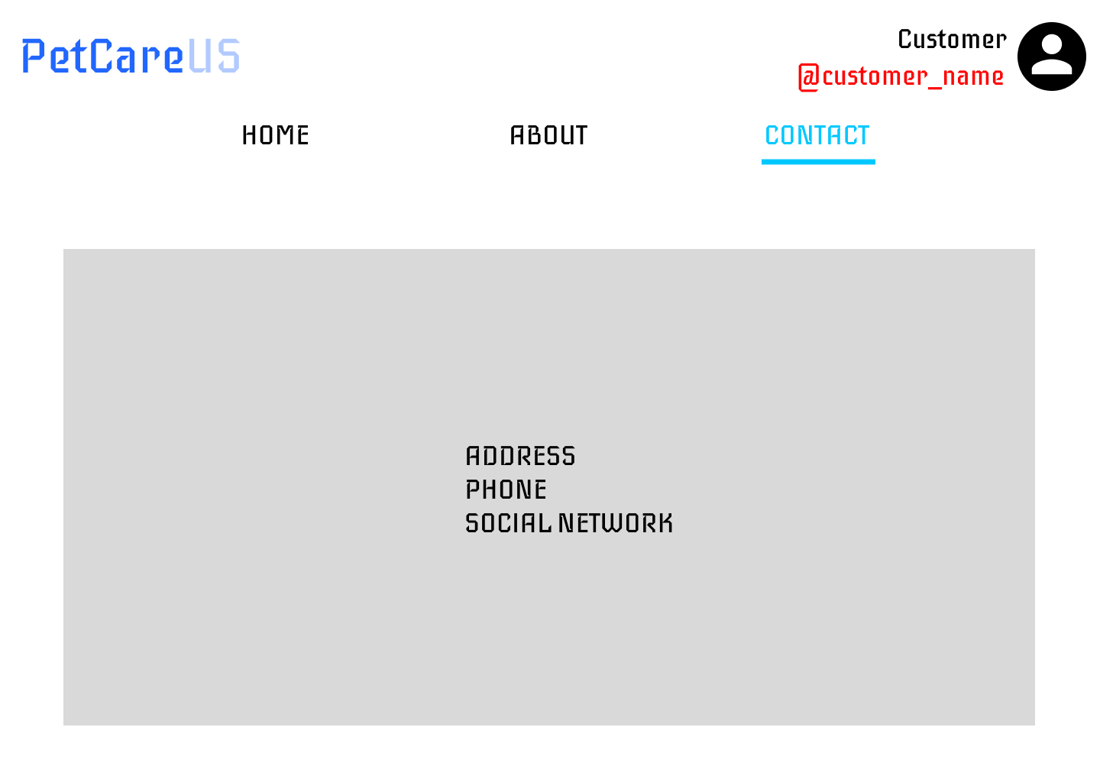
5.6 Booking page
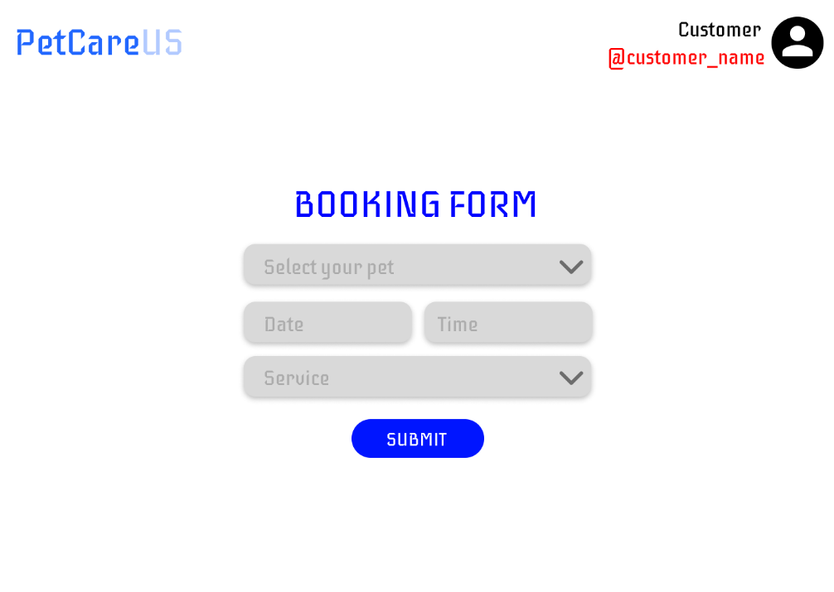

5.7 Customer page (Personal Information)
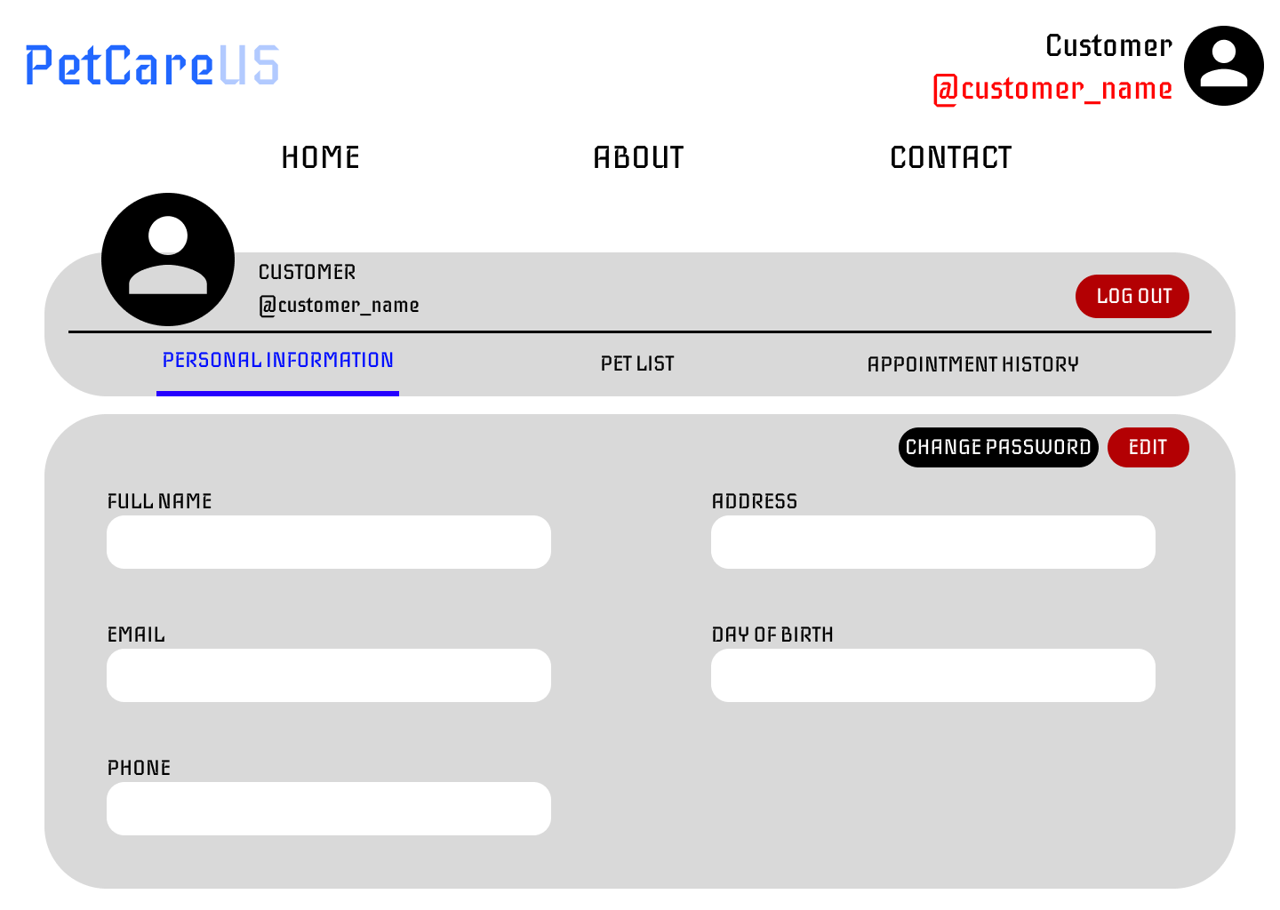

5.8 Customer page (Pet list)
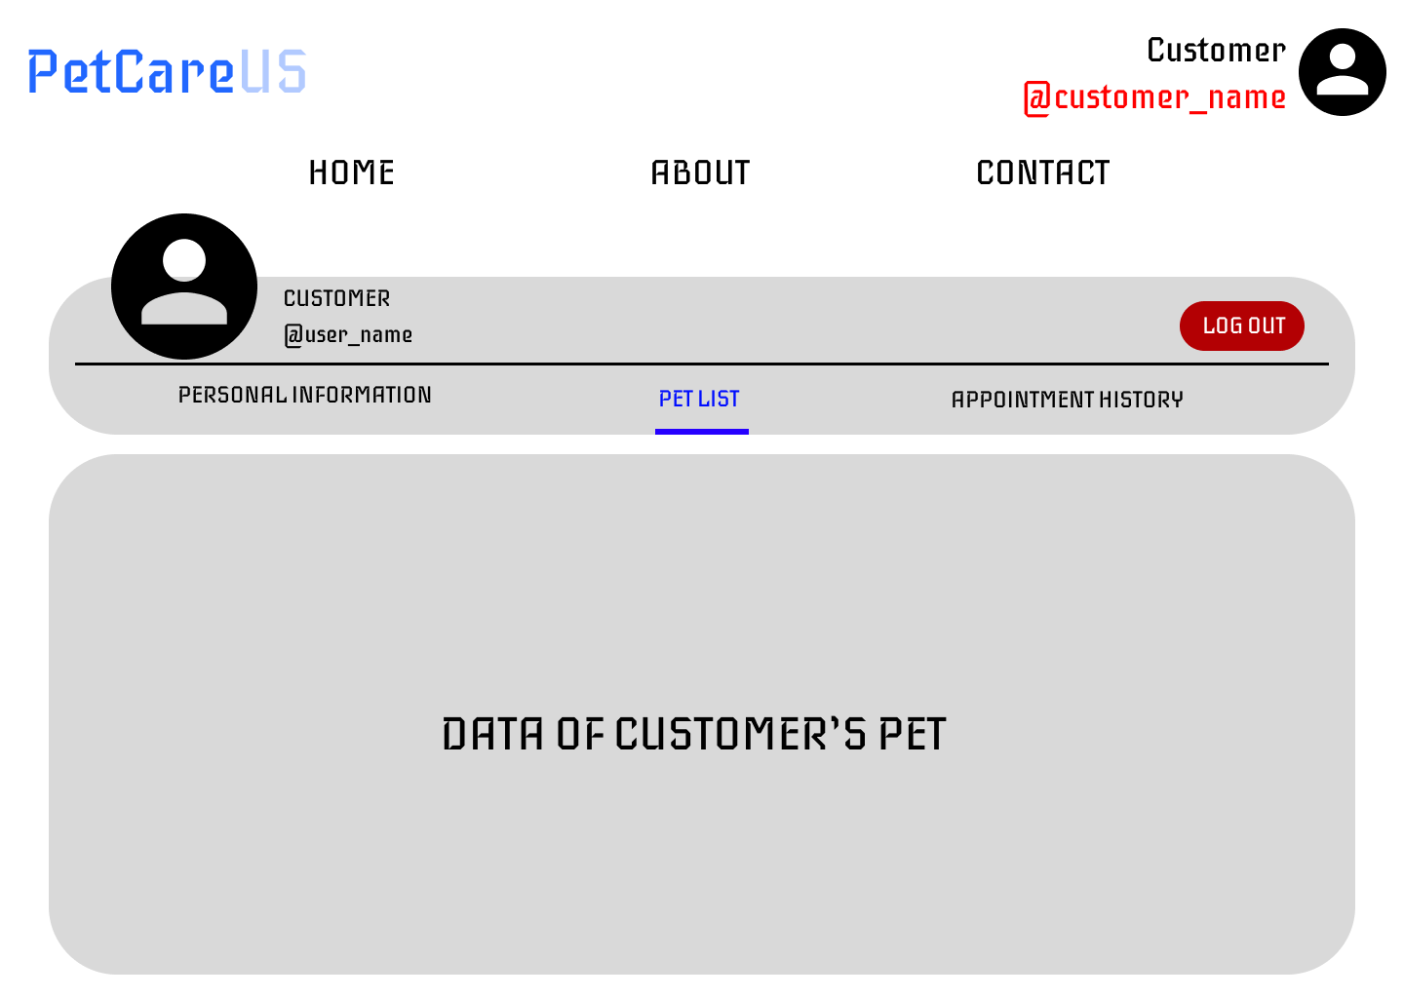
5.9 Customer page (Appointment history)
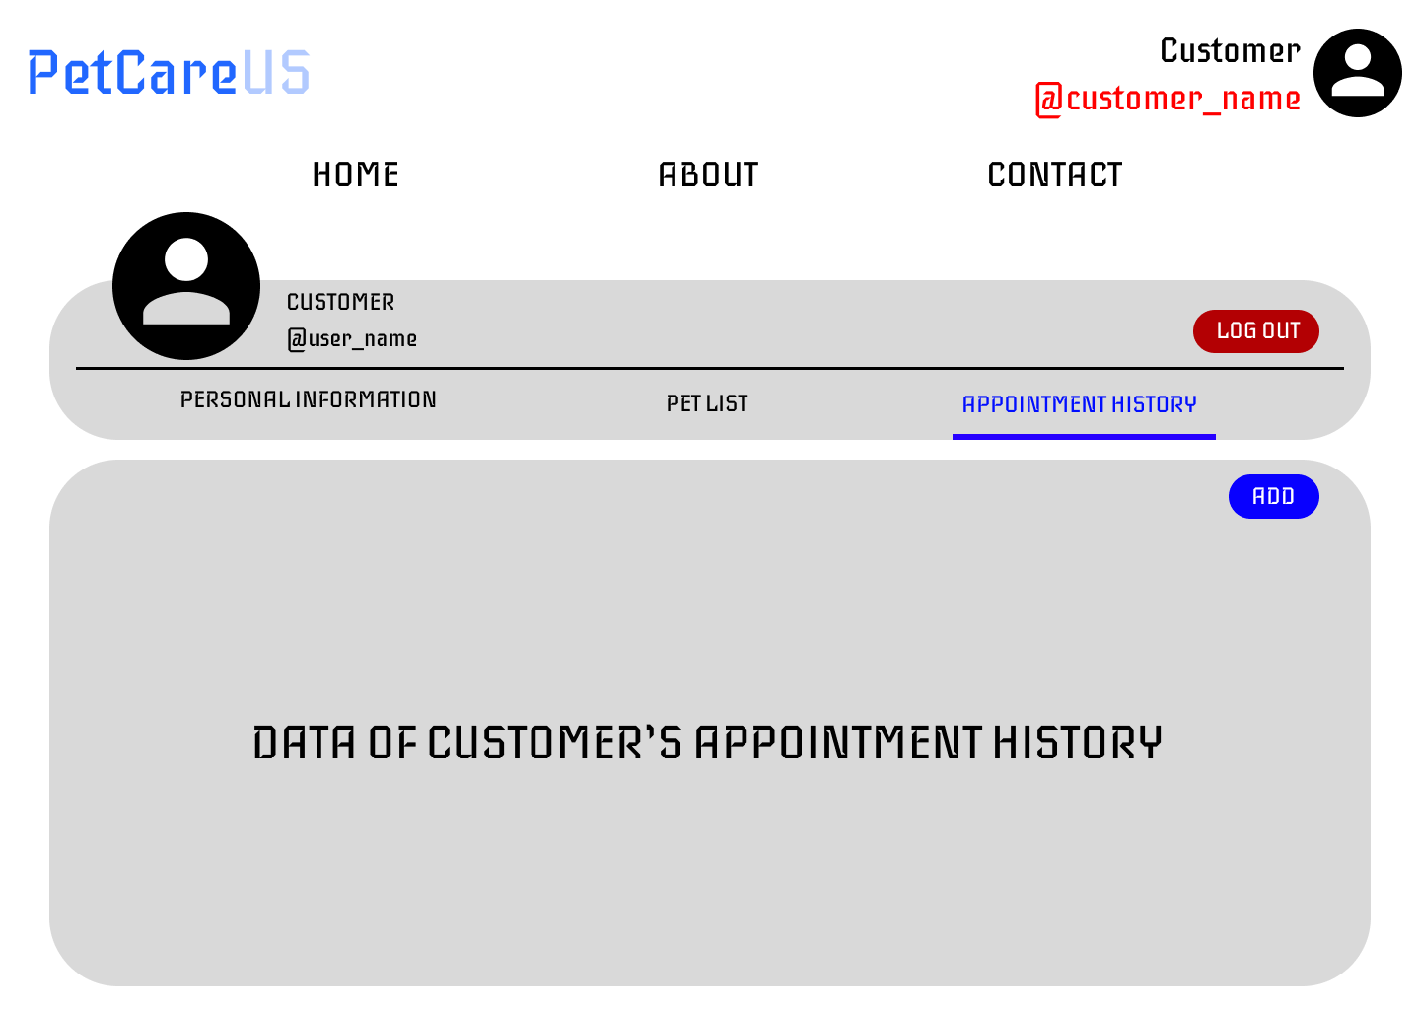

5.10 Doctor page (Schedule)
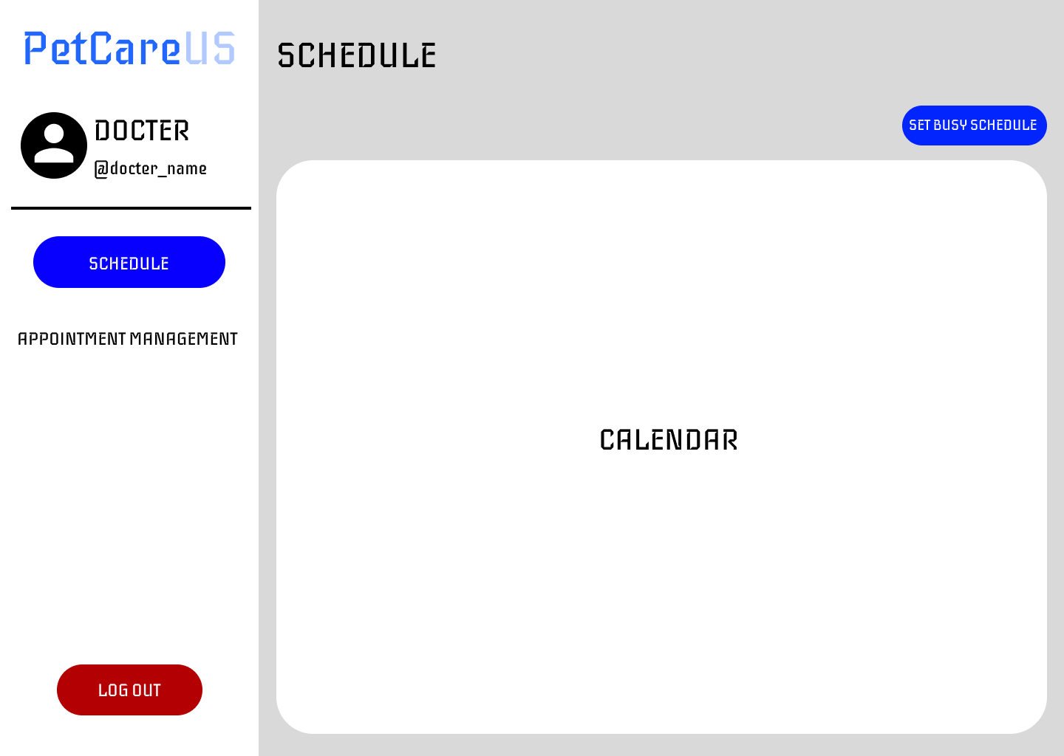
5.11 Doctor page (Appointment)
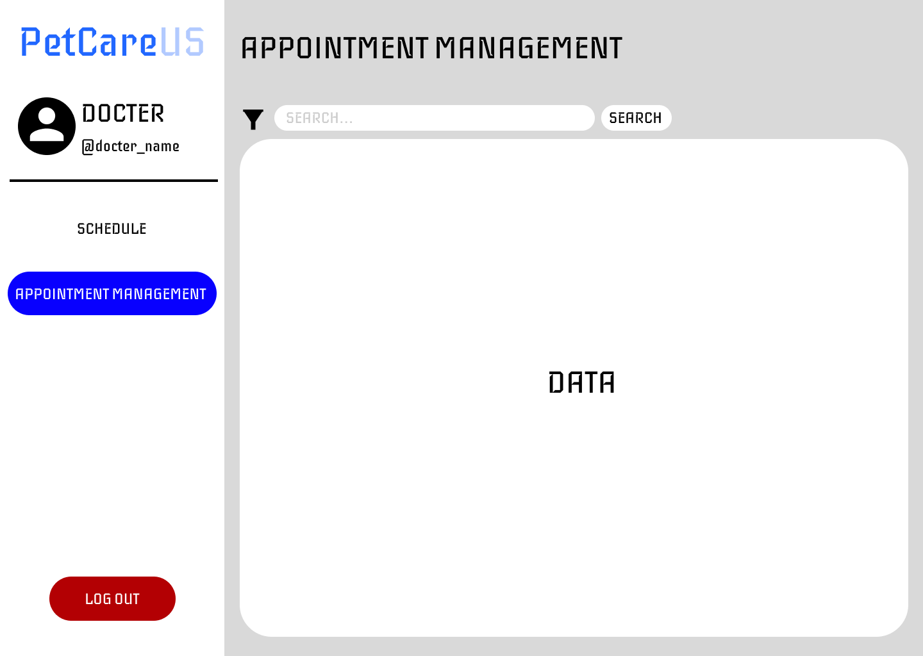

5.12 Admin page (Manage Customer)
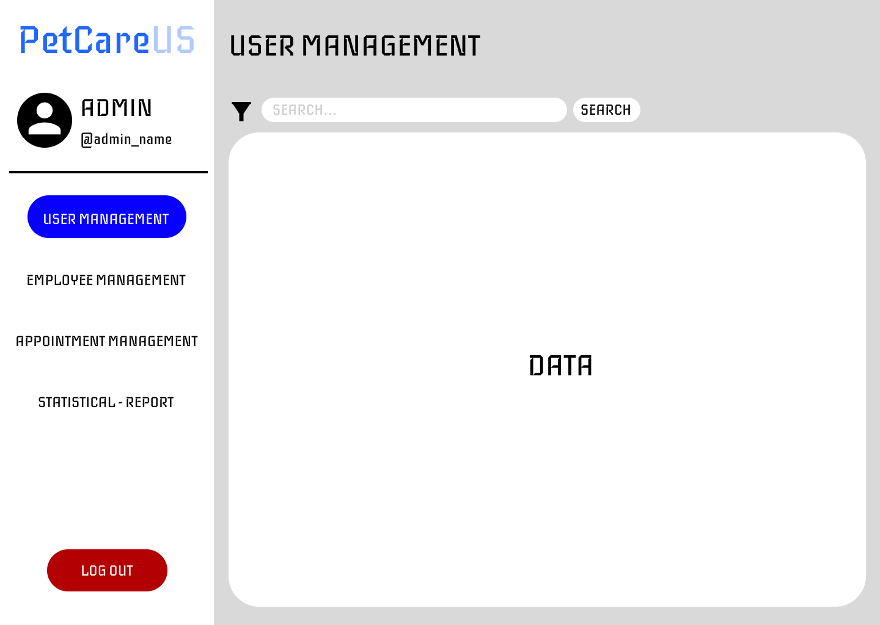

5.13 Admin page (Manage Employee)
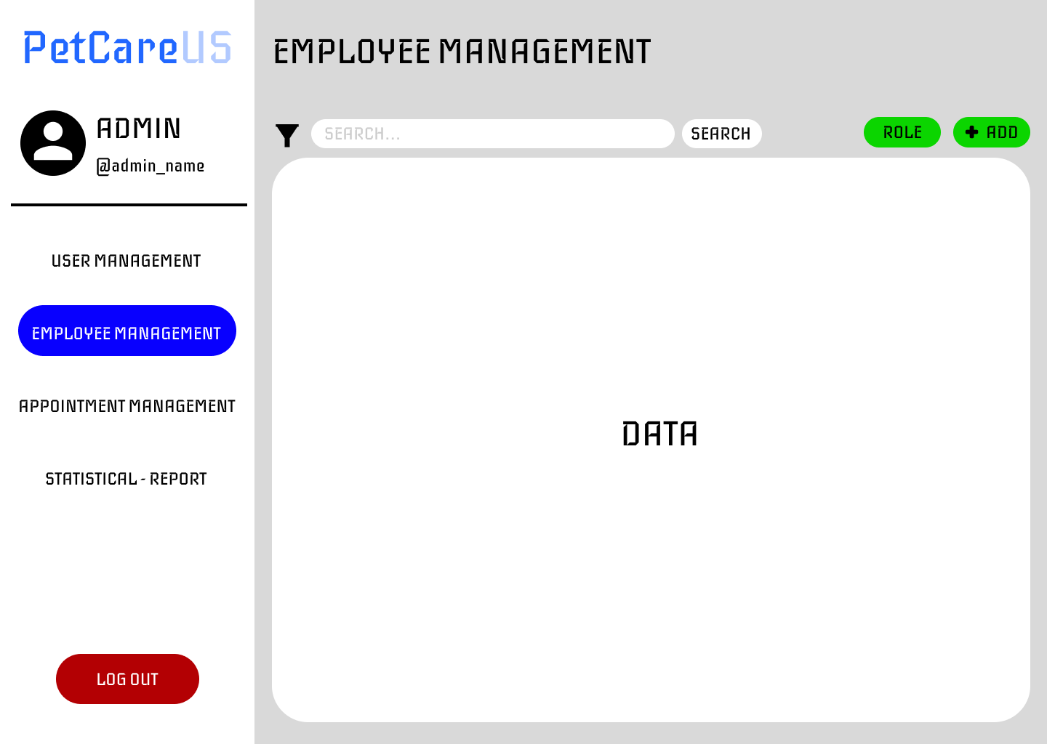
5.14 Admin page (Manage Appointment)
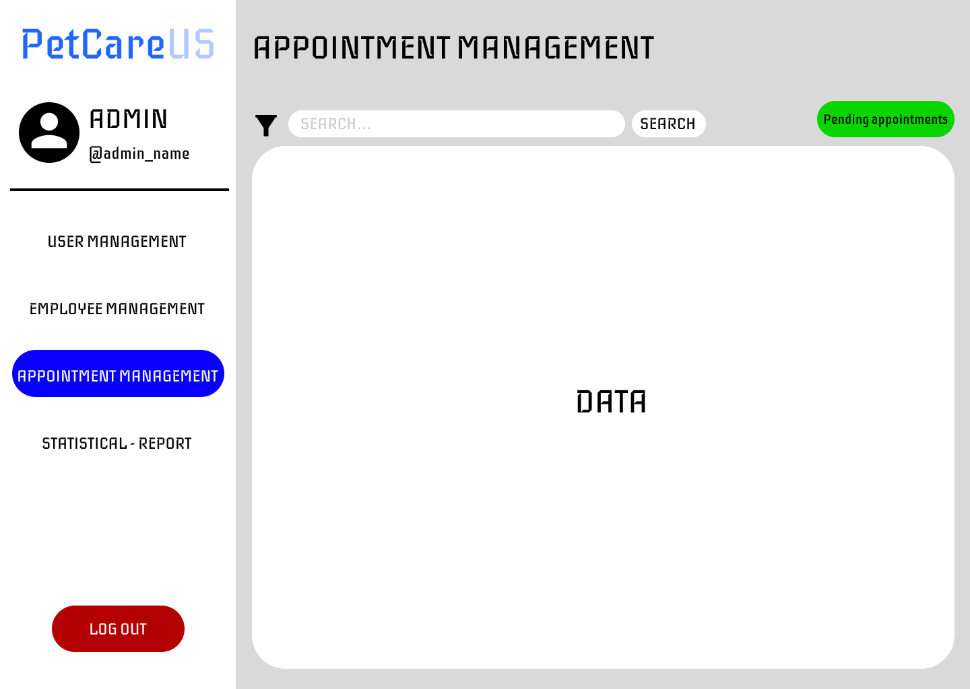
5.15 Admin page (Statistical - report)
