**FULL STACK DEVELOPMENT**

**Lab Exercise 5**

Student Name: Do Huynh

ID: 101293009

POST

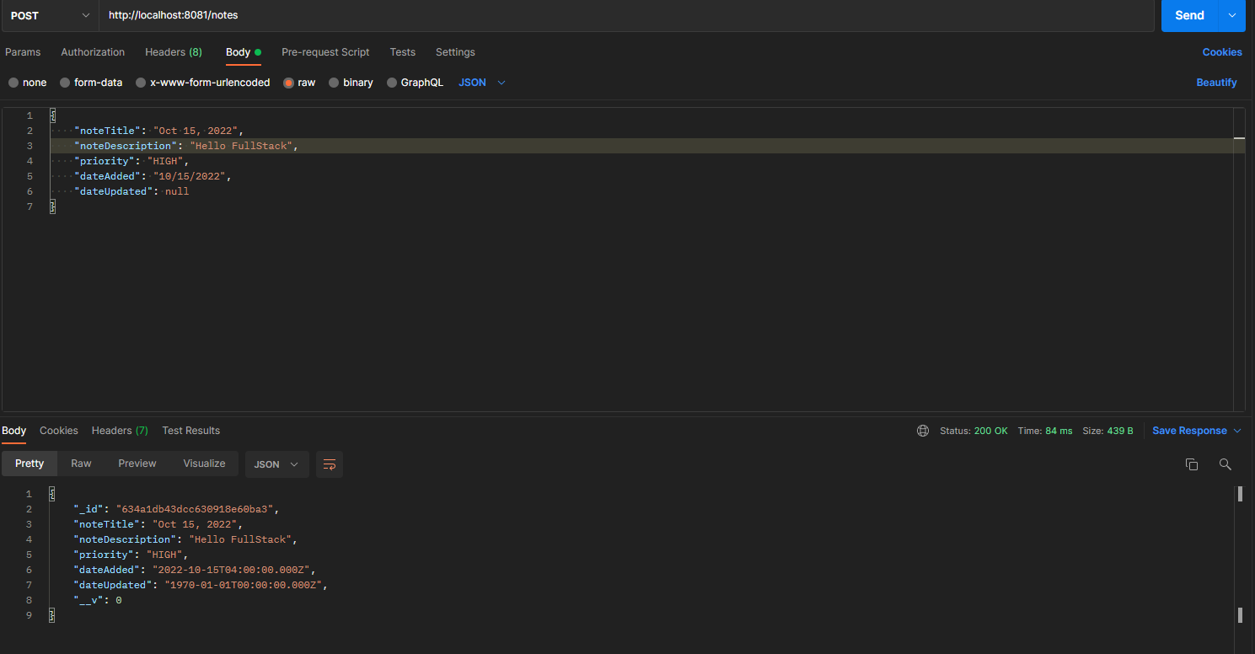

GET (single note)

PUT

