IV. Software Design Description

1. System Design

1.1 System Architecture
The overall architecture of OctaPoint is shown below. The system follows a client-server model with a layered backend. All clients talk to one REST API over HTTPS, and the API keeps its data in PostgreSQL. The blockchain is used only as an external place to store proof, so a Sui outage never blocks a customer transaction.
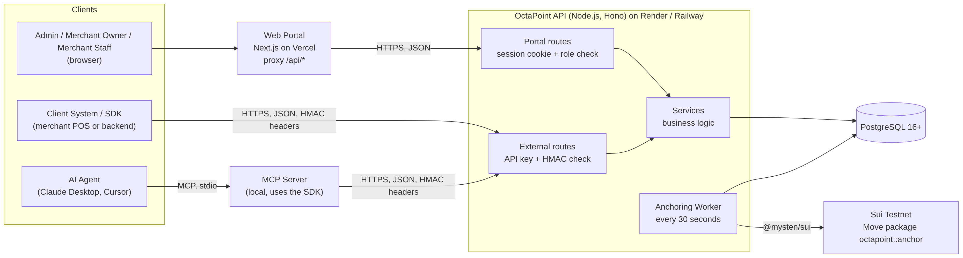
1.1 System Architecture
- UI Components
  - Web Portal (Next.js): One web application used by three roles.
    - Functionality: The Admin approves or suspends merchants and watches platform counters and the system ledger. The Merchant Owner sets loyalty rules, manages customers, staff and API keys, and reads the ledger. The Merchant Staff looks up customers and issues or redeems points.
    - Note: End customers have no screen (LI-07). The merchant's own POS or app talks to OctaPoint through the SDK.
  - TypeScript SDK (Client System): A Node.js library that a merchant developer installs in a POS or e-commerce backend. It signs every request automatically.
  - MCP Server (AI Agent): A small program that runs on the machine of the AI client (for example Claude Desktop). It gives the assistant three read-only tools.
- Core System (Server-side)
  - REST API (Hono): The central part of the system. It has two groups of routes. Portal routes use a session cookie, and external routes use an API key with an HMAC signature.
  - Anchoring Worker: A background job inside the API process. Every 30 seconds it takes saved transactions that are waiting (PENDING_ANCHOR) and writes their proof to Sui.
- External Systems
  - Sui Testnet: Holds the Move package octapoint::anchor. It stores only a transaction code and a 32-byte hash. The platform wallet pays all gas fees.
  - Vercel: Hosts the Web Portal.
  - Render or Railway: Hosts the API and the PostgreSQL database.
- Database Layer
  - PostgreSQL: Stores accounts, sessions, customers, balances, the ledger, API keys, idempotency records and the audit log. It is the single source of truth for balances (BR-11).
  - Note: There is no Redis or ClickHouse in this version (LI-06).

1.1.1 Backend Architecture
The backend uses a layered architecture so that each layer has one job.
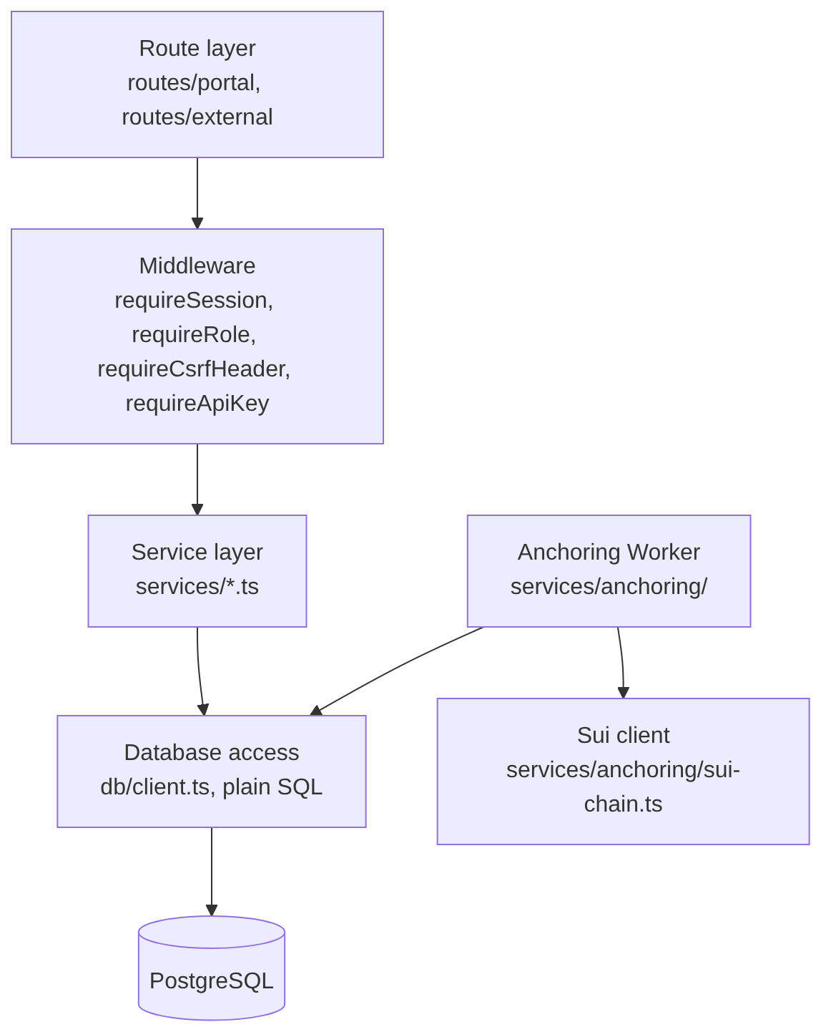
1.1.1 Backend Architecture
- Route layer: Receives the HTTP request, reads and validates the body with zod, calls one service function and returns the JSON result. A route never writes SQL.
- Middleware: Runs before the route. For the portal it checks the session, the role and the X-Requested-With header. For external calls it checks the API key, the timestamp and the HMAC signature.
- Service layer: Holds the business rules, for example the points formula, the row lock on the customer, the reversal checks and the audit logging. A service receives a Sql handle, and every function that changes balances runs inside one database transaction (withTransaction).
- Database access: Plain SQL through the postgres client. There is no ORM, so row locks and triggers stay visible in the code.
- Worker and Sui client: The worker reads and updates only the anchoring columns of transactions. The Sui client wraps @mysten/sui behind the AnchorChain interface so the worker can be tested without the network.

1.1.2 Web Application Architecture
The Web Portal is built with Next.js (App Router), TypeScript, Tailwind CSS and shadcn/ui. It is desktop-first and English only (LI-10).
- App routing: Pages are grouped in two route groups. (auth) holds the public pages Login and Register. (portal) holds every page that needs a session, and its layout.tsx wraps them in the application shell (sidebar, top bar, role-based menu). The menu of each role follows the matrix in SRS §3.1.6 and is defined in one file, lib/navigation.ts.
- Pages: Each screen of SRS §3.1.2 and §3.1.4 is one page: Dashboard, Customers, Loyalty Rules, API Keys, Staff, Ledger and Account for the Merchant roles, and Dashboard, Merchants and System Ledger for the Admin. Forms such as Issue / Redeem points, Add customer, Add staff and Generate key open in dialogs.
- Session: AuthProvider (lib/auth.tsx) loads the profile with GET /auth/me and keeps it in React state. No token is kept in JavaScript or localStorage; the HttpOnly cookie does the work. When any call answers MSG35, the API client sends the user to /login.
- Data layer: lib/api-client.ts is a typed client for the Portal API. It calls relative URLs such as /api/v1/auth/login, and a Next.js rewrite in next.config.mjs forwards /api/* to the backend (API_BASE_URL). The session cookie therefore stays first-party and no CORS setting is needed. Every changing request carries X-Requested-With: octapoint-portal. A network failure is shown with the MSG23 text.
- Idempotency in the UI: The Issue / Redeem dialog uses one key per submission (lib/idempotency.ts). A double click or a retry of the same request reuses the same key; a different amount gets a new key.
- Mock mode: With NEXT_PUBLIC_USE_MOCKS=true the portal runs on in-memory demo data (lib/mocks.ts) and needs no API or database. It is meant for screen demos only and is never enabled in production.

1.2 Package Diagram
The source code is one pnpm monorepo. The table below lists its top-level packages.

1.2.1 Repository Packages
No | Package | Description
1 | apps/api | Backend. Contains the Hono API, the anchoring worker, SQL migrations and the seed and reset scripts.
2 | apps/web | The Next.js Web Portal for Admin, Merchant Owner and Merchant Staff.
3 | packages/sdk | The TypeScript SDK. It builds the signing string, signs requests and exposes the client methods. It is not published to npm (LI-10).
4 | packages/mcp | The MCP Server. It is built on packages/sdk and registers read-only tools only.
5 | contracts/anchor | The Sui Move package octapoint::anchor with its unit tests.
6 | docs | The SRS, the database, API and anchoring documents, the diagrams, and the guides.

1.2.2 Web App Package Description (apps/web/src)
No | Package | Description
1 | app/(auth) | Public pages login and register, with a shared two-column layout (components/auth-layout.tsx).
2 | app/(portal) | Session pages: dashboard, customers, rules, api-keys, staff, ledger, account for merchant users, and admin, admin/merchants, admin/ledger for the Admin. layout.tsx checks the session and the role before it shows a page.
3 | components | Shared parts: app-shell, page-header, stat-card, status-badge, pagination, empty-state, modal, confirm-dialog and copy-button.
4 | components/ui | shadcn/ui building blocks: button, input, label, select, card, table, badge, skeleton and the toast host sonner.
5 | lib | api-client.ts and api-types.ts (typed Portal API), api-error.ts, auth.tsx, navigation.ts (role menus), messages.ts (copy of the MSG texts), notify.ts, idempotency.ts, format.ts, password-policy.ts, use-api.ts, and the demo data mocks*.ts, mock-http.ts, mock-accounts.ts.
6 | next.config.mjs | The rewrite of /api/* to the backend, the NEXT_PUBLIC_USE_MOCKS switch, and the loading of the root .env file.
7 | test | Seven Vitest files for the API client, navigation, formatting, messages, idempotency and the mock API.

1.2.3 Backend Package Description (apps/api/src)
No | Package | Description
1 | env.ts, config.ts | Load the root .env file and check every setting at start-up. All problems are printed together.
2 | index.ts, app.ts | Start the server and build the Hono app: request id, /health, global error handler and the "not found" answer.
3 | db | client.ts (connection and withTransaction), migrate.ts (runs numbered SQL files and checks their checksums) and migrations/0001_init.sql.
4 | lib | Small shared helpers: messages.ts (all MSG codes), errors.ts (AppError), pg-errors.ts, codes.ts (TXN and MCH codes), crypto.ts (AES-256-GCM), hmac.ts, request-target.ts, proof-hash.ts, password.ts, password-policy.ts, validation.ts, http.ts, prompt.ts, logger.ts.
5 | middleware | auth.ts for the portal (session, role, CSRF header) and api-key.ts for external calls (requireApiKey).
6 | routes | routes/index.ts mounts every route module. routes/portal/* are the session-based routes and routes/external/* are the API-key routes (points, customers, loyalty rules).
7 | services | Business logic, one file per area (see 1.2.4).
8 | scripts | seed-admin.ts creates the first Admin. reset-password.ts resets a password by hand (LI-14). anchor-check.ts and anchor-seed.ts are helper scripts to try the anchoring worker on Sui Testnet.
9 | types.ts | Shared types: roles, statuses, AuthContext, Actor, row and view types, AuditEntry.

1.2.4 Backend Business Modules
No | Module | Files | Description
1 | Authentication | services/auth.ts, routes/portal/auth.ts | Login, logout, sessions, current user and password change.
2 | Merchant | services/merchants.ts, routes/portal/registration.ts, routes/portal/admin-merchants.ts | Merchant registration, merchant list, approve and suspend.
3 | Staff | services/staff.ts, routes/portal/staff.ts | Create and deactivate staff accounts.
4 | API key | services/apikeys.ts, routes/portal/api-keys.ts | Generate, list and revoke API keys; look up a key for the gateway.
5 | Customer | services/customers.ts, routes/portal/customers.ts | Customer records, search, deactivate and reactivate, and the locked read used by points.
6 | Loyalty rule | services/rules.ts, routes/portal/rules.ts | Read and save the earn ratio and the minimum redemption.
7 | Points | services/points.ts, services/transactions.ts, services/idempotency.ts, lib/proof-hash.ts | Issue and redeem, ledger rows, proof hash and idempotency.
8 | Ledger | services/ledger.ts | Ledger list and reversal.
9 | Gateway | middleware/api-key.ts, lib/hmac.ts, lib/request-target.ts | Check API key, timestamp and signature of external calls.
10 | Anchoring | services/anchoring/ (run.ts, worker.ts, db.ts, sui-chain.ts, errors.ts, index.ts) | The worker and the Sui client.
11 | Dashboard | services/dashboard.ts | Counters for the Admin and for a merchant.
12 | Audit | services/audit.ts | writeAudit for every action listed in CR-04.

1.2.5 Key Services
No | Service | Description
1 | Session handling (auth.ts) | Creates a random token, stores only its SHA-256 hash, and checks session, user and merchant status on every request.
2 | withTransaction (db/client.ts) | Opens a database transaction, commits when the function ends and rolls back when it throws.
3 | withIdempotency (idempotency.ts) | Takes an advisory lock per key, returns a saved response for a repeated key, and saves the new response in the same transaction.
4 | issuePointsInTx, redeemPointsInTx (points.ts) | Lock the customer, read the rules, check the limits, update the balance and insert the ledger row.
5 | insertTransaction (transactions.ts) | Generates the TXN code, takes created_at once, computes the proof hash and inserts the row.
6 | reverseTransaction (ledger.ts) | Creates an offsetting REVERSAL after the eligibility and balance checks.
7 | runAnchorOnce (anchoring/run.ts) | Claims due rows, calls Sui, then marks them ANCHORED, schedules a retry or marks them FAILED.
8 | writeAudit (audit.ts) | Writes one audit row in the same transaction as the change it records.

2. Database Design

2.1 Entity Relationship Diagram
The full diagram is in docs/diagrams/erd-v2.svg. The schema is described in docs/db-schema.md and created by apps/api/src/db/migrations/0001_init.sql.
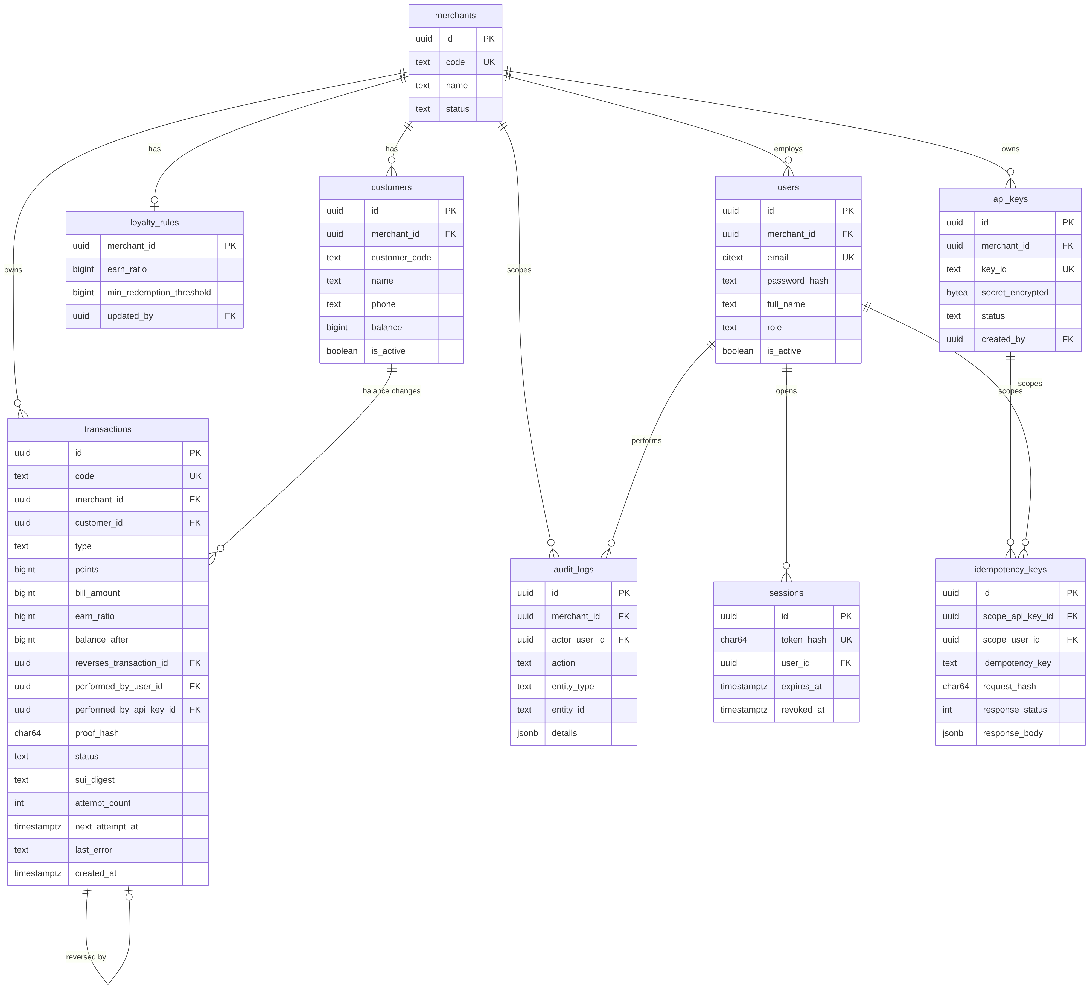
2.1 Entity Relationship Diagram (main columns only)

2.2 Table Description
All IDs are uuid. Times are timestamptz in UTC. Points, amounts and balances are bigint. Status and type columns are text with a CHECK constraint.
No | Table | Description
1 | merchants | One row per merchant. code follows MCH-XXXXXX. status is PENDING, ACTIVE or SUSPENDED (BR-18).
2 | users | Admin, Owner and Staff accounts. email is case-insensitive and unique. A CHECK makes merchant_id empty only for ADMIN, and a unique index allows one Owner per merchant.
3 | sessions | One row per login. Only the SHA-256 hash of the cookie token is stored. expires_at is 8 hours after creation (BR-19).
4 | loyalty_rules | One row per merchant with earn_ratio and min_redemption_threshold, both between 1 and 1,000,000. No row means the rules are not set (MSG32).
5 | api_keys | Public key_id (oct_ followed by 32 hex characters) and the secret encrypted with AES-256-GCM. status is ACTIVE, SUSPENDED or REVOKED.
6 | customers | customer_code is unique per merchant and uses A-Z and 0-9 only. balance is checked to stay between 0 and 1,000,000,000. A phone number, if given, is unique per merchant.
7 | transactions | The ledger (see the table below).
8 | idempotency_keys | Saved responses for issue and redeem. The scope is either an API key or a user. A key is kept for 24 hours.
9 | audit_logs | One row for each action listed in CR-04. It is stored in the database only (LI-03).
Columns of transactions
No | Column | Description
1 | code | TXN-YYYYMMDD-XXXXXXXX (21 characters). It is also the ID written on Sui.
2 | merchant_id, customer_id | A composite foreign key to customers(id, merchant_id) guarantees that a transaction belongs to a customer of the same merchant (BR-01).
3 | type, points | ISSUE, REDEEM or REVERSAL; points is always positive and the type gives the direction.
4 | bill_amount, earn_ratio | Filled for ISSUE only: the bill and the earn ratio that was used.
5 | balance_after | The customer's balance after this transaction.
6 | reverses_transaction_id | Filled for REVERSAL only. A unique index allows one reversal per original (BR-21).
7 | performed_by_user_id, performed_by_api_key_id | Exactly one of the two is filled.
8 | proof_hash | SHA-256 hash of the fixed fields, calculated once when the row is created (see 2.3).
9 | status, sui_digest | PENDING_ANCHOR, ANCHORED or FAILED. The digest exists if and only if the status is ANCHORED.
10 | attempt_count, next_attempt_at, last_error | Retry information for the worker (BR-12).
11 | created_at | Taken once in the API (UTC, milliseconds) and used both in the row and in the hash.

2.3 Ledger Protection and Proof Hash
Ledger protection (BR-03, BR-21). Three database triggers protect the transactions table.
No | Trigger | What it does
1 | trg_transactions_guard | Rejects every DELETE. Rejects any change to the fixed columns. After ANCHORED or FAILED, the status and the digest cannot change any more (LI-08).
2 | trg_transactions_no_truncate | Rejects TRUNCATE.
3 | trg_transactions_check_reversal | A REVERSAL must point to an ISSUE or REDEEM of the same merchant and customer with the same points. This also makes a reversal of a reversal impossible.
Because the ledger cannot be deleted, database tests never clean tables. Each test file creates its own database with createTestDatabase() and drops it at the end.
Proof hash (BR-20).
- The API takes the current UTC time in milliseconds once, before the insert.
- It builds an object with the keys transaction_id, merchant_id, customer_code, type, points, created_at, and for a REVERSAL also reverses_transaction_id (the code of the original).
- It writes the JSON with the keys sorted alphabetically and no spaces, and takes the SHA-256 as lowercase hex.
status, sui_digest, balances and retry fields are not part of the hash. The test vector below must pass in the tests of T07.
canonical: {"created_at":"2026-11-01T03:15:42.123Z","customer_code":"CUS001","merchant_id":"3f0c2b8e-6f55-4c1a-9d0e-1a2b3c4d5e6f","points":1500,"transaction_id":"TXN-20261101-K7P2M9QX","type":"ISSUE"}
sha256 : fbf42511ae75ae2327bccf4fe9b4560825f52580379e7eaf8e6d340f649ee2a1

2.4 Move Smart Contract
The contract is the package octapoint::anchor in contracts/anchor/sources/anchor.move. It is published on Sui Testnet; the package ID is in contracts/anchor/Published.toml and is copied into SUI_PACKAGE_ID. The design is described in docs/anchoring.md.
No | Item | Specification
1 | Network | Sui Testnet only (LI-02).
2 | Purpose | Store tx_id → proof_hash as proof. The contract holds no balance and no personal data (BR-20).
3 | Who can write | AnchorRegistry is an owned object, created in init and sent to the publisher (the platform wallet). Only its owner can pass an owned object to a transaction, so no other address can write (SRS §3.2.2.2).
4 | Gas | Paid by the platform wallet (BR-13).
5 | Settings | After publishing, the package ID and the registry object ID are copied into SUI_PACKAGE_ID and SUI_REGISTRY_ID.
6 | Abort codes | E_DUPLICATE = 1 (the code was anchored before) and E_BAD_HASH = 2 (the hash is not 32 bytes).
7 | Read functions | contains(registry, tx_id) and proof_hash_of(registry, tx_id) let a reviewer check a proof without sending a transaction.
module octapoint::anchor;
use std::string::String;
use sui::clock::Clock;
use sui::event;
use sui::table::{Self, Table};
const E_DUPLICATE: u64 = 1;
const E_BAD_HASH: u64 = 2;
public struct AnchorRegistry has key {
id: UID,
entries: Table<String, vector<u8>>,
}
public struct Anchored has copy, drop {
tx_id: String,
proof_hash: vector<u8>,
anchored_at_ms: u64,
}
fun init(ctx: &mut TxContext) {
transfer::transfer(
AnchorRegistry { id: object::new(ctx), entries: table::new(ctx) },
ctx.sender(),
);
}
public entry fun anchor(
registry: &mut AnchorRegistry,
tx_id: String,
proof_hash: vector<u8>,
clock: &Clock,
) {
assert!(proof_hash.length() == 32, E_BAD_HASH);
assert!(!registry.entries.contains(tx_id), E_DUPLICATE);
registry.entries.add(tx_id, proof_hash);
event::emit(Anchored { tx_id, proof_hash, anchored_at_ms: clock.timestamp_ms() });
}
The listing shows the core of the file. The unit tests are in contracts/anchor/tests/anchor_tests.move: a new ID succeeds, the same ID again aborts with E_DUPLICATE, and a hash that is not 32 bytes aborts with E_BAD_HASH. They are run with sui move test inside contracts/anchor.

3. Detailed Design
In this section every use case has a class diagram, a sequence diagram and a class specification, in the order of SRS §3.2. The backend is written as TypeScript modules with exported functions, so a "class" in the diagrams and tables is a service module or a route module, for example AuthService is the file services/auth.ts.

3.1 Register Merchant (UC-18)

3.1.1 Class Diagram
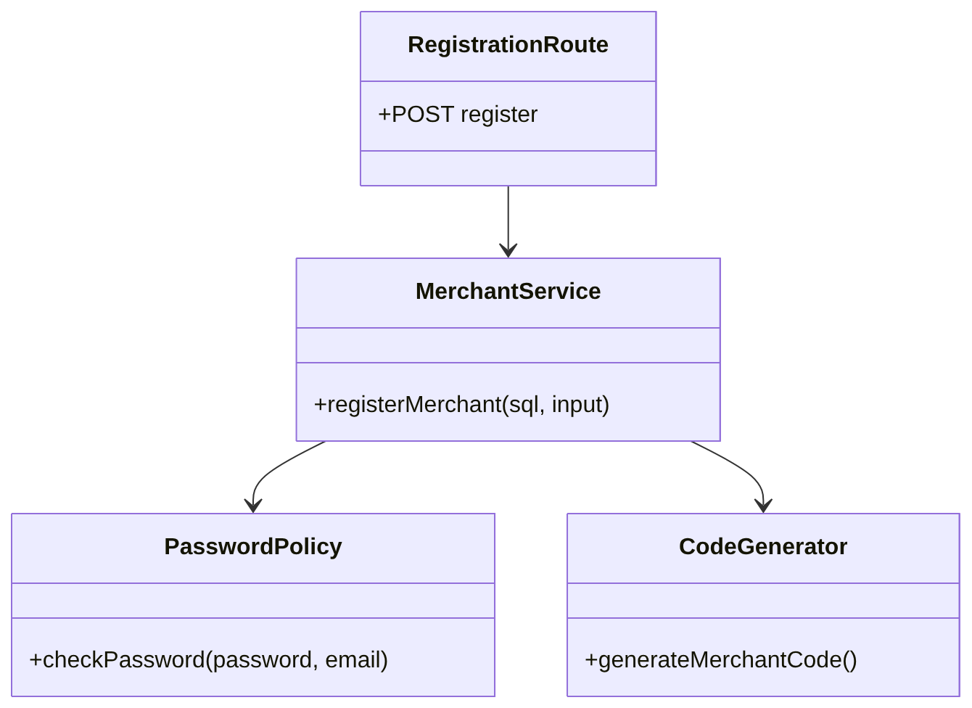
3.1.1 Register Merchant Class diagram

3.1.2 Sequence Diagram
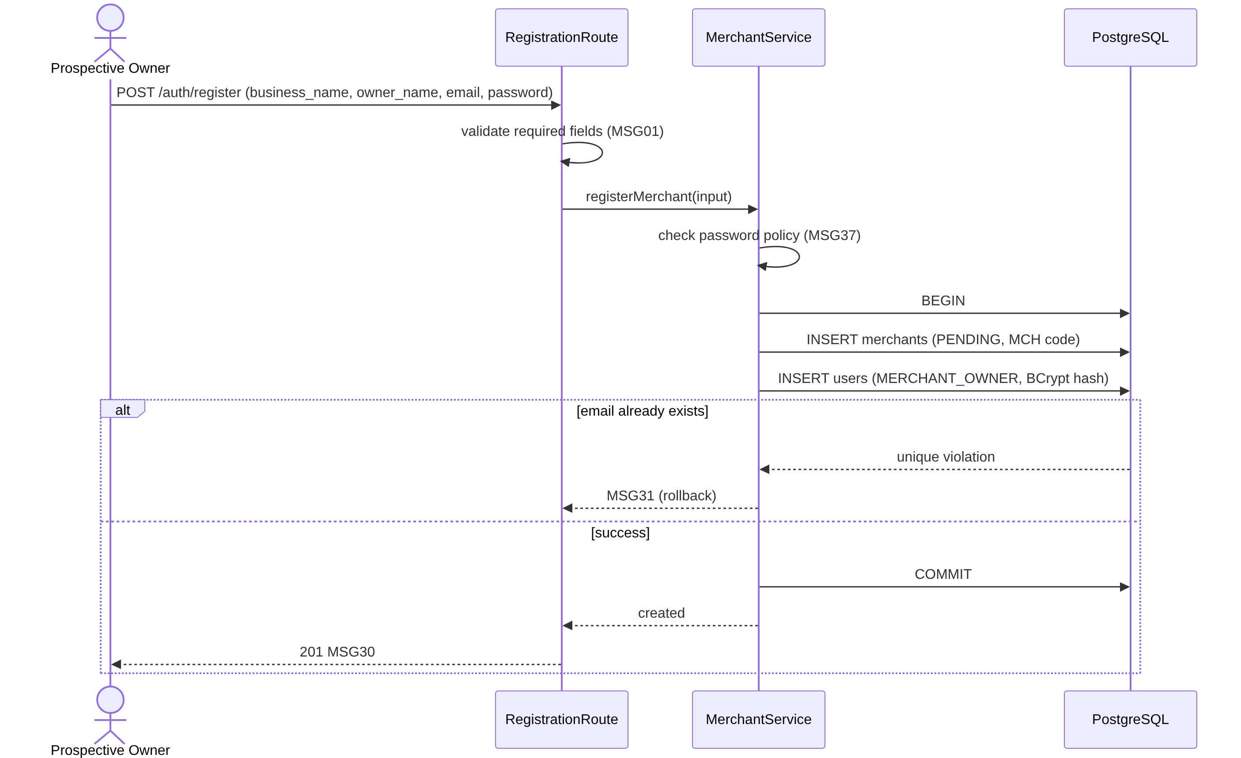
3.1.2 Register Merchant Sequence diagram

3.1.3 Class Specification
No | Class | Attributes / Methods | Description
1 | RegistrationRoute | register | Route POST /api/v1/auth/register. Public. Reads the body with zod and returns MSG30.
2 | MerchantService | registerMerchant(sql, input) | Creates the merchant (PENDING) and its Owner in one transaction. Maps a duplicate email to MSG31.
3 | PasswordPolicy | checkPassword | Applies CR-08: 8 to 64 characters, at least one letter and one digit, different from the email.
4 | CodeGenerator | generateMerchantCode | Returns MCH- and 6 random characters from A-Z0-9. A duplicate code is generated again.
5 | Merchant, User | id, code, name, status; email, passwordHash, fullName, role | Rows created by the service.

3.2 Log in / Log out (UC-01)

3.2.1 Class Diagram
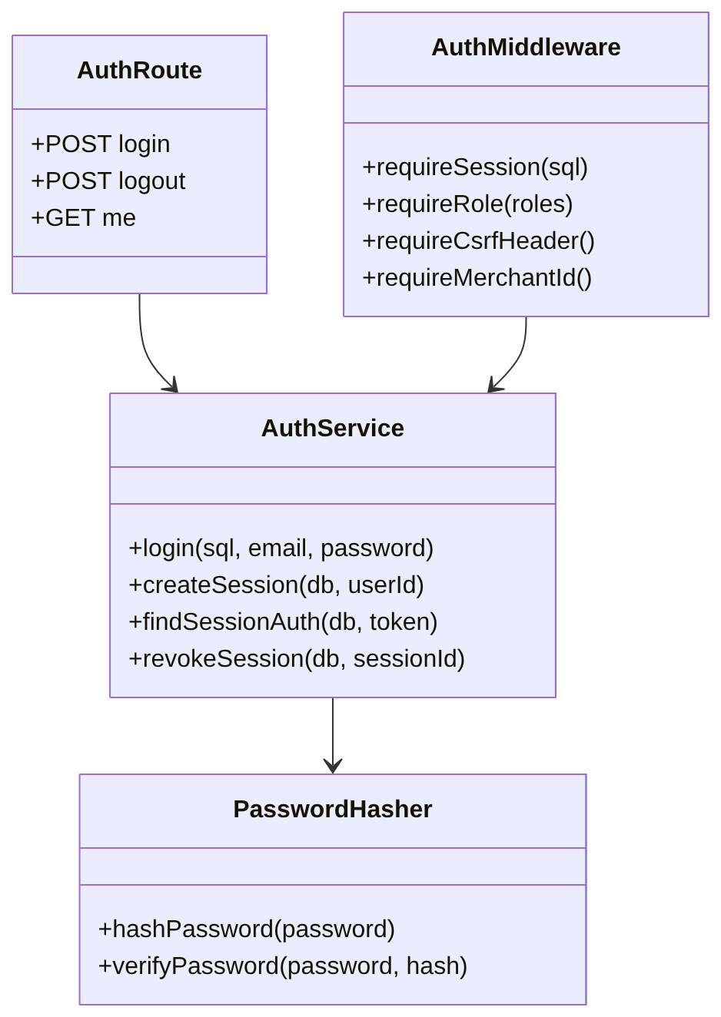
3.2.1 Log in Class diagram

3.2.2 Sequence Diagram
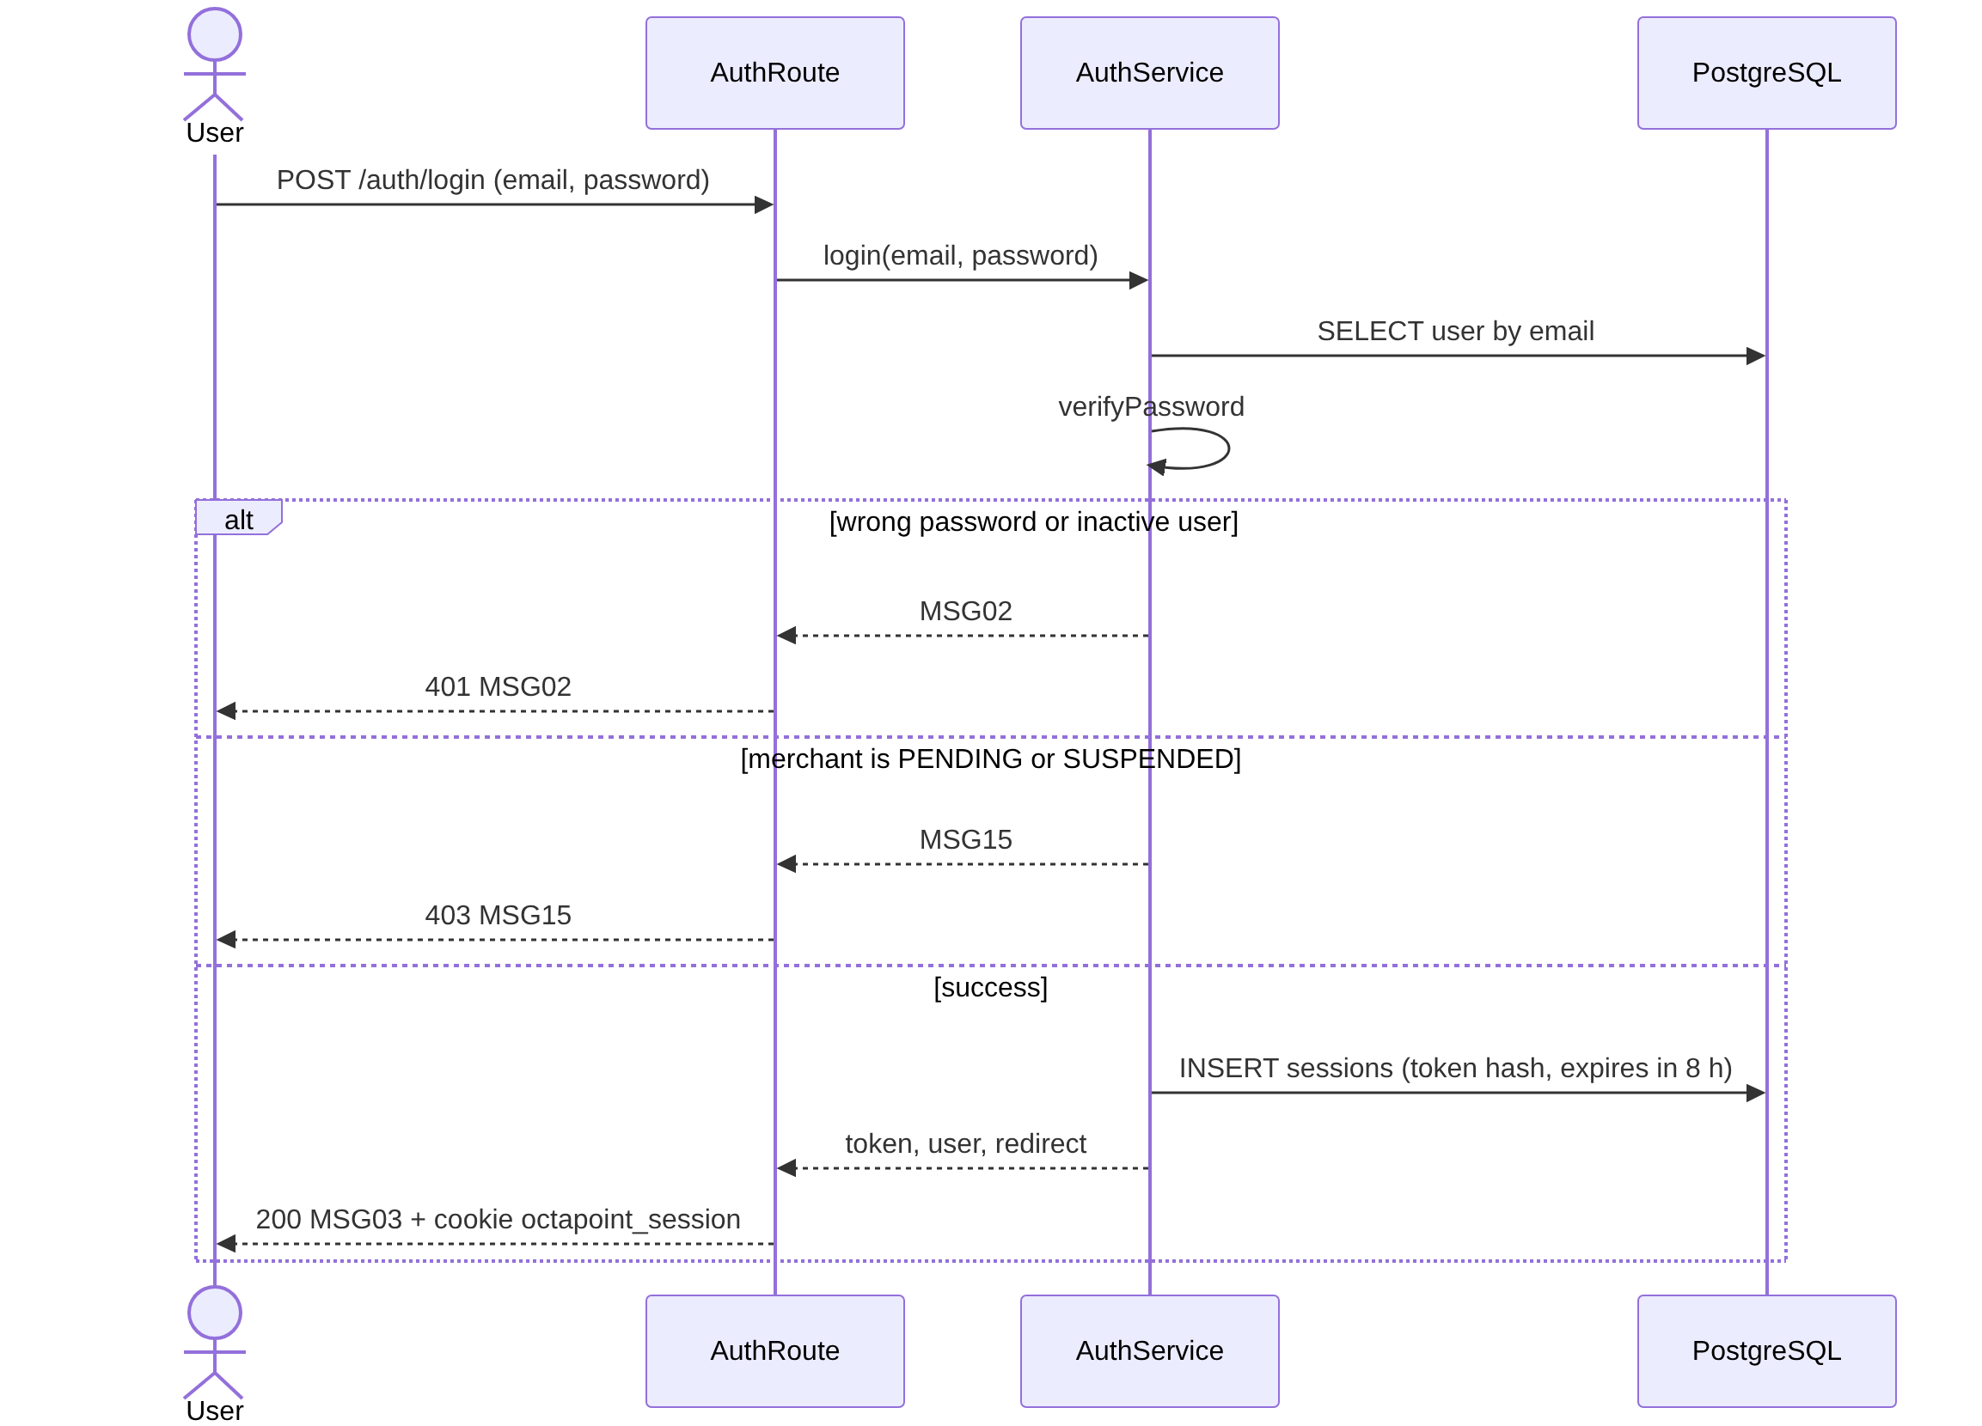
3.2.2 Log in Sequence diagram

3.2.3 Class Specification
No | Class | Attributes / Methods | Description
1 | AuthRoute | login, logout, me | Routes under /api/v1/auth. Sets or clears the cookie octapoint_session (HttpOnly, Secure, SameSite=Lax).
2 | AuthService | login, createSession, findSessionAuth, revokeSession, getMe | login checks the email and the password first, then the merchant status, so the reason of a failed login is not revealed. The session token is random and only its SHA-256 hash is stored.
3 | AuthMiddleware | requireSession, requireRole, requireCsrfHeader, requireMerchantId | On every request: session not revoked and not expired, user active, merchant ACTIVE (MSG35). Then the role (MSG04). Changing requests also need X-Requested-With: octapoint-portal.
4 | PasswordHasher | hashPassword, verifyPassword | SHA-256 pre-hash and then BCrypt cost 12. The pre-hash avoids the 72-byte limit of BCrypt.
5 | Session | id, tokenHash, userId, expiresAt, revokedAt | Row in sessions. Logout sets revokedAt.

3.3 Manage Account Profile (UC-02)

3.3.1 Class Diagram
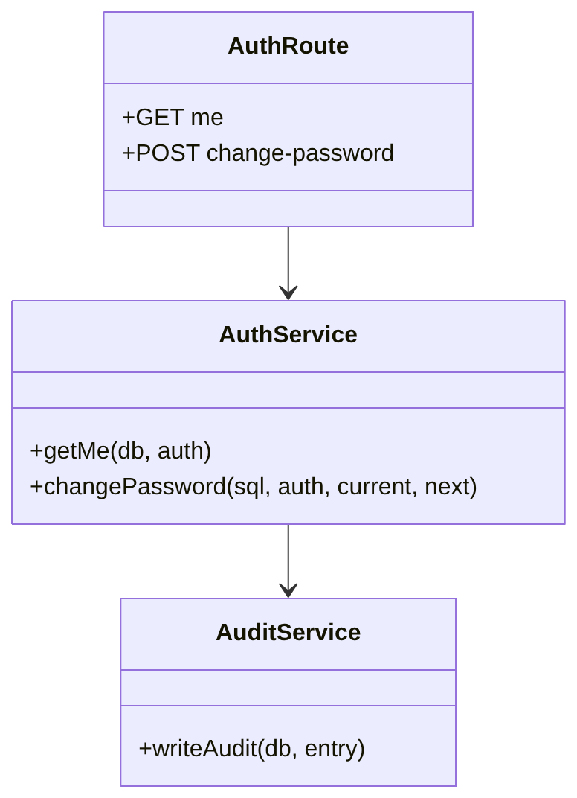
3.3.1 Manage Account Profile Class diagram

3.3.2 Sequence Diagram
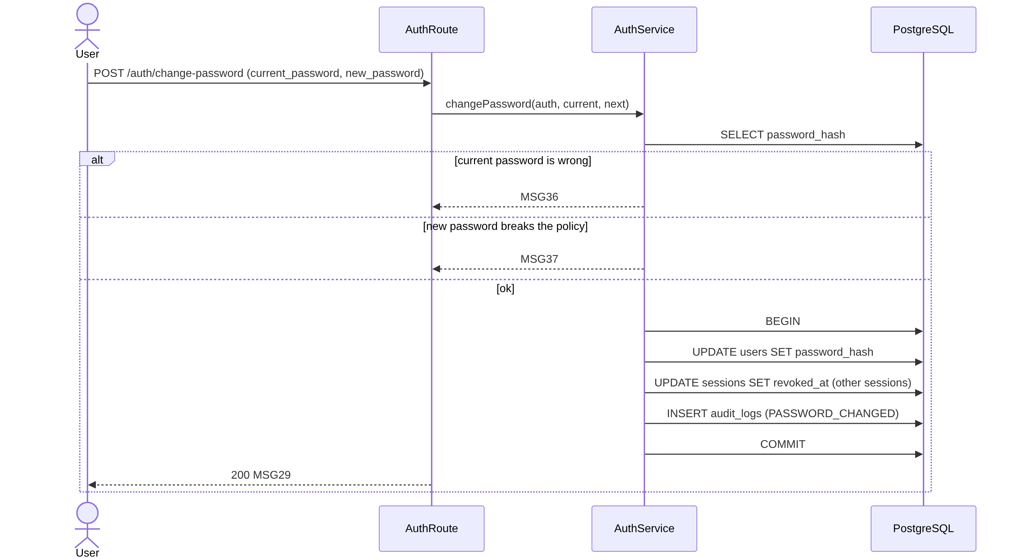
3.3.2 Manage Account Profile Sequence diagram

3.3.3 Class Specification
No | Class | Attributes / Methods | Description
1 | AuthRoute | me, change-password | Shows full name, email, role and merchant; changes the password.
2 | AuthService | getMe, changePassword | Checks the current password (MSG36) and the policy of CR-08 (MSG37), stores the new hash, and revokes the user's other sessions.
3 | AuditService | writeAudit | Writes PASSWORD_CHANGED in the same transaction. The reset script writes the same action with details = {"by":"script"}.

3.4 Approve / Suspend Merchants (UC-04)

3.4.1 Class Diagram
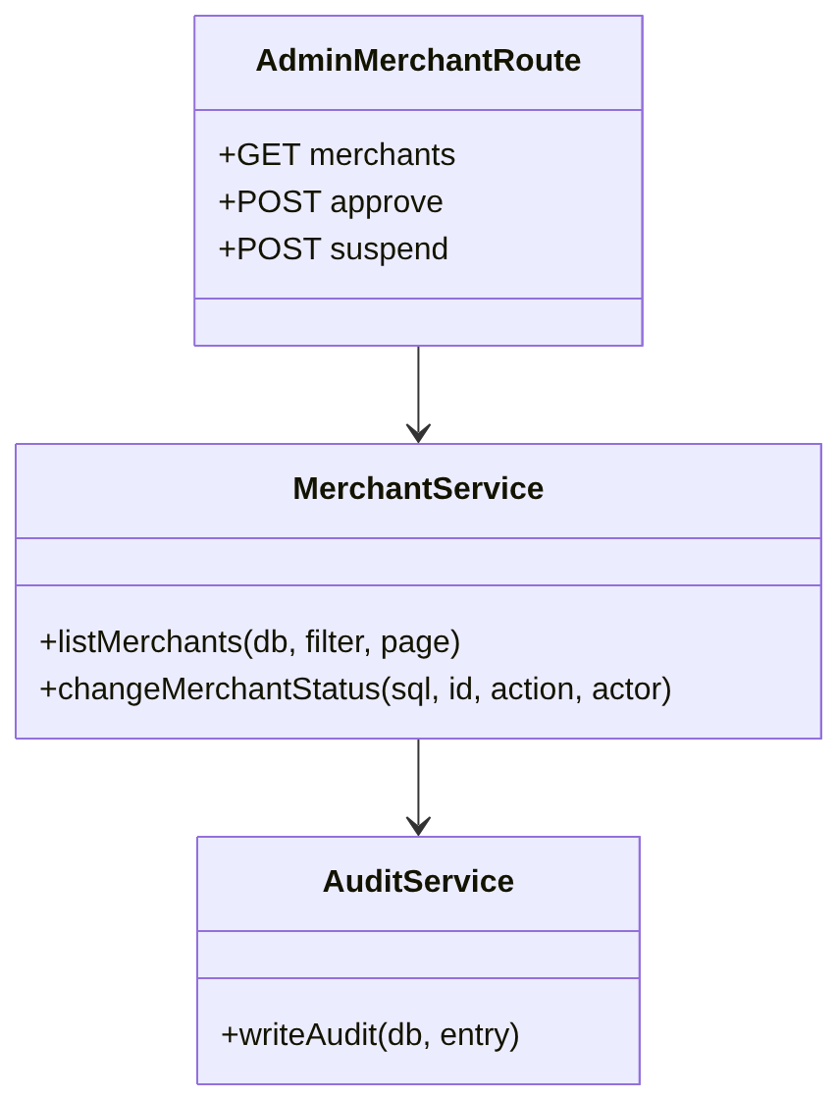
3.4.1 Approve / Suspend Merchants Class diagram

3.4.2 Sequence Diagram
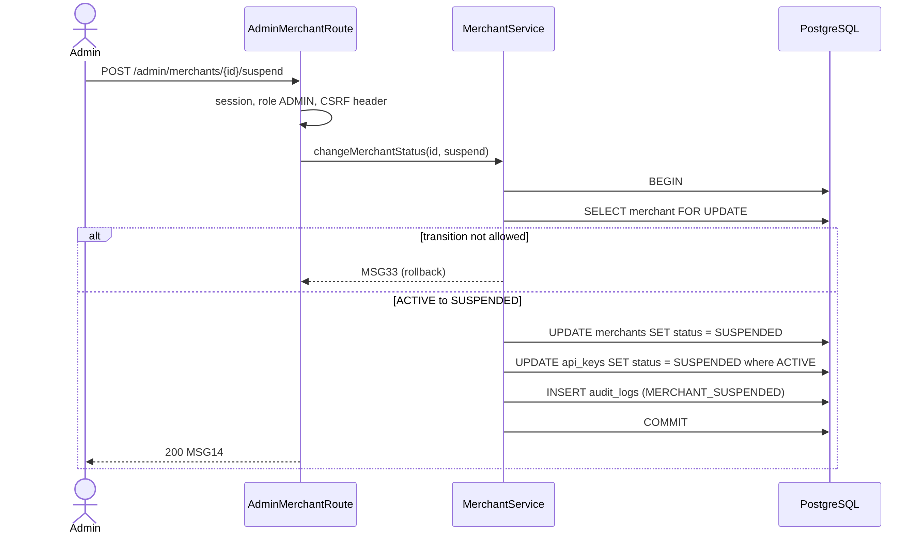
3.4.2 Approve / Suspend Merchants Sequence diagram

3.4.3 Class Specification
No | Class | Attributes / Methods | Description
1 | AdminMerchantRoute | list, approve, suspend | Admin only. The list shows code, name, owner email, status and creation date.
2 | MerchantService | listMerchants, changeMerchantStatus | Allowed changes: PENDING to ACTIVE, SUSPENDED to ACTIVE (approve), ACTIVE to SUSPENDED (suspend). Approve turns this merchant's SUSPENDED keys back to ACTIVE and never touches REVOKED keys. Suspend turns its ACTIVE keys to SUSPENDED.
3 | AuditService | writeAudit | MERCHANT_APPROVED or MERCHANT_SUSPENDED.
Sessions of the merchant's users end on their next request, because the merchant is no longer ACTIVE (MSG35).

3.5 Manage Staff Accounts (UC-08)

3.5.1 Class Diagram
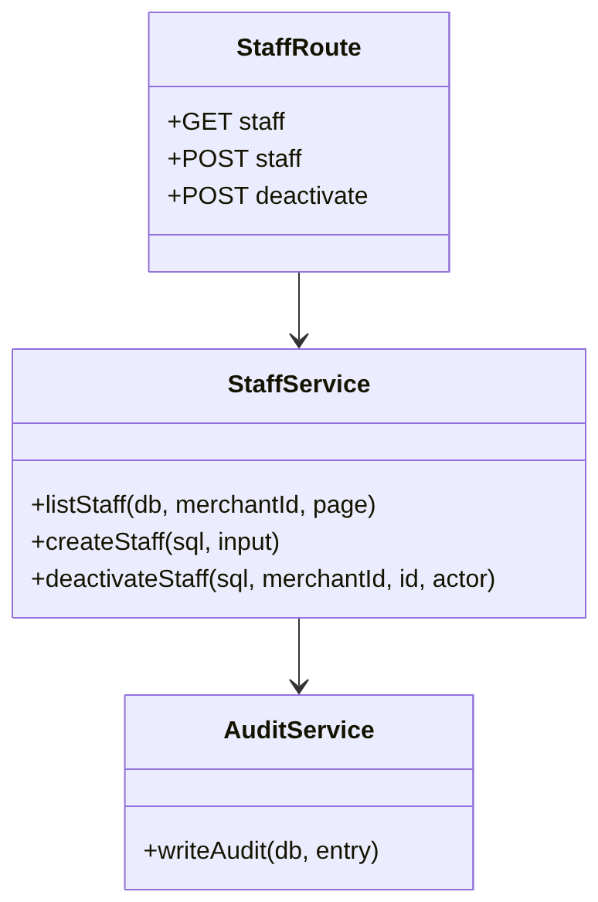
3.5.1 Manage Staff Accounts Class diagram

3.5.2 Sequence Diagram
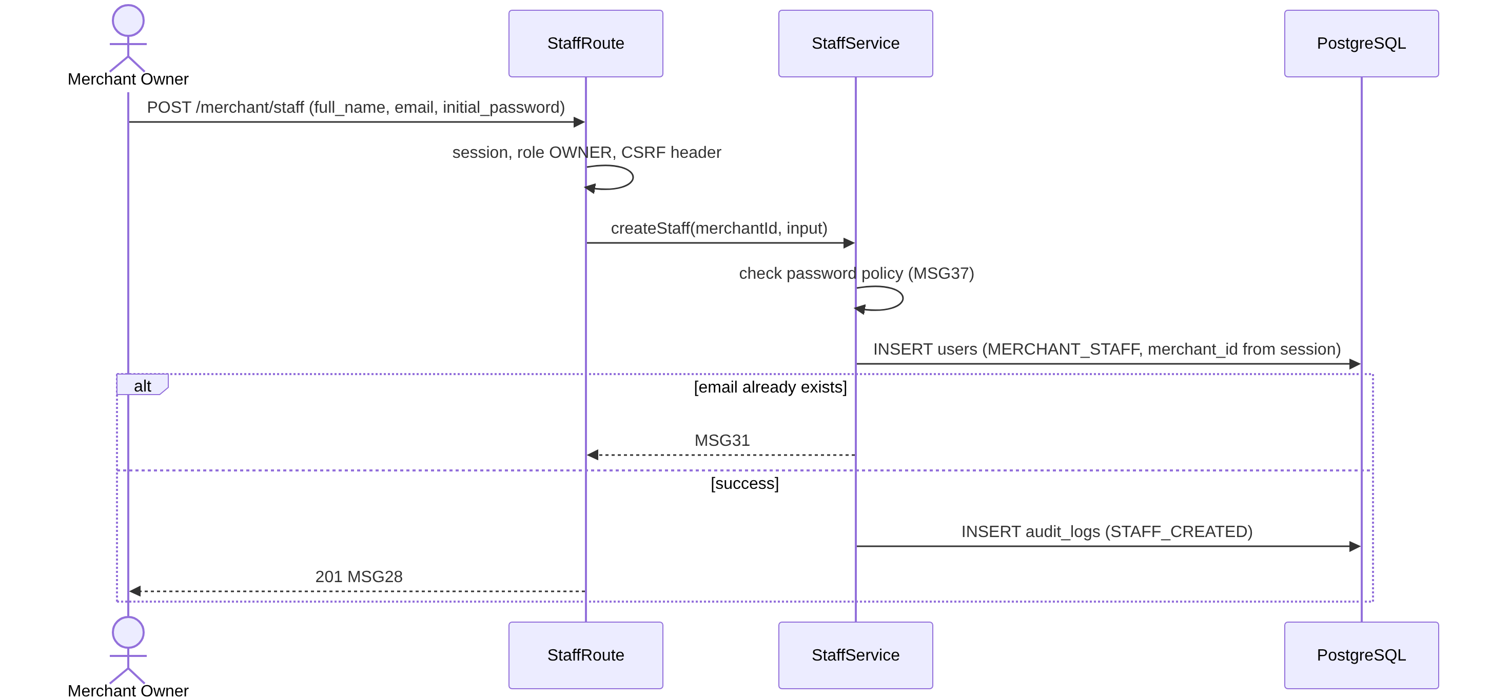
3.5.2 Manage Staff Accounts Sequence diagram

3.5.3 Class Specification
No | Class | Attributes / Methods | Description
1 | StaffRoute | list, create, deactivate | Owner only. merchant_id always comes from the session.
2 | StaffService | listStaff, createStaff, deactivateStaff | Creates a MERCHANT_STAFF user. Deactivation sets is_active = false and revokes that user's sessions. Staff cannot be deleted or reactivated.
3 | AuditService | writeAudit | STAFF_CREATED, STAFF_DEACTIVATED.

3.6 Configure Loyalty Rules (UC-06)

3.6.1 Class Diagram
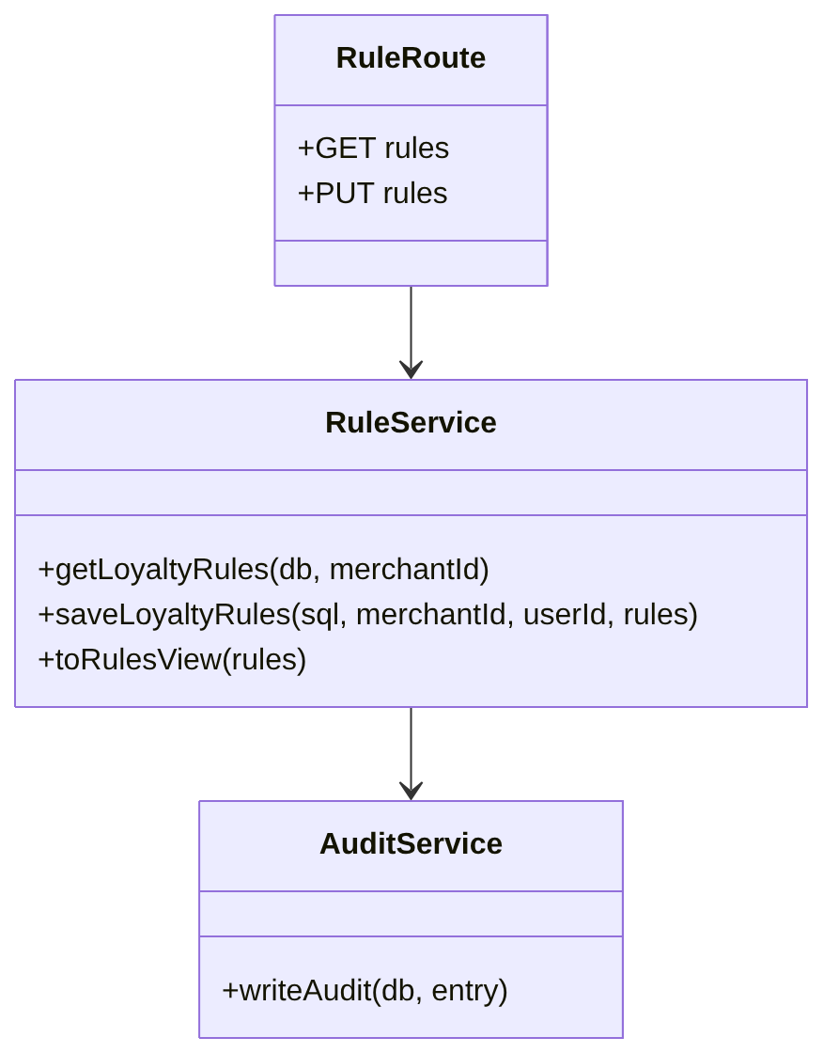
3.6.1 Configure Loyalty Rules Class diagram

3.6.2 Sequence Diagram
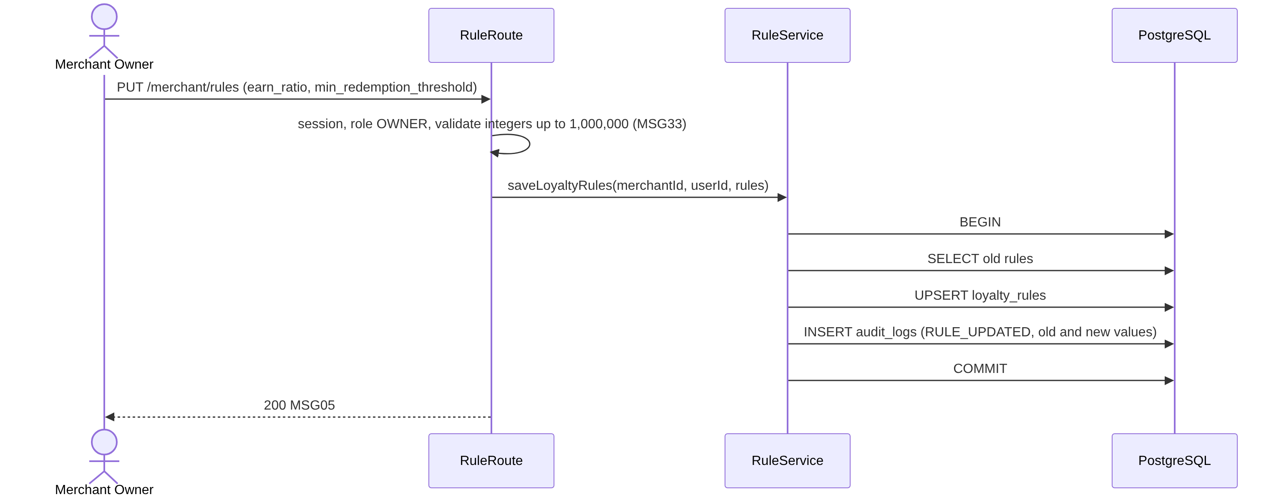
3.6.2 Configure Loyalty Rules Sequence diagram

3.6.3 Class Specification
No | Class | Attributes / Methods | Description
1 | RuleRoute | get, put | Owner only. GET returns {} when the rules are not set.
2 | RuleService | getLoyaltyRules, saveLoyaltyRules, toRulesView | Both values are positive integers up to RULE_MAX (1,000,000). A change applies to later transactions only (BR-22).
3 | LoyaltyRules | earnRatio, minRedemptionThreshold | Rule values of one merchant. earnRatio means VND per point.

3.7 Manage Customers (UC-09)

3.7.1 Class Diagram
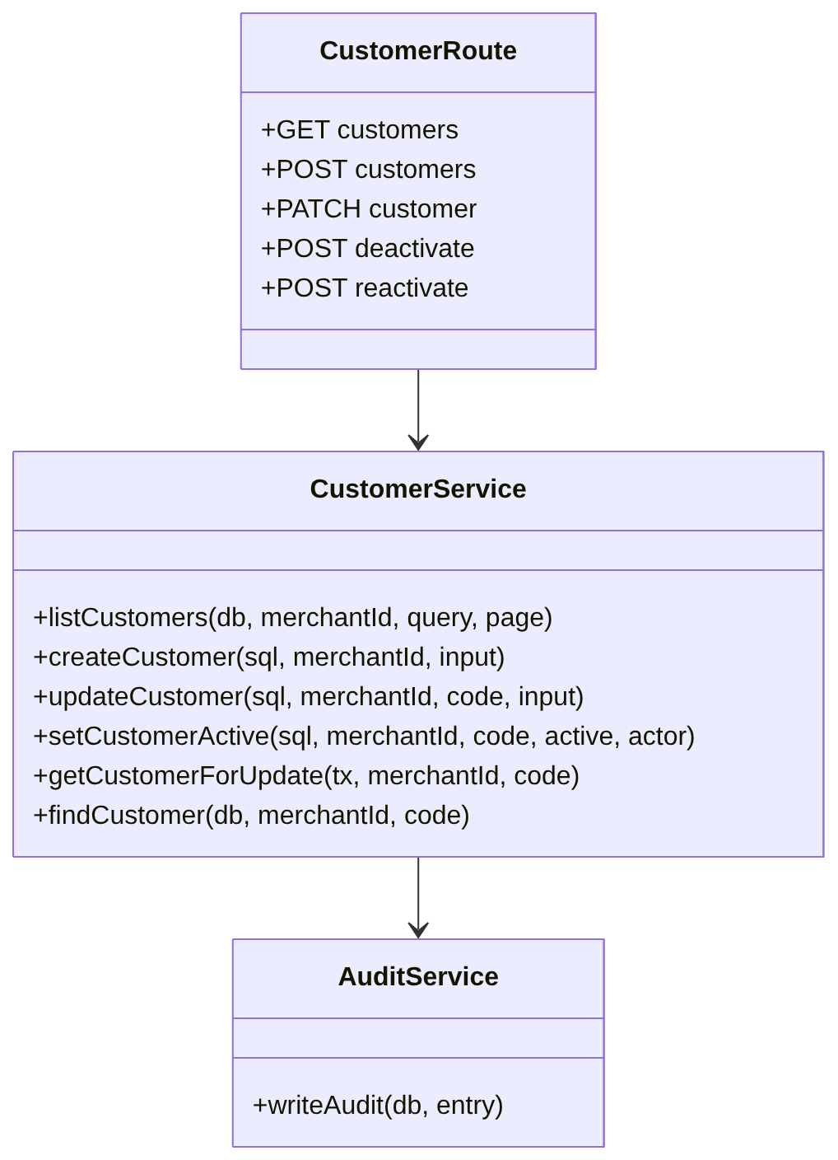
3.7.1 Manage Customers Class diagram

3.7.2 Sequence Diagram
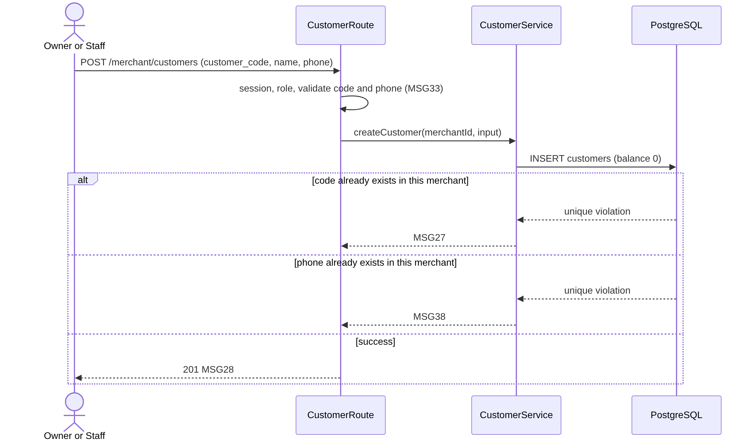
3.7.2 Manage Customers Sequence diagram

3.7.3 Class Specification
No | Class | Attributes / Methods | Description
1 | CustomerRoute | list, create, update, deactivate, reactivate | Staff can list, create and update. Deactivate and reactivate are Owner only.
2 | CustomerService | listCustomers, createCustomer, updateCustomer, setCustomerActive | The code cannot be changed, and a customer cannot be deleted or merged (LI-15). Deactivating keeps the history and the balance, and the code stays reserved.
3 | CustomerService (shared) | getCustomerForUpdate, findCustomer | getCustomerForUpdate runs SELECT ... FOR UPDATE filtered by merchant_id; it is used by points and reversal. findCustomer reads without a lock.
4 | Customer | id, merchantId, customerCode, name, phone, balance, isActive | Row of customers. Code format ^[A-Z0-9]{1,32}$, phone 10 digits starting with 0.

3.8 Issue Points (UC-10)

3.8.1 Class Diagram
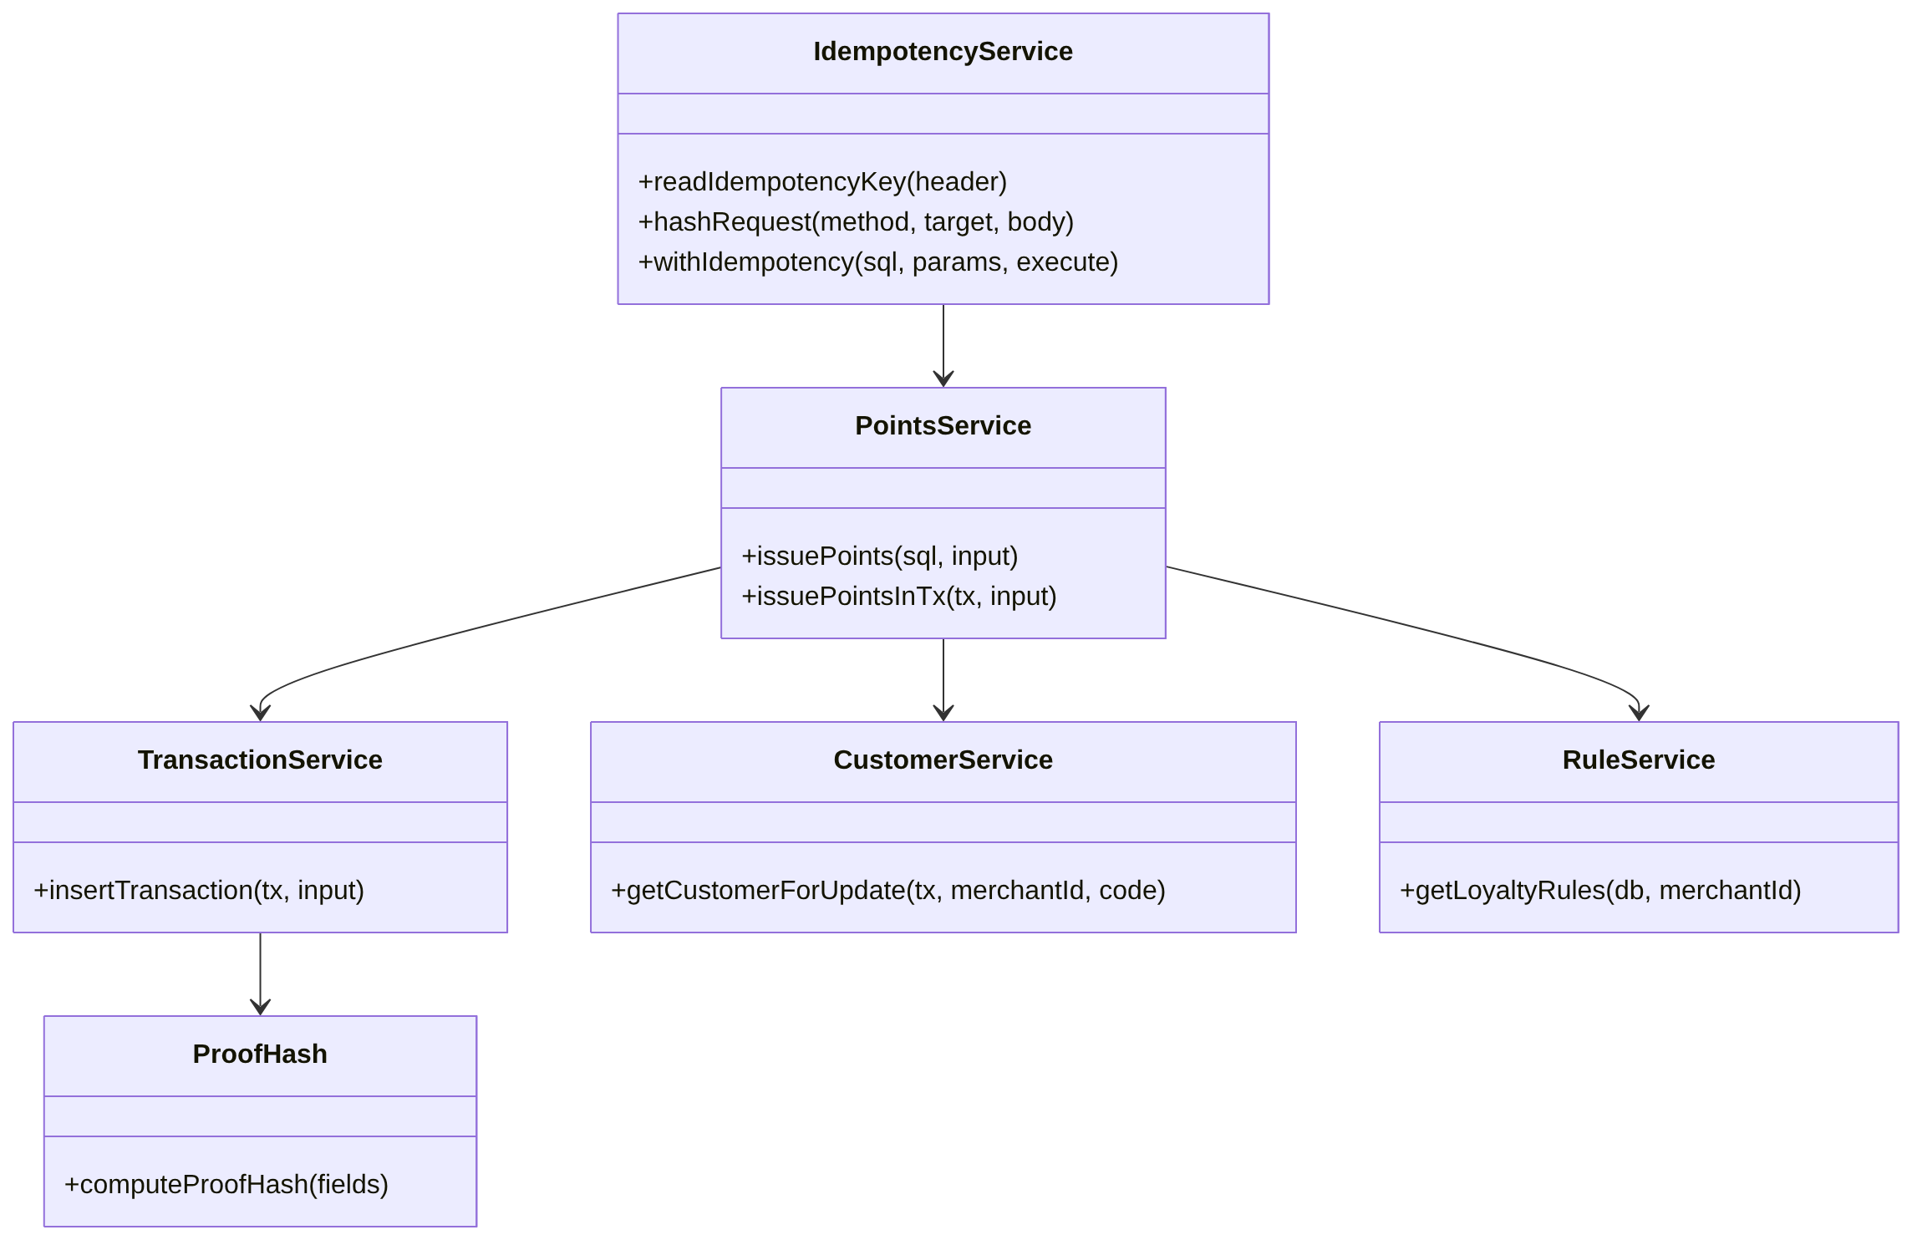
3.8.1 Issue Points Class diagram

3.8.2 Sequence Diagram
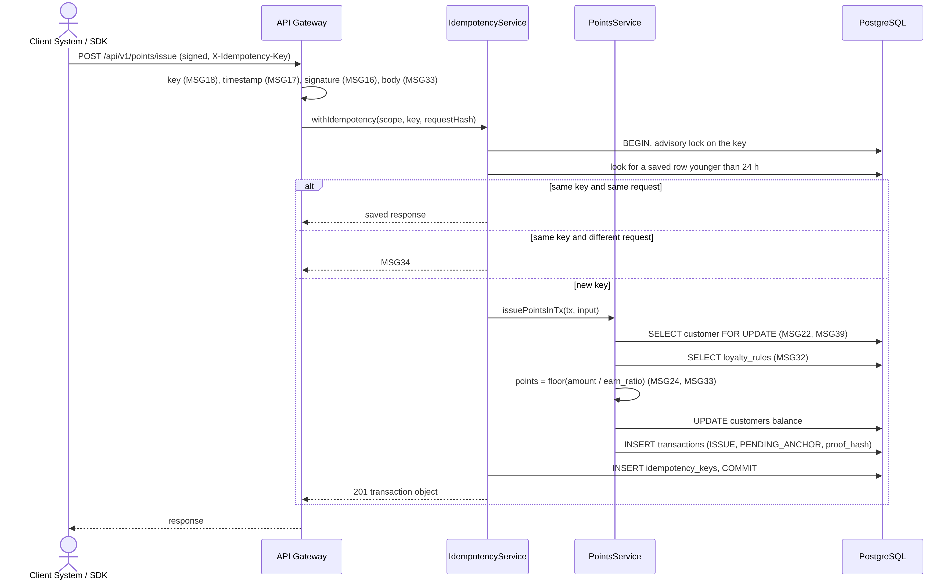
3.8.2 Issue Points Sequence diagram

3.8.3 Class Specification
No | Class | Attributes / Methods | Description
1 | PointsService | issuePoints, issuePointsInTx | issuePointsInTx works inside an open transaction. The order is fixed: lock the customer first, then read the rules, then check, then update (BR-06). Points are floor(amount / earn_ratio); 0 gives MSG24; more than 1,000,000 points or a balance above 1,000,000,000 gives MSG33.
2 | IdempotencyService | readIdempotencyKey, hashRequest, withIdempotency | The key has 1 to 128 characters (MSG33 if missing). The request hash is sha256(method.target.sha256(body)). A key is kept 24 hours. From the portal the scope is the logged-in user, from the API it is the API key.
3 | TransactionService | insertTransaction | Generates the TXN code (generates again on a duplicate), takes created_at once, calculates the proof hash and inserts the row as PENDING_ANCHOR.
4 | ProofHash | computeProofHash | Canonical JSON and SHA-256 as in section 2.3.
5 | CustomerService, RuleService | getCustomerForUpdate, getLoyaltyRules | Implemented. Used inside the same transaction.
6 | IssueInput | merchantId, customerCode, amount, actor | actor is USER (portal) or API_KEY (external call).
The Portal calls the same service through POST /merchant/customers/{code}/issue; the session replaces the gateway checks.

3.9 Redeem Points (UC-11)

3.9.1 Class Diagram
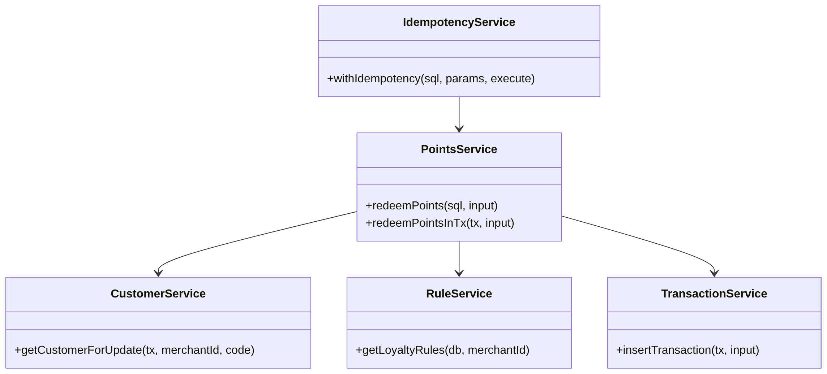
3.9.1 Redeem Points Class diagram

3.9.2 Sequence Diagram
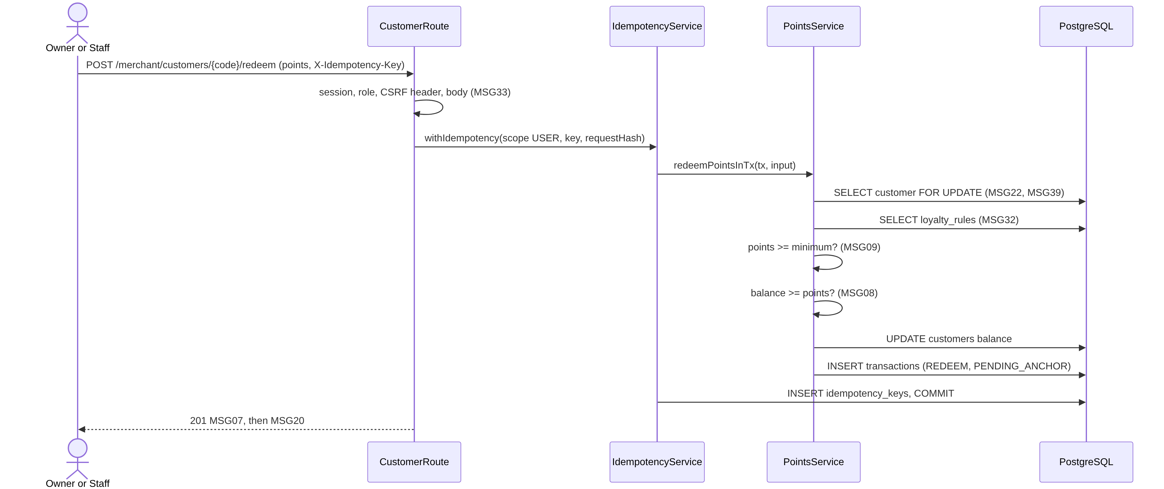
3.9.2 Redeem Points Sequence diagram

3.9.3 Class Specification
No | Class | Attributes / Methods | Description
1 | PointsService | redeemPoints, redeemPointsInTx | After the customer row is locked: first points >= min_redemption_threshold (MSG09), then balance >= points (MSG08). The balance never goes below 0 (BR-05).
2 | IdempotencyService | withIdempotency | Same as 3.8. Two identical requests at the same time create one transaction.
3 | RedeemInput | merchantId, customerCode, points, actor | Points are between 1 and 1,000,000.

3.10 Check Customer Balance (UC-12)

3.10.1 Class Diagram
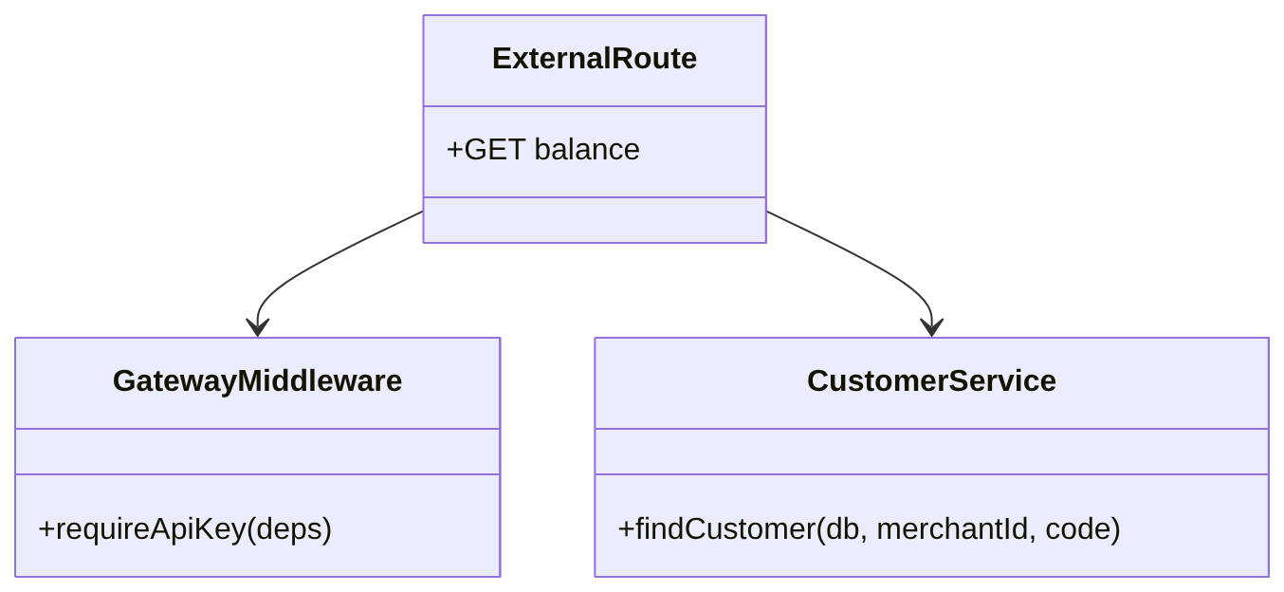
3.10.1 Check Customer Balance Class diagram

3.10.2 Sequence Diagram
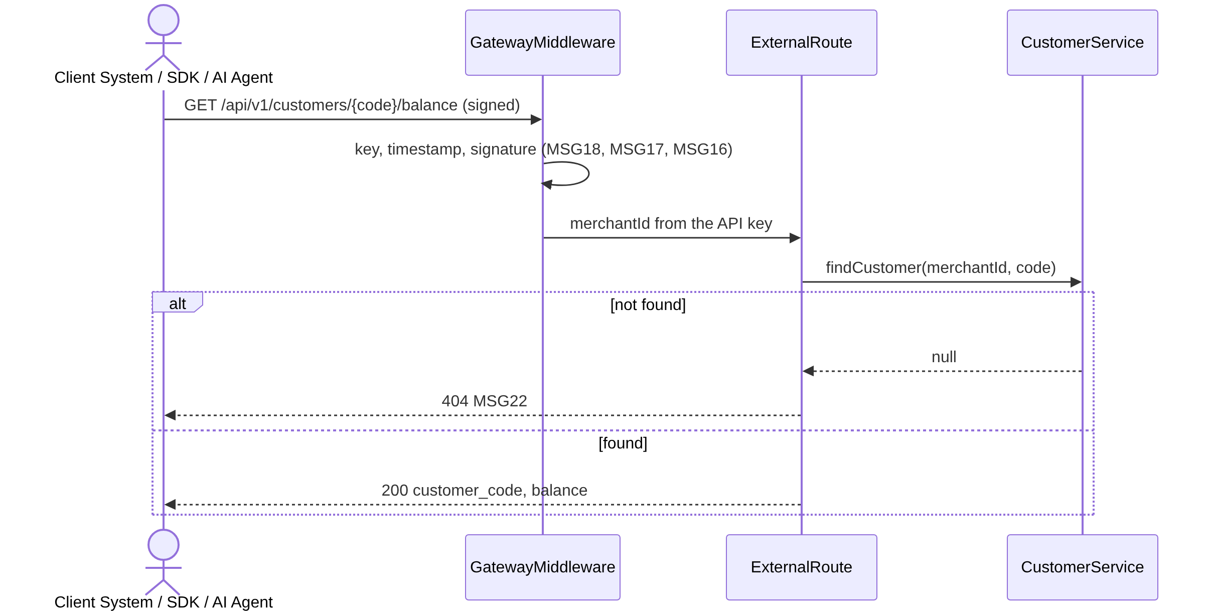
3.10.2 Check Customer Balance Sequence diagram

3.10.3 Class Specification
No | Class | Attributes / Methods | Description
1 | ExternalRoute | balance | Returns the balance without a lock. An inactive customer still returns the balance.
2 | GatewayMiddleware | requireApiKey | See 3.12.
3 | CustomerService | findCustomer | Implemented. Always filters by merchant_id.
Owner and Staff see the balance in the Customers screen (GET /merchant/customers).

3.11 Manage API Credentials (UC-07)

3.11.1 Class Diagram
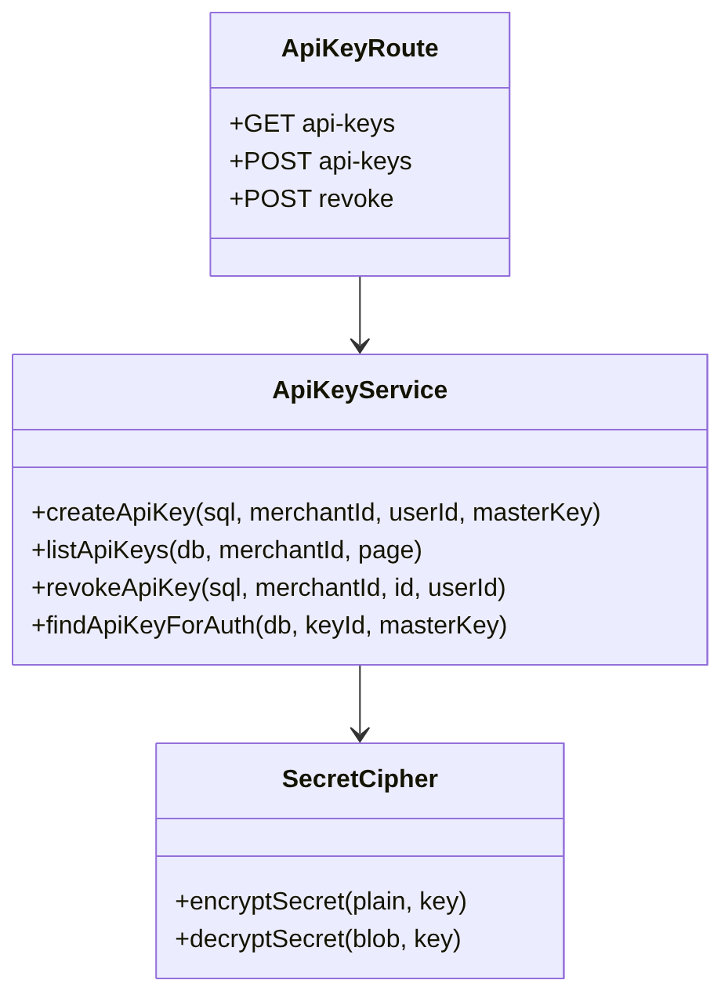
3.11.1 Manage API Credentials Class diagram

3.11.2 Sequence Diagram
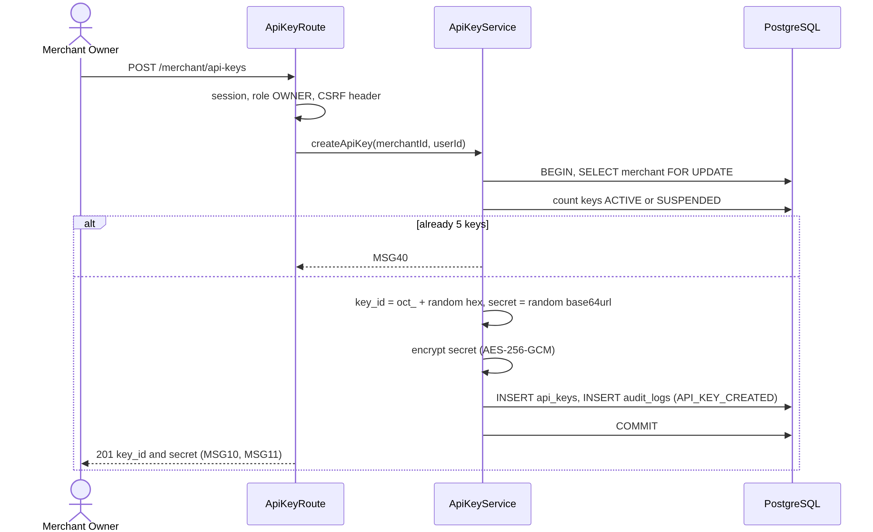
3.11.2 Manage API Credentials Sequence diagram

3.11.3 Class Specification
No | Class | Attributes / Methods | Description
1 | ApiKeyRoute | list, create, revoke | Owner only. The list shows a masked key ID (first 8 and last 4 characters), status and date.
2 | ApiKeyService | createApiKey, listApiKeys, revokeApiKey, findApiKeyForAuth | A merchant can hold at most 5 keys that are ACTIVE or SUSPENDED (MSG40); the merchant row is locked before counting. Revoking is permanent. findApiKeyForAuth returns the decrypted secret to the gateway only.
3 | SecretCipher | encryptSecret, decryptSecret | AES-256-GCM with a random 12-byte nonce. The stored value is nonce, ciphertext and tag. The master key is SECRET_ENCRYPTION_KEY (CR-07).
4 | ApiKey | id, merchantId, keyId, secretEncrypted, status, createdBy, revokedAt | Row of api_keys.
The secret is shown once in the response of POST /merchant/api-keys and is never returned again.

3.12 Verify API Request (UC-15)

3.12.1 Class Diagram
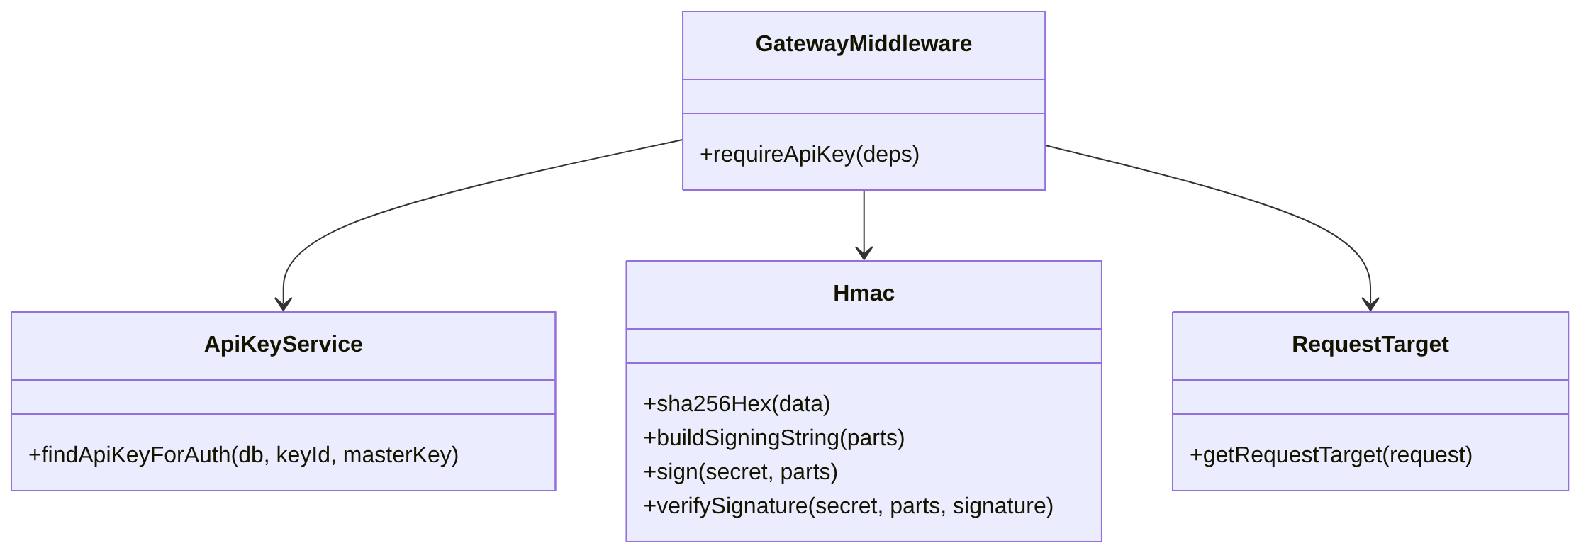
3.12.1 Verify API Request Class diagram

3.12.2 Sequence Diagram
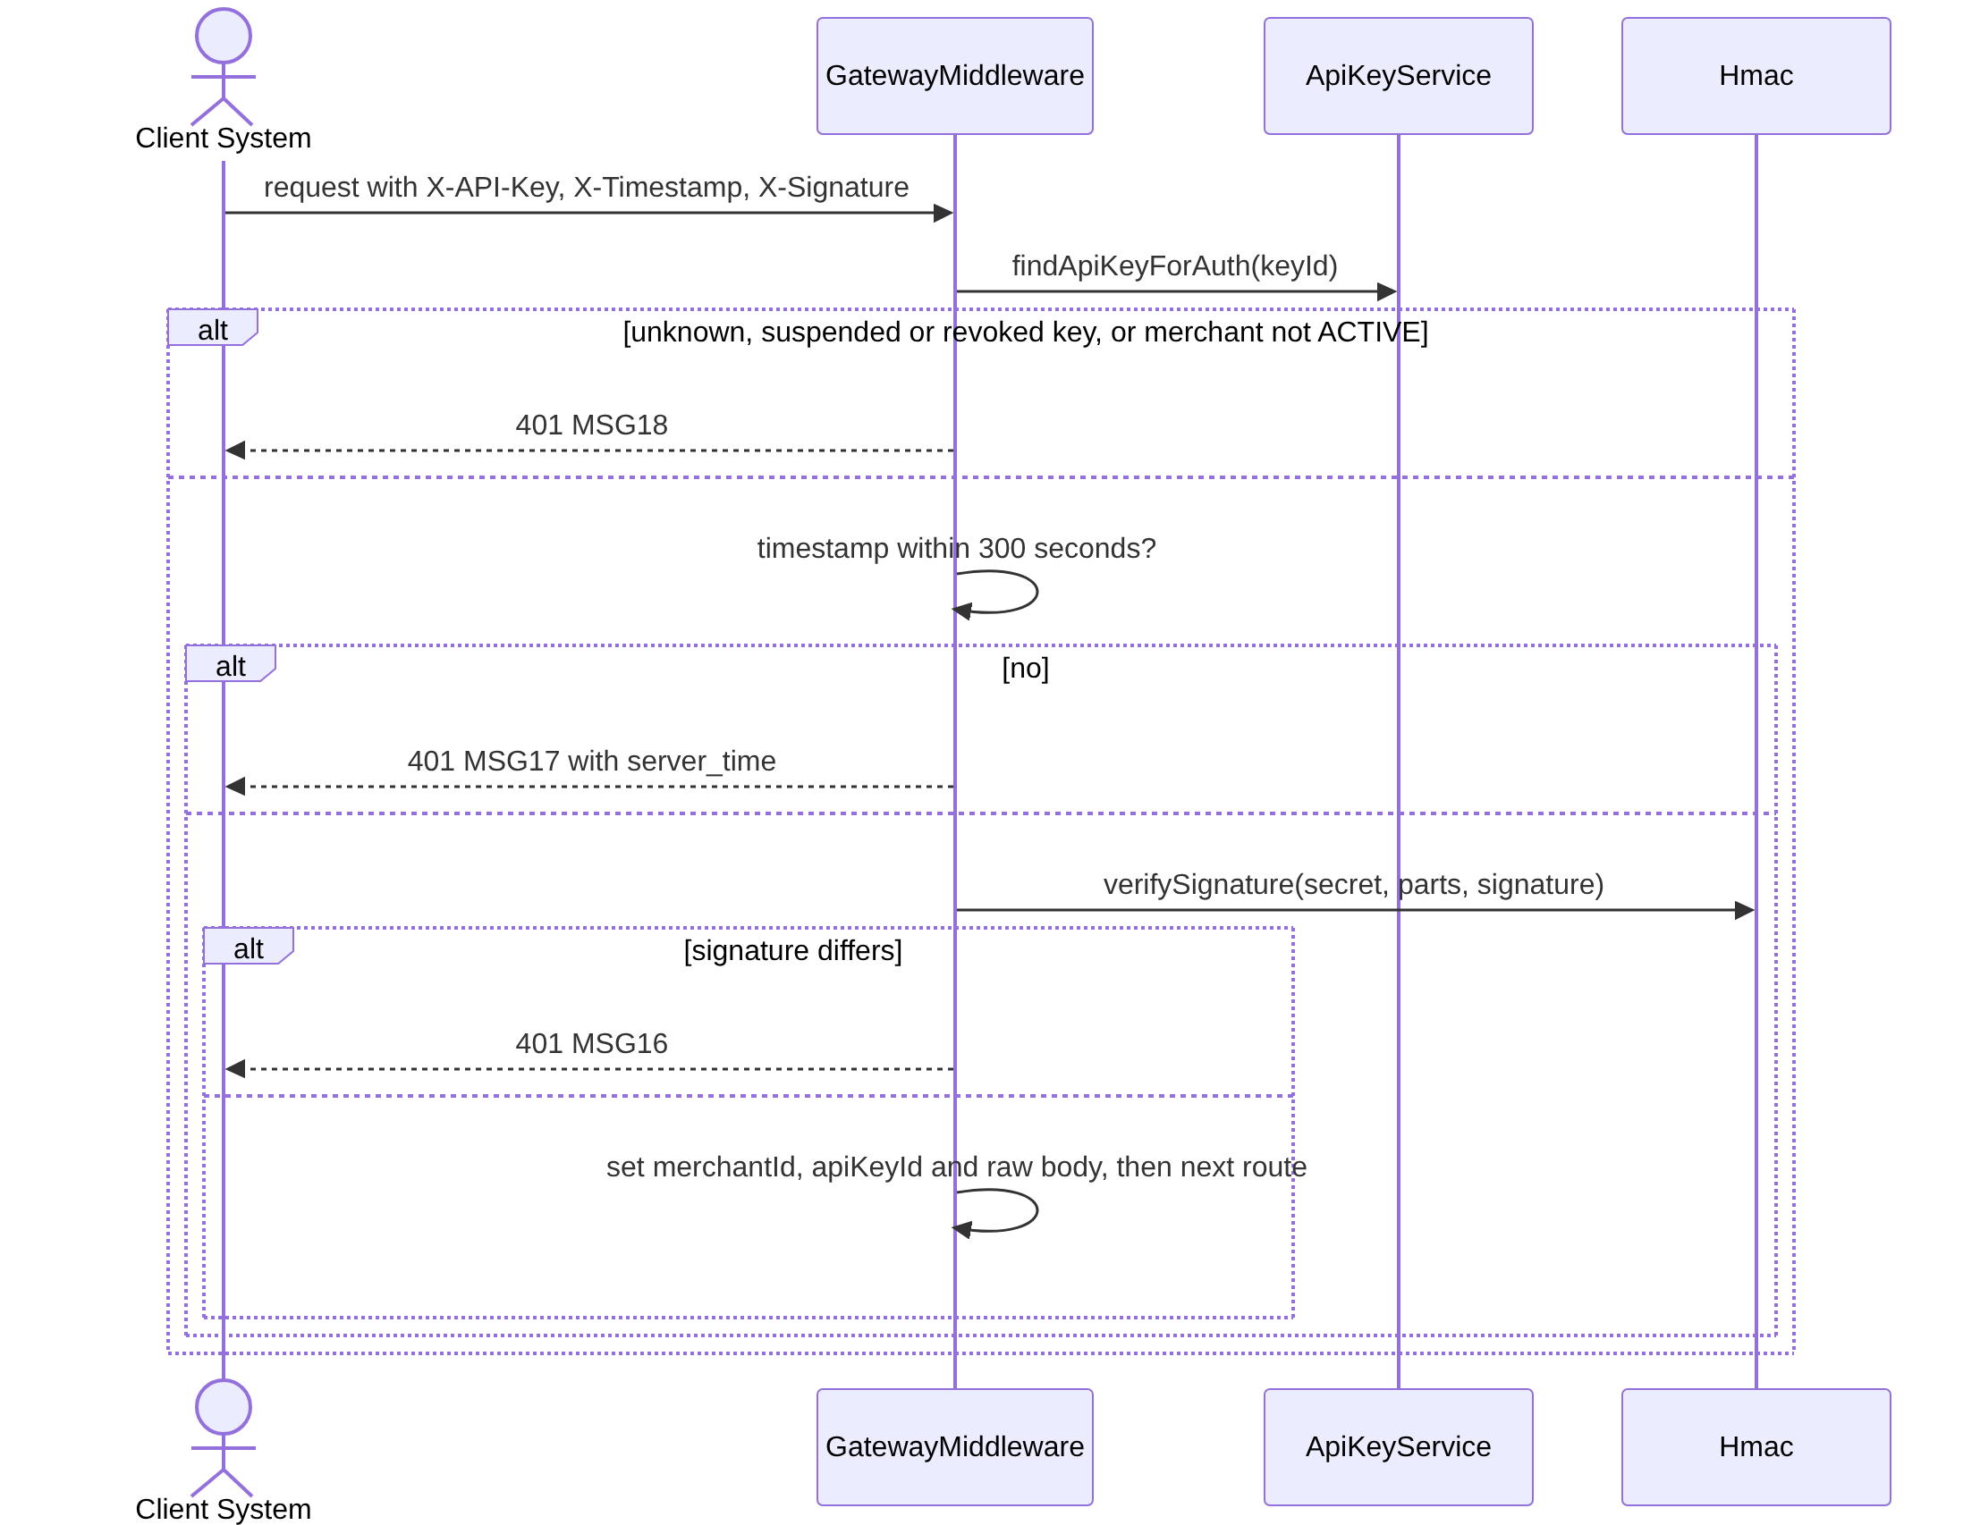
3.12.2 Verify API Request Sequence diagram

3.12.3 Class Specification
No | Class | Attributes / Methods | Description
1 | GatewayMiddleware | requireApiKey | Checks in this order: key and merchant (MSG18), timestamp (MSG17), signature (MSG16). Body validation (MSG33) and idempotency come after. It reads the raw body bytes before JSON parsing. The merchant is taken only from the key (BR-01).
2 | Hmac | sha256Hex, buildSigningString, sign, verifySignature | Signing string: timestamp.METHOD.path_with_query.sha256(body).idempotency_key. HMAC-SHA256, lowercase hex, compared with timingSafeEqual. Implemented and tested with the vectors of docs/api-spec.md A.2.
3 | RequestTarget | getRequestTarget | Returns the request target exactly as sent, including /api/v1 and the query string.
4 | ApiKeyService | findApiKeyForAuth | Implemented (see 3.11).

3.13 Query Credit via MCP (UC-17)

3.13.1 Class Diagram
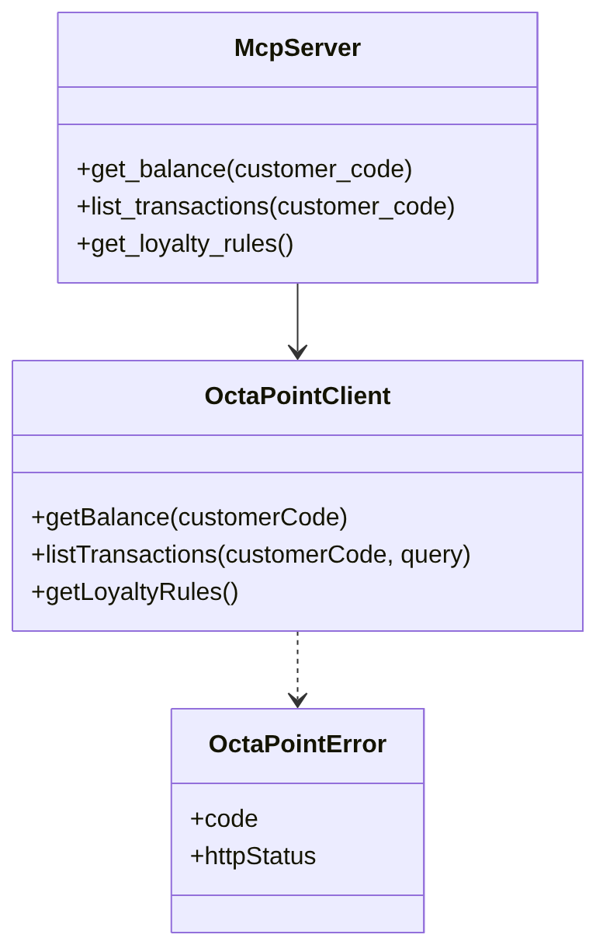
3.13.1 Query Credit via MCP Class diagram

3.13.2 Sequence Diagram
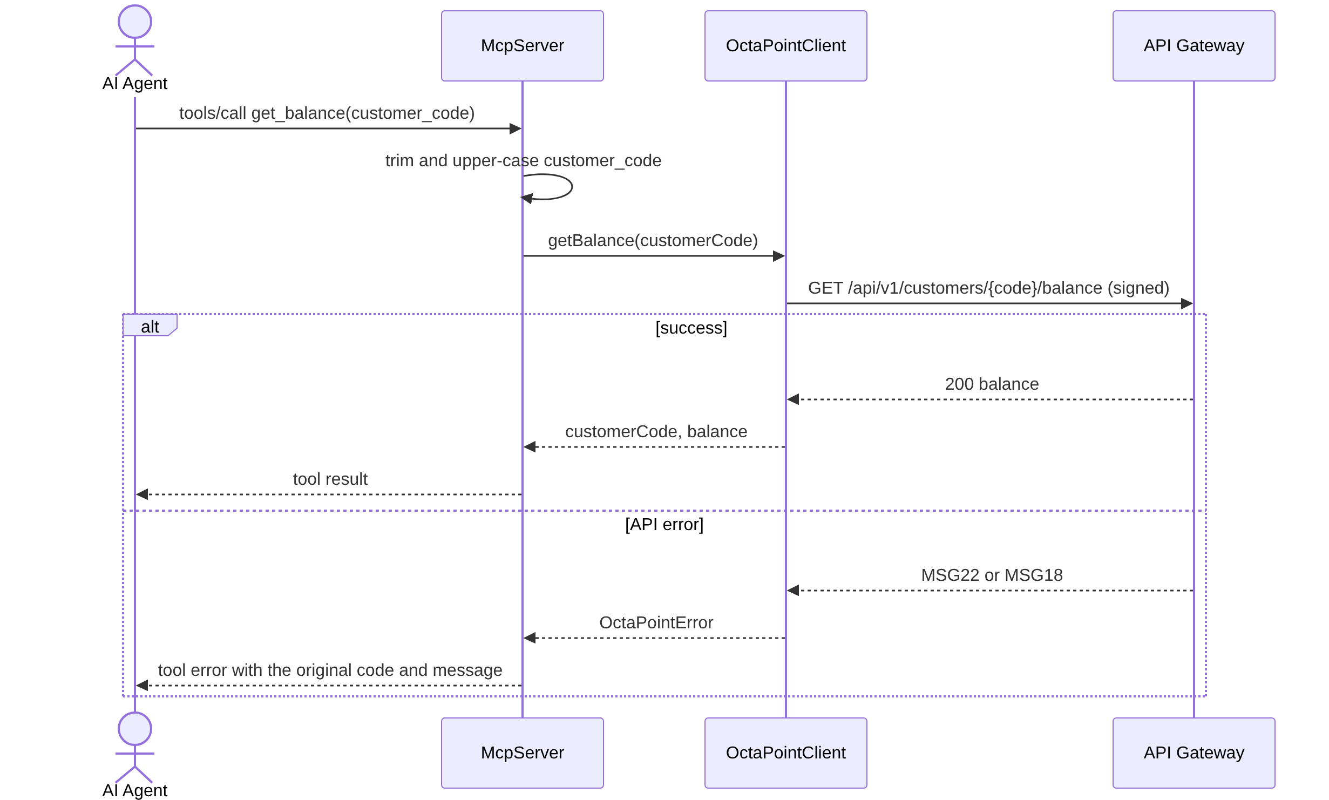
3.13.2 Query Credit via MCP Sequence diagram

3.13.3 Class Specification
No | Class | Attributes / Methods | Description
1 | McpServer (packages/mcp/src/server.ts) | createServer, registerTools | Runs over stdio for one merchant. Only the three tools of TOOL_NAMES are registered, and a test checks the tool list (BR-14).
2 | ToolHandlers (tools.ts) | createToolHandlers, normalizeCustomerCode, TRANSACTION_LIMIT | get_balance, list_transactions and get_loyalty_rules. list_transactions returns the latest 10 records (TRANSACTION_LIMIT): ID, type, points, status and Sui digest. An API error is turned into a tool error that keeps the original code and message.
3 | McpConfig (config.ts) | loadConfig | Reads OCTAPOINT_BASE_URL, OCTAPOINT_API_KEY and OCTAPOINT_API_SECRET and stops with a clear message when one is missing.
4 | OctaPointClient (packages/sdk/src/client.ts) | issuePoints, redeemPoints, getBalance, listTransactions, getLoyaltyRules | Signs every call with the signing function of signing.ts. Created with baseUrl, apiKey, apiSecret and an optional timeoutMs. The MCP Server uses only the read methods.
5 | OctaPointError (errors.ts) | code, message, httpStatus, serverTime | Thrown for every API error. serverTime is set only for MSG17. A network failure or a timeout is thrown as MSG23 with httpStatus 0.
The MCP Server is started with pnpm --filter @octapoint/mcp start (see Part VI).

3.14 View Transaction Ledger (UC-13)

3.14.1 Class Diagram
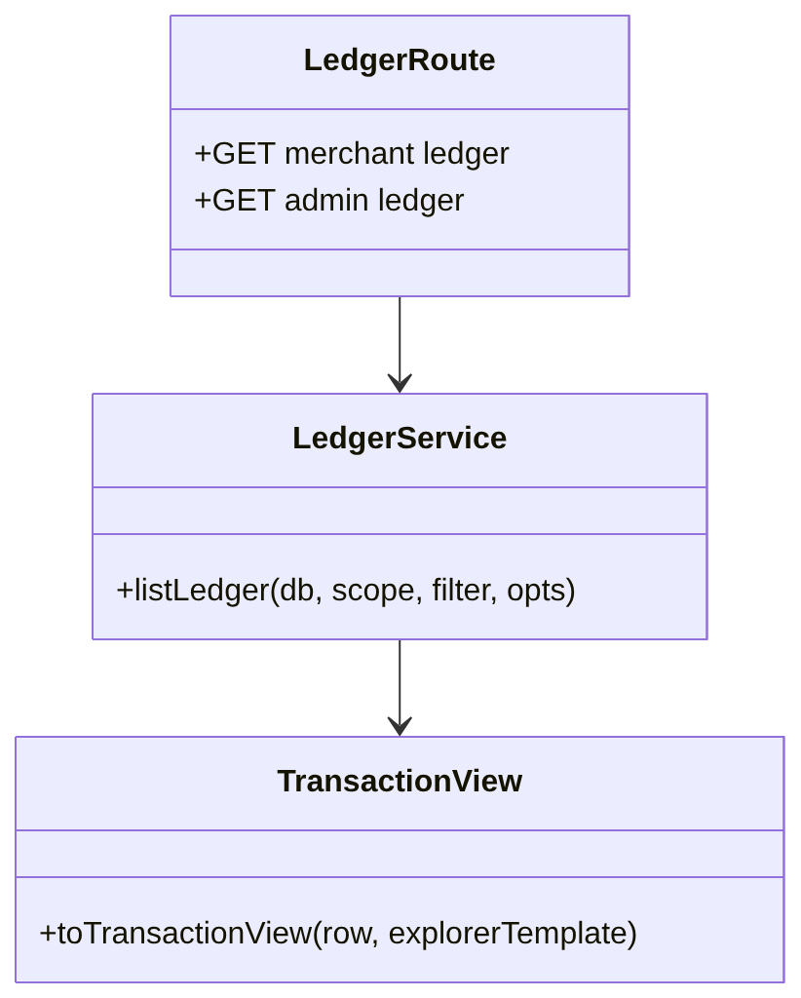
3.14.1 View Transaction Ledger Class diagram

3.14.2 Sequence Diagram
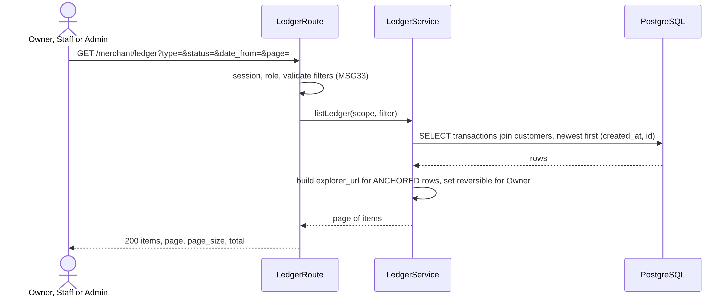
3.14.2 View Transaction Ledger Sequence diagram

3.14.3 Class Specification
No | Class | Attributes / Methods | Description
1 | LedgerRoute | merchant ledger, admin ledger, customer transactions | Owner and Staff see their own merchant. The Admin sees all merchants, read-only, with the extra filter merchant_code.
2 | LedgerService | listLedger | Filters: type, status, date (UTC+7, inclusive), customer code. 20 rows per page, ordered by created_at and then id, so a page never repeats or skips a row. The scope is merchantId (null for Admin).
3 | LedgerItem | transaction fields, bill_amount, performed_by, reversible, merchant_code | performed_by is a user or an API key label. reversible is calculated for the Owner only.
4 | TransactionView | toTransactionView | explorer_url is built from SUI_EXPLORER_TX_URL for ANCHORED rows and is null otherwise.

3.15 Create Reversal Transaction (UC-14)

3.15.1 Class Diagram
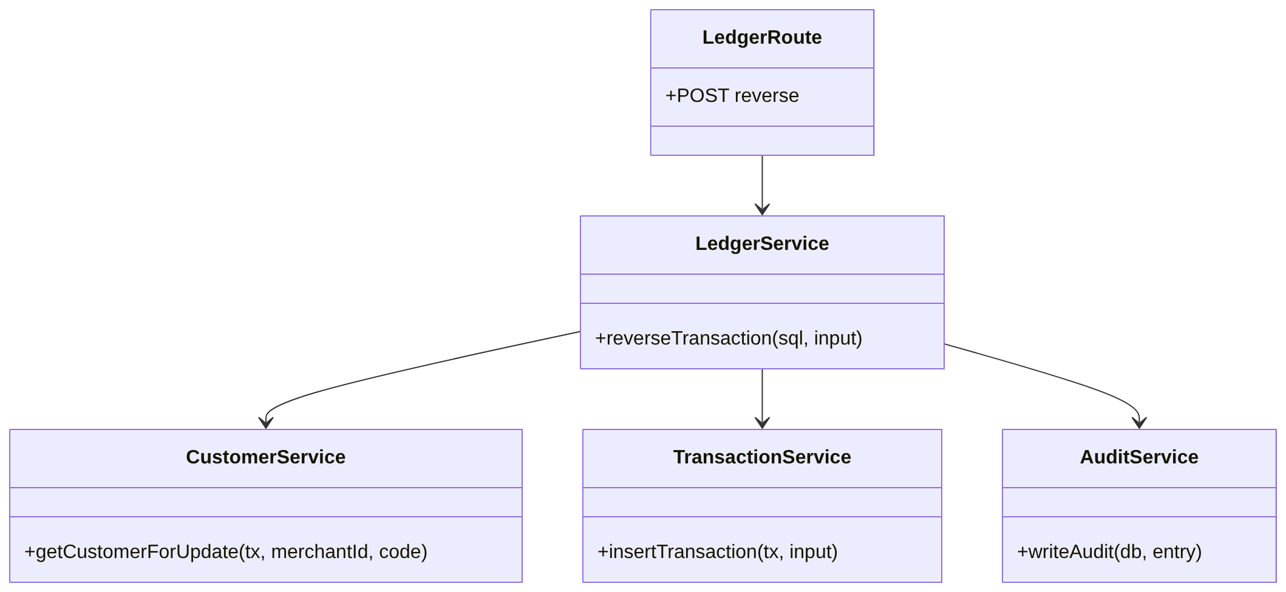
3.15.1 Create Reversal Transaction Class diagram

3.15.2 Sequence Diagram
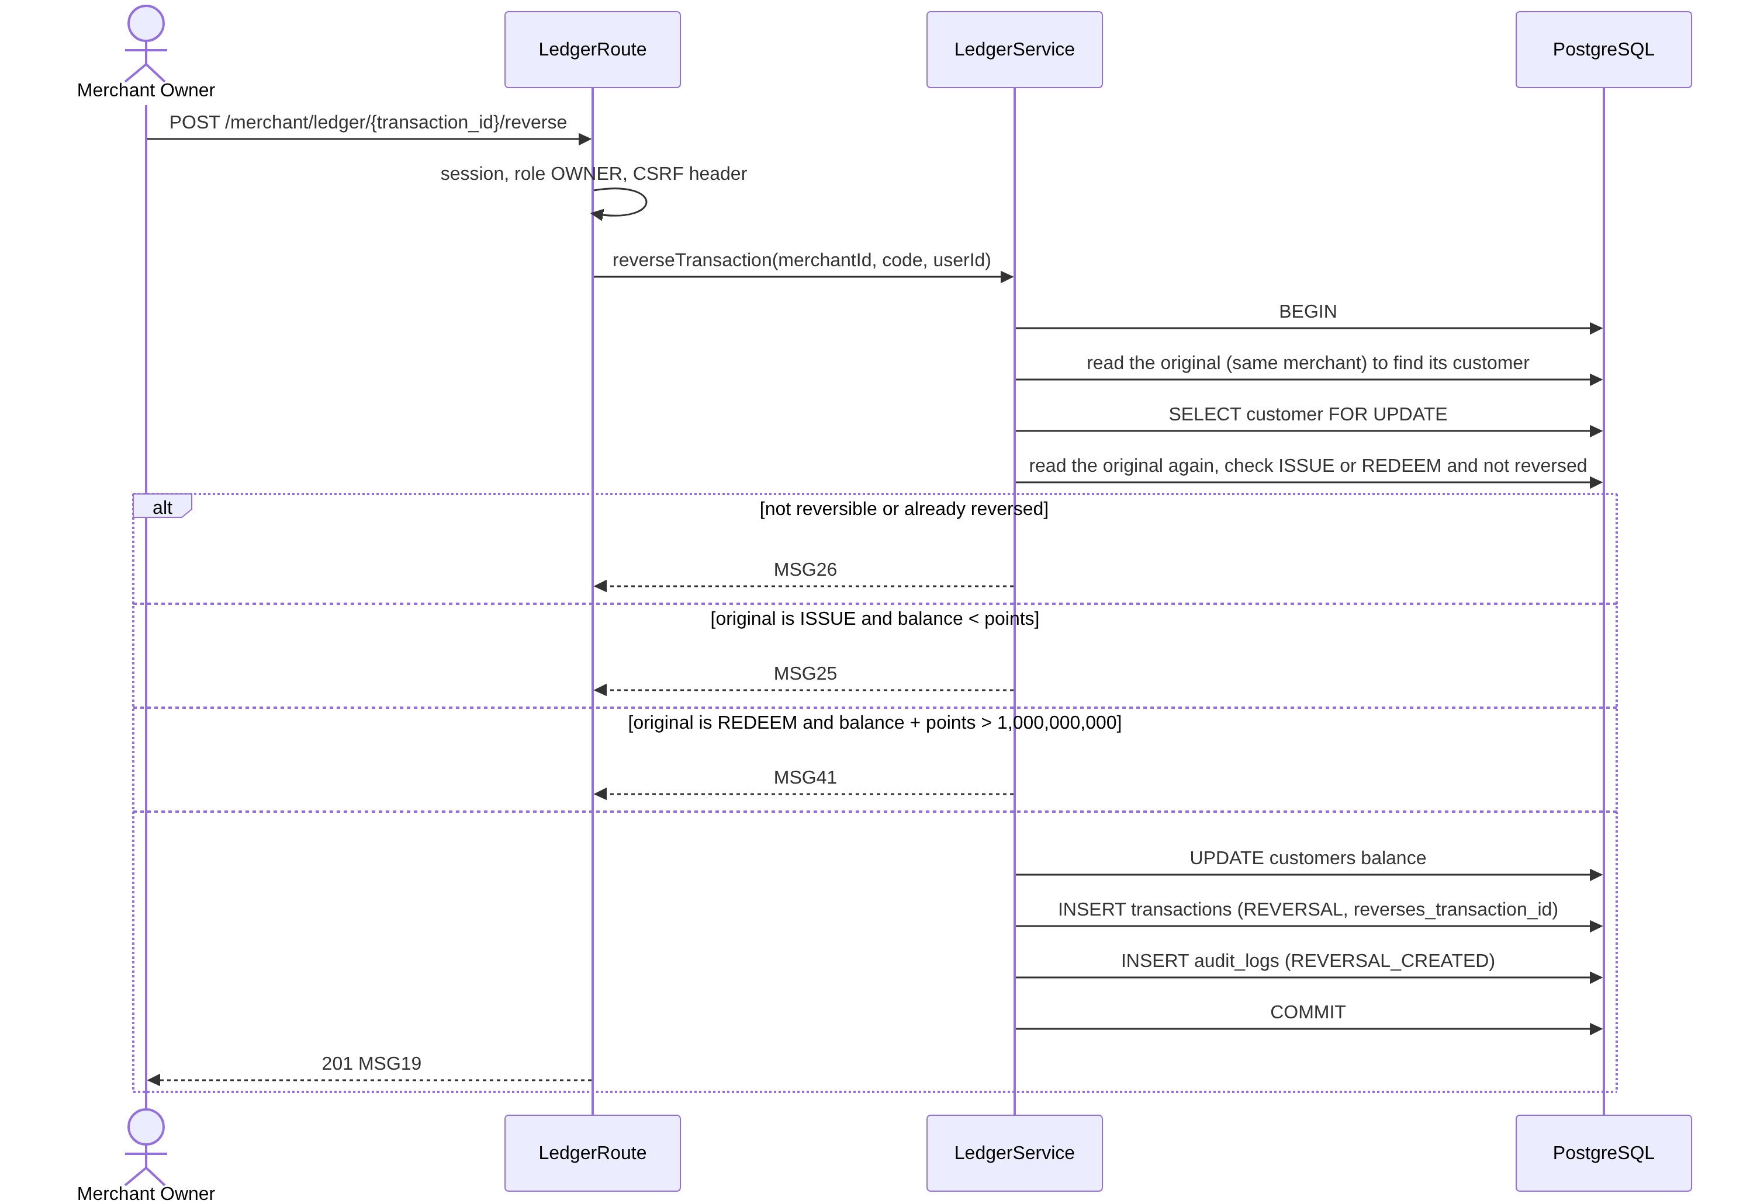
3.15.2 Create Reversal Transaction Sequence diagram

3.15.3 Class Specification
No | Class | Attributes / Methods | Description
1 | LedgerRoute | reverse | Owner only. No request body.
2 | LedgerService | reverseTransaction | Reverses an ISSUE or REDEEM once (BR-21). The request carries only the transaction code, so the customer is found with a first read without a lock; the second read after the lock is the one that decides. Two requests at the same time give one success and one MSG26. It works for an inactive customer, and it does not depend on the anchoring status of the original.
3 | TransactionService | insertTransaction | Inserts the REVERSAL row with the original's id and code.
4 | AuditService | writeAudit | Action REVERSAL_CREATED.
The original row is never changed (BR-03). The database also refuses a second reversal and a reversal of a reversal.

3.16 Anchor Transactions on Sui Testnet (UC-16)

3.16.1 Class Diagram
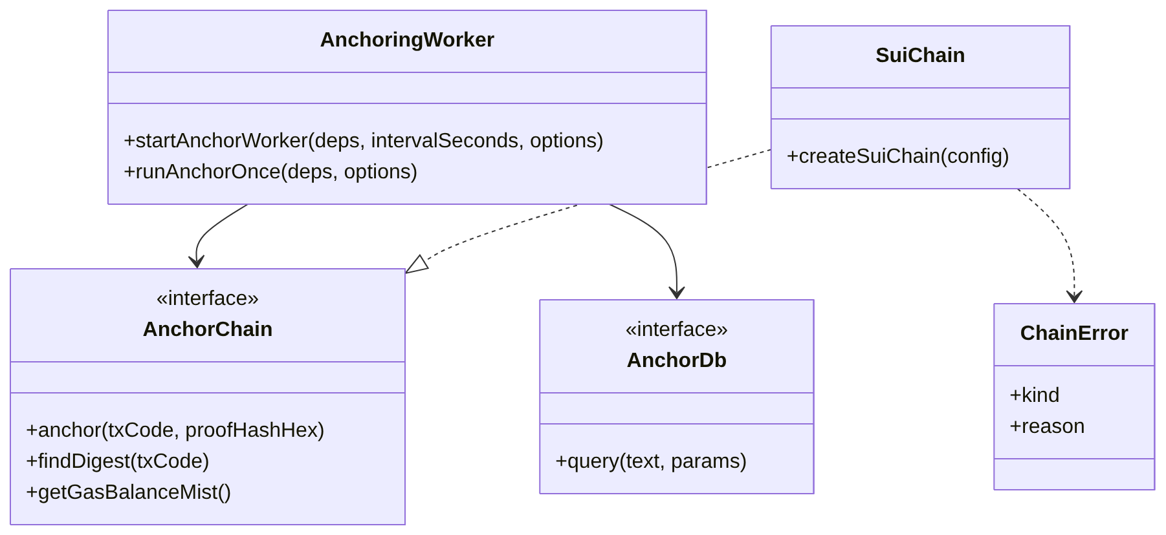
3.16.1 Anchor Transactions Class diagram

3.16.2 Sequence Diagram
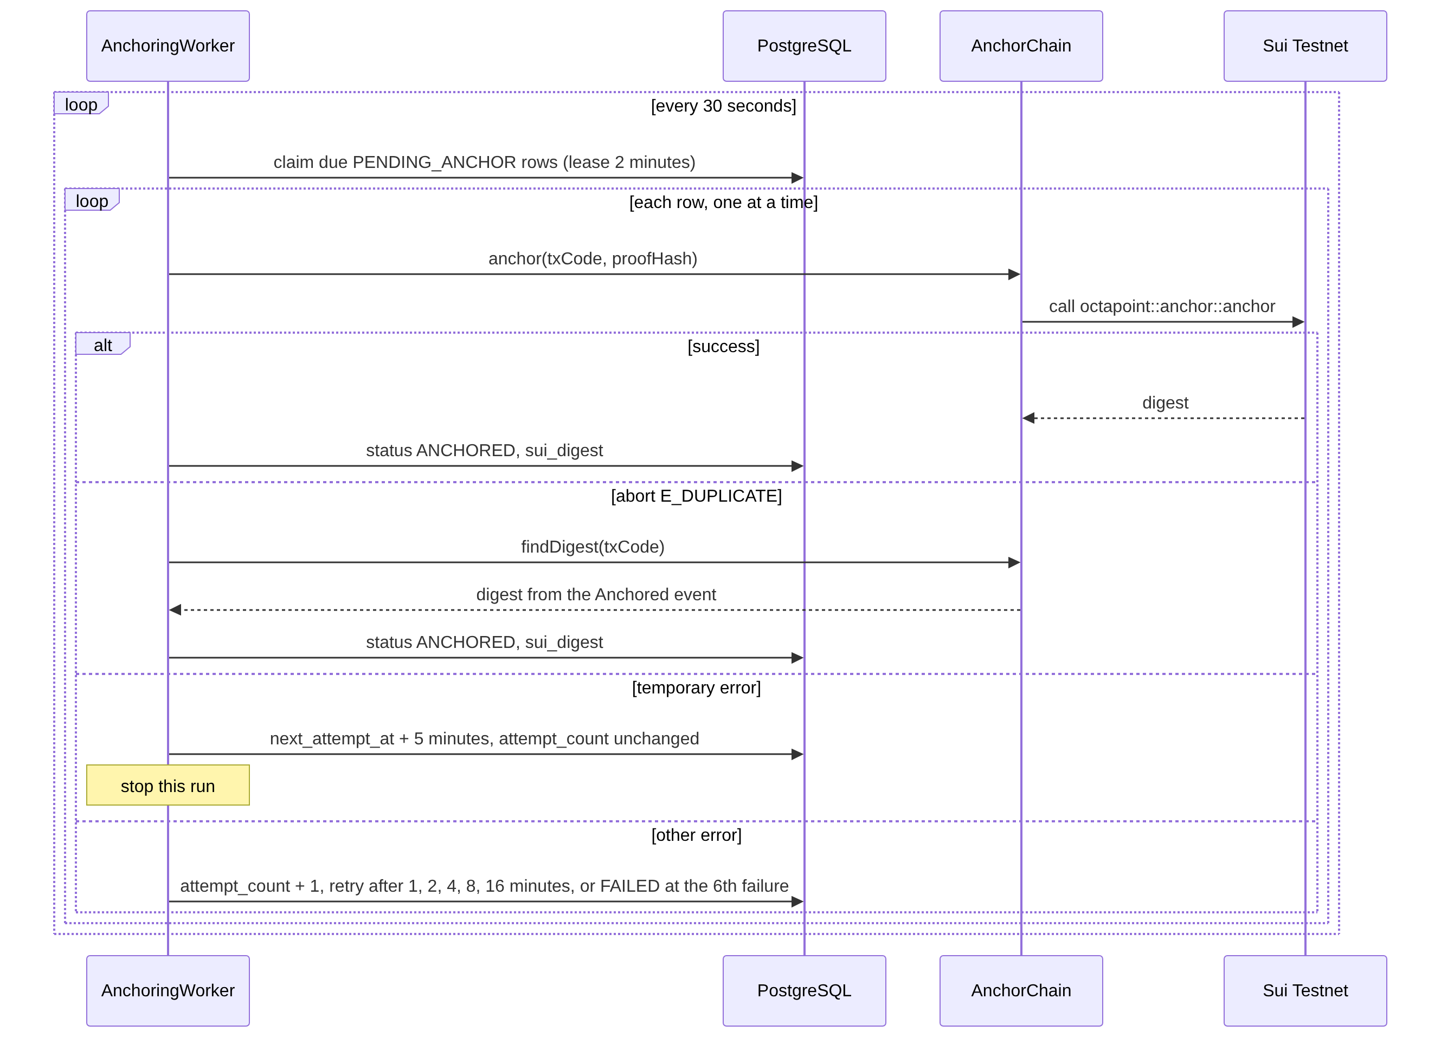
3.16.2 Anchor Transactions Sequence diagram
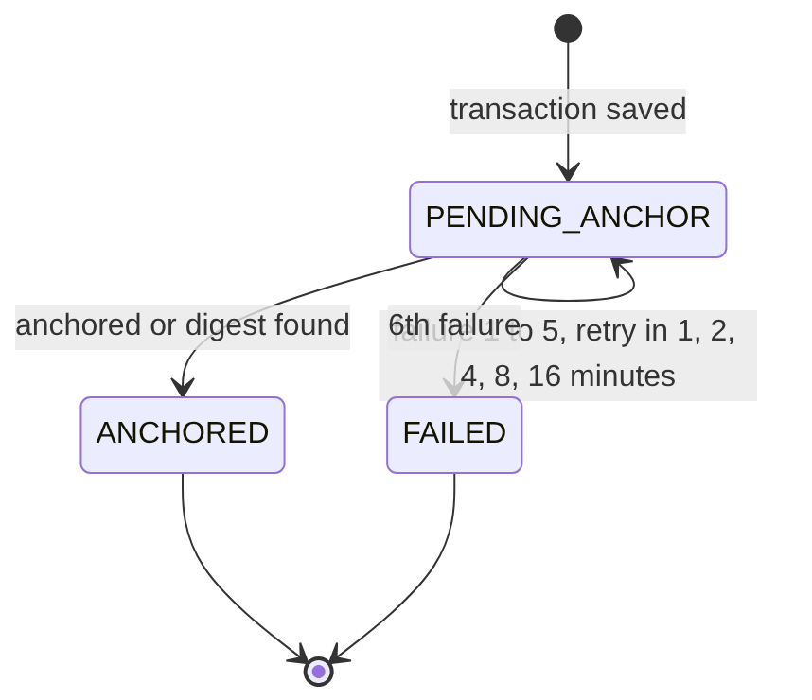
3.16.2 Transaction anchoring status (state diagram)

3.16.3 Class Specification
No | Class | Attributes / Methods | Description
1 | AnchoringWorker (run.ts, worker.ts) | runAnchorOnce, startAnchorWorker | Runs in the API process only when ENABLE_ANCHOR_WORKER=true; exactly one instance may enable it. A run takes up to ANCHOR_BATCH_SIZE (20) rows, oldest first, with FOR UPDATE SKIP LOCKED, and sets a 2-minute lease so the rows of a crashed run come back. It sends one transaction at a time because one wallet and one gas coin are used. The scheduler starts the next run only after the previous one has finished, so runs never overlap, and stop() waits for the run in progress.
2 | AnchorChain (run.ts) | anchor, findDigest, getGasBalanceMist | The interface between the worker and Sui. findDigest reads the Anchored events, newest first, at most 20 pages of 50 events. getGasBalanceMist is optional; when the wallet has less than 0.05 SUI the worker logs "platform wallet balance too low".
3 | AnchorDb (db.ts) | query, toAnchorDb | A small wrapper over the SQL client, so the worker can be tested with a fake database.
4 | SuiChain (sui-chain.ts) | createSuiChain | Uses @mysten/sui with the settings SUI_RPC_URL, SUI_GRAPHQL_URL, SUI_PRIVATE_KEY, SUI_PACKAGE_ID, SUI_REGISTRY_ID. After a successful call it waits until the fullnode has seen the transaction, so the next transaction uses the new versions of the gas coin and the registry.
5 | ChainError (errors.ts) | kind, reason, classifyThrown, classifyExecutionFailure, shortError | kind is temporary, duplicate or permanent. temporary covers network errors, timeouts, RPC 5xx or limits, no gas and object-version conflicts, and it is not counted as an attempt. duplicate means the contract aborted with E_DUPLICATE. shortError shortens the text stored in last_error and removes any private key.
6 | Move contract octapoint::anchor | anchor | See section 2.4.
The worker updates only status, sui_digest, attempt_count, next_attempt_at and last_error, and never changes a balance (BR-11). FAILED is final in this version (LI-08). To check a transaction by hand, rebuild the canonical JSON from the ledger record, take the SHA-256, and compare it with the hash in the Anchored event shown in Sui Explorer.

3.17 View Admin Dashboard (UC-03)

3.17.1 Class Diagram
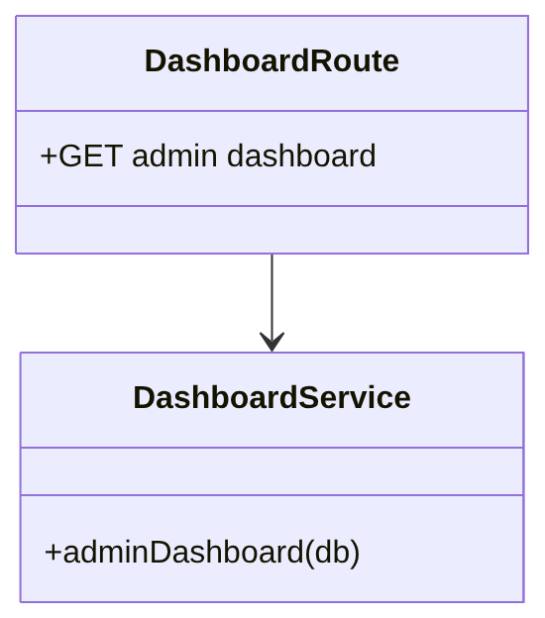
3.17.1 View Admin Dashboard Class diagram

3.17.2 Sequence Diagram
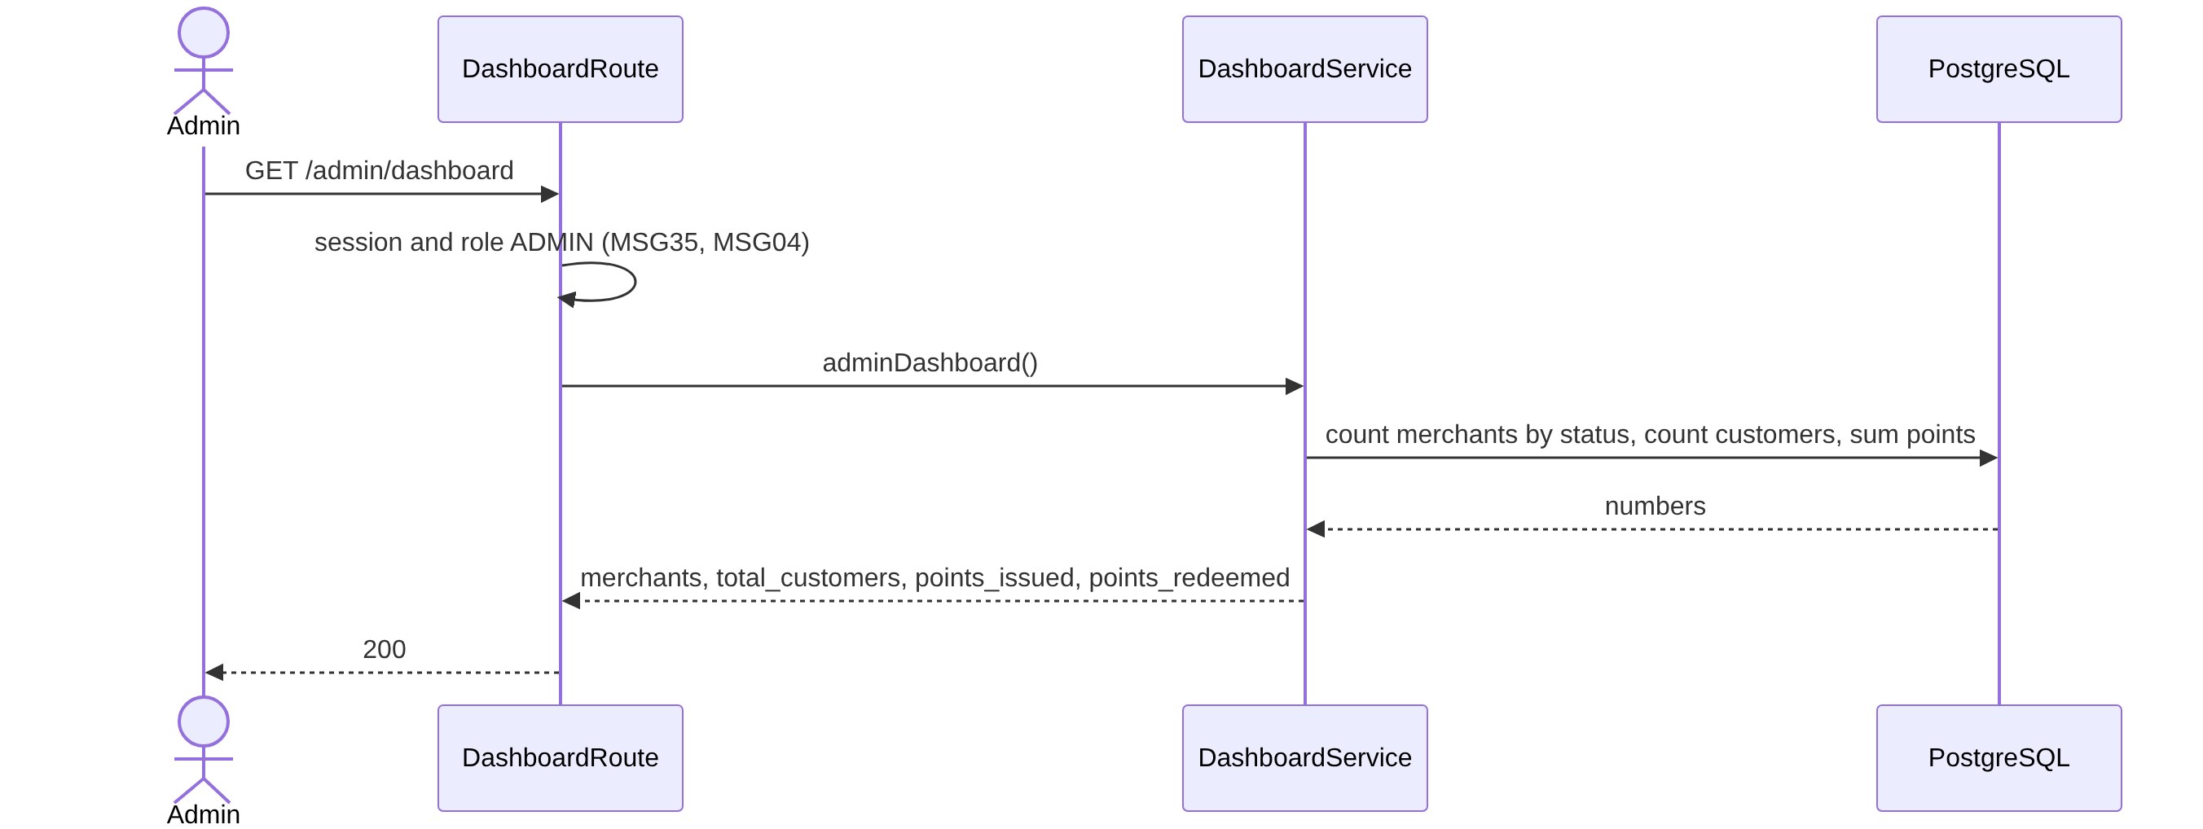
3.17.2 View Admin Dashboard Sequence diagram

3.17.3 Class Specification
No | Class | Attributes / Methods | Description
1 | DashboardRoute | admin dashboard | Admin only.
2 | DashboardService | adminDashboard | Merchants split by PENDING, ACTIVE, SUSPENDED; customers of all merchants. Points issued = ISSUE points minus the points of REVERSAL rows whose original is an ISSUE. Points redeemed = REDEEM points minus the points of REVERSAL rows whose original is a REDEEM. The SQL is in docs/db-schema.md section 6.

3.18 View Merchant Dashboard (UC-05)

3.18.1 Class Diagram
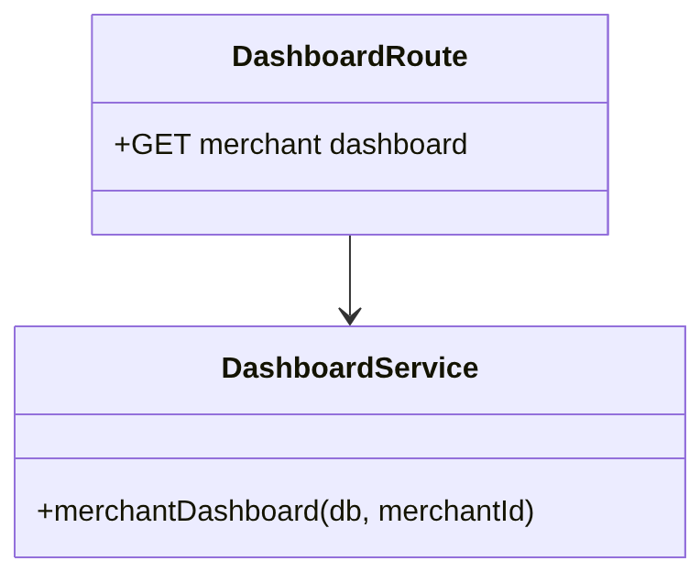
3.18.1 View Merchant Dashboard Class diagram

3.18.2 Sequence Diagram
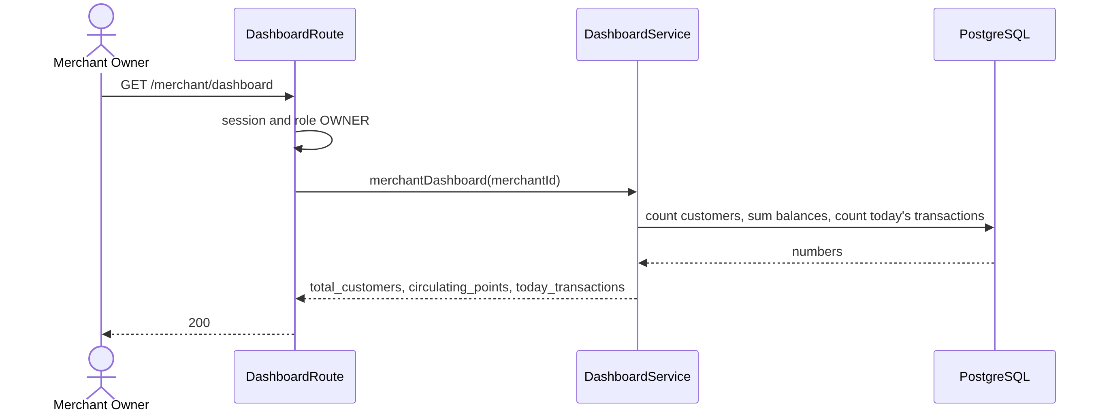
3.18.2 View Merchant Dashboard Sequence diagram

3.18.3 Class Specification
No | Class | Attributes / Methods | Description
1 | DashboardRoute | merchant dashboard | Owner only. merchant_id comes from the session.
2 | DashboardService | merchantDashboard | Total customers; circulating points = sum of all balances; today's transactions = all types and statuses created since midnight in UTC+7.

4. Supporting Design Information

4.1 API Summary
The full API specification is docs/api-spec.md. Every path starts with /api/v1. Errors use the body { "code": "MSGxx", "message": "..." } (CR-06).
HTTP Status | Message Codes
400 | MSG01, MSG33, MSG37
401 | MSG02, MSG16, MSG17, MSG18, MSG35
403 | MSG04, MSG15
404 | MSG22
409 | MSG25, MSG26, MSG27, MSG31, MSG34, MSG38, MSG40, MSG41
422 | MSG08, MSG09, MSG24, MSG32, MSG36, MSG39
500 | MSG23
External API (API key + HMAC).
No | Endpoint | UC | Description
1 | POST /points/issue | UC-10 | Body customer_code, amount. Header X-Idempotency-Key required. Returns 201 with the transaction.
2 | POST /points/redeem | UC-11 | Body customer_code, points. Header X-Idempotency-Key required. Returns 201.
3 | GET /customers/{code}/balance | UC-12 | Returns customer_code and balance.
4 | GET /customers/{code}/transactions | UC-13 | Filters type, status, date_from, date_to, page. 20 per page, newest first.
5 | GET /loyalty-rules | UC-17 | Should item. Returns earn_ratio and min_redemption_threshold.
Portal API (session cookie).
No | Endpoint | UC | Roles
1 | POST /auth/register, POST /auth/login, POST /auth/logout, GET /auth/me, POST /auth/change-password | UC-18, UC-01, UC-02 | Public / any
2 | GET /admin/dashboard, GET /admin/merchants, POST /admin/merchants/{id}/approve, POST /admin/merchants/{id}/suspend, GET /admin/ledger | UC-03, UC-04, UC-13 | Admin
3 | GET /merchant/dashboard | UC-05 | Owner
4 | GET and PUT /merchant/rules | UC-06 | Owner
5 | GET and POST /merchant/api-keys, POST /merchant/api-keys/{id}/revoke | UC-07 | Owner
6 | GET and POST /merchant/staff, POST /merchant/staff/{id}/deactivate | UC-08 | Owner
7 | GET and POST /merchant/customers, PATCH /merchant/customers/{code} | UC-09 | Owner, Staff
8 | POST /merchant/customers/{code}/deactivate and /reactivate | UC-09 | Owner
9 | POST /merchant/customers/{code}/issue and /redeem | UC-10, UC-11 | Owner, Staff
10 | GET /merchant/ledger | UC-13 | Owner, Staff
11 | POST /merchant/ledger/{transaction_id}/reverse | UC-14 | Owner

4.2 Exception Handling
No | Situation | System Behavior | Code
1 | The SDK loses the network or times out during issue or redeem | The SDK does not retry by itself. The caller sends the same idempotency key again and gets the saved response, so only one transaction exists. | –
2 | Two identical requests arrive at the same time | The second waits for the advisory lock and then returns the saved response. | –
3 | Same idempotency key with a different request, or key missing | Rejected. | MSG34, MSG33
4 | Unknown, suspended or revoked API key, or suspended merchant | Rejected at the first gateway step. | MSG18
5 | Timestamp is not an integer or is more than 300 seconds away | Rejected. The answer includes server_time. | MSG17
6 | Signature is missing or wrong, or a signed request is replayed with another key | Rejected. | MSG16
7 | Wrong format: lower-case customer code, number out of range, bad page or filter | Rejected. | MSG33
8 | Unknown customer, inactive customer, rules not set | Rejected. | MSG22, MSG39, MSG32
9 | Issue gives 0 points | Rejected. | MSG24
10 | Redeem below the minimum, or balance too low | Rejected. The minimum is checked first. | MSG09, MSG08
11 | Wrong role, or a changing portal request without X-Requested-With | Rejected. | MSG04
12 | Session expired, logged out, user deactivated or merchant not ACTIVE | Rejected, and the portal goes to Login. | MSG35
13 | Merchant suspended while sessions and keys are in use | Next portal request gets MSG35, next API call gets MSG18, and saved transactions are still anchored. | MSG35, MSG18
14 | Duplicate email, customer code or phone, even from two simultaneous requests | The unique violation is turned into the message. | MSG31, MSG27, MSG38
15 | Sixth ACTIVE or SUSPENDED API key | Rejected. | MSG40
16 | Reversal not allowed, or the balance would leave the range | Rejected, and the original row is unchanged. | MSG26, MSG25, MSG41
17 | Database error, deadlock or unexpected exception | The whole transaction is rolled back. Details go only to the server log. No ledger row and no idempotency row exist, so the same key can be used again. | MSG23
18 | Sui Testnet or RPC down, network error, or wallet out of gas | The worker stops the run. The row stays PENDING_ANCHOR and is tried again after 5 minutes. No attempt is counted. | –
19 | Contract abort E_DUPLICATE | The worker finds the digest in the Anchored event and marks the row ANCHORED. | –
20 | Any other anchoring error | Retry after 1, 2, 4, 8, 16 minutes, then FAILED (final). Balances are never changed. | –
21 | The worker stops in the middle of a run | The 2-minute lease ends and the rows are claimed again. | –
22 | MCP Server gets wrong credentials or an unknown customer | Returned as a tool error with the original code and message. | MSG18, MSG22
23 | SDK, MCP Server or Web Portal cannot reach the API (network failure or timeout) | The SDK throws OctaPointError with code MSG23 and HTTP status 0. The MCP Server returns it as a tool error. The Web Portal shows the MSG23 text in a toast. | MSG23

4.3 Security Design
No | Threat | Control | Rule
1 | Forged API request | HMAC-SHA256 over timestamp, method, path, body hash and idempotency key; compared in constant time. | BR-08
2 | Replay of a captured request | A 300-second time window, the idempotency key inside the signature, and a saved response for 24 hours. | BR-09, BR-10
3 | Double spending by concurrent requests | The customer row is locked before any balance check, and the database checks balance >= 0. | BR-05, BR-06
4 | Access to another merchant's data | merchant_id comes from the session or the key. Every query filters by it. The ledger has a composite foreign key. | BR-01
5 | Using a function without permission | Role check on every portal endpoint. Hiding a menu item in the UI is only a convenience. | BR-02, CR-03
6 | Cross-site request on the portal | SameSite=Lax cookie and the X-Requested-With header. | CR-03
7 | Stolen database content | BCrypt passwords, API secrets encrypted with AES-256-GCM and a key outside the database, session tokens stored as hashes. | CR-07, CR-08
8 | Changing the ledger | Triggers block edit, delete and truncate. The proof hash is anchored on Sui. | BR-03, BR-20
9 | Personal data on a public chain | Only the transaction code and a hash are written. | BR-20
10 | An AI agent changing data | No write tool is registered in the MCP Server. | BR-14
11 | Leak of the platform wallet key | The key is only in SUI_PRIVATE_KEY on the server. The wallet is a Testnet wallet. | BR-13
12 | Information in error messages | Only the CR-06 body is returned. Details stay in the server log. | CR-06
Rate limiting, brute-force protection and personal-data protection are outside this version (LI-09).

4.4 Non-functional Requirements in the Design
No | Requirement (SRS §4.2) | Design measure
1 | 95% of issue, redeem, balance and history requests within 200 ms, with up to 20 concurrent clients | Anchoring is outside the request. Each request is one short transaction with one row lock. Indexes on (merchant_id, created_at, id) and (customer_id, created_at, id). This is a design target and is not load-tested (LI-11). The connection pool has 10 connections (createSql, max).
2 | 10 merchants, 10,000 customers each, 5 transactions per second | Locks are per customer, so different customers do not block each other. The worker catches up from a backlog over several runs.
3 | Sui outages must not block transactions | Asynchronous anchoring. Temporary errors never use up the retries.
4 | Screens load within 3 seconds; issuing or redeeming takes at most 3 steps | One dialog per action: enter the value, confirm. Same-origin proxy without CORS.
5 | Maintainability | Layers of section 1.1.1. One place for messages (messages.ts) and one error type (AppError). Lint, type check and tests run in CI.

4.5 Requirement-to-Design Traceability
UC | Features | Rules | Design section | Task and status
UC-01 | FE1 | BR-02, BR-18, BR-19 | 3.2 | T02, completed
UC-02 | FE1 | BR-02, CR-08 | 3.3 | T02, completed
UC-03 | FE7 | BR-01, BR-02 | 3.17 | T10, completed
UC-04 | FE2 | BR-02, BR-18, BR-19 | 3.4 | T03, completed
UC-05 | FE7 | BR-01, BR-02 | 3.18 | T10, completed
UC-06 | FE4 | BR-01, BR-07, BR-22 | 3.6 | T06, completed
UC-07 | FE6 | BR-01, BR-08, BR-18, CR-07 | 3.11 | T04, completed
UC-08 | FE1 | BR-01, BR-02, BR-19 | 3.5 | T04, completed
UC-09 | FE3 | BR-01, BR-04 | 3.7 | T05, completed
UC-10 | FE3, FE4 | BR-05, BR-06, BR-07, BR-10, BR-12, BR-17, BR-22 | 3.8 | T07, completed
UC-11 | FE3 | BR-05, BR-06, BR-07, BR-10, BR-12 | 3.9 | T07, completed
UC-12 | FE3 | BR-01 | 3.10 | T09, completed
UC-13 | FE5 | BR-01, BR-03, BR-12 | 3.14 | T08, T09, completed
UC-14 | FE5 | BR-03, BR-05, BR-06, BR-21 | 3.15 | T08, completed
UC-15 | FE6 | BR-08, BR-09, BR-10 | 3.12 | T09, completed
UC-16 | FE8 | BR-03, BR-11, BR-12, BR-13, BR-20 | 2.4, 3.16 | T11, completed
UC-17 | FE10 | BR-01, BR-14 | 3.13 | T15, completed
UC-18 | FE2 | BR-18, CR-08 | 3.1 | T03, completed
All features FE1 to FE10 are implemented (tasks T00 to T15), and every use case is covered by automated tests, manual test cases, or both (see Part V). Nothing in this design is outside the SRS: there is no transfer between merchants (BR-15), no reversal through the API or SDK (LI-13), no customer creation through the API (LI-16), no rate limiting (LI-09), and none of the technologies of LI-06.

4.6 Implementation Summary
Task | Content | Package | Automated tests
T00 | Project scaffold, messages, configuration, migration runner, HMAC and request-target helpers | apps/api | included below
T01 | Database migration, ledger triggers, seed Admin | apps/api | included below
T02 | Login, sessions, account settings | apps/api | included below
T03 | Merchant registration, approve and suspend | apps/api | included below
T04 | Staff accounts, API keys | apps/api | included below
T05 | Customers | apps/api | included below
T06 | Loyalty rules | apps/api | included below
T07 | Points engine (issue, redeem, idempotency, proof hash) | apps/api | included below
T08 | Ledger view and reversal | apps/api | included below
T09 | API Gateway and external endpoints | apps/api | included below
T10 | Dashboards | apps/api | included below
T11 | Move contract | contracts/anchor | 3 (Move)
T12 | Anchoring worker | apps/api | included below
T13 | Web Portal | apps/web | 70
T14 | TypeScript SDK | packages/sdk | 24
T15 | MCP Server | packages/mcp | 18
 | Backend (T00 to T10, T12) | apps/api | 374
 | Total (backend, web, SDK, MCP, contract) | all packages | 489

