Problem 1:

Create a single HTML document that presents two different appearances, determined by thedocument's CSS stylesheet. Your HTML file should be called p1.html and the two stylesheets should becalled p1a.css and p1b.css. If the HTML file links to p1a.css then it should appear like this ("Version

A")

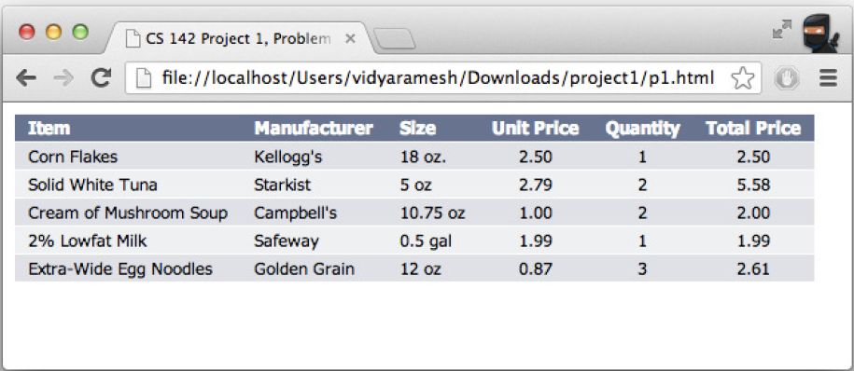

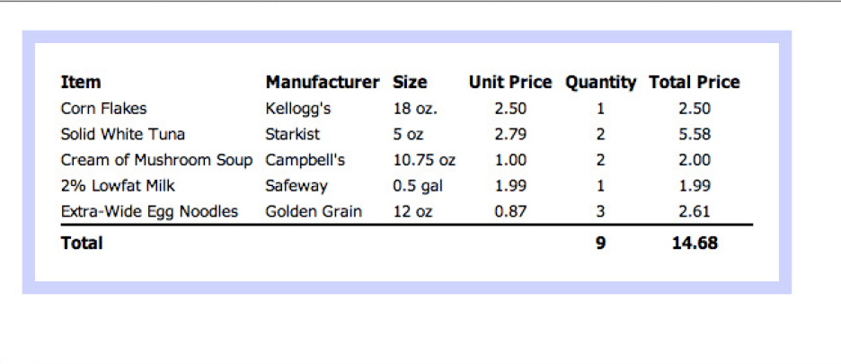

Problem 2:

Problem 2

Create a simple mashup page that displays display the Yahoo! news page (http://news.yahoo.com),

the San Jose Mercury News home page (http://www.mercurynews.com), Cleveland Plain Dealer page

and Cleveland CAVS home page. You can add anything more as you want in this section to be

creative.

Your solution should be in a file p2.html. Note: your solution for this problem does not need to

validate (there are validation errors in the Yahoo! and Mercury News pages). For this problem you

need not create a separate CSS file: you can put the style information directly in p2.html.