**Assignment3. Recommendation**

2017029561 Nam Jihoon

1. **Summary**

"Recommendation Algorithm" is an important algorithm. This is because the recommended purchase list of users with purchasing power can be selected in advance to boost consumption potential. The methods vary as much as the important algorithms. First, it recommends items in categories similar to those already purchased by users. Second, we recommend based on data from other people who are close to the user. But the last way we use it is different. Set other users with similar user and purchasing behavior as the same neighborhood group. I recommend a list of the neighbors by understanding their propensity. We will use this "Collective Filtering" method.

1. **Functions description**
2. **Pearson_eq**

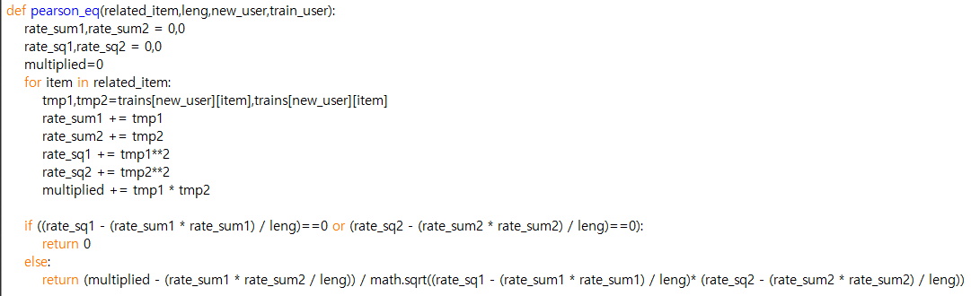

It is a function that calculates "Pearson correction coeffient" to analyze the degree of association. The mathematical representation of the formula for this function is as follows.

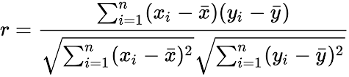

1. **Correlation()**

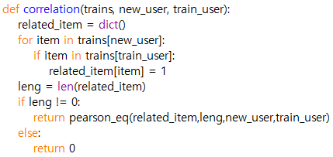

It is a function that analyzes how many common items the two users have and returns the appropriate values before finding "Pearson Correlation Cofficiency."

1. **Find_neighbor()**

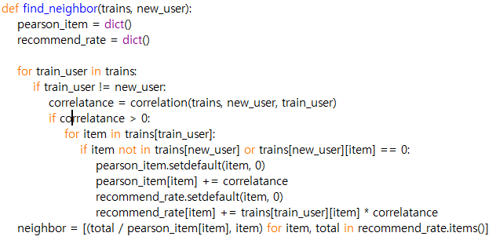

Based on the computed "Pearson Correlation coeffient", it is a function that determines how much it relates to other neighbors. Based on this, the recommended rate is determined.

1. **Cf_algorithm()**

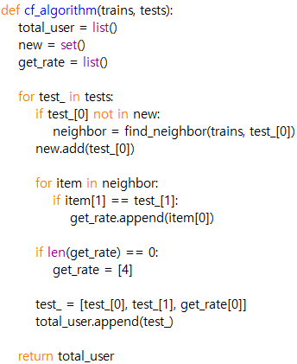

A function that uses the "Collective Filtering" algorithm to score and return all expected ratings of each user. To determine this, Pearson Correlation is used and has a key function to invoke other functions necessary for collabative filtering.

1. **Compiling Instruction**

The Program written by Python Idle and used Python 3.7.2.

This program was tested on the Windows 10 command prompt

[1] download recommender.py and input files in same directory

[2] get in to directory that recommender.py is downloaded and enter the command “recommender.py u1.base u1.test”S

[3] repeat procedure[2] for another data files

[4] To check the test result, enter the command “PA4.exe u1”,,,etc.

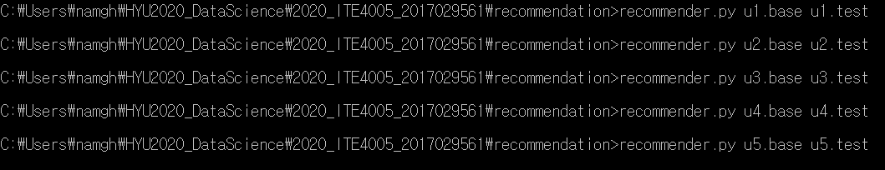

1. **Result**

 