Lab3.1

MainActivity.java

**package** com.example.namgoong.yeonwoo;  
**import** android.graphics.Color;  
**import** android.support.v7.app.AppCompatActivity;  
**import** android.app.Activity;  
**import** android.os.Bundle;  
**import** android.util.Log;  
**import** android.os.Bundle;  
**import** android.content.Intent;  
**import** android.content.Context;  
**import** android.view.*;  
**import** android.webkit.WebView;  
**import** android.webkit.WebViewClient;  
**import** android.widget.ArrayAdapter;  
**import** android.widget.Button;  
**import** android.widget.CheckBox;  
**import** android.widget.EditText;  
**import** android.widget.LinearLayout;  
**import** android.widget.ListView;  
**import** android.widget.RadioButton;  
**import** android.widget.RadioGroup;  
**import** android.widget.TextView;  
**import** android.widget.Toast;  
  
**public class** MainActivity **extends** AppCompatActivity {  
 Button **mBtn**;  
  
 @Override  
 **protected void** onCreate(Bundle savedInstanceState) {  
 **super**.onCreate(savedInstanceState);  
 setContentView(R.layout.***activity_main***);  
 **mBtn**=findViewById(R.id.***button***);  
 registerForContextMenu(**mBtn**);  
 }  
 **public void** onCreateContextMenu (ContextMenu menu, View v,ContextMenu.ContextMenuInfo menuInfo) {  
 **super**.onCreateContextMenu(menu, v, menuInfo);  
 menu.setHeaderTitle(**"Button Menu"**);  
  
 menu.add(0,1,0,**"Red"**);  
 menu.add(0,2,0,**"Green"**);  
 menu.add(0,3,0,**"Blue"**);}  
  
 **public boolean** onContextItemSelected (MenuItem item){  
 **if**(item.getItemId()==1)  
 **mBtn**.setTextColor(Color.***RED***);  
 **if**(item.getItemId()==2)  
 **mBtn**.setTextColor(Color.***GREEN***);  
 **if**(item.getItemId()==3)  
 **mBtn**.setTextColor(Color.***BLUE***);  
 **return true**;  
 }  
}

activity_main.xml

*<?***xml version="1.0" encoding="utf-8"***?>*<**LinearLayout  
 xmlns:android="http://schemas.android.com/apk/res/android"  
 android:orientation="vertical"  
 android:id="@+id/activity_main"  
 android:layout_width="match_parent"  
 android:layout_height="match_parent"** >  
 <**Button  
 android:id="@+id/button"  
 android:layout_width="wrap_content"  
 android:layout_height="wrap_content"  
 android:text="TEXT COLOR CHANGE"**/>  
  
  
</**LinearLayout**>

스크린샷

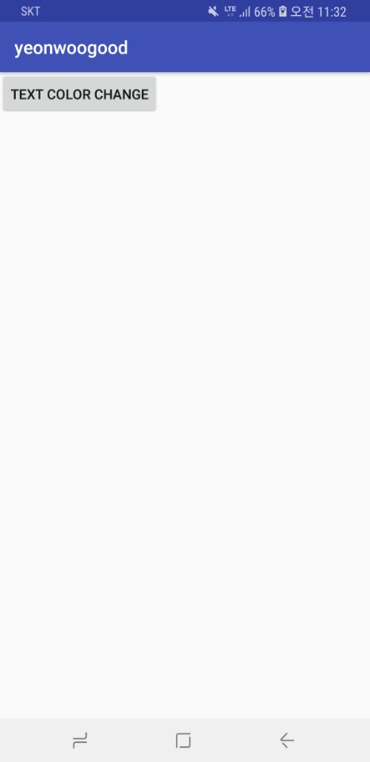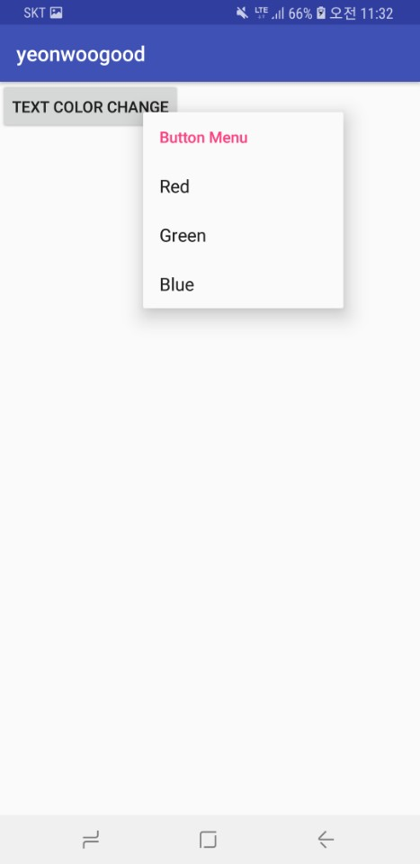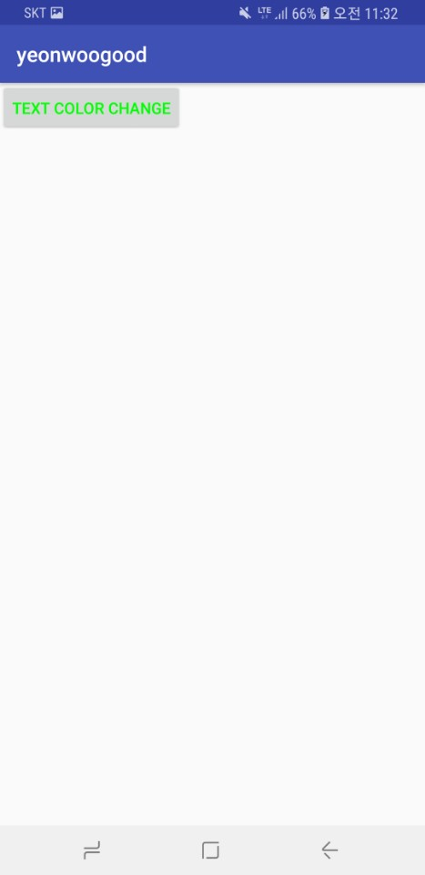

Lab3-2

MainActivity.java

**package** com.example.namgoong.yeonwoo;  
**import** android.graphics.Color;  
**import** android.support.v7.app.AppCompatActivity;  
**import** android.app.Activity;  
**import** android.os.Bundle;  
**import** android.util.Log;  
**import** android.os.Bundle;  
**import** android.content.Intent;  
**import** android.content.Context;  
**import** android.view.*;  
**import** android.webkit.WebView;  
**import** android.webkit.WebViewClient;  
**import** android.widget.ArrayAdapter;  
**import** android.widget.Button;  
**import** android.widget.CheckBox;  
**import** android.widget.EditText;  
**import** android.widget.LinearLayout;  
**import** android.widget.ListView;  
**import** android.widget.RadioButton;  
**import** android.widget.RadioGroup;  
**import** android.widget.TextView;  
**import** android.widget.Toast;  
**public class** MainActivity **extends** AppCompatActivity {  
 EditText **name**;  
 RadioButton **male**,**female**;  
 CheckBox **sms**,**email**;  
 Button **btn**;  
 @Override  
 **protected void** onCreate(Bundle savedInstanceState) {  
 **super**.onCreate(savedInstanceState);  
 setContentView(R.layout.***activity_main***);  
  
 **name**=findViewById(R.id.***editText***);  
 **male**=findViewById(R.id.***male***);  
 **female**=findViewById(R.id.***female***);  
 **sms**=findViewById(R.id.***sms***);  
 **email**=findViewById(R.id.***e_mail***);  
 **btn**=findViewById(R.id.***btn***);  
  
 **btn**.setOnClickListener(**new** View.OnClickListener(){  
 **public void** onClick(View view){  
 String passedname = **name**.getText().toString();  
 *//성별 radiobutton* String gender=**""**;  
 **if**(**male**.isChecked())  
 gender=**"남"**;  
 **else if**(**female**.isChecked())  
 gender=**"여"**;  
  
 *//수신여부 checkbox* String acceptance=**""**;  
 **if**(**sms**.isChecked())  
 acceptance=**"SMS "**;  
 **if**(**email**.isChecked())  
 acceptance+=**"e-mail"**;  
  
 Intent intent = **new** Intent(getApplicationContext(),NewActivity.**class**);  
 intent.putExtra(**"name"**,passedname);  
 intent.putExtra(**"gender"**,gender);  
 intent.putExtra(**"accept"**,acceptance);  
 startActivity(intent);  
 finish();  
 }  
 });  
 }  
}

NewActivity.java

**package** com.example.namgoong.yeonwoo;  
  
**import** android.support.v7.app.AppCompatActivity;  
**import** android.os.Bundle;  
**import** android.content.Intent;  
**import** android.view.View;  
**import** android.widget.Button;  
**import** android.widget.TextView;  
  
**public class** NewActivity **extends** AppCompatActivity {  
 TextView **text**,**gender**,**accept**;  
 Button **prebtn**;  
 **protected void** onCreate(Bundle savedInstanceState) {  
 **super**.onCreate(savedInstanceState);  
 setContentView(R.layout.***activity_new***);  
  
 **text**=findViewById(R.id.***Textt***);  
 **gender**=findViewById(R.id.***gender***);  
 **accept**=findViewById(R.id.***accept***);  
 **prebtn** = findViewById(R.id.***previous***);  
  
 Intent getIntent = getIntent();  
 **if**(getIntent!=**null**) {  
 **text**.setText(getIntent.getStringExtra(**"name"**));  
 **gender**.setText(getIntent.getStringExtra(**"gender"**));  
 **accept**.setText(getIntent.getStringExtra(**"accept"**));  
 }  
 **prebtn**.setOnClickListener(**new** View.OnClickListener(){  
 **public void** onClick(View view){  
 Intent intent = **new** Intent(getApplicationContext(),MainActivity.**class**);  
 startActivity(intent);  
 finish();  
 }  
 });  
  
 }  
}

activity_main.xml

*<?***xml version="1.0" encoding="utf-8"***?>*<**LinearLayout xmlns:android="http://schemas.android.com/apk/res/android"  
 xmlns:app="http://schemas.android.com/apk/res-auto"  
 xmlns:tools="http://schemas.android.com/tools"  
 android:layout_width="match_parent"  
 android:layout_height="match_parent"  
 tools:context=".MainActivity"  
 android:orientation="vertical"**>  
  
 <**TableLayout  
 android:layout_width="match_parent"  
 android:layout_height="wrap_content"  
 android:stretchColumns="3"** >  
 <**TableRow**>  
 <**TextView  
 android:text="성명"** />  
  
 <**EditText  
 android:hint=""  
 android:layout_span="3"  
 android:id="@+id/editText"**/>  
 </**TableRow**>  
  
 <**TableRow**>  
 <**TextView  
 android:text="성별"**/>  
 <**RadioGroup  
 android:layout_height="wrap_content"  
 android:layout_width="wrap_content"  
 android:orientation="horizontal"  
 android:layout_span="2"**>  
 <**RadioButton  
 android:text="남"  
 android:layout_height="wrap_content"  
 android:layout_width="wrap_content"  
 android:id="@+id/male"**/>  
 <**RadioButton  
 android:text="여"  
 android:layout_height="wrap_content"  
 android:layout_width="wrap_content"  
 android:id="@+id/female"**/>  
 </**RadioGroup**>  
 </**TableRow**>  
 <**TableRow**>  
 <**TextView  
 android:text="수신여부"**/>  
 <**CheckBox  
 android:text="SMS"  
 android:id="@+id/sms"**/>  
 <**CheckBox  
 android:text="e-mail"  
 android:id="@+id/e-mail"**/>  
 </**TableRow**>  
 </**TableLayout**>  
 <**Button  
 android:layout_width="wrap_content"  
 android:layout_height="wrap_content"  
 android:text="등록"  
 android:layout_gravity="right"  
 android:id="@+id/btn"**/>  
</**LinearLayout**>

Activity_new.xml

*<?***xml version="1.0" encoding="utf-8"***?>*<**LinearLayout xmlns:android="http://schemas.android.com/apk/res/android"  
 xmlns:app="http://schemas.android.com/apk/res-auto"  
 xmlns:tools="http://schemas.android.com/tools"  
 android:layout_width="match_parent"  
 android:layout_height="match_parent"  
 tools:context=".MainActivity"  
 android:orientation="vertical"**>  
  
 <**TableLayout  
 android:layout_width="match_parent"  
 android:layout_height="wrap_content"  
 android:stretchColumns="3"** >  
 <**TableRow**>  
 <**TextView  
 android:text="성명"** />  
  
 <**EditText  
 android:hint=""  
 android:layout_span="3"  
 android:id="@+id/editText"**/>  
 </**TableRow**>  
  
 <**TableRow**>  
 <**TextView  
 android:text="성별"**/>  
 <**RadioGroup  
 android:layout_height="wrap_content"  
 android:layout_width="wrap_content"  
 android:orientation="horizontal"  
 android:layout_span="2"**>  
 <**RadioButton  
 android:text="남"  
 android:layout_height="wrap_content"  
 android:layout_width="wrap_content"  
 android:id="@+id/male"**/>  
 <**RadioButton  
 android:text="여"  
 android:layout_height="wrap_content"  
 android:layout_width="wrap_content"  
 android:id="@+id/female"**/>  
 </**RadioGroup**>  
 </**TableRow**>  
 <**TableRow**>  
 <**TextView  
 android:text="수신여부"**/>  
 <**CheckBox  
 android:text="SMS"  
 android:id="@+id/sms"**/>  
 <**CheckBox  
 android:text="e-mail"  
 android:id="@+id/e-mail"**/>  
 </**TableRow**>  
 </**TableLayout**>  
 <**Button  
 android:layout_width="wrap_content"  
 android:layout_height="wrap_content"  
 android:text="등록"  
 android:layout_gravity="right"  
 android:id="@+id/btn"**/>  
</**LinearLayout**>

스크린샷

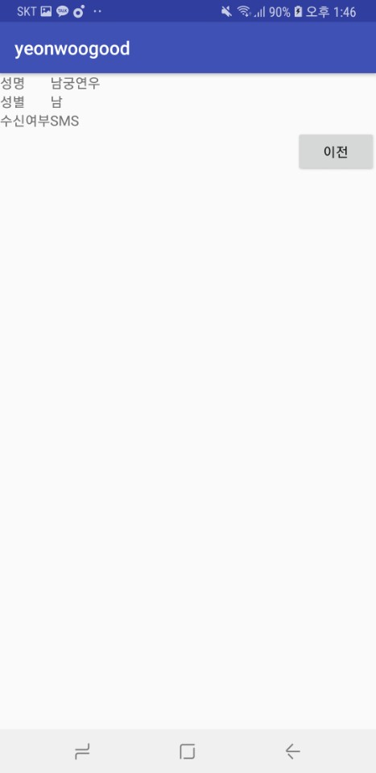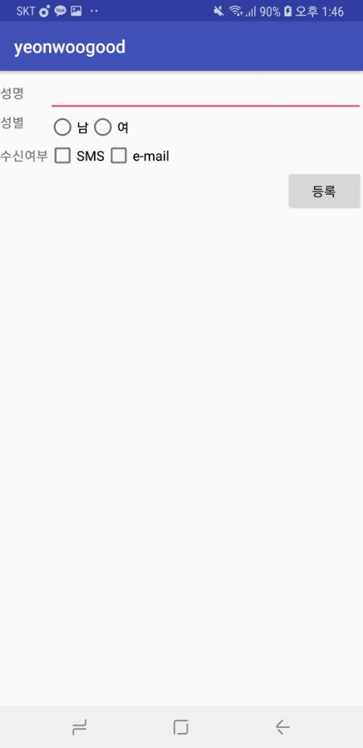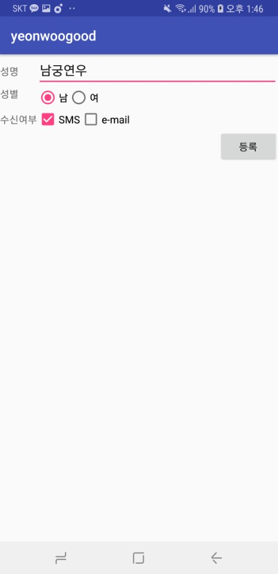

Lab3.3

MainActivity.java

**package** com.example.namgoong.yeonwoo;  
**import** android.graphics.Color;  
**import** android.support.v7.app.AppCompatActivity;  
**import** android.app.Activity;  
**import** android.os.Bundle;  
**import** android.util.Log;  
**import** android.os.Bundle;  
**import** android.content.Intent;  
**import** android.content.Context;  
**import** android.view.*;  
**import** android.webkit.WebView;  
**import** android.webkit.WebViewClient;  
**import** android.widget.ArrayAdapter;  
**import** android.widget.Button;  
**import** android.widget.CheckBox;  
**import** android.widget.EditText;  
**import** android.widget.LinearLayout;  
**import** android.widget.ListView;  
**import** android.widget.RadioButton;  
**import** android.widget.RadioGroup;  
**import** android.widget.TextView;  
**import** android.widget.Toast;  
  
**public class** MainActivity **extends** AppCompatActivity {  
 MainFragment **mainFragment**;  
 NewFragment **newFragment**;  
 Button **button1**;  
 Button **button2**;  
 @Override  
 **protected void** onCreate(Bundle savedInstanceState) {  
 **super**.onCreate(savedInstanceState);  
 setContentView(R.layout.***activity_main***);  
  
 **button1** = findViewById(R.id.***tab1***);  
 **button2** = findViewById(R.id.***tab2***);  
  
 **mainFragment** = **new** MainFragment();  
 **newFragment** = **new** NewFragment();  
  
 **button1**.setOnClickListener(**new** View.OnClickListener(){  
 **public void** onClick(View view){  
 getSupportFragmentManager().beginTransaction().replace(R.id.***framelayout***,**mainFragment**).commit();  
 }  
 });  
 **button2**.setOnClickListener(**new** View.OnClickListener(){  
 **public void** onClick(View view){  
 getSupportFragmentManager().beginTransaction().replace(R.id.***framelayout***,**newFragment**).commit();  
 }  
 });  
 }  
}

EmptyFragment

**package** com.example.namgoong.yeonwoo;  
**import** android.os.Bundle;  
**import** android.support.v4.app.Fragment;  
**import** android.view.LayoutInflater;  
**import** android.view.View;  
**import** android.view.ViewGroup;  
  
**public class** EmptyFragment **extends** Fragment {  
 **public** View onCreateView(LayoutInflater inflater, ViewGroup container, Bundle savedInstanceState){  
 **return** inflater.inflate(R.layout.***fragment_empty***,container,**false**);  
 }  
}

MainFragment

**package** com.example.namgoong.yeonwoo;  
**import** android.support.v7.app.AppCompatActivity;  
**import** android.os.Bundle;  
**import** android.support.v4.app.Fragment;  
**import** android.view.LayoutInflater;  
**import** android.view.View;  
**import** android.view.ViewGroup;  
  
**public class** MainFragment **extends** Fragment {  
 **public** View onCreateView(LayoutInflater inflater, ViewGroup container, Bundle savedInstanceState){  
 **return** inflater.inflate(R.layout.***activity_main_fragment***,container,**false**);  
 }  
}

NewFragment

**package** com.example.namgoong.yeonwoo;  
**import** android.support.v7.app.AppCompatActivity;  
**import** android.os.Bundle;  
**import** android.support.v4.app.Fragment;  
**import** android.view.LayoutInflater;  
**import** android.view.View;  
**import** android.view.ViewGroup;  
  
**public class** NewFragment **extends** Fragment {  
 **public** View onCreateView(LayoutInflater inflater, ViewGroup container, Bundle savedInstanceState){  
 **return** inflater.inflate(R.layout.***activity_new_fragment***,container,**false**);  
 }  
}

activity_main.xml

*<?***xml version="1.0" encoding="utf-8"***?>*<**LinearLayout  
 xmlns:android="http://schemas.android.com/apk/res/android"  
 android:id="@+id/container"  
 android:orientation="vertical"  
 android:layout_width="match_parent"  
 android:layout_height="match_parent"** >  
<**LinearLayout  
 android:layout_width="wrap_content"  
 android:layout_height="wrap_content"**>  
 <**Button  
 android:id="@+id/tab1"  
 android:layout_width="wrap_content"  
 android:layout_height="wrap_content"  
 android:text="TAB1"**/>  
  
 <**Button  
 android:id="@+id/tab2"  
 android:layout_width="wrap_content"  
 android:layout_height="wrap_content"  
 android:text="TAB2"** />  
</**LinearLayout**>  
  
<**FrameLayout  
 android:id="@+id/framelayout"  
 android:layout_width="match_parent"  
 android:layout_height="match_parent"**>  
<**fragment  
 android:id="@+id/fragmentlayout"  
 android:layout_width="match_parent"  
 android:layout_height="match_parent"  
 android:text="fragment area"  
 android:name="com.example.namgoong.yeonwoo.EmptyFragment"**/>  
</**FrameLayout**>  
  
</**LinearLayout**>

Activity_main_fragment.xml

*<?***xml version="1.0" encoding="utf-8"***?>*<**LinearLayout  
 xmlns:android="http://schemas.android.com/apk/res/android" android:layout_width="match_parent"  
 android:layout_height="match_parent"  
 android:id="@+id/mainFragment"  
 android:orientation="vertical"  
 android:background="#ffffccaa"**>  
 <**TextView  
 android:layout_width="match_parent"  
 android:layout_height="wrap_content"  
 android:text="First fragment"**/>  
 <**ImageView  
 android:layout_width="match_parent"  
 android:layout_height="match_parent"  
 android:src="@drawable/flower"  
 android:scaleType="fitXY"**/>  
</**LinearLayout**>

Activity_new_fragment.xml

*<?***xml version="1.0" encoding="utf-8"***?>*<**LinearLayout  
 xmlns:android="http://schemas.android.com/apk/res/android" android:layout_width="match_parent"  
 android:layout_height="match_parent"  
 android:id="@+id/newFragment"  
 android:orientation="vertical"  
 android:background="#ffffccaa"**>  
 <**TextView  
 android:layout_width="match_parent"  
 android:layout_height="wrap_content"  
 android:text="Second fragment"**/>  
 <**ImageView  
 android:layout_width="wrap_content"  
 android:layout_height="wrap_content"  
 android:src="@drawable/flower"  
 android:scaleType="fitXY"**/>  
</**LinearLayout**>

Fragment_empty.xml

*<?***xml version="1.0" encoding="utf-8"***?>*<**LinearLayout  
 xmlns:android="http://schemas.android.com/apk/res/android" android:layout_width="match_parent"  
 android:layout_height="match_parent"  
 android:orientation="vertical"  
 android:background="#ffffccaa"**>  
 <**TextView  
 android:layout_width="match_parent"  
 android:layout_height="match_parent"  
 android:text="Fragment area"  
 android:gravity="center"  
 android:textSize="80dp"  
 android:textColor="#ffffffff"**/>  
  
</**LinearLayout**>

스크린샷

