**ASSIGNMENT WEEK 1 :**

**Student name:** *+ Nam Le – 3549402*

*+ Son Le – 3549585*

**Table of contents:**

1. Web application topics.
2. Target audience.
3. Sitemap.
4. Wireframes.
5. Visual design.

**MY FIRST WEBSITE**

1. **Web Application Topic:**

Due to the increasing of stress in our social daily life, people require more and more different types of refreshing which include movies. However, many people don’t have enough outcomes to pay for the movies that cost a dozen of euro. So, we decide to make a website which would buy movies from the productions and sell them to citizens with lower price. The website will sort the movies into categories such as action, horror, drama and so on. Furthermore, our website also cooperate with cinemas in order to help people who want to go to the movie theater instead of staying at home just by simple steps and mouse-clicks and there will be some discount offers for the users.

1. **Target Audience:**

We aim to the middle class people who want to watch movies with lower price but still have the highest quality. Additionally, for those who love to buying things online, especially movie tickets, our website is absolutely suitable for them.

1. **Sitemap:**

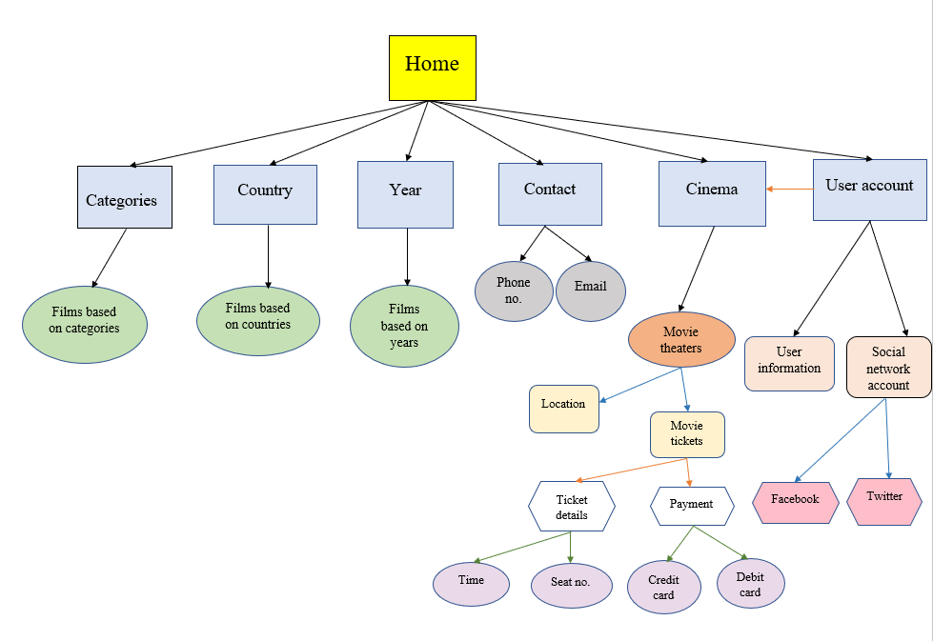

1. **Wireframes:**

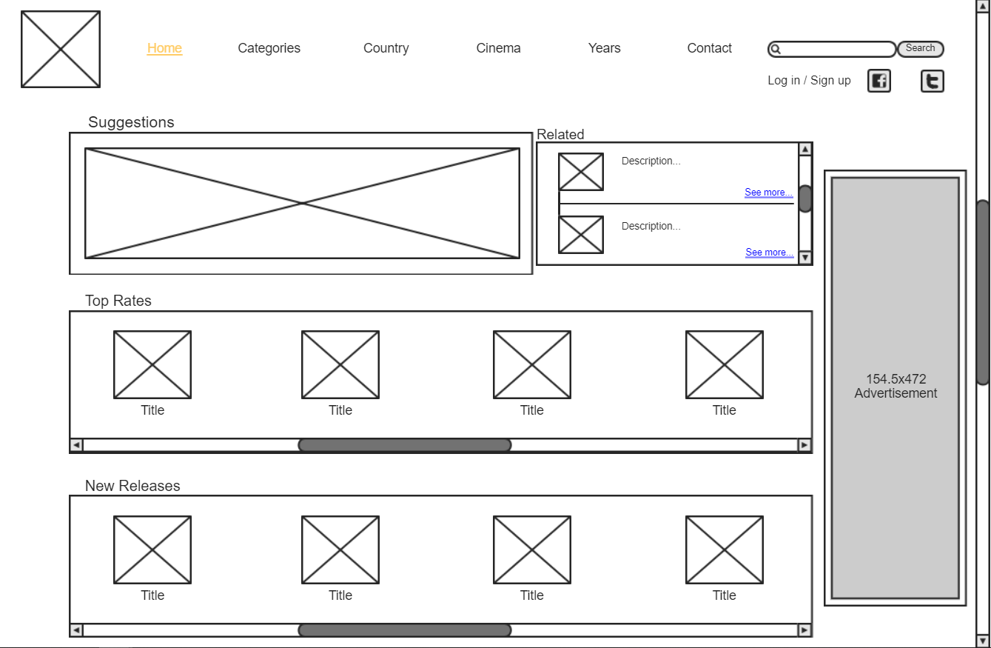

Home Page

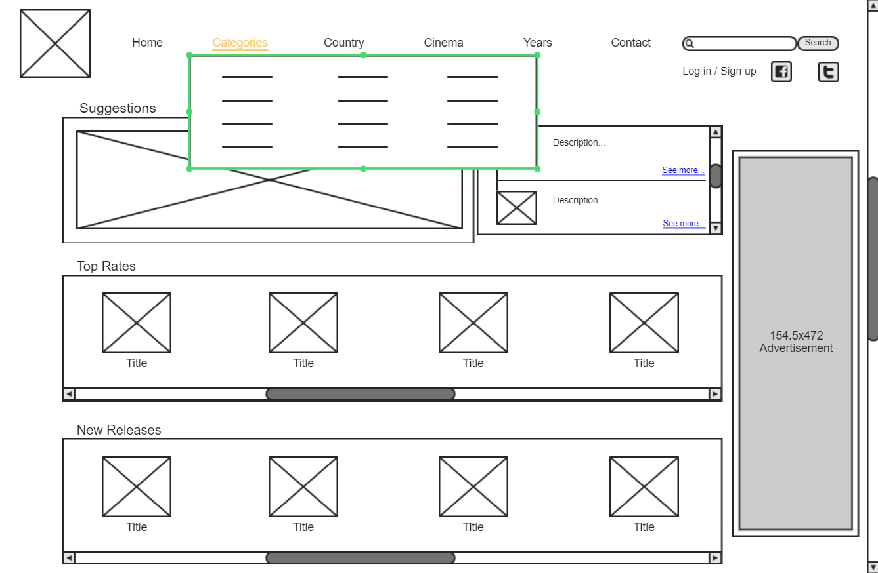

Categories Page

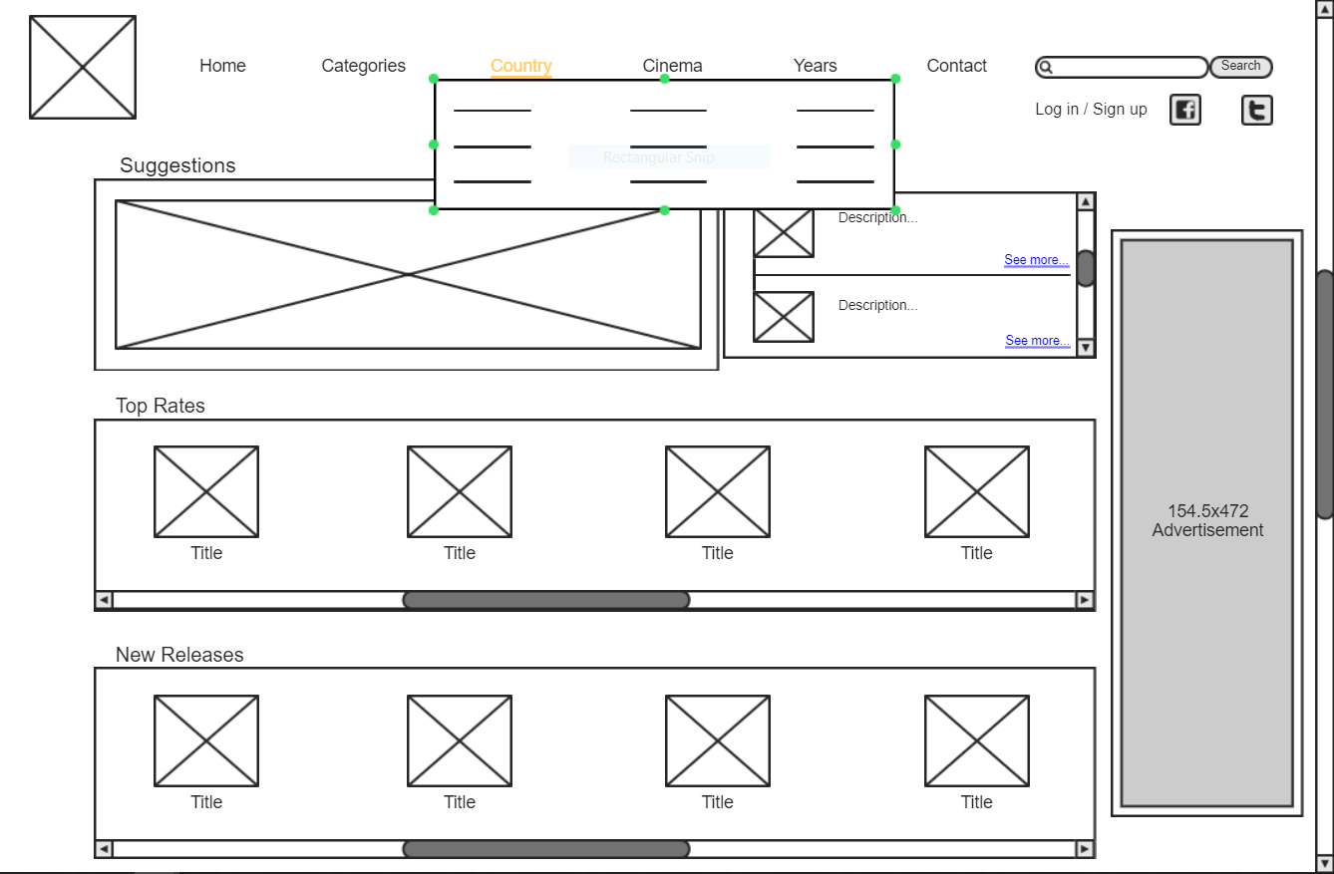

Country Page

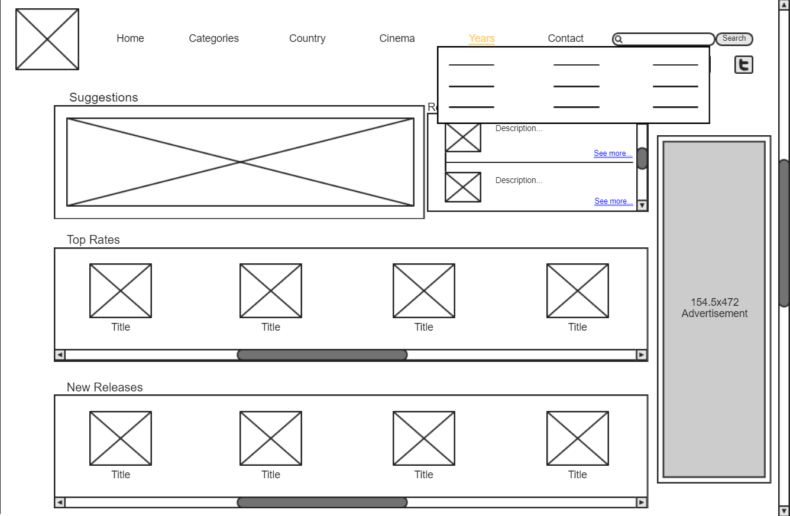

Year Page

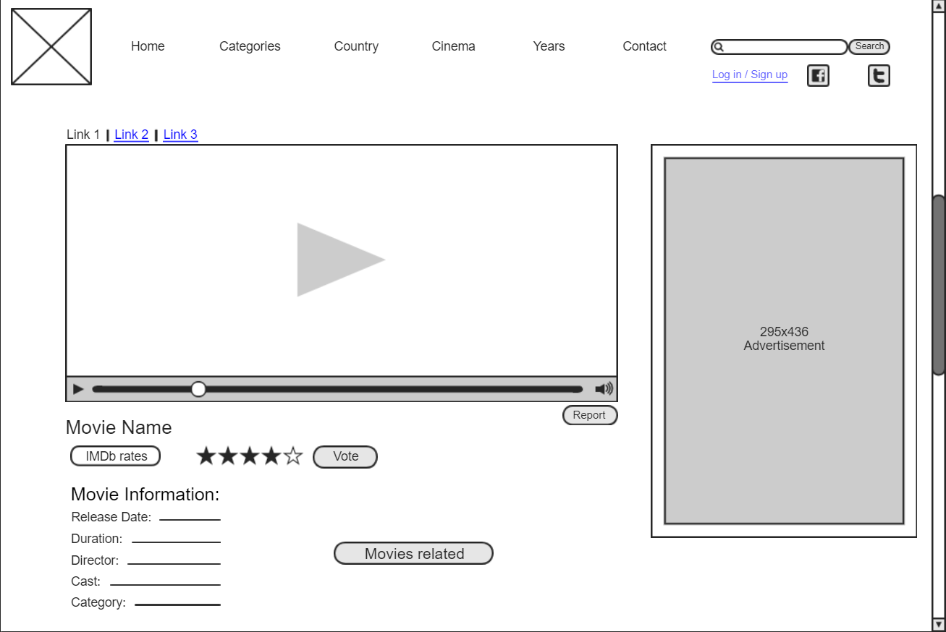

Watching Page

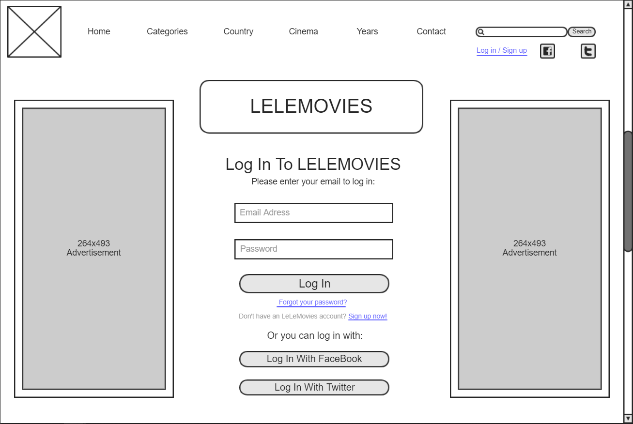

Log in / Sign up Page

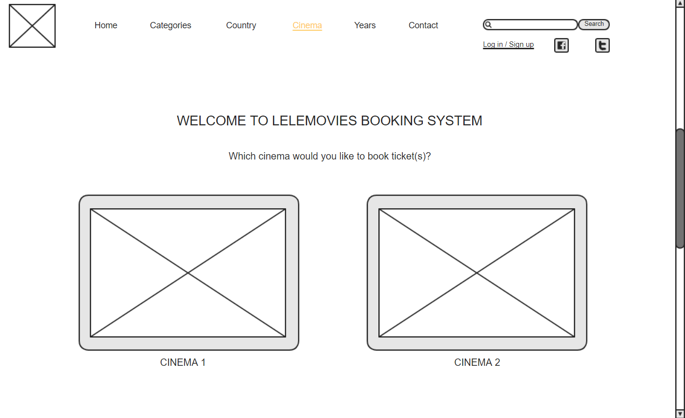

Booking Page

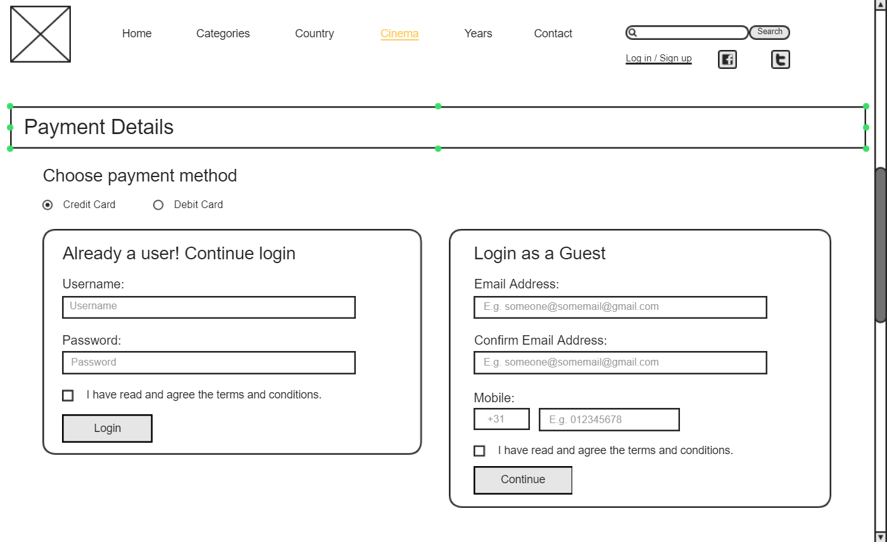

Payment Page

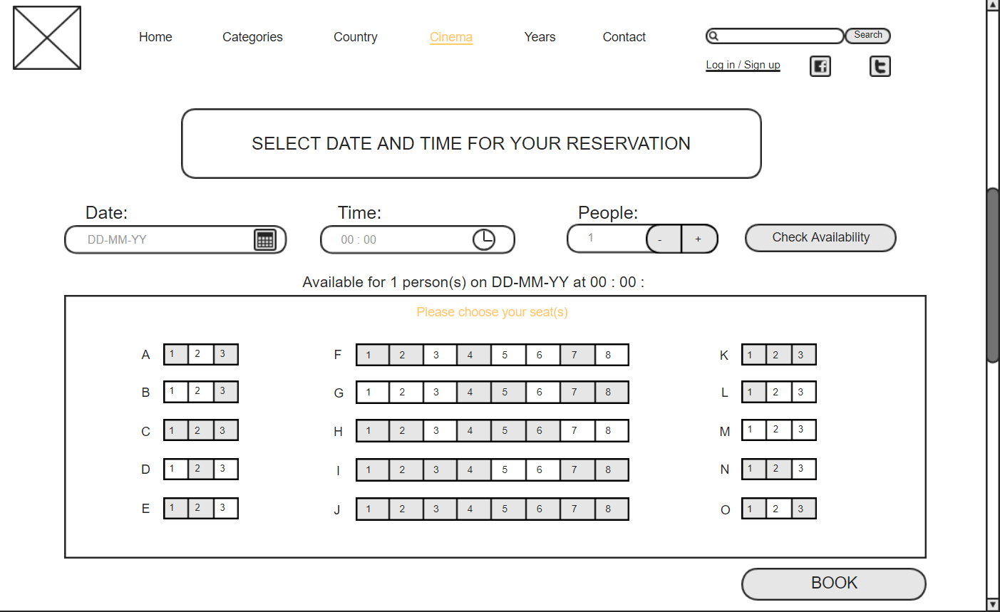

Ticket Details Page

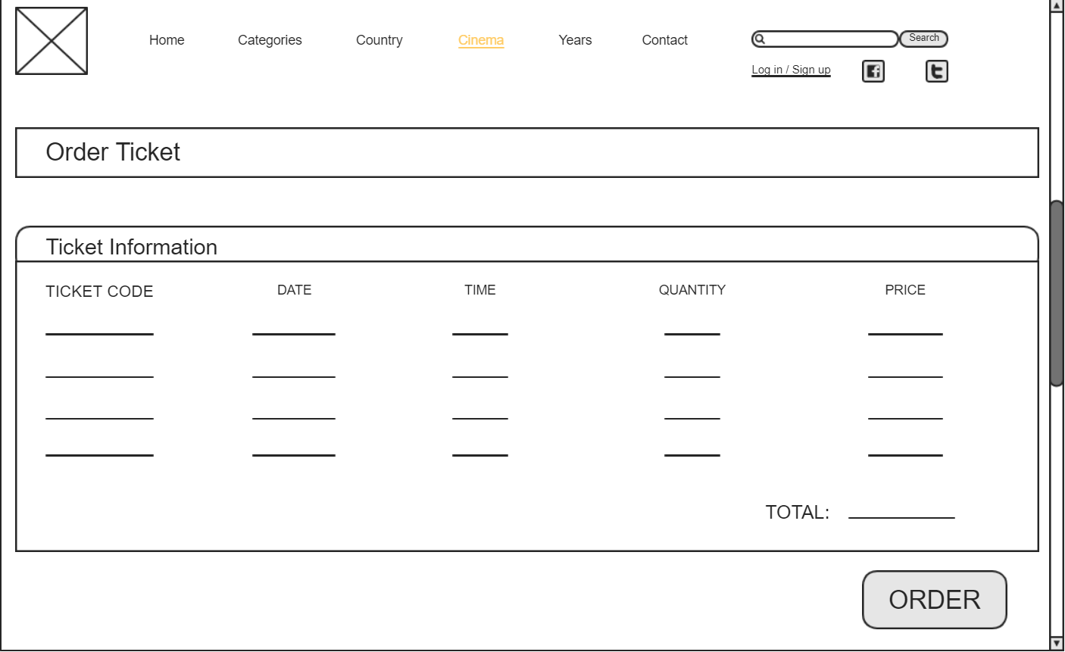

Confirmation Page

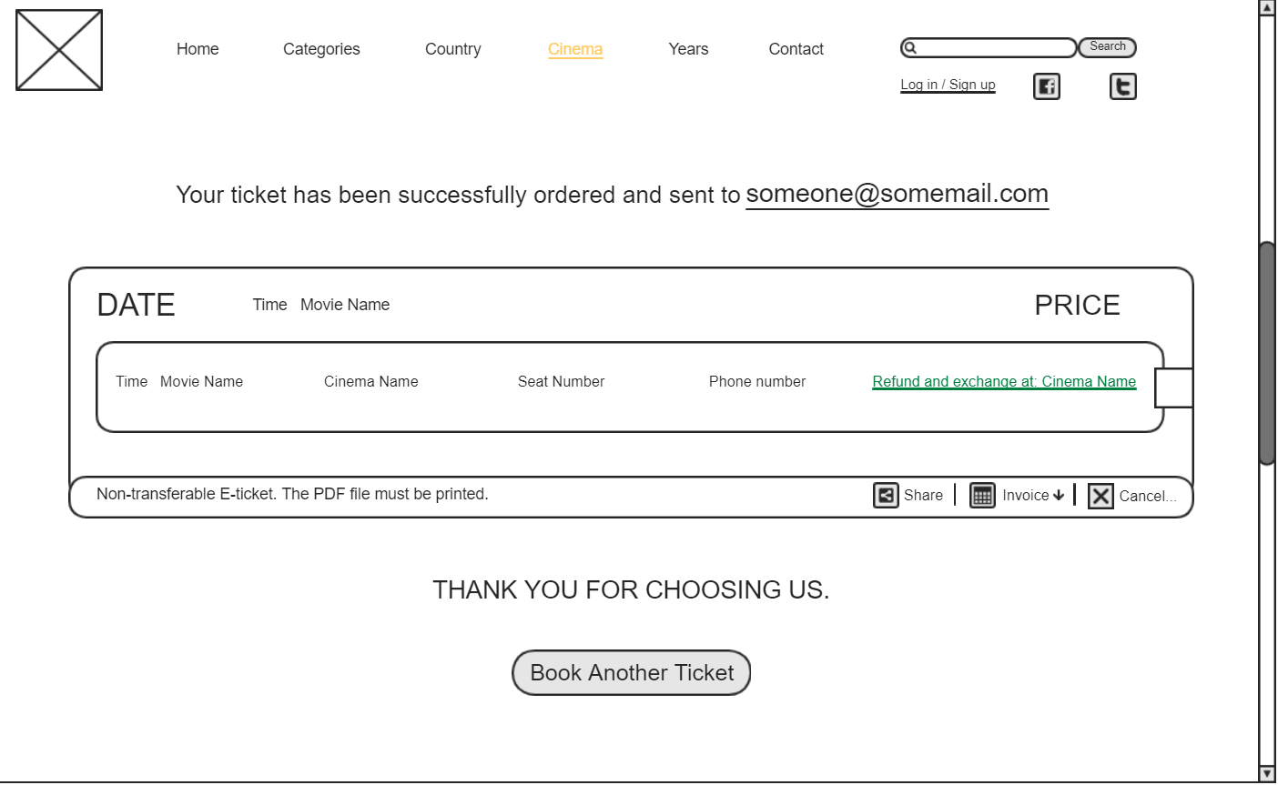

Order Result Page

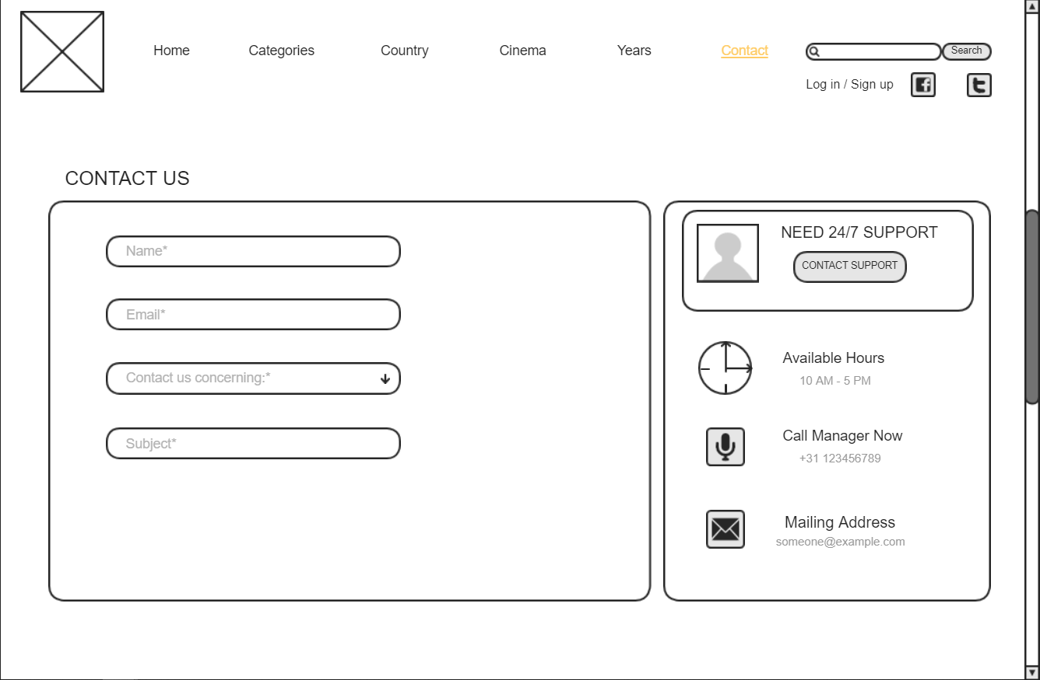

Contact Page

1. **Visual design:**

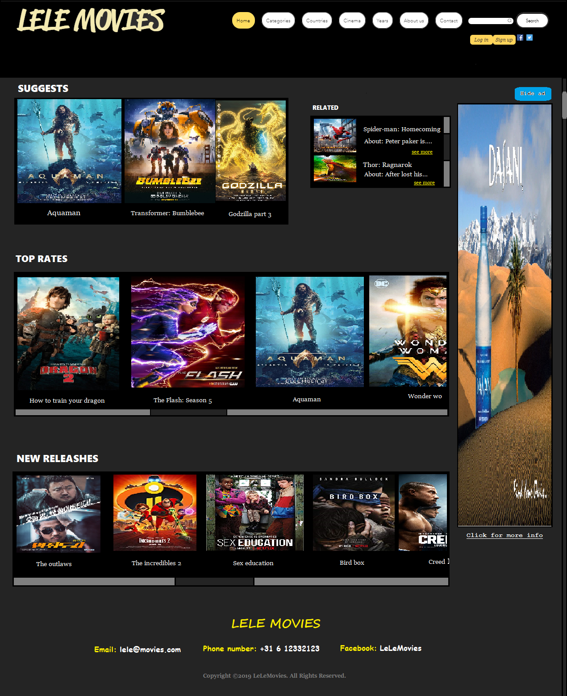

Home Page Design