**Final Project**

**Web Programming - Group E.D.I.T.H**

**Lecturer : PhD.Nguyen Duc Khoan**

**Course : Web Programming**

**Group’s member :**

|  |  |
| --- | --- |
| Nguyễn Xuân Nam | 17110056 |
| Đinh Quốc Thuỵ | 17110081 |

1. **Project Overview** 
   1. **Overview**

* The project is the kind of software management system of university include student, instructor , course, etc.. table. This project will let you know :
  + How to create a basic web application using MVC ( Model-View-Controller ).
  + CRUD method
  + How client-server work ?
  1. **Required Tools**
* Framework : Jquery , Bootstrap
* Languages : C#, HTML, CSS
* Cross-flatform : ASP.NET Core
  1. **Goal**
* Finished the project
* By using MVC model and CRUD method, our team have created tables with functions :
  + Student ( Create/Edit/Details/Delete )
  + Instructor ( Create/Select/Edit/Details/Delete)
  + Course(Create/Edit/Details/Delete)
  + Department(Create/Edit/Details/Delete)
  + Enrollment (Create/Edit/Details/Delete)
  + CourseAssignement(Create/Edit/Details/Delete)
* The project have user management and user authentication by using IdentityUser Class to create a login and register form
* The project can access related data from one table to another table

1. **Usecase** 
   1. **Login**

| **Use Case Name** | **Login** |
| --- | --- |
| Use case Description | A user login to System to access the functionality of the system. |
| Actors | Admin, Users |
| Pre-Condition | System must be connected to the network. |
| Post -Condition | After a successful login 🡪 return redirectly to public page |

| **Use Case Name** | **Register** |
| --- | --- |
| Use case Description | A user must go to register after login to System to access the functionality of the system if user don’t have an account |
| Actors | Users |
| Pre-Condition | System must be connected to the network. |
| Post -Condition | After a succesfull register 🡪 return redirectly to login |

* 1. **Register**
  2. **Create**

| **Use Case Name** | **Create** |
| --- | --- |
| Use case Description | Create new information for all table in database |
| Actors | Admin. |
| Pre-Condition | Only availaible when user login as Admin account |
| Post -Condition | After a successful login 🡪 A create link will show up for admin |

* 1. **Edit**

| **Use Case Name** | **Edit** |
| --- | --- |
| Use case Description | Edit information data that already have in database before |
| Actors | Admin, Users |
| Pre-Condition | Actors must be logged in login form first. |
| Post -Condition | After a successful login 🡪 Edit link will show up |

* 1. **Details**

| **Use Case Name** | **Login** |
| --- | --- |
| Use case Description | View information data of each table in database, include related access data from one table to another table |
| Actors | User, Admin |
| Pre-Condition | Actors must be logged in Login form first. If user don’t have an account, redirect return to Register form |
| Post -Condition | After a successful login 🡪 Details link will show up |

* 1. **Delete**

| **Use Case Name** | **Delete** |
| --- | --- |
| Use case Description | Delete information data of table from database. |
| Actors | Admin |
| Pre-Condition | Actor must have logged in Login form as Admin account .If actor not an admin, they won’t have permission to delete |
| Post -Condition | After a successful login 🡪 Delete link will show up |

* 1. **Select**

| **Use Case Name** | **Select** |
| --- | --- |
| Use case Description | Select a course for instructor to teach in Instructor View |
| Actors | Admin |
| Pre-Condition | Actor must have logged in Login form as Admin account .If actor not an admin, they won’t have permission to delete |
| Post -Condition | After a successful login 🡪 Select link will show up |

* 1. **Usecase diagram for user and admin**

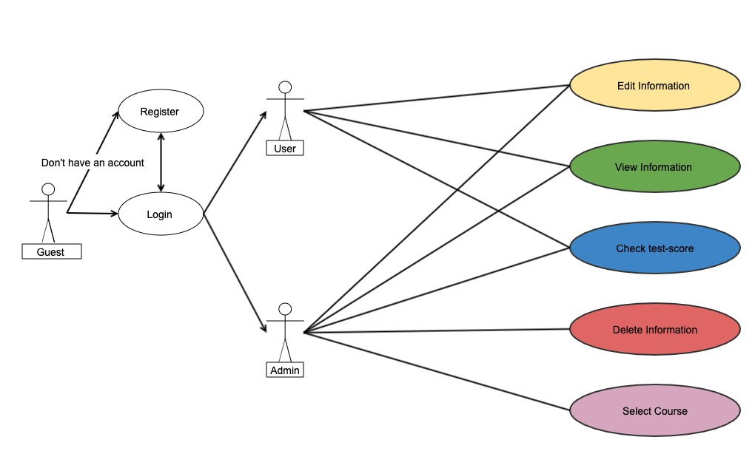

1. **Class Diagram** 
   1. **UTE University System class diagram**

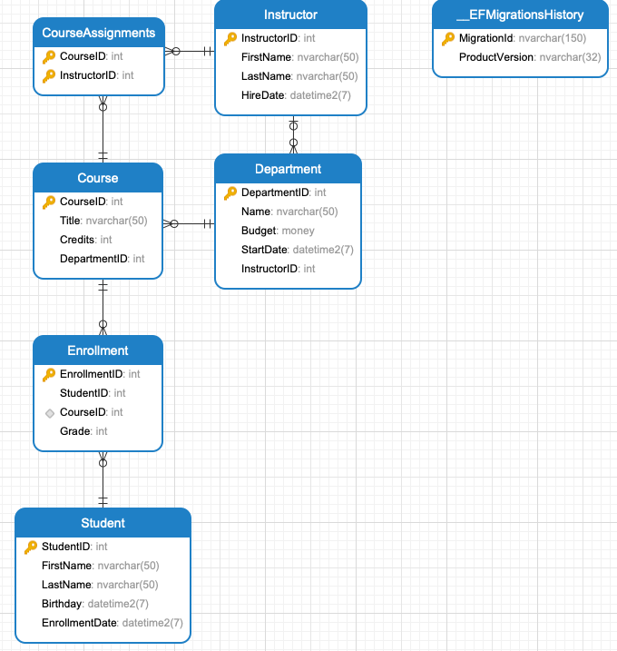

* 1. **IdentityUser class diagram**

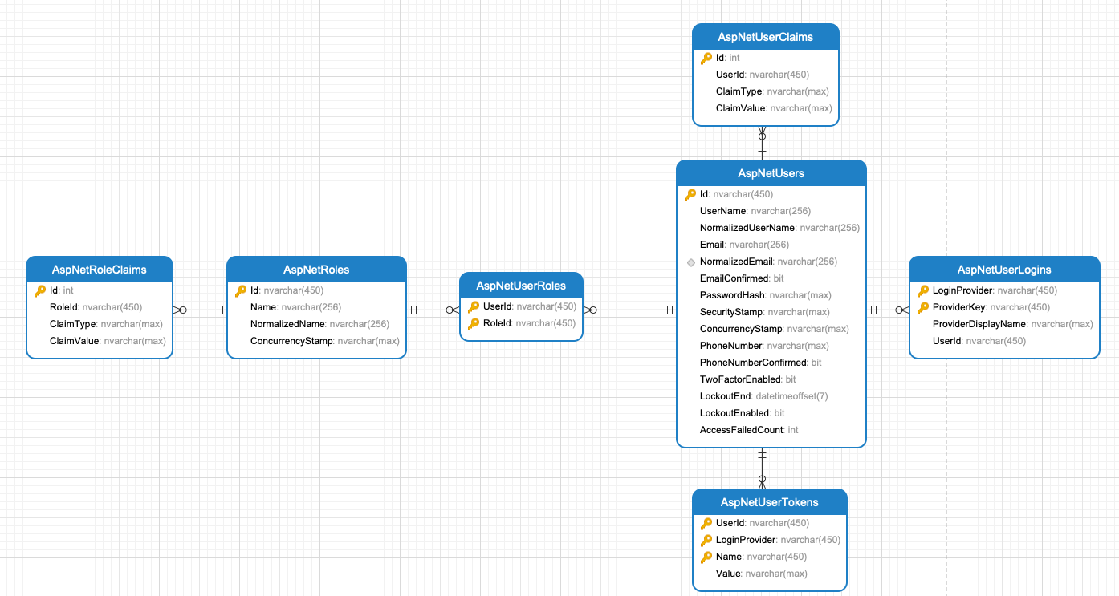

1. **ERD ( Enity_Relationship_Diagram)**

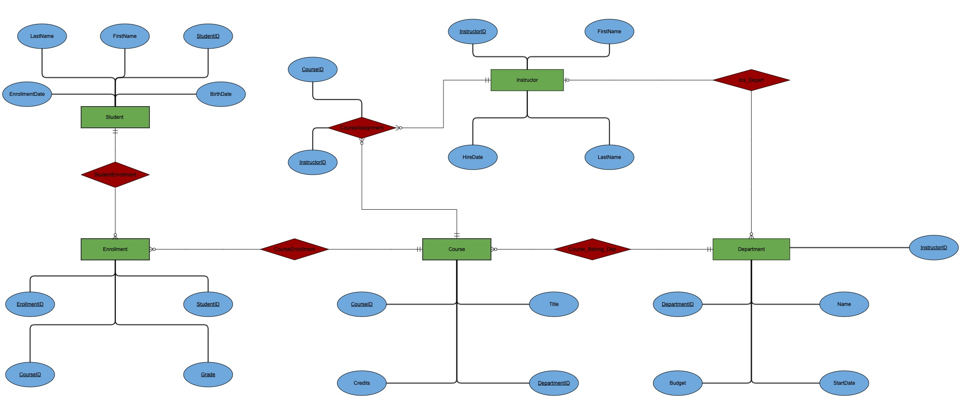

**\*Note :**

**: Entity : Relationship**

**: Attributes**

1. **Work Assignment**

|  |  |
| --- | --- |
| **Name** | **Assignment** |
| **Nguyễn Xuân Nam** | **- Add login, register , instructor page**  **- Create a mange page include : manage roles and manage users**  **-Create forgot, reset password page** |
| **Đinh Quốc Thuỵ** | **Add course ,student,department functions**  **- Adding html,css, javascript template for public page** |

1. **Screenshot** 
   1. **Login Page**

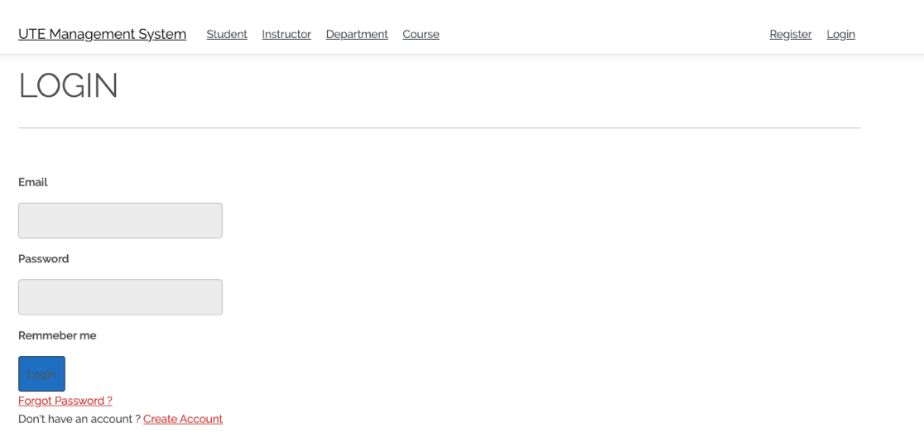

* 1. **Register Page** 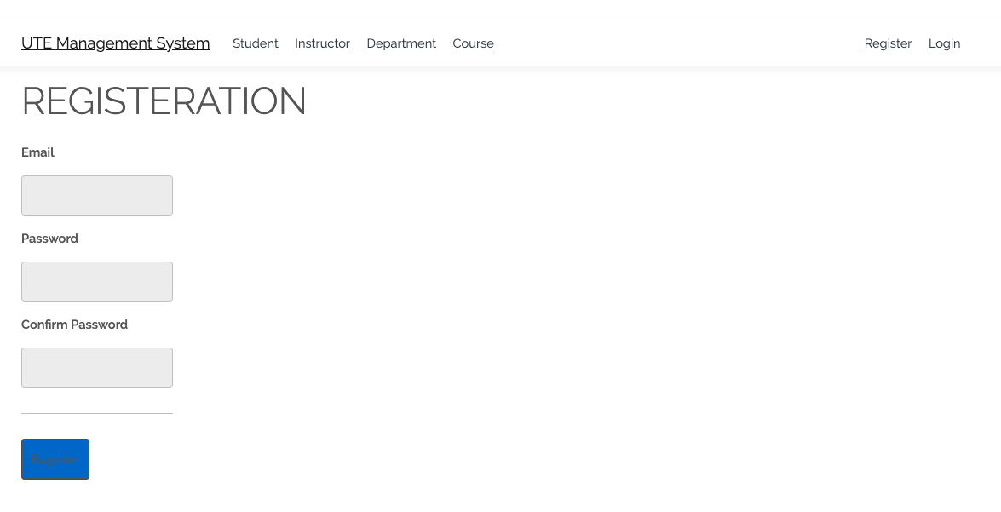
  2. **Public Page**

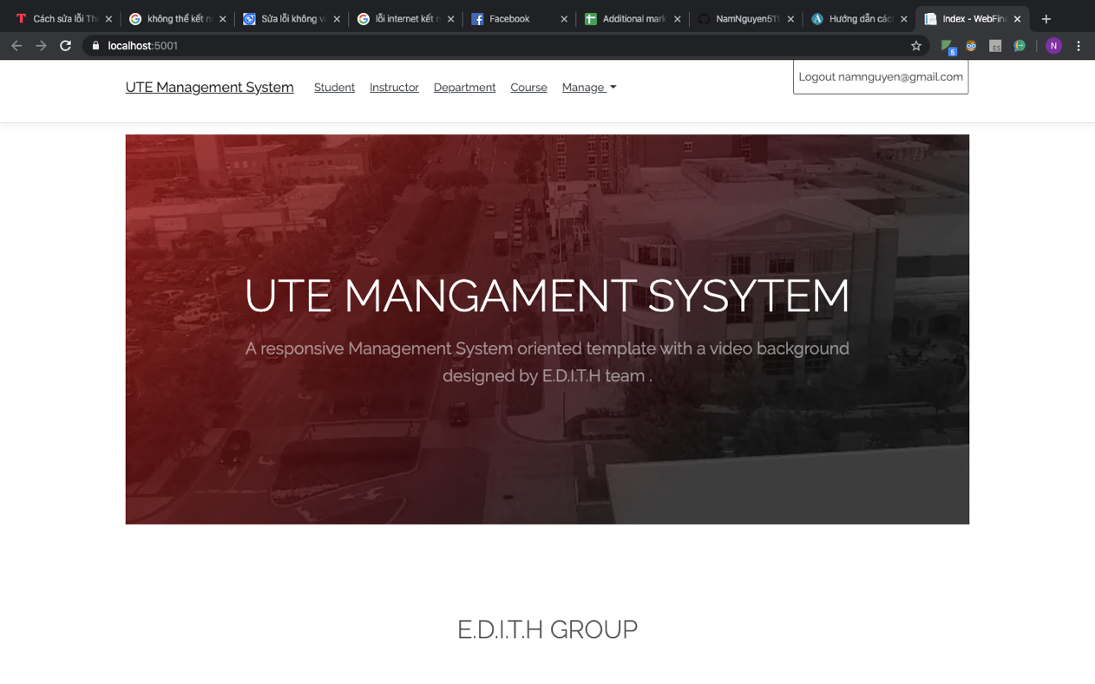

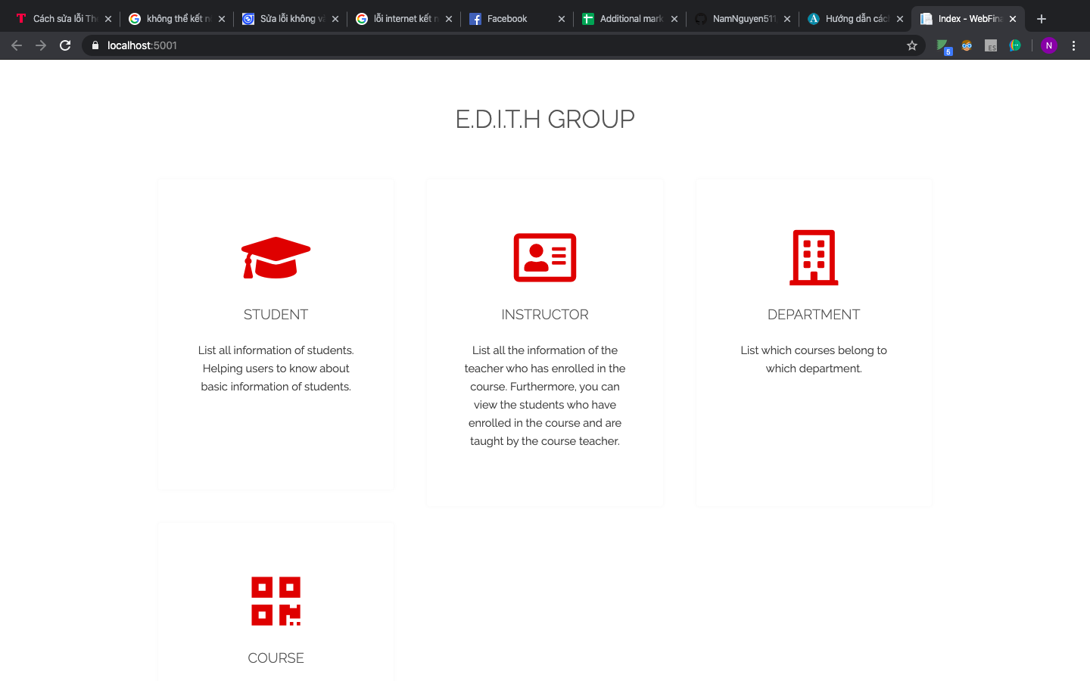

* 1. **Student Page**

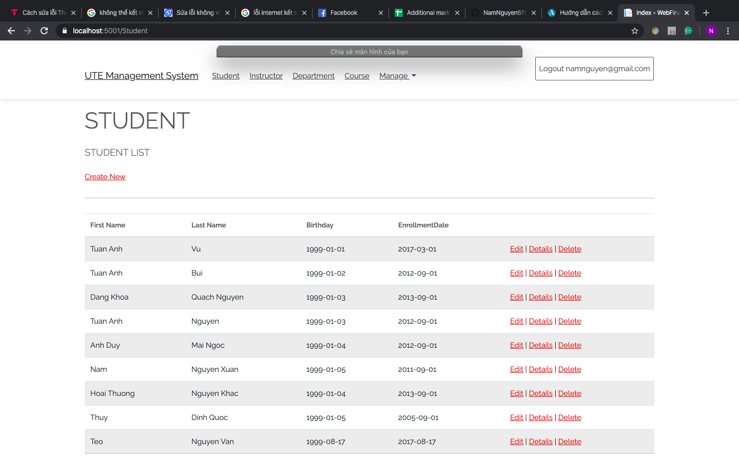

* 1. **Instructor Page**

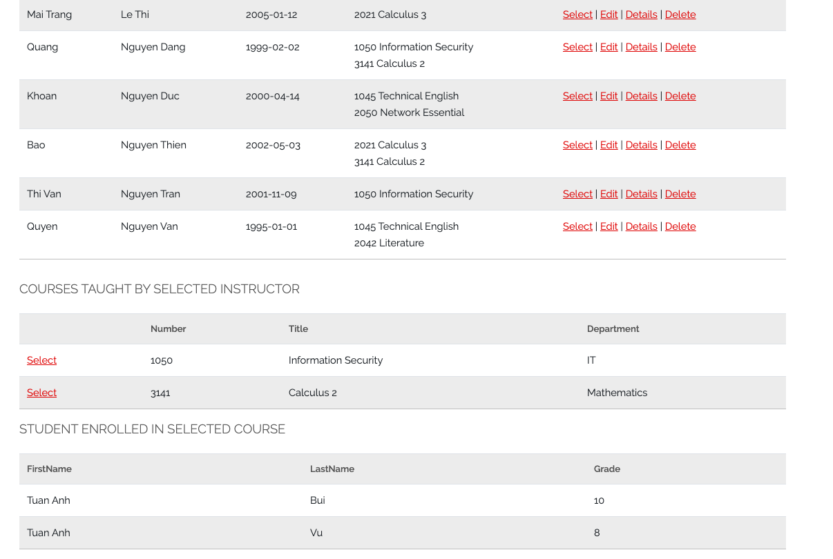

* 1. **Department Page**

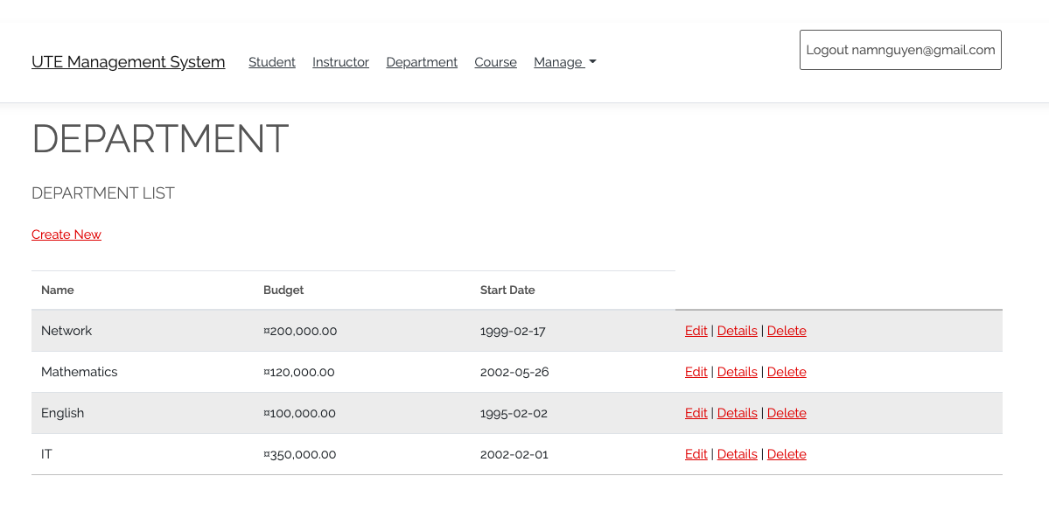

* 1. **Course Page**

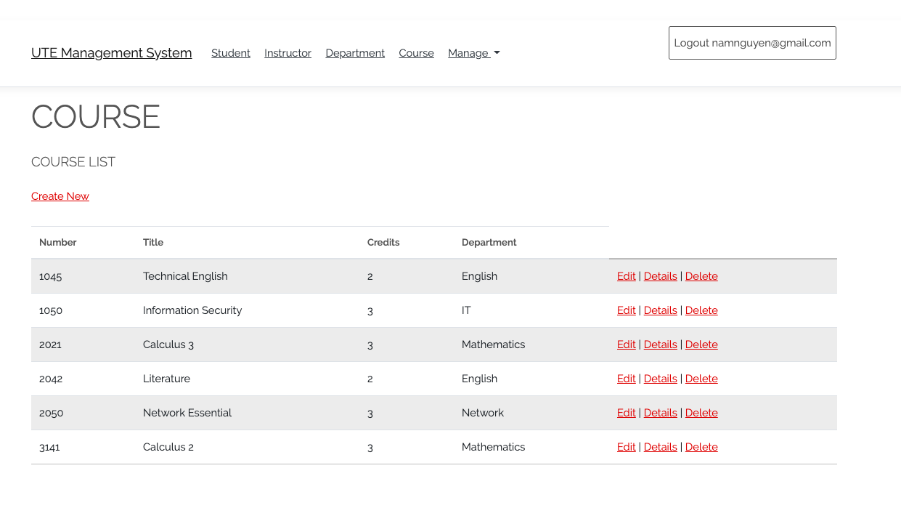

* 1. **Manage Page**
     1. **User Page**

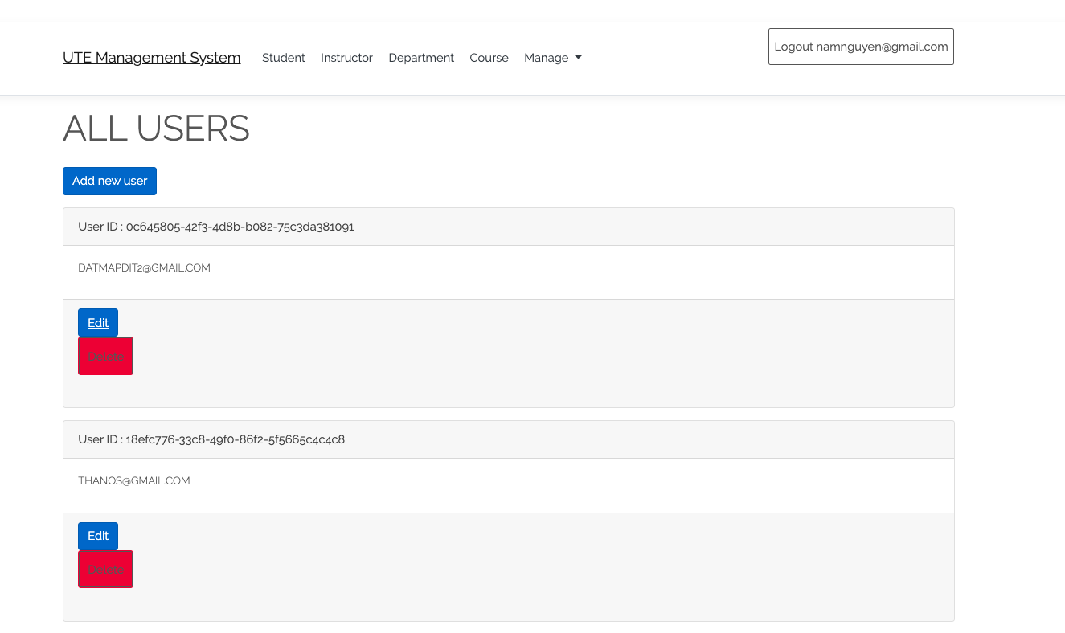

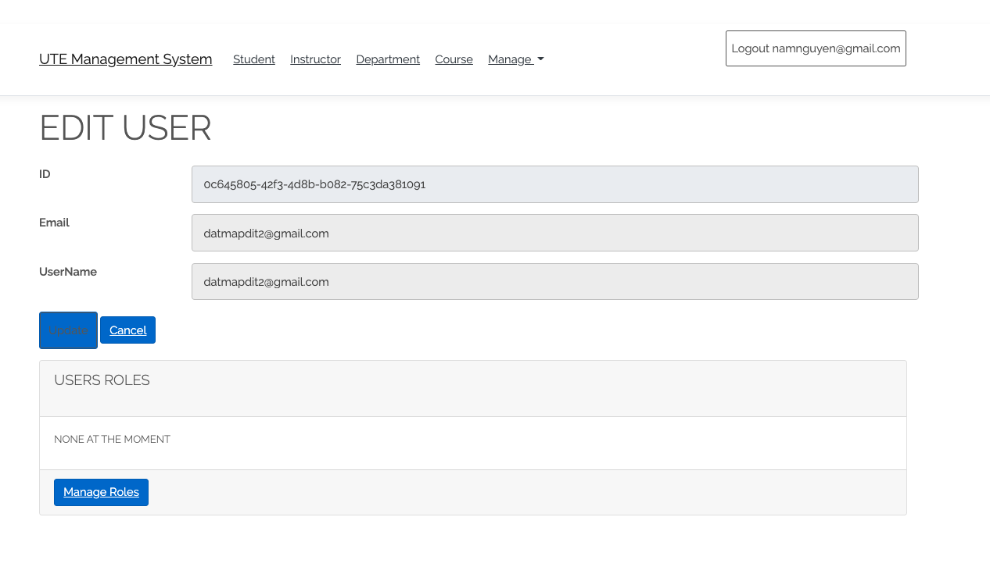

* + 1. **Role Page**

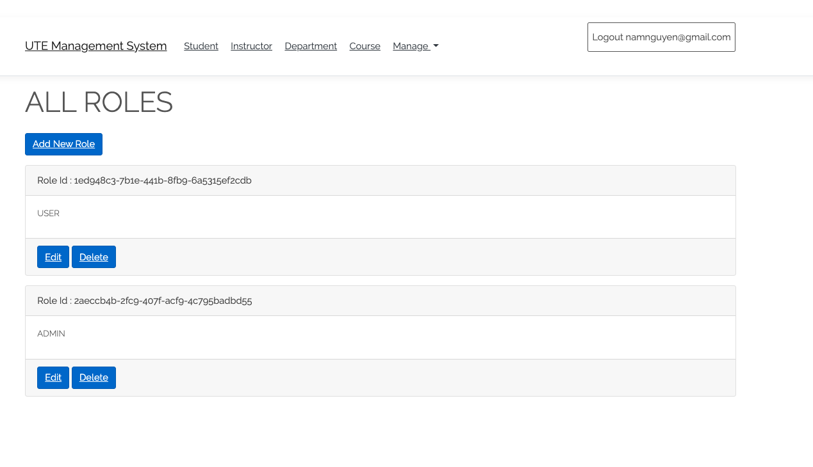

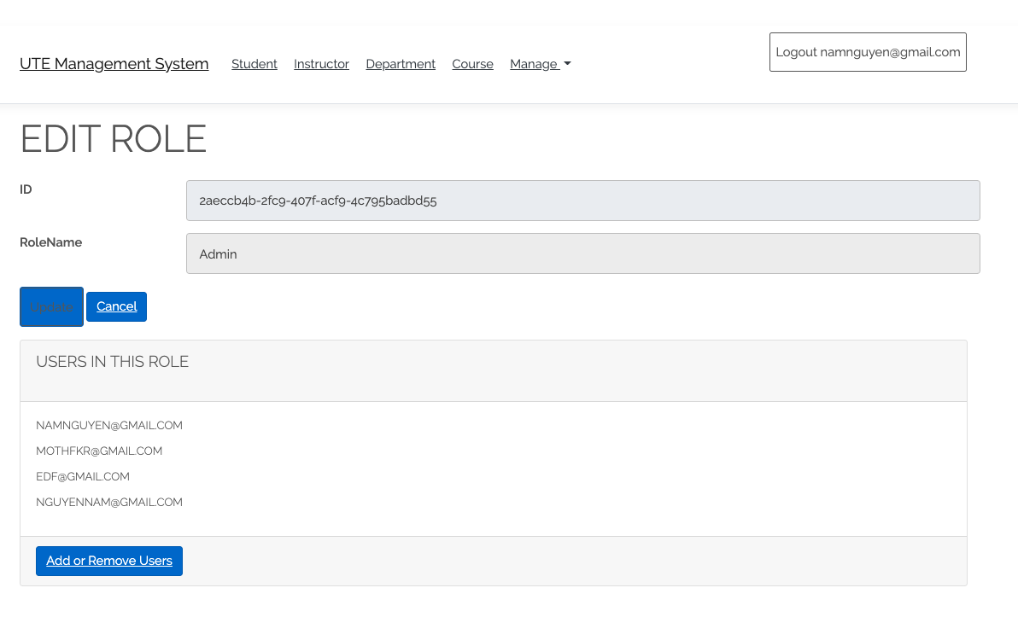

* 1. **Reset Password Page**

