FEASIBILITY REPORT

Skincare Product Sales System - Skinora
Prepared by: Nguyen Tan Nam – Nguyen Hoang Hao
Date: 06/12/2025

1. Executive Summary
This feasibility report evaluates the viability of developing a Skincare Product Sales System, consisting of an e-commerce website, backend services, administrative management tools, and integrated payment and delivery services.
The analysis covers technical, operational, economic, schedule, and risk aspects to determine whether the project should proceed to development.
Findings show that:
- The system is technically feasible using standard, proven technologies.
- Operational requirements are minimal and manageable.
- The total development cost is estimated at 98M–110M VND, a competitive market rate.
- Monthly operating costs are low, ensuring sustainability.
Therefore, the project is recommended for approval.

2. Project Background
The skincare market has grown rapidly, and businesses require digital platforms to expand their customer reach, manage products efficiently, and automate sales processes.
Current manual or semi-digital methods often lead to:
- Poor inventory control
- High staff workload
- Errors in order processing
- Limited marketing analytics
- Inconsistent customer experience
A dedicated Skincare Product Sales System addresses these challenges by providing end-to-end digital sales and management capabilities.

3. Problem Statement
Businesses selling skincare products face the following issues:
- No unified system to manage products, stock, customers, and orders
- Difficulty integrating multiple payment and shipping channels
- Inaccurate order tracking and delayed customer updates
- Lack of real-time analytics for decision-making
The proposed system solves these problems through automation and centralized management.

4. Project Objectives
The main objectives of the project include:
- Create a user-friendly e-commerce platform for selling skincare products.
- Provide an admin dashboard for managing inventory, orders, customers, and promotions.
- Integrate payment gateways and delivery services.
- Improve operational efficiency and reduce manual workload.
- Offer analytics for product performance and business decision-making.

5. Stakeholder Analysis
Stakeholder | Role | Interest
Business Owner | Sponsor | Revenue growth, efficiency
Project Manager | Coordinator | Ensure deliverables and deadlines
Development Team | Implementers | Technical execution
Warehouse Staff | Operations | Inventory accuracy
Marketing Team | Promotion | Campaign performance
Customers | End-users | Easy buying experience

6. Scope of the Project

6.1 In-Scope
- E-commerce website (frontend)
- Backend API & database
- Admin dashboard
- Payment gateway integration
- Shipping API integration
- UI/UX design
- Testing & deployment
- Documentation & training

6.2 Out-of-Scope
- Mobile native app
- Loyalty system phase 2
- ERP/Accounting integration
- Physical warehousing services

7. System Requirements

7.1 Functional Requirements

Website
- User registration/login
- Product browsing, filtering, and searching
- Shopping cart and checkout
- Order tracking
- Review

Admin Dashboard
- Product CRUD
- Inventory management
- Order processing
- Customer management
- Discount
- Sales reports

7.2 Non-Functional Requirements
- High availability
- Secure payment processing
- Scalability
- Fast response time
- Modern UI/UX
- Data backup & recovery

8. Technical Feasibility
The proposed system can be implemented using widely available technologies, reducing risk and ensuring maintainability.

Recommended Technology Stack
- Frontend: ReactJS / Next.js
- Backend: Node.js (Express/NestJS) or ASP.NET Core
- Database: MySQL / PostgreSQL
- Hosting: DigitalOcean / Vultr / AWS Lightsail
- Security: HTTPS, JWT, OWASP compliance

Assessment
Criteria |  | Feasibility
Technology Availability |  | High
Existing Expertise |  | High
Scalability |  | High
Integration Complexity |  | Medium
Security Requirements |  | Medium
Conclusion: Technically feasible with low risk.

9. Operational Feasibility
The system significantly simplifies business operations:
- Automation of order processing
- Improved accuracy in inventory tracking
- Reduced customer service workload
- Easy-to-use dashboard for employees
Minimal staff training is required due to an intuitive interface.
Conclusion: Operational feasibility is high.

10. Economic Feasibility
This section evaluates the total cost of development and ongoing operations.

10.1 Development Cost Estimate
Component | Cost (Low) | Cost (High)
Customer Website (Frontend) | 18,000,000 | 25,000,000
Admin Dashboard | 25,000,000 | 35,000,000
Backend API + Database | 20,000,000 | 30,000,000
Payment Integration | 4,000,000 | 7,000,000
Shipping Integration | 4,000,000 | 7,000,000
UI/UX Design | 6,000,000 | 12,000,000
Testing & Deployment | 6,000,000 | 10,000,000
Total Cost | 83,000,000 | 126,000,000

Recommended Project Price
98,000,000 – 110,000,000 VND
(Competitive market price with full features + 3 months support)

10.2 Operating Cost (Monthly)
Item | Cost
VPS Hosting | 200,000 – 300,000 VND
Domain | 300,000 – 500,000 VND/year
Email SMTP | 100,000 – 200,000 VND
Estimated Total | 250,000 – 500,000 VND/month
Operating cost feasibility: High

11. Schedule Feasibility
Estimated timeline: 10–12 weeks
Phase | Duration
Requirements & Planning | 1 week
UI/UX Design | 2 weeks
Backend Development | 3 weeks
Frontend Development | 3 weeks
Integration (Payment + Shipping) | 1 week
Testing & Deployment | 1–2 weeks
Schedule feasibility: High

12. Risk Analysis
Risk | Probability | Impact | Mitigation
Integration API failures | Medium | Medium | Use fallback, retry mechanism
Requirement changes | High | High | Early documentation & sign-off
Security threats | Medium | High | Penetration testing, secure coding
Hosting downtime | Low | Medium | Choose reliable VPS provider
User adoption resistance | Low | Low | Provide training & simplified UI
Overall risk: Moderate, manageable with mitigation strategies.

13. Conclusion
The feasibility study concludes that the Skincare Product Sales System is a viable project from technical, operational, economic, and scheduling standpoints.
With a reasonable investment of 98M–110M VND, the system will provide long-term business value, improved efficiency, and enhanced customer experience.
The recommendation is to proceed with development.

14. Appendix
- Usecase Diagram

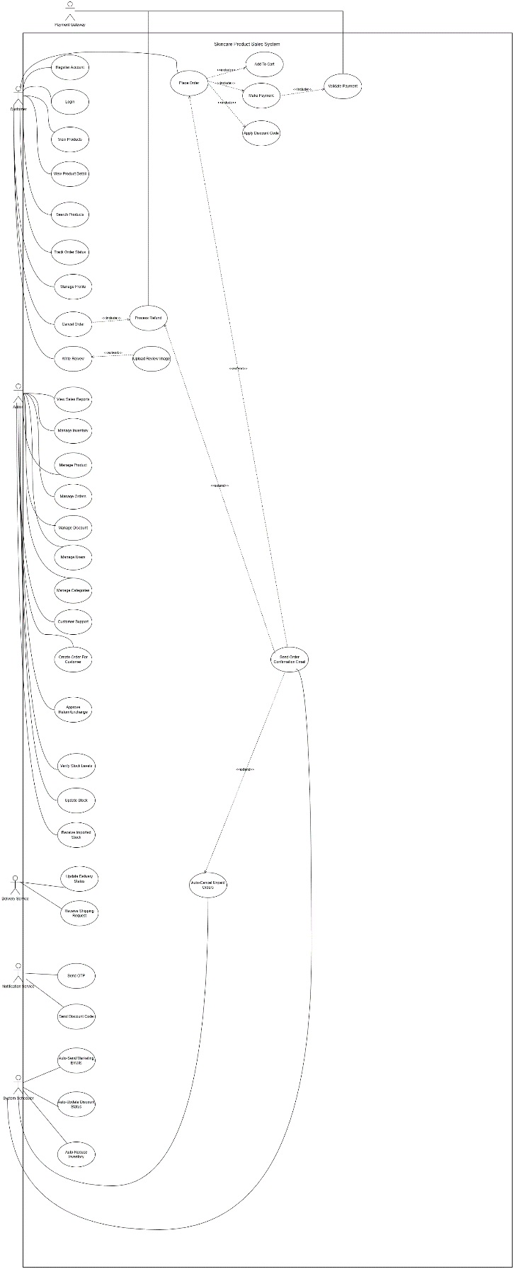
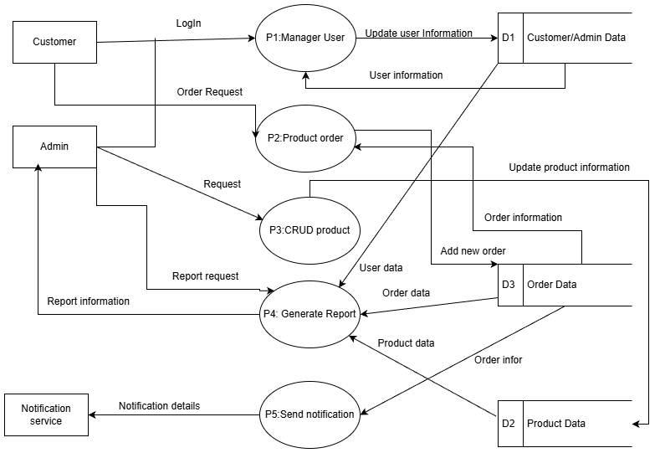
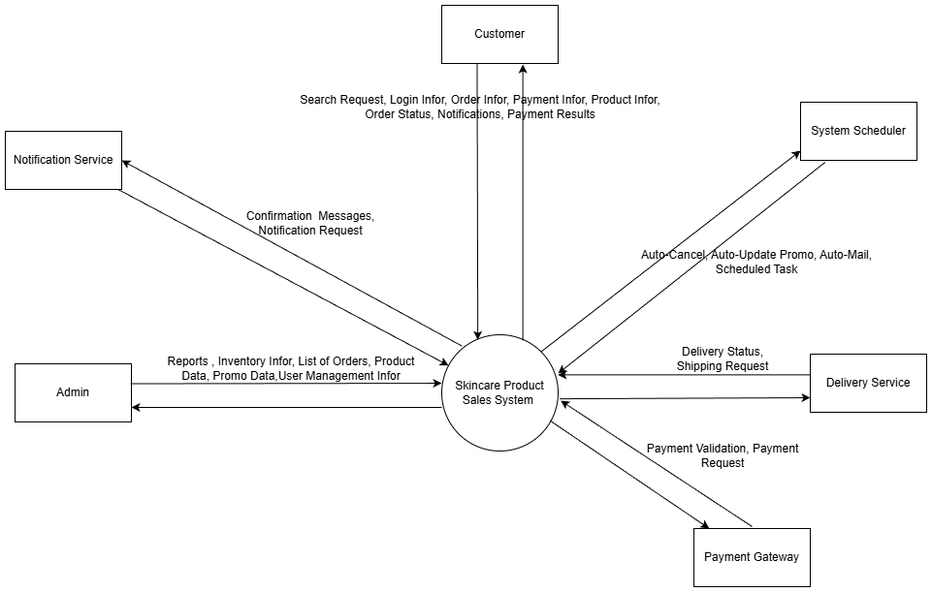
- Data Flow Diagram

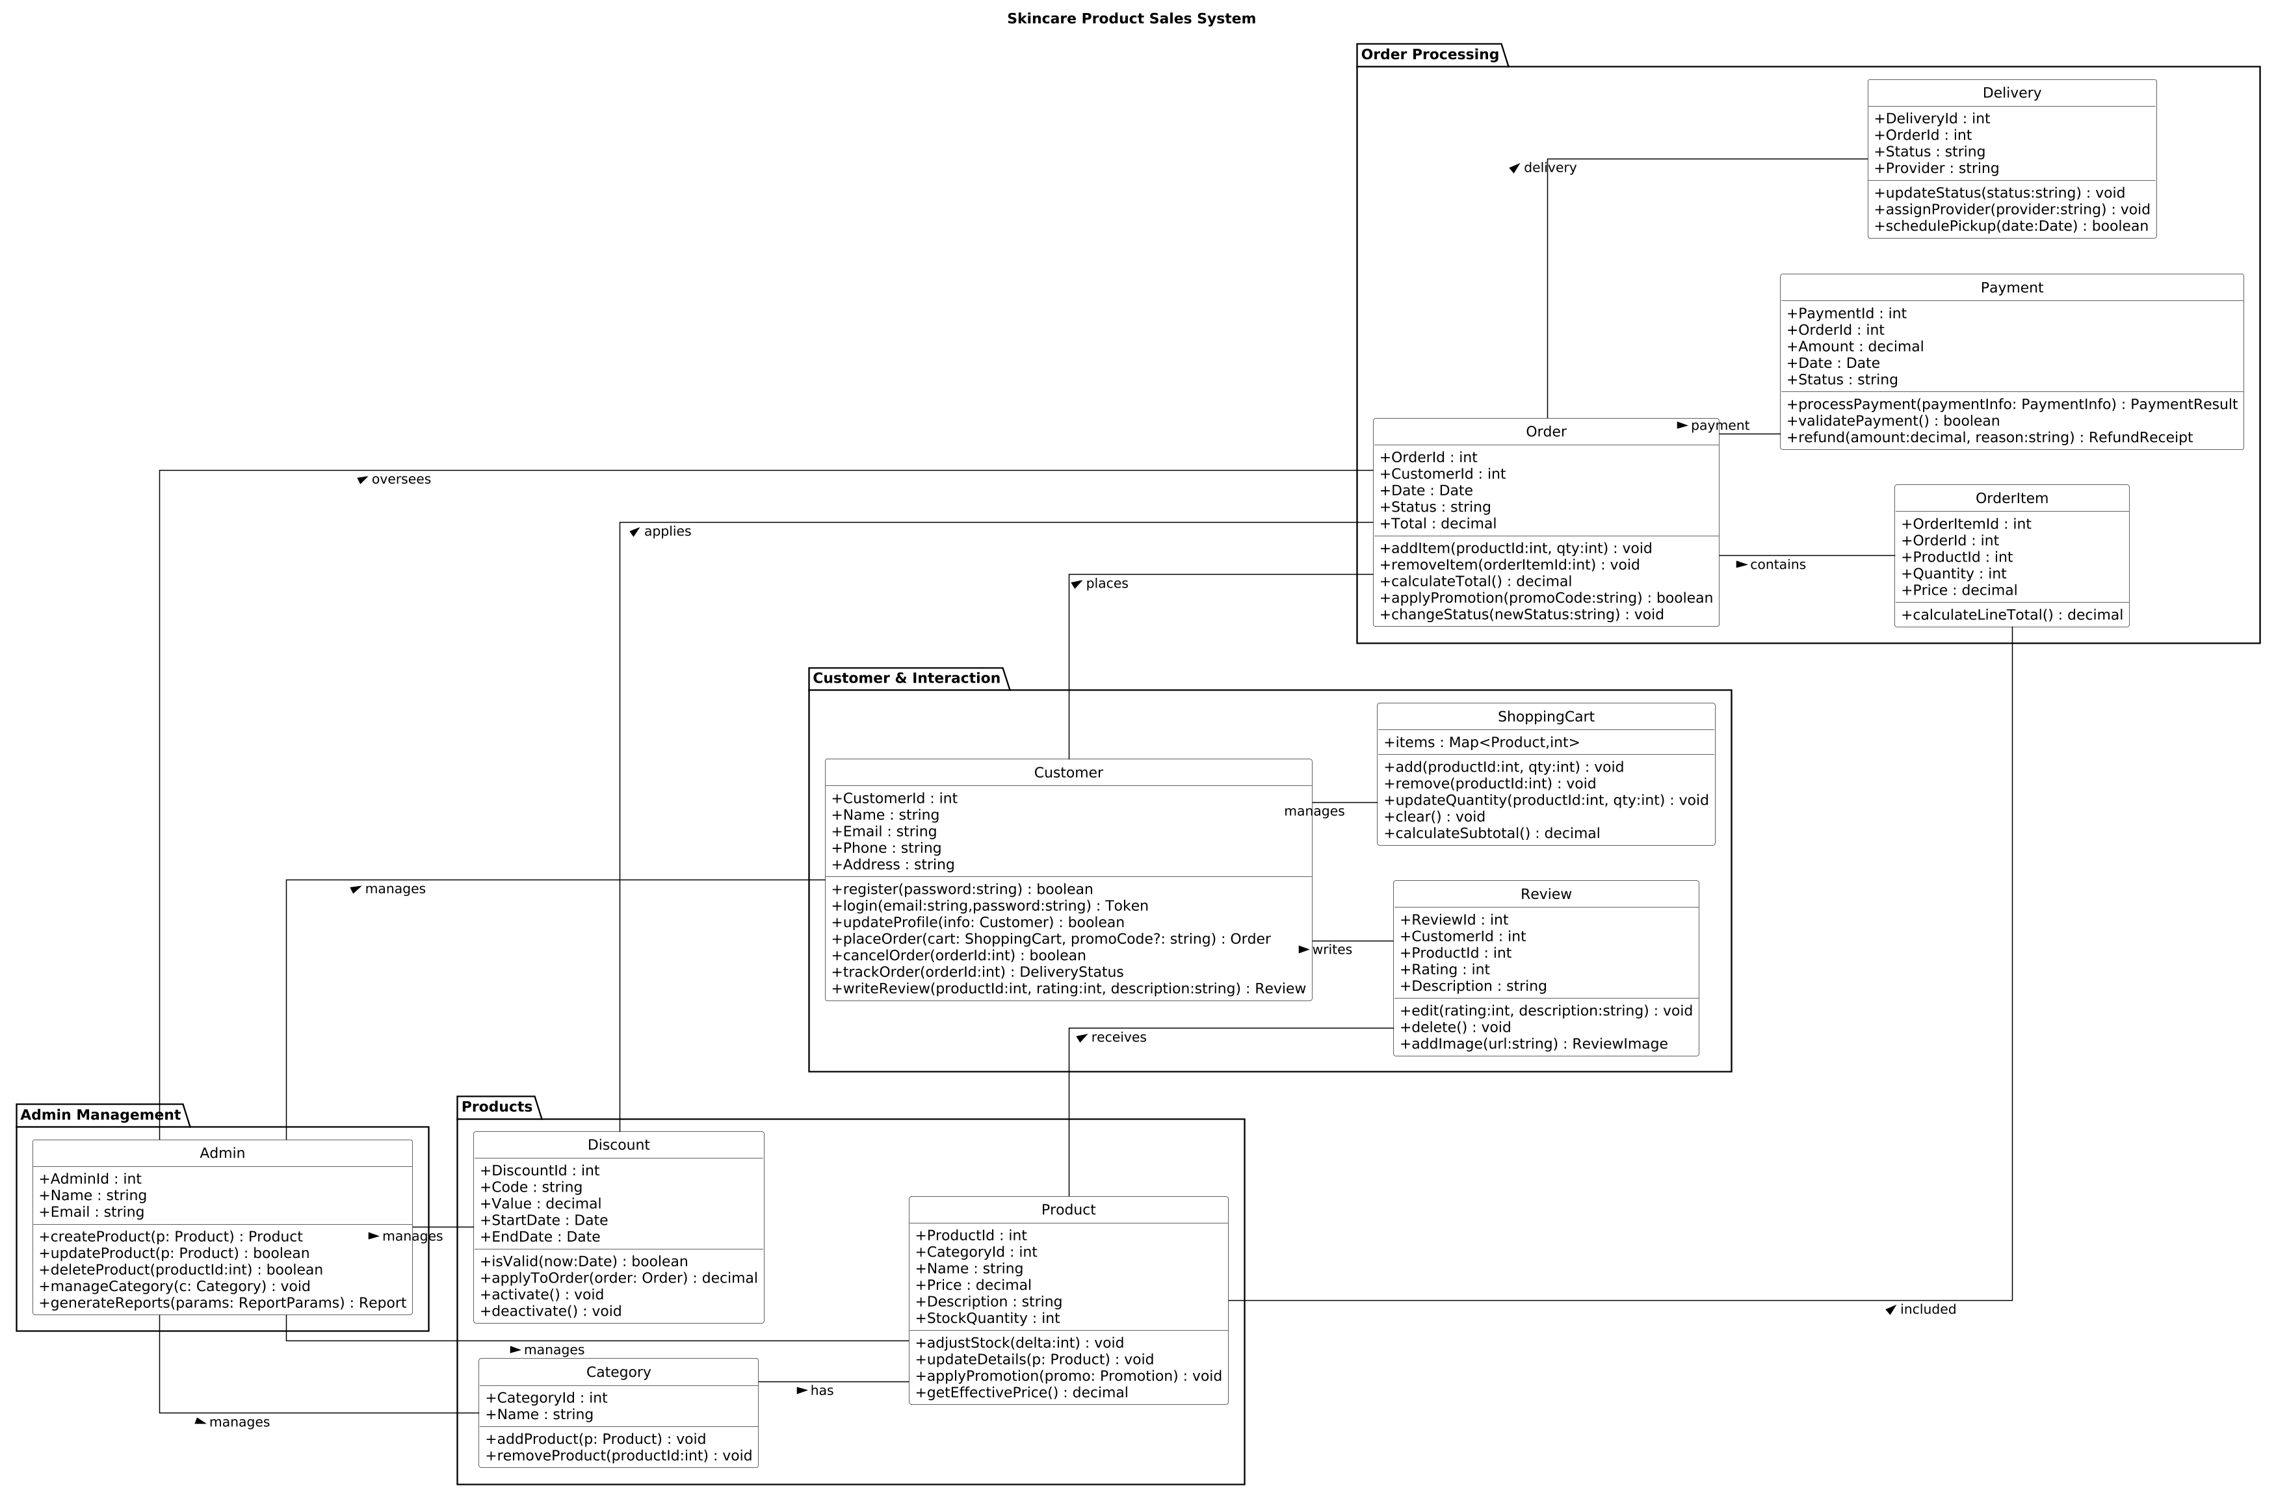
- Class Diagram

- Entity Relationship Diagram

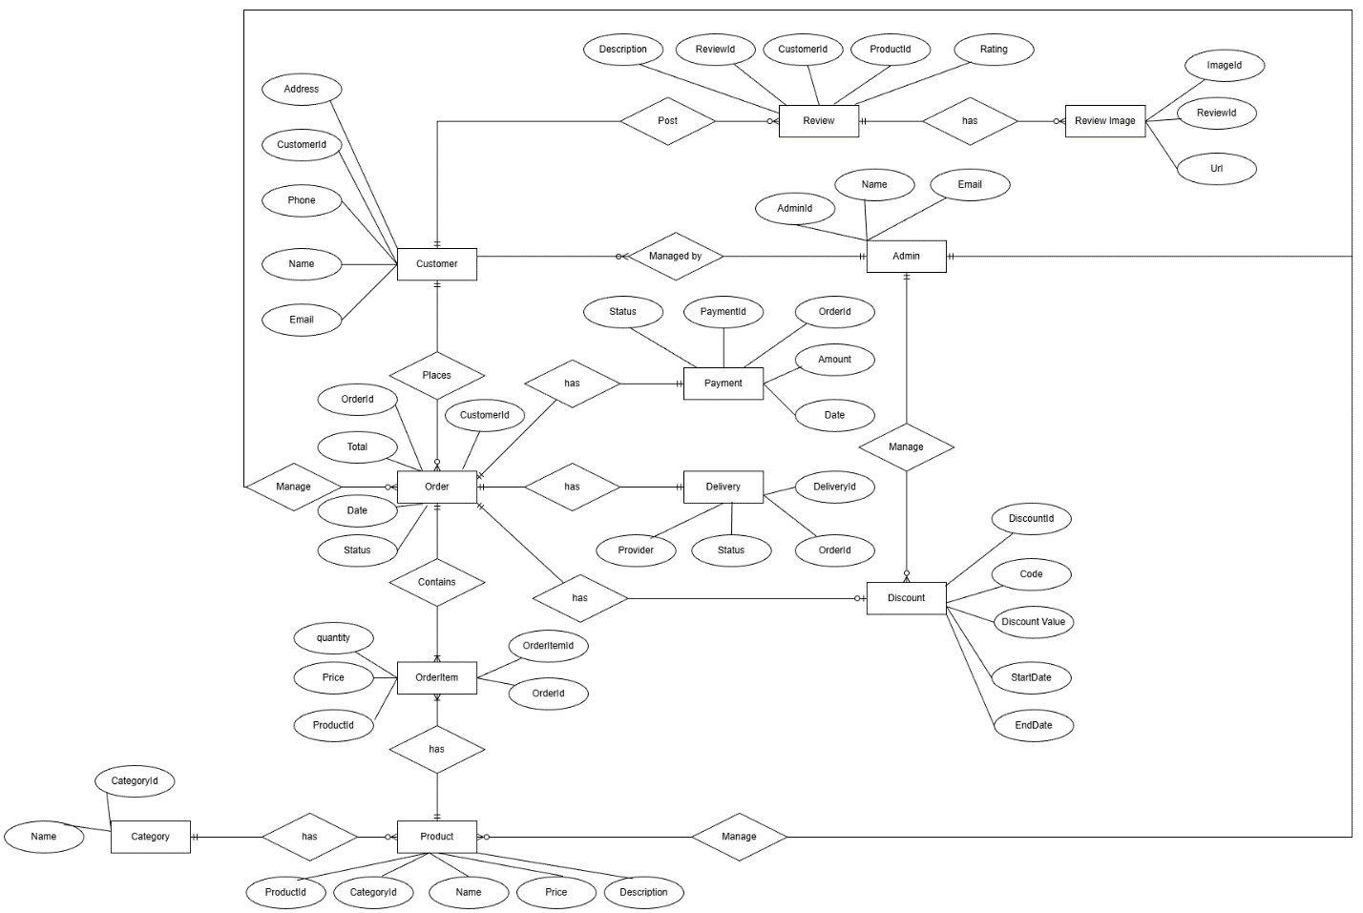
- Sequence Diagram
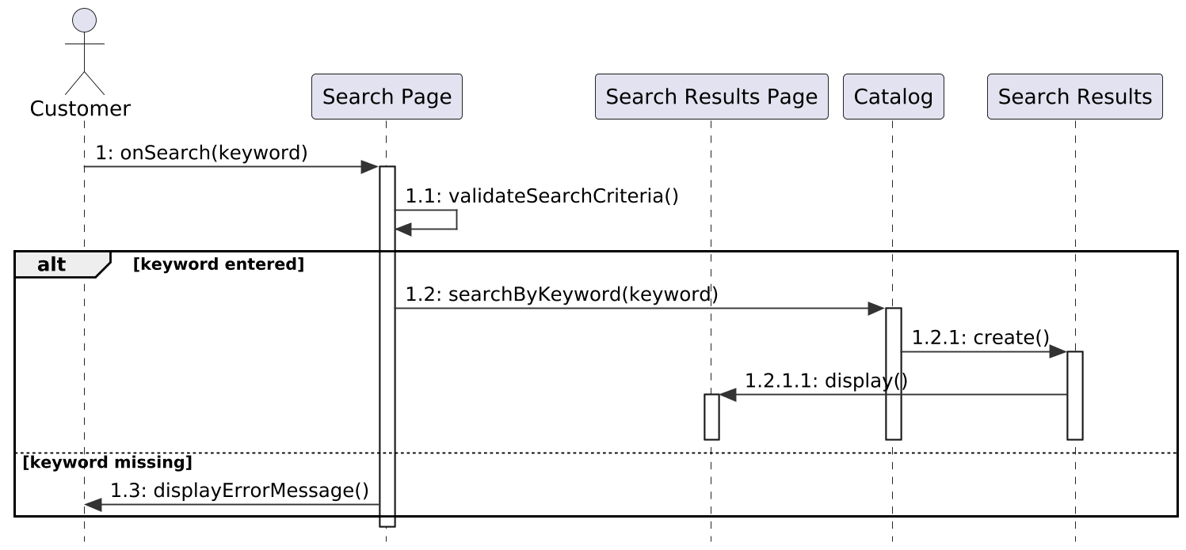
- Search Product

- Place Order
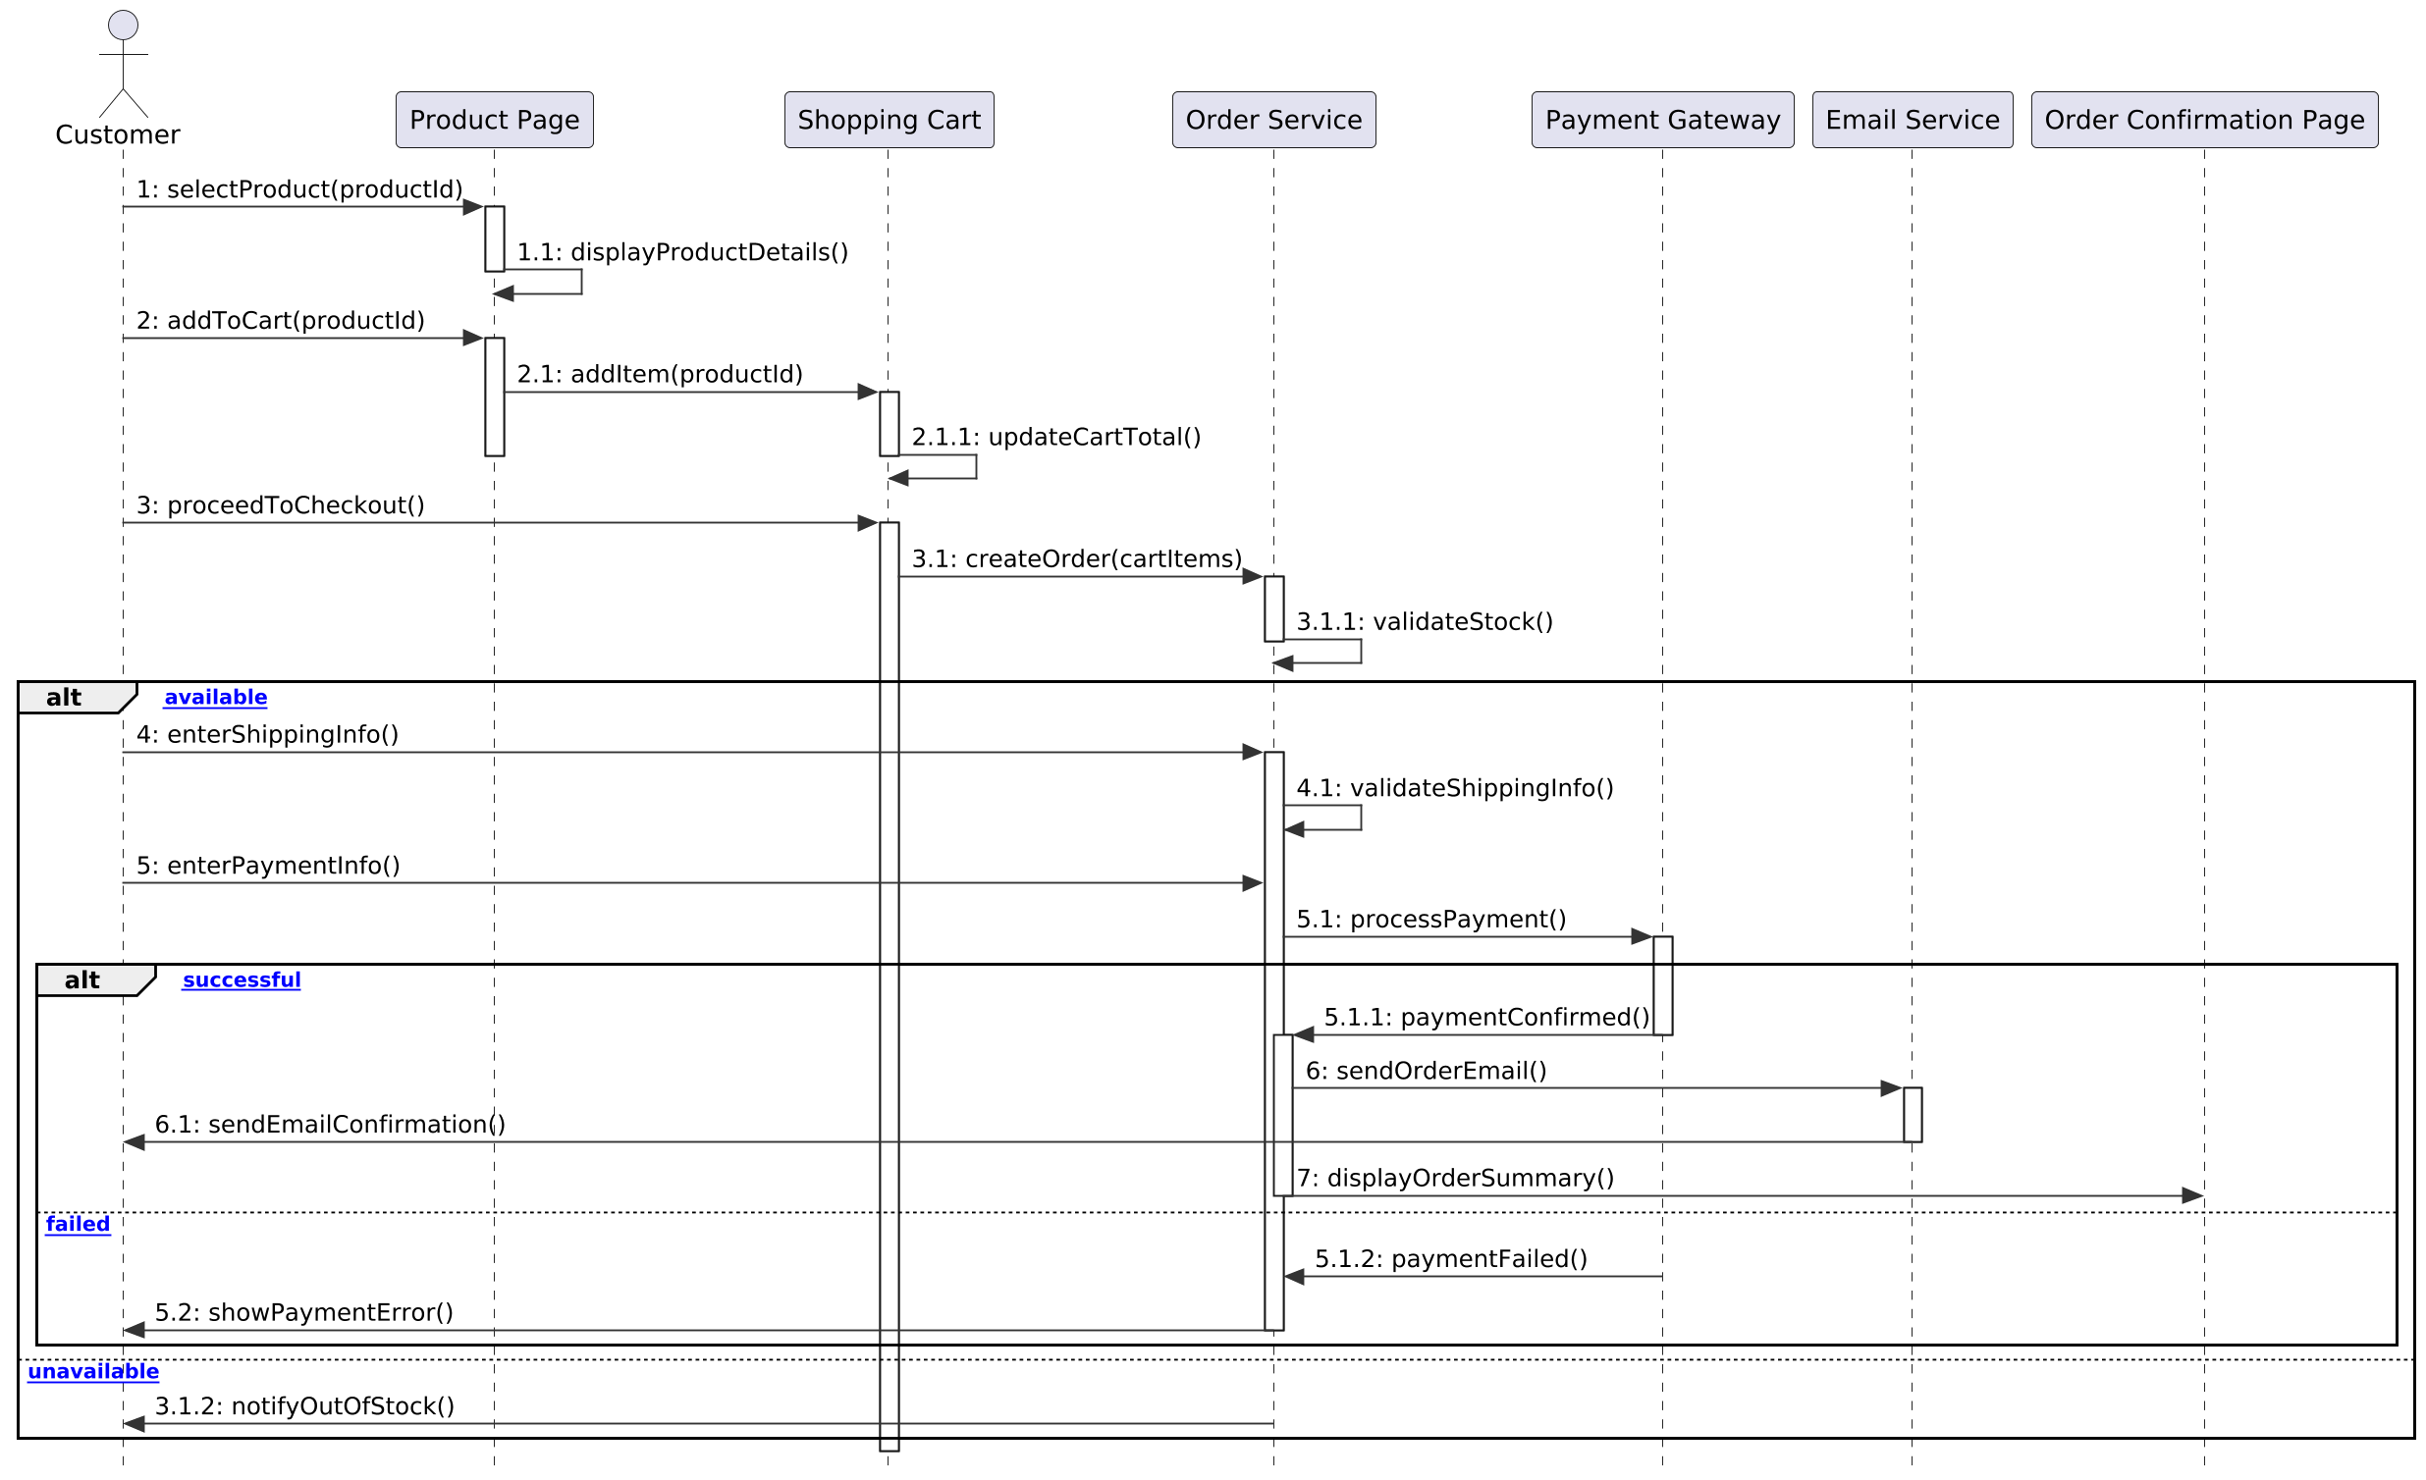

- Manage Product

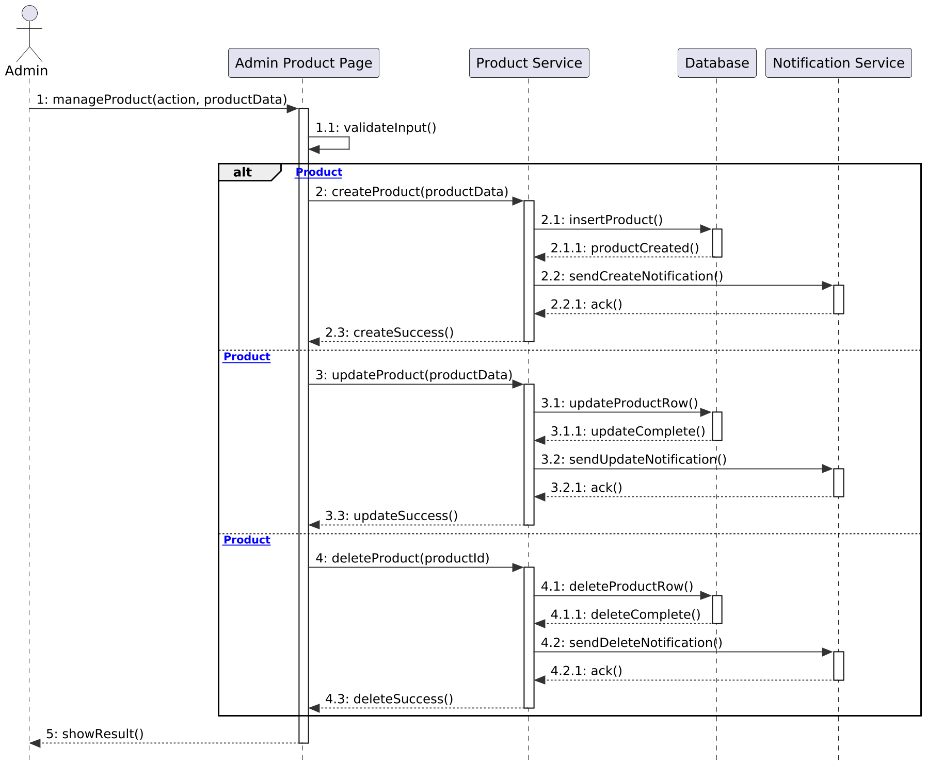
- Write Review

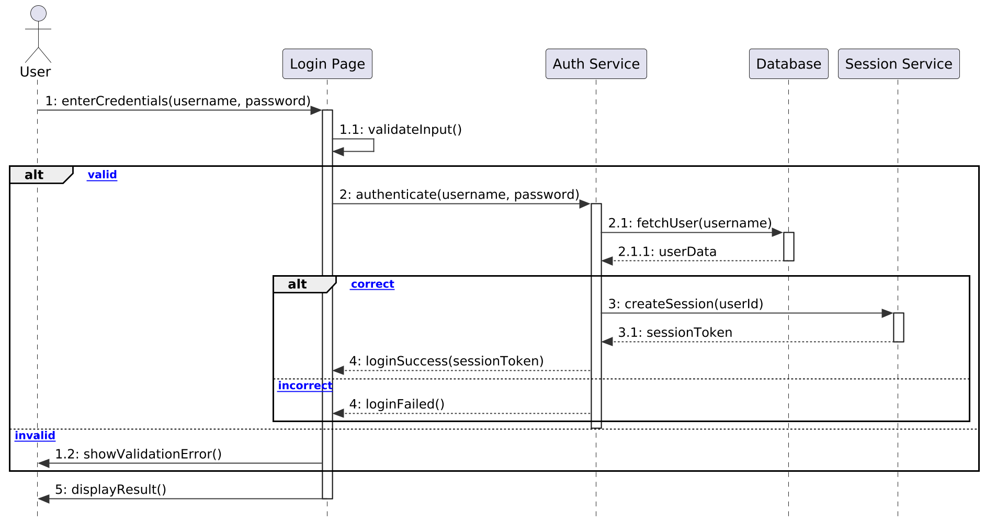
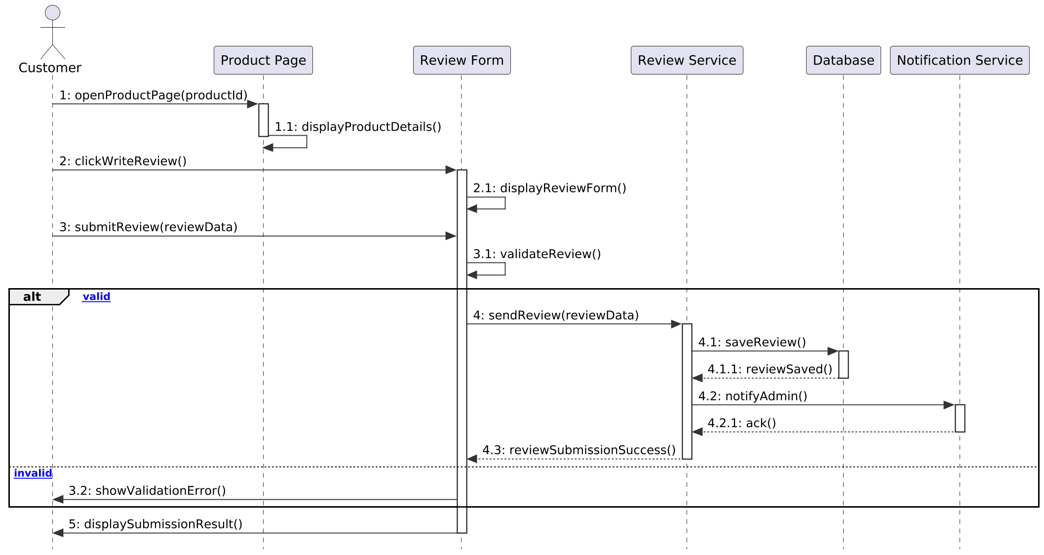
- Login

- Register

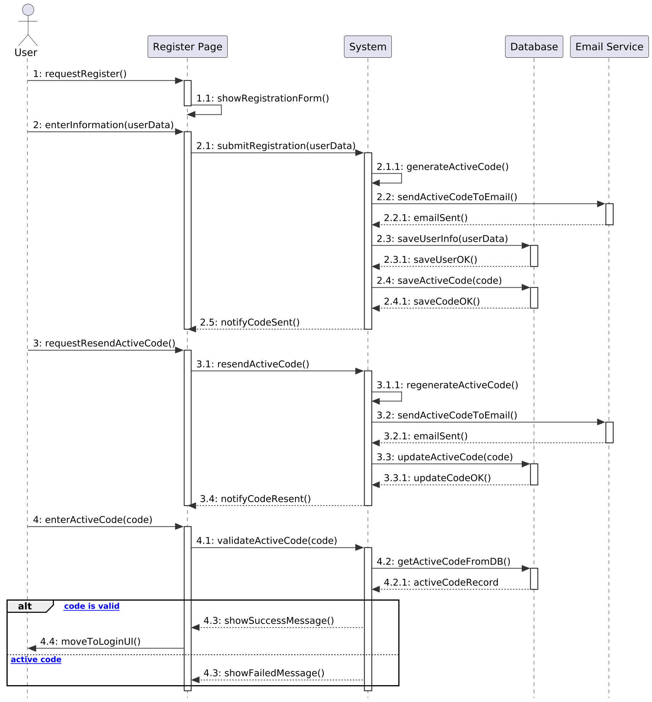

- Update User Account
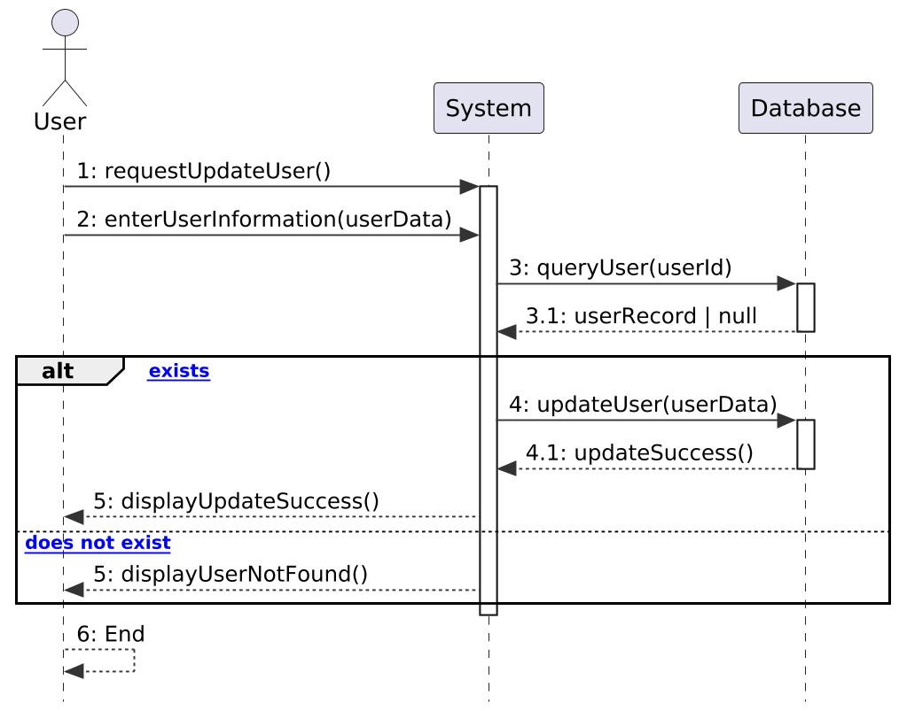
- Process Order

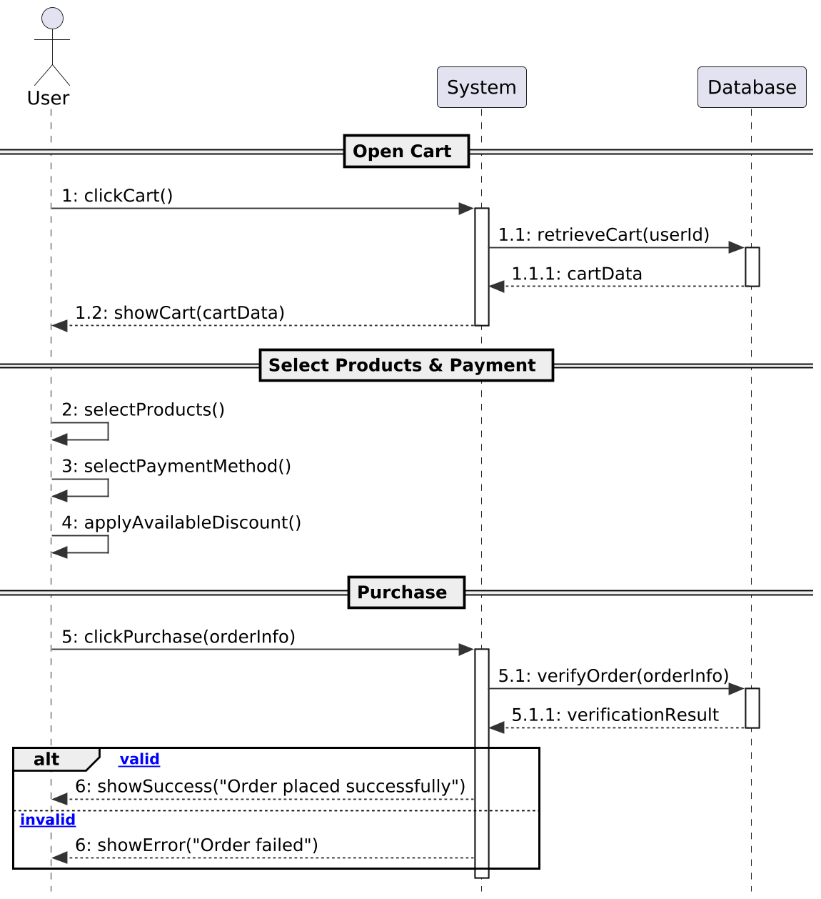
- WireFrame
- Header


- Footer


- Product


- Payment

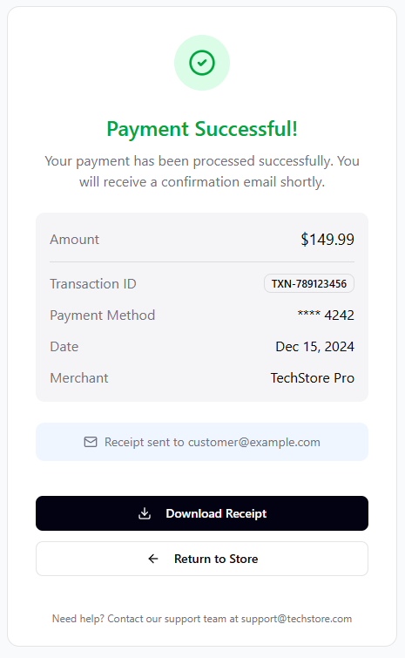
- Cart

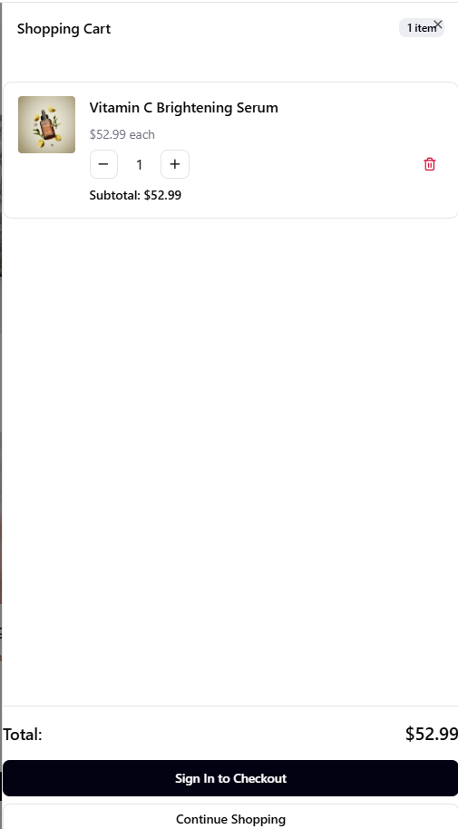
- Login

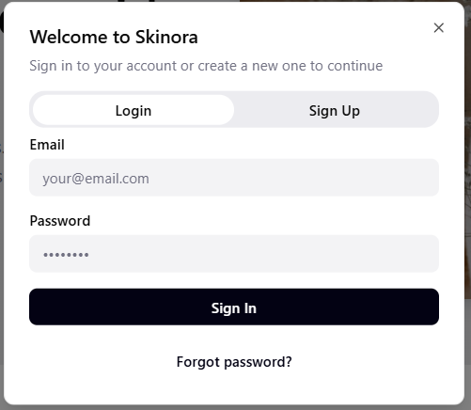
- Register
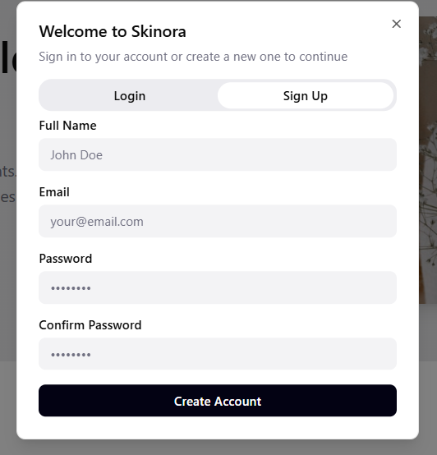

- Activity Diagram

- Register

- Login
- Log out

- View Profile
- Forgot Password

- Order

- Add Product in Cart

- Add product information
- Add Discount for Product

- Search Product

