Nam Phan

Andrew Wang

Ze He

Project 2A

**Features:**

**SpeedDev, XDev, XvelocityChange, ZDev, ZDistance**

**5 x 1 feature**

**SpeedDev**

Decision Tree

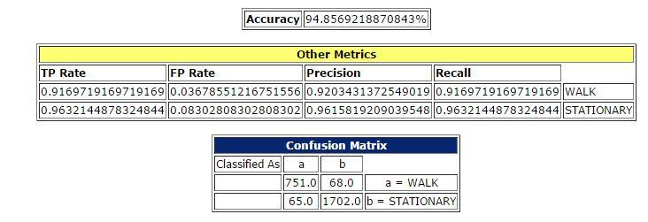

**XDev**

Decision Tree

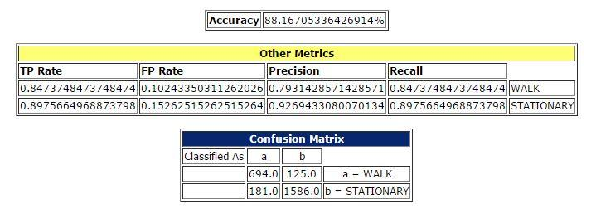

**XvelocityChange**

Decision Tree

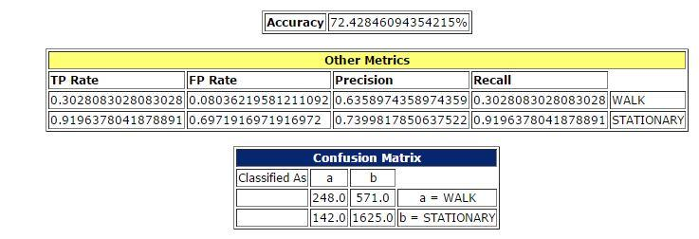

**ZDev**

Decision Tree

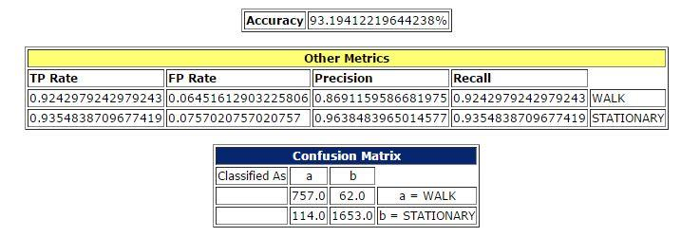

**ZDistance**

Decision Tree

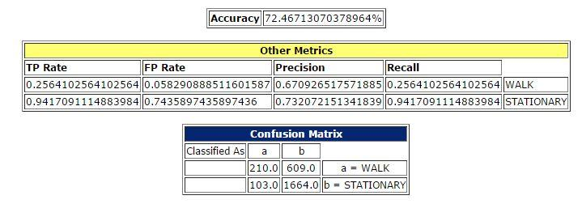

**3 x 2 features**

**SpeedDev + XDev**

Decision Tree

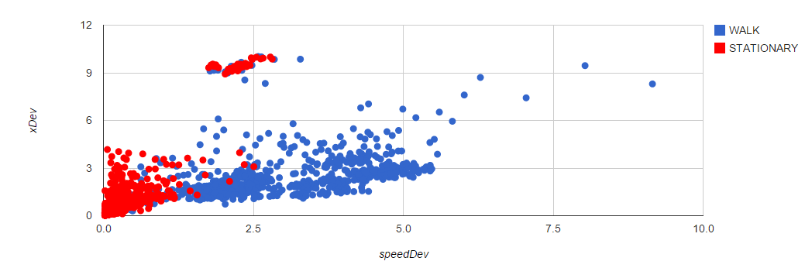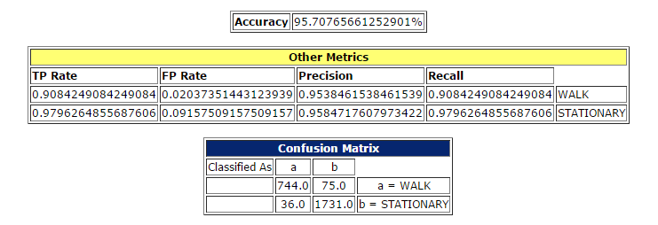

**Xvelocity change + SpeedDev**

Decision Tree

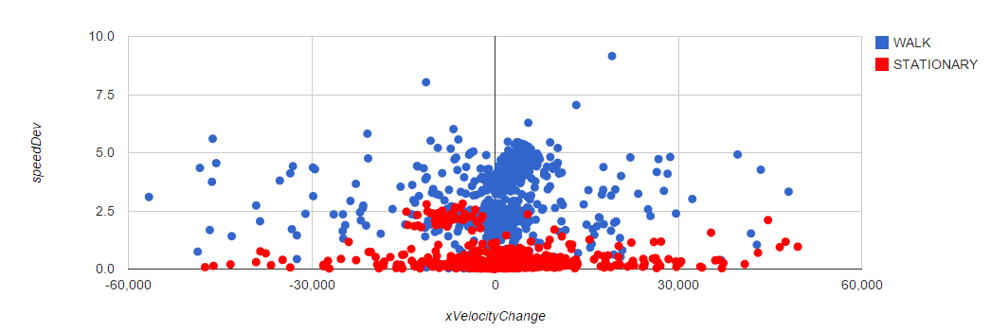

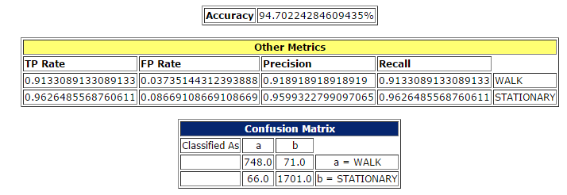

**ZDistance + ZDev**

Decision Tree

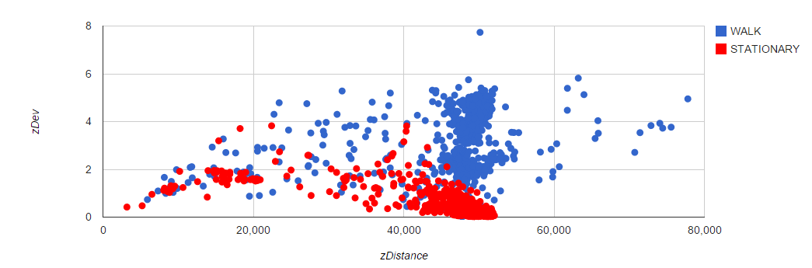

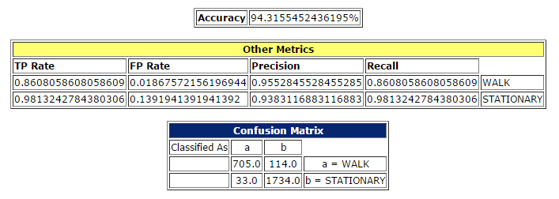

**1 x 5 features**

Decision Tree

