Nam Phan
Andrew Wang
Ze He
Project 2A

Features:
SpeedDev, XDev, XvelocityChange, ZDev, ZDistance

5 x 1 feature
SpeedDev
Decision Tree
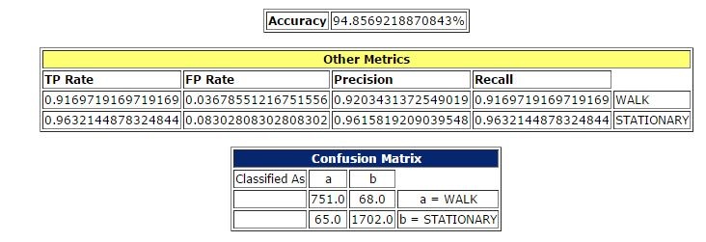

XDev
Decision Tree
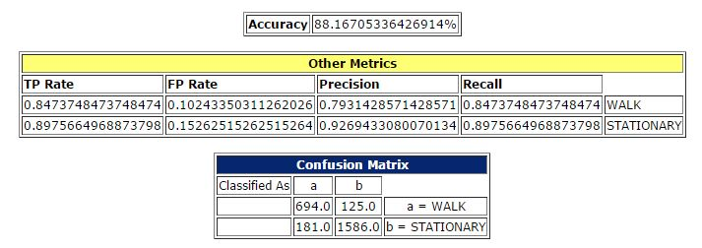

XvelocityChange
Decision Tree
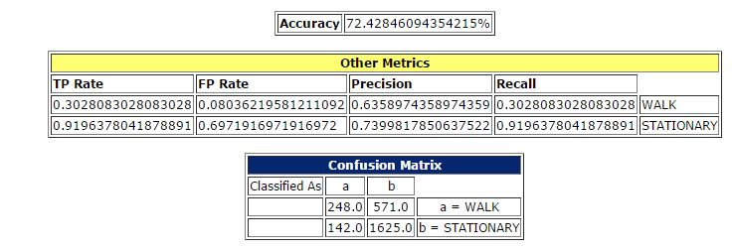

ZDev
Decision Tree
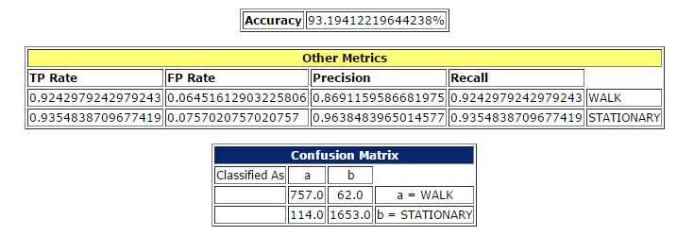

ZDistance
Decision Tree
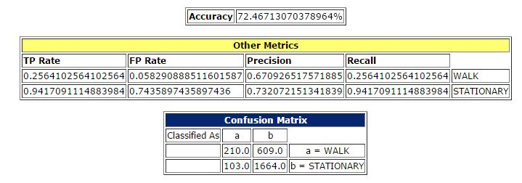

3 x 2 features
SpeedDev + XDev
Decision Tree
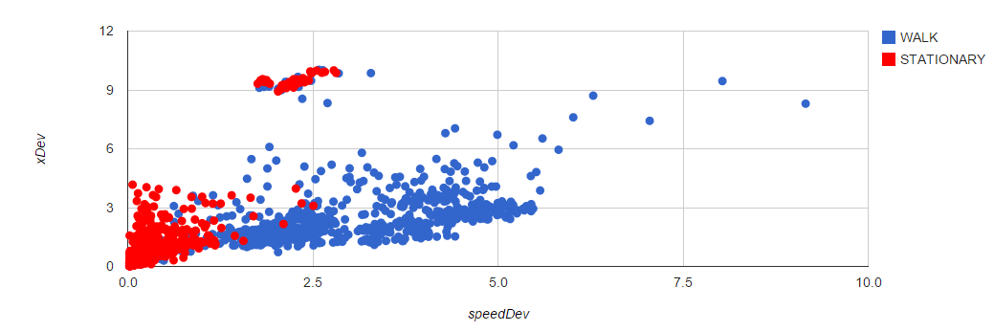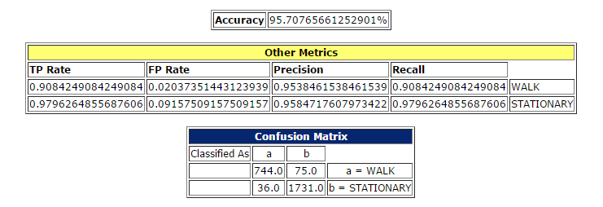

Xvelocity change + SpeedDev
Decision Tree
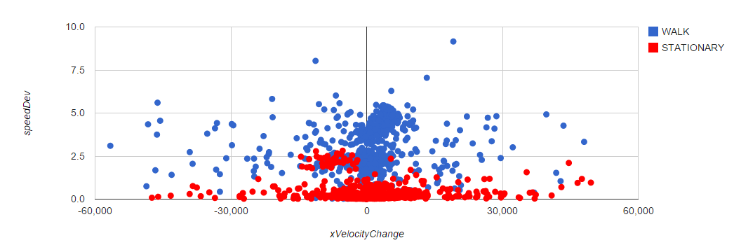
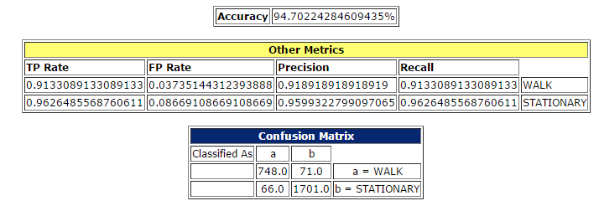
ZDistance + ZDev
Decision Tree
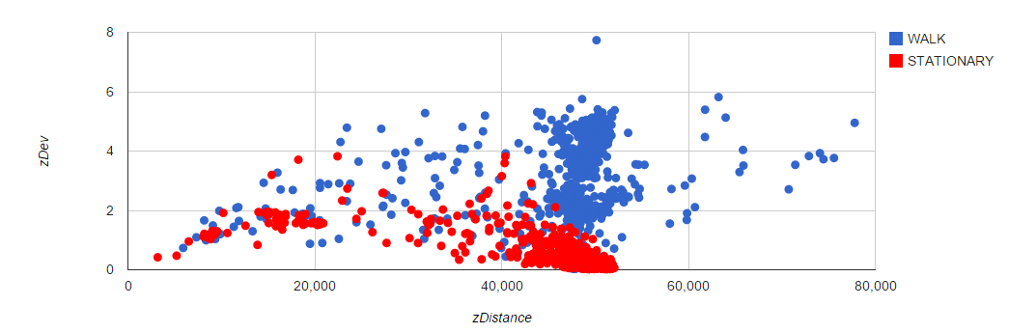
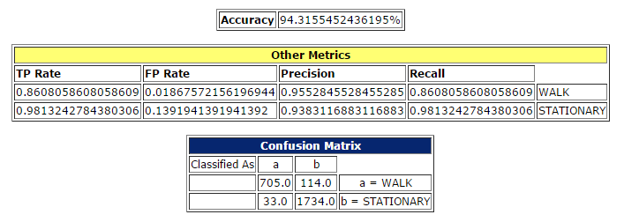

1 x 5 features
Decision Tree
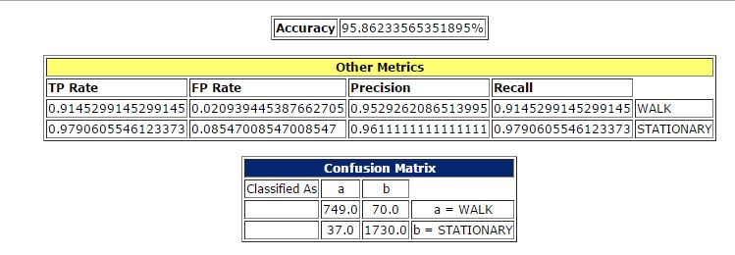

Part B
Classifier: LogiBoost
Confusion Matrix:
