Nam Phan
Ze He
Andrew Wang

Part A

Configuration 1:

Filter: Smoothing
Smoothing Factor: 3
Step Count: 3789
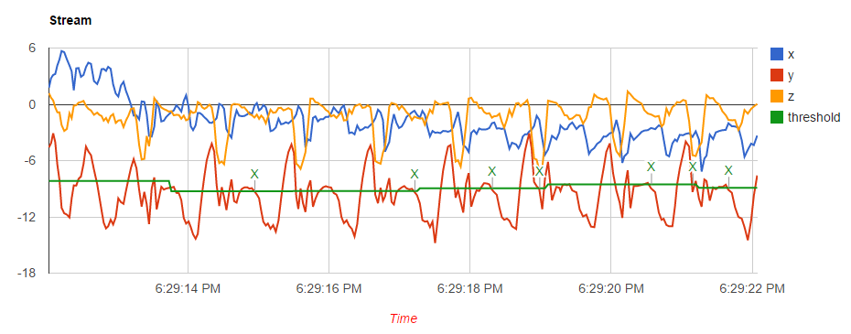

A brief explanation of why the step-detection output is not correct in the above screenshot.

Configuration 2:

Filter: Smoothing
Smoothing Factor: 5
Step Count: 3779
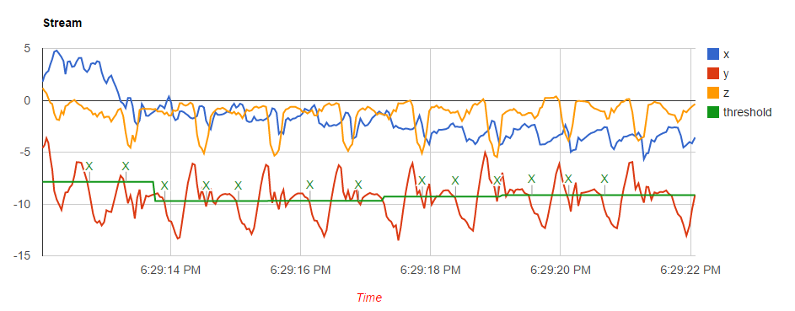
Configuration 3:

Filter: Smoothing
Smoothing Factor: 10
Step Count: 3711
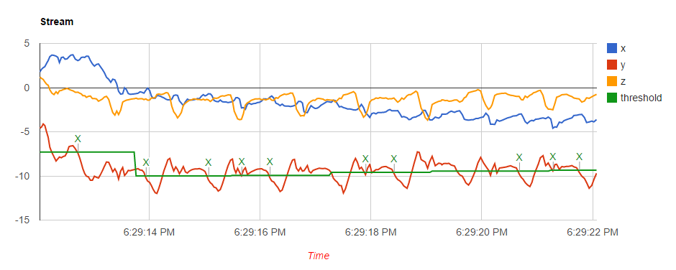
A brief explanation of why the step-detection output is not correct in the above screenshot.

Configuration 4:

Filter: Smoothing
Smoothing Factor: 15
Step Count: 3503
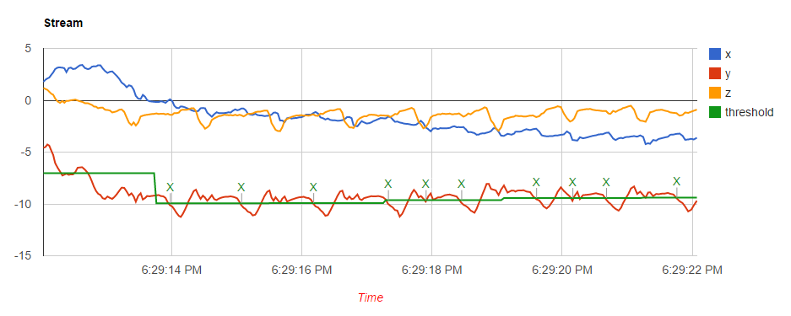
A brief explanation of why the step-detection output is not correct in the above screenshot.

Configuration 5:

Filter: Smoothing
Smoothing Factor: 20
Step Count: 3369
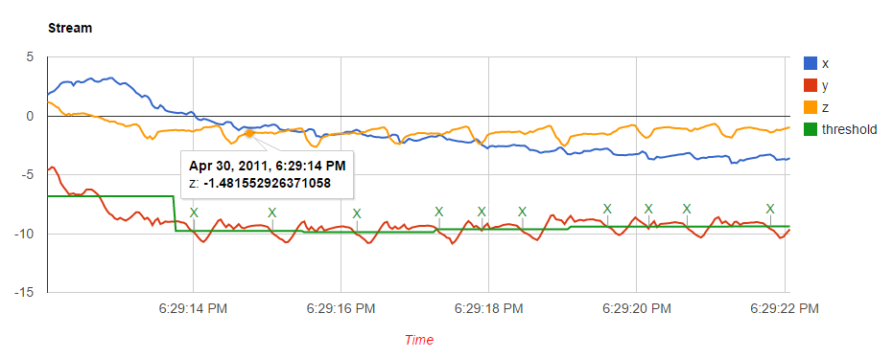
A brief explanation of why the step-detection output is not correct in the above screenshot.

Part B

Phone in Hand

Phone in Bag

