# SCIENTIFIC ARTICLE

# CLASSIFICATION AND GRADING SYSTEM FOR KOI FISH IN REAL TIME (REALTIME BY CAMERA)

**Student: Tran Dinh Nam**

**University of technology and education Ho Chi Minh City**

**Instructor: Nguyen Truong Thinh**

**Project: Artificial intelligence**

# 1. ABSTRACT

Artificial intelligence is appearing more and more densely in an era where everything is geared towards intelligence. Currently, artificial intelligence systems in practice have been using artificial neural networks, which are a complex neural network that closely mimics the neural networks of humans and animals. One of the typical articles on artificial intelligence is projection. Categorize and evaluate Koi fish in real time. Received a lot of attention from researchers, especially when communication networks and social networks are increasingly popular. In this paper, a method using an integrated neural network has been proposed convolutional CNN to perform the task of classifying Koi fish. The experiment was carried out on a dataset collected from many sources on the internet including 18 types of Koi fish that are popular around the world. The final experimental results show that the CNN model has a relatively high efficiency in the prediction process with 92% on the training set and 80% on the test set in the prediction model.

# 2. INTRODUCTION

[1] Koi or more specifically nishikigoi (literally "brocaded carp"), are colored varieties of the Amur carp (Cyprinus rubrofuscus) that are kept for decorative purposes in outdoor koi ponds or water gardens.

Koi is an informal name for the colored variants of C. rubrofuscus kept for ornamental purposes. There are many varieties of ornamental koi, originating from breeding that began in Niigata, Japan in the early 19th century. Several varieties are recognized by the Japanese, distinguished by coloration, patterning, and scalation. Some of the major colors are white, black, red, orange, yellow, blue, brown and cream, besides metallic shades like gold and silver-white ('platinum') scales. The most popular category of koi is the Gosanke, which is made up of the Kohaku, Taisho Sanshoku and Showa Sanshoku varieties.

According to Zen Nippon Airinkai, a group that leads the breeding and dissemination of koi in Japan, there are more than 100 varieties of koi created through breeding. [2] Koi varieties are distinguished by coloration, patterning, and scalation. Some of the major colors are white, black, red, yellow, blue, and cream. Metallic shades of gold and platinum in the scales have also been developed through selective breeding. Although the possible colors are virtually limitless, breeders have identified and named a number of specific categories. The most notable category is Gosanke, which is made up of the Kohaku, Taisho Sanshoku, and Showa Sanshoku varieties.

New koi varieties are still being actively developed. [3] Ghost koi developed in the 1980s have become very popular in the United Kingdom; they are a hybrid of wild carp and Ogon koi and are distinguished by their metallic scales. Butterfly koi (also known as longfin koi, or dragon carp), also developed in the 1980s, are notable for their long and flowing fins. They are hybrids of koi with Asian carp. Butterfly koi and ghost koi are considered by some to be not true nishikigoi. [4]

In this paper I have devised a system to classify Koi fish using deep learning techniques. To help us easily classify the types of Koi fish. In this article, I focus on classifying 18 types of Koi fish including: Asagi, Bekko, Doitsu Koi, Ghosiki, Goromo, Hikarimoyo, Hikarimuji mono, Hikariutsuri, Kanoko Koi, Kawarimono, Kin/Ginrin, Kohaku, Sanke, Showa, Shusui , Tancho, Utsuri, Yamato Nishiki.

I chose these 18 fishes because they are quite popular with us. The data is searched by us on the internet. Use suitable deep learning algorithm for classification. The application of image processing is the most interesting and interesting field in the artificial intelligence industry with many problems with high practical application. At the same time, with the strong development of deep learning algorithms, especially convolutional neural networks (CNN) have given outstanding results in experimental problems. Koi fish are extremely diverse in color, shape. Distinguishing and remembering the names of Japanese koi lines is difficult for beginners to play koi. Therefore, the application of artificial intelligence will help us to easily classify Koi fish.

**3. RECENT STUDIES**

Machine learning has been tested to be very good at classification problems and one of the subsets of Machine Learning is deep learning. The classification problem is one of the typical problems using the creative cognitive intelligence algorithm CNN and has been implemented by researchers for a long time. And in this paper, we will present the methods of building each model individually and the results of the model. First, we will go through each article in turn to get the best overview of the research related to this article. There are many types of research classified according to the objective, depth of study, data analyzed, time required to study the phenomenon, and other factors. It is important to note that a research project will not be limited to one type of research, but will likely use multiple types.

The application of classification technology is currently developing very strongly in many fields (academic, business, security, medical...) and objects (social researchers, government and other stakeholders). other non-profit organizations). Since these organizations own a large amount of unstructured data and data processing becomes much easier if this data is normalized by topics/labels. In this article, I will classify Koi fish based on technology to perform classification problems based on AI (Artificial Intelligence) and deep learning (Deep Learning).

**4. ALGORITHM PROPOSAL**

In this section, the method of using convolutional neural networks (CNN) will be presented to solve the classification problem. To make it easier for readers to understand, I will present it in 3 parts including:

- Introduction of the algorithm used

- BuildingCNN Model

- The result of the model

**4.1 Convolutional Neural Networks**

**4.1.1 Introduction about CNN**

When it comes to convolutional neural networks (CNN), we immediately know that this is the network structure that helps us recognize and classify images. One of the image classification problems that CNN is commonly used for is human face recognition. [5] Convolutional Neural Networks (CNN) can classify images by taking an input image to process and classify by labels such as Frogs, Cats, Birds.... The computer then views the input image as an array of pixels. According to the image resolution, the computer will see the Height x Width x Thickness.

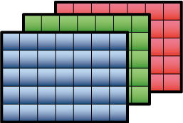

Figure 1: RGB matrix array 6x6x3

Technically, the CNN model for training and testing, each input image will pass it through a series of convolutional layers with filters (Kernals), synthesizing fully connected layers (Full Connected). and apply the Softmax function to classify objects with probability values between 0 and 1.

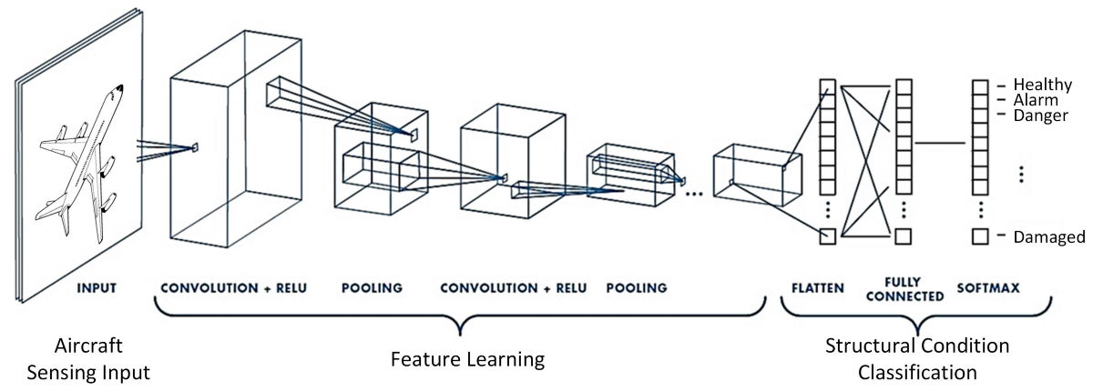

Figure 2: Entire CNN stream for image processing

**4.1.2 Convolution Layer**

A convolution layer is composed of nf filters of the same size and depth. For each filter, we convolve it with the input volume to obtain nf outputs. Next, the outputs are passed to some activation function, ReLU, for example. Finally, those nf outputs is stacked together into a (h — fh + 1) x (w — fw + 1) x nf volume. [7]

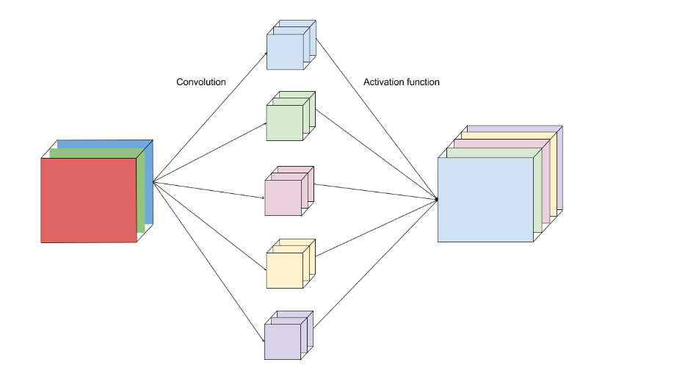

Figure 3: Convolution Layer

Intuitively, we can think of each filter as a “sensor” to detect a feature from the input image. For example, an edge-detecting filter is “activated” and outputs a high pixel value.

**4.1.3 Stride**

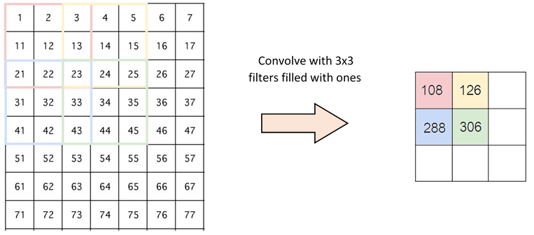

Figure 4: Convolve with 3x3

Stride is the number of pixels that change on the input matrix. When we have a jump of 1 we move the kernels by 1 pixel, when we have a jump of 2 we move the kernels by 2 pixels, when we have a jump of 3 we move the kernels by 3 pixels, and so on. How many hops we move the kernels away by so many pixels. [7]

**4.1.4 Padding and Relu**

There are two methods to help us deal when the kernel is not compatible with the original image, that is, inserting zeros into the shadow of the image or reducing the parts that do not match the kernel.

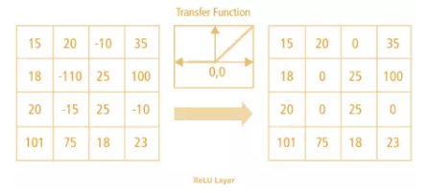

Figure 5: Relu Layer

Relu is a nonlinear function whose output is f(x) = max(0,x), this is a function that is used a lot when building CNNs. Relu presents nonlinearity in ConvNet as the data we normally use are linear values without sound. In addition, we also have the function tanh, sigmoid can also be used to replace the Relu function. However, with the advantage of having good performance, Relu is always used in building CNN models.[7]

**4.1.5 Pooling Layer**

After the convolutional layer, it is a common practice to pass these values into the next layer which is known as the pooling layer. What pooling does is applying a special kind of filter to your output where the two most common form is max and average pooling. With max pooling, this is like applying a max filter on the image. This is also the same for the average pooling.[7]

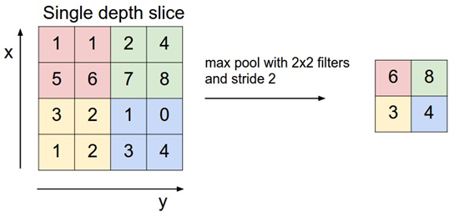

Figure 6: Max pool with 2x2 filters and stride 2

**4.2 Building CNN Model**

**4.2.1 Model building ideas**

In the Koi classification model, I trained the model (CNN) 18 types of Koi fish as follows:

After determining the direction to conduct research on the topic, the next step is to build a CNN convolutional network architecture through Python programming language and conduct model training. Finally, at the end of the training, we will save the h5 file and load it into the realtime code to conduct realtime identification. This image data source I collected on Kaggle and Google and then I preprocessed the dataset according to my wishes and the purpose of training the model.

**4.2.2 Methods of implementation**

To implement the model, you need to think ahead of time and the implementation process follows the sequence of steps as shown in the following figure:

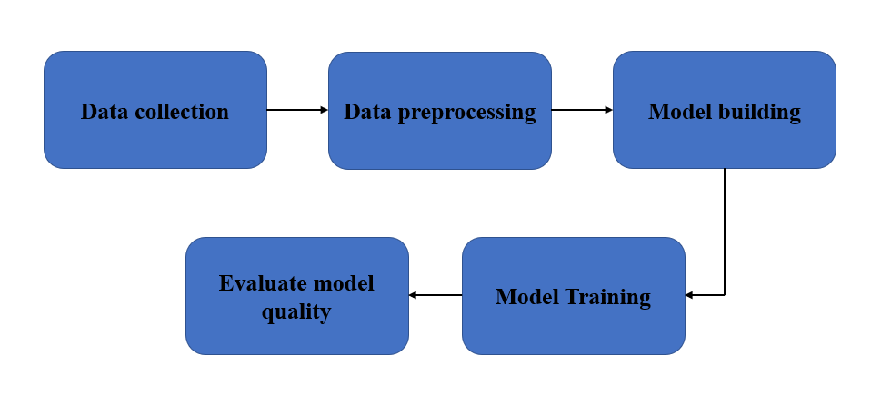

Figure 7: Model execution process

- Data collection:

Regarding the data set for emotions, I collected the data set through kaggle and google images with 18 types of Koi fish. Includes 2 training sets and test sets. The training set includes 760 images and the test set includes 135 images.

- Data preprocessing:

Synchronize data size by color image with size 150x150.

Normalize input data in the range (0,1) instead of 255 as the original.

- Model building:

After the process of data collection and data preprocessing, I proceed to build a model to predict the classification of Koi fish.

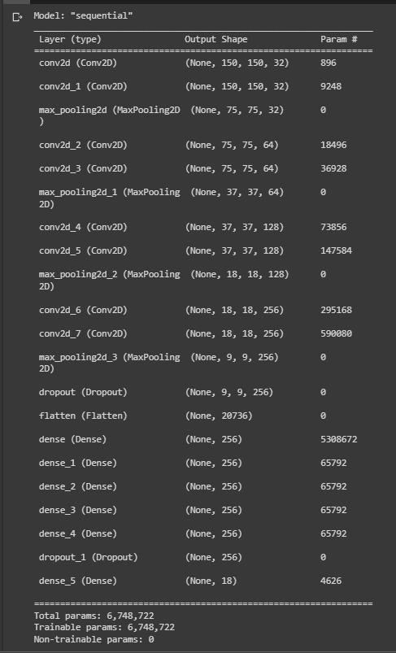

**4.3 THE RESULT OF THE MODEL**

**4.3.1 Model evaluation**

After successfully building the model and training the model, the accuracy of the Koi classification model is quite high on the training set at 90% and the accuracy on the validation set is not high with 66%.

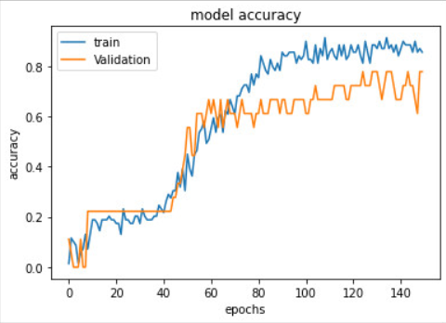

Figure 8: Model accuracy

**4.3.2 Real-time test results**

After completing the model training process and checking the accuracy of the model, the next step is to save the h5 file extension and save it to the realtime code to run it in real time to evaluate the quality of the model.

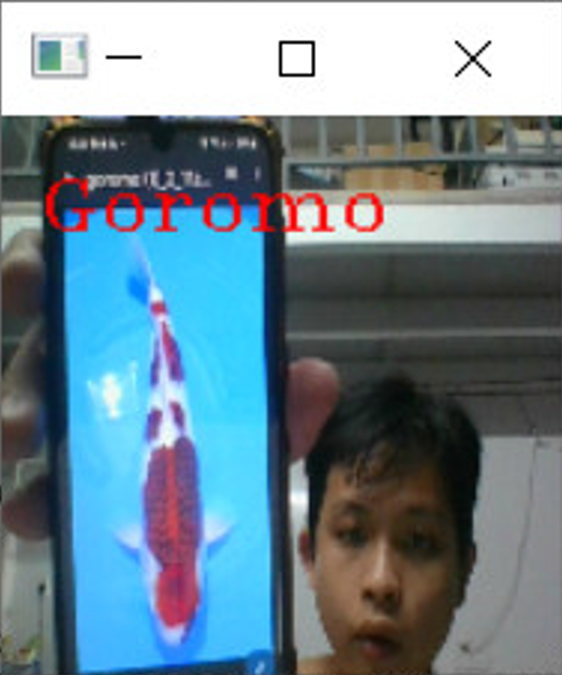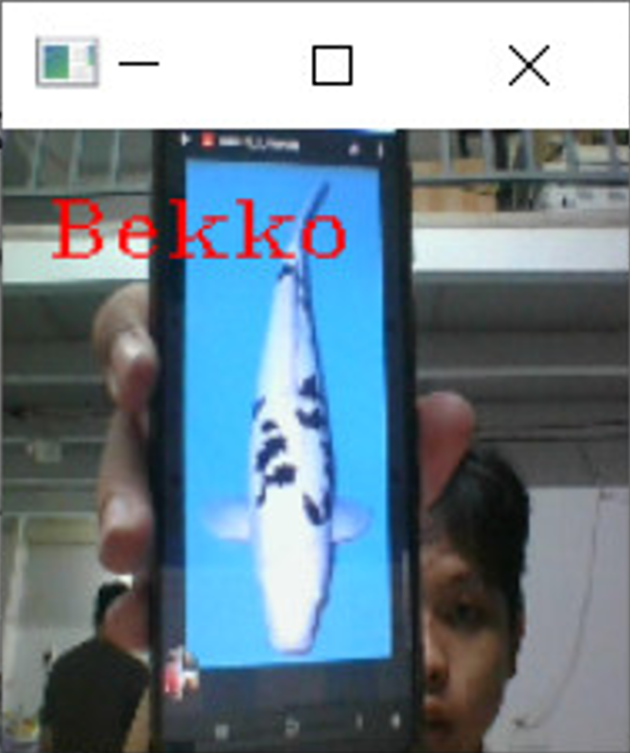

Figure 9: Result run realtime

**5. CONCLUSION AND DEVELOPMENT DIRECTION**

In this research paper, I proposed a deep learning model to identify and classify Koi fish based on laptop camera. This model has been tested many times to build layers of convolutional neural networks (CNNs). At the same time, the model is designed to be able to identify Koi fish in real time. In the near future, I will develop the project to be able to bring to the market for commercialization, and use the pre-train model network layers to improve the accuracy and increase the quality of face prediction according to the model. real time. It also improves the quality of the data, making it more numerous and accurate.

## **Acknowledgement**

Finally, I would like to thank Assoc. Prof. Dr. Nguyen Truong Thinh for imparting the background knowledge during my study to help me carry out this thesis. I have tried to apply the theoretical knowledge learned in class and combine the suggestions from the teacher to complete this article. But due to lack of practical experience, my report still has some shortcomings, I hope to receive everyone's evaluation and suggestions.

**Reference:**

[1] [Japanese Ornamental Koi Carp: Origin, Variation and Genetics](https://www.researchgate.net/publication/285770347_Japanese_Ornamental_Koi_Carp_Origin_Variation_and_Genetics). Retrieved: May 2015

[2] The Varieties of Nishikigoi Zen Nippon Airinkai

[3] Guide to Koi Varieties". mitchkoi.co.uk. Retrieved: 12 April 2014

[4] Informer (Abi), Pond (13 February 2022). "Complete Guide to Ghost Koi". Pond Informer. Retrieved: 7 September 2022.

# [5] [Deep Learning] Tìm hiểu về mạng tích chập (CNN). Retrieved:10 December 2020

### [6] Explanation of Convolutional Neural Networks. Retrieved 11 August 2016

## [7] Interns Explain CNN. Retrieved 17 June 2020