Music Transformer for Symbolic Music Modeling

Abstract
This project implements and evaluates Transformer-based models for symbolic music modeling. We compare a baseline Transformer with absolute positional encoding against a Music Transformer [2] using relative positional attention [2,3] on two datasets: JSB Chorales [5] and Piano-e [6] (MAESTRO [6] subset). The task is autoregressive next-token prediction over symbolic music event streams. Quantitatively, the relative model achieves lower negative log-likelihood (NLL) and perplexity (PPL) than the baseline on JSB (validation NLL 0.502 vs 0.914; validation PPL 1.65 vs 2.49) and also improves Piano-e [6] (validation NLL 1.728 vs 1.907; validation PPL 5.63 vs 6.73). Qualitatively, relative attention yields pianorolls with clearer repetition patterns and self-similarity structure, while temperature-controlled sampling reveals the expected diversity-coherence trade-off. Methodology is grounded in Transformer theory and the course practicals on attention, masking, positional encodings, and transformer layer construction.

1. Introduction
Transformers have become a dominant architecture for sequence modeling due to self-attention, which allows each position to attend to all previous positions. This capability is particularly valuable in symbolic music, where long-range dependencies, motifs, harmonic progressions, and rhythmic patterns may recur over many measures. Music also demands precise temporal alignment, making positional reasoning central to model quality. This project compares a standard Transformer (Vaswani et al. [1]) with absolute positional encodings against a Music Transformer [2] that uses relative positional attention [2,3]. The architecture and hyperparameters are held constant so that observed differences can be attributed to positional bias rather than capacity. The report integrates theoretical insights from the Transformer and Music Transformer [2] papers with the course practicals on attention, masking, and positional encoding.

2. Background / Theory
The baseline Transformer follows Vaswani et al. [1] and encodes order using fixed sinusoidal positional encodings that are added to token embeddings. These sinusoids allow the model to infer absolute positions and to compute relative offsets through linear combinations, but the positional signal is still anchored to absolute indices. In language, this is often sufficient; in music, however, the same motif can appear at different offsets, and the model should treat those occurrences as structurally similar. The Music Transformer [2] addresses this by replacing absolute positional encoding with relative positional attention [2,3], where attention scores are biased by learned embeddings of relative distance. Intuitively, this encodes how far two events are from one another rather than where they occur globally. The core attention mechanism is scaled dot-product attention. For queries Q, keys K, and values V, attention is computed by a scaled similarity between Q and K, followed by a softmax and a weighted sum of V. Multi-head attention applies this in parallel subspaces, allowing the model to attend to different musical aspects (e.g., voice-leading or rhythmic repetition). In autoregressive modeling, a causal mask prevents tokens from attending to the future, while a padding mask excludes padded positions from contributing to attention. These masking mechanisms are central to the course exercises and are used in both models. Relative positional attention modifies the attention score by adding a learned embedding R_{j-i} for each relative distance . The Music Transformer [2] paper shows that a naive implementation requires an O(L^2. D) intermediate tensor and introduces a skewing trick to reduce relative embedding memory to O(L .D). The paper also discusses local attention windows, where attention is limited to a fixed context window to scale to very long sequences. This project uses global relative attention to keep the baseline comparison clean, but the theoretical rationale for relative and local attention is preserved.

3. Dataset

JSB Chorales
JSB Chorales [5] is derived from J.S. Bach’s four-part chorales, a canonical symbolic music benchmark. Each piece is polyphonic with four voices: Soprano, Alto, Tenor, and Bass whose coordinated motion provides a rich testbed for modeling long-range harmonic structure and cadence patterns. In this project, the score is discretized on a fixed sixteenth-note grid. At each timestep, the four voices are serialized into event tokens (S, A, T, B) followed by a time-shift token, yielding a single event stream that preserves the SATB structure. Sequences are concatenated and segmented into fixed-length blocks of 512 tokens for autoregressive prediction. At this block size, the dataset contains approximately 549 training blocks, 183 validation blocks, and 187 test blocks. The small scale enables fast iterations and a clear analysis of positional encoding effects.

Piano-e (MAESTRO subset)
Piano-e [6] is a MIDI-only subset of the MAESTRO [6] performance dataset, containing expressive piano performances from the International Piano-e [6] Competition. Unlike JSB’s fixed-grid chorales, these performances exhibit irregular timing and dense polyphony. The project uses an event-based MIDI representation where note-on tokens encode pitches and time-shift tokens encode elapsed time between events. This avoids a dense grid and reduces sequence length while preserving expressive timing. Token streams are concatenated and segmented into fixed-length blocks of 512 tokens. At this block size, Piano-e [6] yields roughly 20,680 training blocks, 2,421 validation blocks, and 2,654 test blocks, making it substantially larger and more complex than JSB.

General preprocessing
Both datasets are split into train, validation, and test sets, and all preprocessing preserves this split. The learning task is next-token prediction: given a length-512 input sequence, the model predicts the next token at each position under a causal mask. Long contiguous sequences are important for capturing musical structure beyond local context. Symbolic representations do not encode audio timbre or fine-grained expressive nuance; nevertheless, they provide a controlled domain for evaluating positional modeling strategies in long-range sequence generation.

4. Methodology
Evaluation metrics are based on negative log-likelihood (NLL) and perplexity (PPL). NLL is the average cross-entropy loss over tokens in each split, reflecting how well the model predicts the next event. Perplexity is defined as exp(NLL) and provides an interpretable measure of model uncertainty; lower values indicate better predictive performance. Both metrics are reported for train, validation, and test splits to assess fit and generalization.

Baseline Transformer
The baseline model is a decoder-only Transformer trained for autoregressive next-token prediction. Tokens are embedded into a continuous space and combined with absolute sinusoidal positional encodings. Each layer applies multi-head causal self-attention followed by a position-wise feed-forward network, with residual connections and layer normalization. The causal mask prevents access to future tokens, while padding masks remove padded positions from attention weights. This design mirrors the Vaswani architecture and provides a controlled baseline.

Music Transformer
The Music Transformer [2] retains the same depth, width, and parameter count as the baseline but replaces absolute positional encoding with relative positional attention [2,3]. The motivation is musical: motifs and rhythmic patterns repeat at varying offsets, so relative distances are more informative than absolute positions. Relative attention adds a learned embedding of the relative distance to the attention score, biasing the model toward capturing regular temporal relationships. Distances are clipped to a fixed range and mapped to learned embeddings. By holding all other components constant, the comparison isolates the effect of positional encoding. This is a controlled test of whether relative positional bias improves symbolic music modeling.

Comparison framing
Tokenization, training objective, optimizer, and model capacity are identical across models. The only architectural difference is how positional information is represented inside attention. This controlled setup allows observed performance differences to be attributed directly to absolute versus relative positional encoding strategies.

5. Training Setup
Training uses a batch size of 32, a learning rate of 3e-4, gradient clipping at 1.0, and a fixed block_size of 512. The JSB models are trained for 30 epochs and the Piano-e models for 10 epochs. All runs assume a CUDA-capable GPU.

6. Experimental Flow (Pipeline)
At program start the outputs directory is cleaned. The execution order is fixed: JSB baseline training and evaluation, JSB relative model training and evaluation, Piano-e baseline training and evaluation, Piano-e relative model training and evaluation, and finally aggregation of metrics and plots.

7. Outputs Produced
For each dataset and model, the pipeline writes validation curves, metrics JSON files, pianoroll samples, self-similarity heatmaps, and stability plots. It also produces cross-dataset comparison plots and temperature-sweep artifacts for JSB.
Figure 1: JSB baseline vs relative pianoroll samples (grid).
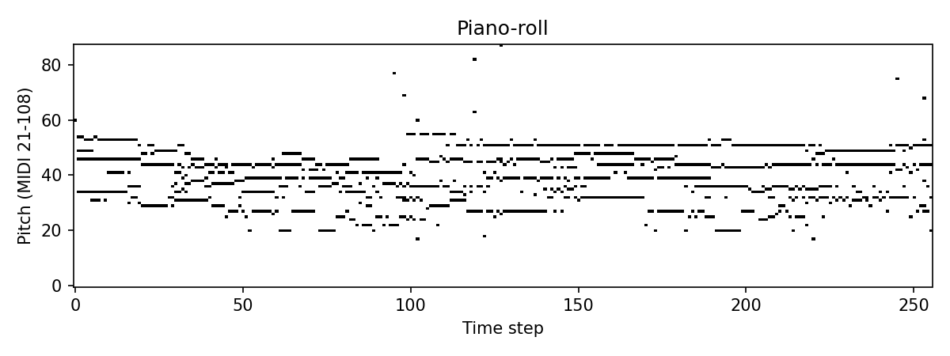 | 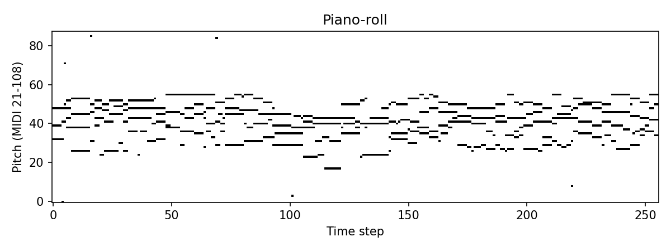

Figure 2: Self-similarity heatmaps (grid).
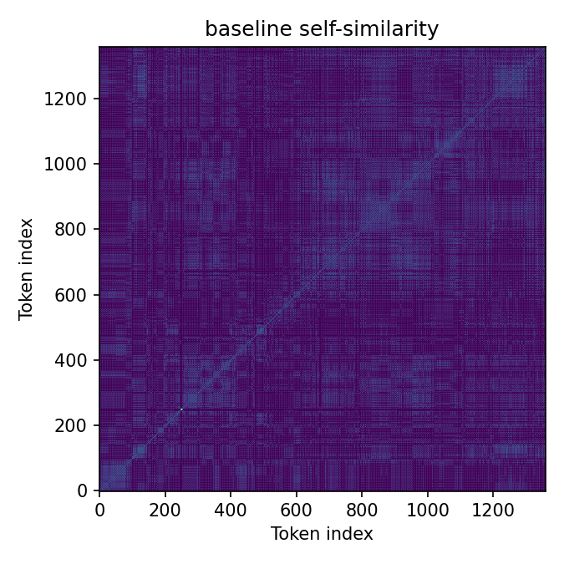 | 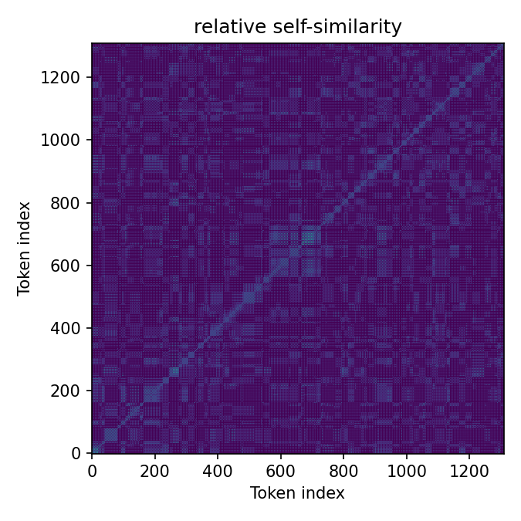

Figure 3: Training stability curves (grid).
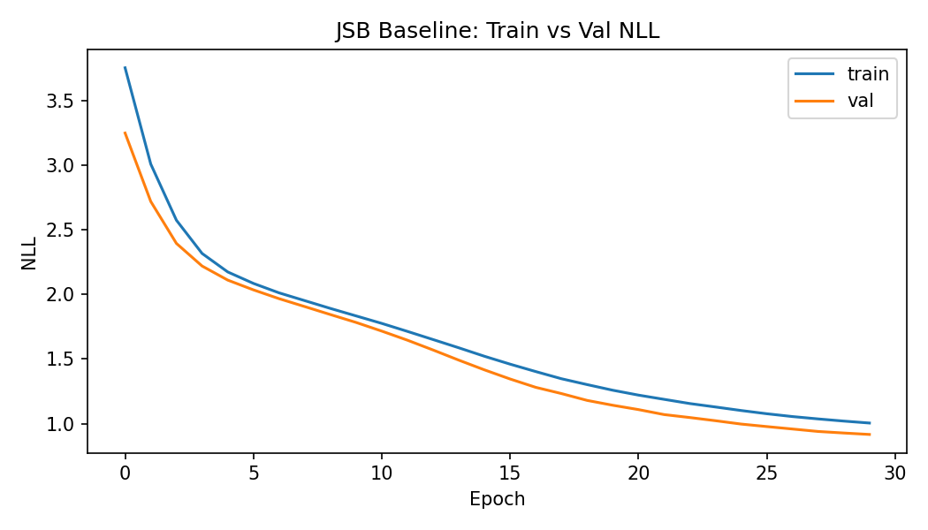 | 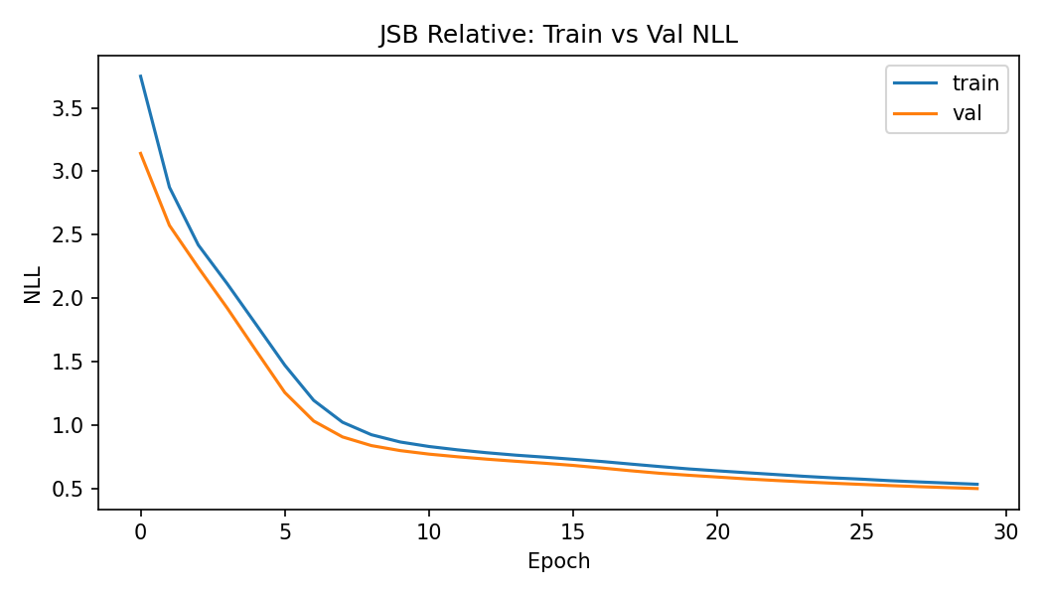
Figure 3b: Piano-e training stability curves (grid).
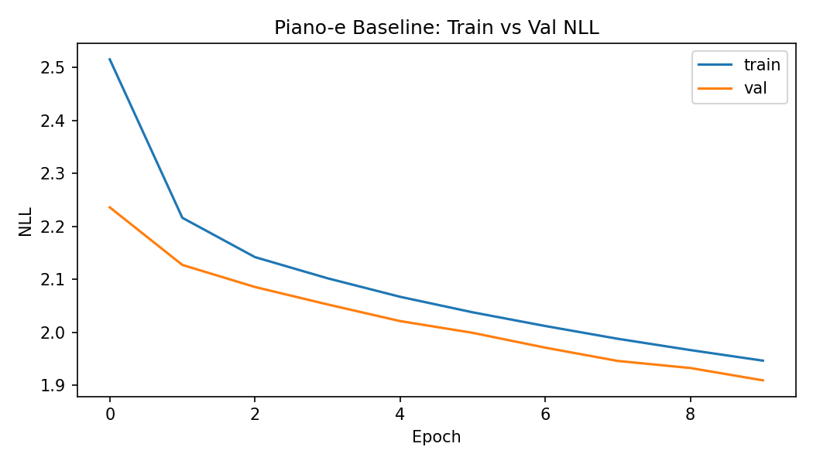 | 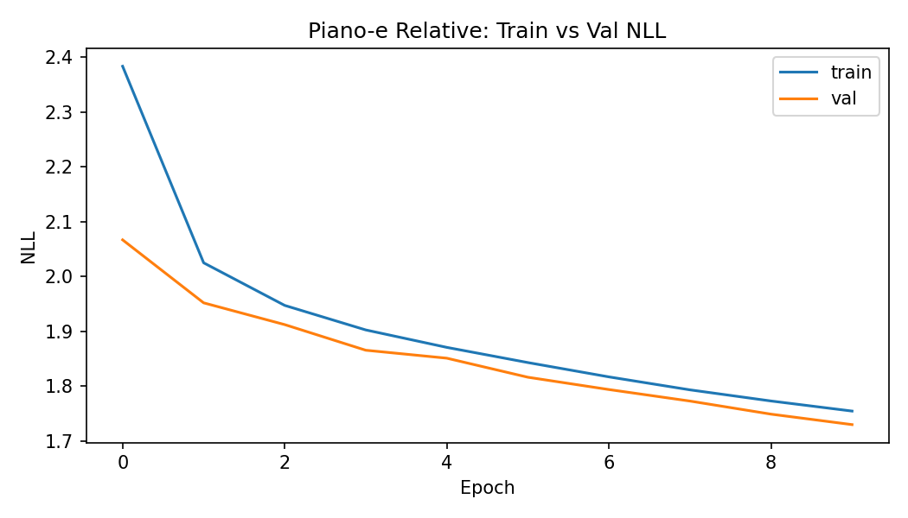

Figure 4: NLL and PPL comparison plots (grid).
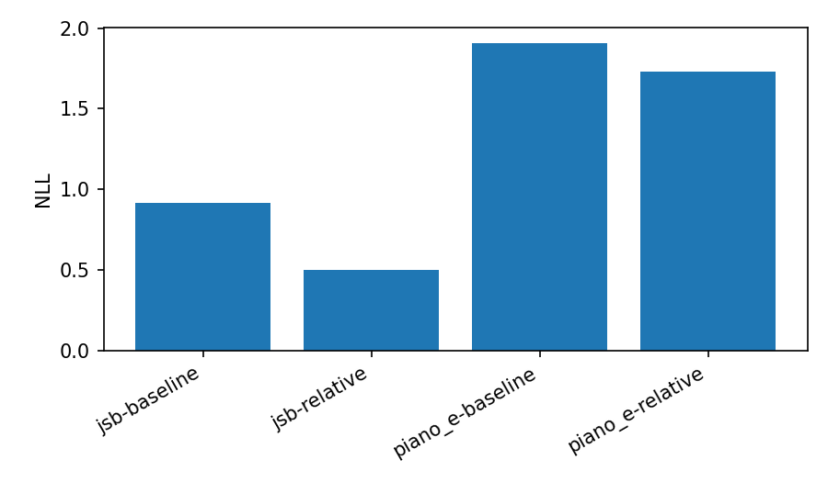 | 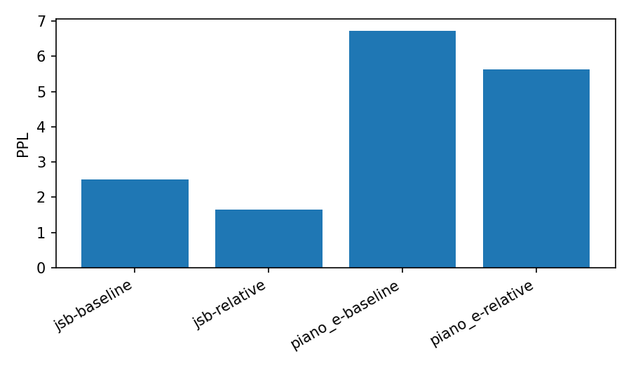

8. Results (Quantitative)
Relative attention improves NLL and PPL on both datasets; the improvement is larger on JSB, but consistent on Piano-e .
Table 1: JSB metrics (NLL / PPL).
Model | Train NLL | Train PPL | Valid NLL | Valid PPL | Test NLL | Test PPL
Baseline | 0.8665 | 2.38 | 0.9140 | 2.49 | 0.9439 | 2.57
Relative | 0.4819 | 1.62 | 0.5024 | 1.65 | 0.5302 | 1.70

Table 2: Piano-e metrics (NLL / PPL).
Model | Train NLL | Train PPL | Valid NLL | Valid PPL | Test NLL | Test PPL
Baseline | 1.8607 | 6.43 | 1.9066 | 6.73 | 1.9053 | 6.72
Relative | 1.6586 | 5.25 | 1.7277 | 5.63 | 1.7139 | 5.55
Table 3: JSB temperature sweep metrics (baseline and relative).
Model | Temp | Note density | Pitch range | Change rate | Time steps
baseline | 0.8 | 4.043 | 36 | 0.016 | 256
baseline | 1.0 | 4.266 | 79 | 0.043 | 256
baseline | 1.2 | 4.152 | 85 | 0.051 | 256
relative | 0.8 | 3.934 | 31 | 0.015 | 256
relative | 1.0 | 3.859 | 40 | 0.020 | 256
relative | 1.2 | 3.965 | 87 | 0.032 | 256

9. Results and Discussion
The relative attention model improves quantitative metrics on both datasets. On JSB, the gains are large and are reflected in qualitative evidence: pianorolls show clearer harmonic stacks and more consistent rhythmic structure, and self-similarity heatmaps display stronger diagonal bands indicative of motif repetition. Piano-e is larger and more expressive, making training more demanding, yet the relative model still shows consistent gains, suggesting that relative positional bias is beneficial even when timing is irregular. The temperature sweep further demonstrates controllability: lower temperature produces stable and conservative sequences, while higher temperature increases pitch range and change rate at the cost of coherence. Together, these results support the hypothesis that relative positional attention better captures temporal structure and can generalize to longer contexts. Limitations include the absence of local attention windows and relatively short training schedules, which likely cap performance on Piano-e.

10. Conclusion
In summary, this project demonstrates that relative positional attention improves symbolic music modeling under a controlled architectural comparison. The baseline and Music Transformer models share identical capacity, yet the relative model achieves lower NLL/PPL and generates more coherent musical structure. The temperature sweep provides an additional small-scale experiment that quantifies diversity-coherence trade-offs without retraining. These findings align with the course practicals on attention design, masking, and positional encoding, and provide a reproducible pipeline for future extensions.

11. References

1.Vaswani, A., Shazeer, N., Parmar, N., Uszkoreit, J., Jones, L., Gomez, A. N., Kaiser, Ł., & Polosukhin, I. (2017). Attention is all you need. In Advances in Neural Information Processing Systems (NeurIPS 2017) (pp. 5998–6008).

2.Huang, C.-Z. A., Vaswani, A., Uszkoreit, J., Shazeer, N., Simon, I., Hawthorne, C., Dai, A. M., Hoffman, M. D., & Eck, D. (2018). Music Transformer [2]: Generating music with long-term structure. arXiv preprint arXiv:1809.04281. https://arxiv.org/abs/1809.04281

3.Shaw, P., Uszkoreit, J., & Vaswani, A. (2018). Self-attention with relative position representations. In Proceedings of the 2018 Conference of the North American Chapter of the Association for Computational Linguistics (NAACL-HLT) (pp. 464–468). Association for Computational Linguistics. https://doi.org/10.18653/v1/N18-2074

4.Oore, S., Simon, I., Dieleman, S., Eck, D., & Simonyan, K. (2018). This time with feeling: Learning expressive musical performance. arXiv preprint arXiv:1808.03715. https://arxiv.org/abs/1808.03715

5.Czhuang, C. (n.d.). JSB Chorales [5] dataset. GitHub repository. https://github.com/czhuang/JSB-Chorales-dataset

6.Hawthorne, C., Stasyuk, A., Roberts, A., Simon, I., Huang, C.-Z. A., Dieleman, S., Elsen, E., Engel, J., & Eck, D. (2019). Enabling factorized piano music modeling and generation with the MAESTRO [6] dataset. In Proceedings of the 7th International Conference on Learning Representations (ICLR 2019). https://magenta.withgoogle.com/datasets/maestro

AI Assistance Disclosure

Portions of this project were developed with the assistance of AI-based tools, including ChatGPT and OpenAI Codex. These tools were used to support code generation, debugging, documentation drafting, and language refinement. All model design decisions, experimental setup, analysis, and interpretations were made by the author, and the final code and report were reviewed and verified for correctness and originality.

Word count: 1983

