Báo Cáo Lập Trình Nhúng.

Trường đại học NTU - Lê Hoàng Nam – MSSV 61133986

Giảng viên bộ môn: Mai Cường Thọ

N T U  Khoa Công nghệ thông tin – Lớp 61CNTT.1

Mục lục

Chương I:

Bài 1. Blinking Led 3

1. Mô tả: 3

2. Sơ đồ: 3

3. Đặt điểm linh kiện: 3

4. Mã lệnh chính: 3

Bài 2. Led Button 4

1. Mô tả: 4

2. Sơ đồ: 4

3. Đặt điểm linh kiện: 4

4. Mã lệnh chính: 4

Bài 3. TMP 6

1. Mô tả: 6

2. Sơ đồ: 6

3. Đặt điểm linh kiện: 6

4. Mã lệnh chính: 6

Bài 4. RGB 8

5. Mô tả: 8

6. Sơ đồ: 8

7. Đặt điểm linh kiện: 8

8. Mã lệnh chính: 8

Bài 5. led 7 đoạn 11

1. Mô tả: 11

2. Sơ đồ: 11

3. Đặt điểm linh kiện: 11

4. Mã lệnh chính: 11

Bài 6. 8 Led 14

1. Mô tả: 14

2. Sơ đồ: 14

3. Đặt điểm linh kiện: 14

4. Mã lệnh chính: 14

Bài 7. Led Matrix 16

1. Mô tả: 16

5. Sơ đồ: 16

6. Đặt điểm linh kiện: 16

7. Mã lệnh chính: 16

Bài 8. Nhúng LCD (Kiểm tra) 18

1. Mô tả: 18

2. Sơ đồ: 18

3. Đặt điểm linh kiện: 18

4. Mã lệnh chính: 18

Bài 9. Led Matrix (Kiểm tra) 20

1. Mô tả: 20

2. Sơ đồ: 20

3. Đặt điểm linh kiện: 20

4. Mã lệnh chính: 20

Chương II:

Bài 1: Blink led 24

5. Mô tả: 24

6. Sơ đồ: 24

7. Đặt điểm linh kiện: 24

8. Mã lệnh chính: 24

Chương I:

# Bài 1. Blinking Led

## Mô tả:

* Làm đèn sáng nhấp nháy.

## Sơ đồ:

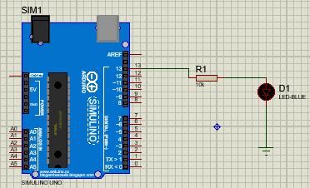

Hình Sơ đồ Proteus Blinking Led

## Đặt điểm linh kiện:

* Led.
* Điện trở.

## Mã lệnh chính:

void setup() {

pinMode(13, OUTPUT);

}

void loop() {

digitalWrite(13, HIGH); // turn the LED on (HIGH is the voltage level)

delay(1000); // wait for a second

digitalWrite(13, LOW); // turn the LED off by making the voltage LOW

delay(1000); // wait for a second

}

# Bài 2. Led Button

## Mô tả:

* Làm đèn sáng sau khi nhấn nút.

## Sơ đồ:

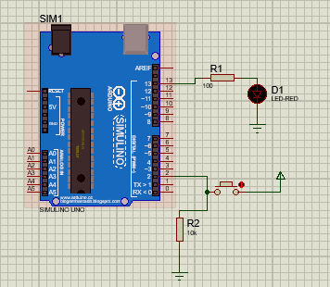

Hình Sơ đồ Proteus Led Button

## Đặt điểm linh kiện:

* Led.
* Điện trở.
* Nút bấm.

## Mã lệnh chính:

int x = 0;

void setup() {

pinMode(2,INPUT);

pinMode(13,OUTPUT);

}

void loop() {

x = digitalRead(2);

if (x==HIGH){

digitalWrite(13,HIGH);

}

else{

digitalWrite(13,LOW);

}

delay(1000);

}

# Bài 3. TMP

## Mô tả:

* Làm đèn sáng sau khi đạt nhiệt độ nhất định.

## Sơ đồ:

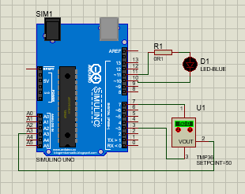

Hình Sơ đồ Proteus TMP

## Đặt điểm linh kiện:

* Led RGB.
* Điện trở.
* TMP 36.

## Mã lệnh chính:

|  |
| --- |
| void setup()  {  Serial.begin(9600);  pinMode(7,1);  pinMode(3,1);  digitalWrite(7,1);  digitalWrite(3,0);  digitalWrite(10,1);  digitalWrite(11,0);  pinMode(11,1);  }  void loop()  {  Serial.println(analogRead(A3));  if(analogRead(A3)<181)digitalWrite(10,1);  if(analogRead(A3)>181)digitalWrite(10,0);} |

# Bài 4. RGB

## Mô tả:

* Làm Led RGB sáng và đổi màu liên tục.

## Sơ đồ:

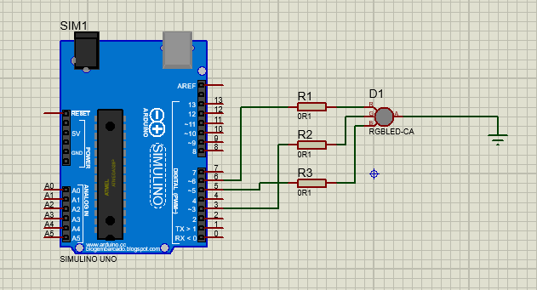

Hình Sơ đồ Proteus LED RGB

## Đặt điểm linh kiện:

* Led RGB.
* Điện trở.

## Mã lệnh chính:

|  |
| --- |
| const int R = 3;  const int G = 5;  const int B = 6;  int Red = 255;  int Green = 0;  int Blue = 0;  void setup()  {  pinMode(R, OUTPUT);  pinMode(G, OUTPUT);  pinMode(B, OUTPUT);  analogWrite(R, Red);  analogWrite(G, Green);  analogWrite(B, Blue);  }  void loop() {  for (Blue = 0; Blue<255; Blue = Blue + 5) {  analogWrite(B, Blue);  delay(10);  }  for (Red = 255; Red>0; Red = Red - 5) {  analogWrite(R, Red);  delay(10);  }  for (Green = 0; Green<255; Green = Green + 5) {  analogWrite(G, Green);  delay(10);  }  for (Blue = 255; Blue>0; Blue = Blue - 5) {  analogWrite(B, Blue);  delay(10);  }  for (Red = 0; Red<255; Red = Red + 5) {  analogWrite(R, Red);  delay(10);  }  for (Green = 255; Green>0; Green = Green - 5) {  analogWrite(G, Green);  delay(10);  }  }  pinMode(11,1);  }  void loop()  {  Serial.println(analogRead(A3));  if(analogRead(A3)<181)digitalWrite(10,1);  if(analogRead(A3)>181)digitalWrite(10,0);} |

# Bài 5. led 7 đoạn

## Mô tả:

* Điều khiển led 7 đoạn hiển thị các số tự nhiên bằng tín hiệu nhị phân.

## Sơ đồ:

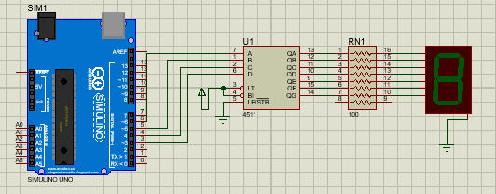

Hình Sơ đồ Proteus Led 7 đoạn

## Đặt điểm linh kiện:

* Led 7 đoạn.
* Điện trở.
* 4511 IC.

## Mã lệnh chính:

int a=6, b=5, c=4, d=3;

void setup() {

pinMode(a, OUTPUT);

pinMode(b, OUTPUT);

pinMode(c, OUTPUT);

pinMode(d, OUTPUT); }

void khong(){

digitalWrite(a, LOW);

digitalWrite(b, LOW);

digitalWrite(c, LOW);

digitalWrite(d, LOW); }

void mot(){

digitalWrite(a, HIGH);

digitalWrite(b, LOW);

digitalWrite(c, LOW);

digitalWrite(d, LOW);

}

void hai(){

digitalWrite(a, LOW);

digitalWrite(b, HIGH);

digitalWrite(c, LOW);

digitalWrite(d, LOW);

}

void ba(){

digitalWrite(a, HIGH);

digitalWrite(b, HIGH);

digitalWrite(c, LOW);

digitalWrite(d, LOW);

}

void bon(){

digitalWrite(a, LOW);

digitalWrite(b, LOW);

digitalWrite(c, HIGH);

digitalWrite(d, LOW);

}

void nam(){

digitalWrite(a, HIGH);

digitalWrite(b, LOW);

digitalWrite(c, HIGH);

digitalWrite(d, LOW);

}

void sau(){

digitalWrite(a, LOW);

digitalWrite(b, HIGH);

digitalWrite(c, HIGH);

digitalWrite(d, LOW);

}

void bay(){

digitalWrite(a, HIGH);

digitalWrite(b, HIGH);

digitalWrite(c, HIGH);

digitalWrite(d, LOW);

}

void tam(){

digitalWrite(a, LOW);

digitalWrite(b, LOW);

digitalWrite(c, LOW);

digitalWrite(d, HIGH);

}

void chin(){

digitalWrite(a, HIGH);

digitalWrite(b, LOW);

digitalWrite(c, LOW);

digitalWrite(d, HIGH);

}

void loop() {

khong(); delay(1000);

mot(); delay(1000);

hai(); delay(1000);

ba(); delay(1000);

bon(); delay(1000);

nam(); delay(1000);

sau(); delay(1000);

bay(); delay(1000);

tam(); delay(1000);

chin(); delay(1000);

}

# Bài 6. 8 Led

## Mô tả:

* Điều khiển led 7 đoạn hiển thị các số tự nhiên bằng tín hiệu nhị phân.

## Sơ đồ:

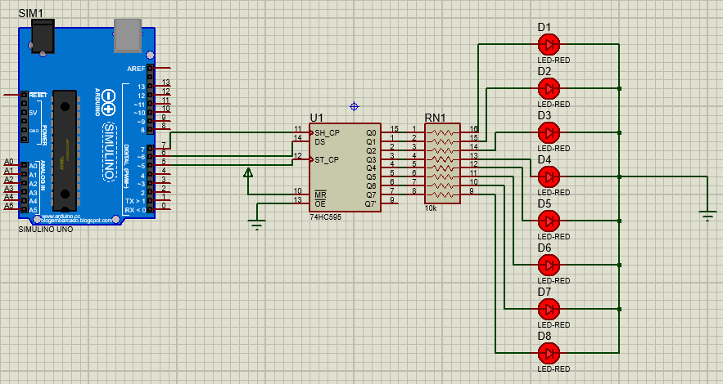

Hình 6 Sơ đồ Proteus 8 Led

## Đặt điểm linh kiện:

* Led.
* Điện trở.
* 74HC595 IC.

## Mã lệnh chính:

int latchPin = 5;

int clockPin = 7;

int dataPin = 6;

byte ledStatus;

void setup() {

pinMode(latchPin, OUTPUT);

pinMode(clockPin, OUTPUT);

pinMode(dataPin, OUTPUT);

}

void loop() {

//Sáng tuần tự

ledStatus = 0;//mặc định là không có đèn nào sáng hết (0 = 0b00000000)

digitalWrite(latchPin, LOW ledStatus = 0b11111111;

//ShiftOut ra IC

shiftOut(dataPin, clockPin, MSBFIRST, ledStatus);

digitalWrite(latchPin, HIGH);//các đèn LED sẽ sáng với trạng thái vừa được cập nhập

delay(1000);

digitalWrite(latchPin, LOW);

ledStatus = 0;

//ShiftOut ra IC

shiftOut(dataPin, clockPin, MSBFIRST, ledStatus);

digitalWrite(latchPin, HIGH);//các đèn LED sẽ sáng với trạng thái vừa được cập nhập

delay(250);

}

# Bài 7. Led Matrix

## Mô tả:

* Điều khiển led matrix hiển thị chữ A.

## Sơ đồ:

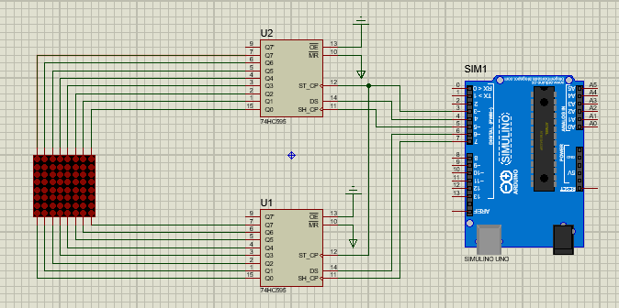

Hình 7 Sơ đồ Proteus Led Matrix

## Đặt điểm linh kiện:

* Led Matrix.
* Điện trở.
* 74HC595 IC.

## Mã lệnh chính:

#define _data_hang 4

#define _clock_hang 5

#define _data_cot 6

#define _clock_cot 7

#define _latch 3

byte chu[][8] = {

{0xFF,0xC0,0x80,0xB7,0xB7,0x80,0xC0,0xFF}, //A

};

byte hang = 0b10000000;

void setup() {

Serial.begin(9600);

pinMode(_latch,OUTPUT);//RCLK

pinMode(_data_hang,OUTPUT);//SER hang

pinMode(_clock_hang,OUTPUT);//SRCLK hang

pinMode(_clock_cot,OUTPUT);//SRCLK cot

pinMode(_data_cot,OUTPUT);//SER cot

}

void loop() {

for(int i = 0;i<10;i++){

digitalWrite(_latch,LOW);

shiftOut(_data_cot,_clock_cot,LSBFIRST,chu[0][i]);// hang 8 - hang 1

shiftOut(_data_hang,_clock_hang,LSBFIRST,hang >> i);// cot 8 - cot 1

digitalWrite(_latch,HIGH);

delay(1);

}

# Bài 8. Nhúng LCD (Kiểm tra)

## Mô tả:

* Liên tục đọc giá trị độ sáng và hiển thị ra màn hình LCD.
* Nếu giá trị <50% thì bật đèn sáng và ngược lại.

## Sơ đồ:

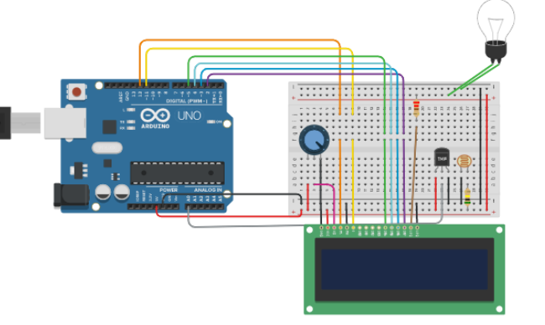

Hình 8 Sơ đồ Proteus LCD

## Đặt điểm linh kiện:

* Led LCD.
* Điện trở.
* Light bult.

## Mã lệnh chính:

#include <LiquidCrystal.h>

#define SENSOR_PIN A0

// initialize the library with the numbers of the interface pins

LiquidCrystal lcd(12, 11, 5, 4, 3, 2);

int LIGHT = 0;

int val =0;

void setup() {

// set up the LCD's number of columns and rows:

pinMode(9,OUTPUT);

digitalWrite(9,LOW);

lcd.begin(16, 2);

// Print a message to the LCD.

Serial.begin(9600);

}

void loop() {

val = analogRead(LIGHT);

if (val < 100)

{

digitalWrite (9, HIGH);

delay(1000);

}

else

{

digitalWrite (9, LOW);

delay(1000);

}

// set the cursor to column 0, line 1

// (note: line 1 is the second row, since counting begins with 0):

lcd.setCursor(0, 0);

// print the number of seconds since reset:

lcd.print("do sang:");

lcd.setCursor(0, 1);

lcd.print(val);

}

# Bài 9. Led Matrix (Kiểm tra)

## Mô tả:

* Hiển thị các số từ 00 đến 99 bằng Led 7 đoạn.

## Sơ đồ:

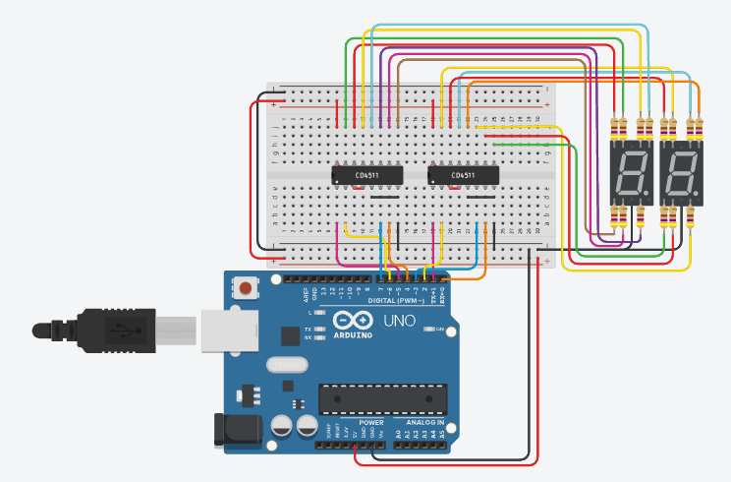

Hình 9 Sơ đồ Proteus 8 Led

## Đặt điểm linh kiện:

* Led 7 đoạn.
* Điện trở.
* 4511 IC.

## Mã lệnh chính:

void setup()

{

pinMode(0, OUTPUT);

pinMode(1, OUTPUT);

pinMode(2, OUTPUT);

pinMode(3, OUTPUT);

pinMode(4, OUTPUT);

pinMode(5, OUTPUT);

pinMode(6, OUTPUT);

pinMode(7, OUTPUT);

}

void show_so(int so, int led = 0)

{

if (so == 0)

{

digitalWrite(0 + led, LOW);

digitalWrite(1 + led, LOW);

digitalWrite(2 + led, LOW);

digitalWrite(3 + led, LOW);

}

else if (so == 1)

{

digitalWrite(0 + led, HIGH);

digitalWrite(1 + led, LOW);

digitalWrite(2 + led, LOW);

digitalWrite(3 + led, LOW);

}

else if (so == 2)

{

digitalWrite(0 + led, LOW);

digitalWrite(1 + led, HIGH);

digitalWrite(2 + led, LOW);

digitalWrite(3 + led, LOW);

}

else if (so == 3)

{

digitalWrite(0 + led, HIGH);

digitalWrite(1 + led, HIGH);

digitalWrite(2 + led, LOW);

digitalWrite(3 + led, LOW);

}

else if (so == 4)

{

digitalWrite(0 + led, LOW);

digitalWrite(1 + led, LOW);

digitalWrite(2 + led, HIGH);

digitalWrite(3 + led, LOW);

}

else if (so == 5)

{

digitalWrite(0 + led, HIGH);

digitalWrite(1 + led, LOW);

digitalWrite(2 + led, HIGH);

digitalWrite(3 + led, LOW);

}

else if (so == 6)

{

digitalWrite(0 + led, LOW);

digitalWrite(1 + led, HIGH);

digitalWrite(2 + led, HIGH);

digitalWrite(3 + led, LOW);

}

else if (so == 7)

{

digitalWrite(0 + led, HIGH);

digitalWrite(1 + led, HIGH);

digitalWrite(2 + led, HIGH);

digitalWrite(3 + led, LOW);

}

else if (so == 8)

{

digitalWrite(0 + led, LOW);

digitalWrite(1 + led, LOW);

digitalWrite(2 + led, LOW);

digitalWrite(3 + led, HIGH);

}

else if (so == 9)

{

digitalWrite(0 + led, HIGH);

digitalWrite(1 + led, LOW);

digitalWrite(2 + led, LOW);

digitalWrite(3 + led, HIGH);

}

}

void loop()

{

static int num1 = 0;

static int num2 = 0;

show_so(num1 % 10, 4);

show_so(num2 % 10);

num2++;

if (num2 % 10 == 0)

{

num2 = 0;

num1++;

}

delay(1000);

}

Chương II:

# Bài 8: Blink led

## Mô tả:

* Làm led nhấp nháy với STM32.

## Sơ đồ:

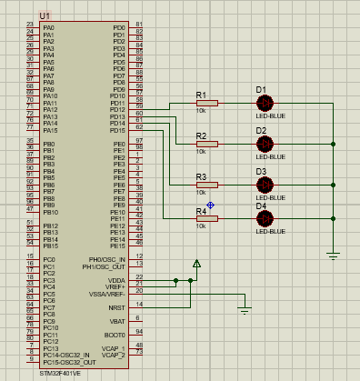

Hình 10 Sơ đồ Proteus 8 Led

## Đặt điểm linh kiện:

* Led 7 đoạn.
* Điện trở.
* 4511 IC.

## Mã lệnh chính:

/* USER CODE BEGIN Header */

/**

******************************************************************************

* @file : main.c

* @brief : Main program body

******************************************************************************

* @attention

*

* <h2><center>&copy; Copyright (c) 2021 STMicroelectronics.

* All rights reserved.</center></h2>

*

* This software component is licensed by ST under BSD 3-Clause license,

* the "License"; You may not use this file except in compliance with the

* License. You may obtain a copy of the License at:

* opensource.org/licenses/BSD-3-Clause

*

******************************************************************************

*/

/* USER CODE END Header */

/* Includes ------------------------------------------------------------------*/

#include "main.h"

#include "stdio.h"

#include "stm32f4xx_hal.h"

/* Private includes ----------------------------------------------------------*/

/* USER CODE BEGIN Includes */

/* USER CODE END Includes */

/* Private typedef -----------------------------------------------------------*/

/* USER CODE BEGIN PTD */

/* USER CODE END PTD */

/* Private define ------------------------------------------------------------*/

/* USER CODE BEGIN PD */

/* USER CODE END PD */

/* Private macro -------------------------------------------------------------*/

/* USER CODE BEGIN PM */

/* USER CODE END PM */

/* Private variables ---------------------------------------------------------*/

/* USER CODE BEGIN PV */

/* USER CODE END PV */

/* Private function prototypes -----------------------------------------------*/

void SystemClock_Config(void);

static void MX_GPIO_Init(void);

/* USER CODE BEGIN PFP */

/* USER CODE END PFP */

/* Private user code ---------------------------------------------------------*/

/* USER CODE BEGIN 0 */

/* USER CODE END 0 */

/**

* @brief The application entry point.

* @retval int

*/

int main(void)

{

/* USER CODE BEGIN 1 */

/* USER CODE END 1 */

/* MCU Configuration--------------------------------------------------------*/

/* Reset of all peripherals, Initializes the Flash interface and the Systick. */

HAL_Init();

/* USER CODE BEGIN Init */

/* USER CODE END Init */

/* Configure the system clock */

SystemClock_Config();

/* USER CODE BEGIN SysInit */

/* USER CODE END SysInit */

/* Initialize all configured peripherals */

MX_GPIO_Init();

/* USER CODE BEGIN 2 */

/* USER CODE END 2 */

/* Infinite loop */

/* USER CODE BEGIN WHILE */

while (1)

{

/* USER CODE END WHILE */

/* USER CODE BEGIN 3 */

}

/* USER CODE END 3 */

}

/**

* @brief System Clock Configuration

* @retval None

*/

void SystemClock_Config(void)

{

RCC_OscInitTypeDef RCC_OscInitStruct = {0};

RCC_ClkInitTypeDef RCC_ClkInitStruct = {0};

/** Configure the main internal regulator output voltage

*/

__HAL_RCC_PWR_CLK_ENABLE();

__HAL_PWR_VOLTAGESCALING_CONFIG(PWR_REGULATOR_VOLTAGE_SCALE2);

/** Initializes the RCC Oscillators according to the specified parameters

* in the RCC_OscInitTypeDef structure.

*/

RCC_OscInitStruct.OscillatorType = RCC_OSCILLATORTYPE_HSE;

RCC_OscInitStruct.HSEState = RCC_HSE_ON;

RCC_OscInitStruct.PLL.PLLState = RCC_PLL_ON;

RCC_OscInitStruct.PLL.PLLSource = RCC_PLLSOURCE_HSE;

RCC_OscInitStruct.PLL.PLLM = 25;

RCC_OscInitStruct.PLL.PLLN = 168;

RCC_OscInitStruct.PLL.PLLP = RCC_PLLP_DIV2;

RCC_OscInitStruct.PLL.PLLQ = 4;

if (HAL_RCC_OscConfig(&RCC_OscInitStruct) != HAL_OK)

{

Error_Handler();

}

/** Initializes the CPU, AHB and APB buses clocks

*/

RCC_ClkInitStruct.ClockType = RCC_CLOCKTYPE_HCLK|RCC_CLOCKTYPE_SYSCLK

|RCC_CLOCKTYPE_PCLK1|RCC_CLOCKTYPE_PCLK2;

RCC_ClkInitStruct.SYSCLKSource = RCC_SYSCLKSOURCE_PLLCLK;

RCC_ClkInitStruct.AHBCLKDivider = RCC_SYSCLK_DIV1;

RCC_ClkInitStruct.APB1CLKDivider = RCC_HCLK_DIV2;

RCC_ClkInitStruct.APB2CLKDivider = RCC_HCLK_DIV1;

if (HAL_RCC_ClockConfig(&RCC_ClkInitStruct, FLASH_LATENCY_2) != HAL_OK)

{

Error_Handler();

}

}

/**

* @brief GPIO Initialization Function

* @param None

* @retval None

*/

static void MX_GPIO_Init(void)

{

GPIO_InitTypeDef GPIO_InitStruct = {0};

/* GPIO Ports Clock Enable */

__HAL_RCC_GPIOH_CLK_ENABLE();

__HAL_RCC_GPIOD_CLK_ENABLE();

__HAL_RCC_GPIOA_CLK_ENABLE();

/*Configure GPIO pin Output Level */

HAL_GPIO_WritePin(GPIOD, GPIO_PIN_12|GPIO_PIN_13|GPIO_PIN_14|GPIO_PIN_15, GPIO_PIN_RESET);

/*Configure GPIO pins : PD12 PD13 PD14 PD15 */

GPIO_InitStruct.Pin = GPIO_PIN_12|GPIO_PIN_13|GPIO_PIN_14|GPIO_PIN_15;

GPIO_InitStruct.Mode = GPIO_MODE_OUTPUT_PP;

GPIO_InitStruct.Pull = GPIO_NOPULL;

GPIO_InitStruct.Speed = GPIO_SPEED_FREQ_HIGH;

HAL_GPIO_Init(GPIOD, &GPIO_InitStruct);

}

/* USER CODE BEGIN 4 */

/* USER CODE END 4 */

/**

* @brief This function is executed in case of error occurrence.

* @retval None

*/

void Error_Handler(void)

{

/* USER CODE BEGIN Error_Handler_Debug */

/* User can add his own implementation to report the HAL error return state */

/* USER CODE END Error_Handler_Debug */

}

#ifdef USE_FULL_ASSERT

/**

* @brief Reports the name of the source file and the source line number

* where the assert_param error has occurred.

* @param file: pointer to the source file name

* @param line: assert_param error line source number

* @retval None

*/

void assert_failed(uint8_t *file, uint32_t line)

{

/* USER CODE BEGIN 6 */

/* User can add his own implementation to report the file name and line number,

tex: printf("Wrong parameters value: file %s on line %d\r\n", file, line) */

/* USER CODE END 6 */

}

#endif /* USE_FULL_ASSERT */

/************************ (C) COPYRIGHT STMicroelectronics *****END OF FILE****/

# Bài 9: chip STM32F401VE sáng led trái tim (22led)

## 1.Mô tả:

* Điều khiển nháy sáng đèn led hình trái tim 22 led cạnh nhau và các hiệu ứng của nó qua mạch RES16DIPIS kết nối chip STM32F401VE.

## 2.Sơ đồ thiết kế

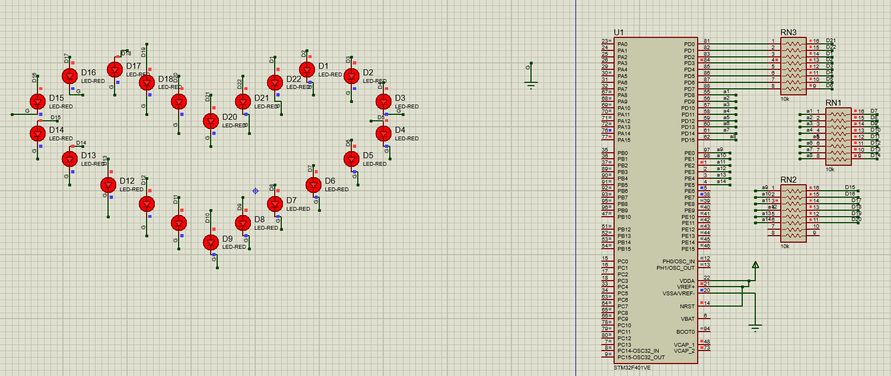

Figure 9 Sơ đồ thiết kế

## 3.Đặc điểm linh kiện:

* 22 Led-Red
* 3 mạch RES16DIPIS
* Chip STM32F401VE

## 4.Code:

#include "main.h"

void SystemClock_Config(void);

static void MX_GPIO_Init(void);

void SANGLED();

void TATLED();

void NHAPNHAY();

void NHAPNHAY3();

void NHAPNHA();

int main(void)

{

HAL_Init();

SystemClock_Config();

MX_GPIO_Init();

while (1)

{

SANGLED();

HAL_Delay(1000);

TATLED();

HAL_Delay(1000);

NHAPNHAY();

HAL_Delay(500);

NHAPNHAY();

NHAPNHAY3();

NHAPNHA();

}

}

void TATLED()

{

SANGLED();

HAL_GPIO_WritePin (GPIOD, GPIO_PIN_0, GPIO_PIN_RESET);

HAL_GPIO_WritePin (GPIOD, GPIO_PIN_1, GPIO_PIN_RESET);

HAL_GPIO_WritePin (GPIOD, GPIO_PIN_2, GPIO_PIN_RESET);

HAL_GPIO_WritePin (GPIOD, GPIO_PIN_3, GPIO_PIN_RESET);

HAL_GPIO_WritePin (GPIOD, GPIO_PIN_4, GPIO_PIN_RESET);

HAL_GPIO_WritePin (GPIOD, GPIO_PIN_5, GPIO_PIN_RESET);

HAL_GPIO_WritePin (GPIOD, GPIO_PIN_6, GPIO_PIN_RESET);

HAL_GPIO_WritePin (GPIOD, GPIO_PIN_7, GPIO_PIN_RESET);

HAL_GPIO_WritePin (GPIOD, GPIO_PIN_8, GPIO_PIN_RESET);

HAL_GPIO_WritePin (GPIOD, GPIO_PIN_9, GPIO_PIN_RESET);

HAL_GPIO_WritePin (GPIOD, GPIO_PIN_10, GPIO_PIN_RESET);

HAL_GPIO_WritePin (GPIOD, GPIO_PIN_11, GPIO_PIN_RESET);

HAL_GPIO_WritePin (GPIOD, GPIO_PIN_12, GPIO_PIN_RESET);

HAL_GPIO_WritePin (GPIOD, GPIO_PIN_13, GPIO_PIN_RESET);

HAL_GPIO_WritePin (GPIOD, GPIO_PIN_14, GPIO_PIN_RESET);

HAL_GPIO_WritePin (GPIOD, GPIO_PIN_15, GPIO_PIN_RESET);

HAL_GPIO_WritePin (GPIOE, GPIO_PIN_0, GPIO_PIN_RESET);

HAL_GPIO_WritePin (GPIOE, GPIO_PIN_1, GPIO_PIN_RESET);

HAL_GPIO_WritePin (GPIOE, GPIO_PIN_2, GPIO_PIN_RESET);

HAL_GPIO_WritePin (GPIOE, GPIO_PIN_3, GPIO_PIN_RESET);

HAL_GPIO_WritePin (GPIOE, GPIO_PIN_4, GPIO_PIN_RESET);

HAL_GPIO_WritePin (GPIOE, GPIO_PIN_5, GPIO_PIN_RESET);

}

void SANGLED()

{

HAL_GPIO_WritePin (GPIOD, GPIO_PIN_0, GPIO_PIN_SET);

HAL_GPIO_WritePin (GPIOD, GPIO_PIN_1, GPIO_PIN_SET);

HAL_GPIO_WritePin (GPIOD, GPIO_PIN_2, GPIO_PIN_SET);

HAL_GPIO_WritePin (GPIOD, GPIO_PIN_3, GPIO_PIN_SET);

HAL_GPIO_WritePin (GPIOD, GPIO_PIN_4, GPIO_PIN_SET);

HAL_GPIO_WritePin (GPIOD, GPIO_PIN_5, GPIO_PIN_SET);

HAL_GPIO_WritePin (GPIOD, GPIO_PIN_6, GPIO_PIN_SET);

HAL_GPIO_WritePin (GPIOD, GPIO_PIN_7, GPIO_PIN_SET);

HAL_GPIO_WritePin (GPIOD, GPIO_PIN_8, GPIO_PIN_SET);

HAL_GPIO_WritePin (GPIOD, GPIO_PIN_9, GPIO_PIN_SET);

HAL_GPIO_WritePin (GPIOD, GPIO_PIN_10, GPIO_PIN_SET);

HAL_GPIO_WritePin (GPIOD, GPIO_PIN_11, GPIO_PIN_SET);

HAL_GPIO_WritePin (GPIOD, GPIO_PIN_12, GPIO_PIN_SET);

HAL_GPIO_WritePin (GPIOD, GPIO_PIN_13, GPIO_PIN_SET);

HAL_GPIO_WritePin (GPIOD, GPIO_PIN_14, GPIO_PIN_SET);

HAL_GPIO_WritePin (GPIOD, GPIO_PIN_15, GPIO_PIN_SET);

HAL_GPIO_WritePin (GPIOE, GPIO_PIN_0, GPIO_PIN_SET);

HAL_GPIO_WritePin (GPIOE, GPIO_PIN_1, GPIO_PIN_SET);

HAL_GPIO_WritePin (GPIOE, GPIO_PIN_2, GPIO_PIN_SET);

HAL_GPIO_WritePin (GPIOE, GPIO_PIN_3, GPIO_PIN_SET);

HAL_GPIO_WritePin (GPIOE, GPIO_PIN_4, GPIO_PIN_SET);

HAL_GPIO_WritePin (GPIOE, GPIO_PIN_5, GPIO_PIN_SET);

}

void NHAPNHAY()

{

TATLED();

HAL_GPIO_WritePin (GPIOD, GPIO_PIN_0, GPIO_PIN_RESET);

HAL_Delay(100);

HAL_GPIO_WritePin (GPIOD, GPIO_PIN_1, GPIO_PIN_SET);

HAL_Delay(100);

HAL_GPIO_WritePin (GPIOD, GPIO_PIN_2, GPIO_PIN_RESET);

HAL_Delay(100);

HAL_GPIO_WritePin (GPIOD, GPIO_PIN_3, GPIO_PIN_SET);

HAL_Delay(100);

HAL_GPIO_WritePin (GPIOD, GPIO_PIN_4, GPIO_PIN_RESET);

HAL_Delay(100);

HAL_GPIO_WritePin (GPIOD, GPIO_PIN_5, GPIO_PIN_SET);

HAL_Delay(100);

HAL_GPIO_WritePin (GPIOD, GPIO_PIN_6, GPIO_PIN_RESET);

HAL_Delay(100);

HAL_GPIO_WritePin (GPIOD, GPIO_PIN_7, GPIO_PIN_SET);

HAL_Delay(100);

HAL_GPIO_WritePin (GPIOD, GPIO_PIN_8, GPIO_PIN_RESET);

HAL_Delay(100);

HAL_GPIO_WritePin (GPIOD, GPIO_PIN_9, GPIO_PIN_SET);

HAL_Delay(100);

HAL_GPIO_WritePin (GPIOD, GPIO_PIN_10, GPIO_PIN_RESET);

HAL_Delay(100);

HAL_GPIO_WritePin (GPIOD, GPIO_PIN_11, GPIO_PIN_SET);

HAL_Delay(100);

HAL_GPIO_WritePin (GPIOD, GPIO_PIN_12, GPIO_PIN_RESET);

HAL_Delay(100);

HAL_GPIO_WritePin (GPIOD, GPIO_PIN_13, GPIO_PIN_SET);

HAL_Delay(100);

HAL_GPIO_WritePin (GPIOD, GPIO_PIN_14, GPIO_PIN_RESET);

HAL_Delay(100);

HAL_GPIO_WritePin (GPIOD, GPIO_PIN_15, GPIO_PIN_SET);

HAL_Delay(100);

HAL_GPIO_WritePin (GPIOE, GPIO_PIN_0, GPIO_PIN_RESET);

HAL_Delay(100);

HAL_GPIO_WritePin (GPIOE, GPIO_PIN_1, GPIO_PIN_SET);

HAL_Delay(100);

HAL_GPIO_WritePin (GPIOE, GPIO_PIN_2, GPIO_PIN_RESET);

HAL_Delay(100);

HAL_GPIO_WritePin (GPIOE, GPIO_PIN_3, GPIO_PIN_SET);

HAL_Delay(100);

HAL_GPIO_WritePin (GPIOE, GPIO_PIN_4, GPIO_PIN_RESET);

HAL_Delay(100);

HAL_GPIO_WritePin (GPIOE, GPIO_PIN_5, GPIO_PIN_SET);

HAL_Delay(100);

}

void NHAPNHAY3()

{

TATLED();

HAL_GPIO_WritePin (GPIOD, GPIO_PIN_0, GPIO_PIN_SET);

HAL_Delay(1000);

HAL_GPIO_WritePin (GPIOD, GPIO_PIN_0, GPIO_PIN_RESET);

HAL_Delay(1000);

HAL_GPIO_WritePin (GPIOD, GPIO_PIN_1, GPIO_PIN_SET);

HAL_Delay(1000);

HAL_GPIO_WritePin (GPIOD, GPIO_PIN_1, GPIO_PIN_RESET);

HAL_Delay(1000);

HAL_GPIO_WritePin (GPIOD, GPIO_PIN_2, GPIO_PIN_SET);

HAL_Delay(1000);

HAL_GPIO_WritePin (GPIOD, GPIO_PIN_2, GPIO_PIN_RESET);

HAL_Delay(1000);

HAL_GPIO_WritePin (GPIOD, GPIO_PIN_3, GPIO_PIN_SET);

HAL_Delay(100);

HAL_GPIO_WritePin (GPIOD, GPIO_PIN_3, GPIO_PIN_RESET);

HAL_GPIO_WritePin (GPIOD, GPIO_PIN_4, GPIO_PIN_SET);

HAL_Delay(100);

HAL_GPIO_WritePin (GPIOD, GPIO_PIN_4, GPIO_PIN_RESET);

HAL_GPIO_WritePin (GPIOD, GPIO_PIN_5, GPIO_PIN_RESET);

HAL_Delay(100);

HAL_GPIO_WritePin (GPIOD, GPIO_PIN_6, GPIO_PIN_RESET);

HAL_Delay(100);

HAL_GPIO_WritePin (GPIOD, GPIO_PIN_7, GPIO_PIN_SET);

HAL_Delay(100);

HAL_GPIO_WritePin (GPIOD, GPIO_PIN_8, GPIO_PIN_SET);

HAL_Delay(100);

HAL_GPIO_WritePin (GPIOD, GPIO_PIN_9, GPIO_PIN_SET);

HAL_Delay(100);

HAL_GPIO_WritePin (GPIOD, GPIO_PIN_10, GPIO_PIN_RESET);

HAL_Delay(100);

HAL_GPIO_WritePin (GPIOD, GPIO_PIN_11, GPIO_PIN_RESET);

HAL_Delay(100);

HAL_GPIO_WritePin (GPIOD, GPIO_PIN_12, GPIO_PIN_RESET);

HAL_Delay(100);

HAL_GPIO_WritePin (GPIOD, GPIO_PIN_13, GPIO_PIN_SET);

HAL_Delay(100);

HAL_GPIO_WritePin (GPIOD, GPIO_PIN_14, GPIO_PIN_SET);

HAL_Delay(100);

HAL_GPIO_WritePin (GPIOD, GPIO_PIN_15, GPIO_PIN_SET);

HAL_Delay(100);

HAL_GPIO_WritePin (GPIOE, GPIO_PIN_0, GPIO_PIN_RESET);

HAL_Delay(100);

HAL_GPIO_WritePin (GPIOE, GPIO_PIN_1, GPIO_PIN_RESET);

HAL_Delay(100);

HAL_GPIO_WritePin (GPIOE, GPIO_PIN_2, GPIO_PIN_RESET);

HAL_Delay(100);

HAL_GPIO_WritePin (GPIOE, GPIO_PIN_3, GPIO_PIN_SET);

HAL_Delay(100);

HAL_GPIO_WritePin (GPIOE, GPIO_PIN_4, GPIO_PIN_SET);

HAL_Delay(100);

HAL_GPIO_WritePin (GPIOE, GPIO_PIN_5, GPIO_PIN_SET);

HAL_Delay(100);

}

void NHAPNHA()

{

TATLED();

HAL_GPIO_WritePin (GPIOD, GPIO_PIN_0, GPIO_PIN_SET);

HAL_Delay(100);

HAL_GPIO_WritePin (GPIOD, GPIO_PIN_0, GPIO_PIN_RESET);

HAL_Delay(100);

HAL_GPIO_WritePin (GPIOD, GPIO_PIN_0, GPIO_PIN_SET);

HAL_GPIO_WritePin (GPIOD, GPIO_PIN_1, GPIO_PIN_SET);

HAL_Delay(100);

HAL_GPIO_WritePin (GPIOD, GPIO_PIN_1, GPIO_PIN_RESET);

HAL_Delay(100);

HAL_GPIO_WritePin (GPIOD, GPIO_PIN_1, GPIO_PIN_SET);

HAL_GPIO_WritePin (GPIOD, GPIO_PIN_2, GPIO_PIN_SET);

HAL_Delay(100);

HAL_GPIO_WritePin (GPIOD, GPIO_PIN_2, GPIO_PIN_RESET);

HAL_Delay(100);

HAL_GPIO_WritePin (GPIOD, GPIO_PIN_2, GPIO_PIN_SET);

HAL_GPIO_WritePin (GPIOD, GPIO_PIN_3, GPIO_PIN_SET);

HAL_Delay(100);

HAL_GPIO_WritePin (GPIOD, GPIO_PIN_3, GPIO_PIN_RESET);

HAL_Delay(100);

HAL_GPIO_WritePin (GPIOD, GPIO_PIN_3, GPIO_PIN_SET);

HAL_GPIO_WritePin (GPIOD, GPIO_PIN_4, GPIO_PIN_SET);

HAL_Delay(100);

HAL_GPIO_WritePin (GPIOD, GPIO_PIN_4, GPIO_PIN_RESET);

HAL_Delay(100);

HAL_GPIO_WritePin (GPIOD, GPIO_PIN_4, GPIO_PIN_SET);

HAL_GPIO_WritePin (GPIOD, GPIO_PIN_5, GPIO_PIN_SET);

HAL_Delay(100);

HAL_GPIO_WritePin (GPIOD, GPIO_PIN_5, GPIO_PIN_RESET);

HAL_Delay(100);

HAL_GPIO_WritePin (GPIOD, GPIO_PIN_5, GPIO_PIN_SET);

HAL_GPIO_WritePin (GPIOD, GPIO_PIN_6, GPIO_PIN_SET);

HAL_Delay(100);

HAL_GPIO_WritePin (GPIOD, GPIO_PIN_6, GPIO_PIN_RESET);

HAL_Delay(100);

HAL_GPIO_WritePin (GPIOD, GPIO_PIN_6, GPIO_PIN_SET);

HAL_GPIO_WritePin (GPIOD, GPIO_PIN_7, GPIO_PIN_SET);

HAL_Delay(100);

HAL_GPIO_WritePin (GPIOD, GPIO_PIN_7, GPIO_PIN_RESET);

HAL_Delay(100);

HAL_GPIO_WritePin (GPIOD, GPIO_PIN_7, GPIO_PIN_SET);

HAL_GPIO_WritePin (GPIOD, GPIO_PIN_8, GPIO_PIN_SET);

HAL_Delay(100);

HAL_GPIO_WritePin (GPIOD, GPIO_PIN_8, GPIO_PIN_RESET);

HAL_Delay(100);

HAL_GPIO_WritePin (GPIOD, GPIO_PIN_8, GPIO_PIN_SET);

HAL_GPIO_WritePin (GPIOD, GPIO_PIN_9, GPIO_PIN_SET);

HAL_Delay(100);

HAL_GPIO_WritePin (GPIOD, GPIO_PIN_9, GPIO_PIN_RESET);

HAL_Delay(100);

HAL_GPIO_WritePin (GPIOD, GPIO_PIN_9, GPIO_PIN_SET);

HAL_GPIO_WritePin (GPIOD, GPIO_PIN_10, GPIO_PIN_SET);

HAL_Delay(100);

HAL_GPIO_WritePin (GPIOD, GPIO_PIN_10, GPIO_PIN_RESET);

HAL_Delay(100);

HAL_GPIO_WritePin (GPIOD, GPIO_PIN_10, GPIO_PIN_SET);

HAL_GPIO_WritePin (GPIOD, GPIO_PIN_11, GPIO_PIN_SET);

HAL_Delay(100);

HAL_GPIO_WritePin (GPIOD, GPIO_PIN_11, GPIO_PIN_RESET);

HAL_Delay(100);

HAL_GPIO_WritePin (GPIOD, GPIO_PIN_11, GPIO_PIN_SET);

HAL_GPIO_WritePin (GPIOD, GPIO_PIN_12, GPIO_PIN_SET);

HAL_Delay(100);

HAL_GPIO_WritePin (GPIOD, GPIO_PIN_12, GPIO_PIN_RESET);

HAL_Delay(100);

HAL_GPIO_WritePin (GPIOD, GPIO_PIN_12, GPIO_PIN_SET);

HAL_GPIO_WritePin (GPIOD, GPIO_PIN_13, GPIO_PIN_SET);

HAL_Delay(100);

HAL_GPIO_WritePin (GPIOD, GPIO_PIN_13, GPIO_PIN_RESET);

HAL_Delay(100);

HAL_GPIO_WritePin (GPIOD, GPIO_PIN_13, GPIO_PIN_SET);

HAL_GPIO_WritePin (GPIOD, GPIO_PIN_14, GPIO_PIN_SET);

HAL_Delay(100);

HAL_GPIO_WritePin (GPIOD, GPIO_PIN_14, GPIO_PIN_RESET);

HAL_Delay(100);

HAL_GPIO_WritePin (GPIOD, GPIO_PIN_14, GPIO_PIN_SET);

HAL_GPIO_WritePin (GPIOD, GPIO_PIN_15, GPIO_PIN_SET);

HAL_Delay(100);

HAL_GPIO_WritePin (GPIOD, GPIO_PIN_15, GPIO_PIN_RESET);

HAL_Delay(100);

HAL_GPIO_WritePin (GPIOD, GPIO_PIN_15, GPIO_PIN_SET);

HAL_GPIO_WritePin (GPIOE, GPIO_PIN_0, GPIO_PIN_SET);

HAL_Delay(100);

HAL_GPIO_WritePin (GPIOE, GPIO_PIN_0, GPIO_PIN_RESET);

HAL_Delay(100);

HAL_GPIO_WritePin (GPIOE, GPIO_PIN_0, GPIO_PIN_SET);

HAL_GPIO_WritePin (GPIOE, GPIO_PIN_1, GPIO_PIN_SET);

HAL_Delay(100);

HAL_GPIO_WritePin (GPIOE, GPIO_PIN_1, GPIO_PIN_RESET);

HAL_Delay(100);

HAL_GPIO_WritePin (GPIOE, GPIO_PIN_1, GPIO_PIN_SET);

HAL_GPIO_WritePin (GPIOE, GPIO_PIN_2, GPIO_PIN_SET);

HAL_Delay(100);

HAL_GPIO_WritePin (GPIOE, GPIO_PIN_2, GPIO_PIN_RESET);

HAL_Delay(100);

HAL_GPIO_WritePin (GPIOE, GPIO_PIN_2, GPIO_PIN_SET);

HAL_GPIO_WritePin (GPIOE, GPIO_PIN_3, GPIO_PIN_SET);

HAL_Delay(100);

HAL_GPIO_WritePin (GPIOE, GPIO_PIN_3, GPIO_PIN_RESET);

HAL_Delay(100);

HAL_GPIO_WritePin (GPIOE, GPIO_PIN_3, GPIO_PIN_SET);

HAL_GPIO_WritePin (GPIOE, GPIO_PIN_4, GPIO_PIN_SET);

HAL_Delay(100);

HAL_GPIO_WritePin (GPIOE, GPIO_PIN_4, GPIO_PIN_RESET);

HAL_Delay(100);

HAL_GPIO_WritePin (GPIOE, GPIO_PIN_4, GPIO_PIN_SET);

HAL_GPIO_WritePin (GPIOE, GPIO_PIN_5, GPIO_PIN_SET);

HAL_Delay(100);

HAL_GPIO_WritePin (GPIOE, GPIO_PIN_5, GPIO_PIN_RESET);

HAL_Delay(100);

HAL_GPIO_WritePin (GPIOE, GPIO_PIN_5, GPIO_PIN_SET);

SANGLED();

HAL_Delay(100);

TATLED();

HAL_Delay(500);

SANGLED ();

HAL_Delay(500);

TATLED();

HAL_Delay(500);

SANGLED ();

HAL_Delay(500);

TATLED();

HAL_Delay(500);

SANGLED ();

}

/**

* @brief System Clock Configuration

* @retval None

*/

void SystemClock_Config(void)

{

RCC_OscInitTypeDef RCC_OscInitStruct = {0};

RCC_ClkInitTypeDef RCC_ClkInitStruct = {0};

__HAL_RCC_PWR_CLK_ENABLE();

__HAL_PWR_VOLTAGESCALING_CONFIG(PWR_REGULATOR_VOLTAGE_SCALE2);

RCC_OscInitStruct.OscillatorType = RCC_OSCILLATORTYPE_HSI;

RCC_OscInitStruct.HSIState = RCC_HSI_ON;

RCC_OscInitStruct.HSICalibrationValue = RCC_HSICALIBRATION_DEFAULT;

RCC_OscInitStruct.PLL.PLLState = RCC_PLL_NONE;

if (HAL_RCC_OscConfig(&RCC_OscInitStruct) != HAL_OK)

{

Error_Handler();

}

/** Initializes the CPU, AHB and APB buses clocks

*/

RCC_ClkInitStruct.ClockType = RCC_CLOCKTYPE_HCLK|RCC_CLOCKTYPE_SYSCLK

|RCC_CLOCKTYPE_PCLK1|RCC_CLOCKTYPE_PCLK2;

RCC_ClkInitStruct.SYSCLKSource = RCC_SYSCLKSOURCE_HSI;

RCC_ClkInitStruct.AHBCLKDivider = RCC_SYSCLK_DIV1;

RCC_ClkInitStruct.APB1CLKDivider = RCC_HCLK_DIV1;

RCC_ClkInitStruct.APB2CLKDivider = RCC_HCLK_DIV1;

if (HAL_RCC_ClockConfig(&RCC_ClkInitStruct, FLASH_LATENCY_0) != HAL_OK)

{

Error_Handler();

}

}

/**

* @brief GPIO Initialization Function

* @param None

* @retval None

*/

static void MX_GPIO_Init(void)

{

GPIO_InitTypeDef GPIO_InitStruct = {0};

/* GPIO Ports Clock Enable */

__HAL_RCC_GPIOE_CLK_ENABLE();

__HAL_RCC_GPIOD_CLK_ENABLE();

/*Configure GPIO pin Output Level */

HAL_GPIO_WritePin(GPIOE, GPIO_PIN_2|GPIO_PIN_3|GPIO_PIN_4|GPIO_PIN_5

|GPIO_PIN_6|GPIO_PIN_7|GPIO_PIN_0|GPIO_PIN_1, GPIO_PIN_RESET);

/*Configure GPIO pin Output Level */

HAL_GPIO_WritePin(GPIOD, GPIO_PIN_8|GPIO_PIN_9|GPIO_PIN_10|GPIO_PIN_11

|GPIO_PIN_12|GPIO_PIN_13|GPIO_PIN_14|GPIO_PIN_15

|GPIO_PIN_0|GPIO_PIN_1|GPIO_PIN_2|GPIO_PIN_3

|GPIO_PIN_4|GPIO_PIN_5|GPIO_PIN_6|GPIO_PIN_7, GPIO_PIN_RESET);

/*Configure GPIO pins : PE2 PE3 PE4 PE5

PE6 PE7 PE0 PE1 */

GPIO_InitStruct.Pin = GPIO_PIN_2|GPIO_PIN_3|GPIO_PIN_4|GPIO_PIN_5

|GPIO_PIN_6|GPIO_PIN_7|GPIO_PIN_0|GPIO_PIN_1;

GPIO_InitStruct.Mode = GPIO_MODE_OUTPUT_PP;

GPIO_InitStruct.Pull = GPIO_NOPULL;

GPIO_InitStruct.Speed = GPIO_SPEED_FREQ_LOW;

HAL_GPIO_Init(GPIOE, &GPIO_InitStruct);

/*Configure GPIO pins : PD8 PD9 PD10 PD11

PD12 PD13 PD14 PD15

PD0 PD1 PD2 PD3

PD4 PD5 PD6 PD7 */

GPIO_InitStruct.Pin = GPIO_PIN_8|GPIO_PIN_9|GPIO_PIN_10|GPIO_PIN_11

|GPIO_PIN_12|GPIO_PIN_13|GPIO_PIN_14|GPIO_PIN_15

|GPIO_PIN_0|GPIO_PIN_1|GPIO_PIN_2|GPIO_PIN_3

|GPIO_PIN_4|GPIO_PIN_5|GPIO_PIN_6|GPIO_PIN_7;

GPIO_InitStruct.Mode = GPIO_MODE_OUTPUT_PP;

GPIO_InitStruct.Pull = GPIO_NOPULL;

GPIO_InitStruct.Speed = GPIO_SPEED_FREQ_LOW;

HAL_GPIO_Init(GPIOD, &GPIO_InitStruct);

}

void Error_Handler(void)

{

__disable_irq();

while (1)

{}

}

#ifdef USE_FULL_ASSERT

#endif

# Bài 10: Ngắt ngoài và ngắt ưu tiên trên STM32F4

## Mô tả:

* Ngắt ngoài bằng nút bấm điều khiển đèn led và mạch chính 3 đèn led vẫn hoat đông song hành đươc kết nối chim STM32F401VE.

## Sơ đồ:

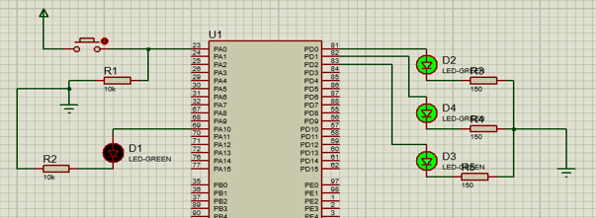

Hình 10 Sơ đồ Proteus 8 Led

## Đặt điểm linh kiện:

* Led 7 đoạn.
* Điện trở.
* 4511 IC.

## Mã lệnh chính:

#include "main.h"

void SystemClock_Config(void);

static void MX_GPIO_Init(void);

int main(void){

HAL_Init();

SystemClock_Config();

MX_GPIO_Init();

while (1)

{

HAL_GPIO_TogglePin(GPIOD, GPIO_PIN_0|GPIO_PIN_1|GPIO_PIN_2);

HAL_Delay(1000);

}

}

void HAL_GPIO_EXTI_Callback(uint16_t GPIO_Pin)

{

if (GPIO_Pin == GPIO_PIN_0)

{

HAL_GPIO_TogglePin(GPIOA, GPIO_PIN_10);

}

}

/**

* @brief System Clock Configuration

* @retval None

*/

void SystemClock_Config(void)

{

RCC_OscInitTypeDef RCC_OscInitStruct = {0};

RCC_ClkInitTypeDef RCC_ClkInitStruct = {0};

__HAL_RCC_PWR_CLK_ENABLE();

__HAL_PWR_VOLTAGESCALING_CONFIG(PWR_REGULATOR_VOLTAGE_SCALE2);

RCC_OscInitStruct.OscillatorType = RCC_OSCILLATORTYPE_HSI;

RCC_OscInitStruct.HSIState = RCC_HSI_ON;

RCC_OscInitStruct.HSICalibrationValue = RCC_HSICALIBRATION_DEFAULT;

RCC_OscInitStruct.PLL.PLLState = RCC_PLL_NONE;

if (HAL_RCC_OscConfig(&RCC_OscInitStruct) != HAL_OK)

{

Error_Handler();

}

RCC_ClkInitStruct.ClockType = RCC_CLOCKTYPE_HCLK|RCC_CLOCKTYPE_SYSCLK

|RCC_CLOCKTYPE_PCLK1|RCC_CLOCKTYPE_PCLK2;

RCC_ClkInitStruct.SYSCLKSource = RCC_SYSCLKSOURCE_HSI;

RCC_ClkInitStruct.AHBCLKDivider = RCC_SYSCLK_DIV1;

RCC_ClkInitStruct.APB1CLKDivider = RCC_HCLK_DIV1;

RCC_ClkInitStruct.APB2CLKDivider = RCC_HCLK_DIV1;

if (HAL_RCC_ClockConfig(&RCC_ClkInitStruct, FLASH_LATENCY_0) != HAL_OK)

{

Error_Handler();

}

}

/**

* @brief GPIO Initialization Function

* @param None

* @retval None

*/

static void MX_GPIO_Init(void)

{

GPIO_InitTypeDef GPIO_InitStruct = {0};

__HAL_RCC_GPIOA_CLK_ENABLE();

__HAL_RCC_GPIOD_CLK_ENABLE();

HAL_GPIO_WritePin(GPIOA, GPIO_PIN_10, GPIO_PIN_RESET);

HAL_GPIO_WritePin(GPIOD, GPIO_PIN_0|GPIO_PIN_1|GPIO_PIN_2, GPIO_PIN_RESET);

GPIO_InitStruct.Pin = GPIO_PIN_0;

GPIO_InitStruct.Mode = GPIO_MODE_IT_RISING;

GPIO_InitStruct.Pull = GPIO_NOPULL;

HAL_GPIO_Init(GPIOA, &GPIO_InitStruct);

/*Configure GPIO pin : PA10 */

GPIO_InitStruct.Pin = GPIO_PIN_10;

GPIO_InitStruct.Mode = GPIO_MODE_OUTPUT_PP;

GPIO_InitStruct.Pull = GPIO_NOPULL;

GPIO_InitStruct.Speed = GPIO_SPEED_FREQ_LOW;

HAL_GPIO_Init(GPIOA, &GPIO_InitStruct);

/*Configure GPIO pins : PD0 PD1 PD2 */

GPIO_InitStruct.Pin = GPIO_PIN_0|GPIO_PIN_1|GPIO_PIN_2;

GPIO_InitStruct.Mode = GPIO_MODE_OUTPUT_PP;

GPIO_InitStruct.Pull = GPIO_NOPULL;

GPIO_InitStruct.Speed = GPIO_SPEED_FREQ_LOW;

HAL_GPIO_Init(GPIOD, &GPIO_InitStruct);

/* EXTI interrupt init*/

HAL_NVIC_SetPriority(EXTI0_IRQn, 0, 0);

HAL_NVIC_EnableIRQ(EXTI0_IRQn);

}

void Error_Handler(void)

{

__disable_irq();

while (1)

{

}

/* USER CODE END Error_Handler_Debug */

}

#ifdef USE_FULL_ASSERT

# Bài 12: STM32 LCD

## Mô tả:

* Bài này ta thực hiện việc lập trình điều khiển qua lệnh , con trỏ để hiển thị thông tin trên màn hình LCD .
* LCD là một màn hình nhiều điểm ảnh, có thể coi là một Led ma trận dạng lớn

## Sơ đồ:

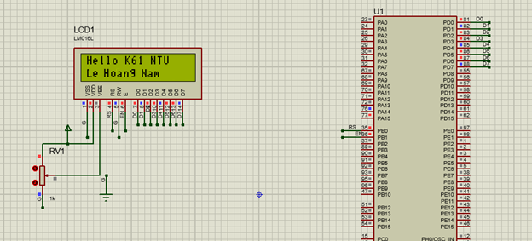

Hình 10 Sơ đồ Proteus 8 Led

## Đặt điểm linh kiện:

* LCD
* STM32F401VE IC.

## Mã lệnh chính:

#include "main.h"

void SystemClock_Config(void);

static void MX_GPIO_Init(void);

//HAM GUI LENH

void send8bit(char D)

{

int b0,b1,b2,b3,b4,b5,b6,b7;

if ((D &1)==0) b0=0; //2^0

else b0=1;

if ((D &2)==0) b1=0;

else b1=1;

if ((D &4)==0) b2=0;

else b2=1;

if ((D &8)==0) b3=0;

else b3=1;

if ((D &16)==0) b4=0;

else b4=1;

if ((D &32)==0) b5=0;

else b5=1;

if ((D &64)==0) b6=0;

else b6=1;

if ((D &128)==0) b7=0;

else b7=1;

HAL_GPIO_WritePin(GPIOD,GPIO_PIN_0,b0);

HAL_GPIO_WritePin(GPIOD,GPIO_PIN_1,b1);

HAL_GPIO_WritePin(GPIOD,GPIO_PIN_2,b2);

HAL_GPIO_WritePin(GPIOD,GPIO_PIN_3,b3);

HAL_GPIO_WritePin(GPIOD,GPIO_PIN_4,b4);

HAL_GPIO_WritePin(GPIOD,GPIO_PIN_5,b5);

HAL_GPIO_WritePin(GPIOD,GPIO_PIN_6,b6);

HAL_GPIO_WritePin(GPIOD,GPIO_PIN_7,b7);

}

void sendlcd(char cmd)

{

// Rw dat muc thap

//b2 dat chan rs=0,de noi rang cmd la lenh

HAL_GPIO_WritePin(GPIOB, GPIO_PIN_0, GPIO_PIN_RESET);

//B3 GUI 8 BIET VAO 8 PIN

send8bit(cmd);

//b4 enable cho kytu -- < lcd

HAL_GPIO_WritePin(GPIOB, GPIO_PIN_1, GPIO_PIN_RESET);

HAL_GPIO_WritePin(GPIOB, GPIO_PIN_1, GPIO_PIN_SET);

HAL_Delay(10);

}

// ham gui ky tu

void sendchar(char kytu)

{

// Rw dat muc thap

//b2 dat chan rs=1

HAL_GPIO_WritePin(GPIOB, GPIO_PIN_0, GPIO_PIN_SET);

//B3 GUI 8 BIET VAO 8 PIN

send8bit(kytu);

//b4 enable cho kytu -- < lcd

HAL_GPIO_WritePin(GPIOB, GPIO_PIN_1, GPIO_PIN_RESET);

HAL_GPIO_WritePin(GPIOB, GPIO_PIN_1, GPIO_PIN_SET);

HAL_Delay(10);

}

void sendstring(char *str)

{

for (int i =0;str[i] !='\0';i++)

sendchar(str[i]);

}

int main(void)

{

HAL_Init();

SystemClock_Config();

MX_GPIO_Init();

//xoa noi dung

sendlcd(0x01);

// bat hien thi man hinh, tat con tro

sendlcd(0x0C);

//hello

sendstring("Hello K61 NTU");

//xuong dong

sendlcd(0x38);//che do 2 dong

sendlcd(0xC0);

sendstring("Le Hoang Nam");

while (1)

{

/* USER CODE END WHILE */

/* USER CODE BEGIN 3 */

}

/* USER CODE END 3 */

}

/**

* @brief System Clock Configuration

* @retval None

*/

void SystemClock_Config(void)

{

RCC_OscInitTypeDef RCC_OscInitStruct = {0};

RCC_ClkInitTypeDef RCC_ClkInitStruct = {0};

/** Configure the main internal regulator output voltage

*/

__HAL_RCC_PWR_CLK_ENABLE();

__HAL_PWR_VOLTAGESCALING_CONFIG(PWR_REGULATOR_VOLTAGE_SCALE2);

/** Initializes the RCC Oscillators according to the specified parameters

* in the RCC_OscInitTypeDef structure.

*/

RCC_OscInitStruct.OscillatorType = RCC_OSCILLATORTYPE_HSI;

RCC_OscInitStruct.HSIState = RCC_HSI_ON;

RCC_OscInitStruct.HSICalibrationValue = RCC_HSICALIBRATION_DEFAULT;

RCC_OscInitStruct.PLL.PLLState = RCC_PLL_NONE;

if (HAL_RCC_OscConfig(&RCC_OscInitStruct) != HAL_OK)

{

Error_Handler();

}

/** Initializes the CPU, AHB and APB buses clocks

*/

RCC_ClkInitStruct.ClockType = RCC_CLOCKTYPE_HCLK|RCC_CLOCKTYPE_SYSCLK

|RCC_CLOCKTYPE_PCLK1|RCC_CLOCKTYPE_PCLK2;

RCC_ClkInitStruct.SYSCLKSource = RCC_SYSCLKSOURCE_HSI;

RCC_ClkInitStruct.AHBCLKDivider = RCC_SYSCLK_DIV1;

RCC_ClkInitStruct.APB1CLKDivider = RCC_HCLK_DIV1;

RCC_ClkInitStruct.APB2CLKDivider = RCC_HCLK_DIV1;

if (HAL_RCC_ClockConfig(&RCC_ClkInitStruct, FLASH_LATENCY_0) != HAL_OK)

{

Error_Handler();

}

}

/**

* @brief GPIO Initialization Function

* @param None

* @retval None

*/

static void MX_GPIO_Init(void)

{

GPIO_InitTypeDef GPIO_InitStruct = {0};

/* GPIO Ports Clock Enable */

__HAL_RCC_GPIOB_CLK_ENABLE();

__HAL_RCC_GPIOD_CLK_ENABLE();

/*Configure GPIO pin Output Level */

HAL_GPIO_WritePin(GPIOB, GPIO_PIN_0|GPIO_PIN_1, GPIO_PIN_RESET);

/*Configure GPIO pin Output Level */

HAL_GPIO_WritePin(GPIOD, GPIO_PIN_0|GPIO_PIN_1|GPIO_PIN_2|GPIO_PIN_3

|GPIO_PIN_4|GPIO_PIN_5|GPIO_PIN_6|GPIO_PIN_7, GPIO_PIN_RESET);

/*Configure GPIO pins : PB0 PB1 */

GPIO_InitStruct.Pin = GPIO_PIN_0|GPIO_PIN_1;

GPIO_InitStruct.Mode = GPIO_MODE_OUTPUT_PP;

GPIO_InitStruct.Pull = GPIO_NOPULL;

GPIO_InitStruct.Speed = GPIO_SPEED_FREQ_LOW;

HAL_GPIO_Init(GPIOB, &GPIO_InitStruct);

/*Configure GPIO pins : PD0 PD1 PD2 PD3

PD4 PD5 PD6 PD7 */

GPIO_InitStruct.Pin = GPIO_PIN_0|GPIO_PIN_1|GPIO_PIN_2|GPIO_PIN_3

|GPIO_PIN_4|GPIO_PIN_5|GPIO_PIN_6|GPIO_PIN_7;

GPIO_InitStruct.Mode = GPIO_MODE_OUTPUT_PP;

GPIO_InitStruct.Pull = GPIO_NOPULL;

GPIO_InitStruct.Speed = GPIO_SPEED_FREQ_LOW;

HAL_GPIO_Init(GPIOD, &GPIO_InitStruct);

}

/* USER CODE BEGIN 4 */

/* USER CODE END 4 */

/**

* @brief This function is executed in case of error occurrence.

* @retval None

*/

void Error_Handler(void)

{

/* USER CODE BEGIN Error_Handler_Debug */

/* User can add his own implementation to report the HAL error return state */

__disable_irq();

while (1)

{

}

/* USER CODE END Error_Handler_Debug */

}

#ifdef USE_FULL_ASSERT