**Bài led 7 đoạn**

**1.Mô tả:**

**2.Sơ đồ:**

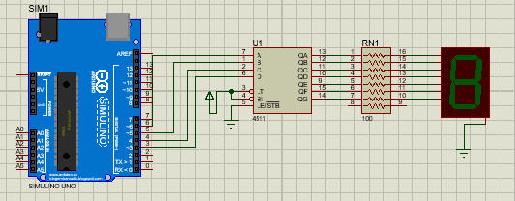

**3.Đặt điểm linh kiện:**

- Led 7 đoạn

- Điện trở

- 4511 IC

**4.Mã lệnh chính:**

int a=6, b=5, c=4, d=3;

void setup() {

pinMode(a, OUTPUT);

pinMode(b, OUTPUT);

pinMode(c, OUTPUT);

pinMode(d, OUTPUT); }

void khong(){

digitalWrite(a, LOW);

digitalWrite(b, LOW);

digitalWrite(c, LOW);

digitalWrite(d, LOW); }

void mot(){

digitalWrite(a, HIGH);

digitalWrite(b, LOW);

digitalWrite(c, LOW);

digitalWrite(d, LOW);

}

void hai(){

digitalWrite(a, LOW);

digitalWrite(b, HIGH);

digitalWrite(c, LOW);

digitalWrite(d, LOW);

}

void ba(){

digitalWrite(a, HIGH);

digitalWrite(b, HIGH);

digitalWrite(c, LOW);

digitalWrite(d, LOW);

}

void bon(){

digitalWrite(a, LOW);

digitalWrite(b, LOW);

digitalWrite(c, HIGH);

digitalWrite(d, LOW);

}

void nam(){

digitalWrite(a, HIGH);

digitalWrite(b, LOW);

digitalWrite(c, HIGH);

digitalWrite(d, LOW);

}

void sau(){

digitalWrite(a, LOW);

digitalWrite(b, HIGH);

digitalWrite(c, HIGH);

digitalWrite(d, LOW);

}

void bay(){

digitalWrite(a, HIGH);

digitalWrite(b, HIGH);

digitalWrite(c, HIGH);

digitalWrite(d, LOW);

}

void tam(){

digitalWrite(a, LOW);

digitalWrite(b, LOW);

digitalWrite(c, LOW);

digitalWrite(d, HIGH);

}

void chin(){

digitalWrite(a, HIGH);

digitalWrite(b, LOW);

digitalWrite(c, LOW);

digitalWrite(d, HIGH);

}

void loop() {

khong(); delay(1000);

mot(); delay(1000);

hai(); delay(1000);

ba(); delay(1000);

bon(); delay(1000);

nam(); delay(1000);

sau(); delay(1000);

bay(); delay(1000);

tam(); delay(1000);

chin(); delay(1000);

}