**Angular CI**

Go to <https://dev.azure.com/>

First create new project as shown below.

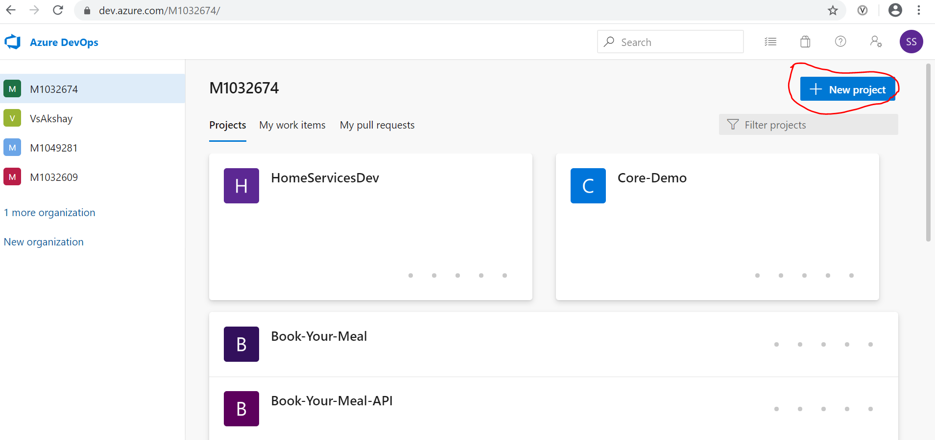

After you click on create project, you get below page, write project name ,select private. In advance select Git and basic.

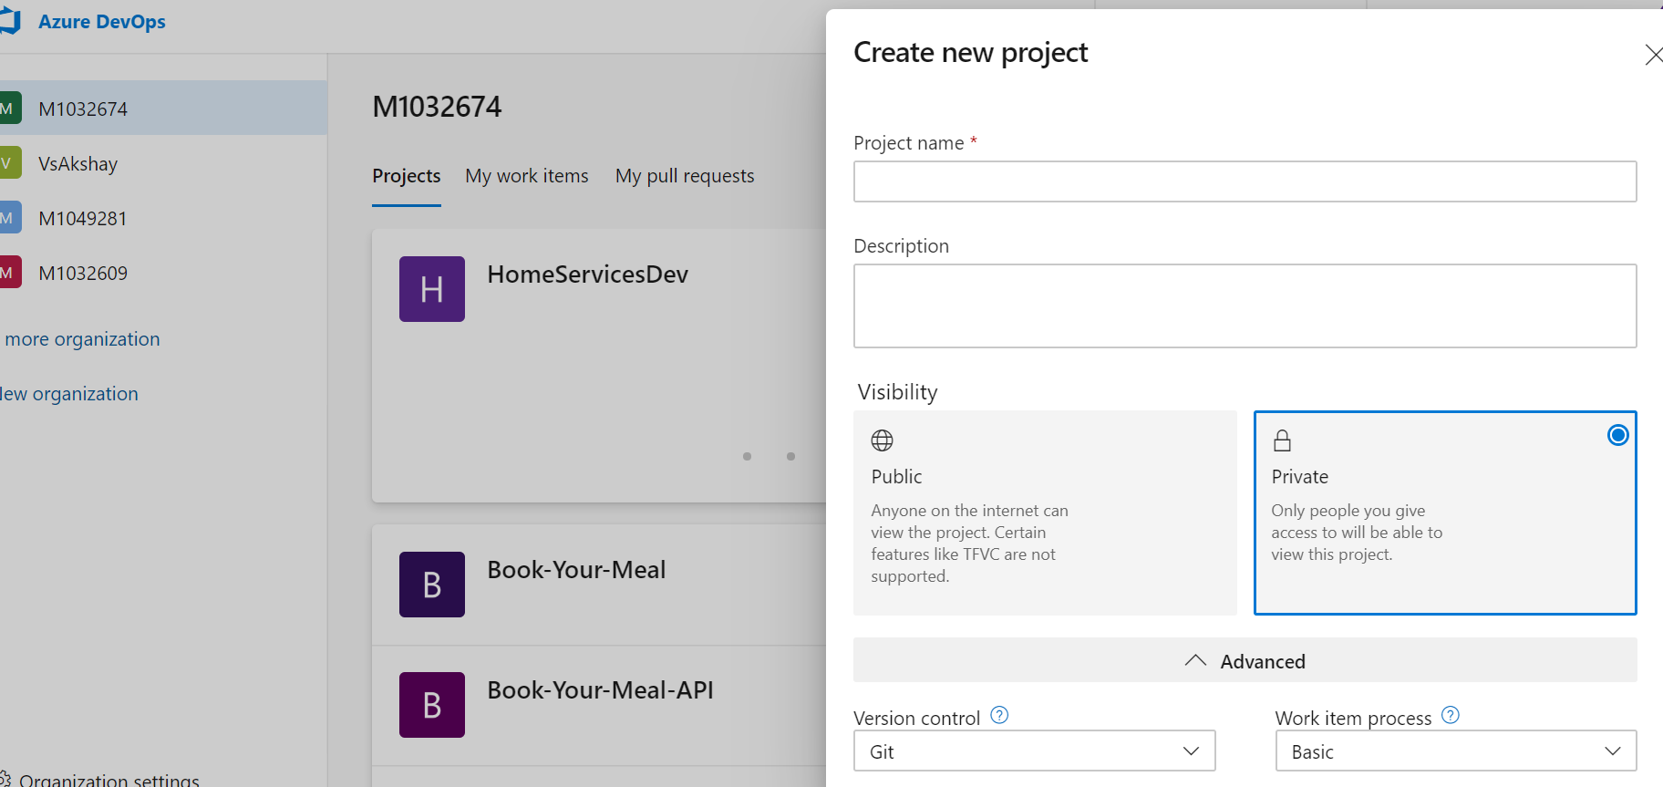After successfully creation of project,Click on Repo from the left menu as shown below.Clone the Repository in VC code by select clone in VS Code.So this is your repository where you will be pushing your code from VS code.

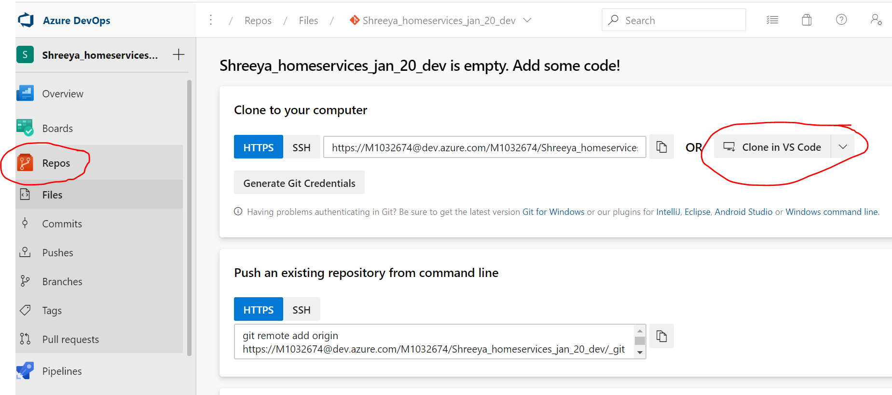

Now click on pipeline from left menu. You will the below page. Click on ’use classing editor’.

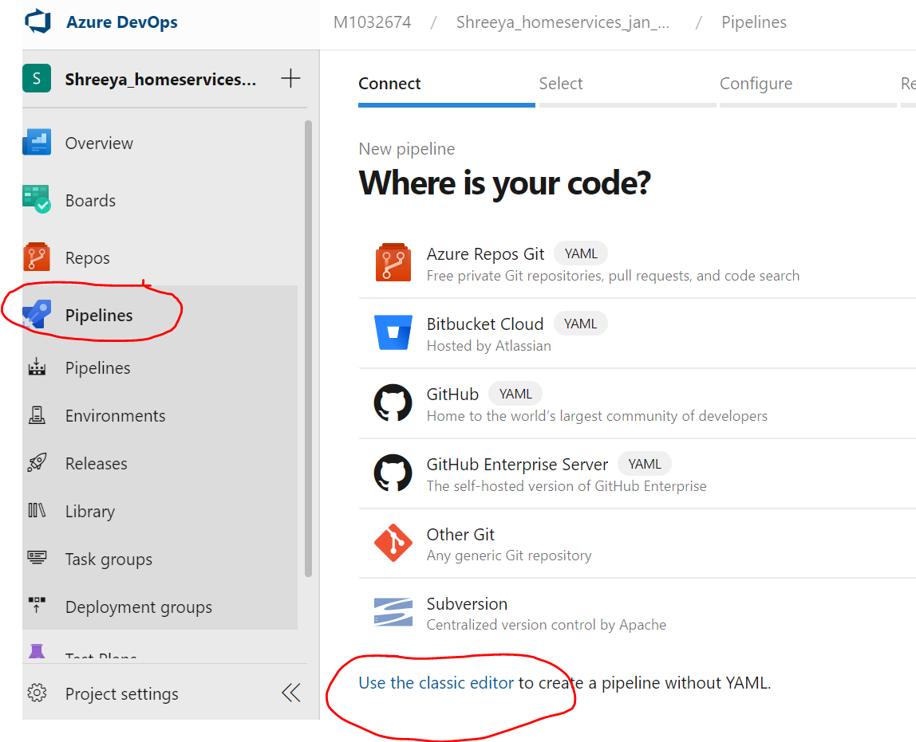

You will get below page,Select Azure Repo Git as your repo is n Azure.Select the repo which you want to connect from this pipeline from the dropdown. [Note] It will the repo you have created inside the project.Click on continue.

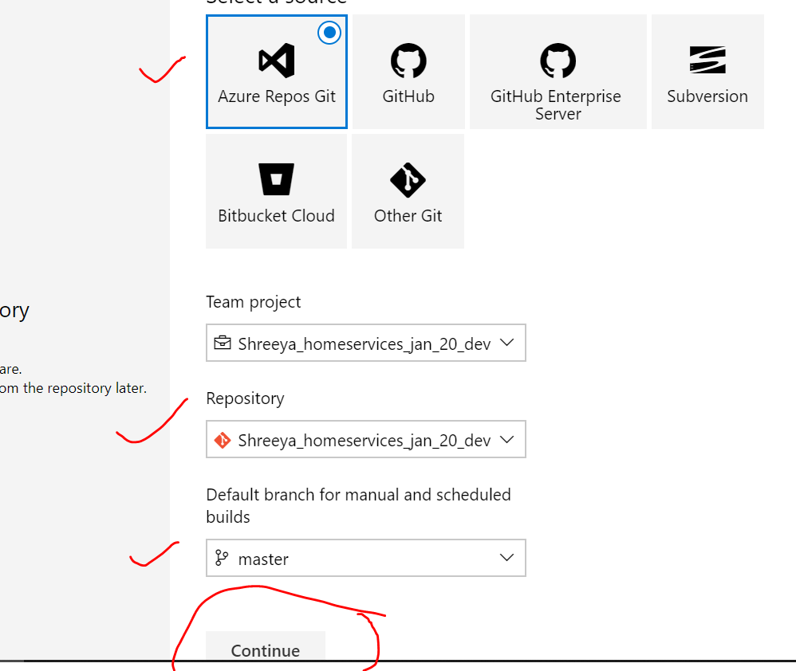

After continue, you will get below page to create steps of Agent job. Click on plus sign as shown below.

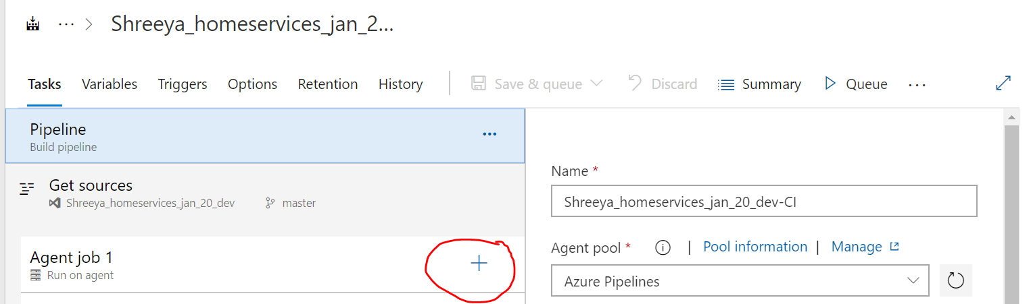

Once you click on plus sign, you will get below pop-up to seach.Search npm here ,you will get many npm related searches ,select only npm and click on Add.

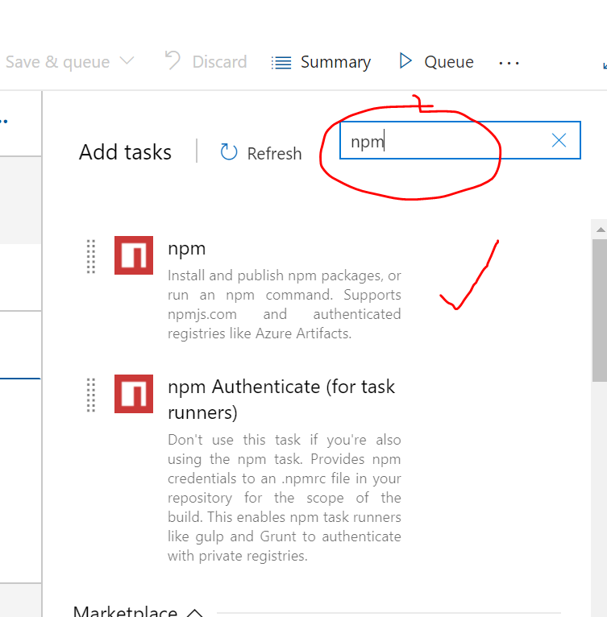

Select npm and write the following commands as shown below. Select the folder which contains package.json using three dots.

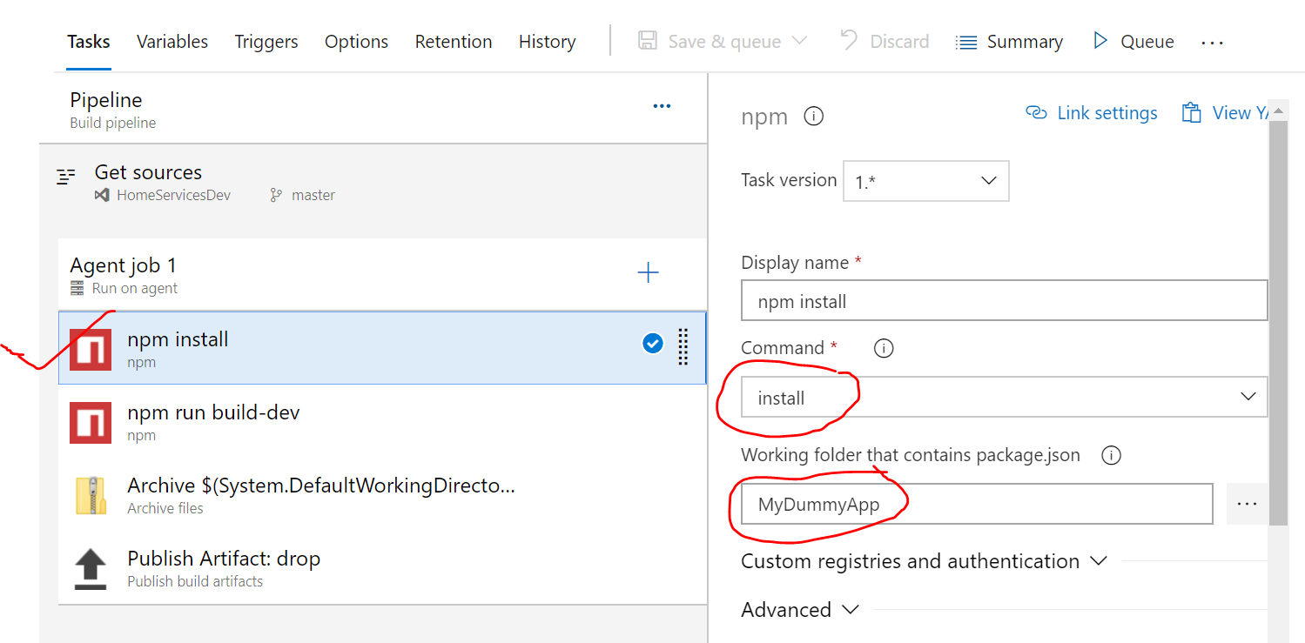

Once again you click on plus sign, you will get below pop-up to seach.Search npm here ,you will get many npm related searches ,select only npm and click on Add again.

Then select second npm step and write the following command as shown below.

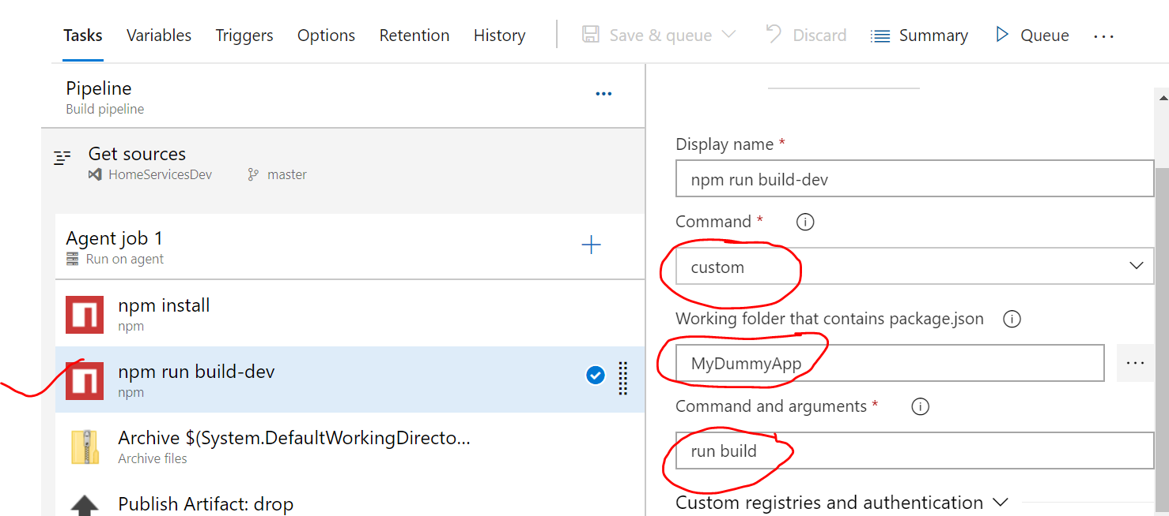

Once again you click on plus sign, you will get below pop-up to seach.Search Archive files and add it.

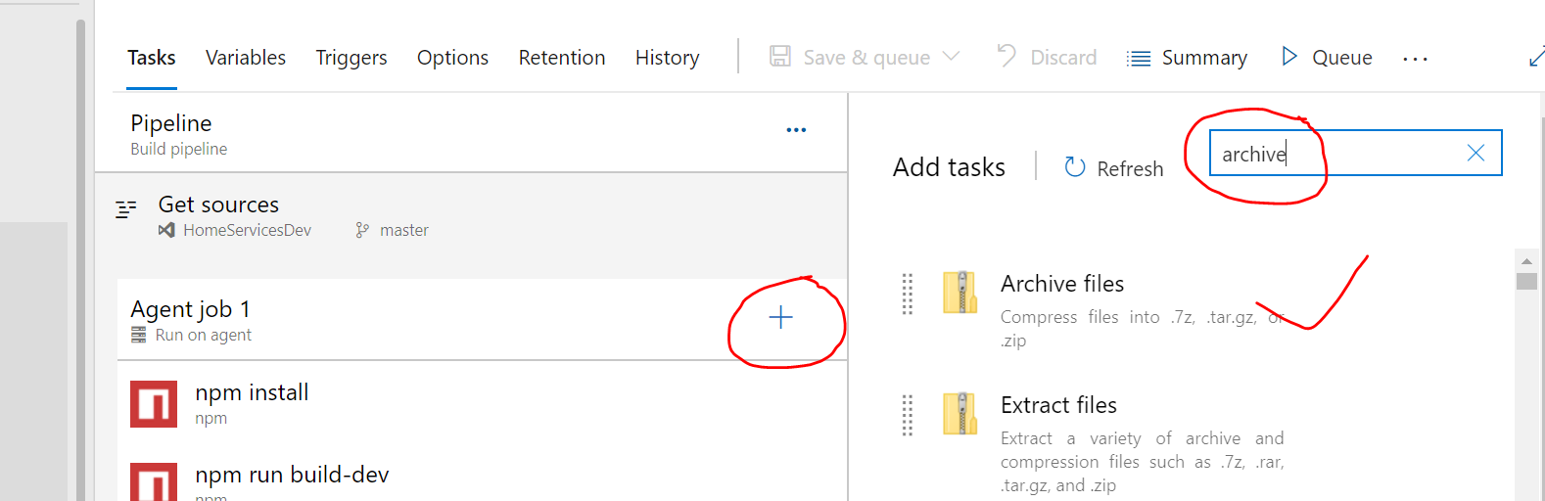

After adding archive files,write the commands as shpwn below for archive files steps.

Here root foler will be project folder inside dist as it is an angular project.You can build locally also and check where it is creating built files.Uncheck prepend check box.

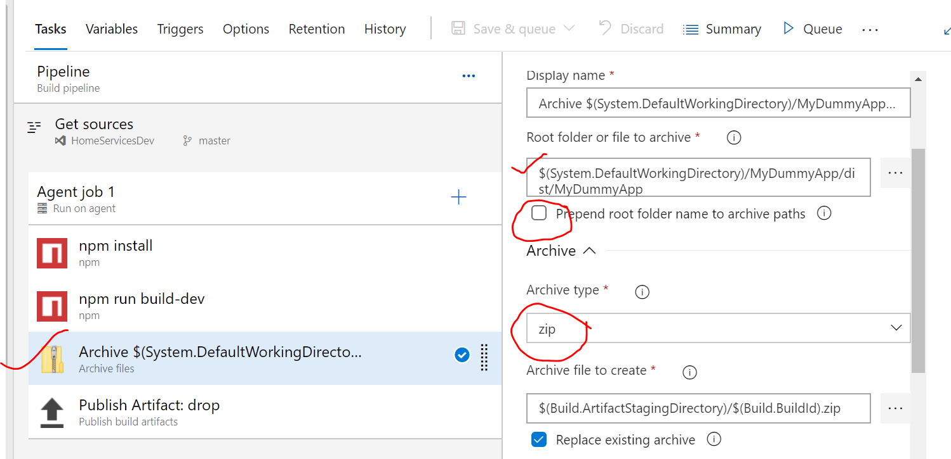

Once again you click on plus sign, you will get below pop-up to seach.Search for publish build artifact,select ot and add it.

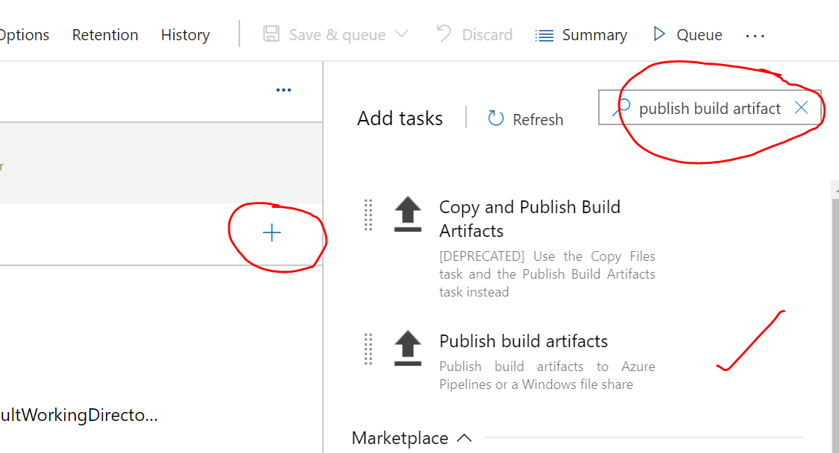

Once added,let the default commands be threre.No need to change it.

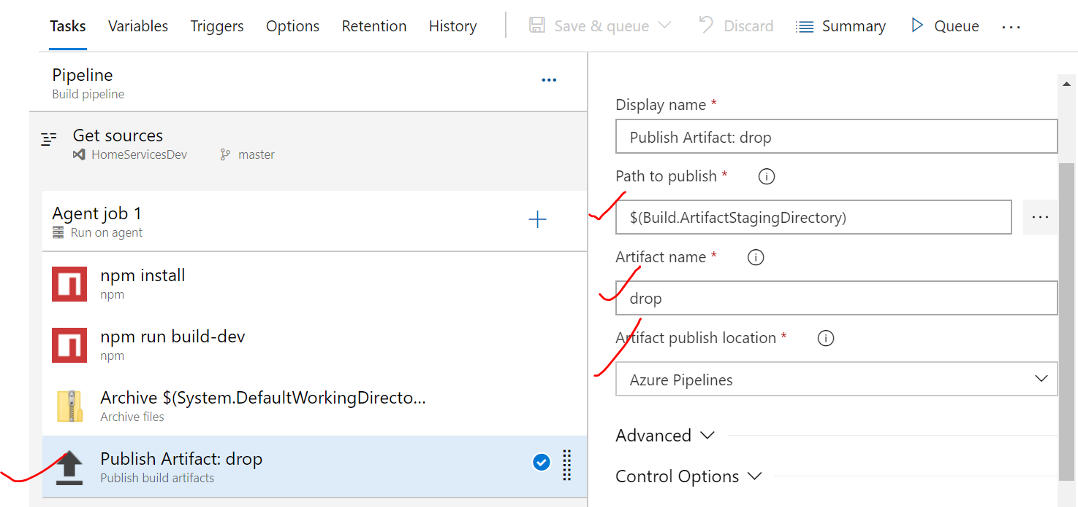

Now click on Triggers and enable continuous integration as shown below.

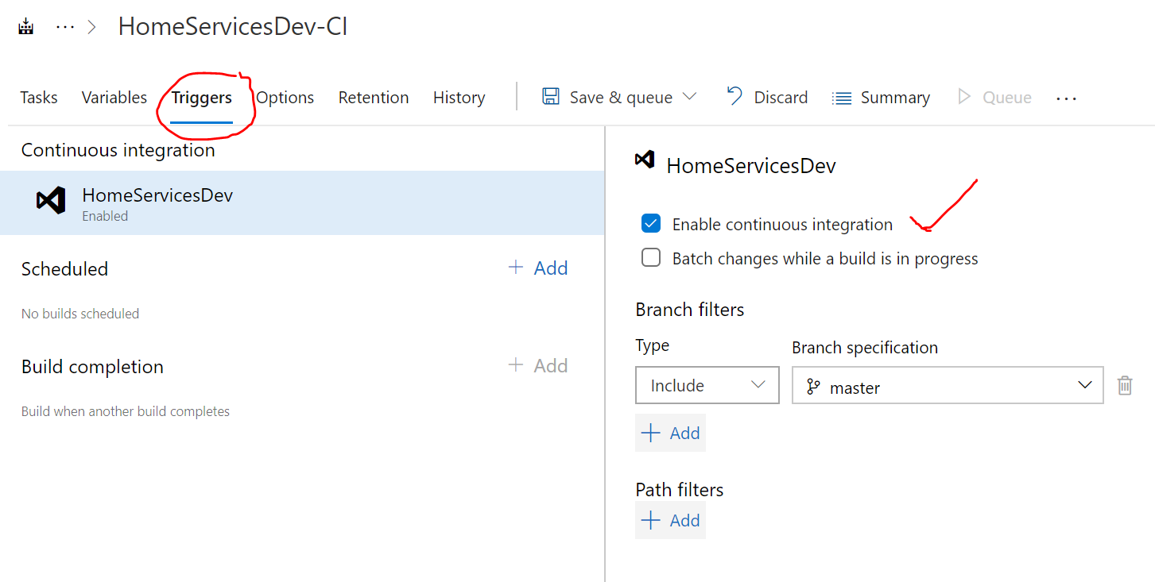

**Angular CD**

Now click on Releases from the left menu as shown below.

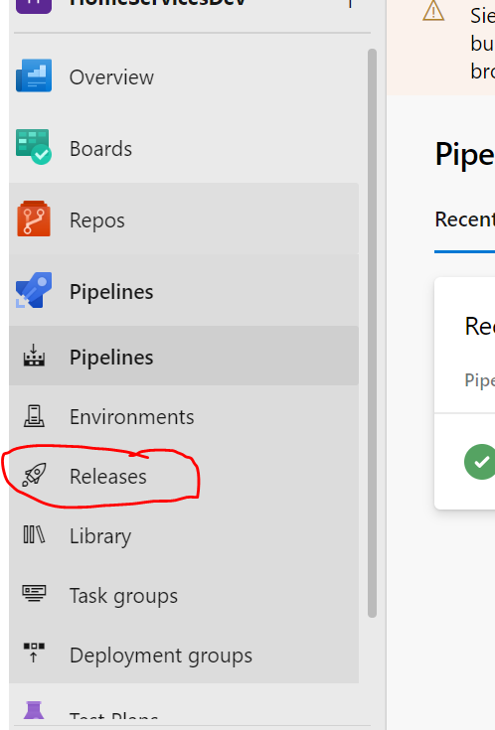

Once you selected release, then click on create new pipeline. You will get below page. Click on empty job.

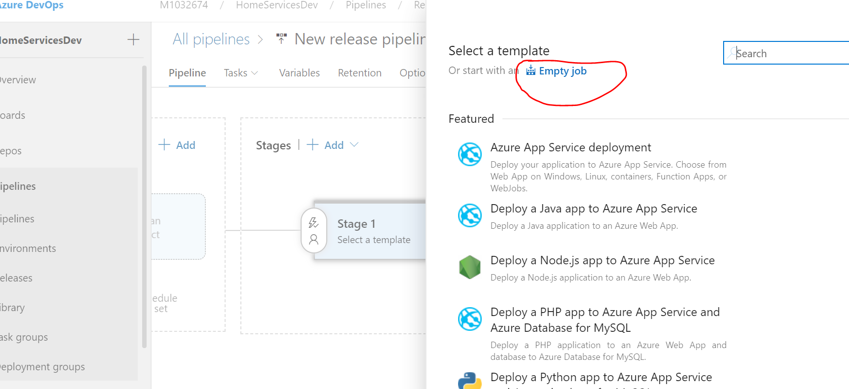

After it ,you will get below page ,change the stage name to Deploy to Azure app service and save it.

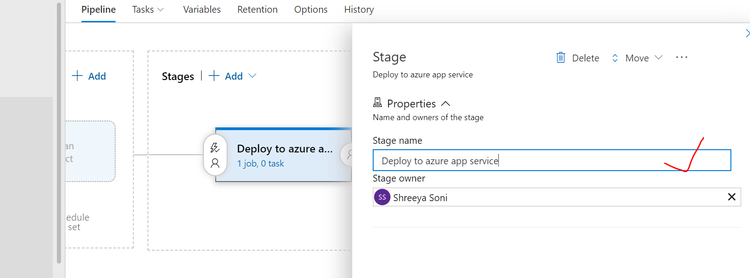

**Now you will get below page, click on trigger as shown below and enable CD.**

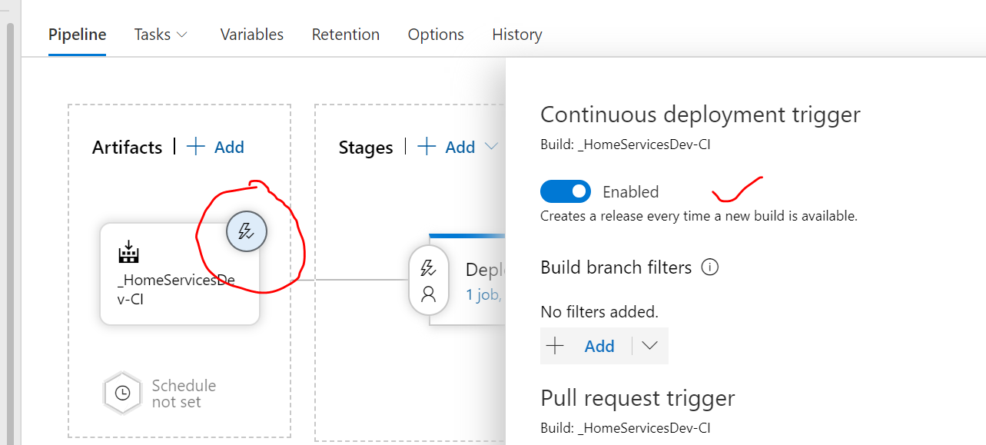

Now click on artifacts,and select the source which will be your CI name.

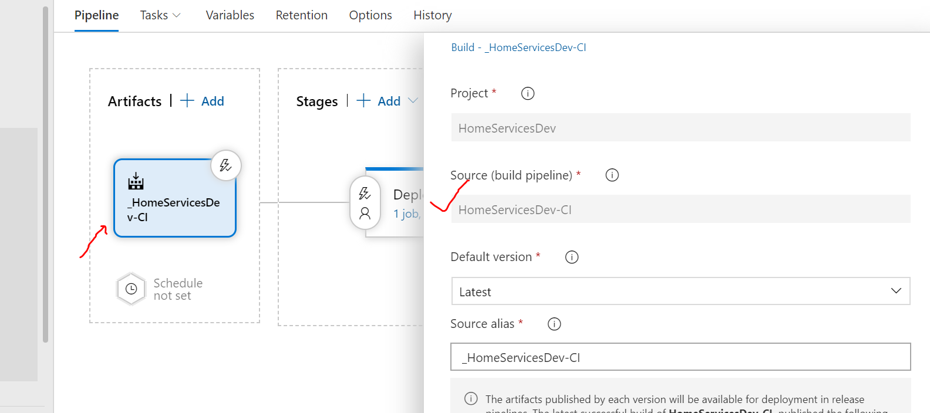

Now click on 1 job,2tasks link as show below. For you it will show 0 tasks as there will not be any tasks

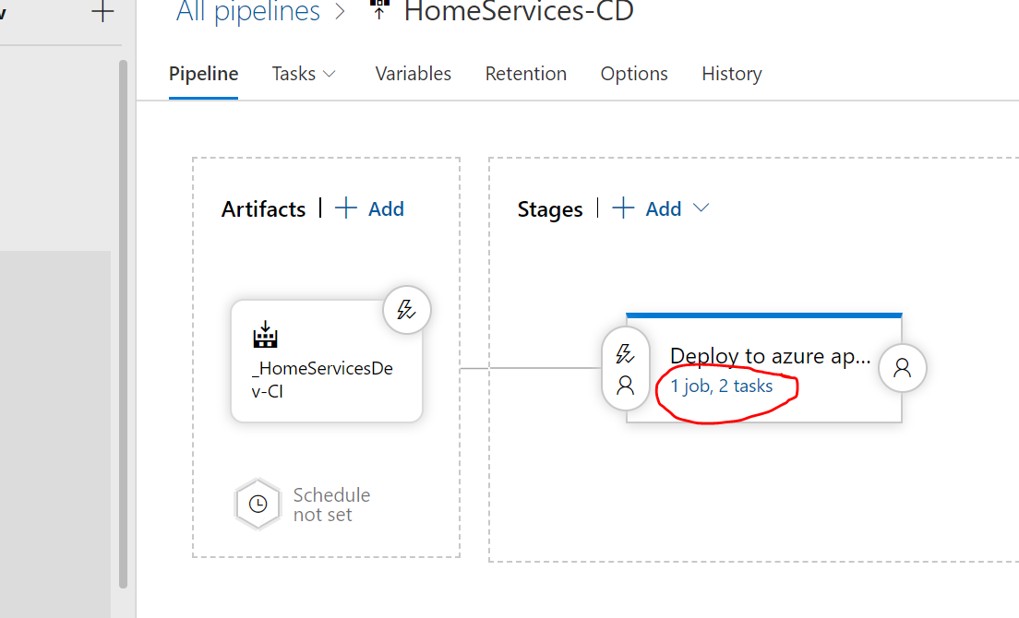

Once again you click on plus sign, you will get below pop-up to seach.Search for extract files,select and add it.

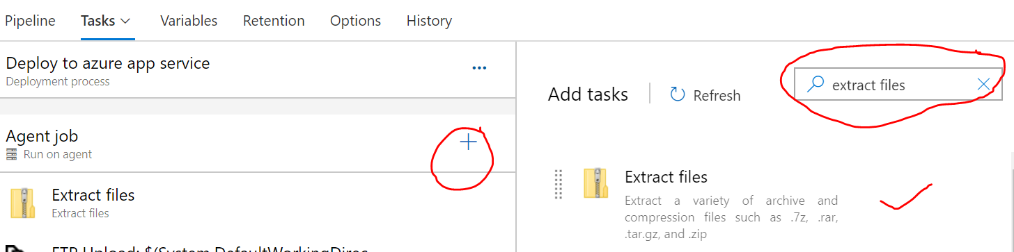

Now select extract files from the tasks and write the following commands as shown below. Go to three dots select the CI alias name given to ci pipeline. Then add the folder name extracted where you want to extract the files.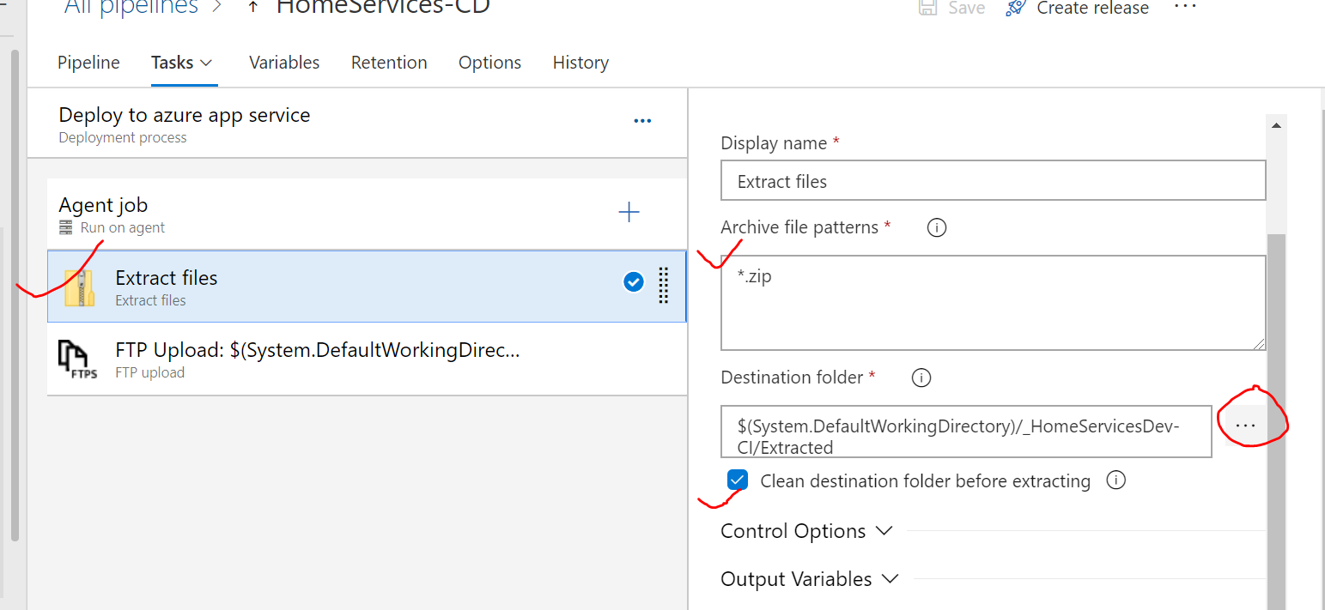

Once again you click on plus sign, you will get below pop-up to seach.Search for FTP Upload, select and add it to your task. Write the below command as shown.

Here your root folder and will be same as destination folder given in extract files task above.

[Note]For FTP you first need to create app service in azure portal ,get the url, username and password from app service🡪deployment center🡪FTP.

