* To configure mail:

<https://docs.microsoft.com/en-us/azure/devops/notifications/howto-manage-team-notifications?view=azure-devops>

Start with Empty Job

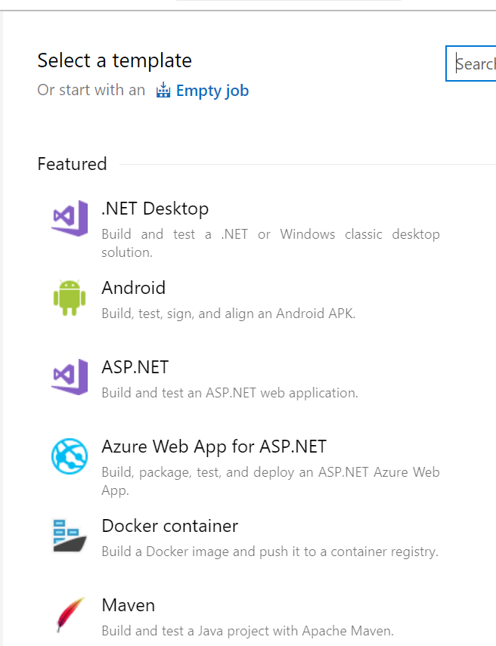

* Create the Pipeline with proper naming convention
* Click on ‘+’ button beside Agent Job to start adding steps

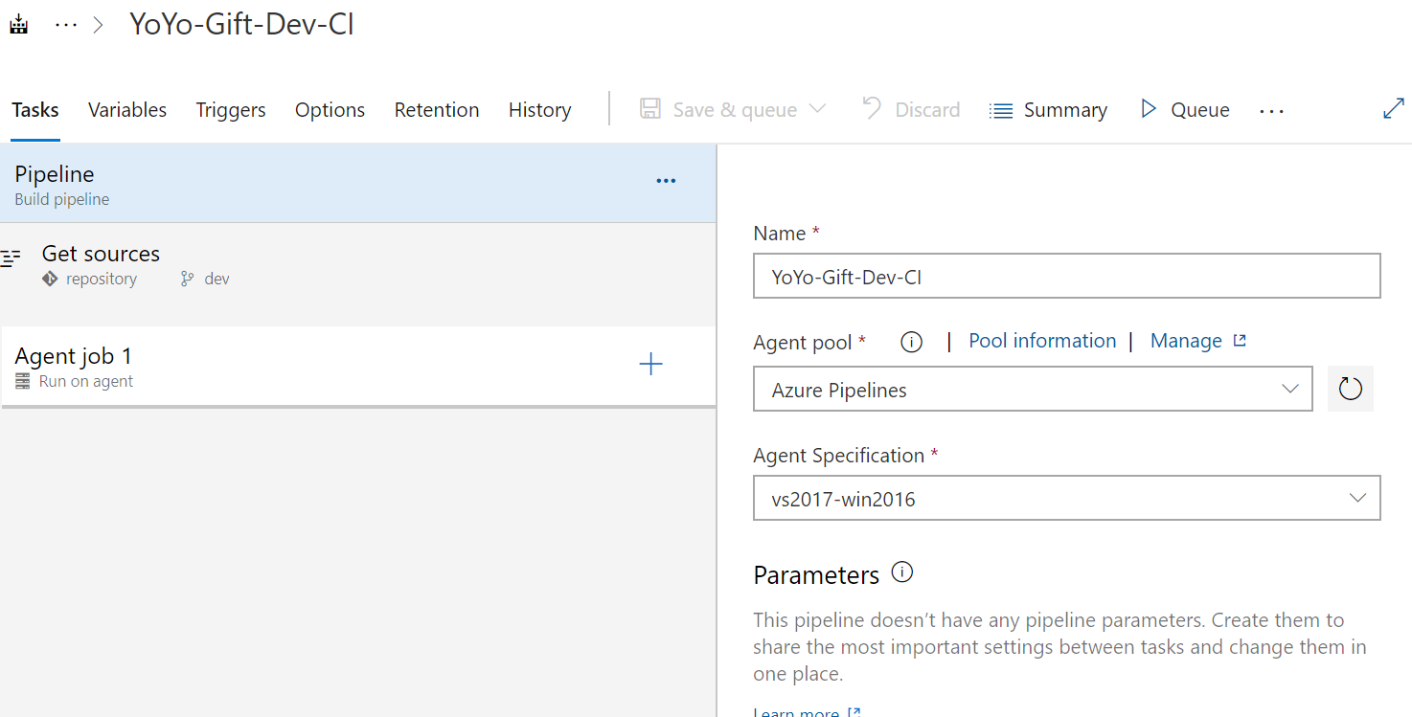

* Search for npm from task as mentioned shown below:

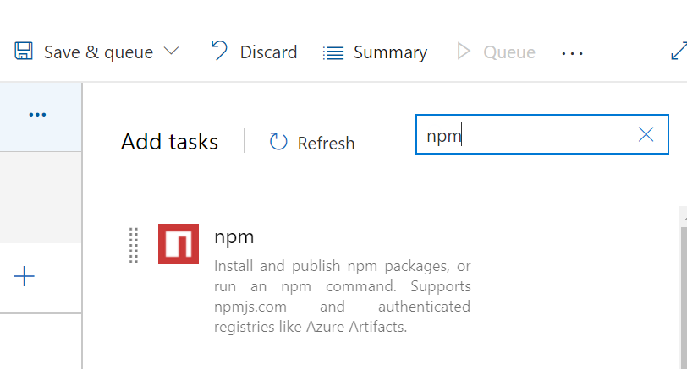

* Add first step as ‘npm-install’.

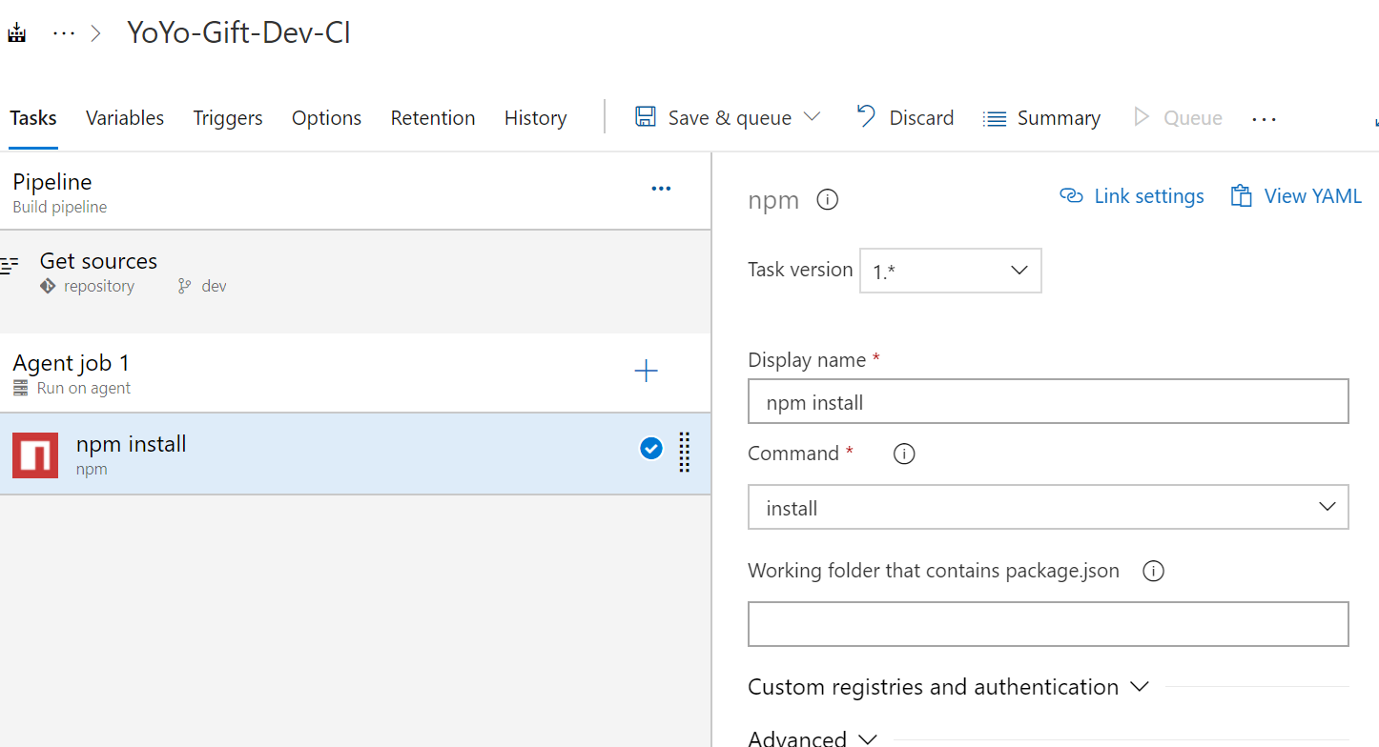

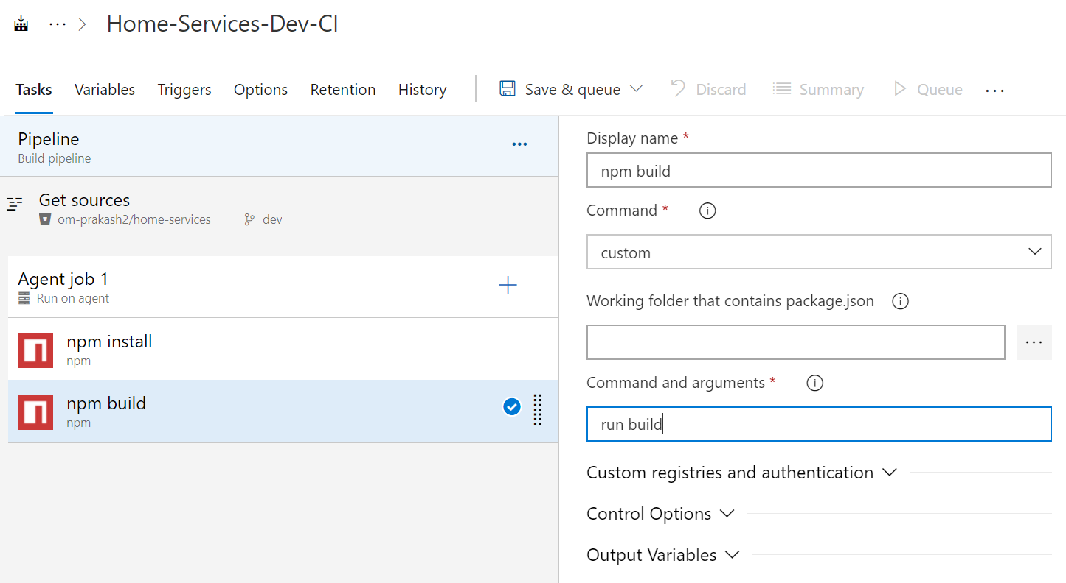

* Archive Files
  + Change the Root Folder or file to archive
  + In Root folder to archive use <$system.>/dist/<name of the folder on repository> => kindly ensure to verify the repository-folder name should match
  + Uncheck prepend root folder

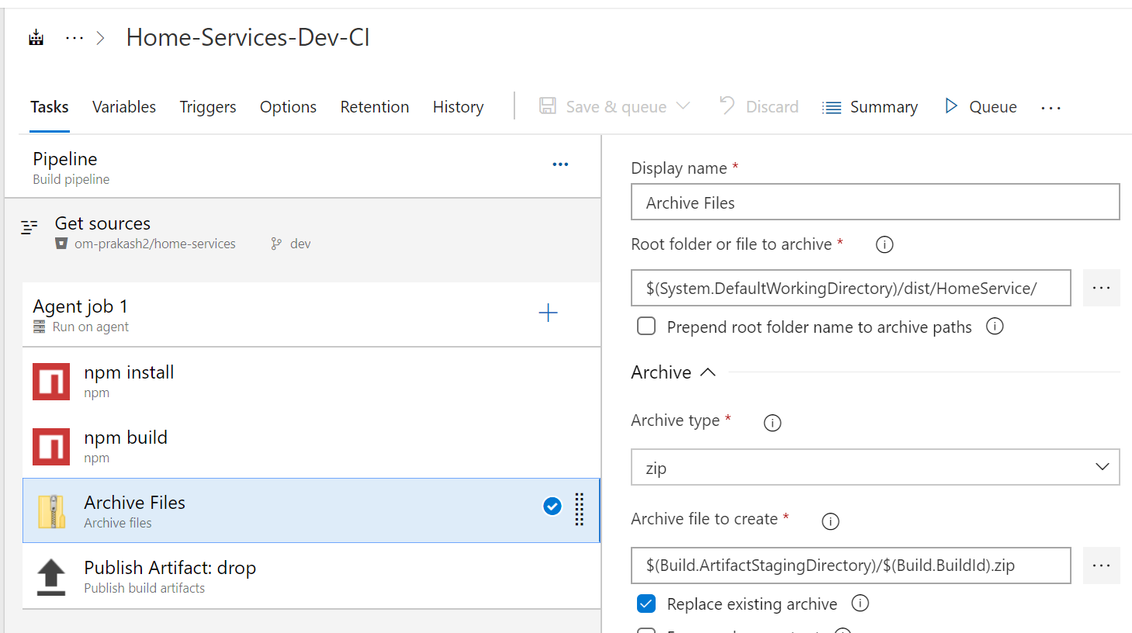

* Search for Publish and select the one highlighted below

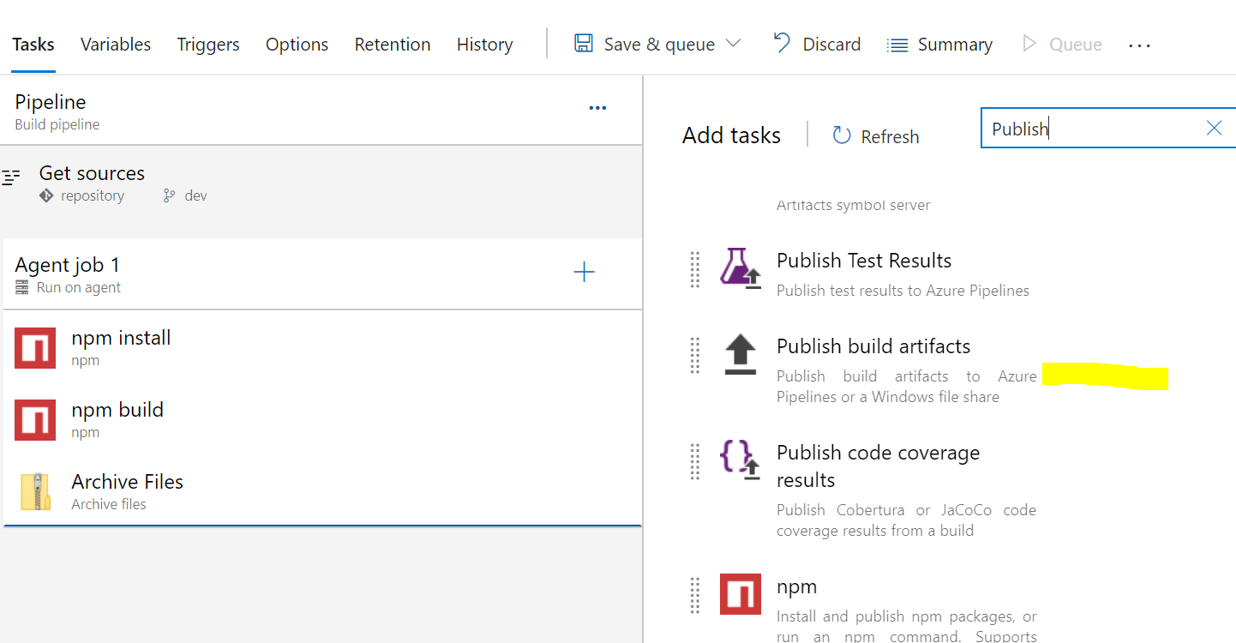

Publish Artifacts:

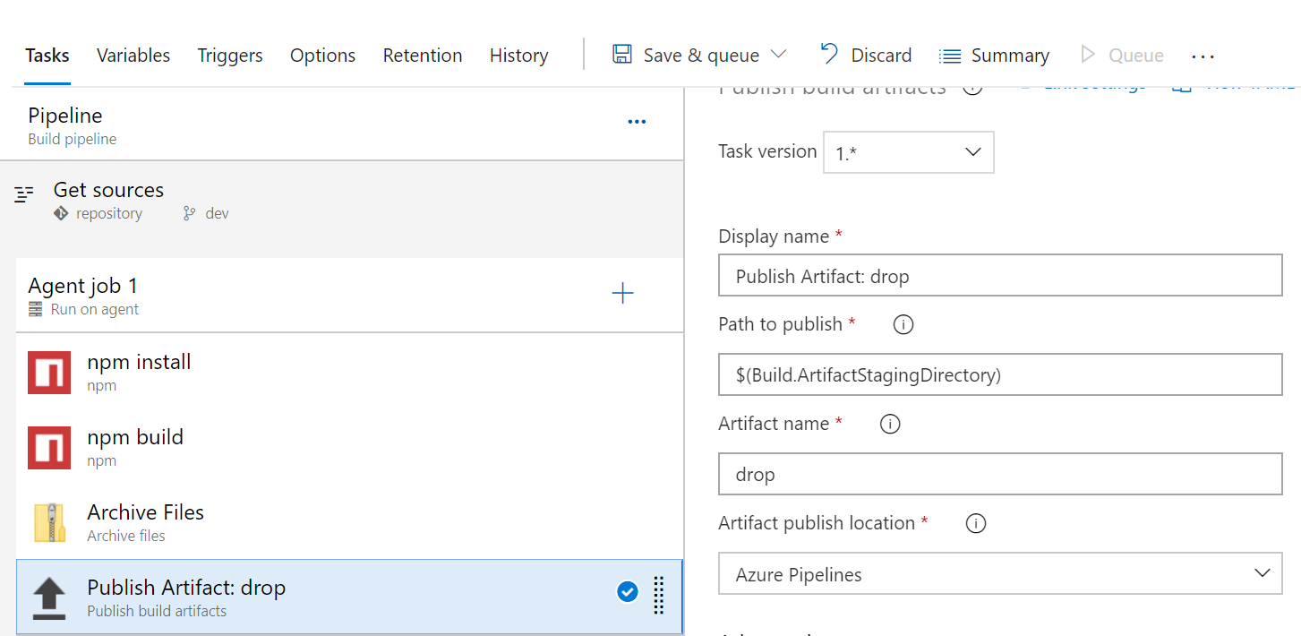

CD:

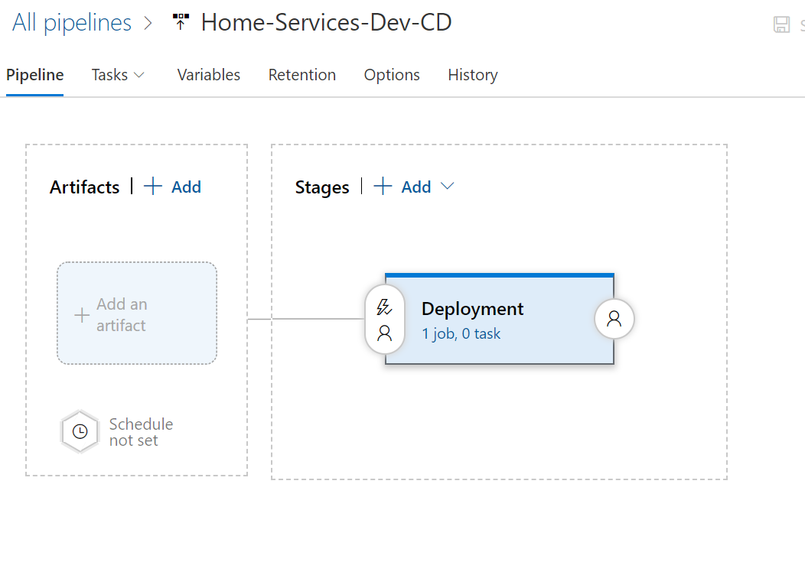

* Choose Empty Job
* Click on “Add an Artifact”

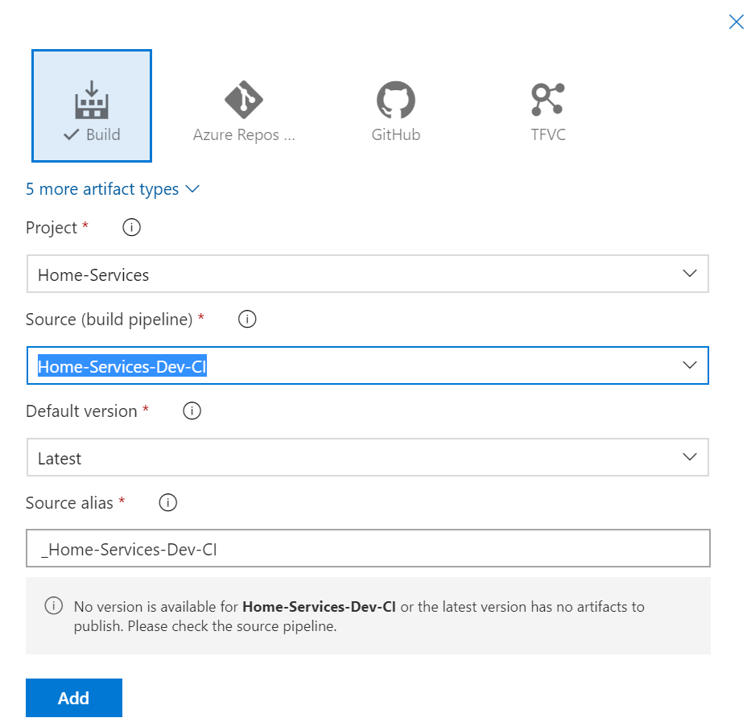

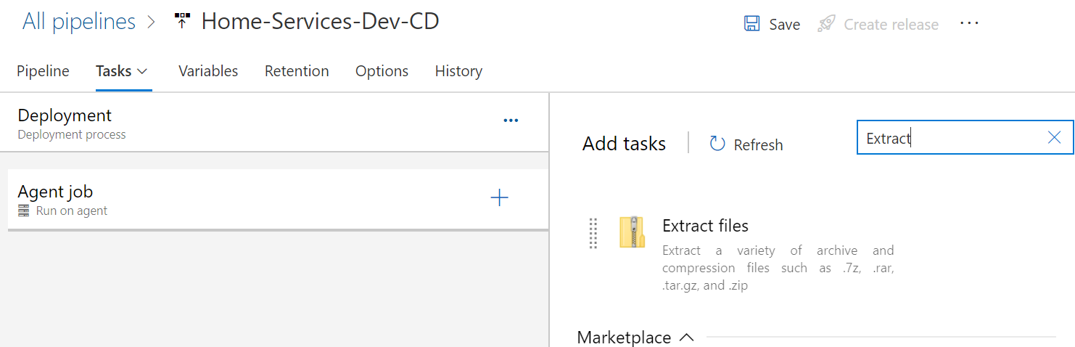

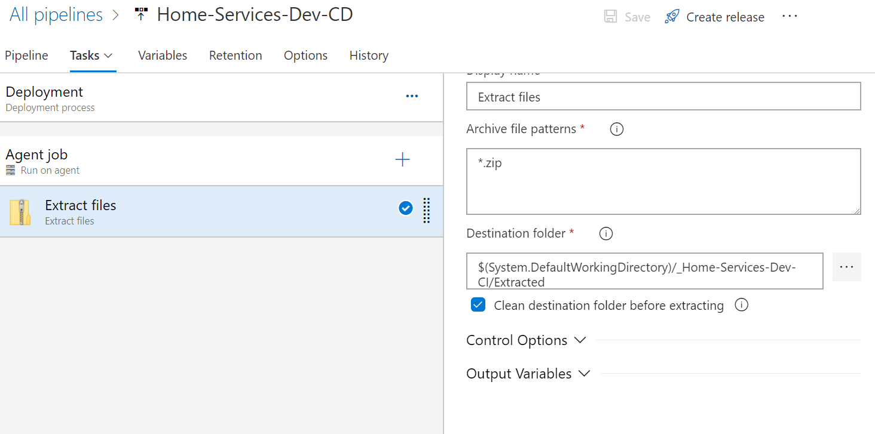

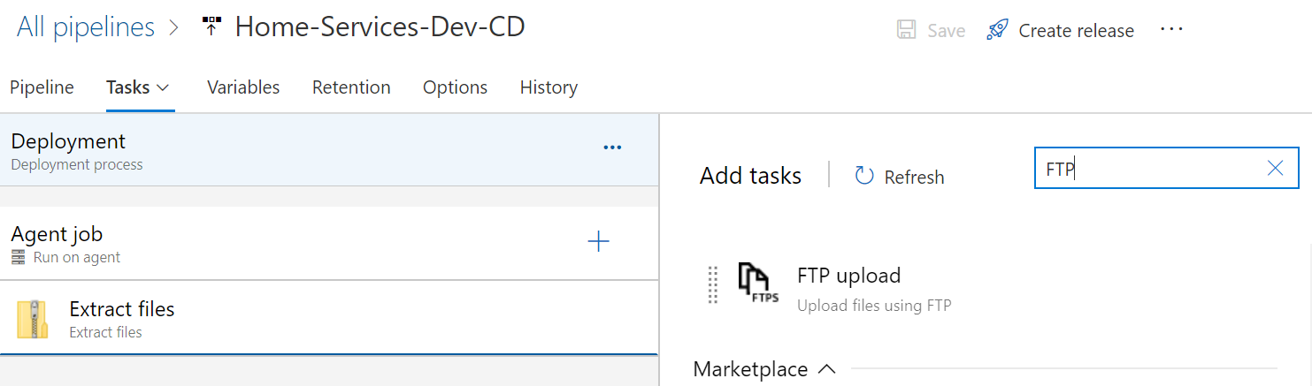

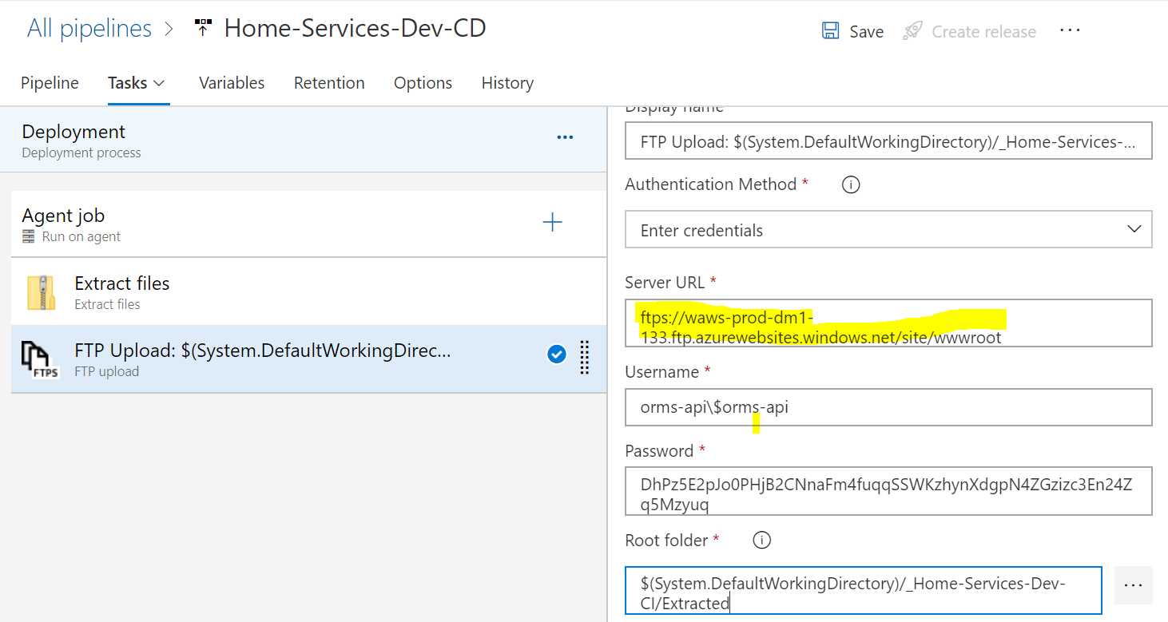

* Change remote directory
* Check Delete Remmote directory
* Trust Server certificate

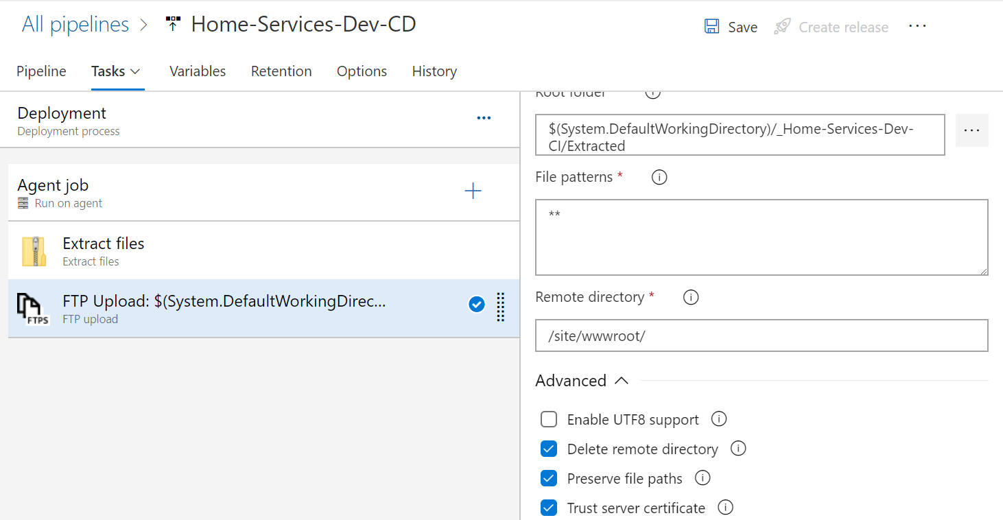

* For automated CI-CD on code push. Under pipeline go to triggers and check enable continuous integration

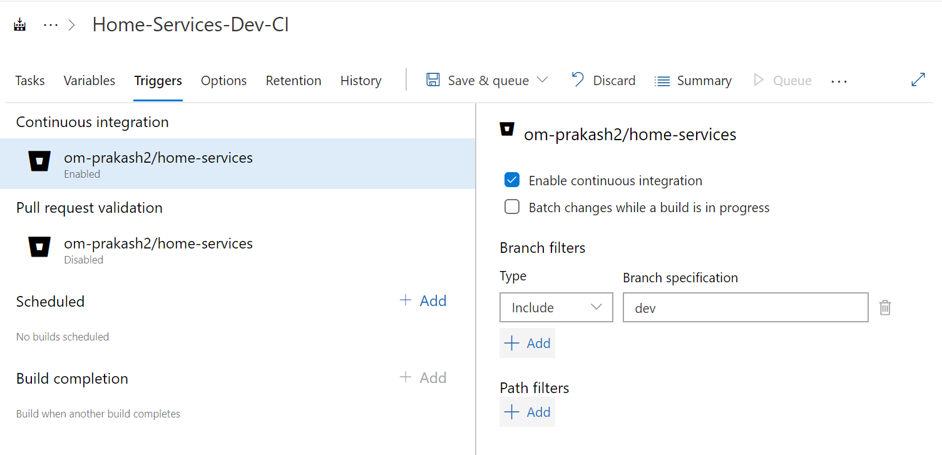

**Pipeline for .net core project**

**CI:**

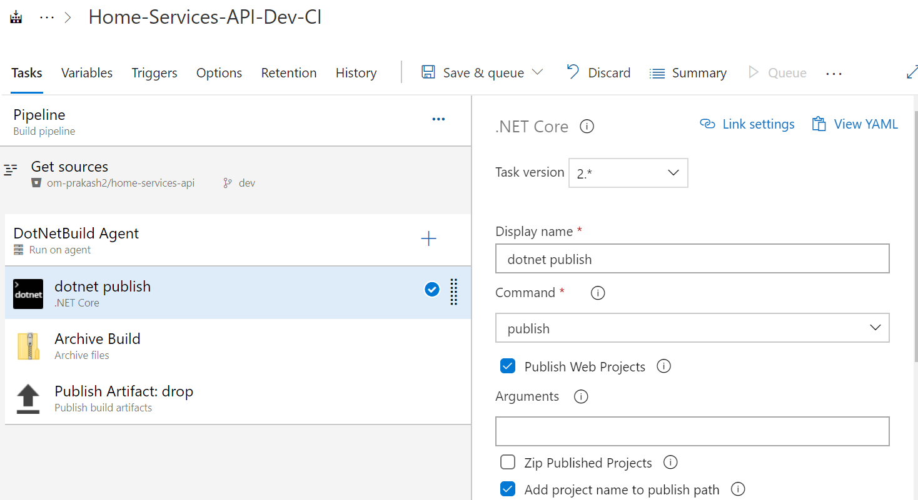

1. Dotnet publish
   1. Ensure ‘Zip Published Projects’ needs to unchecked and check ‘Add projects name to publish path’
2. Archive

* Check the Root folder or file to archive, it should end with publish/

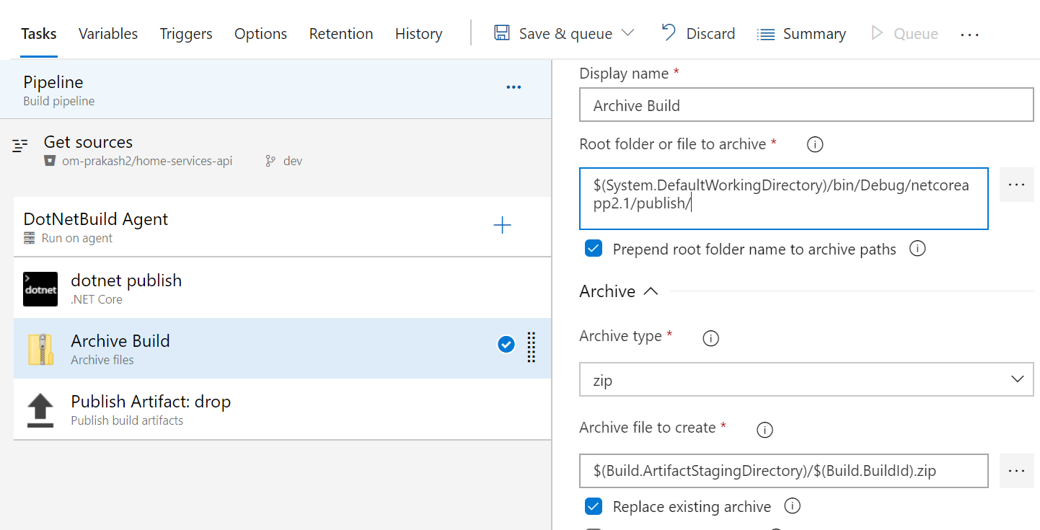

1. Publish Artifact

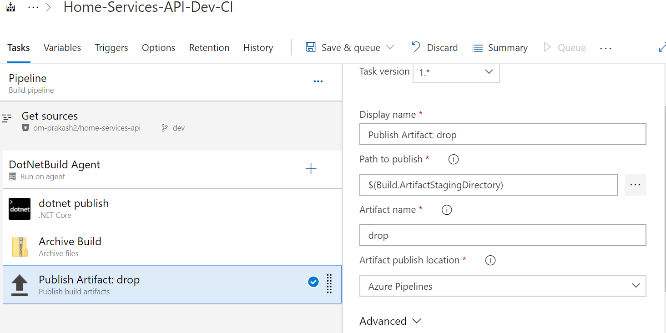

CI- Dotnet publish : The other use case:

Because the solution file and project are under different directory, please find the changes as required

