# Configure NgInx

# Configure Sonar

Install Java SDK

1. [Download](https://www.sonarqube.org/downloads/" \t "_blank) the SonarQube Community Edition.
2. As a **non-root user**, unzip it, let's say in C:\sonarqube or /opt/sonarqube.
3. As a **non-root user**, start the SonarQube Server:
4. # On Windows, execute:
5. C:\sonarqube\bin\windows-x86-xx\StartSonar.bat
6. # On other operating systems, as a non-root user execute:
7. /opt/sonarqube/bin/[OS]/sonar.sh console

 If your instance fails to start, check your [logs](https://docs.sonarqube.org/latest/setup/troubleshooting/) to find the cause.

1. Log in to [http://localhost:9000](http://localhost:9000/) with System Administrator credentials (login=admin, password=admin).
2. Click the **Create new project** button to analyze your first project.

# Configure Sonar Runner

<https://docs.sonarqube.org/latest/analysis/scan/sonarscanner-for-msbuild/>

dotnet tool install --global dotnet-sonarscanner --version 4.7.1

dotnet <path to SonarScanner.MSBuild.dll> begin /k:"project-key"

dotnet build <path to solution.sln>

dotnet <path to SonarScanner.MSBuild.dll> end

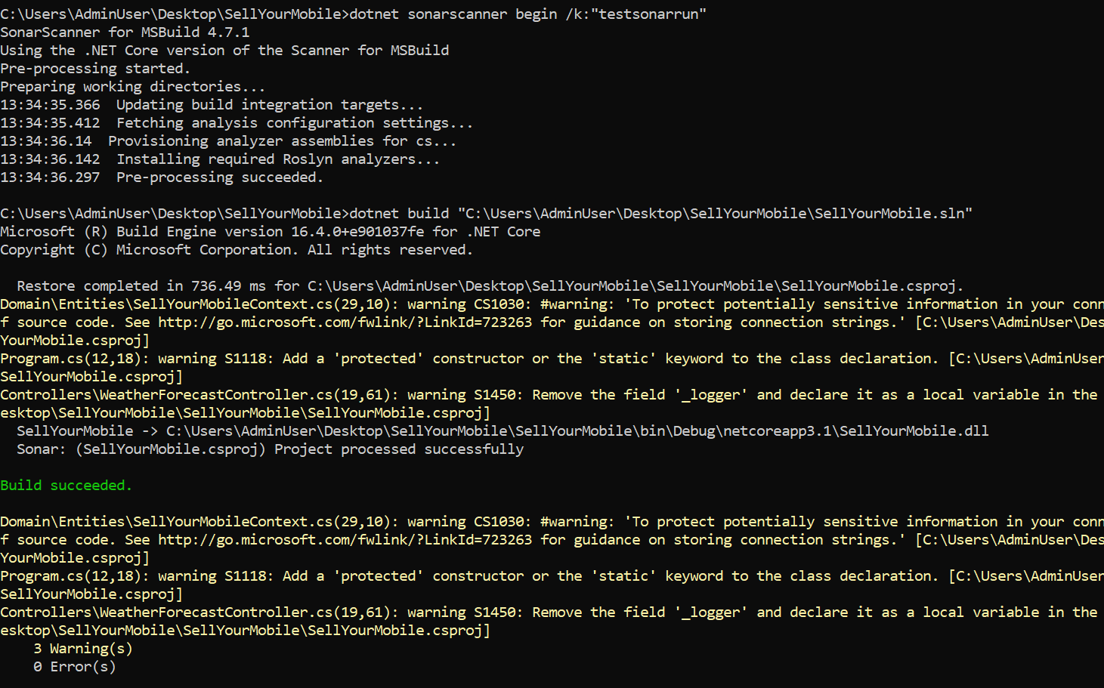

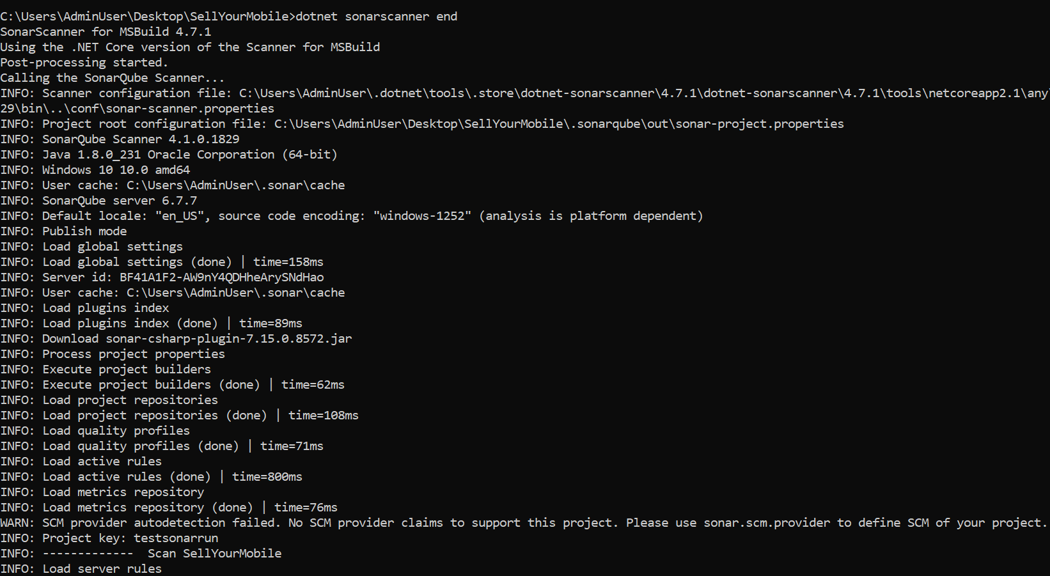

# Azure Devops