Contents

Assignment 2

Data 2

Review criteria 4

References 4

# Assignment

Create a Mater detail view based on wireframe below. A list of items are shown on the left pane. They could be selected by clicking or tapping. On a laptop or tablet screen, selecting items on the left will show respective details on right.

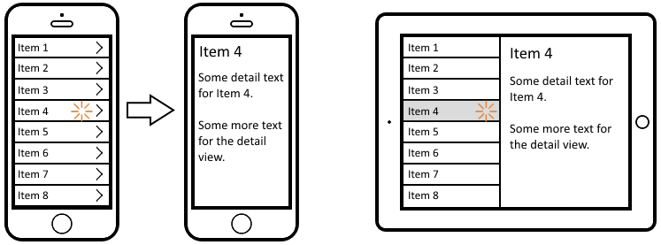

On a smaller screen like a phone, screen is not wide enough and hence the UI need to adapt to navigate to a different view to show details.



# Data

Please use following JSON object to render data. It is dinosaur information that need to be represented on the above mentioned UI screens.

{

"bruhathkayosaurus": {

"appeared": -70000000,

"height": 25,

"length": 44,

"order": "saurischia",

"vanished": -70000000,

"weight": 135000

},

"lambeosaurus": {

"appeared": -76000000,

"height": 2.1,

"length": 12.5,

"order": "ornithischia",

"vanished": -75000000,

"weight": 5000

},

"linhenykus": {

"appeared": -85000000,

"height": 0.6,

"length": 1,

"order": "theropoda",

"vanished": -75000000,

"weight": 3

},

"pterodactyl": {

"appeared": -150000000,

"height": 0.6,

"length": 0.8,

"order": "pterosauria",

"vanished": -148500000,

"weight": 2

},

"stegosaurus": {

"appeared": -155000000,

"height": 4,

"length": 9,

"order": "ornithischia",

"vanished": -150000000,

"weight": 2500

},

"triceratops": {

"appeared": -68000000,

"height": 3,

"length": 8,

"order": "ornithischia",

"vanished": -66000000,

"weight": 11000

}

}

# Review criteria

* Working code
* Presentable UI
* Code best practices followed
* Unit Tests

**Note:** Commit and push your code to <http://code.cognizant.com>. Present the application end of the assignment. Be prepared to talk code and explain features.

# References

Source for JSON object – sample dinosaur dataset from Firebase <https://dinosaur-facts.firebaseio.com/dinosaurs.json>

Master details screenshot used from [Scott Logic blog post](http://blog.scottlogic.com/wreilly/assets/ionic-master-detail/master-detail-example.png)