Abstract:

The Online Bookstore project is a simple web-based application that allows customers to browse and purchase books online. The project includes functionality for customers to register for an account, log in, browse books by category, add books to their shopping cart, and complete their purchase. The database includes tables for storing information about customers, books, orders, and order details.

Architecture used: Connected architecture

Why because:

The connected architecture in the example code because it is simpler and more suitable for a small-scale project like an online bookstore. In a connected architecture, you can execute queries directly on the database and get immediate results, which can be useful for small applications that don't require a lot of data manipulation.

Sql code: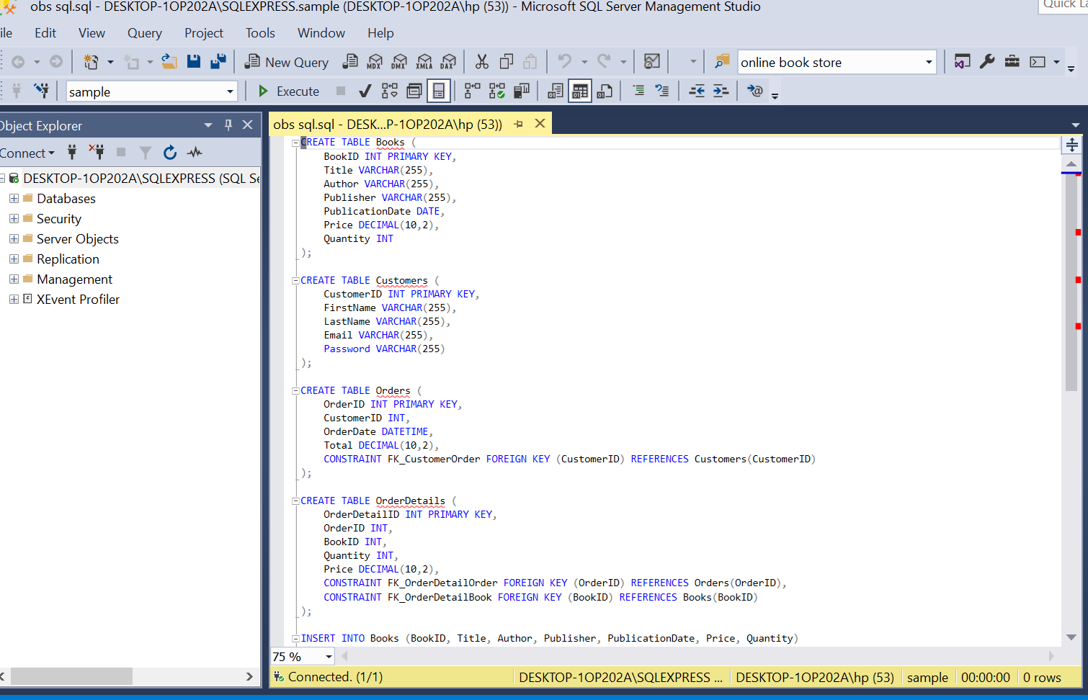

This code creates five tables: Authors, Books, Customers, Orders, and OrderDetails. The Authors table stores information about book authors, the Books table stores information about books, the Customers table stores information about customers, the Orders table stores information about orders, and the OrderDetails table stores information about the books in each order.

Sections used:connection string,main method,view books method,add to cart method,viewcart method,checkout method.

Output:

