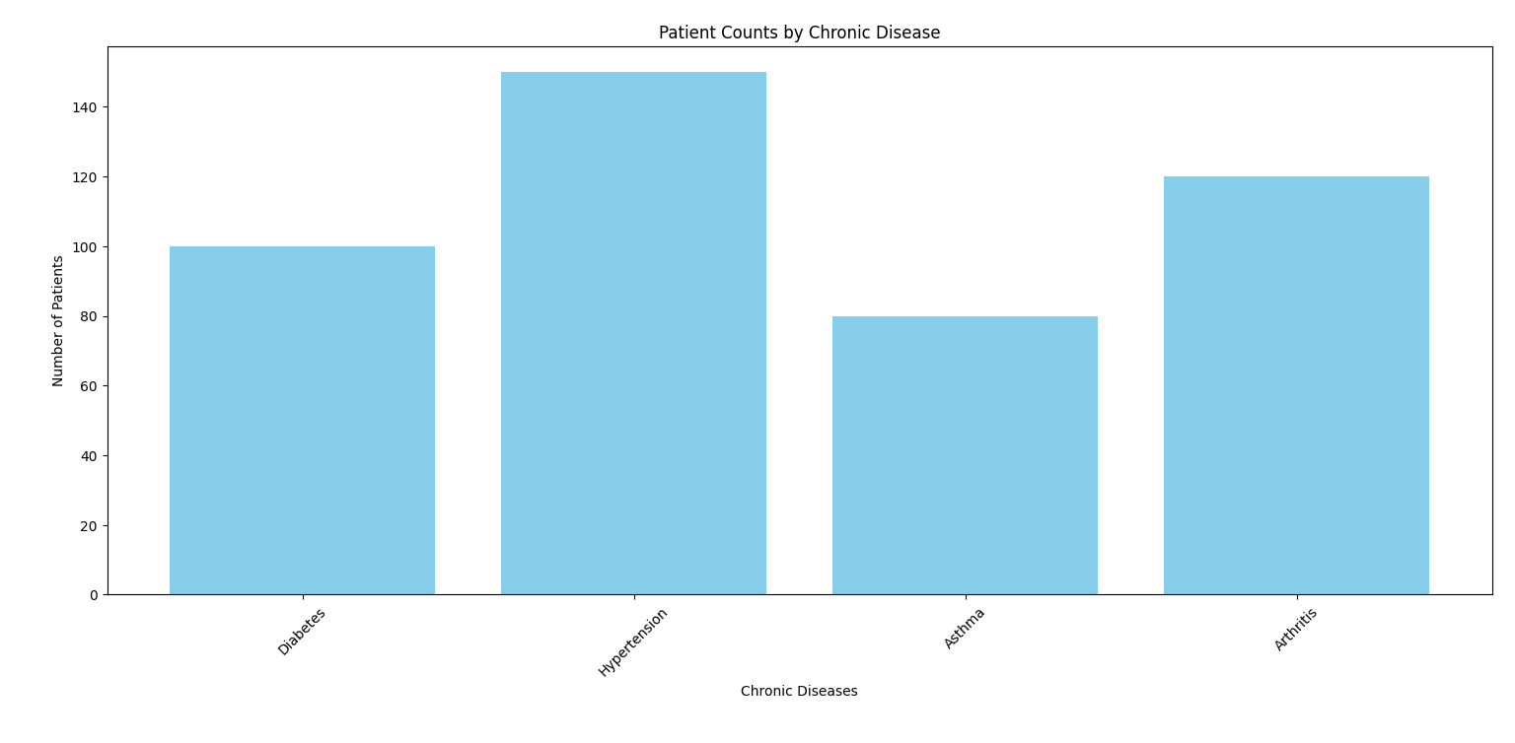

Fig: representing the approximate count of patients sick over different chronic diseases.

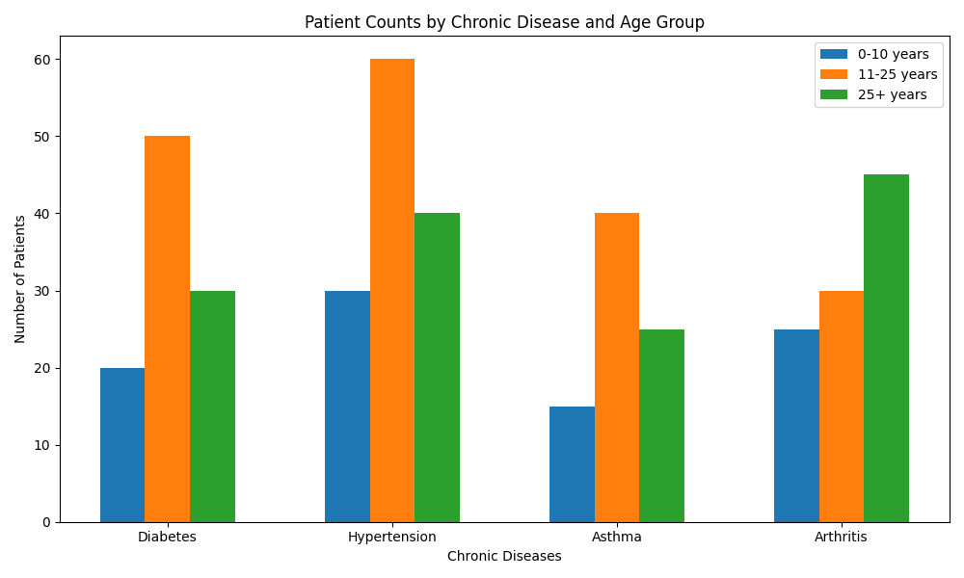

Fig: representing patient counts by chronic diseases with respect to their age groups

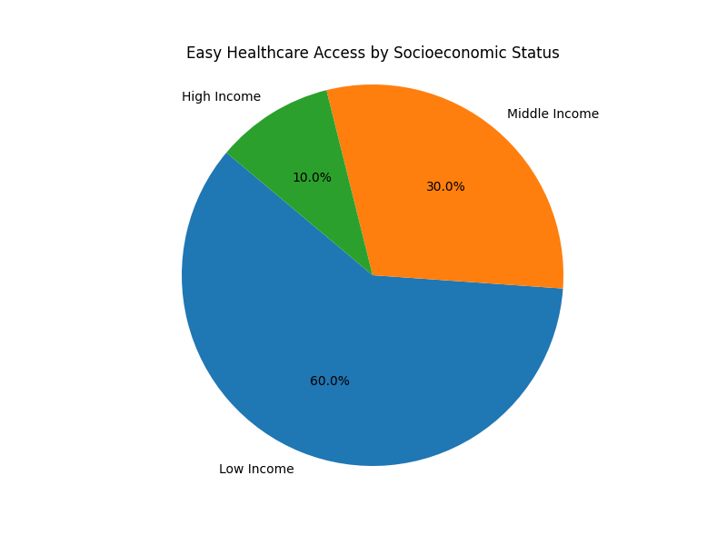

Pie chart representing the access of healthcare by socio-economic status

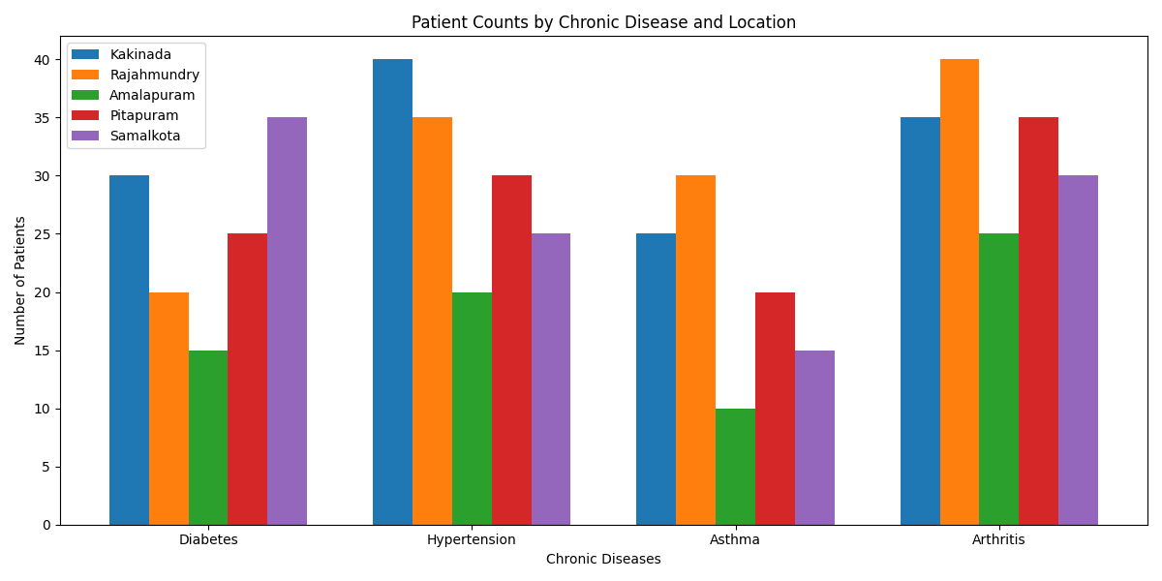

Fig: representing the patient counts by chronic disease according to locations