E-Commerce Application

# Statement about the Problem:

The e-commerce sector is rapidly evolving, with increasing consumer demand for a streamlined and efficient online shopping experience. This project aims to address the challenges and inefficiencies faced by both consumers and businesses in managing and accessing information about accessories like electronic devices (laptops, phones, iPads, etc.). The primary objective is to design and develop a comprehensive e-commerce application that includes separate modules/interfaces for administrators and customers, ensuring secure and convenient management of product-related data. The development of this application is aimed at creating a more efficient, user-centric, and secure shopping environment. The successful implementation of this project will improve the quality of e-commerce services, enhance the customer experience, and facilitate smooth operations of the business functions.

# Why this particular topic is chosen?

The choice of creating an e-commerce application for accessories is driven by several compelling reasons and considerations:

* **Improving Shopping Efficiency:** The e-commerce industry directly impacts the convenience and satisfaction of consumers. By developing this application, the aim is to enhance the efficiency of the shopping process, leading to better customer satisfaction and increased business profitability.
* **Enhancing Customer Experience:** Customer satisfaction and convenience are essential in e-commerce. This application can streamline product browsing, order placement, and customer service, leading to an improved overall shopping experience.
* **Data Management:** E-commerce businesses generate vast amounts of data daily. Managing this data efficiently is crucial for providing quality service and making data-driven decisions. This application can centralize and organize this data, making it easily accessible to authorized users.
* **Remote Access:** In the digital age, the ability to access shopping services remotely is essential. This application enables remote access for customers, ensuring convenience and continuity of service.
* **Security and Compliance:** E-commerce data is sensitive and subject to privacy and security regulations. Developing this application allows for the implementation of robust security measures to protect customer information and ensure compliance with relevant laws.

# Objective of the E-Commerce Application:

1. **Product Information Management:** To create a comprehensive system that efficiently manages and streamlines various aspects of product information, including descriptions, prices, and stock levels.
2. **Customer Information:** To record and manage essential information about customers, ensuring accurate and accessible customer data.
3. **Order and Billing Management:** To automate and simplify the order placement and billing process, including generating invoices, tracking payments, and handling returns seamlessly.
4. **Product Category Management:** To maintain detailed records of diﬀerent product categories, facilitating eﬀective browsing and search functionality.
5. **Promotion and Discounts Management:** To manage promotions and discounts eﬀectively, ensuring that customers are informed about current deals and oﬀers.

# Scope of the E-Commerce Application Project:

1. **Product Information Management:** The system will capture comprehensive product data, including but not limited to name, description, price, stock levels, and category. This information will be securely stored and easily retrievable, eliminating the need for redundant data entry.
2. **Automated Order and Invoicing:** The system will automate the order process by recording and tracking the cost of products purchased by each customer. It will generate itemized invoices, which can be reviewed, adjusted, and consolidated into a final invoice, simplifying financial transactions and reducing errors.
3. **Integrated Category and Search Functionality:** Product category information will be digitally recorded within the system. Each product's details will be accessible to customers through an integrated search functionality, ensuring a smooth and efficient shopping experience.
4. **Promotion and Discounts Management:** The system will maintain a comprehensive record of ongoing promotions and discounts, including schedules and details. Automated notifications will ensure customers are informed about the latest deals, promoting sales and customer satisfaction.
5. **Customer Feedback and Support:** The system will include a centralized platform for customer feedback and support, allowing customers to submit inquiries and receive timely responses, enhancing overall customer service.

# Methodology:

The "Waterfall methodology" will be used to complete this e-commerce application. Waterfall methodology is straightforward and involves five phases: Requirements Gathering, System Design, Implementation, Integration and Testing, and Maintenance.

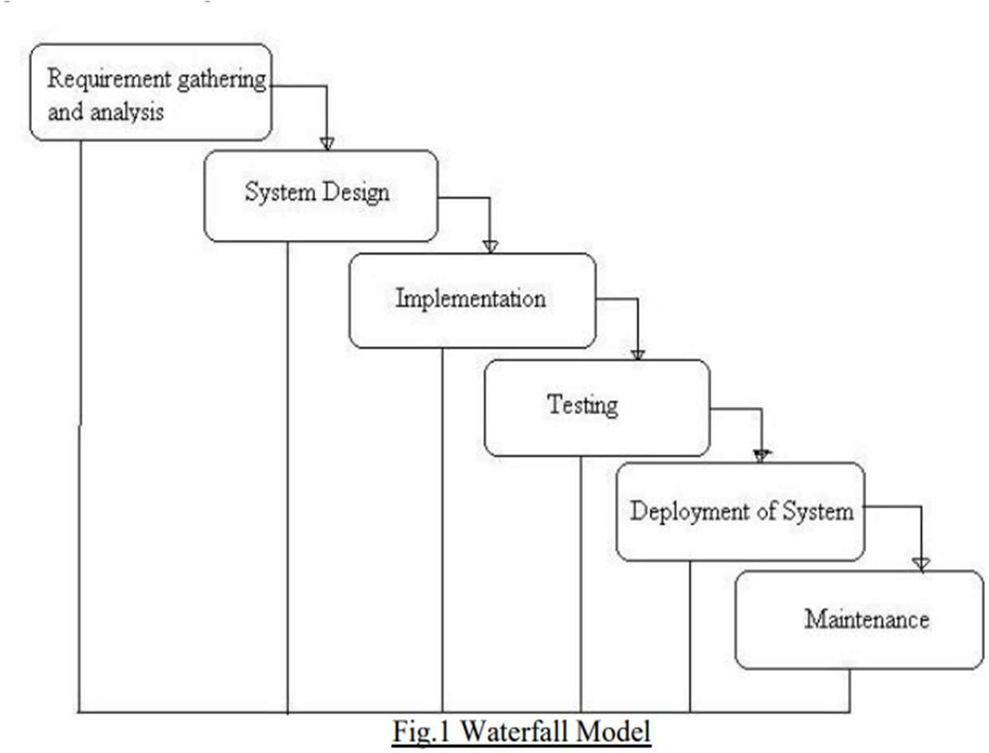

# ER Diagram:

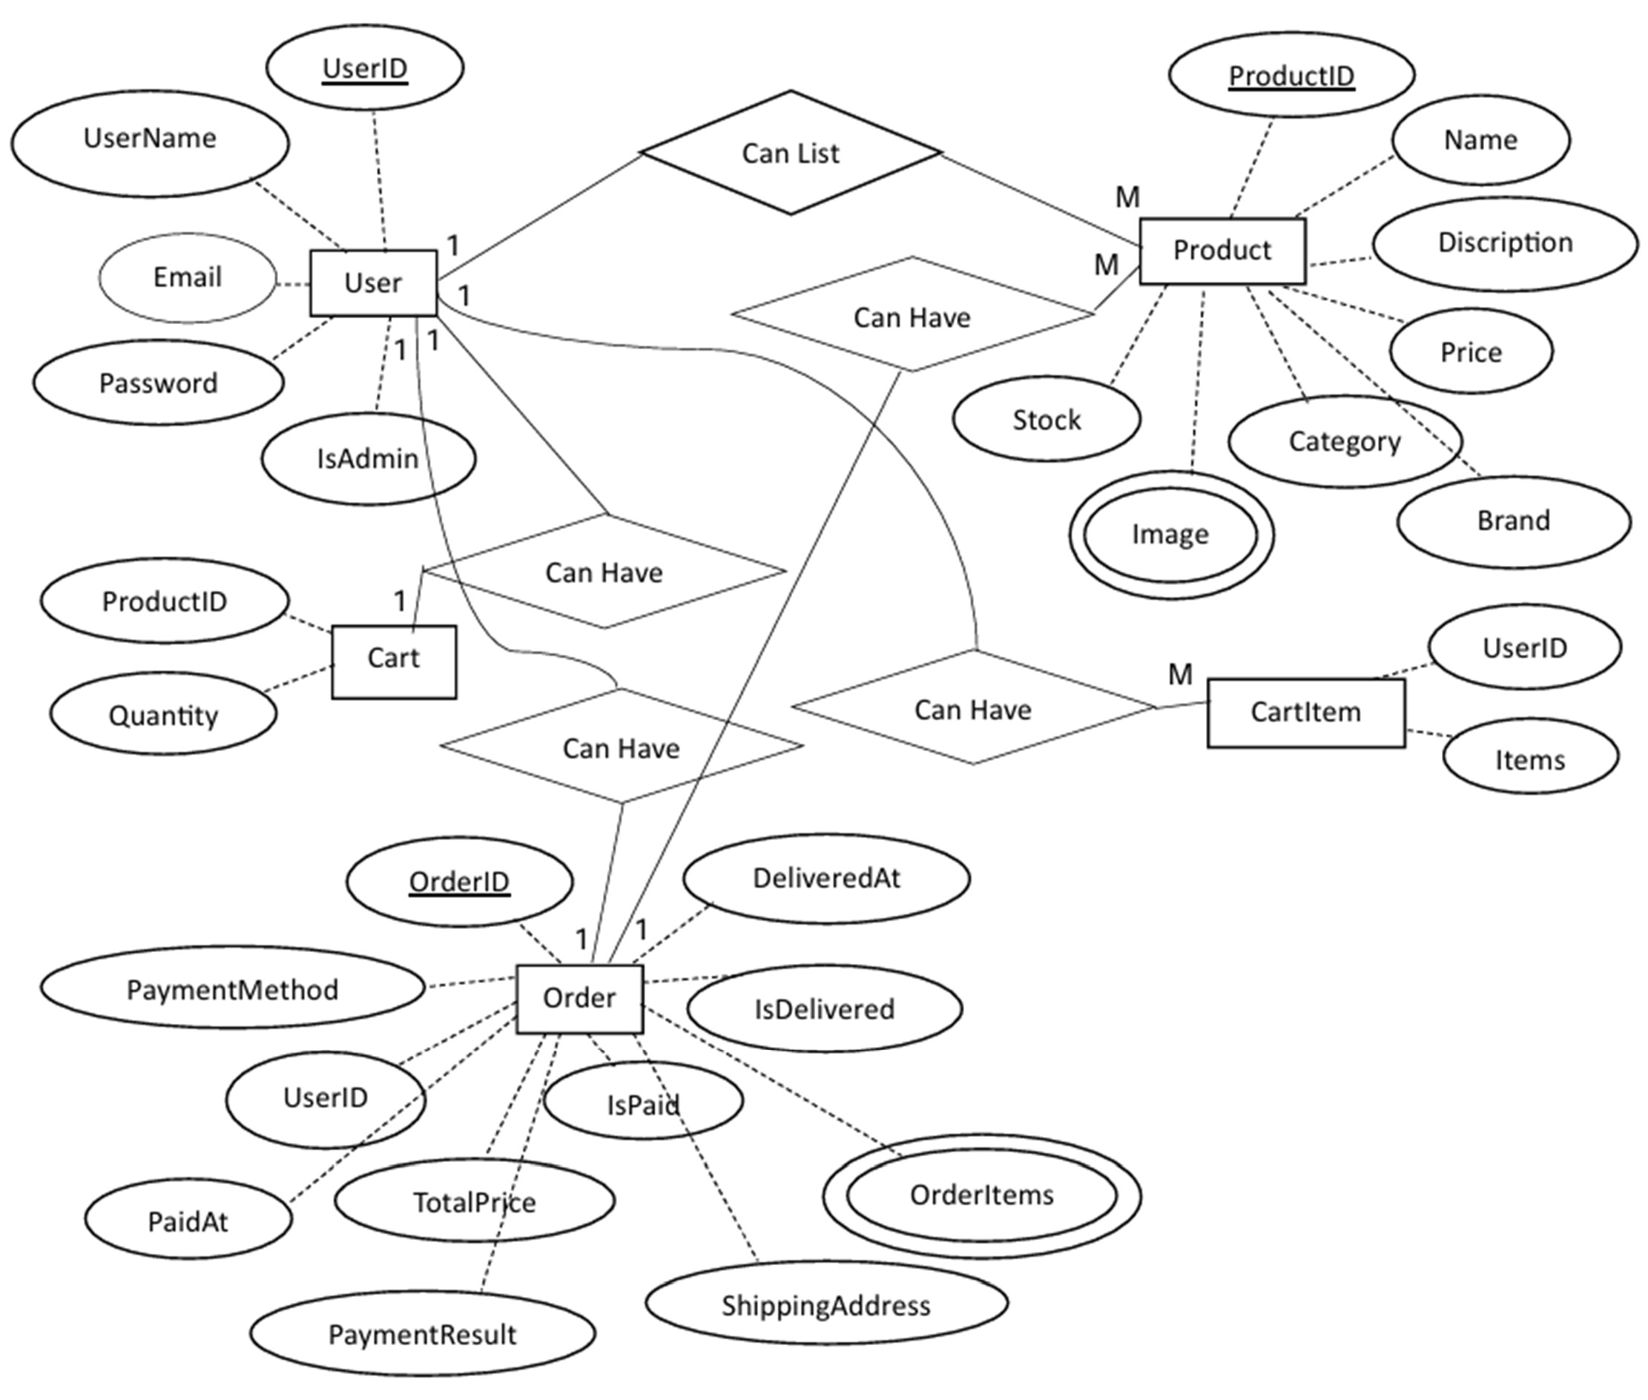

**Data Dictionary: Table 1:** User

|  |  |  |  |
| --- | --- | --- | --- |
| **S.no** | **Field name** | **Field type** | **Constraint** |
| 1 | UserID | Number | Primary key |
| 2 | UserName | String | Not null |
| 3 | Email | String | Not null |
| 4 | Password | String | Not null |
| 5 | IsAdmin | Boolean | Default |

**Table 2:** Product

|  |  |  |  |
| --- | --- | --- | --- |
| **S.no** | **Field name** | **Field type** | **Constraint** |
| 1 | ProductID | Number | Primary key |
| 2 | Name | String | Not null |
| 3 | Discription | String | Not null |
| 4 | Price | Number | Not null |
| 5 | Category | String | Not null |
| 6 | Brand | String | Not null |
| 7 | Image | String | Not null |
| 8 | Stock | Number | Not null |

**Table 3:** Order

|  |  |  |  |
| --- | --- | --- | --- |
| **S.no** | **Field name** | **Field type** | **Constraint** |
| 1 | OrderID | Number | Primary key |
| 2 | PaymentMethod | String | Not null |
| 3 | UserID | Number | Foreign key |
| 4 | PaidAT | Number | Not null |
| 5 | TotalPrice | Number | Not null |
| 6 | IsPaid | Boolean | Not null |
| 7 | IsDelivered | Boolean | Not null |
| 8 | DeliveredAt | Date | Not null |
| 9 | OrderItems | Array | Not null |
| 10 | ShippingAddress | String | Not null |
| 11 | PaymentResult | Array | Not null |

**Table 4:** Cart

|  |  |  |  |
| --- | --- | --- | --- |
| **S.no** | **Field name** | **Field type** | **Constraint** |
| 1 | ProductID | Number | Foreign key |
| 2 | Quantity | Number | Not null |

**Table 5:** CartItem

|  |  |  |  |
| --- | --- | --- | --- |
| **S.no** | **Field name** | **Field type** | **Constraint** |
| 1 | UserID | Number | Foreign key |
| 2 | Items | Array | Not null |

# Hardware & Software to be used: Hardware:

* Processor: Intel Core i3
* RAM: 4GB
* Hard disk: 1 TB (minimum 80GB)

# Software:

* Operating System: Windows 7, 10
* Front-end: HTML, CSS, JavaScript, React
* Server-side: Node.js
* Database: MongoDB
* IDE: Visual Studio Code
* Project type: Web application

# Testing Technologies used:

The project involves two main types of testing:

* **Unit Testing:** Focuses on verifying the correctness of small, isolated pieces of code within the backend and frontend. It helps catch and rectify errors in the early stages of development.
* **Manual Testing:** Essential for evaluating user interfaces and overall user experiences. It assesses aspects that may be challenging to automate, such as visual design, usability, and subjective user interfaces.

# Contribution of the E-Commerce Application Project:

An e-commerce application project can make several valuable contributions to the industry. It can streamline shopping operations, reduce paperwork, and minimize administrative burdens on staﬀ. It can streamline product browsing, order placement, and access to information, leading to an improved overall customer experience. The application enables remote access for customers, ensuring convenience and continuity of service. Developing this application allows for the implementation of robust security measures to protect customer information and ensure compliance with relevant laws.