SIT333 – Software Quality and Testing
Task – 1.2P

Live Video Demonstration
https://youtu.be/OTYjw91fHNw

Git Repository Link
https://github.com/Naman-Dhankhar/SIT333.git

Screenshot of Eclipse IDE console output
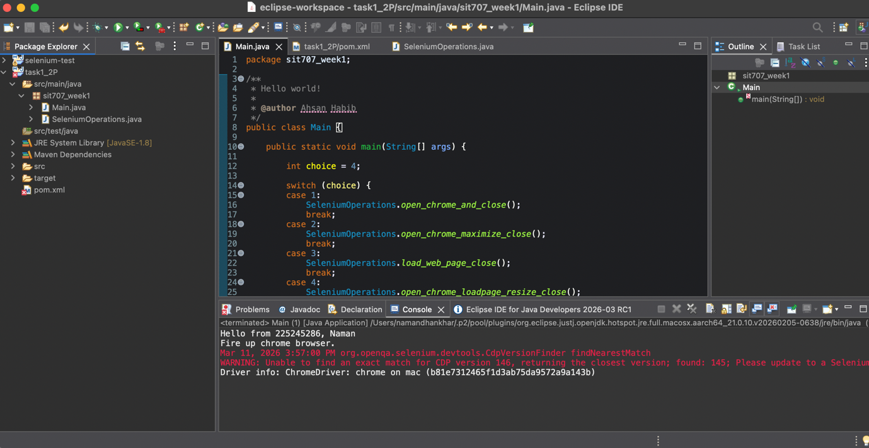

Screenshot of chromium browser opened by Selenium
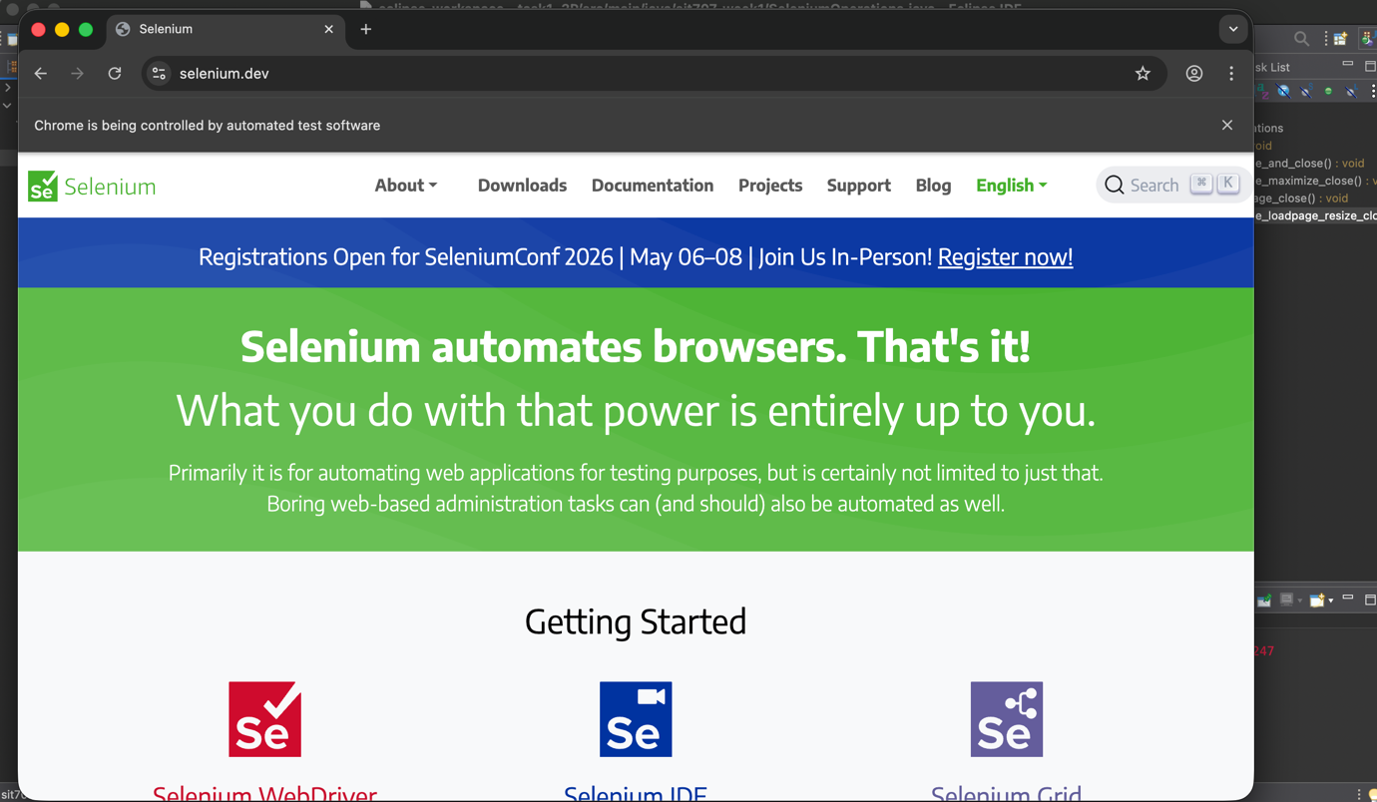
Program’s source code (SeleniumOperations.java)
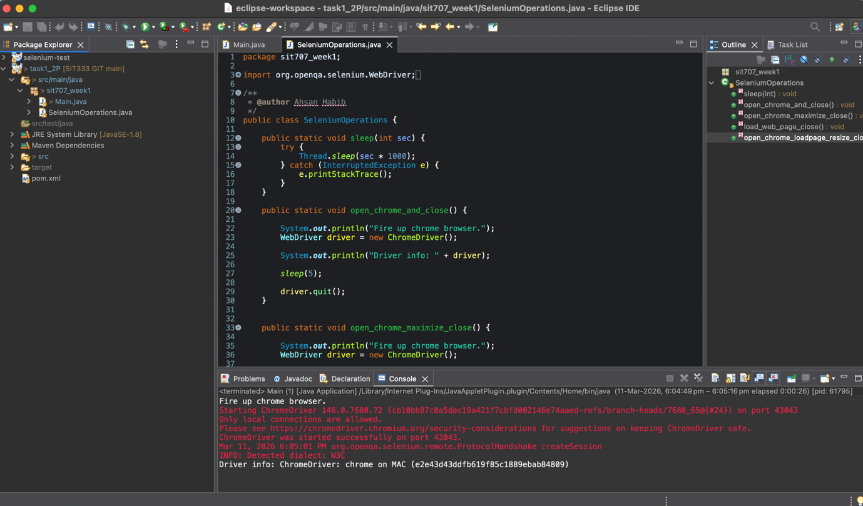

Screenshot Github page where latest project folder is pushed
