FINAL PROJECT REPORT
Mess Food Waste Tracking and Meal Optimization
A C++ Console Application
Tracking food waste, forecasting demand and optimising cooking quantities and menus
Case study: IIIT Bhubaneswar Ground Floor Mess
Language: C++17 (standard library only)
Submitted by
Roll number
Programme / Branch
Guide / Supervisor
Institution
Date | October 2026

Abstract
Large hostel and campus messes usually cook food for a fixed headcount, although the number of students who actually eat changes with the day and the meal, and students do not like every dish equally. The result is food that is cooked but never eaten. This project presents a console application, written entirely in standard C++17, that tracks and reduces food waste in a mess. Using the weekly menu of the IIIT Bhubaneswar Ground Floor Mess as the case study, it records the quantity of every dish cooked, left over and thrown from plates, together with the expected and actual headcount of each meal, and measures waste in kilograms, percentage and rupees.
A forecasting module tests three methods on past data and automatically uses the most accurate one to predict the next meal’s headcount. An optimization module turns the forecast and each dish’s real per-student demand into cooking quantities for the scheduled menu, and searches for menus within a cost and calorie limit. On four weeks of simulated waste data for the real menu, the system measured about 34% waste and estimated a saving of roughly Rs 10,500 for one day’s cooking.
Keywords: C++, food waste, mess management, demand forecasting, meal optimization.
Table of Contents
Abstract 1
1. Introduction 3
2. Problem Statement and Objectives 3
3. Requirements 4
4. Methodology 4
5. System Design 5
6. Concepts Used 6
7. Implementation 7
8. Testing 9
9. Output and Results 10
10. Conclusion and Future Scope 12
References 12
Appendix A: Building and Running 12

1. Introduction

1.1 Background and motivation
A mess cooks food in bulk for a number of students decided hours in advance. Because running out of food is more visible than throwing food away, kitchens err on the side of cooking too much. Food is wasted at three points: over-production, leftover (cooked but never served) and plate waste (served but discarded). Most messes do not measure any of these, so nobody knows which dishes, meals or days are responsible, and quantities are decided by habit, usually for the same headcount every day.

1.2 Scope
The project is a console program, written only in C++ with no external libraries, that records cooked, leftover and plate-waste quantities and the headcount of each meal; analyses waste by dish, meal and weekday; forecasts the next headcount; plans the quantity to cook for each scheduled dish; suggests menus within a budget; and writes a report. Purchasing, inventory and per-student tracking are out of scope. The mess serves three meals, so the project works with breakfast, lunch and dinner.

1.3 Case study
The case study is the Ground Floor Mess of IIIT Bhubaneswar. Its menu is a fixed weekly cycle. Breakfast is one list of items with tea or coffee and milk. Lunch and dinner have four slots: Common (rice and roti with a dal and accompaniments), Dry item, Gravy and Dessert, and several slots offer a choice such as “Egg Curry / Mix Veg”. Egg or banana, tea or coffee, milk and pickle are compulsory. The real menu is stored as data, so the cooking plans are for the dishes the mess actually serves each weekday.

2. Problem Statement and Objectives

2.1 Problem statement
A mess cooks for a headcount that does not change from day to day, while real attendance does: Sunday breakfast is thin, Saturday dinner is thinner, a special lunch is crowded. Dishes also differ in popularity. Cooking the same quantity for the same number of people therefore produces large, avoidable waste that nobody can measure because nothing is recorded (Figure 2.1). The problem is to build a C++ program that, from a history of daily records and the weekly menu, measures the waste, predicts the next headcount, recommends how much of each scheduled dish to cook, and suggests low-cost, nutritious, well-accepted menus.
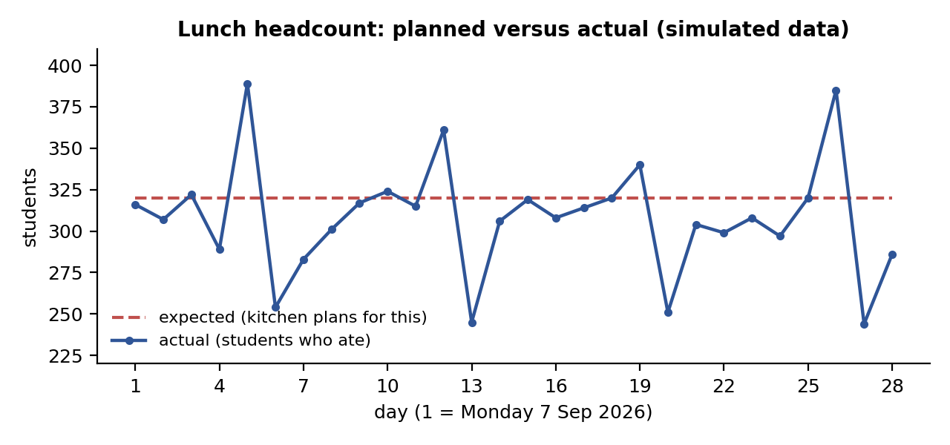
Figure 2.1: The kitchen plans for a fixed 320 students at lunch, but the actual headcount varies (simulated data).

2.2 Objectives
- Track the quantity cooked, left over and thrown from plates for every dish at every meal.
- Measure waste in kilograms, percentage and rupees, and find the worst dishes, meals and weekdays.
- Forecast the headcount of the next meal and choose the forecasting method from the data.
- Plan the quantity of each scheduled dish from the forecast and the real demand per student.
- Suggest menus that are low in cost, adequate in calories and well accepted.
- Validate all data, test the program and generate a written report.

3. Requirements
Table 3.1: Software and hardware requirements
Item | Requirement
Operating system | Windows 10 or later, Linux or macOS
Compiler | Any C++17 compiler: g++ 8+, clang 7+, Visual C++ 2017+
Libraries | None; only the C++ standard library
Hardware | Any ordinary computer; well under 1 MB of disk space
Interface | A text console

Functional requirements. The system loads and validates four CSV files; lets the user add, search and delete records; computes waste overall and by dish, meal and weekday; computes per-dish acceptance and demand per student; forecasts the headcount with automatic method selection; produces cooking plans for the scheduled menu; suggests menus under budget and calorie limits; displays the weekly menu; and writes a full report.
Non-functional requirements. Calculations must agree with hand calculation; invalid input is rejected, not stored; the same source builds on Windows, Linux and macOS; the full report takes a few hundredths of a second; the code is modular and tested; all data are plain text files the mess can edit.

4. Methodology

4.1 Overall approach
The project follows the cycle in Figure 4.1. Four CSV files hold the data. At start-up the program loads them and checks every record. The data feed four tasks: analysing waste, forecasting demand, planning cooking quantities and suggesting menus. Results are shown on screen and written to a report, and new daily records are saved and used by the next forecast.
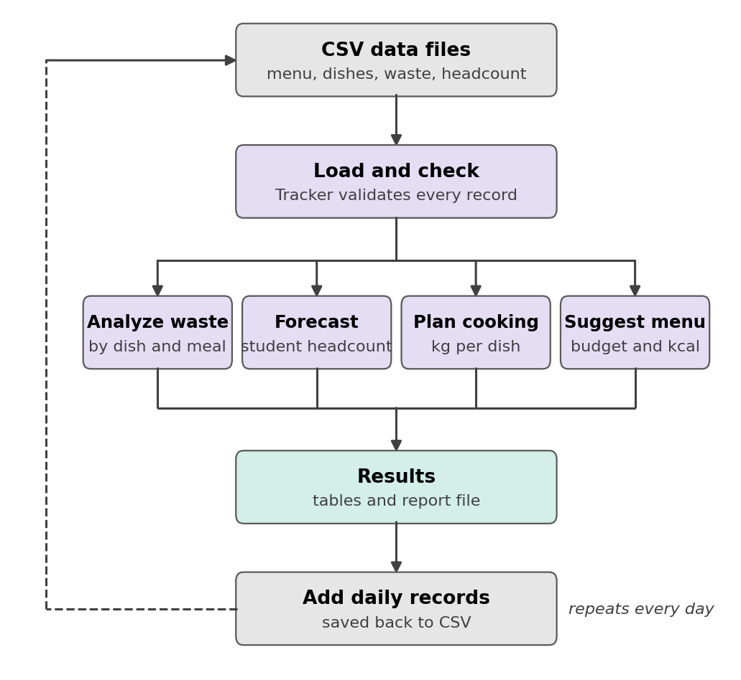
Figure 4.1: Flowchart of how the project works.
Table 4.1: The four data sets
Data (file) | Contents | Source
Weekly menu (menu.csv) | Weekday, meal, slot, dish, fixed or choice | Real: mess menu
Dishes (dishes.csv) | Category, meals, cost per kg, portion, calories, protein | Names real; costs, portions, nutrition estimated
Waste log (waste_log.csv) | Date, meal, dish, kg cooked, leftover, plate waste | Simulated (weighed in practice)
Attendance (attendance.csv) | Date, meal, expected and actual headcount | Simulated (mess register in practice)

4.2 Measuring waste
waste = leftover + plate waste waste % = waste ÷ cooked × 100
cost of waste = waste kg × cost per kg served = cooked − leftover
For each dish the program also computes the acceptance (share of the cooked food that is eaten) and the served quantity per student (total served kg divided by the students who ate), which is the real demand for the dish. Leftover and plate waste are recorded separately because leftover can be avoided by cooking less, while plate waste depends on the dish and the portion.

4.3 Demand forecasting
Three methods predict the headcount of a meal: the moving average of the last 7 days; exponential smoothing (level = 0.4 × latest + 0.6 × previous level); and the weekday average of the last 4 same weekdays. The program decides by a walk-forward test: from the eighth day on, it predicts each day using only earlier days and records the error. The method with the smallest mean absolute error, MAE = (1 ÷ n) Σ |predicted − actual|, makes the forecast, and its MAE is reported.

4.4 Cooking-quantity planning
For a date, the program takes the dishes scheduled for that weekday and meal and computes, for each dish,
cook kg = forecast headcount × served kg per student × 1.05
where 1.05 is a 5% safety buffer. The plan also shows the usual quantity (the past average) and the saving in kilograms and rupees. A dish with no history uses the standard portion and no saving is claimed. Every alternative of a choice slot is planned; its per-student demand already reflects how many choose it.

4.5 Menu optimization
Each dish gets a score between 0 and 1: score = 0.45 × acceptance + 0.25 × cost score + 0.30 × nutrition score, where cost and protein are scaled within the dish’s category. A menu has one dish from each required category (breakfast: main, tea/coffee, milk; lunch and dinner: staple, dal, dry item, gravy) and optionally a side and a dessert. The program tries every combination, rejects those over the budget or under the calorie minimum, and keeps the highest total score. A weekly plan avoids the main dishes of the previous two days.

5. System Design

5.1 Architecture
The program is divided into layers (Figure 5.1); each layer uses only the layers below it, and a small utility module is used by all.
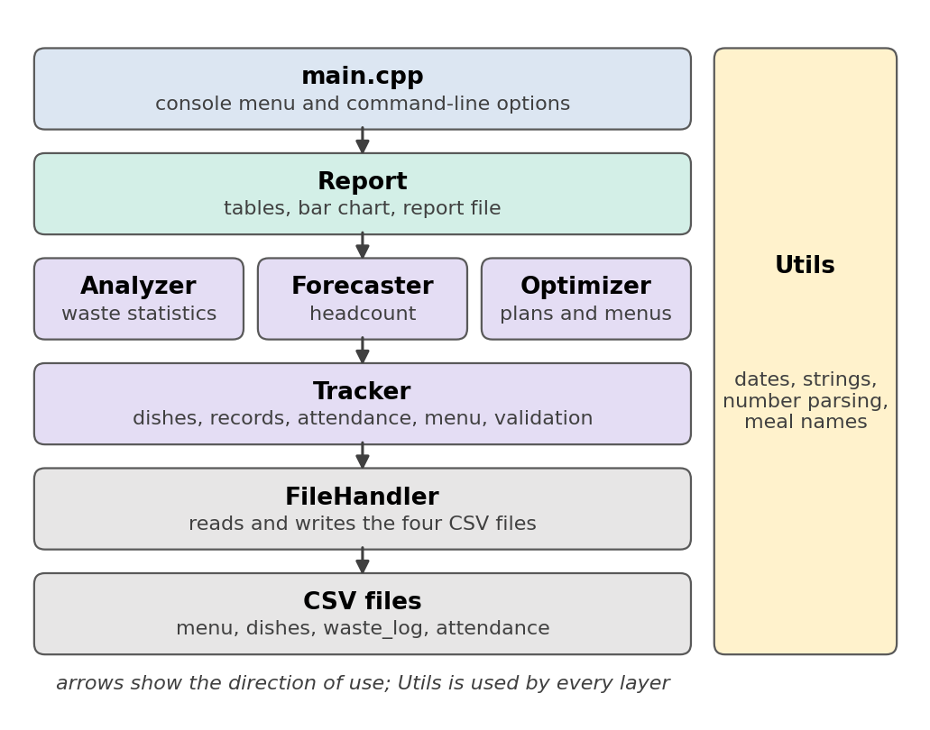
Figure 5.1: Software architecture.
Table 5.1: Modules
Module | Responsibility
Utils | Strings, safe number parsing, date validation and arithmetic, weekday, meal names
FileHandler | Reads and writes the four CSV files; rejects invalid rows with file and line number
Tracker | Holds data in memory; validates every addition; looks up the menu of a weekday and meal
Analyzer | Waste by dish, meal, weekday and date; rankings; per-dish acceptance and demand
Forecaster | Three forecasting methods; automatic selection by walk-forward error
Optimizer | Cooking plans, dish scores, menu search, weekly rotation
Report / main | Tables, bar chart, report file; console menu and command-line options

5.2 Representing the mess menu
The menu photograph was converted into menu.csv, one row per dish per slot. “Rice & Roti + Dalma + Papad + Curd” became five rows because each item is cooked, served and wasted separately; alternatives such as “Egg Curry / Mix Veg” became rows of type choice. The printed quantity notes (2 pieces, 75 g paneer, 100 g chicken, 70 ml tea, 150 ml milk) guided the portion sizes in dishes.csv. The menu gives no prices or nutrition values, so the cost per kg, calories and protein are estimates. The compulsory items are not tied to a meal on the menu; Egg/Banana was attached to breakfast and Pickle to lunch and dinner. These are the only assumptions about the menu.

6. Concepts Used
Table 6.1: C++ concepts used
C++ concept | Where used | Purpose
Structures and classes | Dish, WasteRecord, Tracker, Analyzer, Forecaster, Optimizer | Group data and behaviour
Header / source separation | include/ and src/ | Declare once, reuse everywhere
Containers and algorithms | vector, map, set, sort, lambda | Store, group and rank records
File streams and exceptions | FileHandler | Read and write CSV; report bad lines
Function pointers | Forecaster | Test all methods in one loop
Recursion | Menu search in Optimizer | Try every combination
Namespaces, const, references | utils, Report; throughout | Structure; avoid copies and mistakes

- Date arithmetic with day numbers (Hinnant’s algorithm); weekday = (days + 3) mod 7, since 1 January 1970 was a Thursday.
- Time-series smoothing: moving average, exponential smoothing, weekday average; walk-forward validation with mean absolute error.
- Min–max normalization and weighted scoring to combine acceptance, cost and nutrition.
- Exhaustive search with pruning: branches that exceed the budget are dropped early.
- Software engineering: modular design, input validation, data-driven design (menu and costs are data), unit testing and reproducible simulation.

7. Implementation
Table 7.1: Project structure
Folder | Contents | C++ lines
include/ | 10 headers: Analyzer, Dish, FileHandler, Forecaster, Menu, Optimizer, Report, Tracker, Utils, WasteRecord | 352
src/ | 8 sources: the modules above and main.cpp | 1489
tools/ | generate_sample_data.cpp: simulated waste and attendance for the real menu | 140
tests/ | 6 unit-test programs and a test helper | 431
data/ | menu.csv, dishes.csv, waste_log.csv, attendance.csv | -

Forecaster. The three methods share one signature and are stored in an array; forecast tests each by walk-forward error and uses the winner (Listing 7.1).
Listing 7.1: Automatic choice of the forecasting method (Forecaster.cpp)
Forecast Forecaster::forecast(const std::string& meal, const std::string& targetDate) const {
Forecast result;
const std::vector<Point> pts = series(meal);
if (pts.empty()) {
result.method = "no attendance data";
return result;
}
const int wd = utils::weekdayOf(targetDate);
const size_t minHistory = 7;
if (pts.size() <= minHistory) {
result.value = movingAverage(pts, wd);
result.method = "Moving average (not enough history to compare methods)";
return result;
}
struct Candidate { const char* name; Predictor fn; };
const Candidate candidates[] = {{"Moving average (7 days)", &Forecaster::movingAverage},
{"Exponential smoothing", &Forecaster::exponentialSmoothing},
{"Weekday average", &Forecaster::weekdayAverage}};
double bestMae = std::numeric_limits<double>::infinity();
const Candidate* best = &candidates[0];
for (const auto& c : candidates) {
const double mae = meanAbsError(c.fn, pts, minHistory);
if (mae < bestMae) { bestMae = mae; best = &c; }
}
result.value = best->fn(pts, wd);
result.method = best->name;
result.mae = bestMae;
return result;
}

Optimizer. The cooking plan multiplies the forecast headcount by the real demand per student (Listing 7.2).
Listing 7.2: Cooking-quantity plan (Optimizer.cpp)
CookPlan Optimizer::planQuantities(const std::string& date, const std::string& meal,
const std::vector<std::string>& dishNames) const {
CookPlan plan;
plan.date = date;
plan.meal = meal;
const Forecast f = Forecaster(tracker_).forecast(meal, date);
plan.forecastHeads = static_cast<int>(std::lround(f.value));
plan.method = f.method;

std::map<std::string, DishStats> stats;
for (const auto& s : Analyzer(tracker_).dishStats()) stats[s.dish] = s;

for (const auto& name : dishNames) {
const Dish* d = tracker_.findDish(name);
if (!d) {
plan.unknownDishes.push_back(name);
continue;
}
CookPlanItem item;
item.dish = d->name;
auto it = stats.find(d->name);
if (it != stats.end() && it->second.hasPerHead) {
item.hasHistory = true;
item.perHeadKg = it->second.servedPerHeadKg; // real demand, not what was cooked
item.plannedKg = plan.forecastHeads * item.perHeadKg * (1.0 + buffer_);
item.baselineKg = it->second.avgCookedKg;
} else {
item.perHeadKg = d->portionG / 1000.0; // no history: fall back to the standard portion
item.plannedKg = plan.forecastHeads * item.perHeadKg * (1.0 + buffer_);
item.baselineKg = item.plannedKg; // nothing to compare with, so no saving claimed
}
item.savedKg = item.baselineKg - item.plannedKg;
item.savedCost = item.savedKg * d->costPerKg;
plan.totalPlannedKg += item.plannedKg;
plan.totalBaselineKg += item.baselineKg;
plan.totalSavedKg += item.savedKg;
plan.totalSavedCost += item.savedCost;
plan.items.push_back(item);
}
return plan;
}

Other modules. FileHandler checks every CSV row and throws an error naming the file and line; Tracker validates each new record (real date, valid meal, known dish, waste not larger than the quantity cooked); Analyzer groups records with std::map; Report prints through an std::ostream, so the same code writes to the screen and to the report file. The generator simulates four weeks for the real menu with a fixed random seed, so its output is identical every time.
Building. make, CMake or g++ -std=c++17 -Iinclude src/*.cpp -o mess_tracker build the program on any system. On Windows, build_windows.bat creates mess_tracker.exe (Appendix A).

8. Testing
Each module is tested with small data sets whose answers can be calculated by hand, and the tests never touch the real data folder. Table 8.1 lists the six test programs; all pass (Output 8.1).
Table 8.1: Unit tests
Test program | What it checks
test_utils | Dates including leap years, weekdays, adding days, splitting, number parsing, meal names
test_filehandler | Save and reload; skipping comments; rejecting a missing file, impossible date, waste larger than cooked, missing column, invalid meal
test_analyzer | Totals, waste %, cost of waste, rankings, per-student statistics, record validation
test_forecaster | Weekday method wins on a perfect weekly pattern; fallback with little history
test_menu | Loading and saving the menu; bad menu files; weekday lookup; menu mistakes
test_optimizer | Quantity and saving arithmetic; budget and calorie limits; exclusions; weekly variety

Output 8.1: Running all unit tests
== test_analyzer
All checks passed
== test_filehandler
All checks passed
== test_forecaster
All checks passed
== test_menu
All checks passed
== test_optimizer
All checks passed
== test_utils
All checks passed

The interactive program rejects invalid input, as Output 8.2 shows: the date 30 February is asked again, and a record whose waste (13 kg) exceeds the quantity cooked (10 kg) is not stored. Finally, the overall waste percentage, the waste by meal and weekday and the dish rankings were recomputed outside the program directly from the CSV files and agree with the program’s report.
Output 8.2: Invalid input is refused
Choose: 2
Date (YYYY-MM-DD): 2026-02-30
Use a real date in YYYY-MM-DD format.
Date (YYYY-MM-DD): 2026-10-05
Meal (Breakfast/Lunch/Dinner): Lunch
Dish name: Dalma
Cooked quantity (kg): 10
Leftover, never served (kg): 8
Plate waste, thrown from plates (kg): 5
Not saved: Leftover + plate waste cannot be more than the quantity cooked.

9. Output and Results
The weekly menu is real. The dish costs, portions and nutrition values are estimates, and the waste and attendance records are simulated for 28 days (7 September to 4 October 2026). The figures below therefore illustrate what the system produces; they are not measurements of the real mess.

9.1 Waste analysis
Table 9.1: Overall waste
Measure (28 days) | Value
Food cooked | 18,209.5 kg
Leftover (never served) | 5,411.3 kg
Plate waste | 790.4 kg
Waste as a share of food cooked | 34.1 %
Cost of the waste (estimated costs) | Rs 6,95,295

About a third of the food is wasted, and leftover is almost seven times larger than plate waste, so most of the waste could be avoided by cooking less. Saturday (44.9%) and Sunday (39.3%) are the worst days (Figure 9.1) because fewer students eat while the same quantity is cooked. The dishes with the highest waste percentage are Karela Chips 67.8%, Upma 66.6%, Veg Navratna 62.5%. By cost, Paneer Bhurji (Rs 46,451), Mutton Curry (Rs 38,682), Kadhai Paneer (Rs 37,764) come first, because paneer and mutton are expensive.
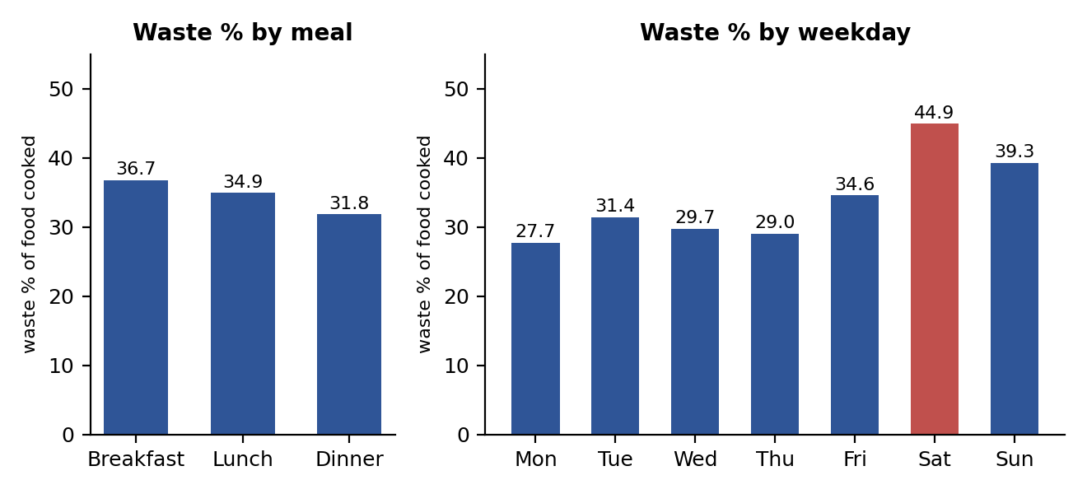
Figure 9.1: Waste percentage by meal and by weekday.

9.2 Headcount forecast
Output 9.1 is the forecast for Monday 5 October 2026. The weekday average won for breakfast and lunch, and the moving average for dinner; the average past error (about 9, 14 and 20 students) is shown with each forecast.
Output 9.1: Headcount forecast
Choose: 11
Date to forecast (YYYY-MM-DD, Enter = day after last data):

Breakfast on 2026-10-05 (Monday): about 227 students [Weekday average, average past error 8.7 students]
Lunch on 2026-10-05 (Monday): about 309 students [Weekday average, average past error 13.8 students]
Dinner on 2026-10-05 (Monday): about 278 students [Moving average (7 days), average past error 19.6 students]

9.3 Cooking plan
Output 9.2 is the plan for the Friday biryani lunch: the scheduled menu, then for each dish the demand per student, the kilograms to cook, the usual kilograms and the difference. A negative “Saved kg” means the plan cooks slightly more than usual because Friday attendance is high.
Output 9.2: Cooking plan for the scheduled Friday lunch
Choose: 12
Date (YYYY-MM-DD, Enter = day after last data): 2026-10-09
Meal (Breakfast/Lunch/Dinner): Lunch
Scheduled menu: Common: Roti + Chips + (Chicken Biryani / Veg Biryani) | Dry: Raita + Biryani Gravy | Gravy: Kadhai Paneer | Compulsory: Pickle
Dishes, separated by commas (Enter = the scheduled menu above):

Cooking plan: Lunch on 2026-10-09
=================================
Forecast headcount: 369 (Weekday average)

Dish g/head Cook kg Usual kg Saved kg Saved Rs
--------------------------------------------------------------------------------
Chicken Biryani 177 68.6 88.8 20.2 5245
Veg Biryani 103 40.0 73.8 33.9 4066
Roti 95 36.7 34.9 -1.8 -107
Chips 26 9.9 9.8 -0.1 -21
Raita 58 22.3 29.8 7.5 523
Biryani Gravy 47 18.2 23.7 5.5 984
Kadhai Paneer 54 20.8 31.1 10.4 3522
Pickle 8 2.9 4.0 1.1 162
--------------------------------------------------------------------------------
TOTAL 219.4 296.0 76.5 14374

For Monday 5 October 2026 (Figure 9.2) the plan cooks about 19% less at breakfast, 21% less at lunch and 23% less at dinner than the usual quantities, with an estimated saving of Rs 1,850, Rs 3,843 and Rs 4,844, in total Rs 10,538 for the day. This is an estimate that assumes the forecast is right and the estimated dish costs are correct.
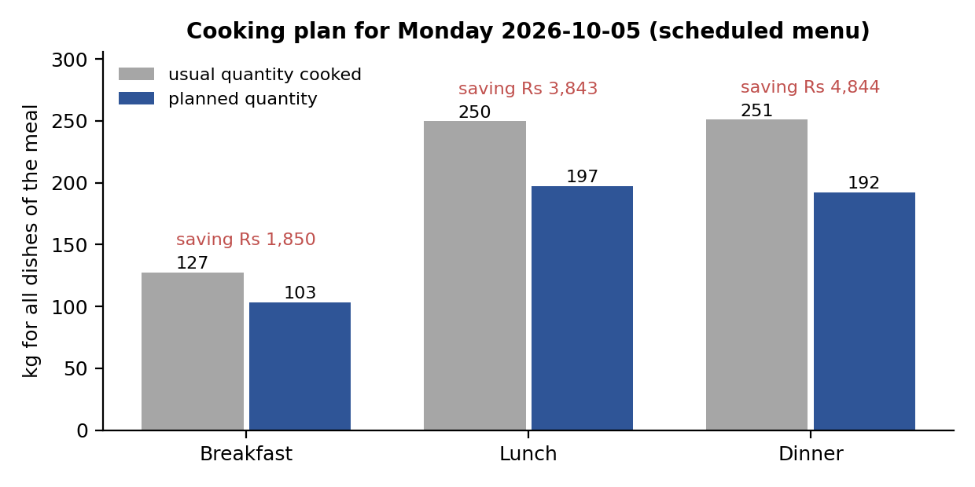
Figure 9.2: Planned versus usual quantity for Monday 5 October 2026.

9.4 Summary
Table 9.2: Summary of results
Result | Value (simulated data)
Overall waste | 34.1% of food cooked
Waste by meal (breakfast / lunch / dinner) | 36.7% / 34.9% / 31.8%
Dish with the highest waste percentage | Karela Chips 67.8%
Forecast error (breakfast / lunch / dinner) | 8.7 / 13.8 / 19.6 students
Estimated saving for one day | Rs 10,538

The program also writes a complete report (mess_tracker --report) with the waste analysis, the forecast, the cooking plan, menu suggestions and the weekly menu.

10. Conclusion and Future Scope
This project implemented, in standard C++17 only, a system that tracks food waste in a mess and uses the records to forecast demand and plan cooking quantities and menus. The real weekly menu of the IIIT Bhubaneswar Ground Floor Mess is stored as data and drives the plans. The system validates its data, measures waste in kilograms, percentage and rupees, selects a forecasting method by measured error, converts the forecast into a quantity to cook for each scheduled dish, and writes a complete report. Six unit-test programs pass, and an independent recomputation agrees with the program.
On simulated data the system found weekends and expensive dishes to be the main problems and estimated a saving of about Rs 10,500 in a day. These numbers illustrate the method; with real weighed records and real costs the same program measures the real saving.
Limitations: the waste and attendance data are simulated and the dish costs and nutrition are estimates; the forecast ignores holidays and exams; the optimizer does not model rice and roti together or the veg / non-veg split; the interface is a console menu.
Future scope: real records and costs; a holiday calendar in the forecast; student ratings in the dish score; linear programming for weekly menus; inventory and purchasing; a graphical interface.

References
- ISO/IEC 14882:2017, Programming languages – C++ (the C++17 standard).
- cppreference.com, C++ reference. https://en.cppreference.com
- H. Hinnant, “chrono-Compatible Low-Level Date Algorithms”. https://howardhinnant.github.io/date_algorithms.html
- R. J. Hyndman and G. Athanasopoulos, Forecasting: Principles and Practice, 3rd edition, OTexts, 2021. https://otexts.com/fpp3/

Appendix A: Building and Running
Linux or macOS. Run make to build, make test to run the tests, ./mess_tracker for the menu and ./mess_tracker --report to write reports/weekly_summary.txt.
Windows executable (mess_tracker.exe). Install a free C++ compiler once (for example the WinLibs MinGW-w64 zip from https://winlibs.com, with its bin folder added to PATH, or the Visual Studio Build Tools). Then double-click build_windows.bat in the project folder; it creates mess_tracker.exe and generate_sample_data.exe, statically linked so they run on other Windows computers. Keep the data folder next to the .exe and run it from that folder.
Commands. mess_tracker (interactive menu); mess_tracker --report [--out FILE] (write the report); mess_tracker --data FOLDER (use another data folder); generate_sample_data (create simulated waste and attendance for the menu).
Using real data. Replace the estimated costs, portions and nutrition in data/dishes.csv; keep data/menu.csv up to date; replace waste_log.csv and attendance.csv by files with only the header line and enter real records with menu items 2 and 3.
The complete source code, data files, user manual and complete generated report are in the project folder and in the full report (Final_Project_Report.docx).

