Airline Customer Analytics & Segmentation – Detailed Business Report

1. Introduction & Objective
This report presents a detailed business analytics study of airline customer data aimed at understanding customer demographics, travel behavior, preferences, and segmentation patterns. The analysis integrates visual analytics, clustering techniques, and feature importance results to derive actionable business insights.

2. Dataset Overview
The dataset consists of 2,107 airline passengers and includes demographic attributes, travel class, purpose of travel, airline preferences, price sensitivity, loyalty program participation, and other behavioral indicators. This comprehensive dataset supports both descriptive and predictive analysis.

3. Gender Distribution Analysis
The gender distribution indicates a higher proportion of male travelers compared to female travelers. This suggests a stronger representation of business and frequent flyers. Female travelers, though fewer, represent an important growth segment for leisure, family-oriented, and comfort-driven travel offerings.
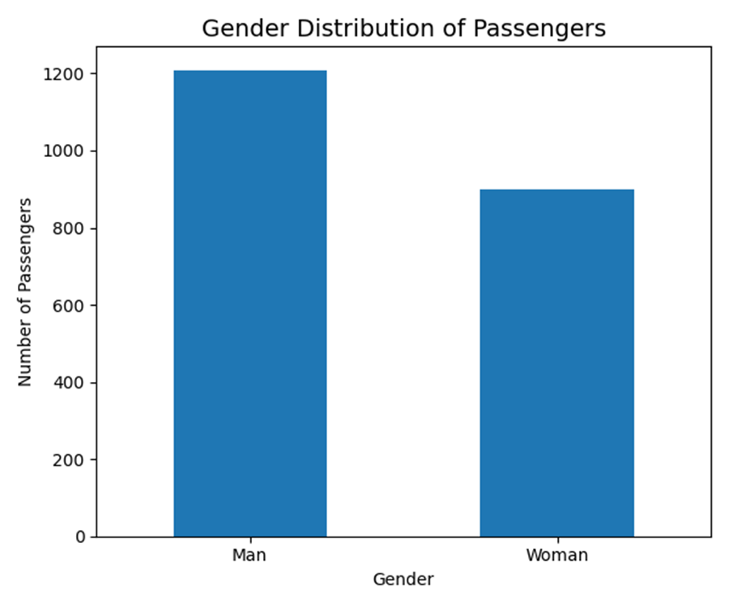

4. Travel Class Preference Analysis
Economy class is the most preferred travel class, highlighting strong price sensitivity among passengers. Business, premium economy, and first class travelers form smaller but high-value segments that prioritize comfort, flexibility, and premium services.
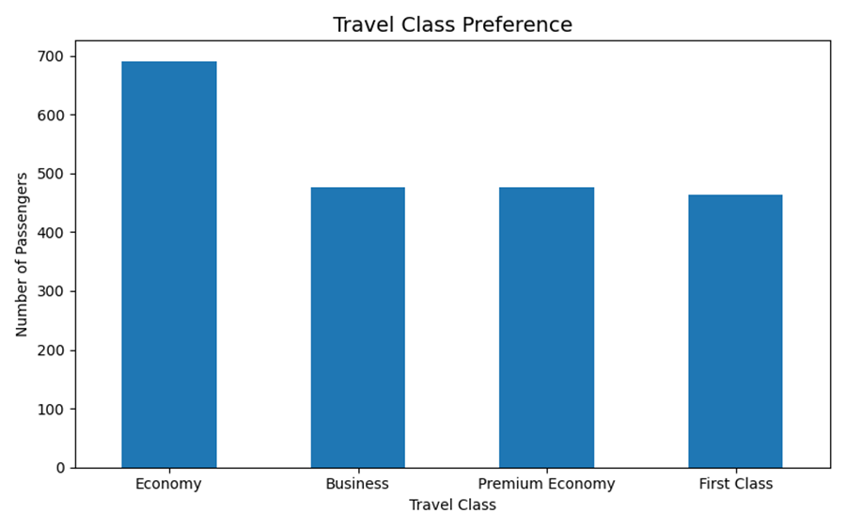

5. Purpose of Travel Analysis
Business and leisure travel dominate overall demand. Business travel drives frequent and predictable trips, while leisure travel is more seasonal and promotion-driven. Family visits, education, and medical travel represent smaller but stable segments with specific pricing and service needs.
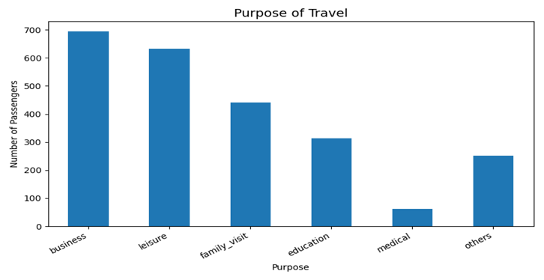

6. Clustering Analysis using Elbow Method
The Elbow Method evaluates the optimal number of clusters by observing changes in inertia. A sharp decrease in inertia up to four clusters followed by a flattening trend indicates that a four-cluster solution provides an effective balance between accuracy and interpretability.
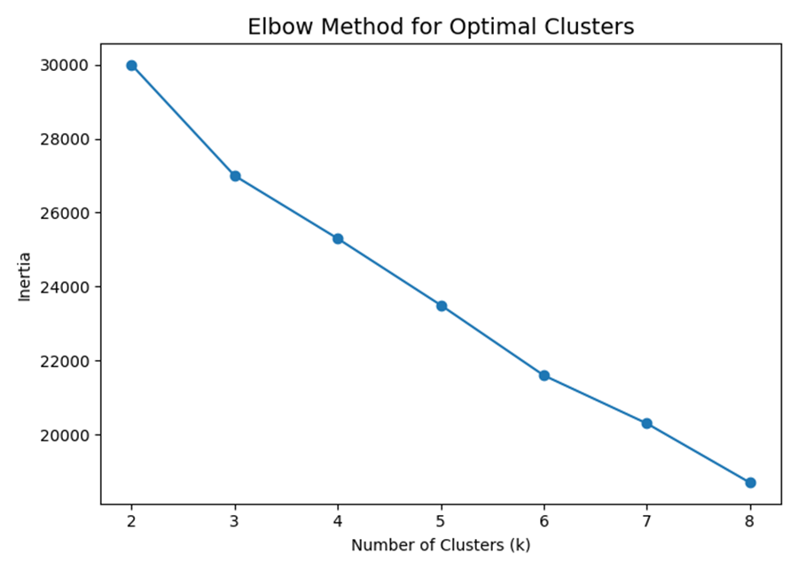

7. Feature Coefficient Analysis
Feature coefficient analysis shows that price sensitivity is the strongest driver of customer behavior, particularly among passengers who are not price-sensitive. Inflight priorities such as extra legroom, seat comfort, cabin crew behavior, and baggage facilities also have strong influence, emphasizing the importance of service quality and comfort.

8. Feature Importance Analysis
Feature importance results further confirm that price sensitivity dominates predictive performance. Airline brand variables such as Indigo, Vistara, and Air India play a secondary but meaningful role, while demographic attributes have relatively lower impact compared to behavioral preferences.

9. Cluster-wise Loyalty Program Analysis
Most customers across clusters are not enrolled in loyalty programs. Cluster 2 shows comparatively higher enrollment, indicating strong retention potential, while Clusters 0 and 1 represent key opportunities for loyalty program expansion.

10. Cluster-wise Price Sensitivity Analysis
Clusters 0, 1, and 2 are dominated by very price-sensitive travelers, making them responsive to discounts. Cluster 3 contains a higher proportion of moderately price-sensitive customers who value service quality alongside price.

11. Cluster-wise Purpose of Travel
Cluster 0 mainly represents business travelers, Cluster 1 family visit travelers, Cluster 2 leisure and education travelers, and Cluster 3 a mixed-purpose segment, indicating diverse travel requirements.

12. Cluster-wise Airline Preference
Indigo dominates airline preference across all clusters, reflecting strong market penetration. Cluster 3 shows higher affinity toward Indigo, Air India, and Akasa, suggesting openness to brand switching when value propositions align. Vistara maintains a niche premium presence.

13. Strategic Business Recommendations
Airlines should implement cluster-specific pricing strategies, strengthen loyalty programs for low-enrollment clusters, invest in inflight comfort and service quality, and position airline brands strategically based on customer value perception and sensitivity.

14. Conclusion
This study highlights that customer behavior is driven more by price sensitivity and service expectations than by demographics. Data-driven segmentation enables airlines to design targeted pricing, service, and loyalty strategies, ultimately improving customer satisfaction and revenue performance.

