Airline Customer Sentiment Analysis
1. Introduction
This report presents an in-depth business analytics study derived from extensive text mining and sentiment analysis performed on airline customer reviews. The objective is to transform unstructured textual feedback into actionable business insights that can support managerial decision-making, service optimization, and competitive strategy formulation within the airline industry.
2. Dataset Composition and Reliability
The dataset consists of more than 23,000 customer reviews collected across five airlines: Indigo, Air India, Akasa, SpiceJet, and Vistara. Each review includes structured attributes such as airline name, rating, and sentiment label, along with unstructured textual feedback. The absence of missing values ensures high reliability and validity of the analytical results.
3. Airline-wise Review Volume Analysis
Review volume analysis shows that Indigo and Air India dominate customer engagement, reflecting their large operational scale. Akasa has moderate visibility, while SpiceJet and Vistara generate relatively fewer reviews. This indicates that smaller airlines may have limited digital presence despite strong service quality.
4. Overall Sentiment Distribution
The sentiment distribution reveals strong polarization among customers, with approximately 54% positive and 45% negative reviews, while neutral sentiment remains minimal. This suggests airline experiences strongly influence customer emotions, leading to decisive opinions.
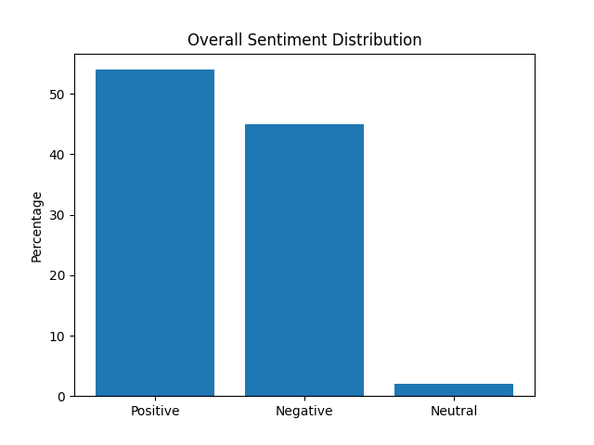
5. Airline-wise Sentiment Performance
Vistara leads in customer satisfaction with nearly 71% positive sentiment, highlighting consistent service excellence. Akasa and SpiceJet also perform well, while Air India shows mixed feedback. Indigo records the highest negative sentiment proportion, reflecting operational pressure at scale.
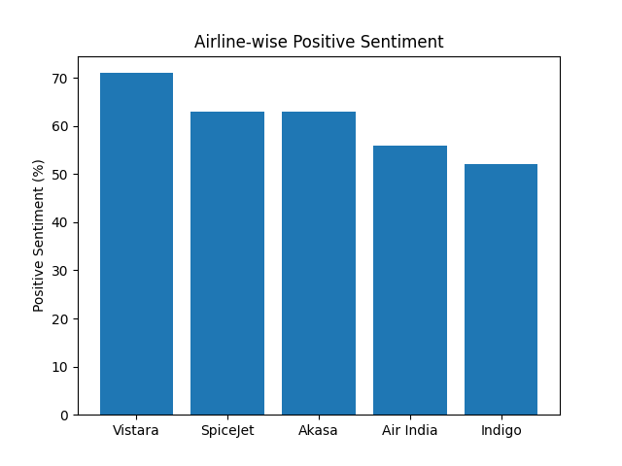
6. Positive Sentiment Drivers
Text mining identifies key positive drivers such as friendly staff, comfortable seating, cleanliness, and overall service quality. These elements significantly enhance customer satisfaction and brand loyalty.
7. Negative Sentiment Drivers
Negative sentiment is driven by delays, cancellations, rude behavior, poor service, and hygiene issues. Such operational and behavioral failures substantially damage customer trust and perception.
8. Operational Issues Impact
Delays and cancellations emerge as the most frequent complaints, creating dissatisfaction that often escalates into strong negative sentiment. Effective operational reliability is therefore critical for reputation management.
9. Staff Behavior Influence
Staff conduct plays a major role in shaping emotional responses. Positive staff interactions mitigate service failures, whereas rude behavior intensifies dissatisfaction, emphasizing the need for customer-service training.
10. Comfort and Cleanliness Analysis
Comfort, cleanliness, and in-flight experience strongly influence customer opinions. Airlines maintaining these standards consistently receive higher satisfaction ratings.
11. Review Length Insight
Longer reviews are commonly associated with negative experiences, indicating customers are more motivated to express dissatisfaction in detail compared to positive experiences.
12. Sentiment Model Effectiveness
The sentiment classification model demonstrates strong predictive accuracy, validating the use of automated analytics for continuous monitoring of customer feedback.
13. Competitive Benchmarking
Airlines with high satisfaction but low visibility hold untapped competitive advantage. Conversely, high-volume airlines face reputational risks if service issues persist.
14. Strategic Business Implications
The analysis confirms that reliability, staff behavior, and comfort outweigh pricing in driving satisfaction. Airlines must address both operational and emotional aspects of service.
15. Airline-specific Recommendations
Indigo should focus on punctuality and staff training. Air India must improve consistency. Vistara should leverage satisfaction in branding. Akasa and SpiceJet should enhance visibility while maintaining service quality.
16. Conclusion
Text mining-based business analytics provides powerful insights into customer behavior. Leveraging these insights enables airlines to improve service quality, manage reputation, and achieve sustainable competitive advantage.

