MA 374 (2021) Financial Engineering Lab Lab 07

**Name:** Udandarao Sai Sandeep

**Roll Number:** 180123063

**Dept.:** Mathematics and Computing

**Q1.**

The formula used to calculate **Call** **option** **price** is as follows:





Put was calculated as follows:



**Q2.** The plots of **Call Option** Prices (green) and **Put Option** Prices (blue) are as follows:

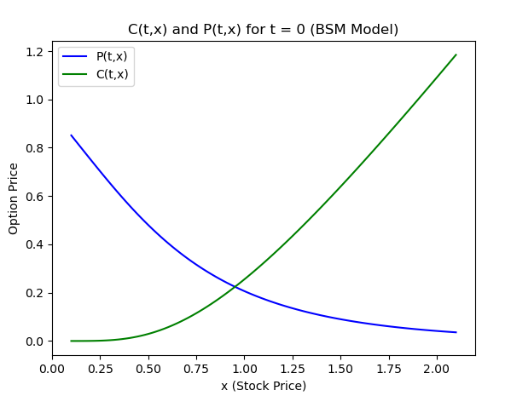

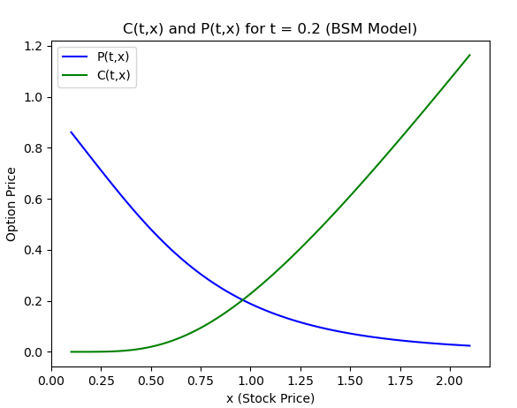

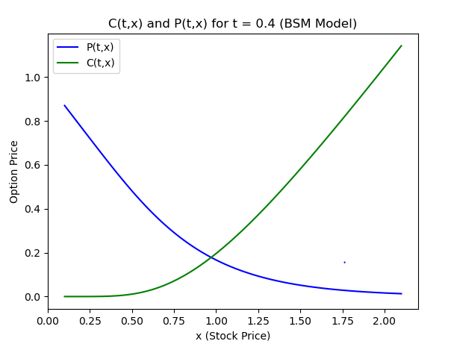

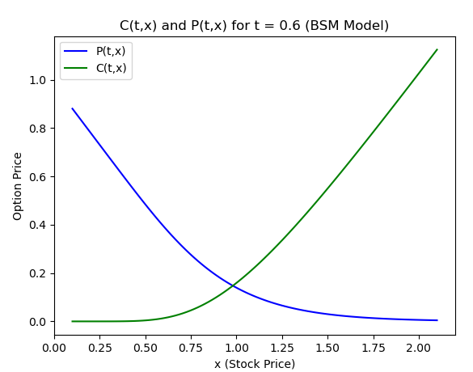

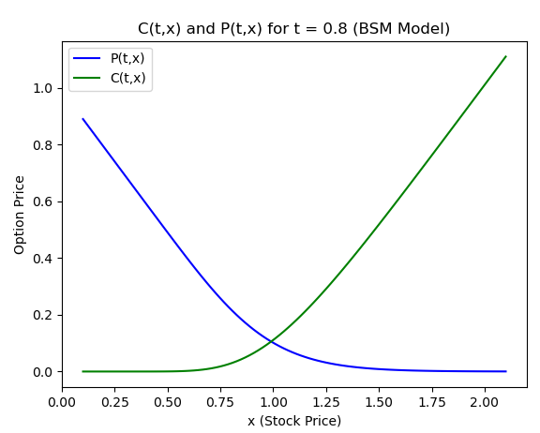

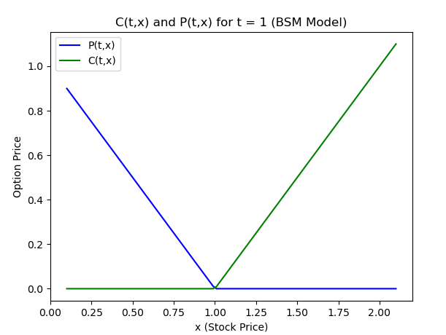

As expected, the call option price increases with increase in stock price, and the put option price decreases with increase in stock price.

Surface Plots:

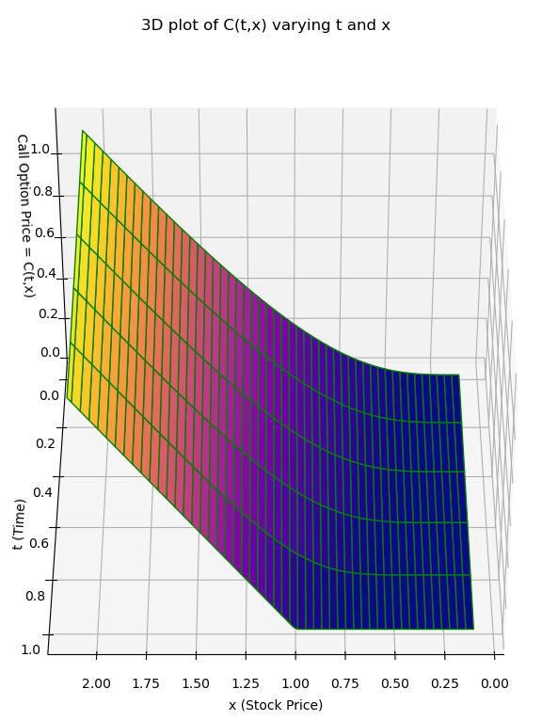

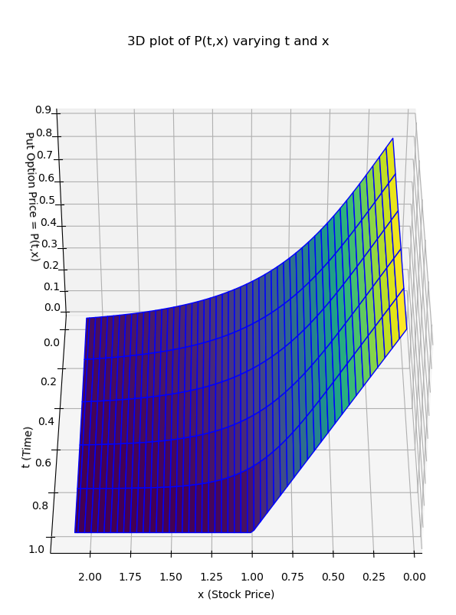

**Q3.**

Smooth 3D plots: -

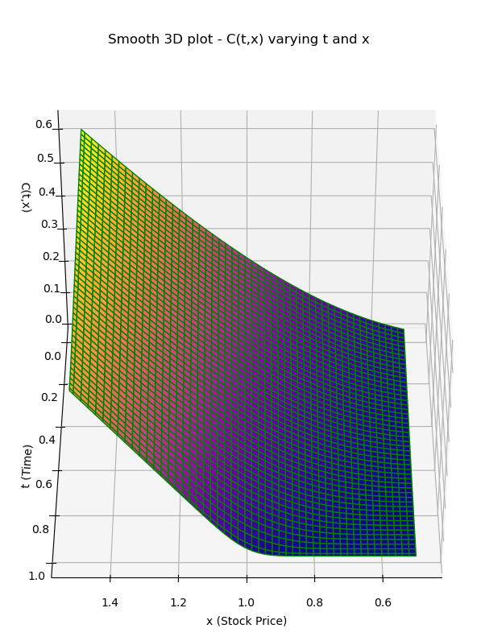

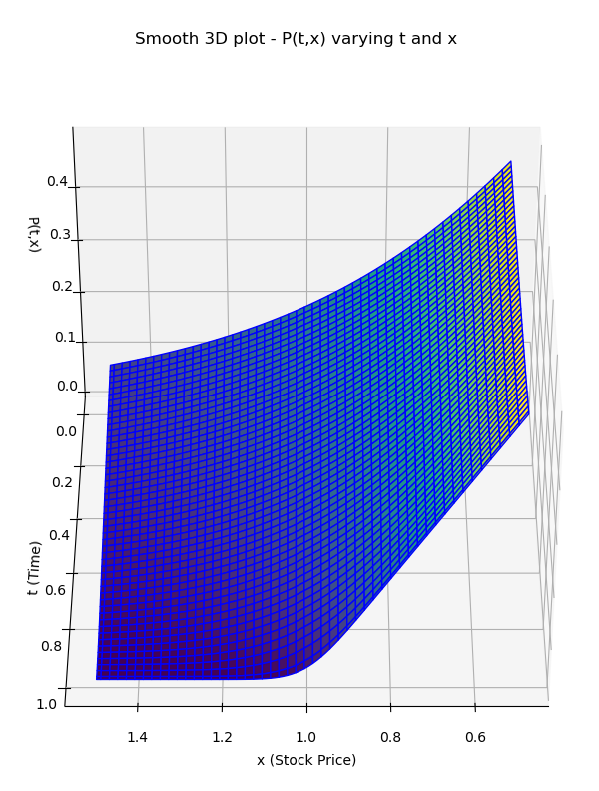

**Q4.** Model parameters:

(**Strike Price (K), sigma(σ), rate (r) and Final Time (T)**)

x = 1, t =0.5

**2D graphs**

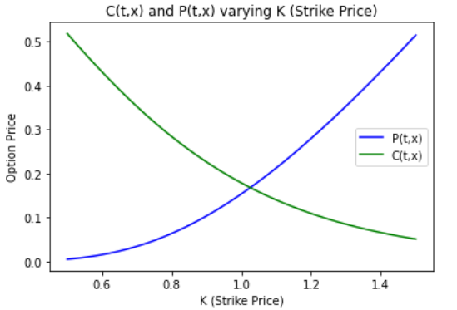

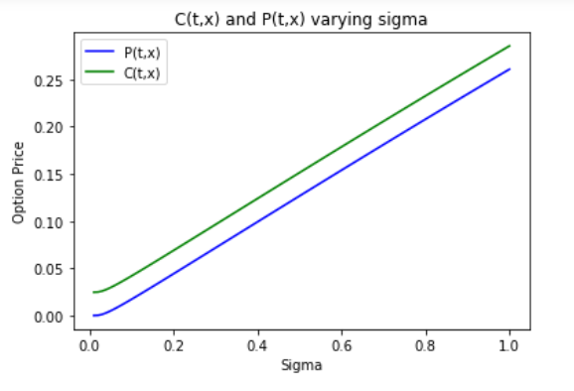

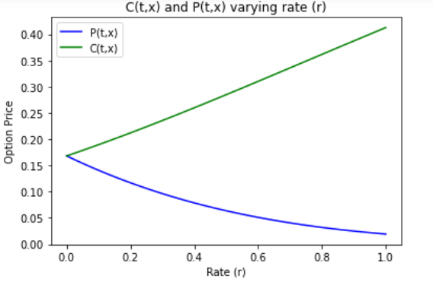

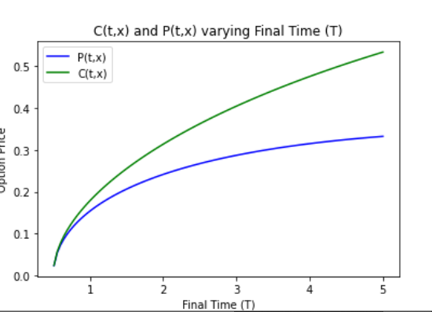  
**3D graphs**

|  |  |  |
| --- | --- | --- |
| Parameters | Call Option Price | Put Option Price |
| K  and  sigma |  |  |
| K  and  r |  |  |
| K  and  T |  |  |
| r  and  T |  |  |
| r  and  sigma |  |  |
| T  and  sigma |  |  |