NeoStat – Retail Sales Pipeline

Technical Documentation

Architecture Overview
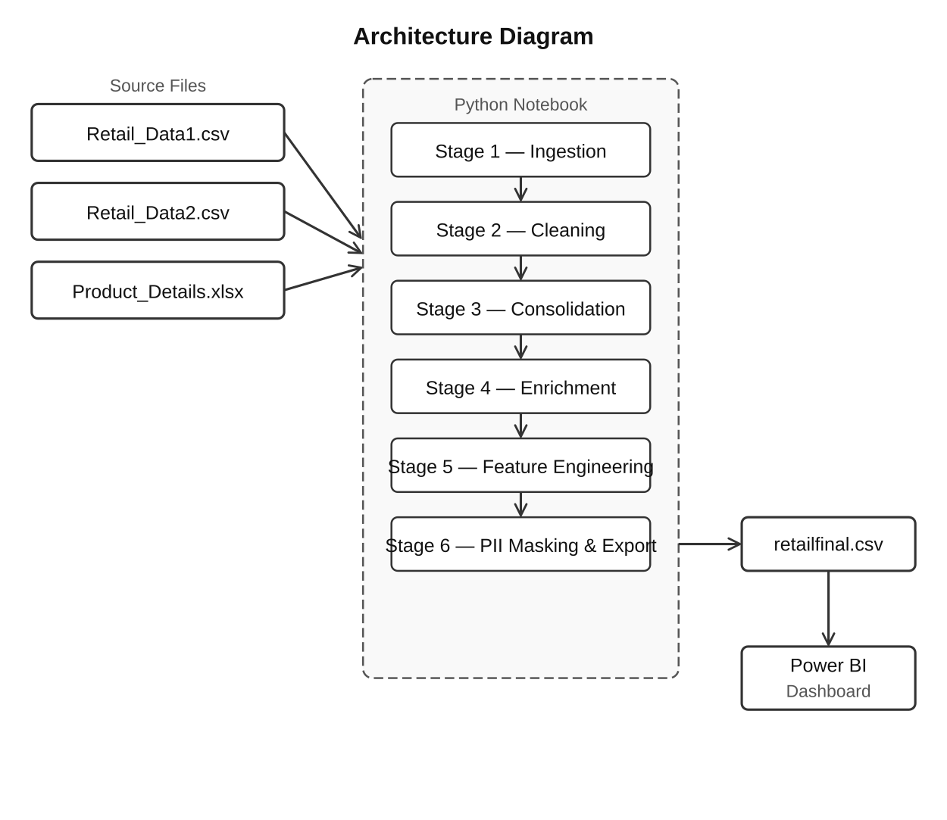

What was done and how:
Data sources were taken from two retail transactional data tables alongside a product reference data table. An end-to-end pipeline has been developed using Python Notebook, which imports, cleans, merges, enriches, and transforms the data into a single analytics-ready CSV file suitable for usage in Power BI.
The following six major processes have been carried out to prepare the data:
• Stage 1 – Data Ingestion: All three retail source data sets were imported using pandas.read_csv() and pandas.read_excel(). The data source files were imported into Python code as individual pandas DataFrames.
• Stage 2 – Data Cleaning: Duplicates were eliminated, invalid quantities were filtered, and missing value treatment was done using median and mode techniques. Standardization was done on all product names and other categorical variables as well. Dates of transactions were converted into a datetime datatype to maintain consistency across all the reports.
• Stage 3 – Data Consolidation: Both the retail data tables were concatenated to get one retail transaction set. The new 'Source_System' column was inserted right before the concatenation process.
• Stage 4 – Data Enrichment: The consolidated data table from stage 3 was left-joined with the product details data set using Product_ID as the key variable. Enrichment helped in adding standardized product name, category, and price details to all transactions.
• Stage 5 – Feature Engineering: Following feature engineering steps were performed to generate new analytically useful features such as revenue, year, month, quarter, and purchase channel.
Revenue = (Quantity × Unit_Price) − Discount
• Stage 6 – PII Masking and Data Exporting: Email addresses were hashed using SHA-256 algorithm, whereas phone numbers were partially masked. The final data set was then saved as final.csv without any index values.

Data Model
Power BI loads only one flat table which is called RetailTransactions taken from retailfinal.csv. No star schema or table relationships were needed because all joins, transformations, and enrichments have been performed using Python earlier before exporting the file.
Source Datasets:
• Product_Details - reference dataset which contains Product_ID, Product_Name, Category, and Standard_Price
• Retail_Data1 - retail transaction data received from source system 1
• Retail_Data2 - retail transaction data received from source system 2
Final Table (RetailTransactions):
Final dataset consists of retail transaction information enriched by relevant metadata related to the products as well as with some new KPIs.
Columns used in the Dashboard:
• Transaction_ID (Integer) - unique transaction ID generated for each transaction
• Product_ID (String) - main transaction ID used to link transactions with metadata about the product
• Product_Name (String) - standardized name of a product that would be used for analysis by category or by product
• Category (String) - category of the product; it will be used as a slicer/dimension
• Quantity (Integer) - quantity of units purchased during each transaction
• Unit_Price (Float) - price at which product was sold during particular transaction
• Discount (Float) - discount that was applied to each transaction
• Revenue (Engineered Float) - calculated revenue field used in KPI and trends analyses
• Payment_Method (String) - method used by customer to pay: Card, Cash, UPI, and Netbanking
• Purchase_Location (String) - shows where the purchase took place (Online/Offline)
• City (String) - regional field used for city business analysis
• Transaction_Date - date when the transaction occurred (datetime field)
• Year / Quarter / Month (engineered time intelligence fields used in trend analysis)
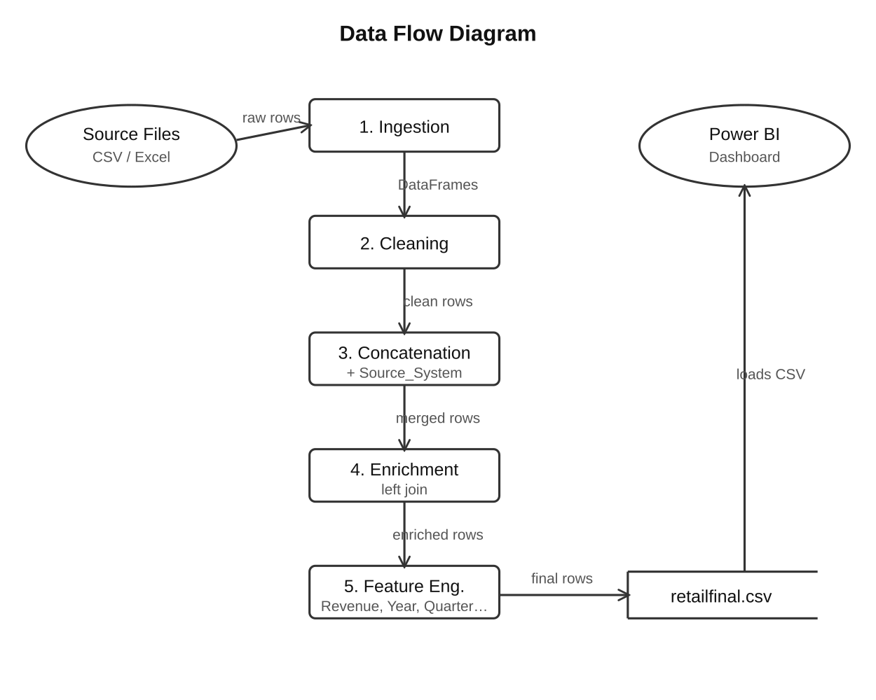

Assumptions Made
Several assumptions were made during design and implementation to keep the pipeline straightforward:
• Product_ID values are assumed to be consistent across all source datasets — no fuzzy matching or normalization was required.
• A left join was used assuming that every retail transaction has a matching Product_ID inside Product_Details. Rows without a match retain null metadata values rather than being removed.
• Revenue is calculated as:
Revenue = (Quantity × Unit_Price) − Discount
This assumes Discount already represents transaction-level discount deduction.
• Transactions with Quantity ≤ 0 are treated as invalid retail records and removed during preprocessing.
• Null values in numeric columns are better handled using median imputation because retail quantity and pricing distributions are often skewed.
• Missing categorical values are assumed recoverable using mode-based imputation.
• Product_Details is treated as the authoritative source for product standardization and category mapping.
• The retail schema structure is assumed to remain stable across pipeline executions.
• All transaction dates are assumed to be uniformly parsable without mixed timezone issues.

Data Cleaning Strategy
Before transformation, the raw retail data was cleaned to ensure quality and reporting consistency. The following steps were applied:
• Duplicate removal: Duplicate transaction records were removed using drop_duplicates(). This prevented inflated revenue calculations and duplicate KPI reporting.
• Invalid quantity filtering: Transactions with Quantity ≤ 0 were identified as invalid business records and removed from the dataset.
• Null handling (numeric): Numeric columns containing missing values such as Quantity, Unit_Price, and Discount were filled using median imputation to reduce outlier impact.
• Null handling (categorical): Missing categorical fields such as Category, Payment_Method, City, and Purchase_Location were filled using mode-based imputation.
• Product name standardisation: Product_Name fields were converted into standardized formats using lowercase conversion, whitespace trimming, and string normalization.
• Transaction date parsing: Transaction_Date columns were converted into datetime64 format using pd.to_datetime(), enabling the Date Hierarchy used in Power BI trend visuals.
• Column name standardisation: Column names were standardized into consistent naming conventions for readability and easier dashboard integration.
• PII masking: Customer email addresses were hashed using SHA-256 encryption and phone numbers were partially masked before export.

Transformation Logic
NeoStat Retail.pbix contains four key report pages which include:
• Revenue Analysis
• Product Performance
• Category Trends
• Regional Insights
There are several visualization techniques employed in the dashboard to help business users make informed decisions including the use of KPI cards, donut charts, clusterd bar charts, line charts, area charts, scatter plots and interactive slicers.
Revenue Analysis Page
• KPI cards
Total revenue: 1.16bn
Total transactions: 8K
Average order value: 147.08K
Average discount%: 22%
These KPIs give us an overview of the total performance of the retail business.
• Line Chart – Total Revenue by year:
The line chart illustrates the total trend of revenues from the period 2025 to 2026 and there seems to be a noticeable drop in the revenue in the year 2026.
• Donut Chart – Revenue by payment method:
A donut chart that illustrates the contribution of revenue by various payment methods like card, cash, UPI and Net banking. The contribution is relatively the same for all payment methods.
• Stacked Chart – Online vs Offline revenues:
It is a stacked chart that illustrates revenues from both online and offline sources monthly. Both generate revenues equally well during the reporting period.
• Slicers
Quarter, Purchase location, Payment method and Year.

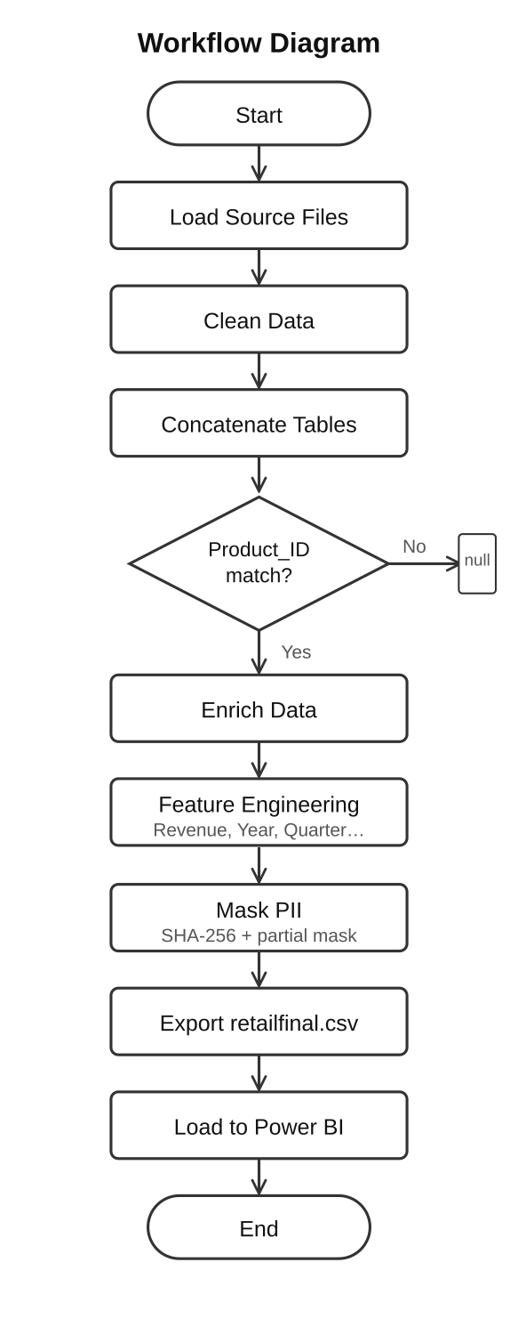

Visual Insights
The Power BI dashboard (NeoStat Retail.pbix) is divided into four report pages:
• Revenue Analysis
• Product Performance
• Category Trends
• Regional Insights
The dashboard contains KPI cards, donut charts, clustered bar charts, line charts, area charts, scatter plots, and interactive slicers for business analysis.

Revenue Analysis Page
• KPI Cards:
- Total Revenue: 1.16bn
- Total Transactions: 8K
- Avg Order Value: 147.08K
- Avg Discount %: 22%
These KPIs provide a high-level executive overview of overall retail performance.
• Line Chart – Total Revenue by Year:
Shows revenue trends between 2025 and 2026. Revenue declines noticeably in 2026, indicating changing business performance or seasonal demand shifts.
• Donut Chart – Revenue by Payment Method:
Breaks down revenue contribution across Card, Cash, UPI, and Netbanking payment methods. Revenue distribution appears relatively balanced across payment channels.
• Stacked Chart – Online vs Offline Revenue Over Time:
Compares online and offline revenue contribution monthly. Both channels contribute significantly across the reporting period.
• Slicers:
Interactive filtering is available using Quarter, Purchase_Location, Payment_Method, and Year dimensions.

Product Performance Page
• KPI Cards:
Total Transactions
Total Revenue
Revenue Contribution
Total Units Sold
• Clustered Bar Graph – Units Sold by Product:
This graph illustrates sales of individual products. Products such as Dining Table, Sofa, Laptop, Shoes, and Mixer have the highest number of unit sales.
• Donut Graph – Revenue Contribution by Category:
This donut graph focuses on revenue contribution at the category level for products in categories like Clothing, Electronics, Furniture, and Home Appliances.
• Horizontal Bar Graph – Revenue by Product:
This bar graph reflects revenue contribution by individual products. Premium products such as Laptop, Phone, and Refrigerator contribute the highest revenues.
• Scatter Graph – Revenue vs Units Sold:
The scatter graph reflects the relationship between units sold and revenue contribution. This graph helps understand which products have higher unit sales and lesser revenue contribution and which are premium products contributing high revenues.

Category Trends Page
Donut Chart – Revenue Share by Category:
This chart shows the revenue share by category, in which electronics was identified to have contributed almost 58% of the total revenue.
Clustered Bar Chart – Revenue by Category in Various Cities:
In this chart, a comparison is made on the category-wise revenue from various cities, i.e., Chennai, Delhi, Hyderabad, Mumbai, and Bangalore. For all cities, electronics contributed maximum revenue among all categories.
Area Chart – Monthly Category-wise Revenue:
This chart indicates the trends of category-wise revenue per month starting from January 2025 to December 2026, in which there was a gradual fall in revenue of all categories.
Bar Chart – Average Discount % by Category:
This graph shows the average discount percentage given among different categories. The maximum discount was received in the electronics category.
Slicers:
Slicers are used in reports for filtering data using multiple dimensions, i.e., City, Year, Quarter, Category, and Purchase Location.

Regional Insights Page
• KPI Cards:
Total Revenue: 1.16bn
Best Performing City: Chennai
Total Transactions: 8K
Units Sold: 23.596K
• Clustered Bar Chart: Online & Offline Revenue by City:
The clustered bar chart helps analyze the revenue contribution from online and offline channels in each city. The highest sales revenue was contributed by Chennai and Delhi.
• Bar Chart: Revenue by City:
This bar chart depicts cities based on their total revenue contribution. Among all cities, Chennai, Delhi, and Hyderabad were found to be the top-performing cities.
• Donut Chart: Revenue Contribution by City:
The donut chart depicts the percentage-wise revenue contribution by Bangalore, Chennai, Delhi, Hyderabad, and Mumbai. It can be seen that revenue contribution is quite evenly distributed across all cities.
• Slicers:
There are slicers available in order to interactively filter the report based on different dimensions including Quarter, Payment_Method, Purchase_Location, Year, and City.

Key Takeaways from the Dashboard
• Total revenue exceeded 1.16 billion across all retail transactions.
• Electronics emerged as the highest revenue-generating category across all regions.
• Chennai generated the highest city-level revenue contribution.
• Online and offline purchase channels contributed almost equally to overall business revenue.
• High-ticket products such as Laptop and Refrigerator generated strong revenue despite moderate unit sales.
• Average discount percentages remained relatively consistent across categories, with Electronics receiving the highest discounts.
• Revenue trends declined from 2025 to 2026 across most business segments, indicating possible demand slowdown or seasonal variation.
• Interactive slicers allow flexible business analysis across cities, categories, years, payment methods, and purchase channels without rebuilding reports.

