CPU Affinity & Priority Agent

Architecture, design, and implementation
Submitted by
Ankit Ray Reg. No. 24BCE0497
Naman Jain Reg. No. 24BKT0140
15 October 2026

1. Overview
The CPU Affinity & Priority Agent is a background service (daemon) for Ubuntu Linux. It controls two things for each selected process: the CPU affinity (the set of logical cores the process may run on) and the scheduling priority, or nice value, which runs from -20 for the highest priority down to 19 for the lowest.
The agent has no user interface. systemd starts, stops, and supervises it; it reads its rules from a JSON file and writes its logs to the systemd journal. An administrator works with it through systemctl and the config file, nothing else.
When a process matches a rule, the agent pins it and sets its priority, and it keeps doing so as new matching processes appear. For example, you can keep nginx on cores 0 and 1, or push every backup rsync onto cores 2 and 3 at a low priority so it never steals time from work that needs to stay responsive.

2. Design approach: agent as a service, no UI
Affinity and priority are per-process kernel attributes, not settings you apply once. Matching processes come and go while the machine runs, so the agent has to keep watching and re-apply its rules rather than run a single pass and exit. systemd handles the rest of the lifecycle:
Concern | How it is handled
Start, stop, enable | systemctl {start,stop,enable} cpu-affinity-agent
Survives reboot | WantedBy=multi-user.target
Restart after a crash | Restart=on-failure
Readiness signal | Type=notify with sd_notify(READY=1)
Reload config, no restart | systemctl reload sends SIGHUP
Clean shutdown | SIGTERM or SIGINT
Logs | journalctl -u cpu-affinity-agent -f
Least privilege | sandbox directives and CAP_SYS_NICE rather than full root

3. System architecture
Figure 1 shows how the pieces fit together. Everything above the dividing line is user space; the scheduler work happens in the kernel. The agent is the only moving part. systemd supervises it, the config file gives it rules, and journald collects whatever it prints.
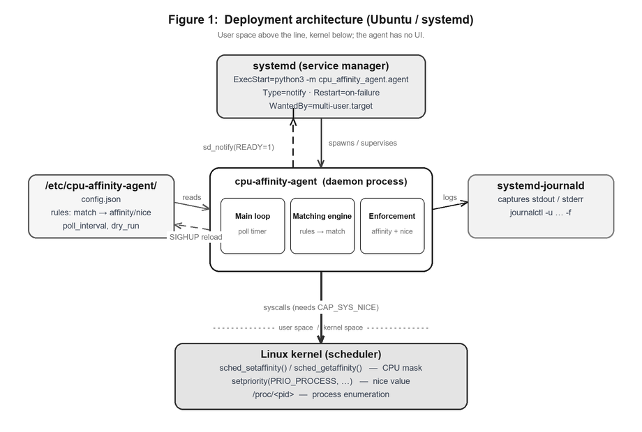
Figure 1: Deployment architecture on Ubuntu with systemd.
The agent tells systemd it is ready over the NOTIFY_SOCKET Unix socket (sd_notify), so a Type=notify unit only counts as active once the first scan is about to run. When you run systemctl reload, systemd sends SIGHUP and the agent reads the config again in place, keeping the state it already has.

4. Internal components and data flow
One poll cycle walks every process, checks it against the rules, and applies the first rule that matches. The matching code is plain logic with no system calls, so it can be unit tested on its own. Only the enforcement step talks to the kernel.
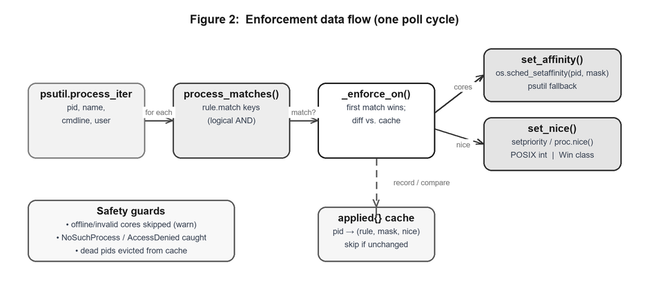
Figure 2: Enforcement data flow within a single poll cycle.

Modules
- Rule and Config load and validate the JSON, rejecting out-of-range nice values, empty matches, and rules that set no action.
- process_matches() is the matching engine. The name, name_regex, cmdline_contains, pid, and user keys all have to match (a logical AND).
- set_affinity() and set_nice() do the work. On Linux they call os.sched_setaffinity directly and fall back to psutil elsewhere.
- Agent ties it together: signal handling, the poll loop, the applied-state cache, and the systemd notification.
An applied{} cache keyed by PID remembers what was last set for each process, so a process that already has the right affinity and priority is skipped and the log only records real changes. Processes that exit are dropped from the cache each cycle, so it does not grow forever.

5. Service lifecycle and poll loop
Figure 3 follows the daemon from launch to shutdown. The wait between cycles is split into short slices, so a SIGTERM or SIGHUP is picked up in a fraction of a second instead of after a whole interval.
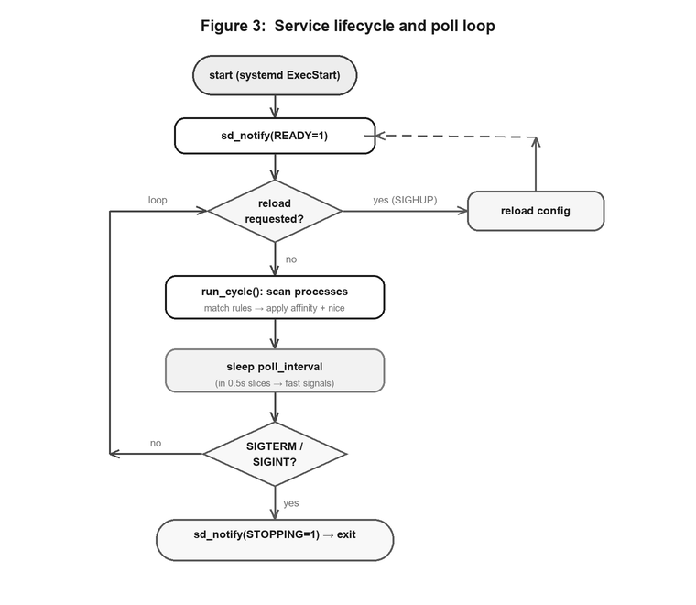
Figure 3: Service lifecycle and poll loop, including signal handling.

6. Underlying kernel interface (C headers)
The agent is written in Python, but each operation maps onto a POSIX or Linux system call. Written in C on Ubuntu, it would use these headers:
Capability | C header | Key functions and macros
CPU affinity | <sched.h> | sched_setaffinity(), cpu_set_t, CPU_SET
Priority (nice) | <sys/resource.h> | setpriority(), getpriority() with PRIO_PROCESS
nice (simple form) | <unistd.h> | nice()
Realtime scheduling | <sched.h> | sched_setscheduler(), SCHED_FIFO, SCHED_RR
List processes | <dirent.h> | read /proc/<pid>/
Signals | <signal.h> | sigaction(), SIGTERM, SIGHUP
systemd notify | <systemd/sd-daemon.h> | sd_notify() (package libsystemd-dev)
Capabilities | <sys/capability.h> | CAP_SYS_NICE (package libcap-dev)
Python wraps the same calls. os.sched_setaffinity calls sched_setaffinity(2), os.setpriority and psutil.nice call setpriority(2), and psutil reads /proc to list processes.

7. Python packages (Ubuntu)
Package | Purpose | Install on Ubuntu
python3 | Runtime, 3.8 or later | sudo apt install python3
python3-psutil | Finds processes and sets affinity and nice | sudo apt install python3-psutil
standard library | os, signal, socket, json, logging, argparse | included with Python
For a system service, install python3-psutil from apt rather than pip, so the package manager tracks it and it keeps working across Python upgrades. The agent uses no network. The socket module only speaks the local sd_notify protocol, and the unit file limits the service to the AF_UNIX address family.

8. Configuration
Rules live in /etc/cpu-affinity-agent/config.json. Each rule has a match block, where every key present has to match, and at least one action. The first rule that matches a process wins.
{
"poll_interval_seconds": 5,
"dry_run": false,
"rules": [
{
"name": "pin-nginx-to-first-cores",
"match": { "name": "nginx" },
"cpu_affinity": [0, 1],
"nice": -5
},
{
"name": "throttle-backup-jobs",
"match": { "cmdline_contains": "rsync" },
"cpu_affinity": [2, 3],
"nice": 15
},
{
"name": "deprioritize-compilers",
"match": { "name_regex": "^(gcc|cc1|cc1plus|ld)$" },
"nice": 10
}
]
}

9. Source code

9.1 cpu_affinity_agent/agent.py
#!/usr/bin/env python3
"""cpu-affinity-agent

A headless (no-UI) agent, designed to run as a systemd service on Ubuntu Linux.
It enforces CPU affinity (which logical cores a process may run on) and
scheduling priority (the POSIX "nice" value) for processes matched by a set of
user-defined rules.

Primary target : Ubuntu Linux, run under systemd (Type=notify/simple).
Logging : stdout/stderr -> captured by journald (journalctl).
Reconfigure : SIGHUP reloads the config without restarting.
Graceful shutdown : SIGTERM / SIGINT.

The agent is portable enough to also run on Windows for development/testing;
the Linux-only pieces (sched_setaffinity, integer nice values) are handled
behind small compatibility shims so the matching/engine logic can be unit
tested on any OS.
"""

from __future__ import annotations

import argparse
import json
import logging
import os
import re
import signal
import sys
import time
from dataclasses import dataclass, field
from typing import Any

import psutil

IS_POSIX = os.name == "posix"
HAS_SCHED_AFFINITY = hasattr(os, "sched_setaffinity")

log = logging.getLogger("cpu-affinity-agent")

# --------------------------------------------------------------------------- #
# Configuration model
# --------------------------------------------------------------------------- #
@dataclass
class Rule:
"""A single enforcement rule."""

name: str
match: dict[str, Any]
cpu_affinity: list[int] | None = None
nice: int | None = None

def __post_init__(self) -> None:
if not self.name:
raise ValueError("rule is missing a 'name'")
if not isinstance(self.match, dict) or not self.match:
raise ValueError(f"rule '{self.name}' has an empty/invalid 'match'")
if self.cpu_affinity is None and self.nice is None:
raise ValueError(
f"rule '{self.name}' must set 'cpu_affinity' and/or 'nice'"
)
if self.cpu_affinity is not None:
if (
not isinstance(self.cpu_affinity, list)
or not self.cpu_affinity
or not all(isinstance(c, int) and c >= 0 for c in self.cpu_affinity)
):
raise ValueError(
f"rule '{self.name}': 'cpu_affinity' must be a non-empty "
"list of non-negative integers"
)
if self.nice is not None and not (-20 <= self.nice <= 19):
raise ValueError(
f"rule '{self.name}': 'nice' must be within [-20, 19]"
)
# Pre-compile a regex match if present so matching stays cheap.
self._name_regex = (
re.compile(self.match["name_regex"]) if "name_regex" in self.match else None
)

@dataclass
class Config:
poll_interval_seconds: float = 5.0
dry_run: bool = False
rules: list[Rule] = field(default_factory=list)

@staticmethod
def from_dict(data: dict[str, Any]) -> "Config":
if not isinstance(data, dict):
raise ValueError("config root must be a JSON object")
interval = float(data.get("poll_interval_seconds", 5.0))
if interval <= 0:
raise ValueError("'poll_interval_seconds' must be > 0")
rules_raw = data.get("rules", [])
if not isinstance(rules_raw, list):
raise ValueError("'rules' must be a list")
rules = [
Rule(
name=r.get("name", ""),
match=r.get("match", {}),
cpu_affinity=r.get("cpu_affinity"),
nice=r.get("nice"),
)
for r in rules_raw
]
return Config(
poll_interval_seconds=interval,
dry_run=bool(data.get("dry_run", False)),
rules=rules,
)

@staticmethod
def load(path: str) -> "Config":
with open(path, encoding="utf-8") as fh:
return Config.from_dict(json.load(fh))

# --------------------------------------------------------------------------- #
# Matching engine (pure logic -- no syscalls, fully unit-testable)
# --------------------------------------------------------------------------- #
def process_matches(rule: Rule, proc_info: dict[str, Any]) -> bool:
"""Return True if a process (described by psutil-style info) matches a rule.

Supported match keys (all present keys must match -> logical AND):
name : exact process name, case-insensitive
name_regex : regex tested against the process name
cmdline_contains: substring that must appear in the joined command line
pid : exact process id
user : owning username (exact)
"""
m = rule.match
name = (proc_info.get("name") or "")
cmdline = " ".join(proc_info.get("cmdline") or [])

if "name" in m and name.lower() != str(m["name"]).lower():
return False
if rule._name_regex is not None and not rule._name_regex.search(name):
return False
if "cmdline_contains" in m and str(m["cmdline_contains"]) not in cmdline:
return False
if "pid" in m and proc_info.get("pid") != int(m["pid"]):
return False
if "user" in m and proc_info.get("username") != m["user"]:
return False
return True

# --------------------------------------------------------------------------- #
# Platform-aware enforcement helpers
# --------------------------------------------------------------------------- #
def _nice_for_platform(nice_value: int) -> Any:
"""Translate a POSIX nice value to whatever the current OS expects.

On POSIX the integer is used directly. On Windows there is no nice value,
so we map ranges onto Win32 priority classes; this keeps the same config
working for development/testing on Windows.
"""
if IS_POSIX:
return nice_value
# Windows priority-class mapping (lower nice => higher priority).
if nice_value <= -15:
return psutil.REALTIME_PRIORITY_CLASS
if nice_value <= -8:
return psutil.HIGH_PRIORITY_CLASS
if nice_value < 0:
return psutil.ABOVE_NORMAL_PRIORITY_CLASS
if nice_value == 0:
return psutil.NORMAL_PRIORITY_CLASS
if nice_value <= 9:
return psutil.BELOW_NORMAL_PRIORITY_CLASS
return psutil.IDLE_PRIORITY_CLASS

def set_affinity(proc: psutil.Process, cores: list[int]) -> None:
"""Pin a process to a set of logical CPUs.

Prefers the native os.sched_setaffinity on Linux (the direct syscall
wrapper); falls back to psutil elsewhere.
"""
if HAS_SCHED_AFFINITY:
os.sched_setaffinity(proc.pid, set(cores))
else:
proc.cpu_affinity(cores)

def get_affinity(proc: psutil.Process) -> list[int]:
if HAS_SCHED_AFFINITY:
return sorted(os.sched_getaffinity(proc.pid))
return sorted(proc.cpu_affinity())

def set_nice(proc: psutil.Process, nice_value: int) -> None:
proc.nice(_nice_for_platform(nice_value))

# --------------------------------------------------------------------------- #
# The agent
# --------------------------------------------------------------------------- #
class Agent:
def __init__(self, config_path: str, config: Config) -> None:
self.config_path = config_path
self.config = config
self._running = True
self._reload_requested = False
# Remember what we have already applied so we only log/act on changes:
# key = pid, value = (rule_name, tuple(affinity) | None, nice | None)
self._applied: dict[int, tuple[str, tuple[int, ...] | None, int | None]] = {}
self._online_cpus = self._detect_online_cpus()

@staticmethod
def _detect_online_cpus() -> set[int]:
if HAS_SCHED_AFFINITY:
return set(os.sched_getaffinity(0))
return set(range(psutil.cpu_count(logical=True) or 1))

# -- signal handlers -------------------------------------------------- #
def request_stop(self, *_: Any) -> None:
log.info("shutdown signal received; stopping after current cycle")
self._running = False

def request_reload(self, *_: Any) -> None:
log.info("SIGHUP received; config reload requested")
self._reload_requested = True

def _reload(self) -> None:
try:
self.config = Config.load(self.config_path)
self._applied.clear()
log.info(
"config reloaded: %d rule(s), interval=%.1fs, dry_run=%s",
len(self.config.rules),
self.config.poll_interval_seconds,
self.config.dry_run,
)
except Exception as exc: # noqa: BLE001 - keep running on bad reload
log.error("config reload failed, keeping previous config: %s", exc)
self._reload_requested = False

# -- enforcement ------------------------------------------------------ #
def _enforce_on(self, proc: psutil.Process, info: dict[str, Any], rule: Rule) -> None:
pid = info["pid"]
want_aff = tuple(sorted(rule.cpu_affinity)) if rule.cpu_affinity else None
want_nice = rule.nice
prev = self._applied.get(pid)
if prev == (rule.name, want_aff, want_nice):
return # already enforced for this pid; nothing changed

label = f"{info.get('name')}({pid})"
if self.config.dry_run:
log.info(
"[dry-run] would apply rule '%s' to %s: affinity=%s nice=%s",
rule.name, label, want_aff, want_nice,
)
self._applied[pid] = (rule.name, want_aff, want_nice)
return

try:
if want_aff is not None:
cores = [c for c in want_aff if c in self._online_cpus]
if not cores:
log.warning(
"rule '%s': none of %s are online CPUs %s; skipping affinity",
rule.name, list(want_aff), sorted(self._online_cpus),
)
else:
set_affinity(proc, cores)
if want_nice is not None:
set_nice(proc, want_nice)
self._applied[pid] = (rule.name, want_aff, want_nice)
log.info(
"applied rule '%s' to %s: affinity=%s nice=%s",
rule.name, label, want_aff, want_nice,
)
except psutil.NoSuchProcess:
self._applied.pop(pid, None)
except psutil.AccessDenied:
log.warning(
"access denied applying rule '%s' to %s "
"(agent likely needs root/CAP_SYS_NICE)", rule.name, label,
)
except (OSError, ValueError) as exc:
log.error("error applying rule '%s' to %s: %s", rule.name, label, exc)

def run_cycle(self) -> int:
"""Scan all processes once and apply rules. Returns #processes acted on."""
acted = 0
seen: set[int] = set()
attrs = ["pid", "name", "cmdline", "username"]
for proc in psutil.process_iter(attrs=attrs):
try:
info = proc.info
except (psutil.NoSuchProcess, psutil.AccessDenied):
continue
seen.add(info["pid"])
for rule in self.config.rules:
if process_matches(rule, info):
before = self._applied.get(info["pid"])
self._enforce_on(proc, info, rule)
if self._applied.get(info["pid"]) != before:
acted += 1
break # first matching rule wins
# Forget pids that have exited so the cache does not grow forever.
for dead in set(self._applied) - seen:
self._applied.pop(dead, None)
return acted

def run(self) -> None:
log.info(
"cpu-affinity-agent starting: %d rule(s), interval=%.1fs, "
"online CPUs=%s, dry_run=%s, backend=%s",
len(self.config.rules),
self.config.poll_interval_seconds,
sorted(self._online_cpus),
self.config.dry_run,
"os.sched_*" if HAS_SCHED_AFFINITY else "psutil",
)
_notify_systemd("READY=1")
while self._running:
if self._reload_requested:
self._reload()
try:
acted = self.run_cycle()
if acted:
log.debug("cycle complete: %d process(es) (re)configured", acted)
except Exception as exc: # noqa: BLE001 - never die on a transient error
log.error("error during scan cycle: %s", exc)
# Sleep in small slices so signals are handled promptly.
slept = 0.0
while slept < self.config.poll_interval_seconds and self._running:
if self._reload_requested:
break
time.sleep(min(0.5, self.config.poll_interval_seconds - slept))
slept += 0.5
_notify_systemd("STOPPING=1")
log.info("cpu-affinity-agent stopped")

# --------------------------------------------------------------------------- #
# systemd sd_notify (optional; only if the service is Type=notify)
# --------------------------------------------------------------------------- #
def _notify_systemd(state: str) -> None:
addr = os.environ.get("NOTIFY_SOCKET")
if not addr or not IS_POSIX:
return
try:
import socket

if addr[0] == "@": # abstract namespace
addr = "\0" + addr[1:]
with socket.socket(socket.AF_UNIX, socket.SOCK_DGRAM) as sock:
sock.connect(addr)
sock.sendall(state.encode())
except OSError:
pass

# --------------------------------------------------------------------------- #
# Entry point
# --------------------------------------------------------------------------- #
def _default_config_path() -> str:
for candidate in ("/etc/cpu-affinity-agent/config.json",
os.path.join(os.path.dirname(__file__), "..", "config", "agent.json")):
if os.path.exists(candidate):
return os.path.abspath(candidate)
return "/etc/cpu-affinity-agent/config.json"

def main(argv: list[str] | None = None) -> int:
parser = argparse.ArgumentParser(description="CPU Affinity & Priority Agent")
parser.add_argument(
"-c", "--config", default=_default_config_path(),
help="path to JSON config (default: %(default)s)",
)
parser.add_argument(
"--once", action="store_true",
help="run a single enforcement cycle and exit (useful for testing)",
)
parser.add_argument(
"--check", action="store_true",
help="validate the config file and exit",
)
parser.add_argument(
"--log-level", default="INFO",
choices=["DEBUG", "INFO", "WARNING", "ERROR"],
)
args = parser.parse_args(argv)

logging.basicConfig(
level=getattr(logging, args.log_level),
format="%(asctime)s %(levelname)s %(name)s: %(message)s",
stream=sys.stdout,
)

try:
config = Config.load(args.config)
except FileNotFoundError:
log.error("config file not found: %s", args.config)
return 2
except (ValueError, json.JSONDecodeError) as exc:
log.error("invalid config %s: %s", args.config, exc)
return 2

if args.check:
log.info("config OK: %d rule(s)", len(config.rules))
return 0

agent = Agent(args.config, config)

if args.once:
agent.run_cycle()
return 0

signal.signal(signal.SIGTERM, agent.request_stop)
signal.signal(signal.SIGINT, agent.request_stop)
if hasattr(signal, "SIGHUP"):
signal.signal(signal.SIGHUP, agent.request_reload)

agent.run()
return 0

if __name__ == "__main__":
raise SystemExit(main())

9.2 systemd/cpu-affinity-agent.service
[Unit]
Description=CPU Affinity & Priority Agent (headless)
Documentation=file:/opt/cpu-affinity-agent/README.md
After=multi-user.target

[Service]
Type=notify
NotifyAccess=main
ExecStart=/usr/bin/python3 -m cpu_affinity_agent.agent --config /etc/cpu-affinity-agent/config.json
# Reload config on `systemctl reload cpu-affinity-agent`
ExecReload=/bin/kill -HUP $MAINPID
WorkingDirectory=/opt/cpu-affinity-agent
Restart=on-failure
RestartSec=3

# --- Privileges ---------------------------------------------------------
# Lowering a nice value (raising priority) and pinning other users' processes
# requires CAP_SYS_NICE. Run as root OR grant just that capability:
# User=caa-agent
# AmbientCapabilities=CAP_SYS_NICE
# CapabilityBoundingSet=CAP_SYS_NICE
User=root

# --- Hardening (sandboxing) --------------------------------------------
NoNewPrivileges=false
ProtectSystem=strict
ProtectHome=true
PrivateTmp=true
ReadOnlyPaths=/etc/cpu-affinity-agent
ProtectKernelTunables=true
ProtectControlGroups=true
RestrictAddressFamilies=AF_UNIX
MemoryDenyWriteExecute=true

[Install]
WantedBy=multi-user.target

9.3 install.sh
#!/usr/bin/env bash
# Installer for cpu-affinity-agent on Ubuntu Linux.
# Run as root: sudo ./install.sh
set -euo pipefail

APP_DIR=/opt/cpu-affinity-agent
CFG_DIR=/etc/cpu-affinity-agent
UNIT=/etc/systemd/system/cpu-affinity-agent.service
SRC_DIR="$(cd "$(dirname "${BASH_SOURCE[0]}")" && pwd)"

if [[ $EUID -ne 0 ]]; then
echo "Please run as root (sudo ./install.sh)" >&2
exit 1
fi

echo "==> Installing Python dependency (psutil)"
if command -v apt-get >/dev/null 2>&1; then
apt-get update -qq
apt-get install -y python3 python3-psutil
else
python3 -m pip install -r "$SRC_DIR/requirements.txt"
fi

echo "==> Copying application to $APP_DIR"
mkdir -p "$APP_DIR"
cp -r "$SRC_DIR/cpu_affinity_agent" "$APP_DIR/"

echo "==> Installing config to $CFG_DIR"
mkdir -p "$CFG_DIR"
if [[ ! -f "$CFG_DIR/config.json" ]]; then
cp "$SRC_DIR/config/agent.json" "$CFG_DIR/config.json"
else
echo " (keeping existing $CFG_DIR/config.json)"
fi

echo "==> Installing systemd unit"
cp "$SRC_DIR/systemd/cpu-affinity-agent.service" "$UNIT"

echo "==> Validating config"
python3 -m cpu_affinity_agent.agent --config "$CFG_DIR/config.json" --check \
&& cd "$APP_DIR" || true

echo "==> Enabling + starting service"
systemctl daemon-reload
systemctl enable --now cpu-affinity-agent.service

echo
echo "Done. Useful commands:"
echo " systemctl status cpu-affinity-agent"
echo " journalctl -u cpu-affinity-agent -f"
echo " systemctl reload cpu-affinity-agent # re-read config after editing"

9.4 tests/test_agent.py
"""Unit + integration tests for cpu-affinity-agent.

The matching engine and config loader are pure logic and run on any OS.
The affinity integration test spawns a real child process and pins it; it is
skipped automatically if the platform/CPU cannot support the requested cores.

Run: python -m pytest tests/ -v
or: python tests/test_agent.py (no pytest required)
"""

import os
import subprocess
import sys
import time

sys.path.insert(0, os.path.abspath(os.path.join(os.path.dirname(__file__), "..")))

import psutil # noqa: E402
import pytest # noqa: E402

from cpu_affinity_agent.agent import ( # noqa: E402
Agent,
Config,
Rule,
get_affinity,
process_matches,
set_affinity,
)

# --------------------------------------------------------------------------- #
# Config loading / validation
# --------------------------------------------------------------------------- #
def test_config_from_dict_ok():
cfg = Config.from_dict({
"poll_interval_seconds": 2,
"rules": [{"name": "r1", "match": {"name": "x"}, "nice": 5}],
})
assert cfg.poll_interval_seconds == 2
assert len(cfg.rules) == 1
assert cfg.rules[0].nice == 5

def test_rule_requires_action():
with pytest.raises(ValueError):
Rule(name="bad", match={"name": "x"}) # no affinity, no nice

def test_rule_rejects_bad_nice():
with pytest.raises(ValueError):
Rule(name="bad", match={"name": "x"}, nice=99)

def test_rule_rejects_empty_match():
with pytest.raises(ValueError):
Rule(name="bad", match={}, nice=1)

def test_rule_rejects_bad_affinity():
with pytest.raises(ValueError):
Rule(name="bad", match={"name": "x"}, cpu_affinity=[-1])

def test_config_rejects_nonpositive_interval():
with pytest.raises(ValueError):
Config.from_dict({"poll_interval_seconds": 0, "rules": []})

# --------------------------------------------------------------------------- #
# Matching engine
# --------------------------------------------------------------------------- #
def test_match_name_exact_case_insensitive():
rule = Rule(name="r", match={"name": "NGINX"}, nice=0)
assert process_matches(rule, {"pid": 1, "name": "nginx", "cmdline": []})
assert not process_matches(rule, {"pid": 1, "name": "apache", "cmdline": []})

def test_match_regex():
rule = Rule(name="r", match={"name_regex": "^cc1(plus)?$"}, nice=0)
assert process_matches(rule, {"pid": 1, "name": "cc1", "cmdline": []})
assert process_matches(rule, {"pid": 1, "name": "cc1plus", "cmdline": []})
assert not process_matches(rule, {"pid": 1, "name": "gcc", "cmdline": []})

def test_match_cmdline_contains():
rule = Rule(name="r", match={"cmdline_contains": "rsync"}, nice=0)
assert process_matches(
rule, {"pid": 1, "name": "sh", "cmdline": ["/bin/sh", "-c", "rsync -a a b"]}
)
assert not process_matches(
rule, {"pid": 1, "name": "sh", "cmdline": ["/bin/sh", "-c", "cp a b"]}
)

def test_match_pid():
rule = Rule(name="r", match={"pid": 42}, nice=0)
assert process_matches(rule, {"pid": 42, "name": "x", "cmdline": []})
assert not process_matches(rule, {"pid": 7, "name": "x", "cmdline": []})

def test_match_is_logical_and():
rule = Rule(name="r", match={"name": "python", "cmdline_contains": "worker"}, nice=0)
assert process_matches(
rule, {"pid": 1, "name": "python", "cmdline": ["python", "worker.py"]}
)
assert not process_matches(
rule, {"pid": 1, "name": "python", "cmdline": ["python", "main.py"]}
)

def test_match_handles_missing_fields():
rule = Rule(name="r", match={"name": "x"}, nice=0)
# No name/cmdline present -> should simply not match, not raise.
assert not process_matches(rule, {"pid": 1})

# --------------------------------------------------------------------------- #
# Agent cycle with a dry-run (no privileges needed)
# --------------------------------------------------------------------------- #
def test_dry_run_cycle_marks_self():
me = psutil.Process()
cfg = Config.from_dict({
"poll_interval_seconds": 1,
"dry_run": True,
"rules": [{"name": "match-self", "match": {"pid": me.pid}, "nice": 1}],
})
agent = Agent("<memory>", cfg)
acted = agent.run_cycle()
assert acted >= 1
assert me.pid in agent._applied
# Second cycle should be a no-op (already applied, nothing changed).
assert agent.run_cycle() == 0

# --------------------------------------------------------------------------- #
# Real affinity integration test (spawns a sleeping child process)
# --------------------------------------------------------------------------- #
def test_set_and_get_affinity_on_child():
ncpu = psutil.cpu_count(logical=True) or 1
if ncpu < 2:
pytest.skip("need at least 2 logical CPUs")
try:
psutil.Process().cpu_affinity()
except (AttributeError, NotImplementedError, psutil.AccessDenied):
pytest.skip("cpu_affinity not supported on this platform")

# A short-lived child we are allowed to control (same user).
child = subprocess.Popen(
[sys.executable, "-c", "import time; time.sleep(30)"]
)
try:
proc = psutil.Process(child.pid)
time.sleep(0.2)
target = [0, 1]
set_affinity(proc, target)
got = get_affinity(proc)
assert set(got) == set(target), f"expected {target}, got {got}"
finally:
child.terminate()
try:
child.wait(timeout=5)
except subprocess.TimeoutExpired:
child.kill()

# --------------------------------------------------------------------------- #
# Allow `python tests/test_agent.py` without pytest installed
# --------------------------------------------------------------------------- #
if __name__ == "__main__":
failures = 0
g = dict(globals())
for fname, fn in sorted(g.items()):
if fname.startswith("test_") and callable(fn):
try:
fn()
print(f"PASS {fname}")
except Exception as exc: # noqa: BLE001
# Treat pytest.skip as a skip, not a failure.
if exc.__class__.__name__ == "Skipped":
print(f"SKIP {fname}: {exc}")
else:
failures += 1
print(f"FAIL {fname}: {exc!r}")
print(f"\n{'OK' if failures == 0 else 'FAILED'} ({failures} failure(s))")
sys.exit(1 if failures else 0)

10. Testing and results
The suite has 14 tests. They cover config validation, the matching engine, a dry-run cycle, and one integration test that spawns a child process, pins it, and reads the mask back to confirm the change took effect.

Commands
# validate the config only
python3 -m cpu_affinity_agent.agent --config config/agent.json --check

# run one enforcement cycle, then exit
python3 -m cpu_affinity_agent.agent --config config/agent.json --once

# full test suite
python3 -m pytest tests/ -v # or: python3 tests/test_agent.py

Results
- All 14 tests passed (14 passed in 4.63s).
- In the end-to-end check, a child process went from all 16 cores down to [0, 1], and its priority changed, in a single cycle.
- On Ubuntu the same path runs through os.sched_setaffinity and a real nice value. You can confirm a running process with taskset -cp <pid> and cat /proc/<pid>/stat.

11. Project layout
cpu_affinity_agent/agent.py # the agent (daemon, engine, CLI)
config/agent.json # sample rules
systemd/cpu-affinity-agent.service # systemd unit (Type=notify, hardened)
install.sh # Ubuntu installer
requirements.txt # psutil
tests/test_agent.py # unit and integration tests
README.md # full documentation

