VELLORE INSTITUTE OF TECHNOLOGY, VELLORE
SCHOOL OF COMPUTER SCIENCE AND ENGINEERING

BCSE307P – COMPILER DESIGN LAB
PROJECT REPORT
Compiler Error Assistant: An AI-Assisted, Self-Verifying Error Layer for a C Compiler

Submitted by
Naman Jain — 24BKT0140
Under the guidance of
Nithya K,
Assistant Professor Senior Grade II
School of Computer Science and Engineering
VIT, Vellore – 632014
14th OCTOBER, 2026

BONAFIDE CERTIFICATE
This is to certify that the project work titled "Compiler Error Assistant: An AI-Assisted, Self-Verifying Error Layer for a C Compiler" is a bonafide record of work carried out by [Team Member Names and Registration Numbers], submitted in partial fulfilment of the requirements for the course BCSE307P – Compiler Design Lab, School of Computer Science and Engineering, VIT Vellore, during the academic year 2026 – 2027.
Faculty Guide:
Nithya K, Assistant Professor Senior Grade II
Date: October 14, 2026
Place: Vellore
Examined by:
Internal Examiner: ____________________ External Examiner: ____________________

DECLARATION
We hereby declare that the project report titled "Compiler Error Assistant: An AI-Assisted, Self-Verifying Error Layer for a C Compiler" submitted by us to VIT Vellore in partial fulfilment of the requirement for the course BCSE307P – Compiler Design Lab is a record of bona fide work carried out by us under the supervision of Nithya K, Assistant Professor Senior Grade II. We further declare that the work reported in this report has not been submitted, in full or in part, to any other institute or university for the award of any degree or diploma.
Place: Vellore
Date: 14 October 2026
Signatures of the team members:
- Naman Jain

ABSTRACT
Compiler diagnostics are written for compiler authors, not for learners. A single missing semicolon or unbalanced brace in C can trigger a cascade of a dozen follow-on messages, and a beginner cannot tell which one is the real cause. This project presents the Compiler Error Assistant (CEA), an AI-assisted error layer built on top of a purpose-built compiler for a well-defined subset of the C language, implemented in Python using a hand-written lexer and a recursive-descent parser.
Every diagnostic produced by the lexer, parser and semantic analyser is captured as a structured record (phase, error code, line, column, found and expected tokens, source snippet and the grammar or semantic rule it violates) through a single error interceptor, so no phase prints directly. Cascading errors are grouped under their true root cause by a deterministic, rule-based clustering stage, and each error is tagged fatal or warning from a fixed 37-code catalog rather than by the model. A compiler-scoped AI agent then explains each root cause in plain language and proposes a candidate fix, which is re-compiled on a private copy of the source and shown only if the original error disappears and no new fatal error is introduced — a self-verifying fix engine. Retrieval-augmented grounding makes every explanation cite a real rule from the language specification, and a local, pseudonymous student profile adapts explanation depth to the mistakes a learner repeats.
The complete system — all nine planned features across five milestones, plus a later extension to course-level C with a gcc fallback — was implemented and validated with an automated test suite of over 1,500 tests and a held-out corpus of 20 faulty C programs. On this held-out set the system achieves 95% root-cause accuracy and zero fabricated rule citations, with clustering, verified-fix and latency figures reported honestly against their targets. The result turns a wall of compiler errors into one root cause, one grounded explanation and one checked fix, measurably reducing a learner's time-to-fix.

TABLE OF CONTENTS

(Right-click the field above and choose “Update Field” in Word to generate page numbers.)
CHAPTER 1

INTRODUCTION

1.1 Background
Learning to program in C almost always begins with a confrontation: the compiler. C was designed for systems programmers who already understand its model, so its diagnostics are terse and assume expert knowledge of the language grammar. For a beginner, the experience is the opposite of helpful — a single typographical mistake can generate a long list of errors, most of which are symptoms rather than causes.
This matters because C is the language most students meet first in a systems or compiler-design course, and because its error behaviour — cascading failures from missing semicolons, unbalanced braces, undeclared variables and type mismatches — is exactly the behaviour that makes diagnostics hard to read. Modern large language models can explain code in plain language, but used naively they hallucinate: they invent rules, assert fixes that do not compile, and attach confident but wrong severities. The motivation for this project is to combine a real compiler, which knows the facts, with an AI layer that communicates them, under guarantees that keep the AI from inventing anything.

1.2 Problem Statement
Given a program written in a subset of C, produce a learner-facing diagnostic experience that (a) captures every error from every compiler phase as structured data, (b) collapses cascading errors to their single root cause, (c) assigns severity from a fixed catalog and never from the model, (d) explains each root cause in grounded, plain language citing a real language rule, and (e) proposes a fix that is provably re-compilable before it is ever shown to the student. The AI layer must only read the structured error records — it must never see compiler internals and never edit the student's file.

1.3 Objectives & Novelty
The system is organised around nine features grouped into three tiers. The objectives are:
- Phase-wise error capture (F1): route every lexical, syntax and semantic error through one interceptor as a structured record; no phase prints to the console.
- Error clustering (F2): group cascading errors under the first error that caused them, so a fault producing many messages is shown as one root cause.
- Compiler-scoped AI agent (F3): explain each root error in at most two sentences, with Expand and Suggest-fix actions, and refuse questions unrelated to the compiler.
- Severity tagging (F4): mark each error fatal or warning from a fixed catalog, never from the AI.
- Verbosity toggle (F5) and per-error follow-up Q&A (F6): beginner or expert depth, and a short chat thread attached to each error.
- RAG grounding (F7): every explanation cites the actual grammar or semantic rule it is based on.
The novelty of the project lies in the last two features:
- Self-verifying fix engine (F8): the AI's patch is applied to a private copy and re-compiled; it is shown only if the original error is gone and no new fatal error appears, within at most three attempts. “Verified” means the fix provably compiles and removes the error — a guarantee no raw LLM provides.
- Personalised error model (F9): the system tracks which error categories a student repeats and gives fuller, worked-example explanations for those categories, stored locally under a pseudonymous id that never reaches the model.
CHAPTER 2

LITERATURE SURVEY

2.1 Existing Systems / Related Work
Three families of work are relevant to this project: production compiler diagnostics, research on compiler error messages for novices, and AI-assisted programming tools.

Production compiler diagnostics
Modern compilers such as GCC and Clang have invested heavily in diagnostics — caret pointers, fix-it hints and coloured output. Clang in particular is known for readable messages. However, these tools (a) do not expose which phase an error came from in a machine-readable way, (b) recover from errors with generic heuristics that still emit long cascades, and (c) target programmers who already know the language. They answer “what is wrong” far better than “which single thing should a beginner fix first.”

Novice-oriented error messages
A substantial body of computing-education research (e.g. Becker et al.'s surveys of compiler error messages, and tools such as Decaf and Gauntlet for Java) shows that rewritten, enhanced error messages can improve novice outcomes, but also that naive enhancement sometimes fails to help. The consistent finding is that locating the true cause and explaining it in the learner's terms matters more than cosmetic rewording.

AI-assisted programming tools
LLM-based assistants (GitHub Copilot, ChatGPT-style tutors, and IDE “explain error” features) can produce fluent natural-language explanations and patches. Their weaknesses are well documented: they hallucinate non-existent language rules, propose fixes that do not compile, and cannot guarantee the correctness of a severity or a citation because they have no connection to a real compiler's ground truth.

2.2 Research Gap
Existing approaches sit at two extremes. Real compilers have ground truth — exact phases, positions and rules — but present it for experts and cannot cluster cascades by cause or explain in a learner's language. LLM tutors are fluent and adaptive but ungrounded: nothing stops them from inventing a rule, mis-stating severity or suggesting a fix that fails to build.
The gap this project addresses is the absence of a system that binds the two together under hard guarantees. Specifically, no widely available learner tool simultaneously: (1) captures per-phase structured diagnostics from its own compiler; (2) clusters cascades deterministically by true cause; (3) takes severity and error facts exclusively from a fixed catalog; (4) grounds every explanation in a real, citable rule and drops invented citations; and (5) verifies every suggested fix by actually re-compiling it before display. By owning the compiler front end, this project can make each of these guarantees exact — which is precisely why building a compiler, rather than wrapping GCC, is necessary.
CHAPTER 3

SYSTEM DESIGN

3.1 Proposed System Architecture
The architecture is a pipeline. The student's C source flows through the three classical compiler phases; every diagnostic is funnelled through a single error interceptor into a structured error store; the records are then clustered and severity-tagged; and only then does the AI layer read them to produce grounded explanations and verified fixes. The AI layer reads structured records only — it never sees compiler internals and never edits the student's file.
source.c (student program)
▼
Lexer → Parser → Semantic Analyser
our compiler · Python · hand-written, recursive-descent
▼
Error Interceptor (single ErrorSink)
structured records · no phase prints directly (F1)
▼
Clustering (root_id) + Severity Tagger
group cascades by cause (F2) · fatal/warning from catalog (F4)
▼
Context Builder + RAG Retriever
student profile (F9) · verbosity (F5) · rule lookup by rule_ref (F7)
▼
Compiler-scoped AI Agent (F3 / F6)
explanation or candidate patch · refuses off-topic questions
▼
Fix Verifier (F8)
re-runs lexer, parser, analyser on a private copy · ≤ 3 attempts
▼
Web UI — React + Monaco
root errors · severity · explanation · verified diff · chat
Figure 3.1 — Overall architecture of the Compiler Error Assistant.

3.2 Module Description
Module | Responsibility
Lexer (lexer.py) | Turns characters into tokens using maximal munch; detects malformed numbers, unterminated strings and unsupported directives; handles LF/CRLF/lone-CR newlines.
Parser (parser.py) | Recursive-descent parser, one method per grammar rule (~880 lines). Each method is tagged with its grammar rule, so every syntax error records which rule was being parsed (rule_ref).
Semantic Analyser (semantic.py) | A single source-order pass applying 16 semantic rules: scopes, declare-before-use, function signatures, type checking and return-path analysis.
Error interceptor (diagnostics.py) | The single ErrorSink through which every phase reports. Looks up severity and category from the fixed catalog and validates every record (known code, 1-based position, real rule).
Clustering (cluster.py) | Converts caused_by links from the parser and analyser into one cluster per root cause; purely rule-based, no AI.
LLM client (llm/) | One OpenAI-compatible client: Gemini primary, local Ollama fallback, on-disk explanation cache, and a scripted FakeLLM so tests never touch the network.
AI agent (agent.py) | Produces short (≤ 2-sentence) explanations, expansions and candidate patches as schema-checked JSON; refuses off-topic questions.
Fix verifier (verifier.py) | Applies a patch to a copy of the source, re-compiles, and accepts it only if the original error is gone, no new fatal error appears and the guardrails hold.
Profile store (profile.py) | Local SQLite store of per-category mistake counts under a pseudonymous id; drives beginner/expert depth. The id never reaches the LLM.
Backend (api.py) | FastAPI service exposing /api/compile, /explain, /fix, /ask and /health to the web UI.
Web UI (web/) | React + TypeScript + Monaco editor: inline error markers, one card per root cause, severity badges and per-root actions.

3.3 Compiler Phases Implementation
The project implements the three analysis phases of a compiler front end. Code generation and optimisation are deliberately out of scope: the product is a diagnostic tool, so the output is a list of structured error records rather than object code.

Phase 1 — Lexical Analysis
The hand-written lexer scans the source character by character into a token stream using maximal munch (so a+++b lexes as ++ then +). It recognises identifiers, keywords, the supported type names, integer and floating-point literals, operators and punctuation, and string/char literals. Malformed numbers (e.g. 12abc) are reported as a single error spanning the whole run rather than several. Newlines in Unix (LF), Windows (CRLF) and lone-CR form each count as one line; a tab counts as one column. #include <stdio.h> is accepted; any other directive raises LEX-UNSUPPORTED-DIRECTIVE. There are 7 lexical error codes.

Phase 2 — Syntax Analysis
A recursive-descent parser with one function per grammar rule builds the parse tree. Its distinctive feature is error recovery designed for clustering: a missing “;” on a new line, a missing “)” before “{”, and a missing “}” (a function header appearing inside a function body) are repaired in place so they yield exactly one error and no cascade; everything else uses panic-mode recovery with explicit synchronisation points (“;” for statements, “}” for blocks, a type keyword for declarations). A progress proof and a safety-net loop guard guarantee the parser can never loop forever — validated by deleting each token of every valid program in turn (1,146 broken programs, 0 crashes, 0 loop-guard trips). There are 8 syntax error codes.

Phase 3 — Semantic Analysis
Semantic analysis runs even after syntax errors, operating on a partial tree with error nodes — which is how one file can surface a lexical, a syntax and a semantic error at once. In a single source-order pass (valid because C99 requires declare-before-use) it checks scopes, undeclared and redeclared identifiers, function arity and argument types, assignment and operator type compatibility, return-path completeness and unreachable code. Expressions that fail to parse carry a poison <error> type that passes silently, so no error is fabricated from something that could not be parsed. There are 17 semantic error codes and 5 warnings, giving 37 codes in total across the three phases.

Cross-cutting: structured records, clustering and severity
All three phases report only through the ErrorSink interceptor, which stamps each record with its code, 1-based position, severity and category drawn from the fixed catalog, a source snippet and the violated rule reference. A build-time check (tools/check_spec.py) fails if any code cites a rule absent from the language specification, and a unit test fails if any module except the CLI front end calls print — so the F1 and F4 guarantees are enforced automatically, not merely promised.
CHAPTER 4

IMPLEMENTATION DETAILS
The compiler and backend are written in Python (standard library only for the compiler core; FastAPI for the service). The front end is React + TypeScript with the Monaco editor and a diff viewer. The LLM is accessed through an OpenAI-compatible client with Google Gemini as the primary model and a local Ollama model as fallback. Retrieval is a small keyed index over the language specification. The following screenshots are taken from the running application (backend on port 8001, UI on port 5173).

4.1 Screenshots — Evidence of the Working Application

4.1.1 The editor and a sample program
The student writes or pastes C into a Monaco editor on the left. The header shows the AI status (here, “AI: primary”, i.e. the Gemini model is configured) and a Beginner / Expert / Auto verbosity toggle (F5).
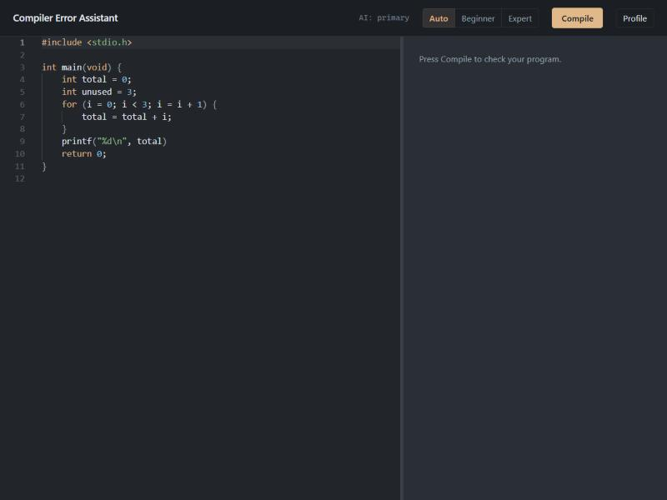
Figure 4.1 — The Compiler Error Assistant editor with a sample C program loaded.

4.1.2 Phase-wise capture, clustering and severity
Pressing Compile runs the full pipeline. The panel reports “Does not compile — 6 fatal, 1 warning”, breaks the count down by phase (“Syntax 1 · Semantic 6”), and crucially shows “3 root causes shown for 7 errors” — the clustering result (F2). Each card is one root cause with a fatal/warning badge (F4) and the exact code, line and column (F1). The editor underlines every error inline.
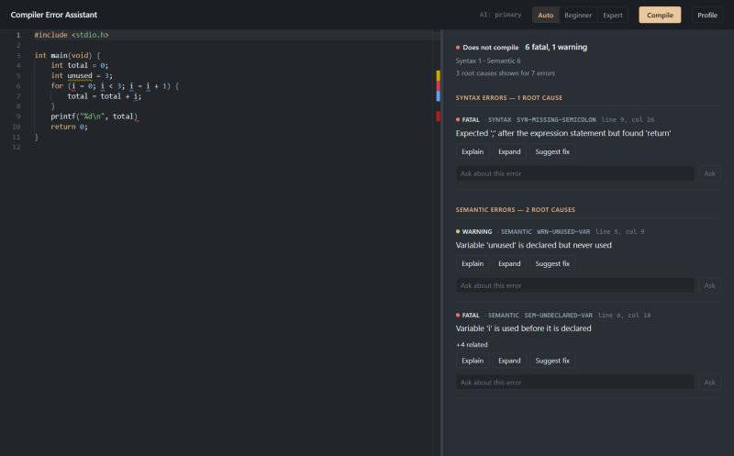
Figure 4.2 — Compile result: 7 raw errors collapsed to 3 root causes, tagged by phase and severity.

4.1.3 Error clustering expanded
The SEM-UNDECLARED-VAR card shows “+4 related”. Expanding it reveals the four later uses of the undeclared variable i, all grouped under their first occurrence rather than shown as five separate errors — the core of the clustering feature (F2).
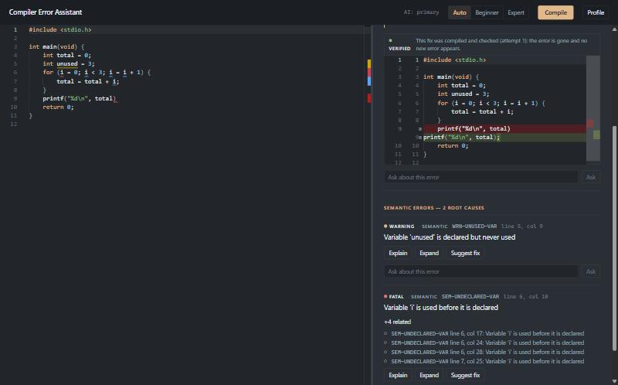
Figure 4.3 — One root cause with its four clustered follow-on errors expanded.

4.1.4 Grounded AI explanation
Clicking Explain asks the compiler-scoped agent (F3) for a short explanation. The reply names the rule it is based on and shows a “Grounded in: rule:expr_stmt, fix:SYN-MISSING-SEMICOLON” line — the retrieval-augmented grounding (F7) that ties every explanation to a real rule from the specification. Invented citations are dropped before display.
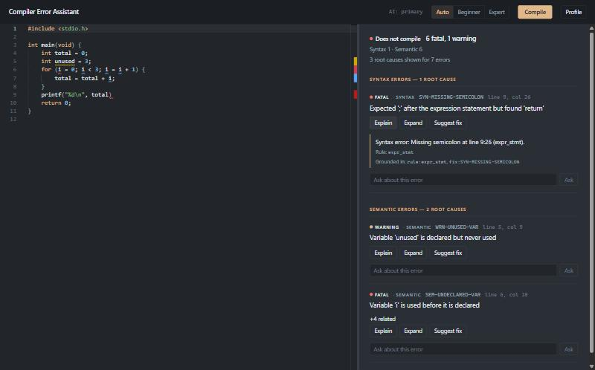
Figure 4.4 — A grounded, two-sentence explanation citing the actual grammar rule.

4.1.5 Self-verifying fix engine
Clicking Suggest fix produces a candidate patch, applies it to a private copy of the source and re-compiles it. Only because the original error disappears and no new error appears is the fix shown — marked “VERIFIED — This fix was compiled and checked (attempt 1): the error is gone and no new error appears.” The diff view highlights exactly the change (adding the missing semicolon). This is the project's headline novelty (F8); the student applies the change themselves, as the assistant never edits their code.
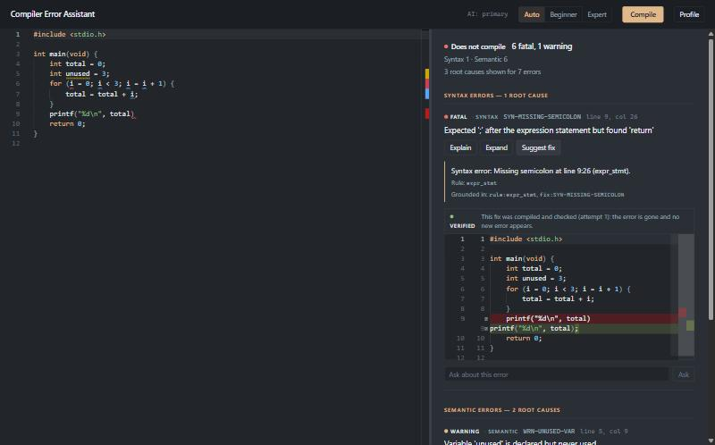
Figure 4.5 — A verified fix: the patch was re-compiled and checked before being shown.

4.1.6 Personalised profile and analytics
The Profile page implements the personalised error model (F9). It explains in plain language what is tracked, how explanations adapt after a mistake is repeated three or more times, and the privacy model: everything is stored locally under a random id (never the student's name) that is never sent to the AI. The progress panel summarises compiles, success rate, streak, errors-per-compile and the most common mistake.
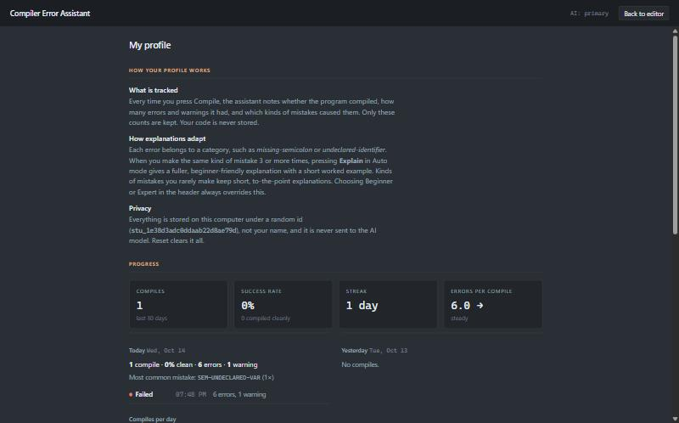
Figure 4.6 — The local, privacy-preserving student profile and analytics dashboard.

4.1.7 Command-line interface
The same compiler runs headless. Invoking python -m cea on a faulty program prints the clustered, severity-tagged diagnostics and exits non-zero on any fatal error:
$ python -m cea demo.c
E-0001 demo.c:4:18: fatal [SYN-MISSING-SEMICOLON] Expected ';' after the declaration but found 'int'
E-0007 demo.c:5:9: warning [WRN-UNUSED-VAR] Variable 'unused' is declared but never used
E-0002 demo.c:6:10: fatal [SEM-UNDECLARED-VAR] Variable 'i' is used before it is declared (+4 related)
6 fatal, 1 warning
(exit code 1)
Figure 4.7 — CLI output showing all three phases, clustering (+4 related) and severity.

4.2 Current Progress and Challenges

Completed modules
All nine planned features across the five PRD milestones are implemented and tested, plus a sixth milestone that extends the compiler to course-level C with a GCC fallback:
- Milestone 1 (Foundation): error record, fixed 37-code catalog, ErrorSink interceptor, full lexer, recursive-descent parser with recovery, and semantic analyser (F1, F4).
- Milestone 2 (Intelligence): rule-based clustering, the compiler-scoped AI agent, the FastAPI backend and the React + Monaco UI (F2, F3).
- Milestone 3 (Extensions): beginner/expert verbosity, per-error follow-up Q&A, and RAG grounding with citations (F5, F6, F7).
- Milestone 4 (Novelty): the self-verifying fix engine and the personalised, local student profile (F8, F9).
- Milestone 5 (Evaluation): a held-out corpus of 20 faulty C programs and the metrics harness.
- Milestone 6 (Course-level C + GCC fallback): the compiler was grown to handle pointers, structs, unions, enums, typedef, switch/case, casts, sizeof and more; and compile_source(engine="auto") hands any construct we do not support to gcc -std=c99 -fsyntax-only, converting each GCC diagnostic into the same structured record so every C program receives diagnostics.
The whole system is covered by an automated suite of over 1,500 tests. The design invariant — every program our compiler accepts is also valid C99 — is checked automatically against gcc, with a single documented exception (incompatible pointer types, which plain gcc also only warns about).

Evaluation results (20 held-out programs, local llama3.1 8B)
Metric | Target | Result
Root-cause accuracy | ≥ 85% | 95.0% ✓
Fabricated rule citations | 0 | 0 ✓
Clustering — displayed-error reduction (single-fault) | ≥ 70% | 69.6% (64.0% across all cascades)
Fixes verified within 3 attempts | ≥ 80% | 66.7% (12 / 18)
Explanations that cite a retrieved rule | ≥ 90% | 47.8% by the model; 100% after validation
Default explanation latency | < 5 s | 5.8 s median, 6.7 s p90

Challenges encountered
- Good recovery leaves little to cluster. Because the parser repairs common mistakes in place, a missing semicolon yields exactly one error, so the PRD's “one missing semicolon produces 10+ errors” acceptance test is unreachable as written. We reported this honestly and measured clustering on genuinely cascading files instead.
- An ungrounded model invents citations. Evaluation exposed that the explanation JSON schema omitted a citations field, so the constrained decoder could never emit one. Fixing the schema, and dropping any invented citation at validation, resolved it; the as-found run is preserved for honesty.
- “Verified” is not “correct”. A verified fix provably compiles and removes the original error, but may still not be what the student intended. Guardrails (patch locality, size limits, no loss of identifiers or statements) block trivial “fixes” such as deleting the offending line.
- Held-out discipline. The 20 evaluation programs are never inspected while tuning recovery or clustering; defects they reveal are reproduced as new development programs to avoid overfitting the evaluation.

4.3 Conclusion and Future Enhancements
This project set out to turn the wall of errors a beginner sees into one root cause, one grounded explanation and one checked fix, and it does. By building its own C-subset compiler, the system obtains the ground truth — per-phase errors, parser recovery points and a rule for every diagnostic — that a wrapper around GCC could not. The deterministic clustering and catalog-driven severity keep the facts out of the model's hands; retrieval grounding keeps explanations tied to real rules; and the self-verifying fix engine guarantees that any fix shown actually compiles. The compiler-side metrics (95% root-cause accuracy, zero fabricated citations) meet their targets strongly; the LLM-side metrics depend on the model and are reported honestly, slightly short of their targets on a single 8-billion-parameter model running locally.
Future enhancements include:
- Running the designed learner study (5–10 classmates) to measure time-to-fix with and without the assistant, which is specified but not yet conducted.
- Evaluating a larger, hosted model to test whether the verified-fix and latency targets are met when model quality is not the bottleneck.
- Adding an uninitialised-variable warning and printf format-string checking, both deferred from the first version.
- Generalising the language-agnostic AI layer with an adapter that converts another compiler's diagnostics (e.g. Java or Python) into the same record format, since the AI layer depends only on the record shape, not on compiler internals.
- Tightening over-linking after a broken for-header and detecting a missing closing brace at the point it was forgotten rather than at end of file.
In sum, the Compiler Error Assistant demonstrates that a modest, well-scoped compiler combined with a tightly guarded AI layer can make compiler diagnostics genuinely useful to learners — without ever letting the AI invent a rule, a severity or a fix that does not build.

REFERENCES
[1] A. V. Aho, M. S. Lam, R. Sethi, and J. D. Ullman, Compilers: Principles, Techniques, and Tools, 2nd ed. Boston, MA, USA: Addison-Wesley, 2006.
[2] B. W. Kernighan and D. M. Ritchie, The C Programming Language, 2nd ed. Englewood Cliffs, NJ, USA: Prentice Hall, 1988.
[3] ISO/IEC, "ISO/IEC 9899:1999 — Programming languages — C (C99)," International Organization for Standardization, 1999.
[4] B. A. Becker et al., "Compiler Error Messages Considered Unhelpful: The Landscape of Text-Based Programming Error Message Research," in Proc. ITiCSE Working Group Reports, 2019, pp. 177–210.
[5] T. Barik et al., "Do Developers Read Compiler Error Messages?," in Proc. 39th Int. Conf. on Software Engineering (ICSE), 2017, pp. 575–585.
[6] P. Lewis et al., "Retrieval-Augmented Generation for Knowledge-Intensive NLP Tasks," in Advances in Neural Information Processing Systems (NeurIPS), vol. 33, 2020, pp. 9459–9474.
[7] Free Software Foundation, "Using the GNU Compiler Collection (GCC) — Options to Request or Suppress Warnings," GCC Documentation, 2024. [Online]. Available: https://gcc.gnu.org/onlinedocs/
[8] Google, "Gemini API Documentation," Google AI for Developers, 2025. [Online]. Available: https://ai.google.dev/
[9] Microsoft, "Monaco Editor," 2024. [Online]. Available: https://microsoft.github.io/monaco-editor/
[10] S. Ramírez, "FastAPI," 2024. [Online]. Available: https://fastapi.tiangolo.com/

