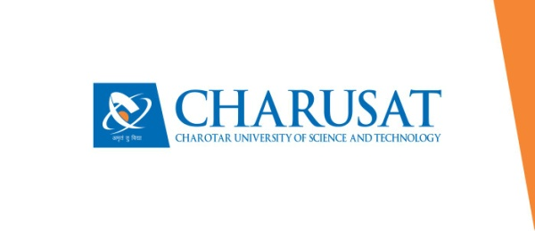

**CERTIFICATE**

This is to certify that the report entitled “**My Book Management**” is a bonafied work carried out by **Mr. Naman Ghevariya(19DCE032) and Mr. Tirth Moradiya(19DCE74)** under the guidance and supervision of **Assistant Prof. Binal S. Kaka** for the subject CE244-**Software Group Project-I** (CE) of 3rd Semester of Bachelor of Technology in **DEPSTAR** at Faculty of Technology & Engineering – CHARUSAT, Gujarat.

To the best of my knowledge and belief, this work embodies the work of candidate himself, has duly been completed, and fulfills the requirement of the ordinance relating to the B.Tech. Degree of the University and is up to the standard in respect of content, presentation and language for being referred to the examiner.

|  |  |
| --- | --- |
| Binal S. Kaka  Assistant Professor  CE Department  DEPSTAR, Changa, Gujarat. |  |
| Dr. Amit Ganatra  Principal, DEPSTAR  Dean, FTE  CHARUSAT, Changa, Gujarat. | |

**Devang Patel Institute of Advance Technology And Research At: Changa, Ta. Petlad, Dist. Anand, PIN: 388 421. Gujarat**