**A**

**Project Report**

**On**

**"My Book Management"**

**Prepared by**

Naman Ghevariya (19DCE032)

Tirth Moradiya(19DCE074)

**Under the guidance of**

Assistant Professor

Binal S. Kaka and Bhavika Patel

A Report Submitted to

Charotar University of Science and Technology

for Partial Fulfillment of the Requirements for the

3rd Semester Software Group Project-I (CE244)

**Submitted at**

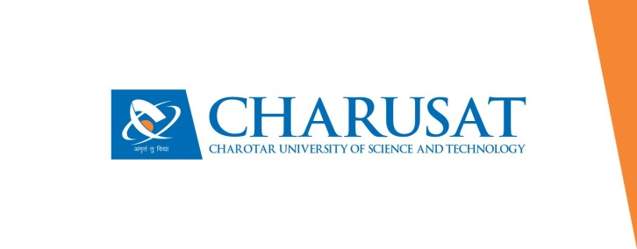

**CE**

**DEPSTAR**

**At: Changa, Dist: Anand – 388421**

**October 2020**