### Chapter 1: PROBLEM STATEMENT

**PROBLEM STATEMENT:**

The problem occurred before having computerized system includes:

* **File lost:**

When computerized system is not implemented file is always lost because of human environment. Sometimes due to some human error there may be a loss of records.

* **File damaged:**

When a computerized system is not their file is always lost due to some accident like spilling of water by some member on file accidentally. Besides some natural disaster like floods or fires may also damage the files.

* **Difficult to search record:**

When there is no computerized system there is always a difficulty in searching of records if the records are large in number.

* **Space consuming**:

After the number of records become large the space for physical storage of file and records also increases if no computerized system is implemented.

* **Cost consuming**:

As there is no computerized system the to add each record paper will be needed which will increase the cost for the management of library.

### Chapter 2: Description

**OVERVIEW:**

* The library management system project is identified with the storage of data in regards to the library.
* The library is the place with the gigantic collection of books.
* It is put from where the students and others issue the books for their reference purposes.
* In any case, the upkeep of keeping the records of issuing and acquiring is troublesome on the off chance that you utilize an ordinary book as a registry.
* To make this undertaking less demanding, the library management system will be exceptionally helpful.
* It helps in keeping up the data with respect to the issuing and getting of books by the students and others.
* The library management system contextual case study gives the case analysis of the library management student.

**MOTIVATION FOR PROJECT:**

* In today’s world most of things are automated like bank operations and college management process etc.
* In the digital world the library process still maintain the bookkeeping manual. It is providing through library card for issuing books and maintains the record in books.
* It’s time consuming for librarian as well as library users. This gives us a chance to develop software for library management.

**OVERVIEW OF PROJECT:**

* Library Management System is an application which refers to library systems which are generally small or medium in size.
* It is used by librarian to manage the library using a computerized system where he/she can record various transactions like issue of books, return of books, addition of new books, addition of new students etc.
* Books and student maintenance modules are also included in this system which would keep track of the students using the library and also a detailed description about the books a library contains.
* With this computerized system there will be no loss of book record or member record which generally happens when a non-computerized system is used.
* In addition, report module is also included in Library Management System.
* If user’s position is admin, the user is able to generate different kinds of reports like lists of students registered, list of books, issue and return reports.
* All these modules are able to help librarian to manage the library with more convenience and in a more efficient way as compared to library systems which are not computerized.

### Chapter 3: Software and Hardware Requirements

### Software and Hardware Requirements:

|  |  |
| --- | --- |
| PROCESSOR | INTEL CORE PROCESSOR OR BETTER PERFORMANCE |
| OPERATING SYSTEM | WINDOWS VISTA ,WINDOWS 7, UBUNTU |
| MEMORY | 1 GB RAM OR MORE |
| HARD DISK | SPACE MINIMUM 3 GB FOR DATABASEUSAGE FOR FUTURE |
| DATABASE | MSSQL |

### Table 3.1 Software and hardware requirements.

### Chapter 4: Major Functionality

### Functionality:

### 

### The software has functionality of login for different user like student, Teacher and Liberian.

### If some is new to library there is functionality of signup to create new user.

### If the user has forgot his/her password, then it can retrieve it with username and question.

### If the user is student or teacher, they can just see book and search or sort data.

### If the user is admin or Liberian, then they can do everything.

### The Liberian can do entry of student and entry for borrow and return book.

### The Liberian can get report of book, magazine, newspaper and borrower.

### Chapter 5: System Flow Chart

### 

Student& Admin

Exit

New Record & Edit Record

ADMIN

ADMIN

New Record & Edit Record

Student list

Borrow book

HOMEPAGE

student

ADMIN

COLLECTION

LOGIN

Start

Report

### Fig 5.1 Flow Chart

### Chapter 6: Screenshots of project output

### Login page:

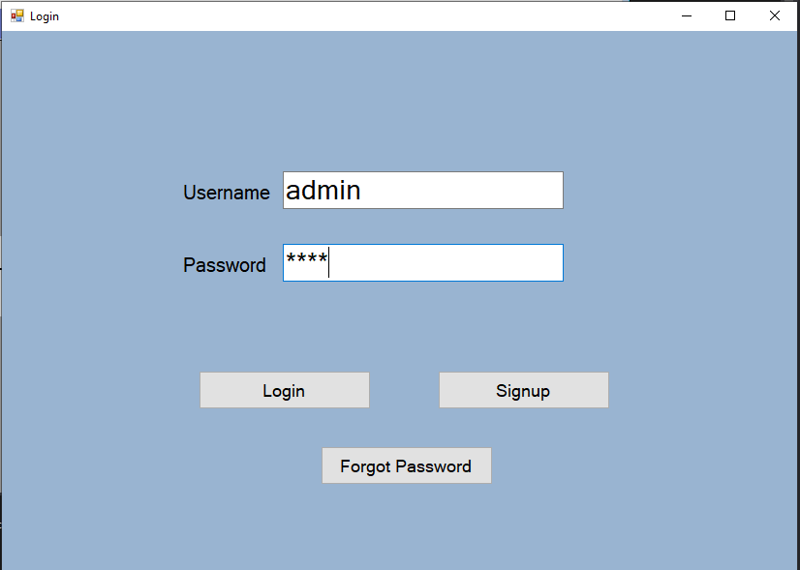

### Fig 6.1 Login Page

### Signup Page:

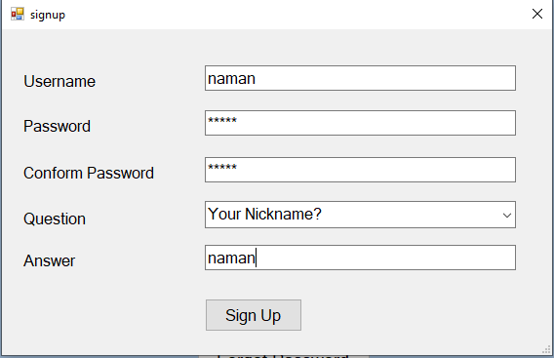

### Fig 6.2 Signup Page

### Forgot Password:

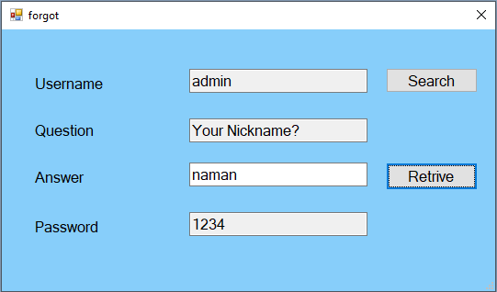

### Fig 6.3 Forgot Password Page

### Selection Page:

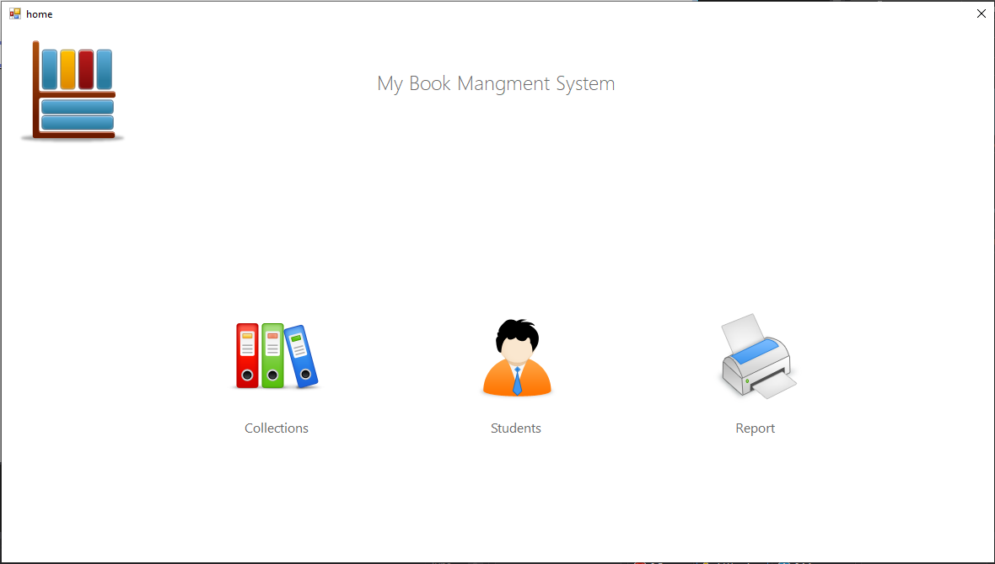

### Fig 6.4 Selection Page

### Collection:

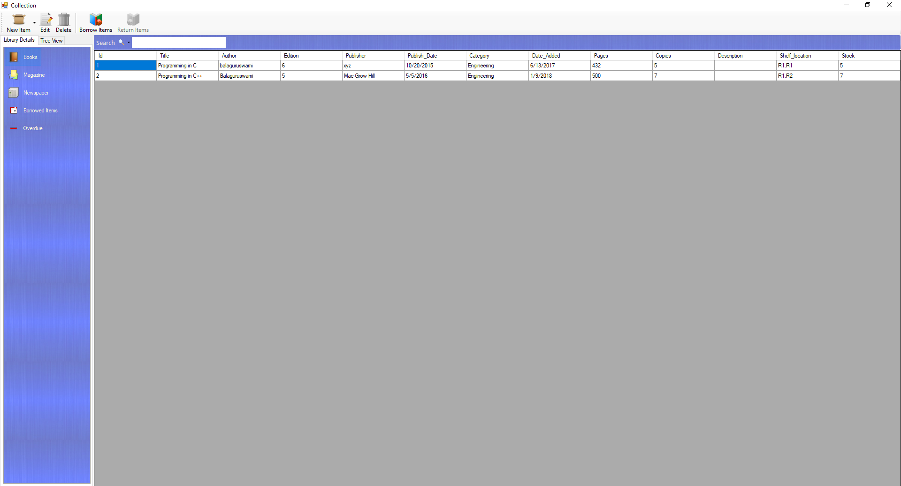

### Fig 6.5 Collection Page

### New Record:

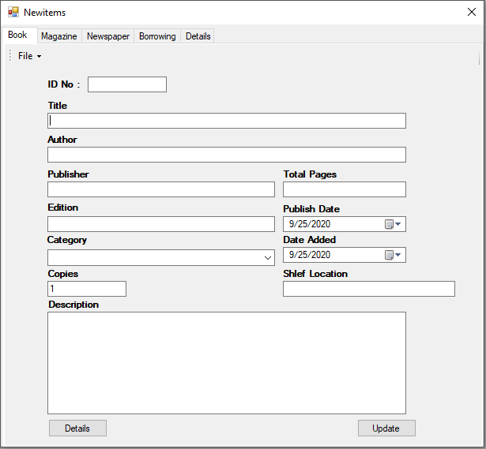

### Fig 6.6 New record Form

### Edit Record:

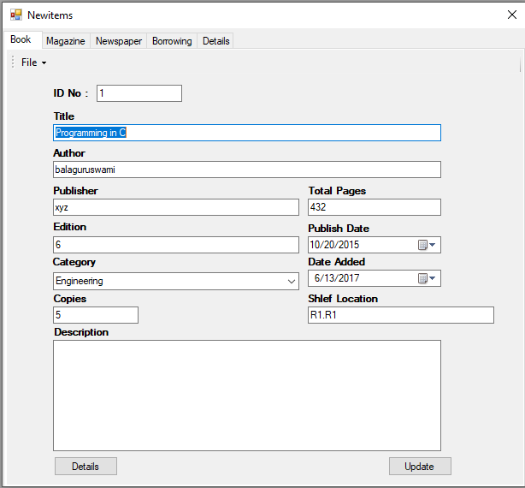

### Fig 6.7 Edit Record Form

### Borrow:

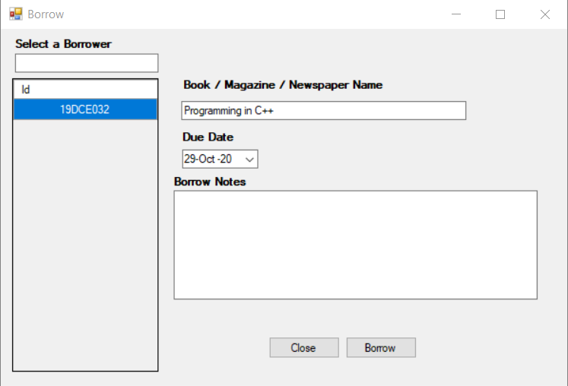

### Fig 6.8 Borrow Book Page

### Student list:

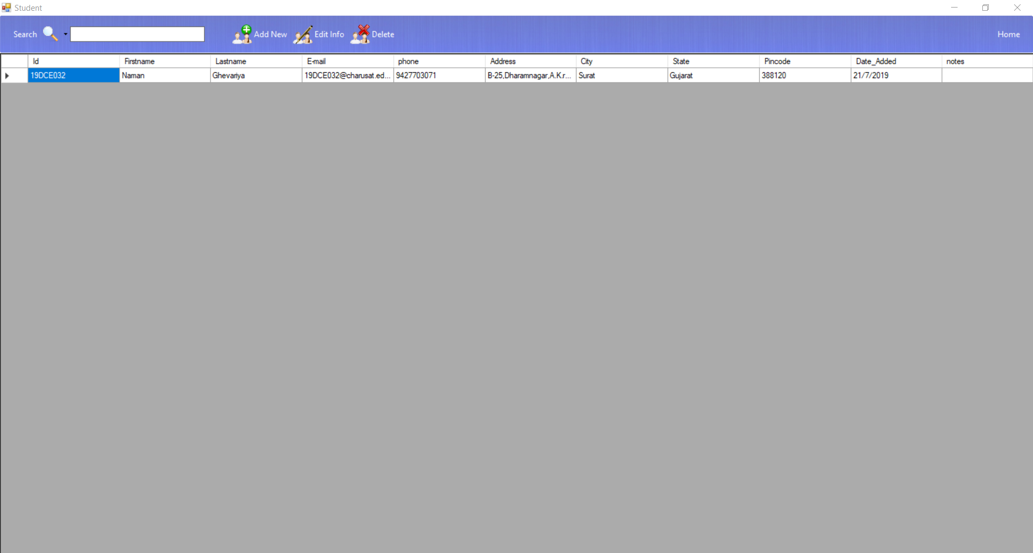

### Fig 6.9 Student List Page

### Report Page:

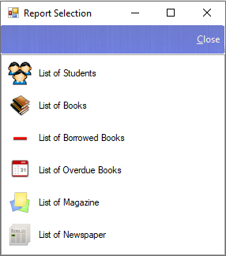

### Fig 6.10 Report Selection Page

### Chapter 7: Limitations of the project

### Limitation:

### The Current System Needed Creating Database Manually.

### The Barcode system is not available in this system.

### The report facility is not available in this system.

### Booking facility of books by student is not available.

### Chapter 8: Project Outcomes

### Outcomes:

### This project can be useful for easy management of library.

### This project is helpful for search and sort data easily.

### This project can help finding the number of books in categories.

### This project can also be helpful to find list of students.

### This project can give list of borrowed book.

### This project can give list of overdue books.

### This project can also be useful in getting report of different things.

### This project consists of tree view having nodes values of category which can give sorted data as per the categories.

### Chapter 9: Future Enhancements

### Futures’ Goal:

### We have planned to implement the barcode reader system for making of database entry automatically.

### We have planned to execute pdf report for different different categories.

### We have planned to add feature of advance booking of book.

### We have planned to add advance features which can also help in searching and sorting of data as per requirement.

### Chapter 10: Bibliography

### Bibliography:

### <https://www.c-sharpcorner.com/blogs/create-tableselect-insertupdate-delete-table-in-sql>

### <http://csharp.net-informations.com/dataview/filter-dataview.htm>

### <https://www.w3schools.com/sql/sql_update.asp>

### [https://docs.microsoft.com/en-us/dotnet/desktop/winforms/controls/selected-cells-rows-and-columns-datagridview?view=netframeworkdesktop-4.8#:~:text=To%20get%20the%20selected%20rows,property%20to%20FullRowSelect%20or%20RowHeaderSelect.](https://docs.microsoft.com/en-us/dotnet/desktop/winforms/controls/selected-cells-rows-and-columns-datagridview?view=netframeworkdesktop-4.8)

### <https://www.aspsnippets.com/Articles/Pass-Send-values-from-DataGridView-to-TextBoxes-in-Windows-Application-using-C-and-VBNet.aspx>