<?xml version="1.0" encoding="UTF-8"?>
<services xmlns:xsi="http://www.w3.org/2001/XMLSchema-instance" xsi:noNamespaceSchemaLocation="http://moqui.org/xsd/service-definition-2.1.xsd">

<!--///// 1 st ////////-->

<service verb="get" noun="FemalePersons">

<out-parameters>
<parameter name="personsList" type="List"/>
</out-parameters>
<actions>
<entity-find entity-name="mantle.party.Person" list="personsList">
<econdition field-name="gender" value="F"/>
</entity-find>
</actions>
</service>

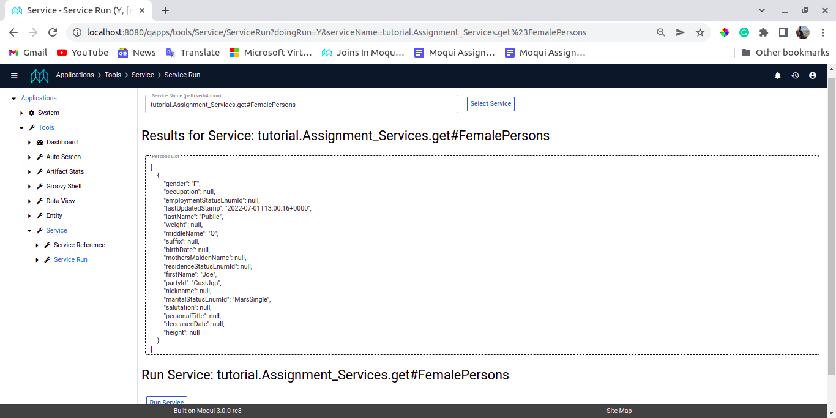

<!--///// 2 nd ////////-->

<service verb="get" noun="Persons">

<out-parameters>
<parameter name="personsList" type="List"/>
</out-parameters>
<actions>
<entity-find entity-name="mantle.party.Person" list="personsList">
<econdition field-name="maritalStatusEnumId" value="MarsMarried"/>
</entity-find>
</actions>
</service>

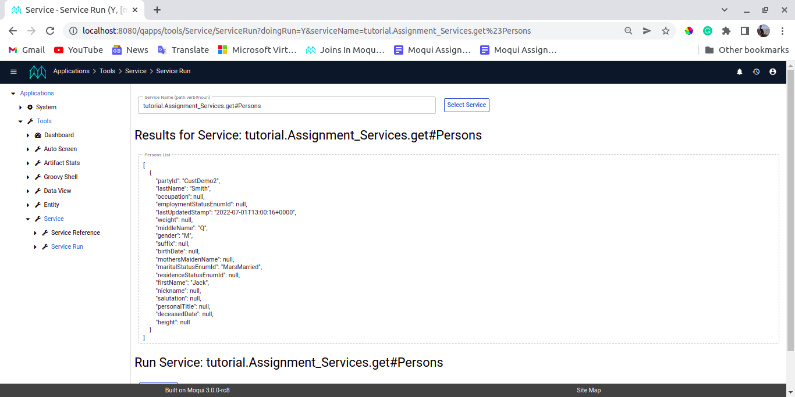

<!--///// 3rd ////////-->

<service verb="get" noun="LatestOrders">

<out-parameters>
<parameter name="ordersList" type="List"/>
</out-parameters>
<actions>
<entity-find entity-name="mantle.order.OrderHeader" list="ordersList">
<order-by field-name="-placedDate"/>
</entity-find>
</actions>
</service>

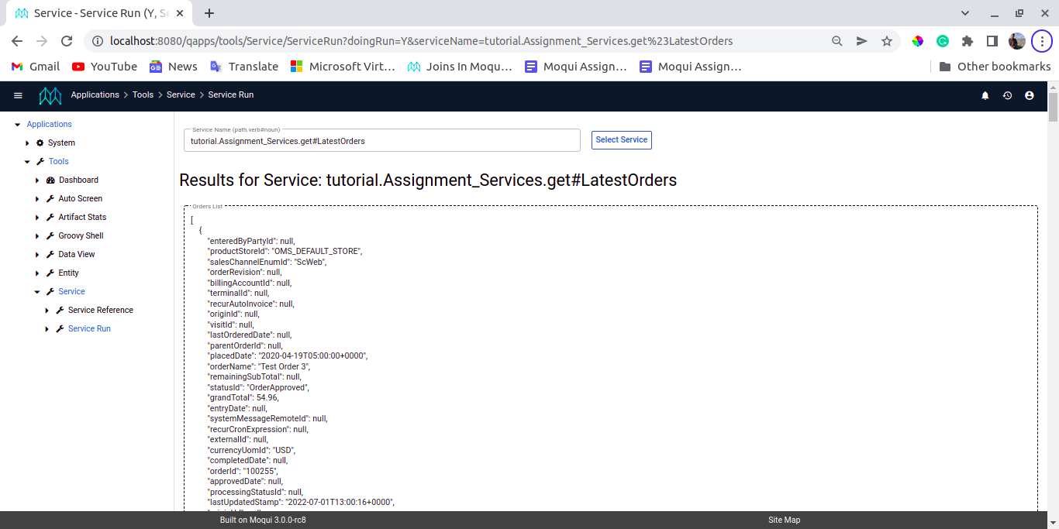

<!--///// 4 th ////////-->

<service verb="get" noun="Order">

<in-parameters>
<parameter name="orderId"/>
</in-parameters>
<out-parameters>
<parameter name="orderDetails" type="List"/>
</out-parameters>
<actions>
<entity-find entity-name="mantle.order.OrderHeader" list="orderDetails">
<econdition field-name="orderId" />
</entity-find>
</actions>
</service>

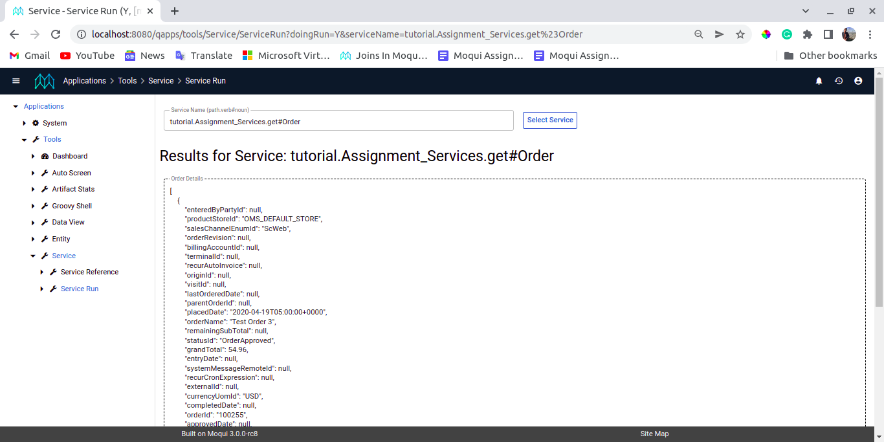

<!--///// 5 th ////////-->

<service verb="get" noun="OrderHeaders">
<out-parameters>
<parameter name="orderHeaderDetails" type="List"/>
</out-parameters>

<actions>

<entity-find entity-name="mantle.order.OrderHeader" list="orderHeaderDetails">
<econdition field-name="grandTotal" operator="greater" from="50"></econdition>
</entity-find>

</actions>
</service>

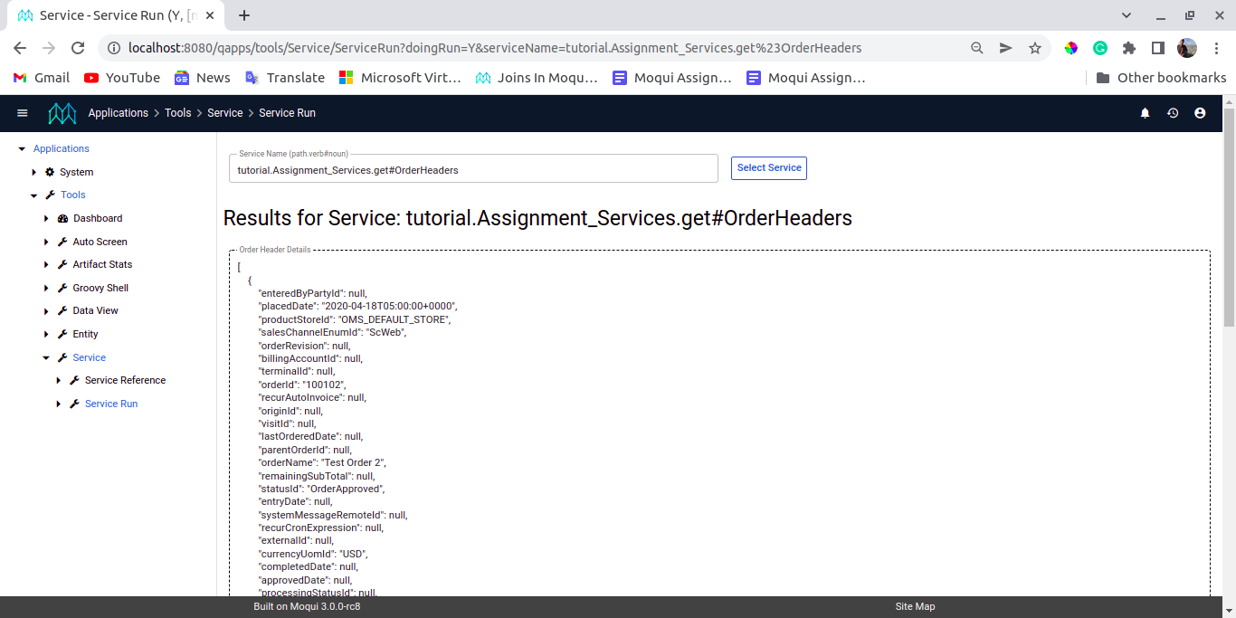

<!--///// 6 th ////////-->

<service verb="get" noun="OrderItems">
<out-parameters>
<parameter name="orderItemDetails" type="List"/>
</out-parameters>
<actions>
<entity-find entity-name="mantle.order.OrderPart" list="orderItemDetails">
<econdition field-name="orderPartSeqId" value="01"/>
<econdition field-name="orderId" value="100102"/>
</entity-find>

</actions>
</service>

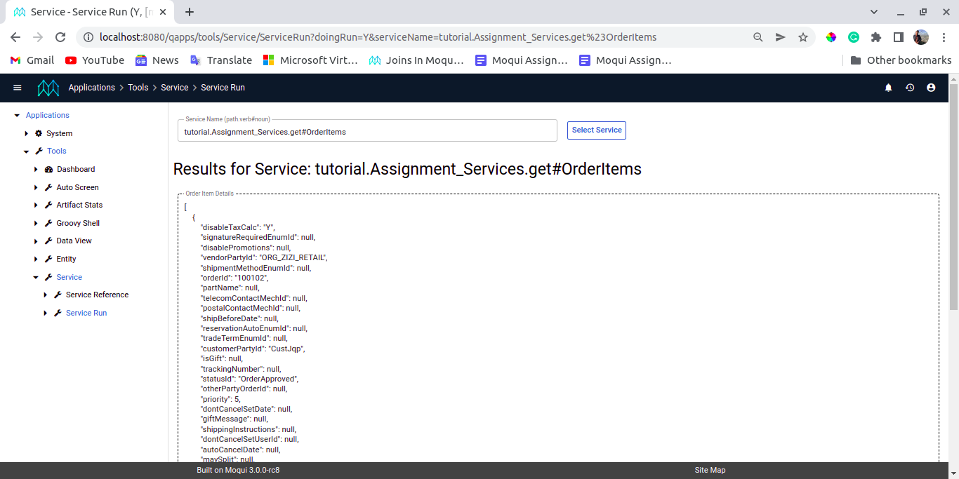

<!--///// 7 th ////////-->

<service verb="get" noun="OrderParts">
<out-parameters>
<parameter name="orderPartDetails" type="List"/>
</out-parameters>
<actions>
<entity-find entity-name="mantle.order.OrderPart" list="orderPartDetails">
<econdition field-name="partTotal" operator="less-equals" from="20" />
</entity-find>
</actions>
</service>

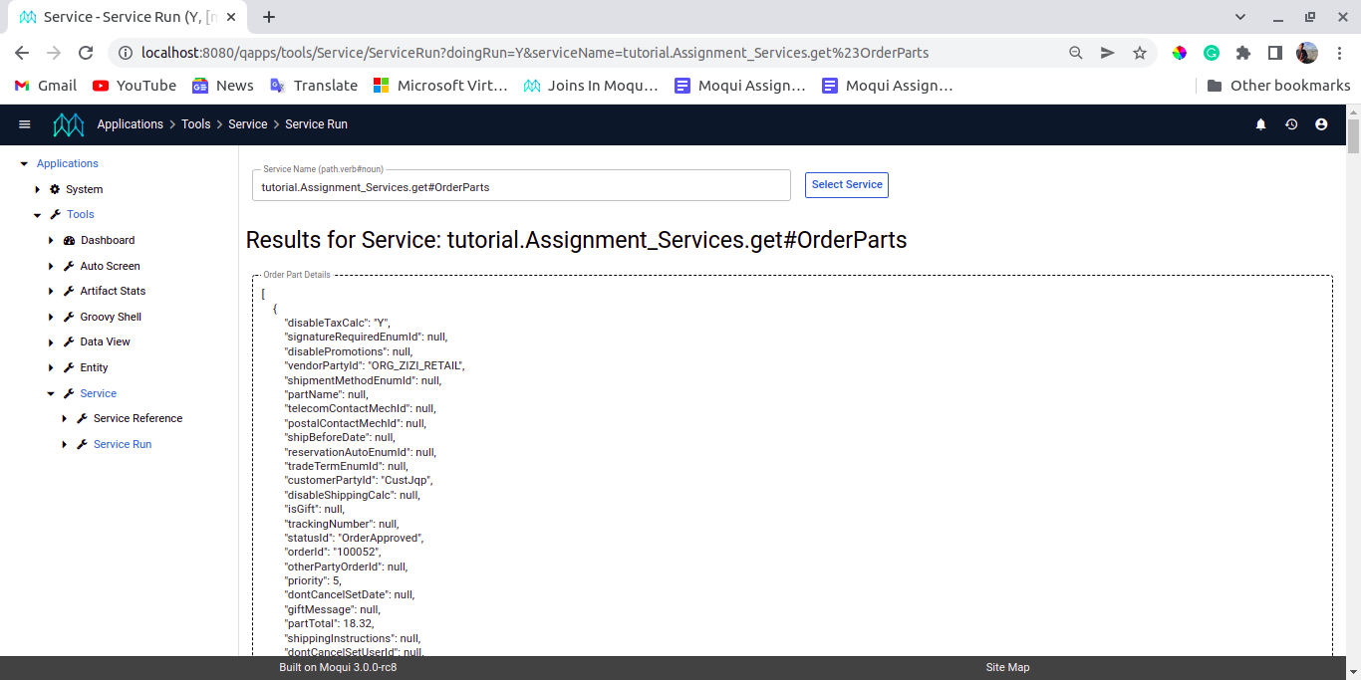

<!--///// 8 th ////////-->

<service verb="get" noun="OrderPartData">
<out-parameters>
<parameter name="orderPartDetails" type="List"/>
</out-parameters>
<actions>
<entity-find entity-name="mantle.order.OrderPart" list="orderPartDetails1">
<econdition field-name="facilityId" value="ZIRET_WH"/>
</entity-find>
<set field="orderPartDetails" from="[]"/>
<iterate list="orderPartDetails1" entry="orderPart">

<set field="orderId" from="orderPart.orderId"/>
<set field="orderPartSeqId" from="orderPart.orderPartSeqId"/>
<set field="facilityId" from="orderPart.facilityId"/>
<set field="partName" from="orderPart.partName"/>
<set field="customerPartyId" from="orderPart.customerPartyId"/>

<set field="orderPartDetails" from="orderPartDetails+[orderId:orderId, orderPartSeqId:orderPartSeqId,

facilityId:facilityId, partName:partName]"/>
</iterate>

</actions>
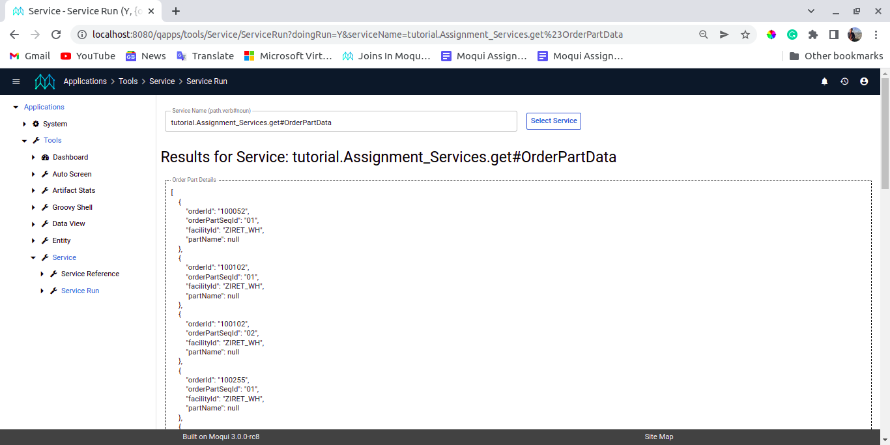
</service>

<!--///// 9 th ////////-->

<service verb="get" noun="OrderPartsCount">
<out-parameters>
<parameter name="orderPartsCount"/>
</out-parameters>
<actions>

<entity-find-count entity-name="mantle.order.OrderPart" count-field="orderPartsCount">
<econdition field-name="customerPartyId" value="CustJqp"/></entity-find-count>
</actions>
</service>

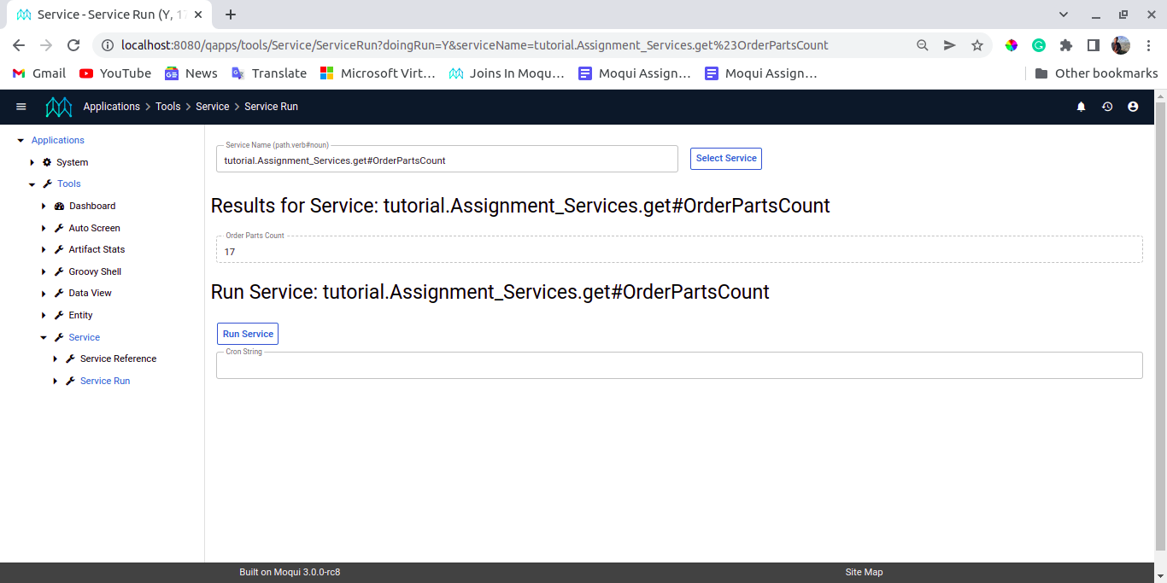

<!--///// 10 th ////////-->

<service verb="get" noun="OrderPartsInfo">
<out-parameters>
<parameter name="orderPartsList" type="List"/>
</out-parameters>
<actions>

<entity-find entity-name="mantle.order.OrderPart" list="orderPartsList" distinct="true">
<econdition field-name="shipmentMethodEnumId" value="ShMthNextDay"/>
<!-- Instid of using ShtMthGround i used ShMthNextDay Because There is no data present according to the check in table -->
<econdition field-name="facilityId" value="ZIRET_WH"/>

</entity-find>
</actions>
</service>

</services>

