<!--///////// 1st ///////-->
<service verb="post" noun="Orders">
<in-parameters>
<parameter name="currencyUomId" default="USD"/>
<parameter name="statusId" default="OrderPlaced"/>
<parameter name="orderName" required="true"/>
<parameter name="placedDate" required="true"/>
</in-parameters>
<out-parameters>
<parameter name="orderId"/>
</out-parameters>
<actions>
<service-call name="create#mantle.order.OrderHeader" in-map="context" out-map="context"/>
</actions>
</service>

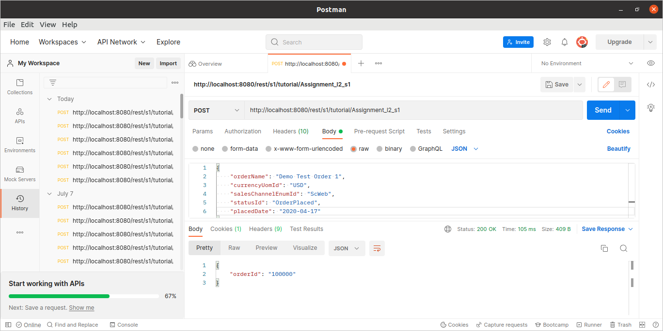

<!-- /////////////////////// 2nd //////////////////////-->
<service verb="post" noun="OrderEntity">
<in-parameters>
<parameter name="orderId" required="true"/>
<parameter name="partName" required="true"/>
<parameter name="facilityId" required="true"/>
<parameter name="shipmentMethodEnumId" default="ShMthGround"/>
<parameter name="customerPartyId" default="CustJqp"/>
<parameter name="item_details" type="List" required="true">
<parameter name="itemMap" type="Map">
<parameter name="productId" required="true"/>
<parameter name="facilityId" required="true"/>
<parameter name="itemDescription"/>
<parameter name="quantity" required="true"/>
<parameter name="unitAmount" required="true"/>
</parameter>
</parameter>
</in-parameters>
<out-parameters>
<!-- Return Order Id and orderPartSeqId Id -->
<parameter name="orderId"/>
<parameter name="orderPartSeqId"/>
</out-parameters>
<actions>
<service-call name="create#mantle.order.OrderHeader" out-map="context" in-map="[orderId:orderId]"/>
<service-call name="create#mantle.order.OrderPart" out-map="orderPartOut" in-map="context + [orderId:orderId,partName:partName,
facilityId:facilityId,shipmentMethodEnumId:shipmentMethodEnumId,customerPartyId:customerPartyId]"/>
<iterate list="item_details" entry="itemDetailMap">
<service-call name="create#mantle.order.OrderItem" out-map="context" in-map="[
orderPartSeqId : orderPartOut ?. orderPartSeqId,
orderId:orderId,productId:productId,facilityId:facilityId,itemDescription:itemDescription,quantity:quantity,
unitAmount:unitAmount]"/>
<set field="orderPartSeqId" from="orderPartOut.orderPartSeqId"/>
<!-- <log message="================================${orderPartSeqId}================================"/>-->
</iterate>
</actions>
</service>

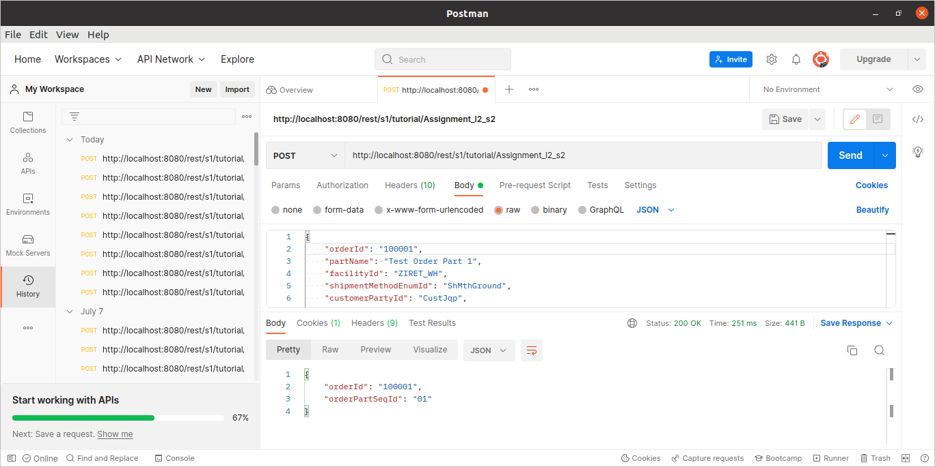

<!-- /////////////////////// 3rd //////////////////////-->
<service verb="get" noun="AllOrder">
<out-parameters>
<parameter name="orders" type="List">
<parameter name="orderMap" type="Map">
<parameter name="orderId"/>
<parameter name="orderName"/>
<parameter name="currencyUom"/>
<parameter name="salesChannelEnumId"/>
<parameter name="statusId"/>
<parameter name="placedDate"/>
<parameter name="grandTotal"/>
<parameter name="customer_details" type="List">
<parameter name="customer_details_Map" type="Map">
<parameter name="firstName"/>
<parameter name="middleName"/>
<parameter name="lastName"/>
</parameter>
</parameter>
<parameter name="order_parts" type="List" required="true">
<parameter name="partMap" type="Map">
<parameter name="orderPartSeqId"/>
<parameter name="partName"/>
<parameter name="facilityId"/>
<parameter name="shipmentMethodEnumId"/>
<parameter name="partStatusId"/>
<parameter name="partTotal"/>
<parameter name="item_details" type="List">
<parameter name="orderItm_Map" type="Map">
<parameter name="orderItemSeqId"/>
<parameter name="productId"/>
<parameter name="itemDescription"/>
<parameter name="quantity"/>
<parameter name="unitAmount"/>
</parameter>
</parameter>
</parameter>
</parameter>
</parameter>
</parameter>
</out-parameters>
<actions>
<entity-find entity-name="OrderHeader" list="orderHeaderList"/>
<set field="orders" from="[]"/>
<set field="orderMap" from="[:]"/>
<iterate list="orderHeaderList" entry="orderHeader">
<set field="currentOrderId" from="orderHeader.orderId"/>
<set field="orderMap" from="[orderId:orderHeader.orderId,orderName:orderHeader.orderName,currencyUom:orderHeader.currencyUom,salesChannelEnumId:orderHeader.salesChannelEnumId,
statusId:orderHeader.statusId,placedDate:orderHeader.placedDate,grandTotal:orderHeader.grandTotal]"/>
<log message="===============orderMap========${orderMap}"/>
<entity-find entity-name="OrderPart" list="orderPartList">
<econdition field-name="orderId" from="currentOrderId"/>
</entity-find>
<log message="=========orderId=========${orderId}============"/>
<iterate list="orderPartList" entry="orderPart">
<set field="order_parts" from="[]"/>
<set field="partMap" from="[:]"/>
<set field="partMap" from="[orderPartSeqId:orderPart.orderPartSeqId,partName:orderPart.partName,facilityId:orderPart.facilityId,shipmentMethodEnumId:orderPart.shipmentMethodEnumId,
statusId:orderPart.statusId,partTotal:orderPart.partTotal]"/>
<set field="currentPartId" from="orderPart.customerPartyId"/>
<set field="currentOrderPartSeqId" from="orderPart.orderPartSeqId"/>
<script>order_parts.add(partMap)</script>
<entity-find entity-name="Person" list="personList">
<econdition field-name="partyId" from="currentPartId"/>
</entity-find>
<iterate list="personList" entry="personMap">
<set field="customer_details" from="[]"/>
<set field="person_Map" from="[:]"/>
<set field="person_Map"
from="[firstName:personMap.firstName,middleName:personMap.middleName,lastName:personMap.lastName]"/>
<script>customer_details.add(person_Map)</script>
</iterate>
</iterate>
<entity-find entity-name="OrderItem" list="orderItemList">
<econdition field-name="orderPartSeqId" operator="equals" from="currentOrderPartSeqId"/>
<econdition field-name="orderId" operator="equals" from="currentOrderId"/>
</entity-find>
<iterate list="orderItemList" entry="orderItem">
<log message="=====orderItem=orderId===${orderItem.orderId}========"/>
<set field="item_details" from="[]"/>
<set field="orderItm_Map" from="[:]"/>
<set field="orderItm_Map" from="[orderItemSeqId:orderItem.orderItemSeqId,productId:orderItem.productId,itemDescription:orderItem.itemDescription,
quantity:orderItem.quantity,unitAmount:orderItem.unitAmount]"/>
<script>item_details.add(orderItm_Map)</script>
<log message="===============item_details=============${item_details}"/>
<!-- <log message="===============orderItemList=============${orderItemList}"/>-->
</iterate>
<set field="order_parts" from="order_parts + [item_details: item_details]"/>
<script>orderMap.put('customer_details', customer_details)</script>
<set field="orderMap" from="orderMap + [order_parts:order_parts]"/>
<script>orders.add(orderMap)</script>
</iterate>
</actions>
</service>

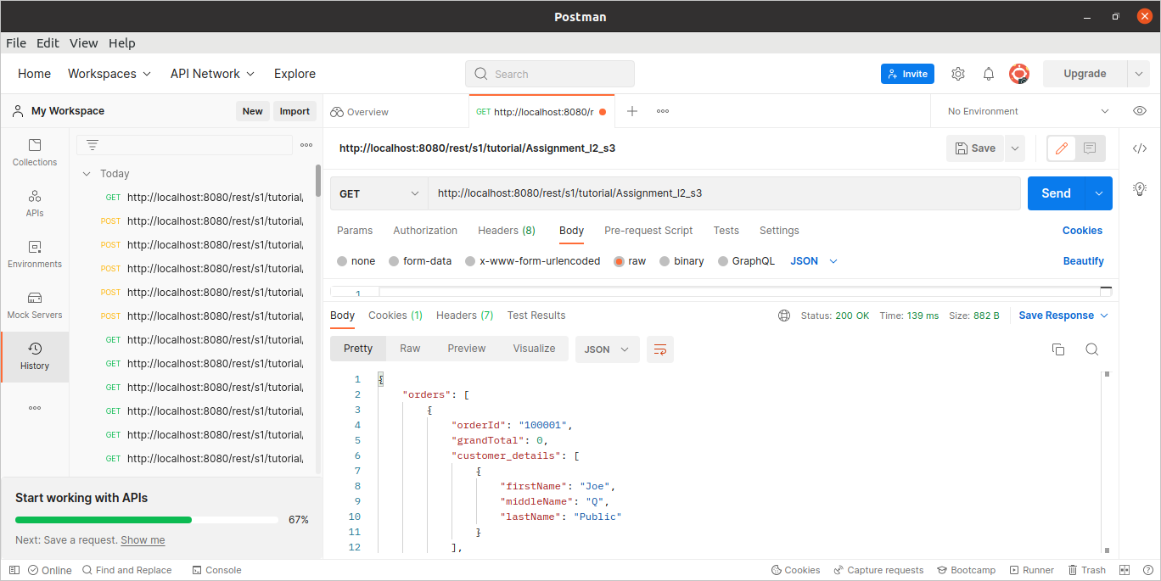

<!-- /////////////////////// 4th //////////////////////-->
<service verb="get" noun="OrderDetails">
<in-parameters>
<parameter name="orderId" required="true"/>
</in-parameters>
<out-parameters>
<parameter name="orders" type="List">
<parameter name="orderMap" type="Map">
<parameter name="orderId"/>
<parameter name="orderName"/>
<parameter name="currencyUom"/>
<parameter name="salesChannelEnumId"/>
<parameter name="statusId"/>
<parameter name="placedDate"/>
<parameter name="grandTotal"/>
<parameter name="customer_details" type="List">
<parameter name="customer_details_Map" type="Map">
<parameter name="firstName"/>
<parameter name="middleName"/>
<parameter name="lastName"/>
</parameter>
</parameter>
<parameter name="order_parts" type="List" required="true">
<parameter name="partMap" type="Map">
<parameter name="orderPartSeqId"/>
<parameter name="partName"/>
<parameter name="facilityId"/>
<parameter name="shipmentMethodEnumId"/>
<parameter name="partStatusId"/>
<parameter name="partTotal"/>
<parameter name="item_details" type="List">
<parameter name="orderItm_Map" type="Map">
<parameter name="orderItemSeqId"/>
<parameter name="productId"/>
<parameter name="itemDescription"/>
<parameter name="quantity"/>
<parameter name="unitAmount"/>
</parameter>
</parameter>
</parameter>
</parameter>
</parameter>
</parameter>
</out-parameters>
<actions>
<entity-find entity-name="OrderHeader" list="orderHeaderList">
<econdition field-name="orderId"/>
</entity-find>
<set field="orders" from="[]"/>
<set field="orderMap" from="[:]"/>
<iterate list="orderHeaderList" entry="orderHeader">
<set field="currentOrderId" from="orderId"/>
<!-- <log message="======currentOrderId=========${currentOrderId}================"/>-->
<set field="orderMap" from="[orderId:orderHeader.orderId,orderName:orderHeader.orderName,currencyUom:orderHeader.currencyUom,salesChannelEnumId:orderHeader.salesChannelEnumId,
statusId:orderHeader.statusId,placedDate:orderHeader.placedDate,grandTotal:orderHeader.grandTotal]"/>
<entity-find entity-name="OrderPart" list="orderPartList">
<econdition field-name="orderId"/>
</entity-find>
<iterate list="orderPartList" entry="orderPart">
<set field="order_parts" from="[]"/>
<set field="partMap" from="[:]"/>
<set field="partMap" from="[orderPartSeqId:orderPart.orderPartSeqId,partName:orderPart.partName,facilityId:orderPart.facilityId,shipmentMethodEnumId:orderPart.shipmentMethodEnumId,
statusId:orderPart.statusId,partTotal:orderPart.partTotal]"/>
<set field="currentPartId" from="orderPart.customerPartyId"/>
<set field="currentOrderPartSeqId" from="orderPart.orderPartSeqId"/>
<script>order_parts.add(partMap)</script>
</iterate>
<entity-find entity-name="Person" list="personList">
<econdition field-name="partyId" from="currentPartId"/>
</entity-find>
<iterate list="personList" entry="personMap">
<set field="customer_details" from="[]"/>
<set field="person_Map" from="[:]"/>
<set field="person_Map"
from="[firstName:personMap.firstName,middleName:personMap.middleName,lastName:personMap.lastName]"/>
<script>customer_details.add(person_Map)</script>
</iterate>
<entity-find entity-name="OrderItem" list="orderItemList">
<econdition field-name="orderPartSeqId" operator="equals" from="currentOrderPartSeqId"/>
<econdition field-name="orderId"/>
</entity-find>
<iterate list="orderItemList" entry="orderItem">
<!-- <log message="=====orderItem=orderId===${orderItem.orderId}========"/>-->
<set field="item_details" from="[]"/>
<set field="orderItm_Map" from="[:]"/>
<set field="orderItm_Map" from="[orderItemSeqId:orderItem.orderItemSeqId,productId:orderItem.productId,itemDescription:orderItem.itemDescription,
quantity:orderItem.quantity,unitAmount:orderItem.unitAmount]"/>
<script>item_details.add(orderItm_Map)</script>
<!-- <log message="===============item_details=============${item_details}"/>-->
<!-- <log message="===============orderItemList=============${orderItemList}"/>-->
</iterate>
<set field="order_parts" from="order_parts + [item_details: item_details]"/>
<script>orderMap.put('customer_details', customer_details)</script>
<set field="orderMap" from="orderMap + [order_parts:order_parts]"/>
<script>orders.add(orderMap)</script>
</iterate>
</actions>
</service>

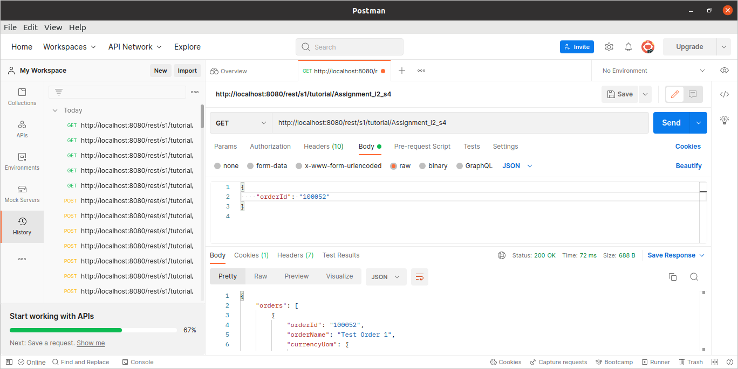

<!-- /////////////////////// 5th //////////////////////-->
<service verb="store" noun="UpdateOrder">
<in-parameters>
<parameter name="orderId" required="true"/>
<parameter name="orderName"/>
</in-parameters>
<out-parameters>
<parameter name="order_List" type="List">
<parameter name="orderMap" type="Map">
<parameter name="orderId"/>
<parameter name="orderName"/>
<parameter name="currencyUomId"/>
<parameter name="salesChannelEnumId"/>
<parameter name="statusId"/>
<parameter name="productStoreId"/>
<parameter name="placedDate"/>
<parameter name="grandTotal"/>
</parameter>
</parameter>
</out-parameters>
<actions>
<entity-find entity-name="mantle.order.OrderHeader" list="OrderHeader">
<econdition field-name="orderId"/>
</entity-find>
<set field="Order_Detail" from="OrderHeader.first"/>
<entity-set value-field="Order_Detail" map="[orderName:orderName]"/>
<entity-update value-field="Order_Detail"/>
<set field="order_List" from="[]"/>
<set field="orderMap" from="[:]"/>
<iterate list="OrderHeader" entry="Order_Map">
<set field="orderMap" from="[orderId:Order_Map.orderId,orderName:Order_Map.orderName,currencyUomId:Order_Map.currencyUomId,salesChannelEnumId:Order_Map.salesChannelEnumId,
statusId:Order_Map.statusId,productStoreId:Order_Map.productStoreId,placedDate:Order_Map.placedDate,grandTotal:Order_Map.grandTotal]"/>
</iterate>
<!-- <log message="========orderName===========${orderName}=============="/>-->
<script>order_List.add(orderMap)</script>
</actions>
</service>
</services>
