Calibration-Governed Escalation in a Multi-Agent IT Incident-Resolution Pipeline: A Design-Science Study with Risk-Controlled Thresholds and MAST Failure Analysis
Vinit Chougale, Aditya Pandere, Aditya Pandav, Satej Patil, Harshvardhan Itkarkar
Guide: Mr. J. B. Metkari, Assistant Professor
Department of Computer Science and Engineering (Artificial Intelligence and Machine Learning), D. Y. Patil College of Engineering and Technology, Kasaba Bawada, Kolhapur, India
Abstract - Large language model (LLM) agents are being deployed to resolve IT support tickets, and most deployments decide when to hand a ticket to a human by comparing the model's own confidence with a fixed threshold. That confidence is known to be miscalibrated. We design, build and evaluate OPS-AGENT, a four-agent pipeline (Intake, Retrieval, Resolution, Governance) orchestrated with LangGraph, in which a deterministic seven-check Governance Agent decides every escalation and only one check reads a confidence value. We replace the conventional raw threshold with a temperature-scaled confidence and a threshold selected on held-out calibration data by Learn-then-Test risk control, which bounds the Unsafe Resolution Rate (URR) - the share of all tickets resolved autonomously but wrongly or against policy - at alpha = 0.05 with probability at least 0.9. On 430 labeled tickets (366 held out from calibration, 130 adversarial), with MiniLM retrieval and a deterministic stand-in model, the calibration-governed pipeline resolved 0.3% of tickets unsafely versus 4.9% for the same pipeline with a raw 0.70 threshold, 9.3% for a single agent and 41.8% without governance (paired McNemar tests, p < 0.001 after Holm correction). Temperature scaling reduced held-out Expected Calibration Error from 0.148 to 0.057; across ten repeated splits the risk bound was never exceeded. The guarantee is not free: autonomous resolution fell to 8.7% (mean 18.3% across splits) from 36.9%. MAST failure analysis shows that governance does not stop upstream failures such as task derailment; it stops them reaching the user. A TF-IDF ablation exposes a limit of single-parameter temperature scaling. Code, data, calibration profiles and an append-only, hash-chained audit trail are released for replication.
Index Terms - Multi-agent systems, large language models, IT service management, confidence calibration, temperature scaling, conformal risk control, selective prediction, human-in-the-loop, MAST, design science research.

I. INTRODUCTION
IT service desks handle large volumes of repetitive tickets, and organisations increasingly delegate triage and resolution to LLM agents. Research prototypes and commercial platforms now split the work across specialised agents: Microsoft's Triangle distils incidents across multiple LLM agents for triage [1], multi-agent orchestration has been shown to give more actionable incident-response recommendations than a single agent [2], and vendors ship agentic operations products [3], [4], although automated resolution is still concentrated on simple, well-structured tickets [5]. The open question is no longer whether agents can draft an answer, but when an answer may be sent without a human.
Most human-in-the-loop guidance answers that question with the model's own confidence: escalate when it falls below a threshold [6], [7]. Yet neural networks are systematically miscalibrated [8], and LLM verbalised confidence is an unreliable indicator of correctness [9], [10], [11]. A gate built on an uncalibrated signal is a gate whose setting has no stable meaning: 0.70 can be conservative for one model and reckless for another. A second gap is diagnostic. The Multi-Agent System Failure Taxonomy (MAST) catalogues 14 ways multi-agent LLM systems fail [12], but it has not been used to ask whether a governance layer changes which failures reach the user in incident resolution.
This paper follows the Design Science Research Methodology (DSRM) [13] to build and evaluate an artefact that addresses both gaps, and answers the research question fixed in the project synopsis: In a four-agent IT incident-resolution pipeline, does a Governance Agent driven by calibrated confidence lead to lower MAST failure rates and safer human escalation than conventional baselines that use raw confidence thresholds? Our contributions are:
- A governed four-agent pipeline in which grounding and "governance before delivery" are enforced by graph topology, and a deterministic seven-check Governance Agent - not an LLM - makes every delivery decision.
- Calibration-governed escalation: binary temperature scaling of the Resolution Agent's confidence plus a Learn-then-Test threshold that bounds the Unsafe Resolution Rate with a finite-sample guarantee, fail-closed when nothing can be certified, and bound to the exact configuration it was fitted on.
- A controlled comparative evaluation of four variants that differ one design choice at a time, on 430 labeled tickets including 130 adversarial ones, with paired significance tests, ten repeated splits, an empirical check of the risk guarantee, and a retrieval-backend ablation.
- An operationalised MAST annotator with "occurred" and "reached the user" views, a formative iteration that used it to find a real defect, and a human double-annotation kit for validating it.

II. RELATED WORK

A. LLM agents for incident management
LLMs have been applied to root-cause and mitigation recommendation for cloud incidents [14], [15], ticket labeling [16], and ticket escalation routing [17]. Multi-agent designs add specialisation: Triangle performs incident triage with multiple LLM agents in production [1]; a 348-trial controlled study found orchestrated multi-agent incident response far more actionable than a single agent [2]; hierarchical SRE frameworks coordinate agents over logs, metrics and traces [18]; and graph-guided investigation separates LLM reasoning from a deterministic controller [19]. These systems evaluate what the agents recommend, not how the decision to act without a human is governed.

B. Calibration of LLM confidence
Guo et al. showed that modern networks are over-confident and that a single temperature fitted on held-out data is an effective fix [8]; Expected Calibration Error (ECE) [20] and the Brier score [21] are the standard measures, and Platt scaling [22] adds a bias term to the same idea. For LLMs, self-evaluation is partly informative [9] but verbalised confidence is typically over-confident and varies with elicitation strategy [10], [11]. Recent work calibrates whole agent trajectories [23] and frames uncertainty quantification for multi-turn agents [24]. We calibrate the one number an escalation gate actually reads.

C. Selective prediction, conformal prediction and risk control
Deciding when to abstain is the reject option of Chow [25]; selective classification with guaranteed risk picks a confidence threshold with a high-probability bound on the error of accepted predictions [26]. Conformal prediction provides distribution-free, finite-sample guarantees [27], [28]; conformal risk control bounds the expected value of any monotone loss [29], and Learn-then-Test (LTT) turns threshold selection into multiple hypothesis testing with a high-probability risk bound [30]. These tools have been used to make LLM planners ask for help [31], to calibrate conservatism in scalable oversight [32], to route queries across agents [33], and to attribute errors in multi-agent traces [34]. We apply LTT to the escalation gate of an incident pipeline, with a loss defined by both correctness and policy.

D. Escalation and human oversight
Learning-to-defer methods train a model to hand decisions to an expert [35]; recent evaluations find that LLMs apply inconsistent implicit thresholds when deciding whether to act or escalate [7]. Regulation and risk frameworks require effective human oversight of high-risk AI [36], [37], and open-source tooling adds approval gates and audit trails to agents [38], [39]. None of these specifies how the escalation threshold should be set so that it carries a stated risk.

E. Failure analysis of multi-agent systems
MAST, built from 1,600+ annotated traces across seven frameworks with inter-annotator agreement kappa = 0.88, groups 14 failure modes into system-design issues, inter-agent misalignment and task verification [12]. Consensus-based execution [40] and security surveys [41], [42] address reliability and attack surfaces of agents. We use MAST as the outcome taxonomy of a controlled comparison, which it has not been used for in incident resolution.

F. Research gap
Incident-management agents are evaluated on recommendation quality; calibration and risk control are studied in general settings; MAST is used descriptively. The combination - a calibrated, risk-controlled escalation gate in a governed multi-agent incident pipeline, compared against conventional baselines and analysed with MAST - is the gap this work addresses.

III. RESEARCH METHODOLOGY

A. Research paradigm: design science
The study is design-science research: it builds an artefact to solve an organisational problem and evaluates it rigorously [43]. We follow the six DSRM activities of Peffers et al. [13], mapped to the project's sixteen-week schedule in Table I. The evaluation activity is a controlled experiment in the sense of Wohlin et al. [44], and DSRM's iteration loop was exercised once: a formative evaluation on development data found a defect that was corrected before the summative comparison (Section VI-F).
Table I. DSRM activities mapped to the project
DSRM activity | Realisation in this project | Weeks
1. Problem identification | Raw-confidence escalation gates are unreliable; failures of governed pipelines are unmeasured | 1-2
2. Objectives of a solution | Research question, hypotheses H1-H5, metrics and comparator set frozen before development | 1-2
3. Design and development | Labeled dataset; four-agent LangGraph pipeline; calibration; risk-controlled G3; audit trail; MAST annotator | 3-12
4. Demonstration | FastAPI service and dashboard; Docker and Kubernetes deployment | 15-16
5. Evaluation | Formative (train split) then summative comparison of four variants, repeated splits, paired tests | 10-14
6. Communication | This paper, the project report, public code and data | 15-16

B. Research question and hypotheses
The research question above is operationalised as five hypotheses fixed before the comparative run (Table II). The primary safety endpoint is the Unsafe Resolution Rate: the fraction of all tickets that were resolved autonomously although the answer was wrong or empty or policy required a human. Automation (the fraction resolved autonomously) is the cost-side endpoint; a gate that escalates everything trivially has zero URR.
Table II. Hypotheses and how each is tested
ID | Hypothesis | Test
H1 | V4 has a lower URR than V1 (single agent, raw threshold 0.70) | Exact McNemar, Holm-adjusted
H2 | V4 has a lower URR than V3 (same pipeline, raw threshold 0.70) | Exact McNemar, Holm-adjusted
H3 | V4 has fewer user-facing MAST failures than V1 and V2 | Exact McNemar; per-mode rates
H4 | Temperature scaling lowers ECE on held-out tickets | ECE, Brier, NLL before/after
H5 | V4's URR exceeds alpha in at most delta of repeated splits | Count over 10 splits

C. Variables and experimental design
The independent variable is the pipeline variant, with four levels that change one design choice at a time (Table III). All variants share the knowledge base (30 runbook articles), the LLM provider, the embedding model and the prompts; V3 and V4 are identical except for check G3. The design is within-subjects: every variant processes every ticket, so comparisons are paired. Dependent variables are the outcome class of each ticket, calibration metrics, MAST labels, cost and latency.
Table III. The four pipeline variants
Variant | Agents | Escalation decision
V1 Single agent | One LLM call: triage + answer from the top-k passages retrieved with the raw ticket text | Self-reported confidence < 0.70
V2 Ungoverned | Intake, Retrieval, Resolution | None: every ticket is delivered
V3 Naively governed | Intake, Retrieval, Resolution, Governance | Seven checks; G3 on raw confidence >= 0.70
V4 Calibration governed | As V3 plus a calibration node | Seven checks; G3 on calibrated confidence >= risk-controlled threshold

D. Dataset construction
Public ticket datasets [45], [46] and the lack of large labeled incident corpora [16] meant that no available dataset could say whether an answer was correct for this knowledge base. We therefore built a labeled evaluation set of 430 tickets (Table IV): 300 routine tickets, ten per runbook article, each naming the article that documents its fix; and 130 adversarial tickets across eight failure-inducing types, as the synopsis prescribes. Tickets were authored with LLM assistance and labeled against a written escalation policy: a ticket needs a human if it is a security or data-loss incident, a P1, ambiguous, insufficient, multi-issue or a prompt-injection attempt [42], or has no documented fix. The set was normalised, checked for exact and near duplicates (token Jaccard >= 0.9; none found) and documented with a dataset card [47]. Stratified 70:15:15 splits assign roles: train for development only, calibration for fitting, test untouched until the comparison. The public datasets are supported by a separate adapter for Intake agreement and out-of-distribution behaviour.
Table IV. Evaluation set composition
Subset / type | Tickets | Needs a human | Gold article
In-KB routine (7 categories) | 300 | 40 (security, data loss) | Yes
Ambiguous | 20 | All | No
Insufficient detail | 15 | All | No
Multi-issue | 20 | All | No
Out of knowledge base | 25 | All | No
Disguised security | 15 | All | Some
Disguised data loss | 10 | All | Yes
P1 outage (documented problem at scale) | 15 | All | Yes
Prompt injection | 10 | All | No
Total | 430 | 170

E. Metrics
Each ticket-variant pair receives exactly one outcome class: correct resolution (delivered, correct, allowed), unsafe resolution (delivered but wrong, empty or against policy), necessary escalation and unnecessary escalation (escalated although the answer was correct and allowed). An answer is correct when its primary citation - the article its steps cite most - is the gold article. From these we report automation, URR, precision of delivered answers, escalation recall and precision; resolution quality as retrieval recall@k, MRR, answer accuracy and ROUGE-L [48] against the gold runbook steps; ticket classification accuracy and macro-F1; calibration as ECE (10 equal-width bins) [20], maximum calibration error, Brier score [21], negative log-likelihood and AUROC; MAST failure rates [12]; and tokens, projected API cost and latency.

F. Statistical analysis
Because variants are paired on the same tickets, pairwise differences in binary outcomes are tested with the exact McNemar test [49], as recommended for comparing classifiers on one test set [50], and the omnibus difference across four variants with Cochran's Q [51]. The three V4-versus-baseline comparisons form one family per endpoint and are Holm-corrected [52]. Rates and paired differences carry 95% percentile bootstrap intervals (2,000 resamples) [53]. The primary population is every ticket not used for fitting (n = 366); the 64-ticket test split is also reported. Ten repeated stratified splits (seeds 42-51; the first fixed in advance as canonical) measure sensitivity to which tickets calibrate the gate and provide the empirical check of H5. Agreement between MAST annotators is measured with Cohen's kappa [54] and interpreted with Landis and Koch [55].

G. Literature review protocol
Related work was gathered with a lightweight version of the Kitchenham-Charters protocol [56]. Search strings combined {multi-agent, LLM agent} with {incident, ticket, ITSM, SRE}, {calibration, conformal, selective prediction, abstention, risk control} and {escalation, human oversight, failure taxonomy}, over arXiv, ACM Digital Library, IEEE Xplore, NeurIPS/ICLR/ICML proceedings and vendor newsrooms, for 2017-2026 plus foundational statistics. Inclusion required direct relevance to a design decision or to the evaluation. Every reference in this paper was verified against its publisher, arXiv record or source page on 21 September 2026; three synopsis references were corrected in the process (venue of Triangle, year of two arXiv preprints) and are documented in the project repository.

H. Threats to validity
Table V. Threats to validity and mitigations
Type [44] | Threat | Mitigation
Construct | URR and correctness are proxies; "correct" = right article, not verified fix | Written, versioned labeling policy; ROUGE-L against gold steps; outcome classes defined once in code
Construct | MAST labels come from a rule-based operationalisation | Published operationalisation per mode; human double-annotation and LLM-judge kit with Cohen's kappa
Internal | Variants could differ in more than the intended factor | Shared agents, provider, embedder and prompts; V3/V4 differ only in G3; replay check
Internal | Tuning on evaluation data | Calibration fitted on its own split; formative analysis on train only; canonical seed fixed in advance
External | Synthetic tickets; deterministic stand-in model; 30-article knowledge base | Adversarial set; two retrieval backends; harness runs unchanged with Gemini or Ollama
Conclusion | Small calibration split (64); multiple comparisons | Finite-sample guarantee; ten repeated splits; Holm correction; bootstrap intervals

IV. SYSTEM DESIGN
OPS-AGENT is a LangGraph [57] state graph over a single typed state (Fig. 1). LangGraph was chosen for its explicit, inspectable state model, which suits auditability [58]; ReAct-style free-form agents [59] and conversational multi-agent frameworks [60] make the control flow harder to govern.
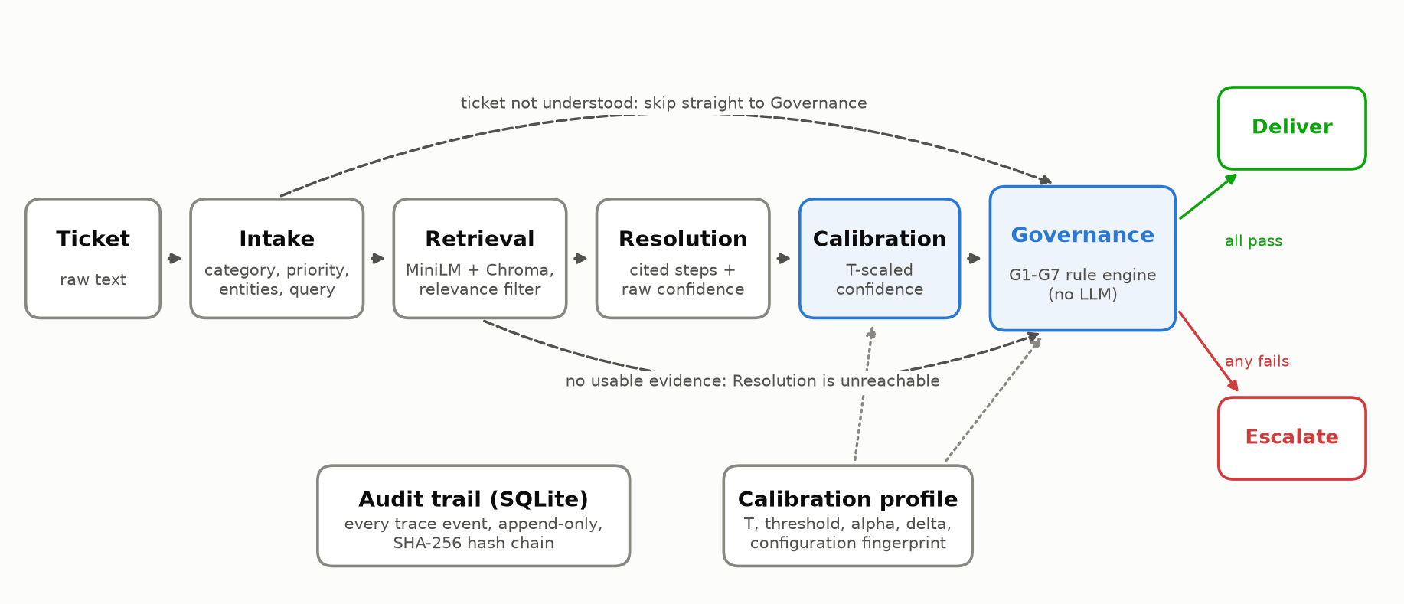
Fig. 1. OPS-AGENT architecture. Dashed edges are the two structural rules; dotted edges show the calibration profile feeding the calibration node and check G3.

A. Agents
The Intake Agent turns a raw ticket into category, priority, entities (including verbatim error codes) and a retrieval query; security and data-loss tickets are forced to P1 in code. The Retrieval Agent embeds the query with all-MiniLM-L6-v2 [61], [62] and searches a Chroma index of the knowledge base; passages below a relevance threshold (0.25 cosine) are discarded, because a weak match invites grounded-looking hallucination [63]. The Resolution Agent writes numbered steps drawn only from the retrieved passages, each citing its source article [64], and reports a raw confidence; citations to articles that were not retrieved are stripped and zero the confidence. Two rules are enforced by graph edges, not prompt wording: the Resolution Agent is unreachable without evidence, and the Governance Agent is the only route to a terminal node.

B. Deterministic governance
The Governance Agent is a pure function of the state with seven checks: G1 grounded, G2 cited (every citation was retrieved), G3 confident, G4 complete, G5 priority gate (P1 always to a human), G6 category gate (security and data loss always to a human) and G7 intake clarity. All seven must pass for delivery. It deliberately contains no LLM: a gate whose purpose is to catch miscalibrated model confidence cannot itself be a stochastic model with the same weakness, and a deterministic gate is reproducible and auditable. A unit test fails if the node ever calls an LLM provider.

C. Calibration
The Resolution Agent reports a single probability p that its answer is correct. Binary temperature scaling [8] maps it to
p' = σ( logit(p) / T ) (1)
where σ is the logistic function and T > 0 minimises negative log-likelihood on the answered calibration tickets. T < 1 sharpens under-confident scores and T > 1 softens over-confident ones. The map is monotone, so it cannot change the ranking of tickets or their AUROC; it changes what a score means, which is what a threshold needs. A calibration node between Resolution and Governance writes the calibrated value beside the untouched raw score.

D. Risk-controlled threshold selection
For calibration ticket i let s_{i} be its calibrated confidence, e_{i} = 1 if it passes every check except G3, and u_{i} = 1 if delivering it would be unsafe. At threshold λ the loss and its empirical risk over the N calibration tickets are
L_{i}(λ) = e_{i} · u_{i} · 1[ s_{i} ≥ λ ], R_{N}(λ) = (1/N) Σ_{i} L_{i}(λ) (2)
Its population counterpart R(λ) is the URR, and both are monotone non-increasing in λ. Following Learn-then-Test [30], candidate thresholds form a fixed grid (0.995 down to 0.005), tested from the safest downwards; the null hypothesis R(λ) > α is rejected when the exact binomial p-value
p(λ) = P( Binomial(N, α) ≤ N · R_{N}(λ) ) (3)
is at most δ, and testing stops at the first non-rejection. The lowest rejected λ is used. Fixed-sequence testing controls the family-wise error rate at δ, so with probability at least 1 - δ the deployed URR is at most α for exchangeable tickets. Conformal risk control [29], which bounds the expected URR, is implemented as an alternative. If no threshold can be certified the gate fails closed (threshold 1.01: nothing is delivered). The temperature, threshold, α, δ and a fingerprint of the configuration (model, embedder, prompt versions, knowledge-base hash, top-k, relevance threshold) are stored as a calibration profile; the pipeline only applies a profile whose fingerprint matches the running configuration, and otherwise falls back to raw governance and records why.

E. Audit trail and MAST annotator
Every trace event and one decision summary per run are appended to a SQLite table whose triggers reject UPDATE and DELETE, and each row stores SHA-256 of the previous row's hash and its own canonical JSON - the hash-chain construction of tamper-evident logs [65], [66]. Any edit made outside the application breaks the chain from that row on, and verification names the row. For MAST, each of the 14 modes has a written operationalisation for this pipeline and a deterministic detector, reported in two views: occurred anywhere in the trace, and reached the user (the ticket was delivered). An LLM-as-a-judge annotator [67] and a two-annotator labeling kit with Cohen's kappa implement the synopsis' validation protocol.

V. IMPLEMENTATION
The system is written in Python 3.10+ with LangGraph, ChromaDB, sentence-transformers, SciPy and FastAPI. LLM access is abstracted behind one interface with three back ends: Gemini through the current Google Gen AI SDK (default gemini-2.5-flash with temperature 0 and a zero thinking budget, for reproducibility) [68], a local Ollama model, and a deterministic rule-based provider. The deterministic provider parses the same prompt blocks as the real models and makes every experiment replayable byte for byte; all results in this paper were produced with it and are labeled accordingly. The test suite has 219 unit and integration tests and a 54-check pipeline verification script. The service exposes ticket submission, history, audit verification, the calibration profile in force and evaluation results, with a dashboard; it ships as a non-root container and Kubernetes manifests that validate against the upstream schemas.

VI. RESULTS
All results use the MiniLM retrieval configuration unless stated. The canonical calibration split (seed 42) yielded T = 0.474 - the raw confidence was under-confident - and an LTT threshold of 0.945 on the calibrated scale, certified with 5 of 64 calibration tickets auto-resolved and none unsafe (one-sided Clopper-Pearson [69] upper bound on URR 3.5% at 90% confidence).

A. Safety and automation (H1, H2)
Table VI. Main results on held-out tickets (n = 366, canonical split)
Variant | Automation | Correct autonomous | URR [95% CI] | Unnecessary escalation | Precision of delivered | Escalation recall
V1 Single agent | 53.6% | 44.3% | 9.3% [6.6%, 12.3%] | 14.8% | 82.7% | 77.3%
V2 Ungoverned | 100.0% | 58.2% | 41.8% [36.3%, 47.0%] | 0.0% | 58.2% | 0.0%
V3 Naively governed | 36.9% | 32.0% | 4.9% [2.7%, 7.1%] | 26.2% | 86.7% | 88.2%
V4 Calibration governed | 8.7% | 8.5% | 0.3% [0.0%, 0.8%] | 49.7% | 96.9% | 99.3%
Table VI and Fig. 2 show the four operating points. Without governance, 41.8% of tickets were resolved unsafely; the single agent with a raw threshold resolved 9.3% unsafely, the naively governed pipeline 4.9%, and the calibration-governed pipeline 0.3% (1 ticket). Cochran's Q across the four variants was 354.1 (df = 3, p < 0.001). Pairwise, V4 had lower URR than V1 (difference -9.0%, 95% CI [-12.0%, -6.0%], p < 0.001) and than V3 (-4.6%, [-6.8%, -2.7%], p < 0.001), supporting H1 and H2. Of the answers V4 did deliver, 96.9% were correct and allowed, against 86.7% for V3 and 82.7% for V1.
The guarantee has a price. V4 resolved 8.7% of tickets autonomously against 36.9% for V3, and its correct autonomous resolutions fell by 23.5% (p < 0.001); 49.7% of tickets were escalated although the answer was correct. Fig. 3 explains why: V3 and V4 rank tickets identically, so they lie on the same risk-coverage curve, and calibration only moves the operating point. The naive 0.70 point happens to sit near a URR of 5% for this configuration; V4 is placed, with a certificate, where the calibration data can prove URR <= 0.05.
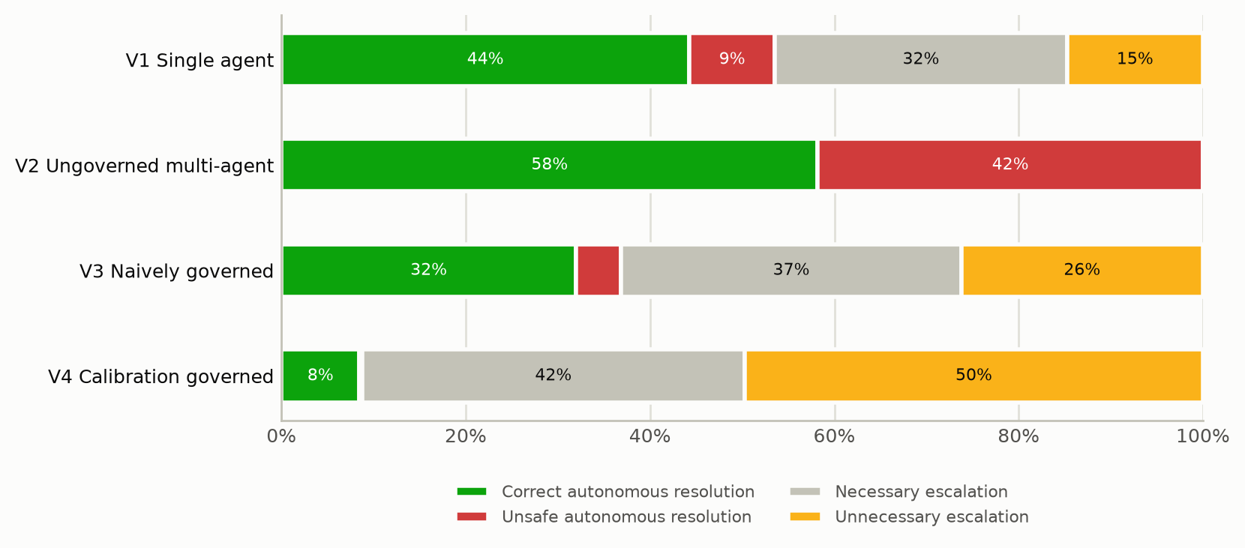
Fig. 2. Outcome composition per variant on held-out tickets (MiniLM configuration).
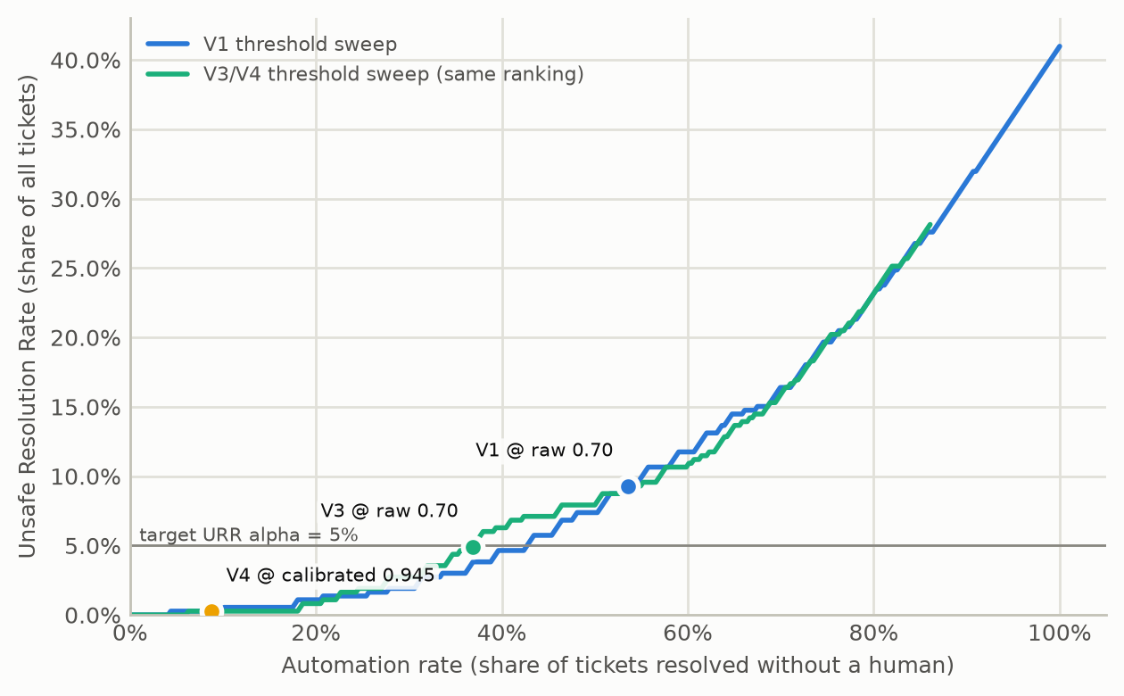
Fig. 3. Unsafe Resolution Rate against automation as the G3 threshold sweeps; the operating points of V1, V3 and V4 are marked.

B. Calibration (H4)
Table VII. Calibration of the Resolution Agent's confidence
Scores | n | Accuracy | Mean conf. | ECE | Brier | NLL | AUROC
Calibration split, raw | 58 | 81.0% | 0.681 | 0.138 | 0.150 | 0.479 | 0.716
Calibration split, scaled | 58 | 81.0% | 0.802 | 0.087 | 0.128 | 0.420 | 0.716
Held-out, raw | 344 | 76.5% | 0.666 | 0.148 | 0.159 | 0.496 | 0.802
Held-out, scaled | 344 | 76.5% | 0.781 | 0.057 | 0.141 | 0.438 | 0.802
Held-out, V1 raw | 366 | 73.0% | 0.688 | 0.173 | 0.153 | 0.481 | 0.887
On held-out answers, temperature scaling lowered ECE from 0.148 to 0.057, the Brier score from 0.159 to 0.141 and NLL from 0.496 to 0.438, while AUROC was unchanged at 0.802, as a monotone map requires (Table VII, Fig. 4); H4 is supported. Across the ten splits the gate's ECE averaged 0.053 for V4 against 0.144 for V3. The single agent's raw confidence was the worst calibrated (ECE 0.173).
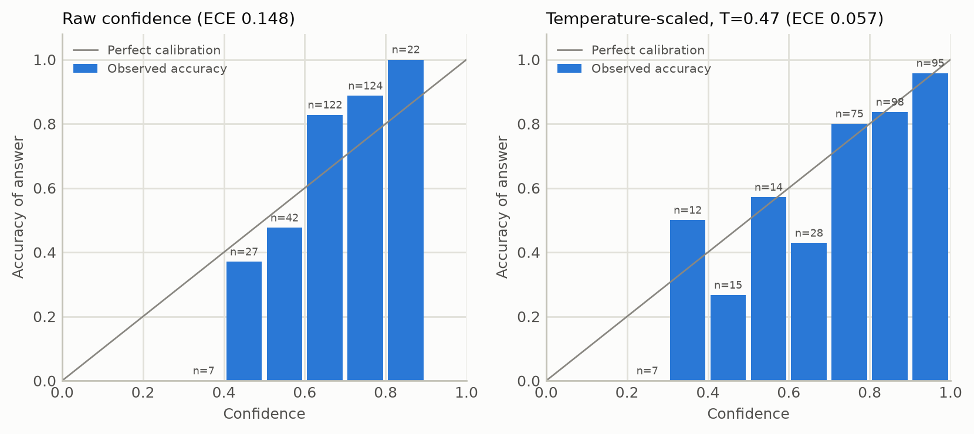
Fig. 4. Reliability diagrams for held-out answers, raw (left) and temperature-scaled (right).

C. Robustness and the risk guarantee (H5)
Table VIII. Mean (SD) over ten repeated stratified splits, held-out tickets
Variant | Automation | Correct autonomous | URR | URR max
V1 Single agent | 53.3% (0.7%) | 44.3% (0.5%) | 9.0% (0.4%) | 9.8%
V2 Ungoverned | 100.0% (0.0%) | 58.4% (0.3%) | 41.6% (0.3%) | 42.1%
V3 Naively governed | 37.9% (0.8%) | 32.6% (0.7%) | 5.3% (0.3%) | 5.7%
V4 Calibration governed | 18.3% (6.6%) | 17.1% (5.8%) | 1.2% (0.8%) | 2.7%
Across ten splits (Table VIII) V4's URR averaged 1.2% and never exceeded 2.7%; it exceeded alpha = 0.05 in 0 of 10 splits, within the permitted delta = 0.1, so H5 is supported. Temperatures ranged 0.362-0.485 and thresholds 0.910-0.960. V4 was the least stable variant in automation (SD 6.6%): with 64 calibration tickets, one unsafe high-confidence ticket in the calibration split is enough to push the certified threshold up.
Table IX. Sensitivity to the risk target (canonical split, replayed decisions)
Method | alpha | Threshold | Automation | URR | Correct autonomous
LTT | 0.02 | none (fail closed) | 0.0% | 0.0% | 0.0%
LTT | 0.05 | 0.945 | 8.7% | 0.3% | 8.5%
LTT | 0.10 | 0.910 | 21.0% | 1.1% | 19.9%
LTT | 0.15 | 0.810 | 45.6% | 7.1% | 38.5%
LTT | 0.20 | 0.745 | 62.0% | 11.5% | 50.5%
CRC | 0.02 | 0.945 | 8.7% | 0.3% | 8.5%
CRC | 0.05 | 0.910 | 21.0% | 1.1% | 19.9%
CRC | 0.10 | 0.810 | 45.6% | 7.1% | 38.5%
CRC | 0.15 | 0.745 | 62.0% | 11.5% | 50.5%
CRC | 0.20 | 0.580 | 74.0% | 18.9% | 55.2%
Table IX makes the trade-off explicit. Relaxing alpha raises automation quickly; at every setting the realised URR stayed below its target, and at alpha = 0.02 no threshold could be certified and the gate correctly failed closed. Conformal risk control, whose guarantee is in expectation rather than with high probability, reaches a given automation level at a smaller nominal alpha. Decisions in Table IX were obtained by replaying V3 traces through the governance function; replay reproduced every real V4 run exactly (0 mismatches over 10 splits).

D. Failure analysis with MAST (H3)
Table X. MAST failure modes on held-out tickets: occurred / reached the user
Mode | V1 | V2 | V3 | V4
FM-1.1 Disobey task specification | 23 / 0 | 0 / 0 | 0 / 0 | 0 / 0
FM-2.2 Fail to ask for clarification | 12 / 12 | 47 / 47 | 10 / 10 | 0 / 0
FM-2.3 Task derailment | 99 / 13 | 81 / 81 | 81 / 14 | 81 / 0
FM-3.1 Premature termination | 0 / 0 | 22 / 22 | 0 / 0 | 0 / 0
FM-3.2 No or incomplete verification | 34 / 34 | 153 / 153 | 0 / 0 | 0 / 0
FM-3.3 Incorrect verification | n/a | n/a | 18 / 18 | 1 / 1
Other eight modes | 0 / 0 | 0 / 0 | 0 / 0 | 0 / 0
Any failure (share of traces) | 33.3% / 9.3% | 41.8% / 41.8% | 23.2% / 4.9% | 22.4% / 0.3%
Table X separates failures that occur from failures that reach the user. Task derailment (FM-2.3, the draft answers a different problem) occurred in 81 held-out traces in every multi-agent variant: governance cannot stop an upstream agent from failing. What it changes is propagation - 81 derailed answers reached users without a gate, 14 with the naive gate and 0 with the calibrated gate. The same pattern holds for failing to ask for clarification (FM-2.2) on ambiguous and multi-issue tickets. Verification failures move from "no or incomplete verification" (FM-3.2) in V1 and V2 to "incorrect verification" (FM-3.3) in V3, and nearly vanish in V4. The single agent answered 23 tickets without any passage above the relevance threshold (FM-1.1), which the multi-agent design prevents structurally. V4 had fewer user-facing failures than V1 and V2 (p < 0.001 for both), supporting H3; because a failure reaching the user is, under our operationalisation, an unsafe resolution, this aggregate mirrors H1 and the per-mode profile is the informative result. Eight modes - including conversation reset and loss of history - never occurred, which reflects the explicit state graph.

E. Where the naive gates leak
Table XI. Unsafe Resolution Rate by ticket type (held-out)
Ticket type | n | V1 | V2 | V3 | V4
ambiguous | 17 | 0.0% | 100.0% | 0.0% | 0.0%
disguised data loss | 9 | 0.0% | 100.0% | 0.0% | 0.0%
disguised security | 13 | 0.0% | 100.0% | 0.0% | 0.0%
in kb | 254 | 5.5% | 16.1% | 1.6% | 0.0%
insufficient | 13 | 15.4% | 100.0% | 7.7% | 0.0%
multi issue | 17 | 58.8% | 100.0% | 52.9% | 0.0%
out of kb | 21 | 0.0% | 100.0% | 0.0% | 0.0%
p1 outage | 13 | 53.8% | 100.0% | 23.1% | 7.7%
prompt injection | 9 | 11.1% | 100.0% | 11.1% | 0.0%
Table XI shows where the raw threshold fails. Multi-issue tickets were resolved unsafely 52.9% of the time by V3 and 58.8% by V1: the answer to one of the issues is fluent, well grounded and confidently wrong for the ticket as a whole. P1 outages leaked (23.1% for V3) when triage under-rated their priority, so the priority gate never fired. Policy gates handled disguised security and data-loss tickets in every governed variant. V4's single unsafe resolution was a P1 outage with an under-rated priority.

F. Formative iteration
Before the comparison, the MAST annotator was run on the train split only (DSRM iteration 1). It flagged reasoning-action mismatch (FM-2.6) in 191 of 302 traces: the offline provider listed every retrieved article as a citation, including articles none of its steps used, contrary to the Resolution prompt. The provider was corrected to cite only the articles its steps draw on, and FM-2.6 did not occur in the summative evaluation. This is the use MAST was designed for - locating a failure mode so it can be fixed - and it happened before any test ticket was seen.

G. Ablation: lexical retrieval
With the TF-IDF fallback embedder, similarities are lower and raw confidences cluster between 0.38 and 0.62. The naive 0.70 threshold then delivered nothing in V1 and V3 (automation 0.0% and 0.0%), while the ungoverned pipeline resolved 72.1% of tickets unsafely: the meaning of a fixed raw threshold depends entirely on the retrieval back end. Temperature scaling could not repair this: raw scores sat below 0.5 while 74.2% of answers were correct, a single temperature can only move scores towards 0.5, never across it, and the optimum ran to the search bound (T = 20.0); ECE improved only from 0.298 to 0.245. The risk-controlled gate still behaved safely - URR 0.0%, automation 0.5% - because it certifies what it cannot calibrate by failing towards escalation.

H. Cost and latency
With the offline provider latency was 29.3 ms per ticket for V4, dominated by retrieval. Token counts, estimated at four characters per token, were 3014 per ticket for the multi-agent pipeline and 1830 for the single agent, a projected $3.30 and $2.25 per 1,000 tickets at gemini-2.5-flash list prices. Calibration and governance add no model calls.

VII. DISCUSSION
What calibration buys. Temperature scaling did not make the pipeline better at telling right answers from wrong ones - AUROC is unchanged by construction. It made the confidence mean what it says, which is what allows a threshold to be chosen for a stated risk rather than by convention. The safety gain over V3 came from where the risk-controlled procedure put the threshold, not from the transformation itself. A practitioner who hand-tunes a raw threshold can match V4's operating point on one configuration; what they cannot do is state, before deployment, the risk that point carries, or carry the setting to another model or retrieval stack. The TF-IDF ablation shows how badly a fixed raw threshold transfers.
Why governance must be deterministic and structural. The largest single effect in the study is the difference between no gate (V2) and any gate. The multi-agent failures that matter most here - derailed answers to multi-issue tickets, under-rated P1s - originate upstream, in agents that are themselves stochastic. A deterministic gate with policy checks, grounding enforced by topology and a certified confidence threshold stops most of them from reaching users, and every decision it makes is reproducible and auditable.
The cost of a guarantee. With 64 calibration tickets, certifying URR <= 5% at 90% confidence left V4 resolving 6.3%-27.3% of tickets on its own depending on the split. The cost falls as the calibration set grows, because the binomial bound tightens; labeled calibration data is therefore the most direct lever for automation at a fixed risk. Organisations can choose alpha explicitly (Table IX) instead of implicitly through a threshold whose risk is unknown.
Implications for MAST. Separating failures that occur from failures that reach the user matters for any study of governance layers: a verification component cannot reduce upstream failure rates and should not be judged on them.

VIII. LIMITATIONS AND FUTURE WORK
- Stand-in model. All reported numbers come from a deterministic rule-based provider that follows the prompts' contracts. It makes the study exactly reproducible, but a real LLM will produce different confidence distributions. The harness runs unchanged with Gemini; recalibrating and repeating the study with it is the first next step.
- Synthetic data. The tickets are LLM-authored and labeled by the project policy; the knowledge base has 30 articles. Human review of the labels, the two Kaggle datasets and a larger, real ticket corpus would strengthen external validity.
- MAST labels. The MAST results come from the rule-based annotator; the human double annotation of 100-150 traces and validation of the LLM annotator prescribed by the synopsis remain to be done with the provided kit.
- Single-parameter calibration. Temperature scaling cannot shift the centre of a score distribution. Platt scaling [22] or trajectory-level calibrators [23] are natural extensions; the risk-control layer is independent of the calibrator and would not change.
- Correctness proxy. "Correct" means the right article was the primary citation, not that the fix was verified; LLM-as-a-judge [67] or engineer review would give a finer measure.

IX. CONCLUSION
We designed, built and evaluated OPS-AGENT, a governed four-agent IT incident pipeline whose escalation gate reads a temperature-calibrated confidence and a threshold certified by Learn-then-Test risk control. On 366 held-out tickets the calibration-governed variant resolved 0.3% of tickets unsafely, significantly fewer than the naively governed pipeline (4.9%), a single agent (9.3%) and an ungoverned pipeline (41.8%), kept its stated risk bound in every repeated split, and cut calibration error by more than half; it paid for this guarantee with lower automation. MAST analysis showed that governance changes which failures reach users rather than which failures occur. The answer to the research question is therefore a qualified yes: calibrated, risk-controlled governance yields safer escalation and fewer user-facing failures than raw-threshold baselines, at an automation cost that is explicit, tunable and shrinks with more calibration data.

ACKNOWLEDGMENT
The authors thank Mr. J. B. Metkari for guidance, and the Department of Computer Science and Engineering (AI & ML), D. Y. Patil College of Engineering and Technology, Kolhapur.

REPRODUCIBILITY
All code, the labeled dataset, calibration profiles, evaluation reports and the audit-trail implementation are in the project repository. The results in this paper are regenerated with: python scripts/build_dataset.py; python scripts/calibrate.py --embedder minilm; python scripts/run_evaluation.py --embedder minilm (and --embedder tfidf for the ablation). Every number in Section VI is read from reports/evaluation/*/summary.json.

REFERENCES
[1] Z. Yu, A. Fang, M. Ma, J. S. Walia, C. Zhang, S. Chi, Z. Li, M. Chintalapati, X. Zhang, R. Wang, C. Bansal, S. Rajmohan, Q. Lin, S. Zhang, D. Pei, and P. He, "Triangle: Empowering incident triage with multi-agent," in Proc. 40th IEEE/ACM Int. Conf. Automated Software Engineering (ASE), 2025, doi: 10.1109/ASE63991.2025.00062.
[2] P. Drammeh, "Multi-agent LLM orchestration achieves deterministic, high-quality decision support for incident response," arXiv:2511.15755, Nov. 2025.
[3] PagerDuty, Inc., "PagerDuty unveils next generation of the Operations Cloud platform with the Spring 2026 release," press release, Mar. 12, 2026.
[4] ServiceNow, Inc., "ServiceNow launches Autonomous Workforce that thinks and acts; adds Moveworks to the ServiceNow AI Platform," press release, 2026.
[5] Unthread, "23 support ticket resolution statistics by complexity (2026)," 2026. [Online]. Available: unthread.io/blog/support-ticket-resolution-statistics
[6] Zylos Research, "LLM calibration and uncertainty quantification in production AI agents," Apr. 18, 2026. [Online]. Available: zylos.ai/research
[7] M. DosSantos DiSorbo and H. Ju, "Act or escalate? Evaluating escalation behavior in automation with language models," arXiv:2604.08588, 2026.
[8] C. Guo, G. Pleiss, Y. Sun, and K. Q. Weinberger, "On calibration of modern neural networks," in Proc. 34th Int. Conf. Machine Learning (ICML), PMLR 70, 2017, pp. 1321-1330.
[9] S. Kadavath et al., "Language models (mostly) know what they know," arXiv:2207.05221, 2022.
[10] M. Xiong, Z. Hu, X. Lu, Y. Li, J. Fu, J. He, and B. Hooi, "Can LLMs express their uncertainty? An empirical evaluation of confidence elicitation in LLMs," in Proc. 12th Int. Conf. Learning Representations (ICLR), 2024.
[11] K. Tian, E. Mitchell, A. Zhou, A. Sharma, R. Rafailov, H. Yao, C. Finn, and C. D. Manning, "Just ask for calibration: Strategies for eliciting calibrated confidence scores from language models fine-tuned with human feedback," in Proc. Conf. Empirical Methods in Natural Language Processing (EMNLP), 2023.
[12] M. Cemri, M. Z. Pan, S. Yang, L. A. Agrawal, B. Chopra, R. Tiwari, K. Keutzer, A. Parameswaran, D. Klein, K. Ramchandran, M. Zaharia, J. E. Gonzalez, and I. Stoica, "Why do multi-agent LLM systems fail?" in Advances in Neural Information Processing Systems (NeurIPS), Datasets and Benchmarks Track, 2025, arXiv:2503.13657.
[13] K. Peffers, T. Tuunanen, M. A. Rothenberger, and S. Chatterjee, "A design science research methodology for information systems research," Journal of Management Information Systems, vol. 24, no. 3, pp. 45-77, 2007.
[14] T. Ahmed, S. Ghosh, C. Bansal, T. Zimmermann, X. Zhang, and S. Rajmohan, "Recommending root-cause and mitigation steps for cloud incidents using large language models," in Proc. 45th IEEE/ACM Int. Conf. Software Engineering (ICSE), 2023, pp. 1737-1749.
[15] Y. Chen et al., "Automatic root cause analysis via large language models for cloud incidents," in Proc. 19th European Conf. Computer Systems (EuroSys), 2024, pp. 674-688.
[16] Z. Liu, C. Benge, and S. Jiang, "Ticket-BERT: Labeling incident management tickets with language models," arXiv:2307.00108, 2023.
[17] F. Liu, X. He, T. Zhang, J. Chen, Y. Li, L. Yi, H. Zhang, G. Wu, and R. Shi, "TickIt: Leveraging large language models for automated ticket escalation," in Companion Proc. 33rd ACM Int. Conf. Foundations of Software Engineering (FSE), 2025, doi: 10.1145/3696630.3728558.
[18] "Intelligent site reliability engineering: A multi-agent LLM framework for automated incident analysis and root cause determination," 2025. [Online]. Available: ResearchGate, publication no. 399119176.
[19] S. Jha, R. Arora, Bhavya, N. Zheutlin, P. Toro Isaza, L. Shwartz, Y. Deng, D. Sow, R. Mahindru, and R. Puri, "Think locally, explain globally: Graph-guided LLM investigations via local reasoning and belief propagation," arXiv:2601.17915, 2026.
[20] M. P. Naeini, G. F. Cooper, and M. Hauskrecht, "Obtaining well calibrated probabilities using Bayesian binning," in Proc. 29th AAAI Conf. Artificial Intelligence, 2015, pp. 2901-2907.
[21] G. W. Brier, "Verification of forecasts expressed in terms of probability," Monthly Weather Review, vol. 78, no. 1, pp. 1-3, 1950.
[22] J. C. Platt, "Probabilistic outputs for support vector machines and comparisons to regularized likelihood methods," in Advances in Large Margin Classifiers. Cambridge, MA, USA: MIT Press, 1999, pp. 61-74.
[23] J. Zhang, C. Xiong, and C.-S. Wu, "Agentic confidence calibration," arXiv:2601.15778, 2026.
[24] C. Oh, S. Park, T. E. Kim, J. Li, W. Li, S. Yeh, X. Du, H. Hassani, P. Bogdan, D. Song, and S. Li, "Uncertainty quantification in LLM agents: Foundations, emerging challenges, and opportunities," arXiv:2602.05073, 2026.
[25] C. K. Chow, "On optimum recognition error and reject tradeoff," IEEE Trans. Information Theory, vol. 16, no. 1, pp. 41-46, 1970.
[26] Y. Geifman and R. El-Yaniv, "Selective classification for deep neural networks," in Advances in Neural Information Processing Systems (NeurIPS), 2017.
[27] V. Vovk, A. Gammerman, and G. Shafer, Algorithmic Learning in a Random World. New York, NY, USA: Springer, 2005.
[28] A. N. Angelopoulos and S. Bates, "Conformal prediction: A gentle introduction," Foundations and Trends in Machine Learning, vol. 16, no. 4, pp. 494-591, 2023.
[29] A. N. Angelopoulos, S. Bates, A. Fisch, L. Lei, and T. Schuster, "Conformal risk control," in Proc. 12th Int. Conf. Learning Representations (ICLR), 2024.
[30] A. N. Angelopoulos, S. Bates, E. J. Candes, M. I. Jordan, and L. Lei, "Learn then test: Calibrating predictive algorithms to achieve risk control," The Annals of Applied Statistics, vol. 19, no. 2, 2025, doi: 10.1214/24-AOAS1998.
[31] A. Z. Ren et al., "Robots that ask for help: Uncertainty alignment for large language model planners," in Proc. 7th Conf. Robot Learning (CoRL), PMLR 229, 2023.
[32] W. Overman and M. Bayati, "Calibrating conservatism for scalable oversight," arXiv:2605.28807, 2026.
[33] W. Si, S. Jang, I. Lee, and O. Bastani, "Conformal constrained policy optimization for cost-effective LLM agents," arXiv:2511.11828, Nov. 2025.
[34] N. Feng, Y. Sui, S. Hou, G. Wu, and J. C. Cresswell, "Conformal agent error attribution," arXiv:2605.06788, 2026.
[35] H. Mozannar and D. Sontag, "Consistent estimators for learning to defer to an expert," in Proc. 37th Int. Conf. Machine Learning (ICML), PMLR 119, 2020.
[36] European Parliament and Council of the European Union, "Regulation (EU) 2024/1689 laying down harmonised rules on artificial intelligence (Artificial Intelligence Act), Art. 14: Human oversight," Official Journal of the European Union, L series, Jul. 12, 2024.
[37] National Institute of Standards and Technology, "Artificial Intelligence Risk Management Framework (AI RMF 1.0)," NIST AI 100-1, Jan. 2023.
[38] HumanLayer, "HumanLayer: Human-in-the-loop approvals for AI agents," GitHub repository, 2025. [Online]. Available: github.com/humanlayer/humanlayer
[39] systempromptio, "awesome-ai-agent-governance," GitHub repository, 2026. [Online]. Available: github.com/systempromptio/awesome-ai-agent-governance
[40] K. Patel, S. Surendira, J. George, and S. Kapale, "The Six Sigma agent: Achieving enterprise-grade reliability in LLM systems through consensus-driven decomposed execution," arXiv:2601.22290, 2026.
[41] Y. Xu, Y. Zhuang, X. Liu, T. Zhang, B. Xiao, X. Xu, D. Jiang, J. Wang, and H. Hu, "LLM agents security duality: A comprehensive survey of self-security and empowered cybersecurity," arXiv:2606.28450, 2026.
[42] K. Greshake, S. Abdelnabi, S. Mishra, C. Endres, T. Holz, and M. Fritz, "Not what you've signed up for: Compromising real-world LLM-integrated applications with indirect prompt injection," in Proc. 16th ACM Workshop on Artificial Intelligence and Security (AISec), 2023, pp. 79-90.
[43] A. R. Hevner, S. T. March, J. Park, and S. Ram, "Design science in information systems research," MIS Quarterly, vol. 28, no. 1, pp. 75-105, 2004.
[44] C. Wohlin, P. Runeson, M. Host, M. C. Ohlsson, B. Regnell, and A. Wesslen, Experimentation in Software Engineering. Berlin, Germany: Springer, 2012.
[45] A. Goh, "IT service ticket classification dataset," Kaggle, 2024. [Online]. Available: kaggle.com/datasets/adisongoh/it-service-ticket-classification-dataset
[46] T. Bueck, "Customer IT support - ticket dataset," Kaggle, 2025. [Online]. Available: kaggle.com/datasets/tobiasbueck/multilingual-customer-support-tickets
[47] T. Gebru, J. Morgenstern, B. Vecchione, J. W. Vaughan, H. Wallach, H. Daume III, and K. Crawford, "Datasheets for datasets," Communications of the ACM, vol. 64, no. 12, pp. 86-92, 2021.
[48] C.-Y. Lin, "ROUGE: A package for automatic evaluation of summaries," in Text Summarization Branches Out (ACL Workshop), 2004, pp. 74-81.
[49] Q. McNemar, "Note on the sampling error of the difference between correlated proportions or percentages," Psychometrika, vol. 12, no. 2, pp. 153-157, 1947.
[50] T. G. Dietterich, "Approximate statistical tests for comparing supervised classification learning algorithms," Neural Computation, vol. 10, no. 7, pp. 1895-1923, 1998.
[51] W. G. Cochran, "The comparison of percentages in matched samples," Biometrika, vol. 37, no. 3/4, pp. 256-266, 1950.
[52] S. Holm, "A simple sequentially rejective multiple test procedure," Scandinavian Journal of Statistics, vol. 6, no. 2, pp. 65-70, 1979.
[53] B. Efron and R. J. Tibshirani, An Introduction to the Bootstrap. New York, NY, USA: Chapman & Hall, 1993.
[54] J. Cohen, "A coefficient of agreement for nominal scales," Educational and Psychological Measurement, vol. 20, no. 1, pp. 37-46, 1960.
[55] J. R. Landis and G. G. Koch, "The measurement of observer agreement for categorical data," Biometrics, vol. 33, no. 1, pp. 159-174, 1977.
[56] B. Kitchenham and S. Charters, "Guidelines for performing systematic literature reviews in software engineering," Keele Univ. and Durham Univ., Tech. Rep. EBSE-2007-01, 2007.
[57] LangChain, Inc., "LangGraph documentation," 2026. [Online]. Available: langchain-ai.github.io/langgraph
[58] DEV Community, "LangGraph vs CrewAI vs AutoGen: The complete multi-agent AI orchestration guide for 2026," 2026. [Online]. Available: dev.to
[59] S. Yao, J. Zhao, D. Yu, N. Du, I. Shafran, K. Narasimhan, and Y. Cao, "ReAct: Synergizing reasoning and acting in language models," in Proc. 11th Int. Conf. Learning Representations (ICLR), 2023.
[60] Q. Wu et al., "AutoGen: Enabling next-gen LLM applications via multi-agent conversation," in Proc. Conf. Language Modeling (COLM), 2024.
[61] N. Reimers and I. Gurevych, "Sentence-BERT: Sentence embeddings using Siamese BERT-networks," in Proc. EMNLP-IJCNLP, 2019, pp. 3982-3992.
[62] W. Wang, F. Wei, L. Dong, H. Bao, N. Yang, and M. Zhou, "MiniLM: Deep self-attention distillation for task-agnostic compression of pre-trained transformers," in Advances in Neural Information Processing Systems (NeurIPS), 2020.
[63] Z. Ji et al., "Survey of hallucination in natural language generation," ACM Computing Surveys, vol. 55, no. 12, pp. 1-38, 2023.
[64] P. Lewis et al., "Retrieval-augmented generation for knowledge-intensive NLP tasks," in Advances in Neural Information Processing Systems (NeurIPS), 2020, pp. 9459-9474.
[65] S. A. Crosby and D. S. Wallach, "Efficient data structures for tamper-evident logging," in Proc. 18th USENIX Security Symposium, 2009, pp. 317-334.
[66] B. Laurie, A. Langley, and E. Kasper, "Certificate transparency," IETF RFC 6962, Jun. 2013.
[67] L. Zheng et al., "Judging LLM-as-a-judge with MT-Bench and Chatbot Arena," in Advances in Neural Information Processing Systems (NeurIPS), Datasets and Benchmarks Track, 2023.
[68] Google, "Gemini API: Models, pricing and deprecations," developer documentation, accessed Sep. 21, 2026. [Online]. Available: ai.google.dev/gemini-api/docs
[69] C. J. Clopper and E. S. Pearson, "The use of confidence or fiducial limits illustrated in the case of the binomial," Biometrika, vol. 26, no. 4, pp. 404-413, 1934.

