LABSHEET 01
Naman Singh, Section D, CU24250110 Roll No. – 43

Task 1.1: Semantic HTML Resume Page
Question
Design a structured HTML resume page incorporating semantic layout blocks such as <header>, <section>, and <footer>, ensuring complete conformance with modern accessibility parameters.
Answer
<!DOCTYPE html>
<html lang="en">
<head>
<meta charset="UTF-8">
<meta name="viewport" content="width=device-width, initial-scale=1.0">
<title>Naman Singh - Resume</title>
<style>
body {
font-family: 'Segoe UI', Arial, sans-serif;
max-width: 820px;
margin: 30px auto;
padding: 24px;
line-height: 1.65;
color: #1f2937;
}
header {
border-bottom: 3px solid #0f766e;
padding-bottom: 16px;
}
header h1 {
color: #0f766e;
margin-bottom: 4px;
}
header p {
margin: 3px 0;
color: #4b5563;
}
nav ul {
list-style: none;
padding: 0;
display: flex;
gap: 22px;
flex-wrap: wrap;
}
nav a {
text-decoration: none;
color: #0f766e;
font-weight: bold;
}
nav a:hover {
text-decoration: underline;
}
section {
margin-top: 26px;
}
section h2 {
color: #0f766e;
border-left: 4px solid #0f766e;
padding-left: 10px;
}
article {
margin-bottom: 15px;
}
.tag-row {
display: flex;
flex-wrap: wrap;
gap: 8px;
margin-top: 8px;
}
.tag {
background: #ccfbf1;
color: #115e59;
padding: 5px 12px;
border-radius: 999px;
font-size: 13px;
font-weight: 600;
}
footer {
border-top: 1px solid #d1d5db;
margin-top: 32px;
padding-top: 12px;
text-align: center;
color: #6b7280;
}
</style>
</head>
<body>
<header>
<h1>Saurabh Sharma</h1>
<p>Generative AI &amp; Full Stack Developer | Roorkee, Uttarakhand, India</p>
<p>Email: rabhs1009@gmail.com | GitHub: 100Rabh-19</p>
<nav aria-label="Resume Navigation">
<ul>
<li><a href="#about">About</a></li>
<li><a href="#education">Education</a></li>
<li><a href="#skills">Skills</a></li>
<li><a href="#projects">Projects</a></li>
<li><a href="#certifications">Certifications</a></li>
</ul>
</nav>
</header>

<main>
<section id="about">
<h2>About Me</h2>
<p>
B.Tech Computer Science student focused on Generative AI, LLM
applications and Retrieval-Augmented Generation. Experienced in
building RAG pipelines, agentic workflows and full-stack web
interfaces using React, FastAPI and modern JavaScript.
</p>
</section>

<section id="education">
<h2>Education</h2>
<article>
<h3>B.Tech in Computer Science Engineering</h3>
<p>2024 – 2028 | COER University, Roorkee | CGPA: 9.10</p>
</article>
</section>

<section id="skills">
<h2>Technical Skills</h2>
<div class="tag-row">
<span class="tag">Python</span>
<span class="tag">LangChain</span>
<span class="tag">React &amp; FastAPI</span>
<span class="tag">ChromaDB</span>
<span class="tag">RAG Systems</span>
<span class="tag">Git &amp; GitHub</span>
</div>
</section>

<section id="projects">
<h2>Projects</h2>
<article>
<h3>AI Video &amp; Meeting Assistant</h3>
<p>
Hybrid RAG (BM25 + ChromaDB via Reciprocal Rank Fusion) with dual
transcription engines and a Mistral-powered meeting dashboard.
</p>
</article>
<article>
<h3>WhatsApp RAG Student Assistant</h3>
<p>
24/7 assistant for COER University students combining structured
slot-filling with a RAG fallback, built on FastAPI and Twilio.
</p>
</article>
</section>

<section id="certifications">
<h2>Certifications</h2>
<ul>
<li>Oracle Cloud AI Foundations</li>
<li>NPTEL Java</li>
<li>Claude Code in Action — Anthropic</li>
</ul>
</section>
</main>

<footer>
<p>&copy; 2026 Naman Singh. All Rights Reserved.</p>
</footer>
</body>
</html>

Output
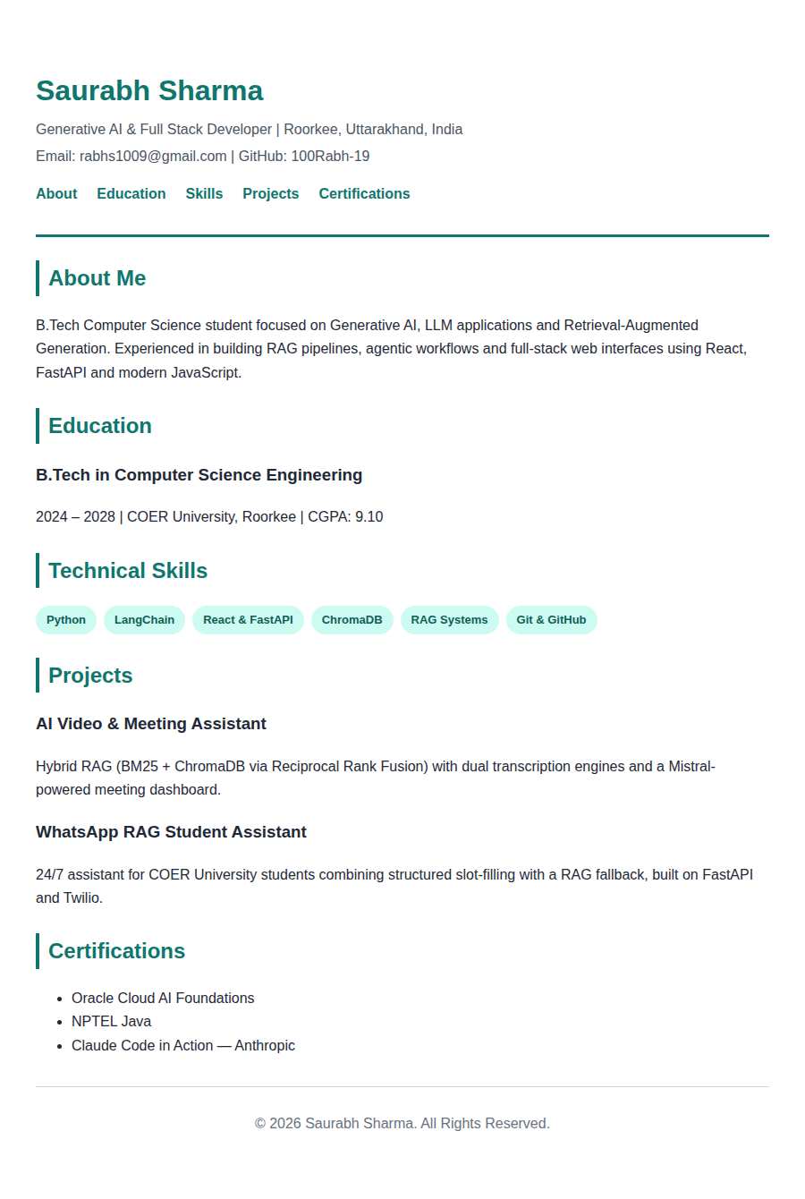
Email- Naman@gmail.com
Naman Singh
Naman

Task 1.2: Nested Navigation Menu Bar
Question
Construct an HTML page implementing a nested navigation menu bar using list item anchors, ensuring absolute path linking patterns to external resource addresses.
Answer
<!DOCTYPE html>
<html lang="en">
<head>
<meta charset="UTF-8">
<meta name="viewport" content="width=device-width, initial-scale=1.0">
<title>AI Learning Hub — Navigation</title>
<style>
body {
margin: 0;
font-family: 'Segoe UI', Arial, sans-serif;
background-color: #f7f8fa;
}
nav {
background-color: #0f3d3e;
}
nav ul {
list-style: none;
margin: 0;
padding: 0;
}
nav > ul {
display: flex;
}
nav li {
position: relative;
}
nav a {
display: block;
padding: 16px 22px;
color: #f0fdfa;
text-decoration: none;
font-weight: 500;
}
nav a:hover {
background-color: #145c5d;
}
nav ul ul {
position: absolute;
top: 100%;
left: 0;
width: 210px;
background-color: #145c5d;
display: none;
box-shadow: 0 8px 20px rgba(0,0,0,0.2);
}
nav li:hover > ul {
display: block;
}
nav ul ul ul {
top: 0;
left: 100%;
}
main {
padding: 36px 7%;
}
main h1 { color: #0f3d3e; }
main p { color: #4b5563; max-width: 600px; }
</style>
</head>
<body>
<nav aria-label="Main Navigation">
<ul>
<li><a href="https://www.aihub.example.com/">Home</a></li>
<li>
<a href="https://www.aihub.example.com/tracks">Learning Tracks</a>
<ul>
<li><a href="https://www.aihub.example.com/tracks/genai">Generative AI</a></li>
<li><a href="https://www.aihub.example.com/tracks/webdev">Full Stack Web</a></li>
<li>
<a href="https://www.aihub.example.com/tracks/llm">LLM Engineering</a>
<ul>
<li><a href="https://python.langchain.com/">LangChain Docs</a></li>
<li><a href="https://docs.anthropic.com/">Anthropic Docs</a></li>
</ul>
</li>
</ul>
</li>
<li>
<a href="https://www.aihub.example.com/resources">Resources</a>
<ul>
<li><a href="https://developer.mozilla.org/">MDN Web Docs</a></li>
<li><a href="https://huggingface.co/">Hugging Face</a></li>
<li><a href="https://github.com/">GitHub</a></li>
</ul>
</li>
<li><a href="https://www.aihub.example.com/contact">Contact</a></li>
</ul>
</nav>
<main>
<h1>AI Learning Hub</h1>
<p>
This page demonstrates a nested navigation menu using HTML unordered
lists and anchor elements, with absolute links to external learning
resources.
</p>
</main>
</body>
</html>

Output
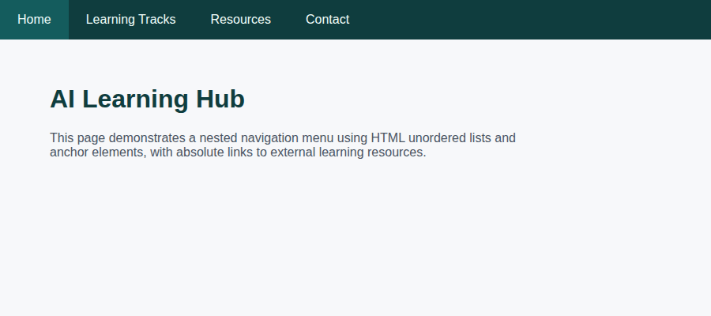
Default state of the navigation bar
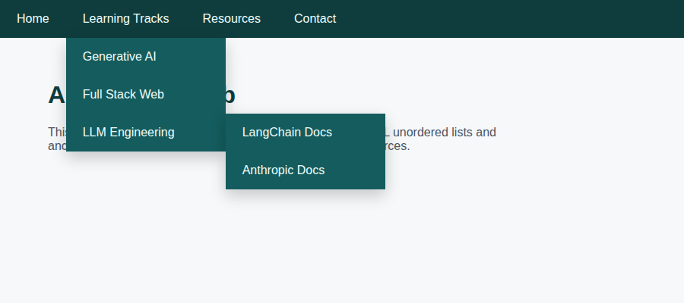
Two-level nested submenu revealed on hover (Learning Tracks → LLM Engineering)

Task 1.3: Itemized Web Catalog Using Definition Lists
Question
Formulate an itemized web catalog interface containing descriptive metadata terms using structured definition lists: <dl>, <dt>, and <dd>.
Answer
<!DOCTYPE html>
<html lang="en">
<head>
<meta charset="UTF-8">
<meta name="viewport" content="width=device-width, initial-scale=1.0">
<title>Tech Gear Catalog</title>
<style>
body {
font-family: 'Segoe UI', Arial, sans-serif;
max-width: 900px;
margin: 30px auto;
padding: 20px;
background-color: #f4f6f8;
}
h1 {
text-align: center;
color: #0f766e;
}
.catalog-grid {
display: grid;
grid-template-columns: repeat(auto-fit, minmax(250px, 1fr));
gap: 20px;
}
.product {
background-color: white;
border: 1px solid #e2e8f0;
border-radius: 12px;
padding: 20px;
box-shadow: 0 4px 14px rgba(0,0,0,0.05);
}
.product h2 {
margin-top: 0;
font-size: 18px;
color: #1f2937;
}
dt {
font-weight: bold;
color: #0f766e;
margin-top: 10px;
font-size: 13px;
text-transform: uppercase;
letter-spacing: 0.03em;
}
dd {
margin-left: 0;
margin-bottom: 6px;
color: #4b5563;
}
.stock {
color: #059669;
font-weight: 600;
}
</style>
</head>
<body>
<h1>Tech Gear Catalog</h1>
<div class="catalog-grid">

<div class="product">
<h2>Mechanical Keyboard — Slate 87</h2>
<dl>
<dt>Brand</dt>
<dd>KeyForge</dd>
<dt>Price</dt>
<dd>₹4,199</dd>
<dt>Category</dt>
<dd>Peripherals</dd>
<dt>Description</dt>
<dd>Hot-swappable mechanical keyboard with per-key RGB and a compact 87-key layout.</dd>
<dt>Availability</dt>
<dd class="stock">In Stock</dd>
</dl>
</div>

<div class="product">
<h2>Noise-Cancelling Headset</h2>
<dl>
<dt>Brand</dt>
<dd>AudioForge</dd>
<dt>Price</dt>
<dd>₹5,999</dd>
<dt>Category</dt>
<dd>Audio</dd>
<dt>Description</dt>
<dd>Over-ear headset with active noise cancellation and a 30-hour battery.</dd>
<dt>Availability</dt>
<dd class="stock">In Stock</dd>
</dl>
</div>

<div class="product">
<h2>1080p Webcam Pro</h2>
<dl>
<dt>Brand</dt>
<dd>ClearView</dd>
<dt>Price</dt>
<dd>₹2,799</dd>
<dt>Category</dt>
<dd>Peripherals</dd>
<dt>Description</dt>
<dd>Full-HD webcam with auto-focus and a built-in privacy shutter.</dd>
<dt>Availability</dt>
<dd class="stock">In Stock</dd>
</dl>
</div>

<div class="product">
<h2>Portable SSD 1TB</h2>
<dl>
<dt>Brand</dt>
<dd>DataDrift</dd>
<dt>Price</dt>
<dd>₹7,499</dd>
<dt>Category</dt>
<dd>Storage</dd>
<dt>Description</dt>
<dd>USB-C portable SSD with read speeds up to 1050 MB/s.</dd>
<dt>Availability</dt>
<dd class="stock">In Stock</dd>
</dl>
</div>

</div>
</body>
</html>

Output
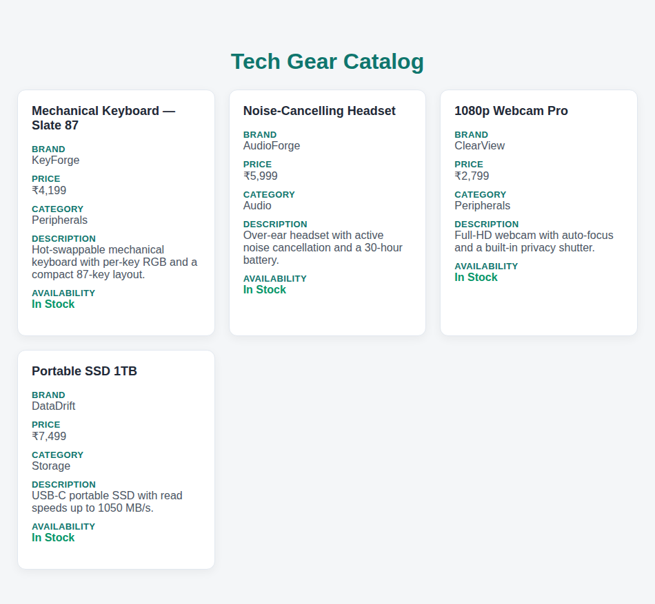
Rendered product catalog with four items

