LAB SHEET 02
Naman Singh, CU24250110, Roll No. - 43

Task 2.1: Interactive Theme-Switcher Landing Page
Aim: Build a responsive landing page that lets the user toggle between a dark and a light theme using CSS custom properties and a small JavaScript event handler.
index.html
<!DOCTYPE html>
<html lang="en">
<head>
<meta charset="UTF-8">
<meta name="viewport" content="width=device-width, initial-scale=1.0">
<title>Theme Switcher Landing Page</title>
<link rel="stylesheet" href="style.css">
</head>
<body>
<header class="topbar">
<h2 class="brand">NovaSpace</h2>
<button id="modeToggle">🌞 Switch to Day</button>
</header>
<main class="banner">
<p class="badge">FAST • CLEAN • ADAPTIVE</p>
<h1>Design Experiences That Adapt.</h1>
<p>A minimal landing page with a smooth light/dark theme switch.</p>
<button class="primaryBtn">Start Now</button>
</main>
<footer class="footer">
<p>&copy; 2026 NovaSpace</p>
</footer>
<script src="script.js"></script>
</body>
</html>

style.css
:root {
--bg: #101820;
--surface: #182531;
--text: #eef3f8;
--muted: #93a3b3;
--accent: #ff7849;
}
body.day {
--bg: #f7f9fc;
--surface: #ffffff;
--text: #14202b;
--muted: #64748b;
--accent: #ea580c;
}
* { box-sizing: border-box; margin: 0; padding: 0; }
body {
min-height: 100vh;
font-family: 'Segoe UI', Arial, sans-serif;
background: var(--bg);
color: var(--text);
display: flex;
flex-direction: column;
transition: background .35s ease, color .35s ease;
}
.topbar {
display: flex;
justify-content: space-between;
align-items: center;
padding: 18px 6%;
background: var(--surface);
box-shadow: 0 2px 10px rgba(0,0,0,0.15);
}
.brand { letter-spacing: 1px; }
button {
border: 0;
border-radius: 8px;
padding: 10px 18px;
background: var(--accent);
color: white;
font-weight: 600;
cursor: pointer;
}
.banner {
flex: 1;
display: grid;
place-items: center;
text-align: center;
padding: 60px 7%;
}
.banner h1 { font-size: clamp(38px, 6vw, 70px); margin: 18px 0; }
.banner p:not(.badge) { color: var(--muted); line-height: 1.7; margin-bottom: 28px; }
.badge { color: var(--accent); font-weight: 700; letter-spacing: 2px; font-size: 14px; }
.footer { text-align: center; padding: 16px; color: var(--muted); font-size: 13px; }
@media (max-width: 600px) { .topbar { padding: 14px 5%; } }

script.js
const modeToggle = document.getElementById("modeToggle");

modeToggle.addEventListener("click", () => {
document.body.classList.toggle("day");
const isDay = document.body.classList.contains("day");
modeToggle.textContent = isDay ? "🌙 Switch to Night" : "🌞 Switch to Day";
});

Output

Night mode (default state)
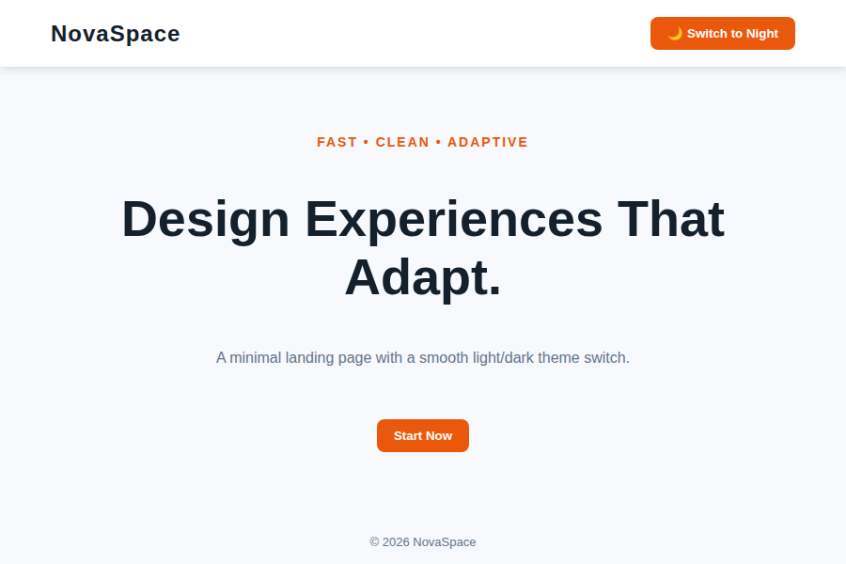
Day mode (after clicking the toggle button)

Task 2.2: Responsive Scenic Photo Wall Using Flexbox
Aim: Build a responsive photo wall that wraps into a single column on small screens and applies a scale + saturation hover effect on each photo.
index.html
<!DOCTYPE html>
<html lang="en">
<head>
<meta charset="UTF-8">
<meta name="viewport" content="width=device-width, initial-scale=1.0">
<title>Scenic Photo Wall</title>
<link rel="stylesheet" href="style.css">
</head>
<body>
<h1>My Scenic Photo Wall</h1>
<div class="wall">
<div class="frame"><img src="sunset.jpg" alt="Sunset Hills"></div>
<div class="frame"><img src="ocean.jpg" alt="Ocean Bay"></div>
<div class="frame"><img src="forest.jpg" alt="Pine Forest"></div>
<div class="frame"><img src="desert.jpg" alt="Desert Dunes"></div>
<div class="frame"><img src="snow.jpg" alt="Snow Peaks"></div>
<div class="frame"><img src="city.jpg" alt="City Lights"></div>
</div>
</body>
</html>

style.css
* { box-sizing: border-box; }
body {
margin: 0;
padding: 40px 6%;
font-family: 'Segoe UI', Arial, sans-serif;
background: #eef1f5;
}
h1 { text-align: center; margin-bottom: 32px; color: #22303f; }
.wall {
display: flex;
flex-wrap: wrap;
gap: 18px;
justify-content: center;
}
.frame {
flex: 1 1 260px;
max-width: 360px;
overflow: hidden;
border-radius: 18px;
box-shadow: 0 6px 16px rgba(0,0,0,0.12);
}
.frame img {
display: block;
width: 100%;
height: 230px;
object-fit: cover;
filter: saturate(0.9);
transition: transform .4s ease, filter .4s ease;
}
.frame:hover img {
transform: scale(1.12) rotate(0.5deg);
filter: saturate(1.2);
}
@media (max-width: 600px) {
.frame { flex-basis: 100%; max-width: none; }
.frame img { height: 210px; }
}

Output

Rendered photo wall (6 images, flex-wrap layout)

Task 2.3: Client-Side Task Manager Application
Aim: Build a task-manager app that creates list items at runtime using the DOM API, validates empty input, and keeps a live count of pending tasks.
index.html (includes embedded CSS and JS)
<!DOCTYPE html>
<html lang="en">
<head>
<meta charset="UTF-8">
<meta name="viewport" content="width=device-width, initial-scale=1.0">
<title>Task Manager</title>
<style>
body { font-family: 'Segoe UI', Arial; background:#f0f4f8; padding:50px 20px; }
.card { max-width:600px; margin:auto; background:white;
padding:30px; border-radius:18px; box-shadow: 0 8px 24px rgba(0,0,0,0.08); }
.card h1 { color: #1e3a5f; }
.row { display:flex; gap:10px; margin-top: 16px; }
#taskField { flex:1; padding:12px; border:1px solid #cbd5e1; border-radius:10px; font-size: 15px; }
button { padding:12px 18px; border:0; border-radius:10px;
background:#0ea5a4; color:white; cursor:pointer; font-weight:600; }
#warning { color:#e11d48; min-height:22px; margin-top:10px; font-size: 14px; }
#counter { color:#64748b; font-size: 13px; margin-top: 4px; }
li { list-style:none; display:flex; justify-content:space-between; align-items:center; padding:12px 14px;
margin-top:10px; background:#f1f5f9; border-radius:10px; }
.removeBtn { background:#e11d48; padding:6px 12px; border-radius: 6px; font-weight: 500; }
</style>
</head>
<body>
<div class="card">
<h1>Task Manager</h1>
<div class="row">
<input id="taskField" type="text" placeholder="What needs to be done?">
<button id="createBtn">Add Task</button>
</div>
<div id="warning"></div>
<div id="counter">0 tasks</div>
<ul id="taskList"></ul>
</div>

<script>
const taskField = document.getElementById("taskField");
const createBtn = document.getElementById("createBtn");
const taskList = document.getElementById("taskList");
const warning = document.getElementById("warning");
const counter = document.getElementById("counter");
let taskCount = 0;

function updateCounter() {
counter.textContent = `${taskCount} task${taskCount === 1 ? "" : "s"}`;
}

function createTask() {
const value = taskField.value.trim();

if (value.length === 0) {
warning.textContent = "Task cannot be empty.";
taskField.focus();
return;
}

warning.textContent = "";

const item = document.createElement("li");
const label = document.createElement("span");
const removeBtn = document.createElement("button");

label.textContent = value;
removeBtn.textContent = "Remove";
removeBtn.className = "removeBtn";

removeBtn.addEventListener("click", () => {
item.remove();
taskCount--;
updateCounter();
});

item.appendChild(label);
item.appendChild(removeBtn);
taskList.appendChild(item);

taskCount++;
updateCounter();

taskField.value = "";
taskField.focus();
}

createBtn.addEventListener("click", createTask);

taskField.addEventListener("keydown", (e) => {
if (e.key === "Enter") createTask();
});
</script>
</body>
</html>

Output
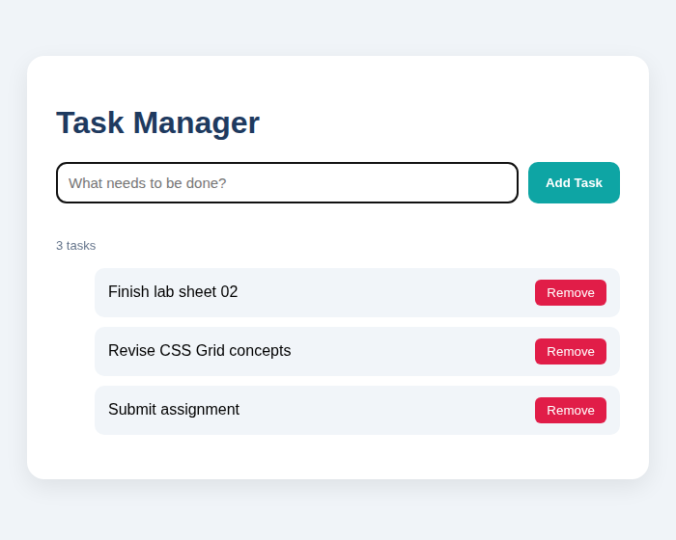
Task manager after adding three tasks

