LAB SHEET 03
Naman Singh, CU24250110, Roll No. - 43

1. Set Up the React App Using Vite
npm create vite@latest task-tracker -- --template react
cd task-tracker
npm install
npm run dev
This scaffolds a React application using Vite. The dev server URL is printed in the terminal once it starts.

2. Project Structure
task-tracker/
├── src/
│ ├── components/
│ │ ├── AddTaskForm.jsx
│ │ ├── TaskList.jsx
│ │ └── TaskItem.jsx
│ ├── App.jsx
│ ├── App.css
│ └── main.jsx
├── index.html
└── package.json

3. Component Tree Diagram
App
│
├── AddTaskForm
│ └── input + Add Task button
│
└── TaskList
├── TaskItem
├── TaskItem
└── TaskItem

4. App.jsx — Parent Component
import { useEffect, useMemo, useState } from "react";
import AddTaskForm from "./components/AddTaskForm";
import TaskList from "./components/TaskList";
import "./App.css";

function App() {
const [tasks, setTasks] = useState(() => {
const stored = localStorage.getItem("task-tracker-items");
return stored ? JSON.parse(stored) : [];
});

useEffect(() => {
localStorage.setItem("task-tracker-items", JSON.stringify(tasks));
}, [tasks]);

const addTask = (label) => {
const newTask = { id: crypto.randomUUID(), label, done: false };
setTasks((prev) => [newTask, ...prev]);
};

const toggleTask = (id) => {
setTasks((prev) =>
prev.map((task) => (task.id === id ? { ...task, done: !task.done } : task))
);
};

const deleteTask = (id) => {
setTasks((prev) => prev.filter((task) => task.id !== id));
};

const remaining = useMemo(() => tasks.filter((t) => !t.done).length, [tasks]);

return (
<div className="app">
<div className="tracker-card">
<h1>Task Tracker</h1>
<p className="subtitle">
{tasks.length === 0
? "Component-based task management"
: `${remaining} of ${tasks.length} task${tasks.length === 1 ? "" : "s"} remaining`}
</p>
<AddTaskForm onAddTask={addTask} />
<TaskList tasks={tasks} onToggle={toggleTask} onDelete={deleteTask} />
</div>
</div>
);
}

export default App;

5. AddTaskForm.jsx
import { useState } from "react";

function AddTaskForm({ onAddTask }) {
const [value, setValue] = useState("");
const [warning, setWarning] = useState("");

const handleSubmit = (e) => {
e.preventDefault();
const trimmed = value.trim();

if (!trimmed) {
setWarning("A task cannot be blank.");
return;
}

onAddTask(trimmed);
setValue("");
setWarning("");
};

return (
<form onSubmit={handleSubmit} className="task-form">
<div className="field-row">
<input
value={value}
onChange={(e) => setValue(e.target.value)}
placeholder="What do you need to do?"
/>
<button type="submit">+ Add Task</button>
</div>
{warning && <p className="warning">{warning}</p>}
</form>
);
}

export default AddTaskForm;

6. TaskList.jsx
import TaskItem from "./TaskItem";

function TaskList({ tasks, onToggle, onDelete }) {
if (tasks.length === 0) {
return <p className="empty-state">Nothing here yet — add your first task above.</p>;
}

return (
<div className="task-list">
{tasks.map((task) => (
<TaskItem
key={task.id}
task={task}
onToggle={onToggle}
onDelete={onDelete}
/>
))}
</div>
);
}

export default TaskList;

7. TaskItem.jsx
function TaskItem({ task, onToggle, onDelete }) {
return (
<div className="task-row">
<label>
<input
type="checkbox"
checked={task.done}
onChange={() => onToggle(task.id)}
/>
<span className={task.done ? "done" : ""}>{task.label}</span>
</label>
<button className="removeBtn" onClick={() => onDelete(task.id)}>
Remove
</button>
</div>
);
}

export default TaskItem;

8. main.jsx
import { StrictMode } from "react";
import { createRoot } from "react-dom/client";
import App from "./App.jsx";

createRoot(document.getElementById("root")).render(
<StrictMode>
<App />
</StrictMode>
);

9. App.css
* {
box-sizing: border-box;
}
body {
margin: 0;
font-family: 'Segoe UI', Arial, sans-serif;
background: #f0f3f9;
}
.app {
min-height: 100vh;
display: grid;
place-items: center;
padding: 30px;
}
.tracker-card {
width: min(640px, 100%);
background: white;
padding: 32px;
border-radius: 20px;
box-shadow: 0 14px 40px rgba(20, 30, 60, 0.12);
}
h1 {
margin-bottom: 4px;
color: #1e293b;
}
.subtitle {
color: #64748b;
margin-top: 0;
}
.field-row {
display: flex;
gap: 10px;
margin: 22px 0 6px;
}
.field-row input {
flex: 1;
padding: 12px 14px;
border: 1px solid #cbd5e1;
border-radius: 10px;
font-size: 15px;
}
button {
border: 0;
border-radius: 10px;
padding: 11px 18px;
background: #0891b2;
color: white;
cursor: pointer;
font-weight: 600;
}
.warning {
color: #dc2626;
font-size: 14px;
}
.task-row {
display: flex;
justify-content: space-between;
align-items: center;
padding: 14px;
margin-top: 10px;
background: #f8fafc;
border-radius: 12px;
border: 1px solid #eef2f7;
}
.done {
text-decoration: line-through;
color: #94a3b8;
}
.removeBtn {
background: #e11d48;
padding: 8px 14px;
}
.empty-state {
color: #94a3b8;
text-align: center;
margin-top: 24px;
}
@media (max-width: 600px) {
.field-row {
flex-direction: column;
}
}

Output
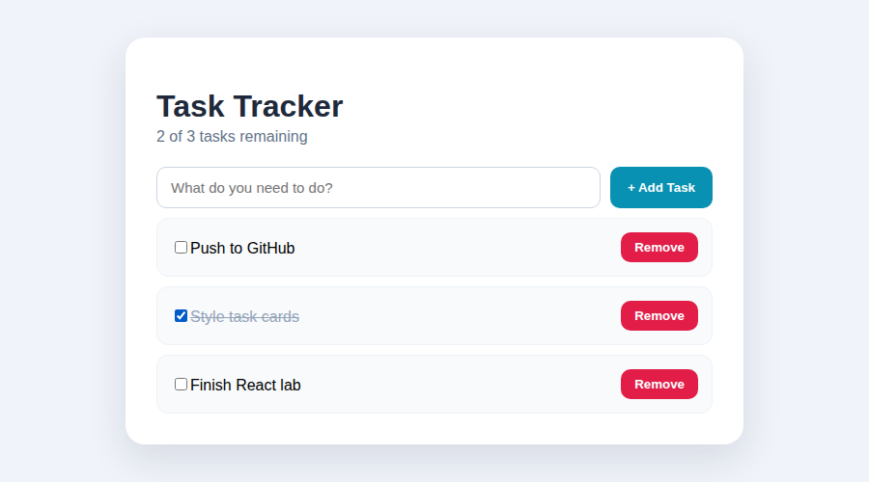
Task Tracker after adding three tasks and completing one (npm run build, served locally)

LAB SHEET 04
Naman Singh,CU24250110, Roll No. - 43

1. Install Dependencies
npm install react-router-dom

2. Project Structure
urban-cart/
├── src/
│ ├── components/
│ │ ├── Navbar.jsx
│ │ ├── ProductCard.jsx
│ │ └── Loading.jsx
│ ├── context/
│ │ └── CartContext.jsx
│ ├── pages/
│ │ ├── Home.jsx
│ │ ├── Products.jsx
│ │ ├── ProductDetails.jsx
│ │ └── NotFound.jsx
│ ├── data.js
│ ├── App.jsx
│ ├── main.jsx
│ └── App.css
└── package.json

3. App.jsx — Routing
import { BrowserRouter, Routes, Route } from "react-router-dom";
import Navbar from "./components/Navbar";
import Home from "./pages/Home";
import Products from "./pages/Products";
import ProductDetails from "./pages/ProductDetails";
import NotFound from "./pages/NotFound";
import "./App.css";

function App() {
return (
<BrowserRouter>
<Navbar />
<Routes>
<Route path="/" element={<Home />} />
<Route path="/products" element={<Products />} />
<Route path="/products/:id" element={<ProductDetails />} />
<Route path="*" element={<NotFound />} />
</Routes>
</BrowserRouter>
);
}

export default App;

4. Product Data (data.js)
export const products = [
{
id: 1,
name: "Bluetooth Earbuds",
price: 1799,
category: "Electronics",
description: "Compact wireless earbuds with active noise cancellation."
},
{
id: 2,
name: "Trail Running Shoes",
price: 2299,
category: "Footwear",
description: "Grippy, lightweight shoes built for off-road running."
},
{
id: 3,
name: "Fitness Band",
price: 1499,
category: "Wearables",
description: "Tracks steps, heart rate, and sleep with a 10-day battery."
},
{
id: 4,
name: "Insulated Water Bottle",
price: 699,
category: "Accessories",
description: "Keeps drinks cold for 24 hours or hot for 12."
}
];

5. Navbar.jsx
import { Link } from "react-router-dom";
import { useCart } from "../context/CartContext";

function Navbar() {
const { items } = useCart();

return (
<nav className="navbar">
<h2>UrbanCart</h2>
<div className="nav-links">
<Link to="/">Home</Link>
<Link to="/products">Shop</Link>
<span className="cart-pill">Cart · {items.length}</span>
</div>
</nav>
);
}

export default Navbar;

6. Home.jsx
function Home() {
return (
<main className="page">
<h1>Welcome to UrbanCart</h1>
<p>A single-page shopping demo built with React Router and Context.</p>
</main>
);
}

export default Home;

7. Products.jsx — Product Listing
import ProductCard from "../components/ProductCard";
import { products } from "../data";

function Products() {
return (
<main className="page">
<h1>Shop All Products</h1>
<div className="product-grid">
{products.map((product) => (
<ProductCard product={product} key={product.id} />
))}
</div>
</main>
);
}

export default Products;

8. ProductDetails.jsx — Route Params
import { Link, useParams } from "react-router-dom";
import { products } from "../data";

function ProductDetails() {
const { id } = useParams();
const product = products.find((item) => item.id === Number(id));

if (!product) {
return <h2>Product not found</h2>;
}

return (
<main className="page">
<h1>{product.name}</h1>
<p>{product.description}</p>
<h2>₹{product.price}</h2>
<p>Category: {product.category}</p>
<Link to="/products">← Back to Shop</Link>
</main>
);
}

export default ProductDetails;

9. CartContext.jsx — Global State
import { createContext, useContext, useState } from "react";

const CartContext = createContext();

export function CartProvider({ children }) {
const [items, setItems] = useState([]);

const addItem = (product) => {
setItems((prev) => [...prev, product]);
};

const removeItem = (id) => {
setItems((prev) => prev.filter((item) => item.id !== id));
};

return (
<CartContext.Provider value={{ items, addItem, removeItem }}>
{children}
</CartContext.Provider>
);
}

export function useCart() {
return useContext(CartContext);
}

10. main.jsx — Context Provider
import { StrictMode } from "react";
import { createRoot } from "react-dom/client";
import App from "./App.jsx";
import { CartProvider } from "./context/CartContext";

createRoot(document.getElementById("root")).render(
<StrictMode>
<CartProvider>
<App />
</CartProvider>
</StrictMode>
);

11. ProductCard.jsx — Using Global State
import { Link } from "react-router-dom";
import { useCart } from "../context/CartContext";

function ProductCard({ product }) {
const { addItem } = useCart();

return (
<article className="product-card">
<div className="thumb" />
<h3>{product.name}</h3>
<p className="cat">{product.category}</p>
<strong>₹{product.price}</strong>
<div className="card-actions">
<Link to={`/products/${product.id}`}>Details</Link>
<button onClick={() => addItem(product)}>Add to Cart</button>
</div>
</article>
);
}

export default ProductCard;

12. Loading.jsx
function Loading() {
return (
<div className="loading">
<p>Fetching products…</p>
</div>
);
}

export default Loading;

13. NotFound.jsx — 404 Page
import { Link } from "react-router-dom";

function NotFound() {
return (
<main className="page">
<h1>404</h1>
<h2>We couldn't find that page</h2>
<p>The page you requested does not exist.</p>
<Link to="/">Back to Home</Link>
</main>
);
}

export default NotFound;

14. App.css
* {
box-sizing: border-box;
}
body {
margin: 0;
font-family: 'Segoe UI', Arial, sans-serif;
background: #f6f7fb;
color: #1c2434;
}
.navbar {
position: sticky;
top: 0;
z-index: 10;
display: flex;
justify-content: space-between;
align-items: center;
padding: 18px 7%;
background: #ffffff;
box-shadow: 0 2px 14px rgba(0,0,0,.06);
}
.nav-links {
display: flex;
align-items: center;
gap: 20px;
}
.navbar a {
color: #0f766e;
text-decoration: none;
font-weight: 600;
}
.cart-pill {
background: #0f766e;
color: white;
padding: 6px 14px;
border-radius: 999px;
font-size: 13px;
font-weight: 600;
}
.page {
max-width: 1100px;
margin: auto;
padding: 50px 7%;
}
.product-grid {
display: grid;
grid-template-columns: repeat(auto-fit, minmax(230px, 1fr));
gap: 20px;
}
.product-card {
background: white;
padding: 20px;
border-radius: 16px;
box-shadow: 0 8px 22px rgba(0,0,0,.07);
}
.thumb {
height: 110px;
border-radius: 10px;
background: linear-gradient(135deg, #ccfbf1, #99f6e4);
margin-bottom: 14px;
}
.cat {
color: #64748b;
margin: 2px 0 8px;
font-size: 13px;
}
.card-actions {
display: flex;
gap: 10px;
margin-top: 14px;
align-items: center;
}
.product-card a,
.product-card button {
padding: 9px 13px;
border: 0;
border-radius: 8px;
background: #0f766e;
color: white;
text-decoration: none;
font-size: 13px;
cursor: pointer;
}

15. Routing and State Flow
Browser URL
│
├── / ──> Home
│
├── /products ──> Products
│ │
│ └── /products/:id
│ ↓
│ Product Details
│
└── any unknown URL ──> 404 Not Found

Global State:
CartProvider
↓
Navbar / ProductCard / other components
↓
items + addItem + removeItem

Output
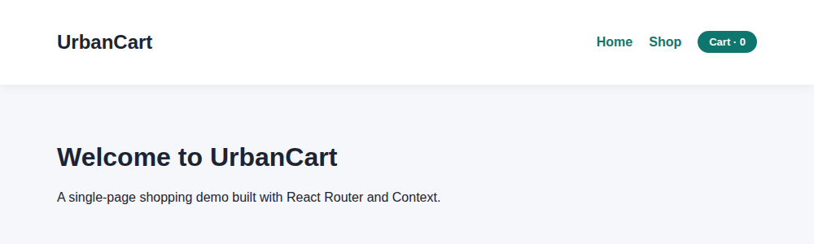
Home page
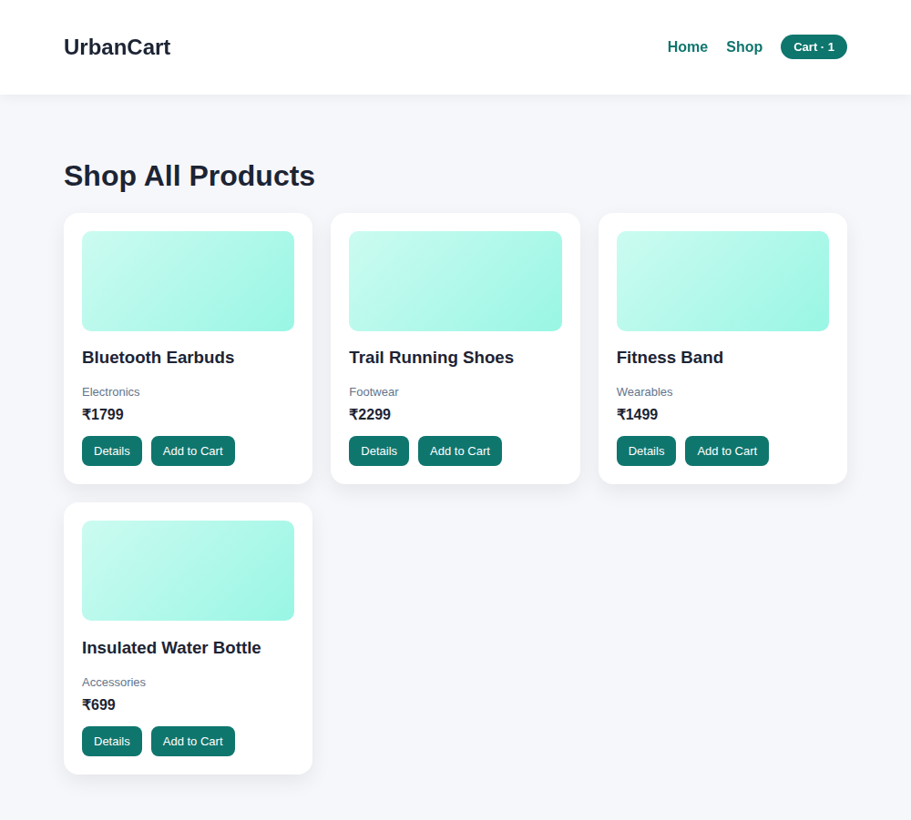
Products listing after adding one item to the cart (cart count updates via Context)
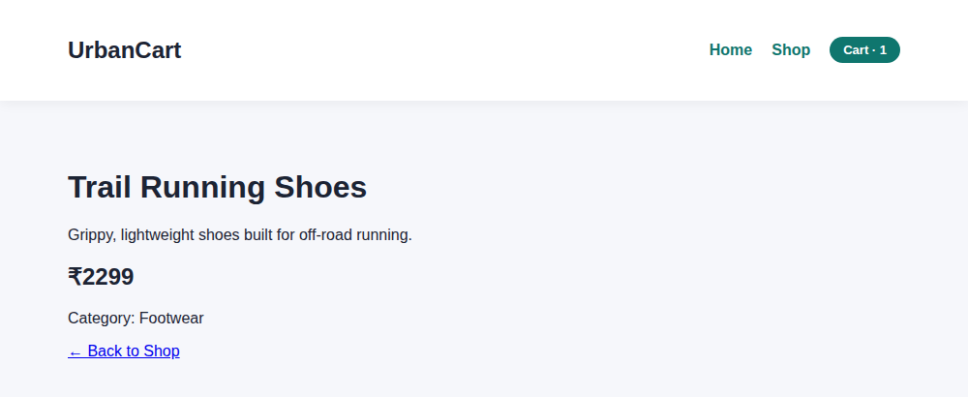
Product details page reached via /products/:id route param
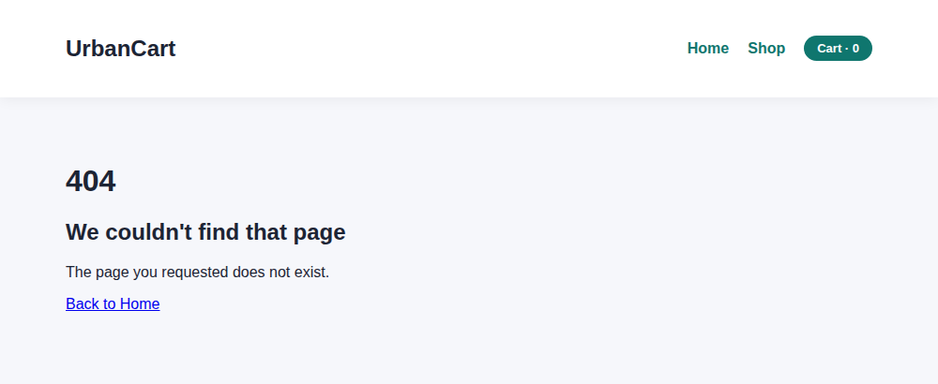
404 page shown for an unmatched route

