PRATICAL5-

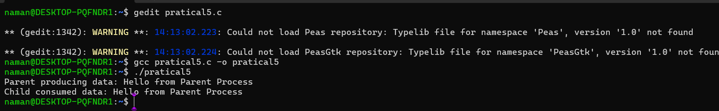

PRATICAL6-

