Game Design Document

Fill up the following document

1. Write the title of your project.

Space journey.

1. What is the goal of the game?

To kill the aline boss .

1. Write a brief story of your game.

After 2000 year the earth was destroy due to asteroids then the 1 human being are remane the name of that human being is Naman were go to space with help of Rocket in the search of other planet there they find the life . after some time he have got one planet there are so many aline they look like human being . He go to the king of planet for asking permision to live on there planet because there planet Earth were destroyed by an asteroids then the king of the planet give them permision to live on there planet . Afte 3 years the bad aline come to there plant he cheat with the king and kill the king of that planet and become the new king . When the naman know that they make a plane to kill the bad aline then the war start naman make a fighter ship wich can help him in war after some day naman win and naman become new king.

1. Which are the playing characters of this game?

* Playing characters are the ones who respond to the user based on the input from the user.
* Cars, monkeys, dinos, wizards, etc., are the playing characters in the game.

|  |  |  |
| --- | --- | --- |
| Number | Character Name | What can this character do? |
| 1 | Naman | He can kill the bad aline . |
| 2 |  |  |
| 3 |  |  |
| 4 |  |  |
| 5 |  |  |
| 6 |  |  |
| 7 |  |  |
| 8 |  |  |

1. Which are the Non-Playing Characters of this game?

* Non-Playing characters are the ones that don't have an action or behavior when the user interacts with the game.
* Hurdles, stones, bananas, coins, etc., are non-playing characters in the game.

|  |  |  |
| --- | --- | --- |
| Number | Character Name | What can this character do? |
| 1 | Bad aline | He is king |
| 2 | The soilder of bad king | They fight |
| 3 |  |  |
| 4 |  |  |
| 5 |  |  |
| 6 |  |  |
| 7 |  |  |
| 8 |  |  |

Draw your imagination of this game. What does this game look like?

* Draw the game either on your computer or on paper.
* Add images of the game scenes to show each of the playing and non-playing characters at least o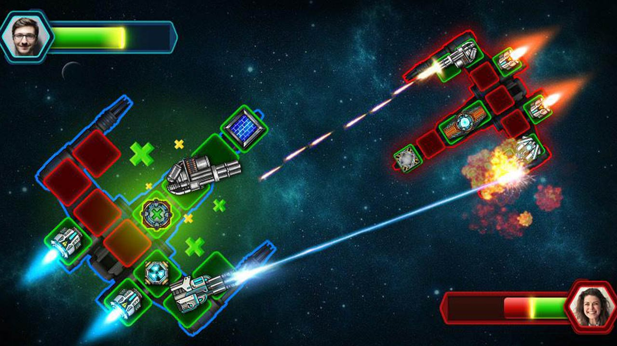
* How do you plan to make your game engaging?

By ading some , animation sound and some specil efect.