Name =Naman Sonawane
PRN=202501070181
Div=et2 e23
Dataset=twitter airline US sentiment
1. Total number of tweets
print(len(df))
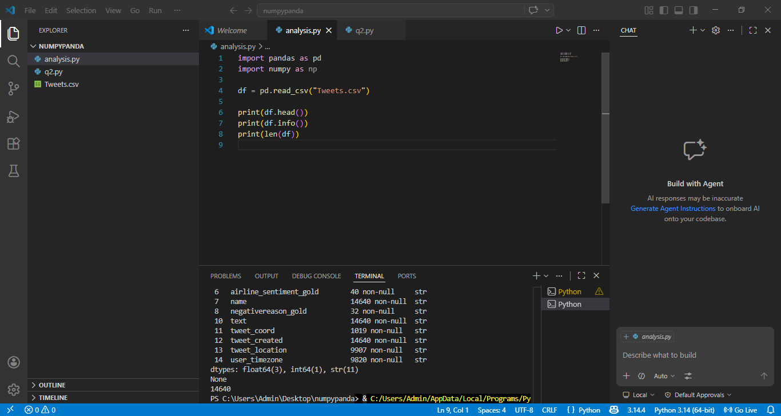
2. Count tweets per airline
print(df['airline'].value_counts())
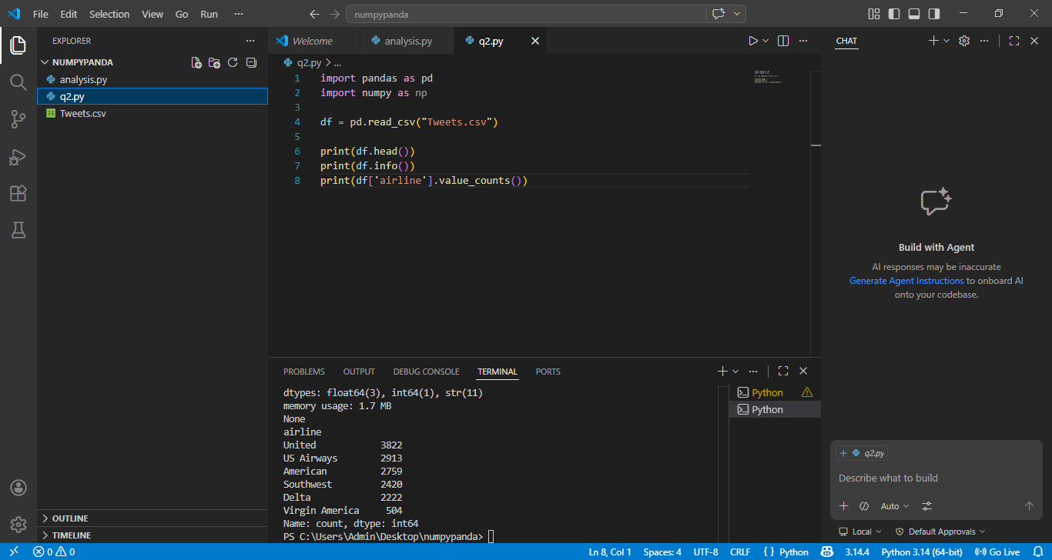

3. Percentage of sentiment (positive/negative/neutral)
print(df['airline_sentiment'].value_counts(normalize=True)*100)
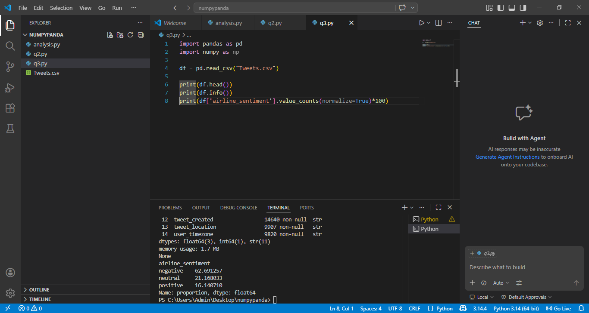
4. Most common airline
print(df['airline'].mode())
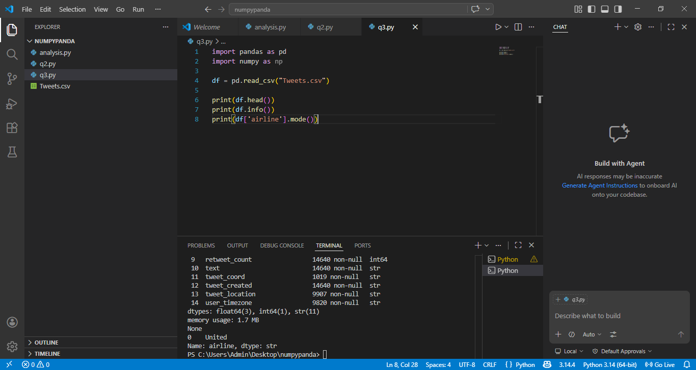

5. Count negative tweets
print((df['airline_sentiment'] == 'negative').sum())
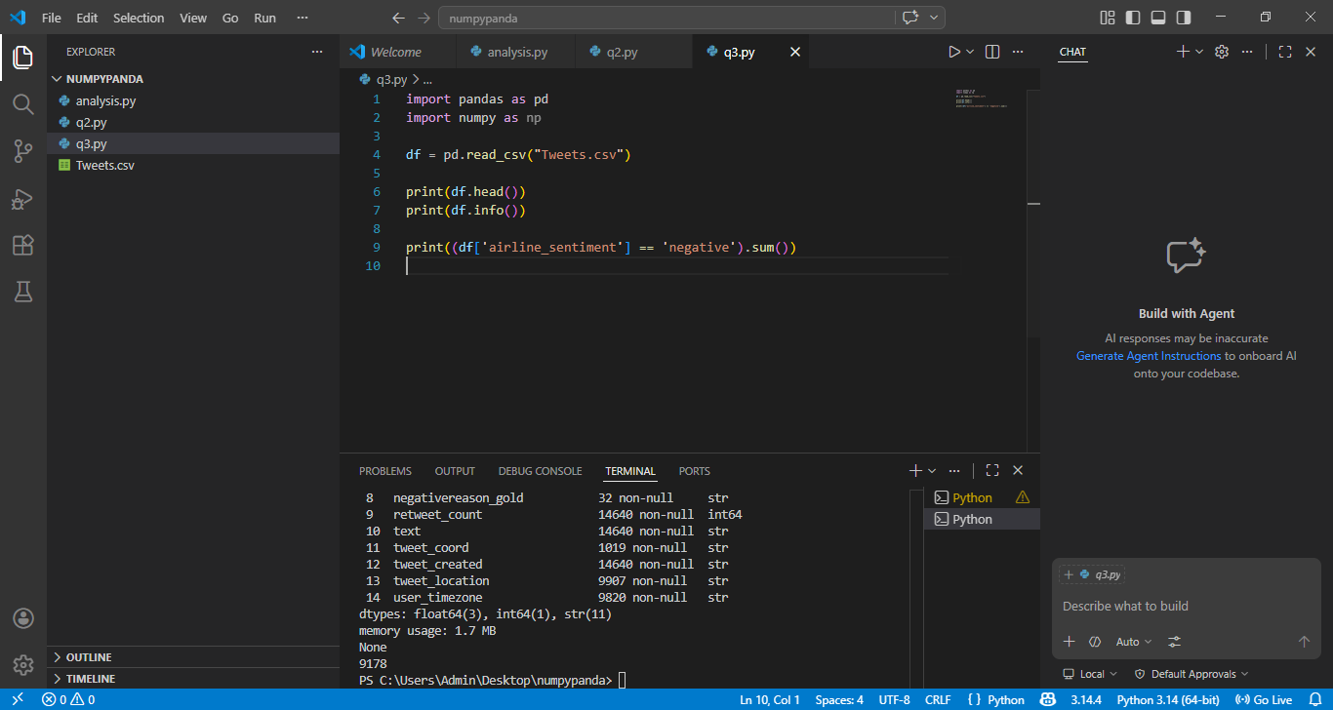
6. Average confidence score
print(np.mean(df['airline_sentiment_confidence']))
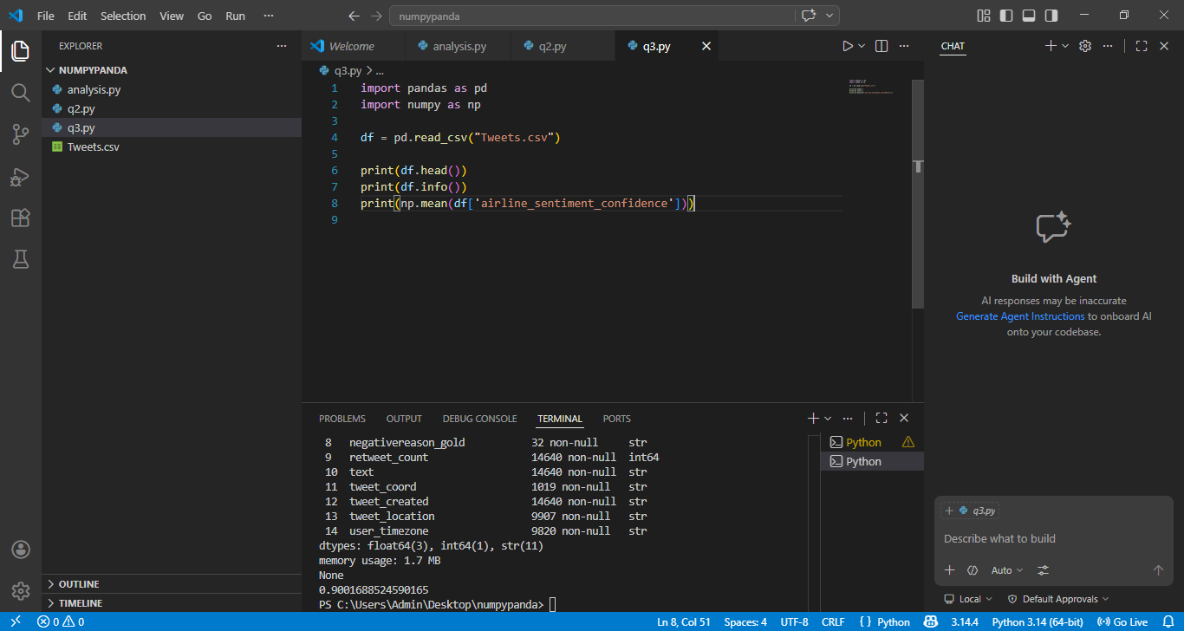

7. Highest confidence tweet
print(df[df['airline_sentiment_confidence'] == df['airline_sentiment_confidence'].max()])
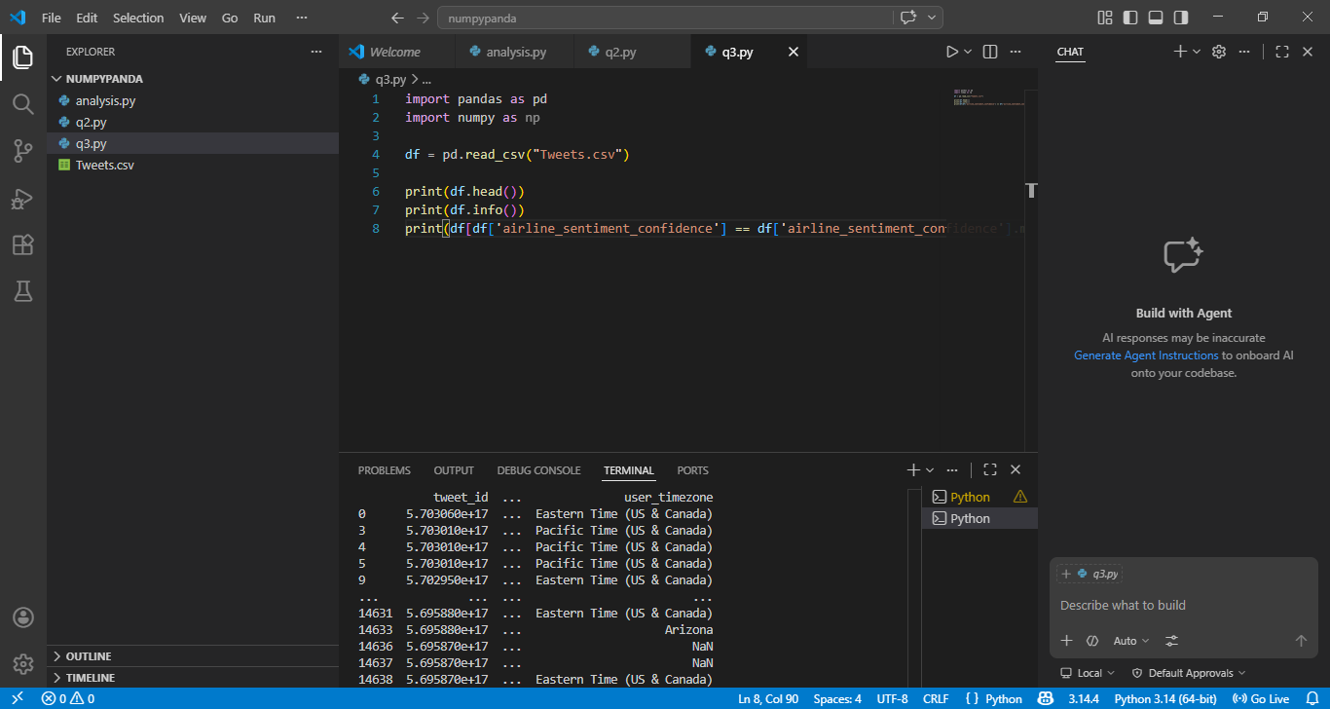
8. Sentiment count per airline
print(df.groupby('airline')['airline_sentiment'].value_counts())
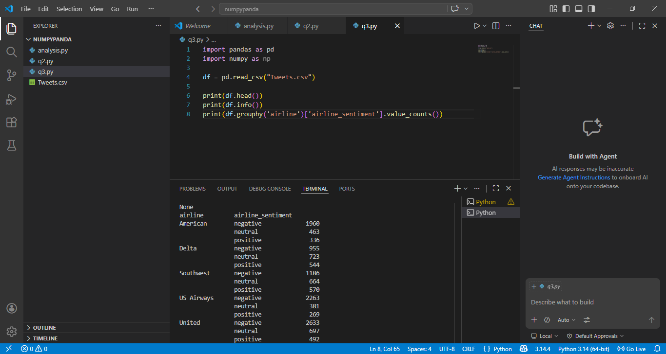

9. Airline with most negative tweets
print(df[df['airline_sentiment']=='negative']['airline'].value_counts())
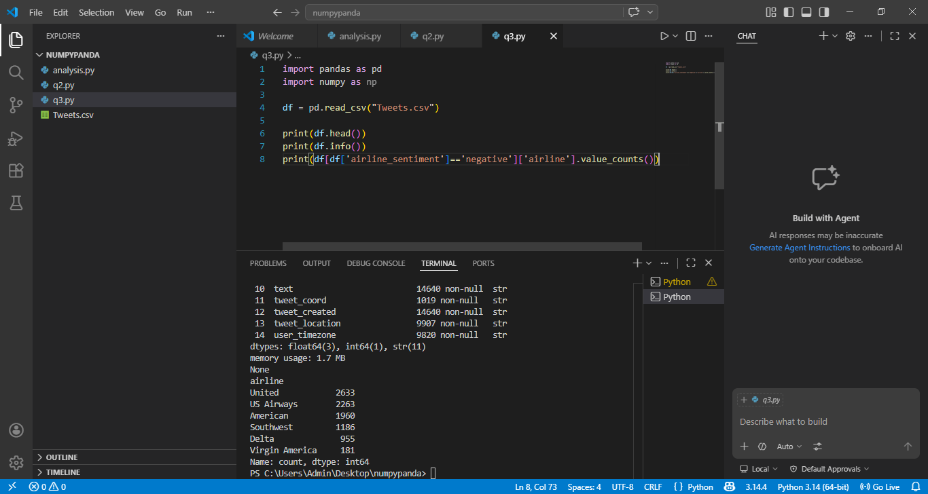
10. Average confidence per airline
print(df.groupby('airline')['airline_sentiment_confidence'].mean())
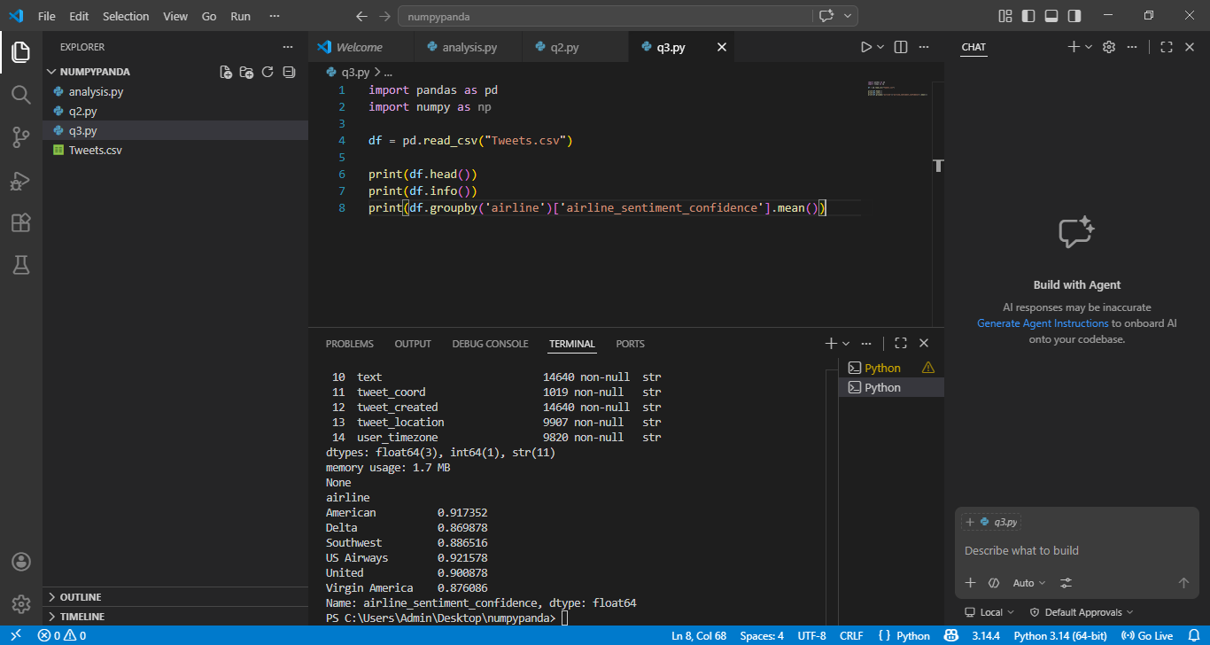

11. Tweets containing "delay"
print(df[df['text'].str.contains('delay', case=False)])
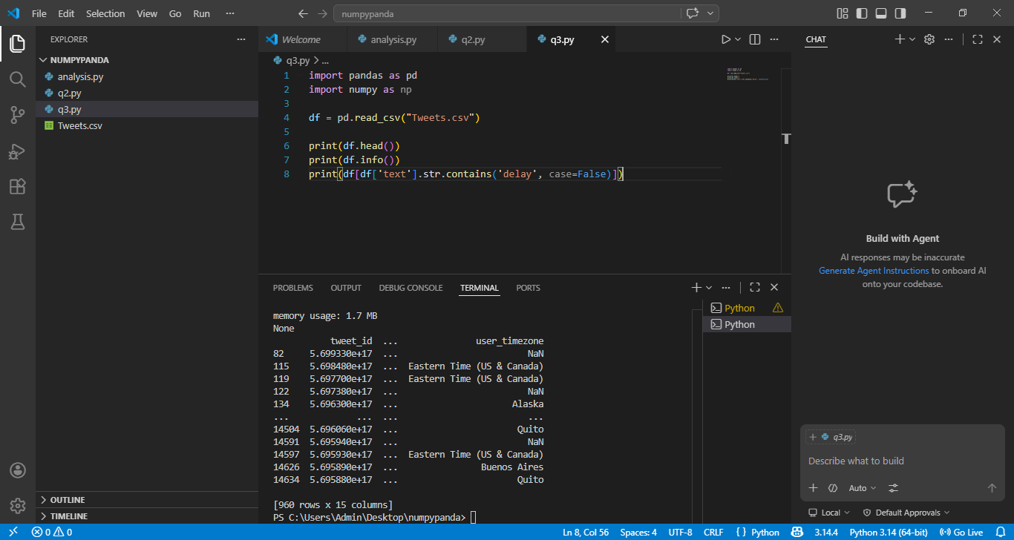

12. Count tweets mentioning "cancelled"
print(df['text'].str.contains('cancel', case=False).sum())
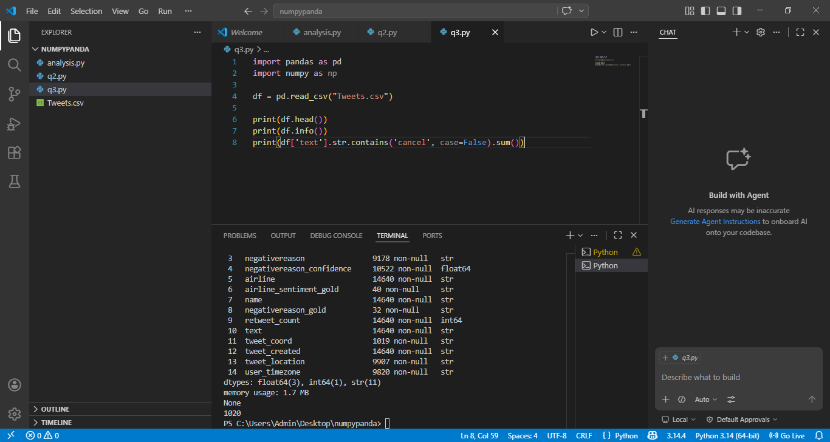

13. Convert tweet time
df['tweet_created'] = pd.to_datetime(df['tweet_created'])
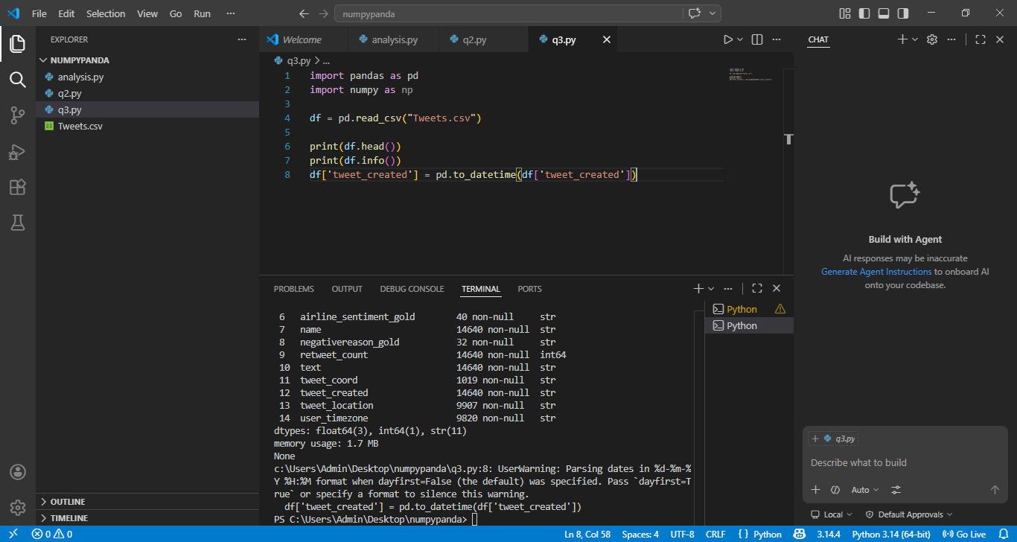

15. Confidence array
conf = df['airline_sentiment_confidence'].to_numpy()
print(np.mean(conf), np.std(conf))
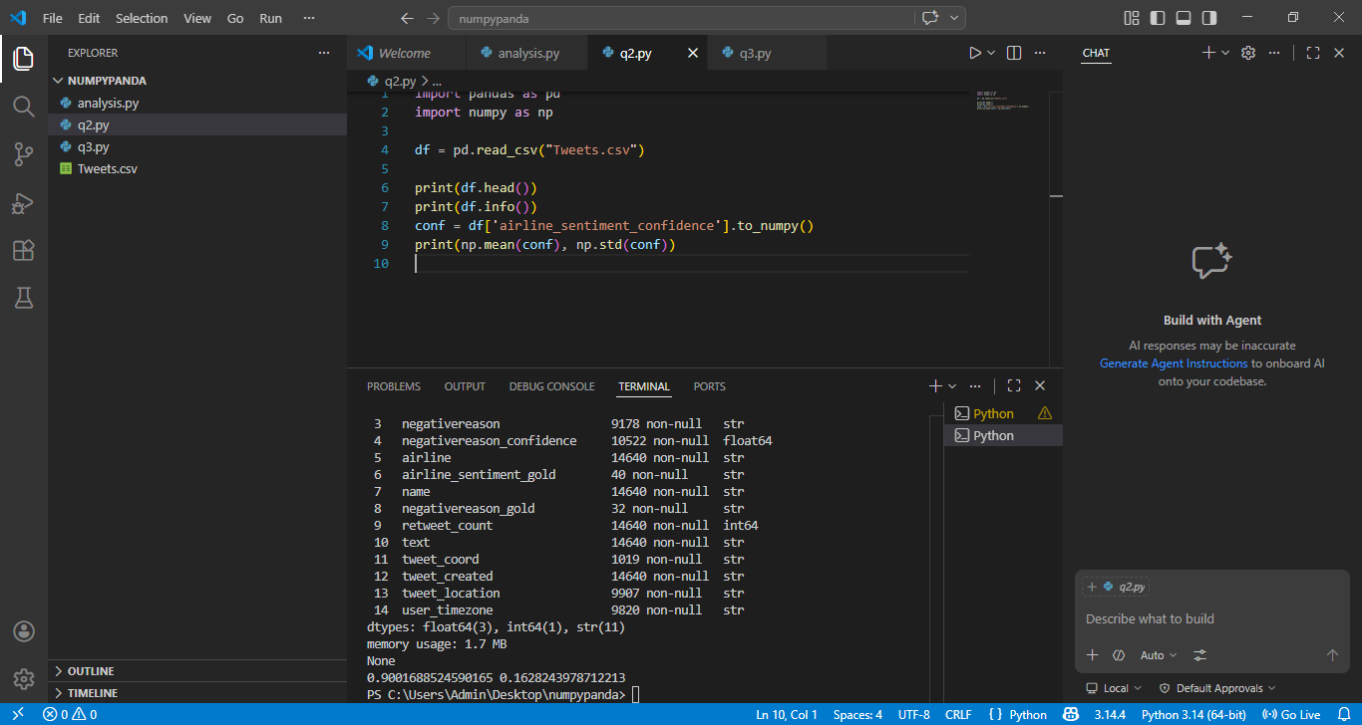

16. Find outliers using NumPy
mean = np.mean(conf)
std = np.std(conf)
outliers = conf[conf > mean + 2*std]
print(len(outliers))
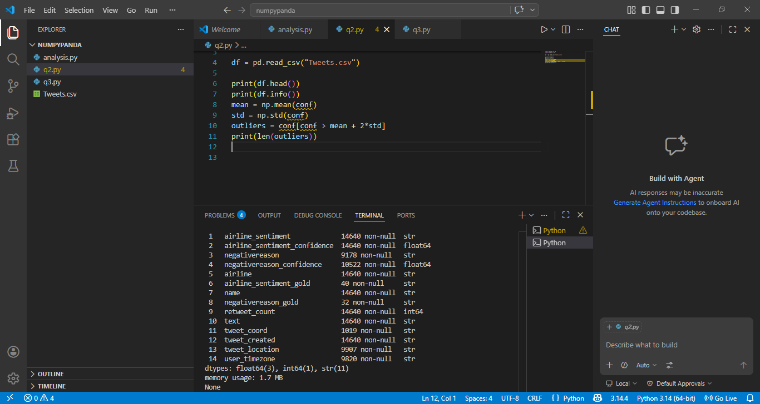

17. Top 5 users who tweeted most
print(df['name'].value_counts().head(5))
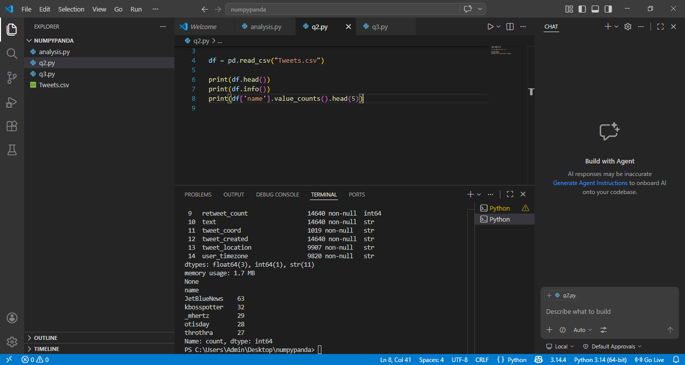

18. Most common negative reason
print(df['negativereason'].value_counts())
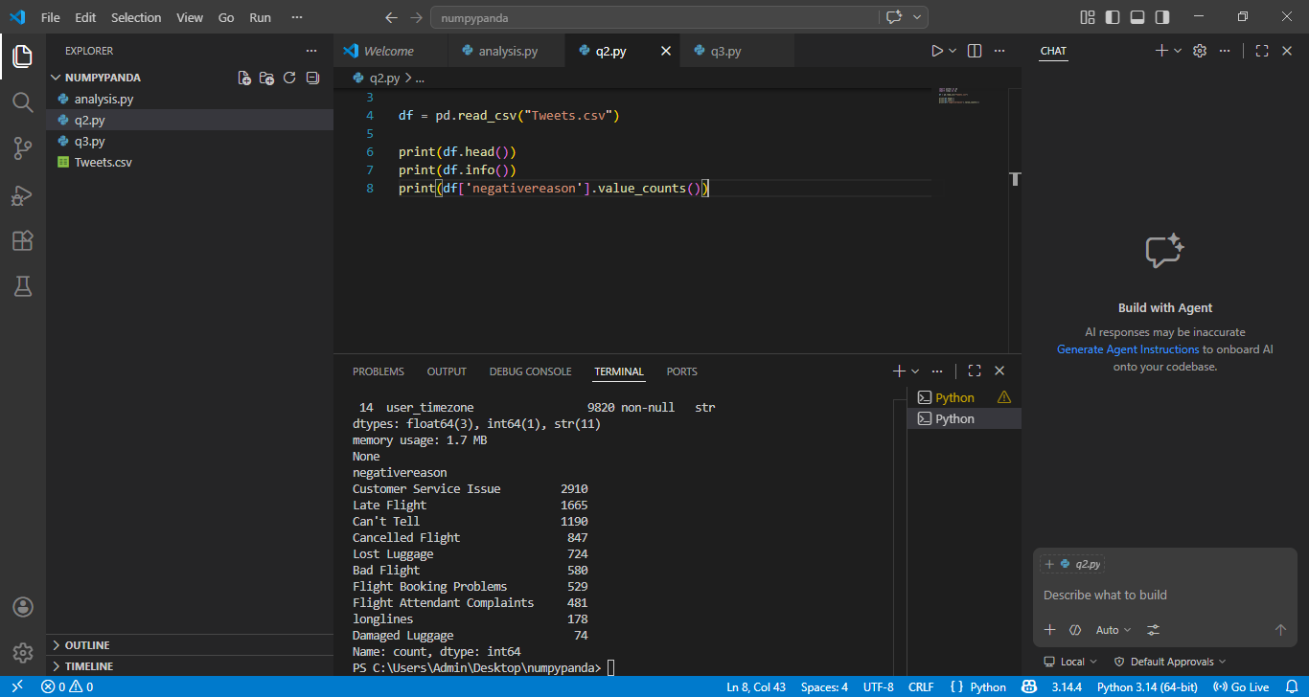

19. Airline with highest positive %
pos = df[df['airline_sentiment']=='positive']
print(pos['airline'].value_counts(normalize=True)*100)
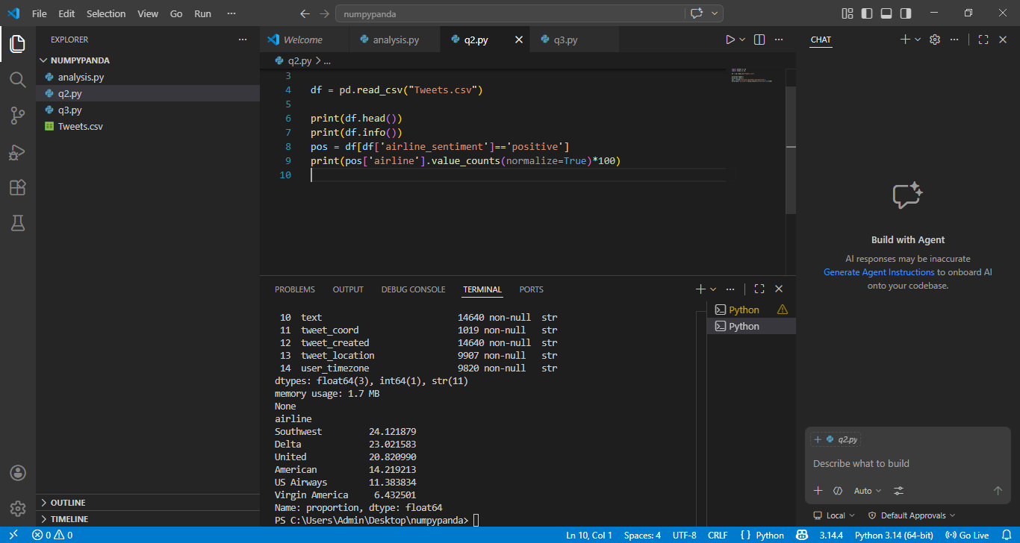

20. Create new column: tweet length
df['tweet_length'] = df['text'].apply(len)
print(df[['text','tweet_length']].head())
